SUPPORTING INFORMATION
Novel Conjugated 5-Alkenyl Rhodanine Tethered 1,4-Benzodioxane Derivatives as Dual-Chitinases Inhibitors to Hinder the Growth of Asian Corn Borer
Jinxiu Chen ^{a,b#}, Dongmei Shi ^{a,b#}, Zhiyang Jiang ^{a,b}, Renxuan Zou ^{a,b}, Jingyu Zhang ^{a,b}, Qing Han ^{a,b}, Na Wang ^{a,b}, Zhijian Xu^{c}, Qing Yang ^{d*}, Hongxia Duan ^{a,b*}
(ª Innovation Center of Pesticide Research, Department of Applied Chemistry, College of Science, China Agricultural University, Beijing 100193, China)
(^{b} Key Laboratory of National Forestry and Grassland Administration on Pest Chemical Control, Beijing 100193, People’s Republic of China)
(^{c} CAS Key Laboratory of Receptor Research, Drug Discovery and Design Center, Shanghai Institute of Materia Medica, Chinese Academy of Sciences, Shanghai 201203, China)
(^{d} State Key Laboratory for Biology of Plant Diseases and Insect Pests, Institute of Plant Protection and Shenzhen Agricultural Genome Research Institute, Chinese Academy of Agricultural Sciences, Beijing 100193, China)
(#These authors contributed equally to this work.)
(*These authors are corresponding authors.)

Figure S1-S48. The 1H NMR, 13C NMR and HRMS spectra of Compounds 3a~3h and 4a~4h.
Spectra data of Compounds 3a~3h, 4a~4h

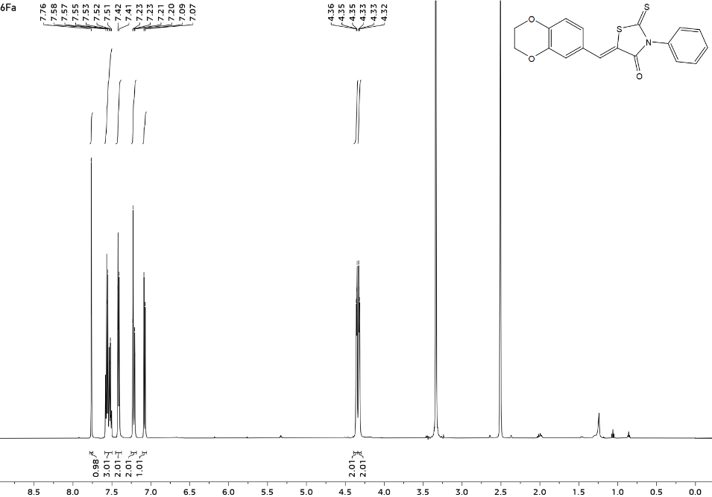
(Z)-5-((2,3-dihydrobenzo[b][1,4]dioxin-6-yl)methylene)-3-phenyl-2-thioxothiazolidin-4-one (3a): yellow solid; yield 87.4%; m.p. 206.3~209.5 ℃. ¹H NMR (500 MHz, DMSO-d₆) δ 7.76 (s, 1H), 7.60 – 7.48 (m, 3H), 7.41 (d, J = 7.9 Hz, 2H), 7.25 – 7.19 (m, 2H), 7.08 (d, J = 8.2 Hz, 1H), 4.36 – 4.34 (m, 2H), 4.33 – 4.31 (m, 2H). ¹³C NMR (125 MHz, DMSO-d₆) δ 194.18, 167.43, 146.74, 144.36, 135.75, 133.23, 129.89, 129.78, 129.23, 126.90, 124.94, 121.14, 119.98, 118.79, 65.05, 64.47. HR-MS (m/z): [M+H]⁺, C₁₈H₁₃NO₃S₂ calculated, 356.0410; found, 356.0415.
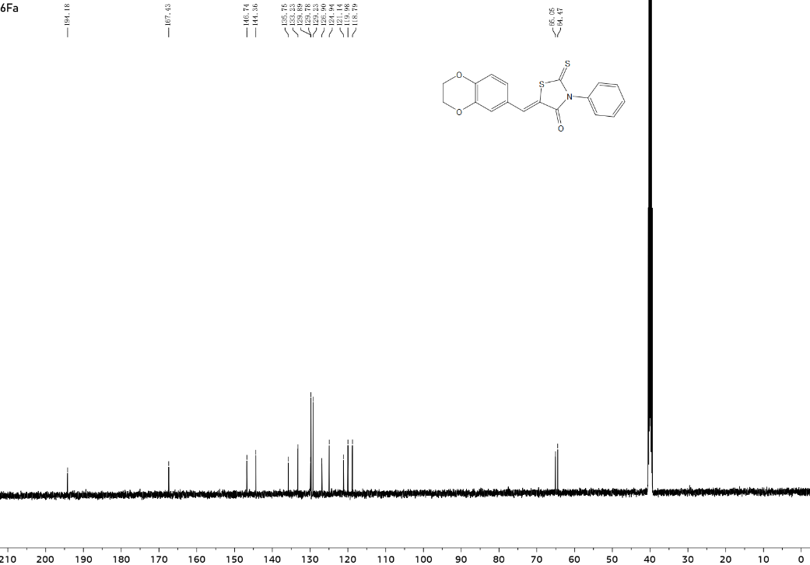
Figure S1. ¹H-NMR spectrum of Compound 3a.
Figure S2. ¹³C-NMR spectrum of Compound 3a.
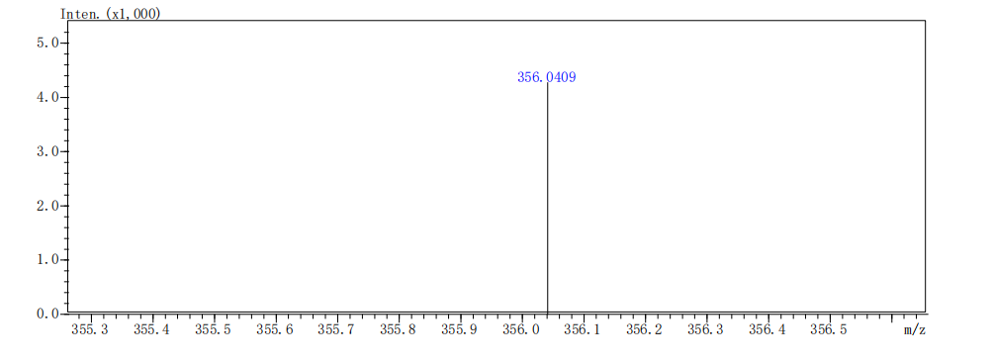
Figure S3. HRMS spectrum of Compound 3a.
(Z)-5-((2,3-dihydrobenzo[b][1,4]dioxin-6-yl)methyl)-3-(4-fluorophenyl)-2-thioxothiazolidin-4-one (3b): yellow solid; yield 20.3%; m.p.178.3~179.1 ℃. ¹H NMR (500 MHz, DMSO-d₆) δ 7.38 (t, J = 8.9 Hz, 2H), 7.22 (s, 2H), 6.86 – 6.77 (m, 2H), 6.73 (dd, J = 8.2, 2.2 Hz, 1H), 5.04 (dd, J = 8.7, 4.6 Hz, 1H), 4.23 (s, 4H), 3.36 (dd, J = 14.0, 4.6 Hz, 1H), 3.22 (dd, J =14.1, 8.8 Hz, 1H). ¹³C NMR (125 MHz, DMSO-d₆) δ 202.52, 175.86, 162.59 (d, J = 246.4 Hz), 143.63, 143.10, 132.06, 131.40, 131.32, 129.61, 122.50, 118.32, 117.50, 116.88, 116.70, 64.53, 64.50, 53.71, 36.51. HR-MS (m/z): [M+H]⁺, C₁₈H₁₄FNO₃S₂ calculated, 376.0472; found, 376.0470.
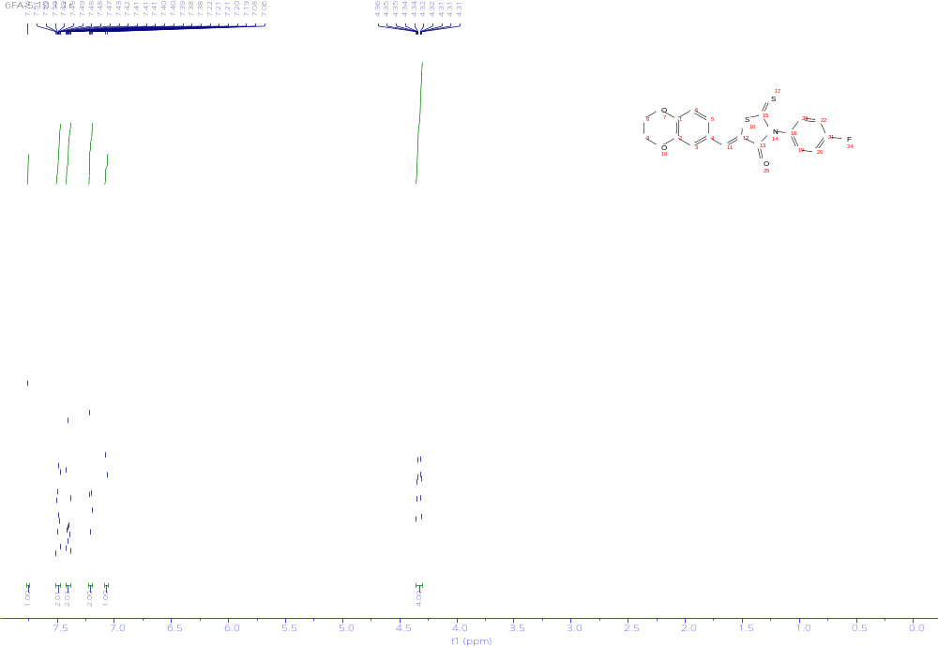
Figure S4. ¹H-NMR spectrum of Compound 3b.
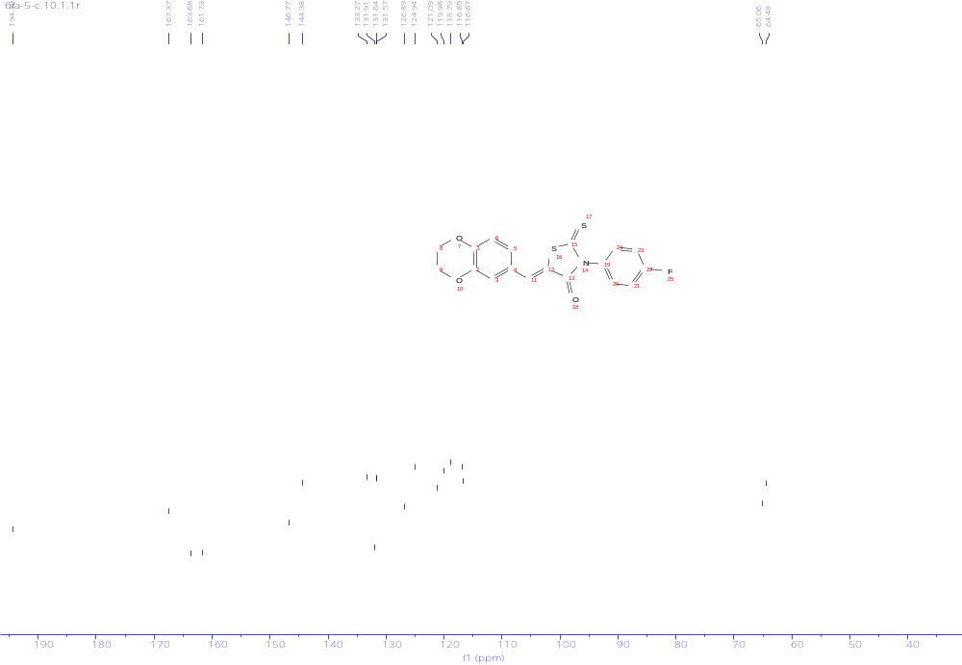
Figure S5. ¹³C-NMR spectrum of Compound 3b.
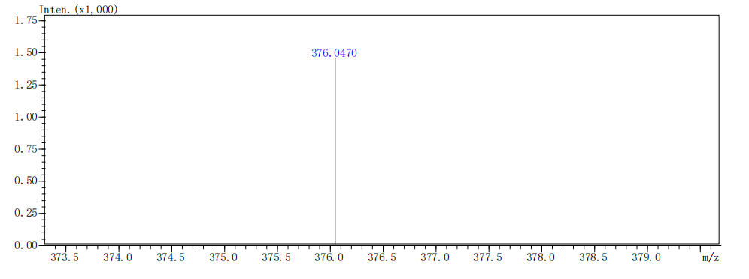
Figure S6. HRMS spectrum of Compound 3b.

(Z)-3-(4-chlorophenyl)-5-((2,3-dihydrobenzo[b][1,4]dioxin-6-yl)methylene)-2-thioxothiazolidin-4-one (3c): yellow solid; yield 80.6%; m.p. 249.4~250.9℃. ¹H NMR (500 MHz, DMSO-d₆) δ 7.76 (s, 1H), 7.66 – 7.62 (m, 2H), 7.49 – 7.46 (m, 2H), 7.23 – 7.19 (m, 2H), 7.07 (d, J = 8.2 Hz, 1H), 4.36 – 4.30 (m, 4H). ¹³C NMR (125 MHz, DMSO-d₆) δ 194.07, 167.23, 146.80, 144.39, 135.08, 133.37, 132.85, 131.56, 126.87, 124.95, 123.28, 121.13, 120.00, 118.81, 65.07, 64.48. HR-MS (m/z): [M+H]⁺, C₁₈H₁₂ClNO₃S₂ calculated, 390.002; found, 390.0017.

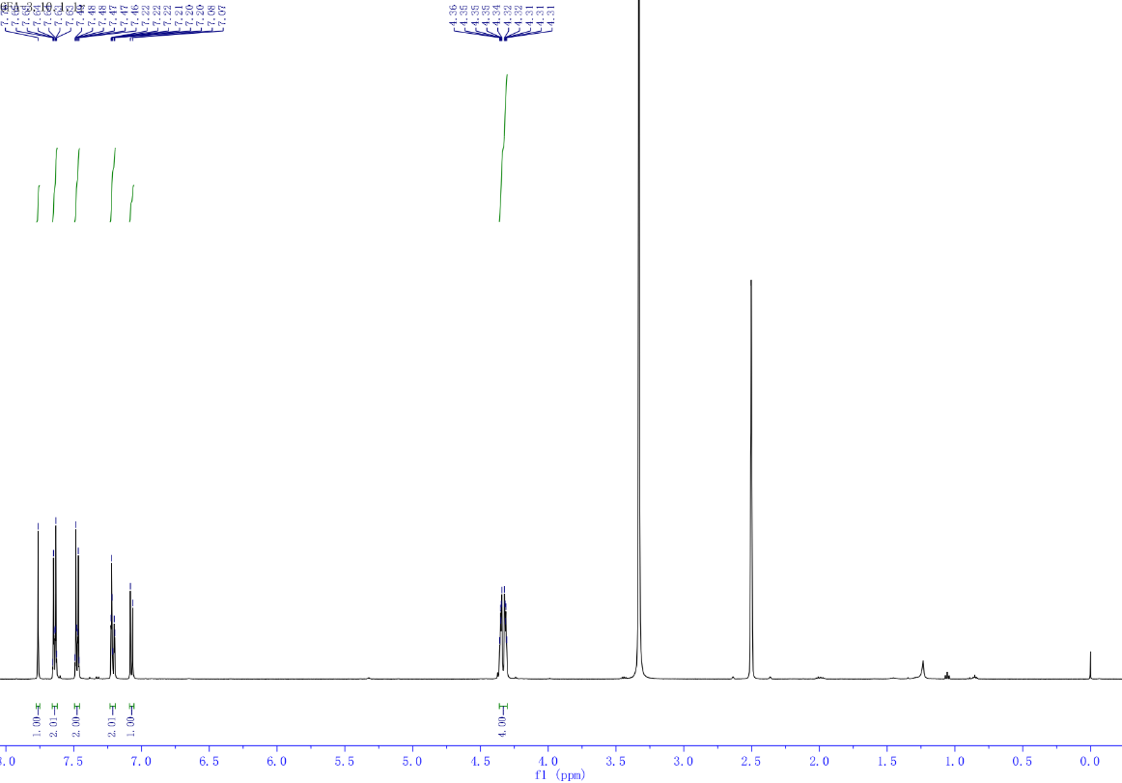
Figure S7. ¹H-NMR spectrum of Compound 3c.
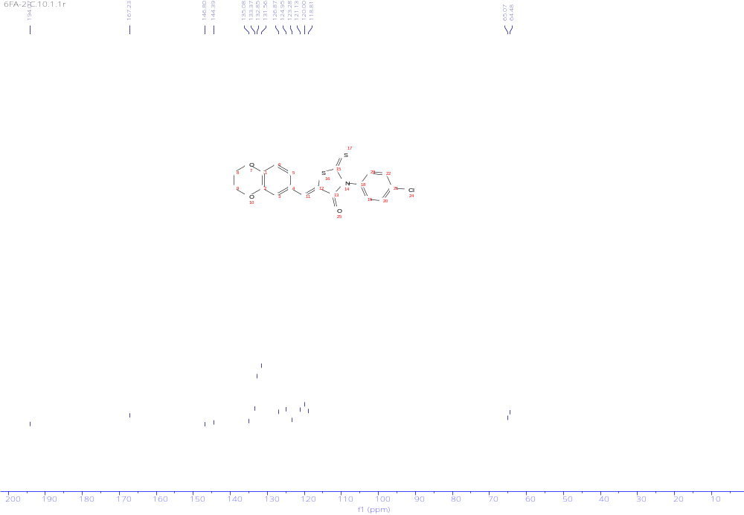
Figure S8. ¹³C-NMR spectrum of Compound 3c.

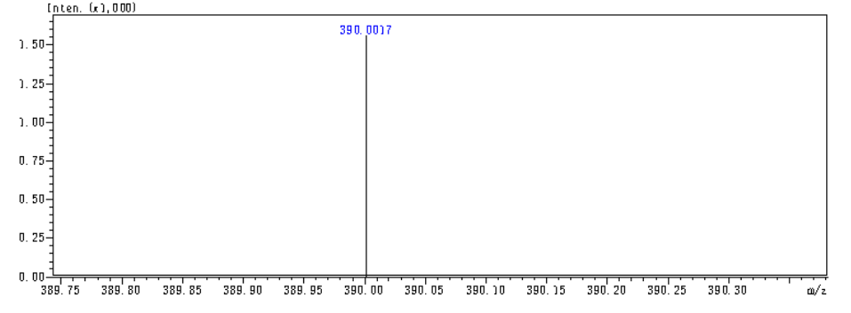
Figure S9. HRMS spectrum of Compound 3c.
(Z)-3-(4-bromophenyl)-5-((2,3-dihydrobenzo[b][1,4]dioxin-6-yl)methylene)-2-thioxothiazolidin-4-one (3d): yellow solid; yield 21.8%; m.p. 118.8~120.4℃.¹H NMR (500 MHz, DMSO-d₆) δ 7.77 – 7.72 (m, 2H), 7.19 – 7.09 (m, 2H), 6.88 – 6.77 (m, 2H), 6.74 (dd, J= 8.2, 2.1 Hz, 1H), 5.05 (dd, J = 8.7, 4.6 Hz, 1H), 4.24 (s, 4H), 3.39 – 3.35 (m, 1H), 3.23 (dd, J = 14.0, 8.7 Hz, 1H). ¹³C NMR (125 MHz, DMSO-d₆) δ 202.25, 175.70, 143.63, 143.10, 135.16, 132.88, 131.31, 129.59, 123.16, 122.49, 118.31, 117.50, 64.53, 64.50, 53.87, 36.50. HR-MS (m/z): [M+H]⁺, C₁₈H₁₄BrNO₃S₂ calculated, 435.9671; found, 435.9680.
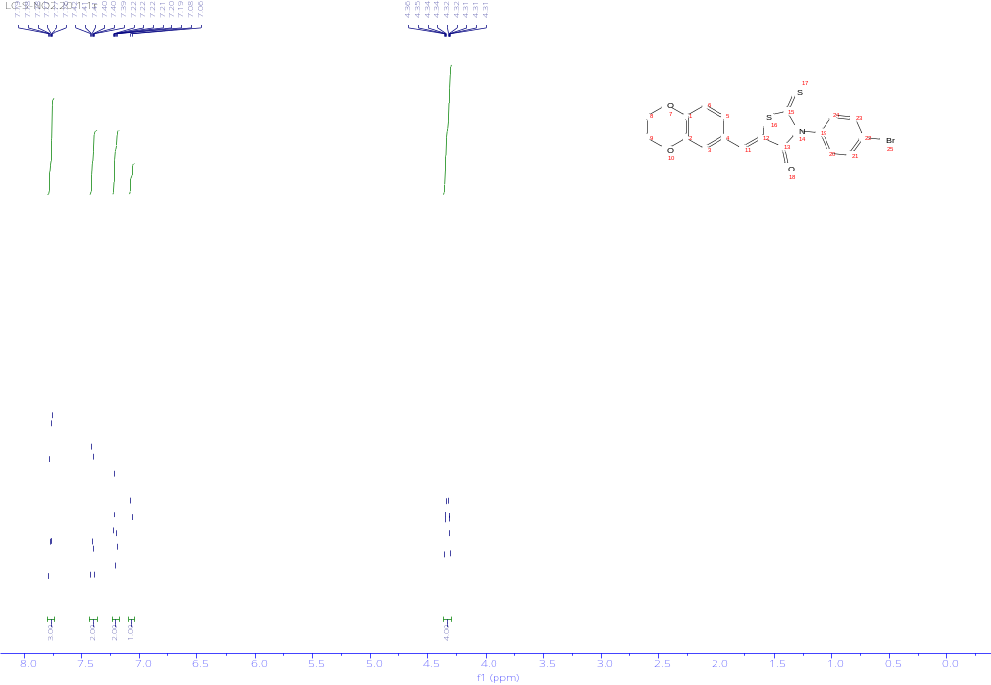
Figure S10. ¹H-NMR spectrum of Compound 3d.
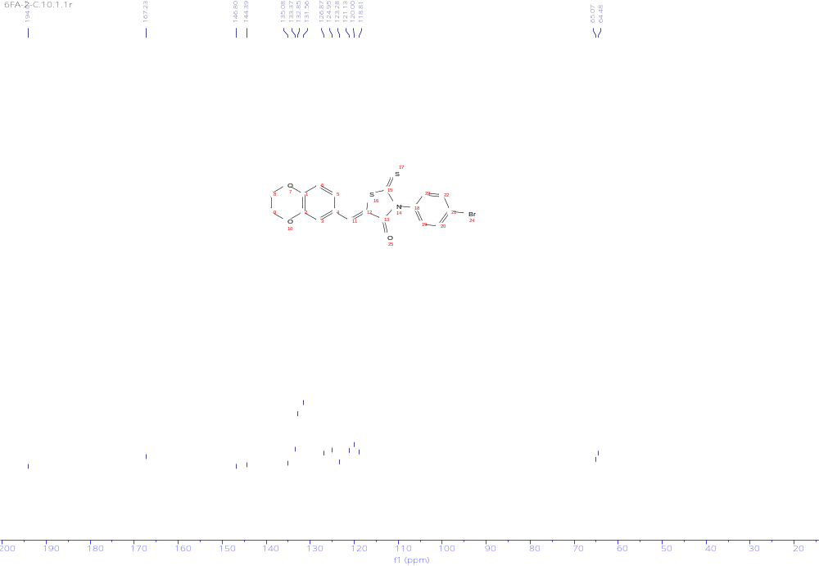
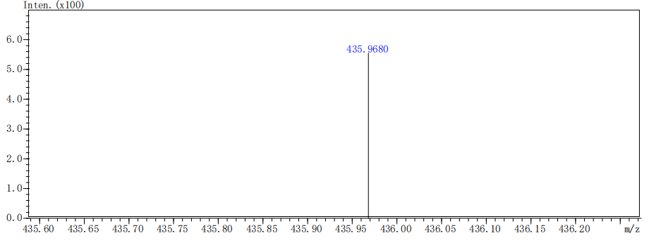
Figure S11. ¹³C-NMR spectrum of Compound 3d.
Figure S12. HRMS spectrum of Compound 3d.
(Z)-5-((2,3-dihydrobenzo[b][1,4]dioxin-6-yl)methylene)-2-thioxo-3-(p-tolyl)thiazolidin-4-one (3e): yellow solid; yield 19.9%; m.p. 135.6~137.2℃. ¹H NMR (500 MHz, DMSO-d₆) δ 7.37 (d, J = 9.3 Hz, 2H), 7.05 (d, J = 7.6 Hz, 2H), 6.88 (d, J = 8.2 Hz, 1H), 6.84 – 6.77 (m, 2H), 5.11 (dd, J = 8.5, 4.6 Hz, 1H), 4.29 (s, 4H), 3.43 – 3.40 (m, 1H), 3.28 (dd, J = 14.1, 8.5 Hz, 1H), 2.42 (s, 3H). ¹³C NMR (125 MHz, DMSO-d₆) δ 202.53, 175.99, 143.61, 143.09, 139.43, 133.28, 130.27, 129.53, 128.71, 122.55, 118.35, 117.46, 64.53, 53.59, 36.52, 21.25.HR-MS (m/z): [M+H]⁺, C₁₉H₁₇NO₃S₂ calculated, 372.0723; found, 372.0727.
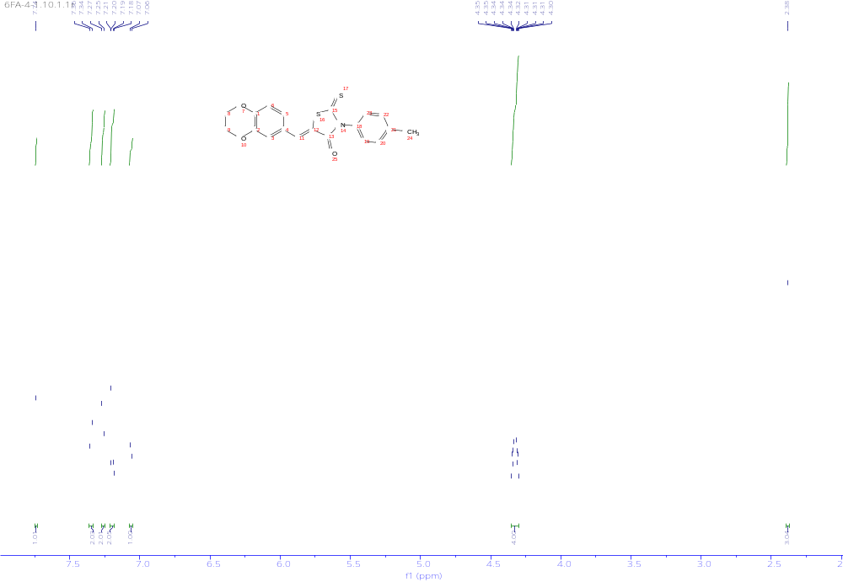
Figure S13. ¹H-NMR spectrum of Compound 3e.
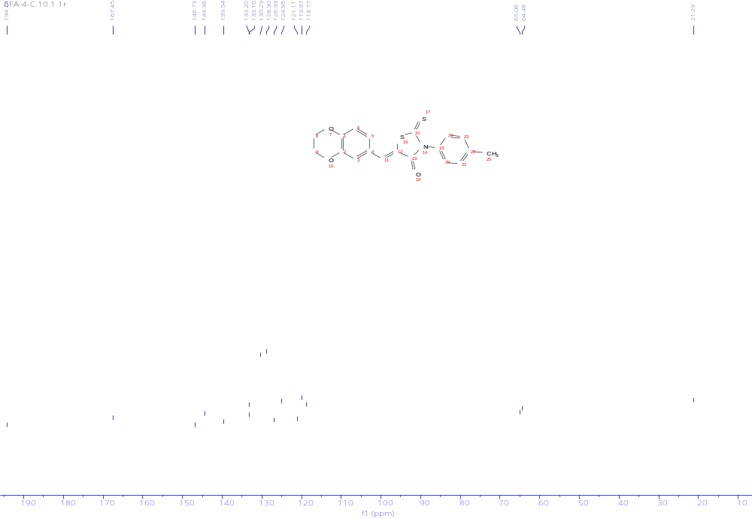
Figure S14. ¹³C-NMR spectrum of Compound 3e.

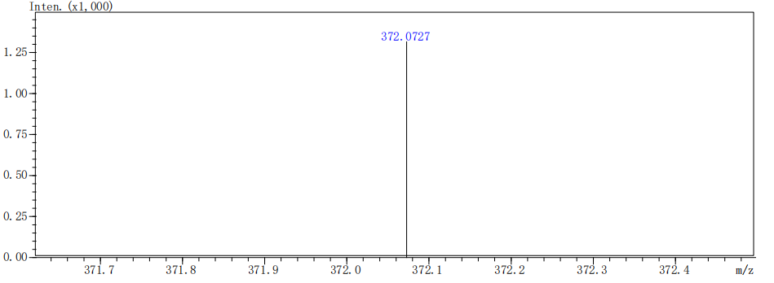
Figure S15. HRMS spectrum of Compound 3e.
(Z)-5-((2,3-dihydrobenzo[b][1,4]dioxin-6-yl)methylene)-3-(4-methoxyphenyl)-2-thioxothiazolidin-4-one (3f): yellow solid; yield 19.9%; m.p. 135.6~137.2℃. ¹H NMR (500 MHz, DMSO-d₆) δ 7.37 (d, J = 9.3 Hz, 2H), 7.05 (d, J = 7.6 Hz, 2H), 6.88 (d, J = 8.2 Hz, 1H), 6.84 – 6.77 (m, 2H), 5.11 (dd, J = 8.5, 4.6 Hz, 1H), 4.29 (s, 4H), 3.43 – 3.40 (m, 1H), 3.28 (dd, J = 14.1, 8.5 Hz, 1H), 2.42 (s, 3H). ¹³C NMR (125 MHz, DMSO-d₆) δ 202.53, 175.99, 143.61, 143.09, 139.43, 133.28, 130.27, 129.53, 128.71, 122.55, 118.35, 117.46, 64.53, 53.59, 36.52, 21.25. HR-MS (m/z): [M+H]⁺, C₁₉H₁₇NO₃S₂ calculated, 372.0723; found, 372.0727.
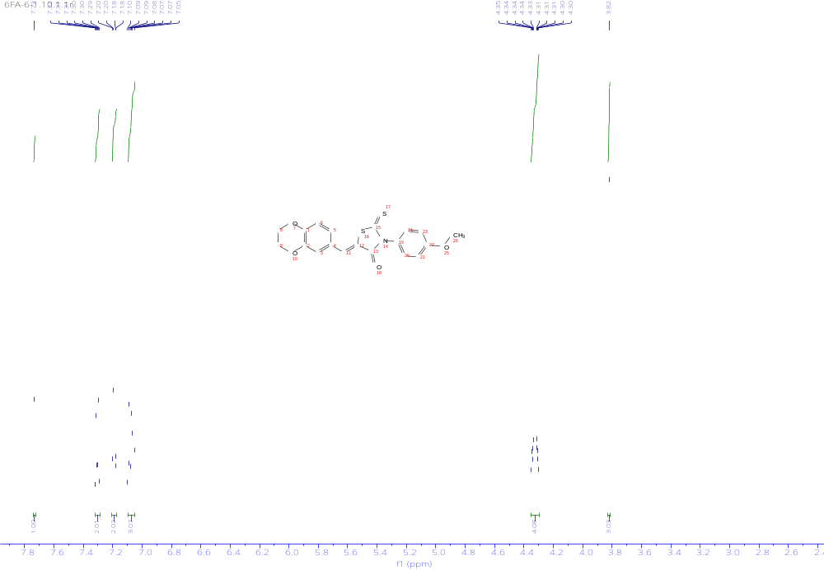
Figure S16. ¹H-NMR spectrum of Compound 3f.
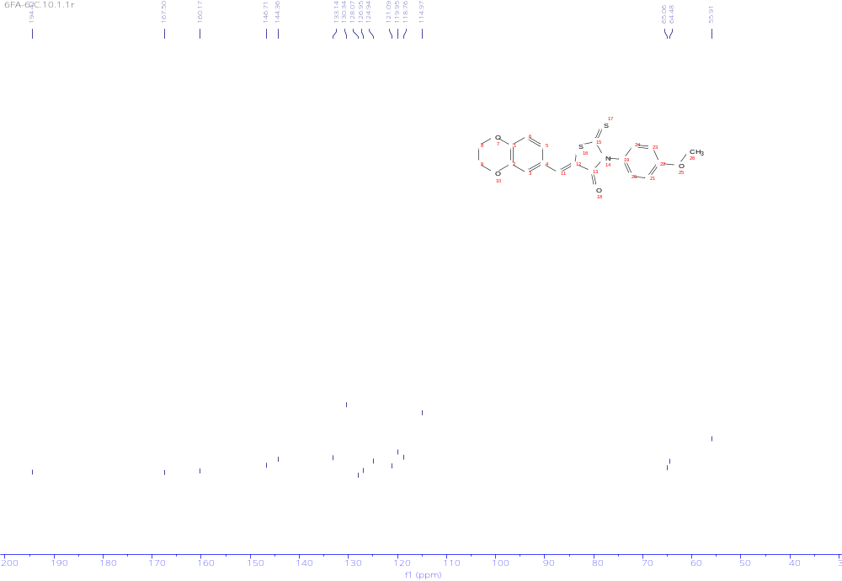
Figure S17. ¹³C-NMR spectrum of Compound 3f.
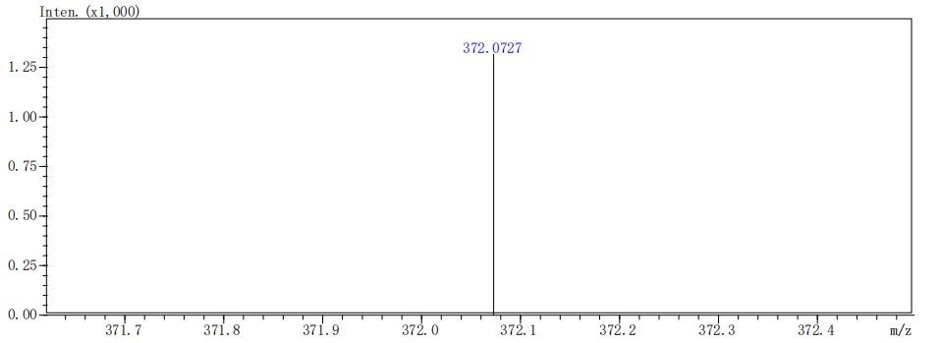
Figure S18. HRMS spectrum of Compound 3f.
(Z)-5-((2,3-dihydrobenzo[b][1,4]dioxin-6-yl)methylene)-2-thioxo-3-(4-(trifluoromethyl)phenyl)thiazolidin-4-one (3g): yellow solid; yield 85.7%; m.p. 272.8~274.9℃. ¹H NMR (500 MHz, DMSO-d₆) δ 7.97 (d, J = 8.3 Hz, 2H), 7.79 (s, 1H), 7.72 (d, J = 8.2 Hz, 2H), 7.23 (dd, J = 10.8, 2.4 Hz, 2H), 7.08 (d, J = 8.4 Hz, 1H), 4.34 (dd, J = 15.3, 5.4 Hz, 4H). ¹³C NMR (125 MHz, DMSO-d₆) δ 194.03, 167.25, 146.84, 144.40, 139.47, 133.49, 130.59, 130.13 (d, J = 32.8 Hz), 126.96, 126.93, 126.84, 125.20 (d, J = 58.8 Hz), 123.27, 121.14, 120.04, 118.83, 65.07, 64.48. HR-MS (m/z): [M+H]⁺, C₁₉H₁₂F₃NO₃S₂ calculated, 424.0283; found, 424.0281.
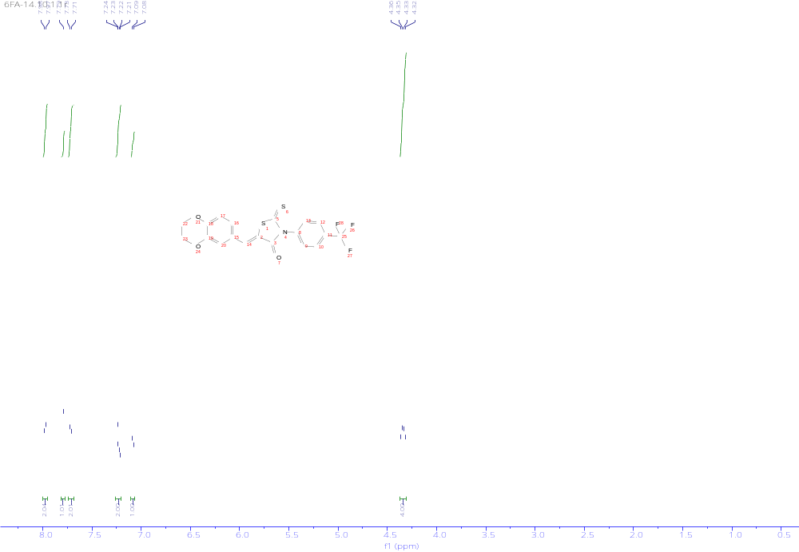
Figure S19. ¹H-NMR spectrum of Compound 3g.
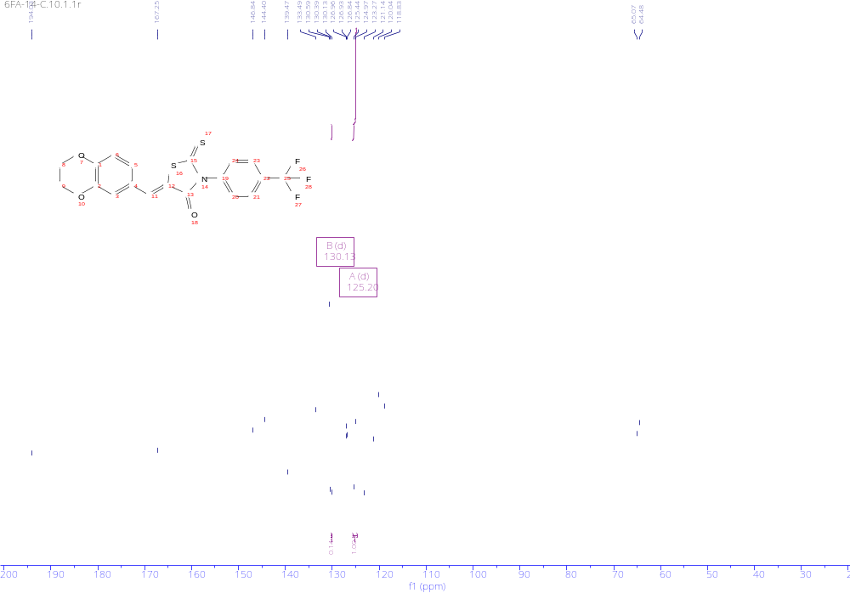
Figure S20. ¹³C-NMR spectrum of Compound 3g.
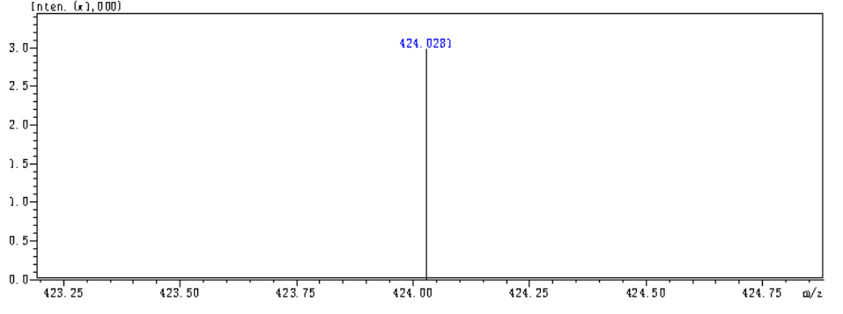
Figure S21. HRMS spectrum of Compound 3g.
(Z)-3-benzyl-5-((2,3-dihydrobenzo[b][1,4]dioxin-6-yl)methylene)-2-thioxothiazolidin-4-one (3h): yellow solid; yield 80.8%; m.p. 137~139.0℃.¹H NMR (500 MHz, DMSO-d₆) δ 7.75 (s, 1H), 7.36 – 7.26 (m, 5H), 7.17 – 7.14 (m, 2H), 7.04 (d, J = 8.1 Hz, 1H), 5.23 (s, 2H), 4.34 – 4.29 (m, 4H). ¹³C NMR (125 MHz, DMSO-d₆) δ 193.63, 167.47, 146.90, 144.35, 135.42, 134.08, 129.04, 128.17, 128.12, 126.77, 125.10, 120.06, 118.75, 65.06, 64.45, 47.56. HR-MS (m/z): [M+H]⁺, C₁₉H₁₅NO₃S₂ calculated, 370.0566; found, 370.0563.
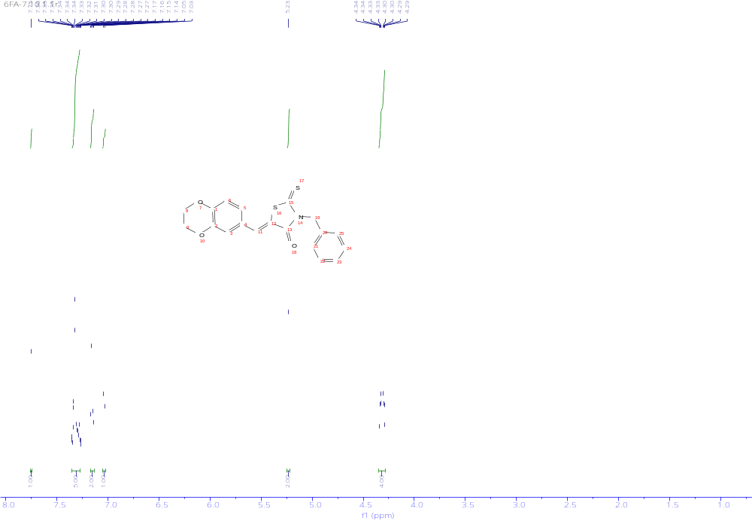
Figure S22. ¹H-NMR spectrum of Compound 3h.
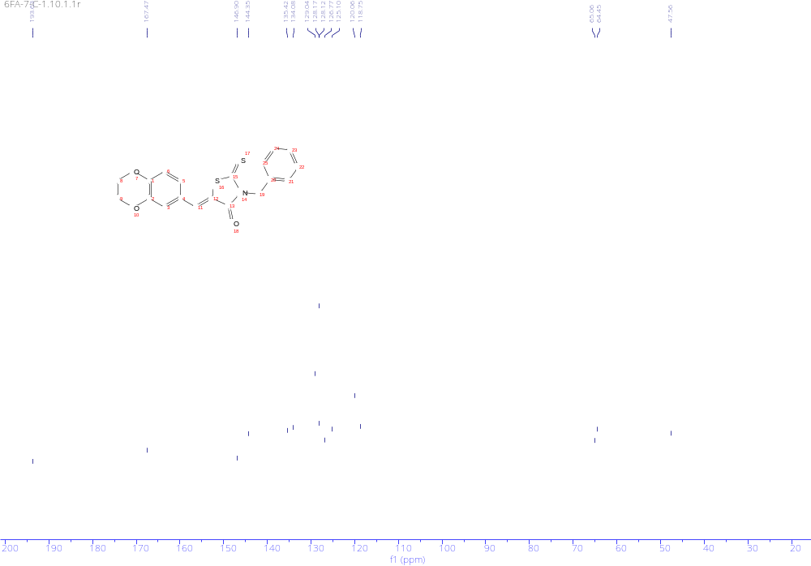
Figure S23. ¹³C-NMR spectrum of Compound 3h.
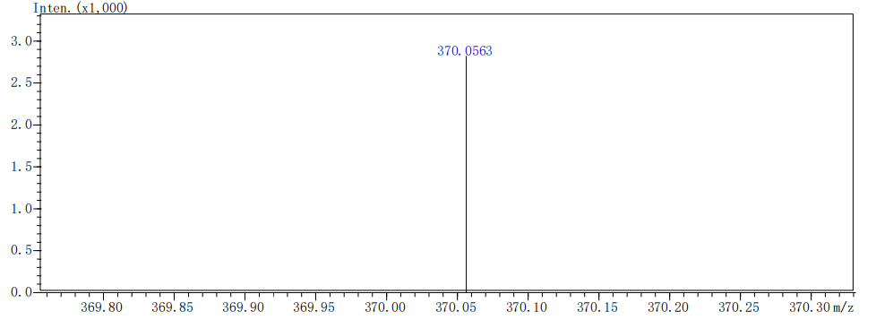
Figure S24. HRMS spectrum of Compound 3h.
5-((2,3-dihydrobenzo[b][1,4]dioxin-6-yl)methyl)-3-phenyl-2-thioxothiazolidin-4-one (4a): yellow solid; yield 20.6%; m.p. 174.7~176.4℃. ¹H NMR (500 MHz, DMSO-d₆) δ 7.55 – 7.46 (m, 3H), 7.16 (dd, J = 30.4, 7.6 Hz, 2H), 6.85 – 6.78 (m, 2H), 6.74 (dd, J = 8.2, 2.1 Hz, 1H), 5.06 (dd, J = 8.5, 4.7 Hz, 1H), 4.23 (s, 4H), 3.36 (dd, J = 14.0, 4.7 Hz, 1H), 3.23 (dd, J = 14.1, 8.5 Hz, 1H). 13C NMR (125 MHz, DMSO-d₆) δ 202.45, 175.96, 143.62, 143.10, 135.91, 129.79, 129.77, 129.55, 129.02, 122.55, 118.36, 117.48, 64.53, 64.51, 53.71, 36.52. HR-MS (m/z): [M+H]⁺, C₁₈H₁₅NO₃S₂ calculated, 358.0566; found, 358.0569.
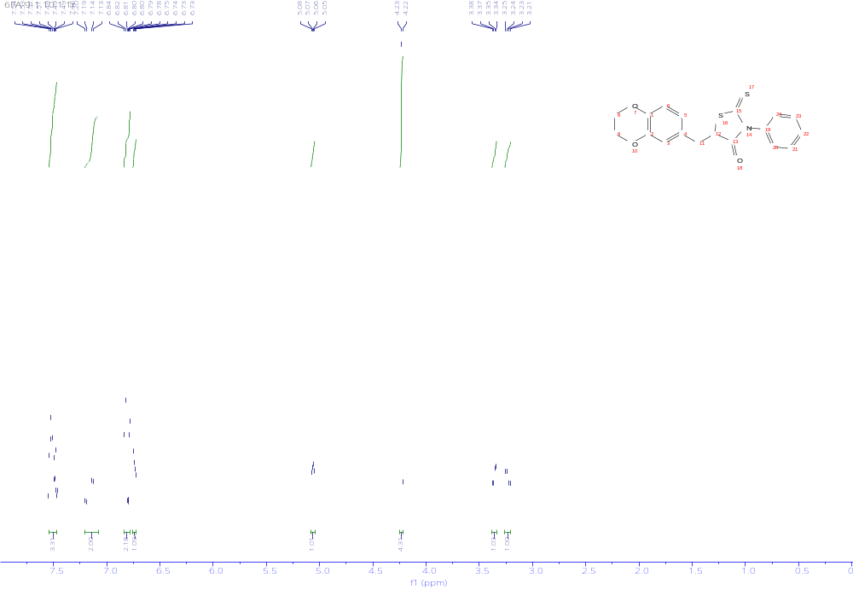
Figure S25. ¹H-NMR spectrum of Compound 4a.
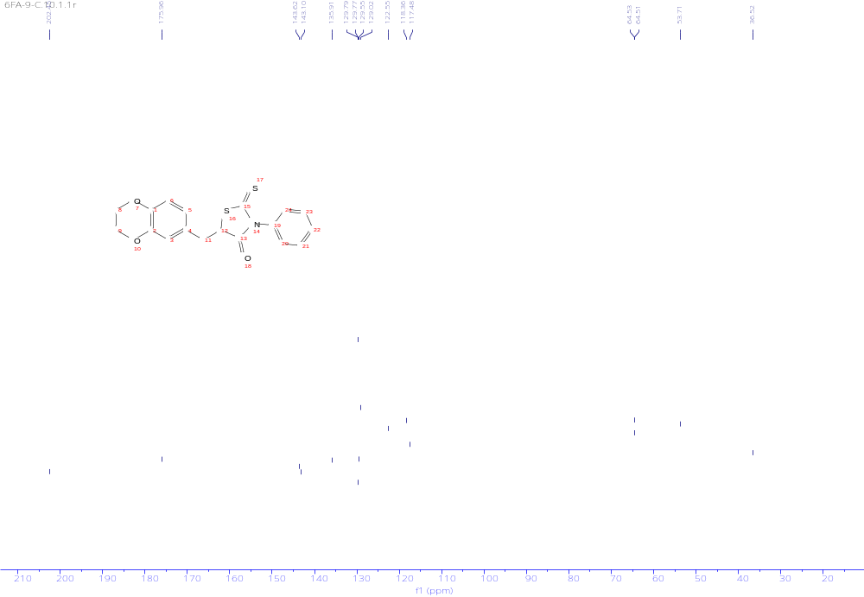
Figure S26. ¹³C-NMR spectrum of Compound 4a.
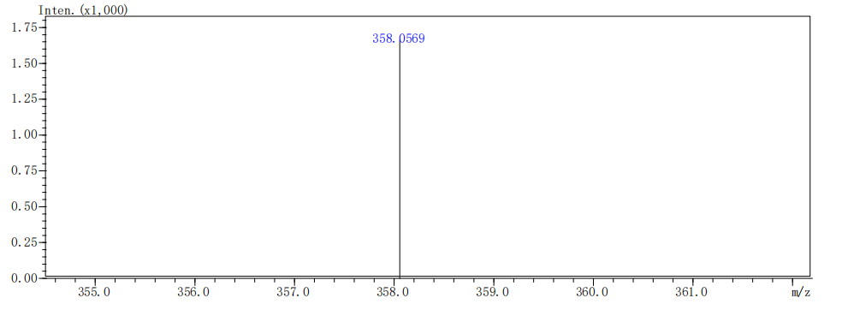
Figure S27. HRMS spectrum of Compound 4a.
5-((2,3-dihydrobenzo[b][1,4]dioxin-6-yl)methyl)-3-(4-fluorophenyl)-2-thioxothiazolidin-4-one (4b): yellow solid; yield 20.3%; m.p. 178.3~179.1℃. ¹H NMR (500 MHz, DMSO-d₆) δ 7.38 (t, J = 8.9 Hz, 2H), 7.22 (s, 2H), 6.86 – 6.77 (m, 2H), 6.73 (dd, J = 8.2, 2.2 Hz, 1H), 5.04 (dd, J = 8.7, 4.6 Hz, 1H), 4.23 (s, 4H), 3.36 (dd, J = 14.0, 4.6 Hz, 1H), 3.22 (dd, J = 14.1, 8.8 Hz, 1H). ¹³C NMR (125 MHz, DMSO-d₆) δ 202.52, 175.86, 162.59 (d, J = 246.4 Hz), 143.63, 143.10, 132.06, 131.40, 131.32, 129.61, 122.50, 118.32, 117.50, 116.88, 116.70, 64.53, 64.50, 53.71, 36.51. HR-MS (m/z): [M+H]⁺, C₁₈H₁₄FNO₃S₂ calculated, 376.0472; found, 376.0470
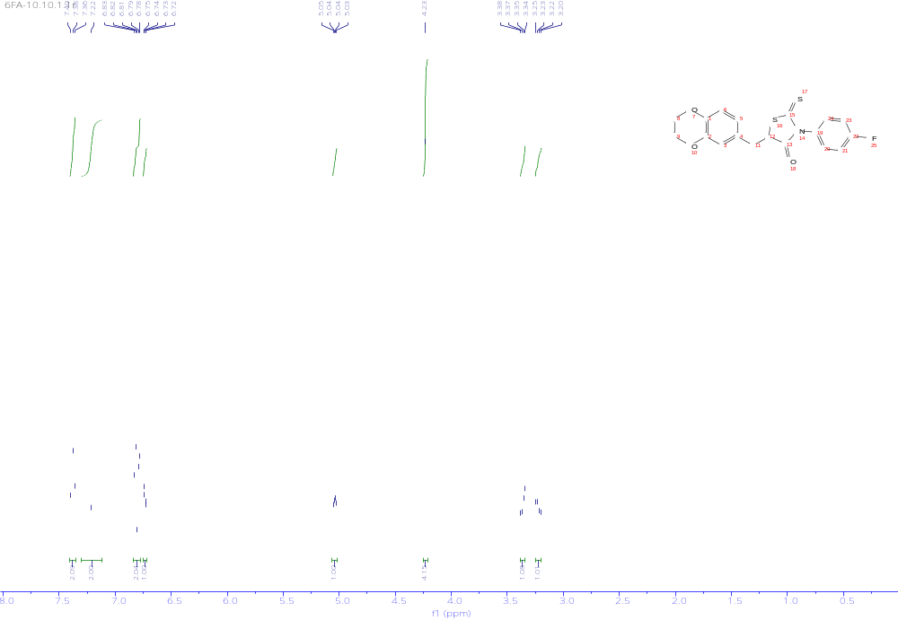
Figure S28. ¹H-NMR spectrum of Compound 4b.
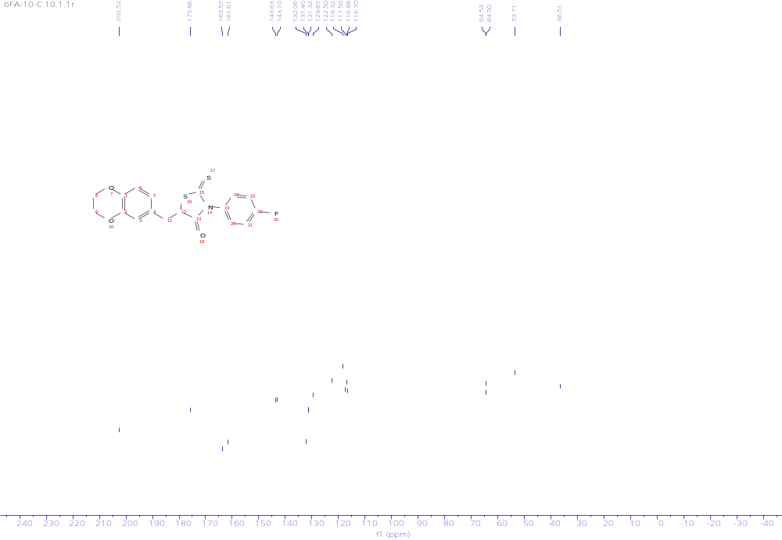
Figure S29. ¹³C-NMR spectrum of Compound 4b.
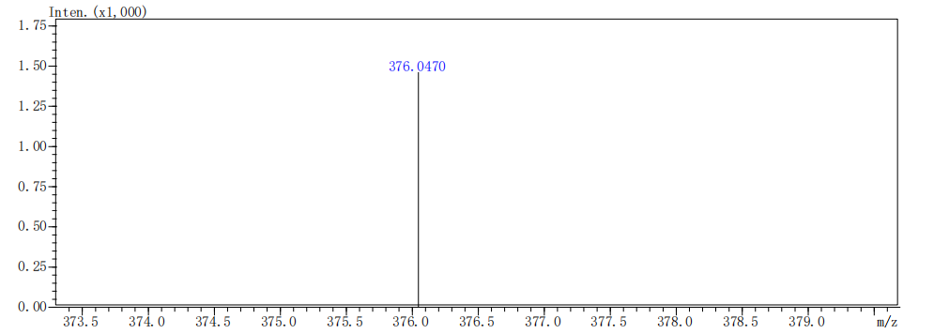
Figure S30. HRMS spectrum of Compound 4b.
3-(4-chlorophenyl)-5-((2,3-dihydrobenzo[b][1,4]dioxin-6-yl)methyl)-2-thioxothiazolidin-4-one (4c): yellow solid; yield 24.5%; m.p. 145.2~147.0℃.1H NMR (500 MHz, DMSO-d₆) δ 7.63 – 7.60 (m, 2H), 7.21 (d, J = 7.6 Hz, 2H), 6.84 – 6.78 (m, 2H), 6.74 (dd, J = 8.2, 2.1 Hz, 1H), 5.05 (dd, J = 8.7, 4.6 Hz, 1H), 4.23 (s, 4H), 3.42 – 3.35 (m, 1H), 3.23 (dd, J = 14.1, 8.8 Hz, 1H). ¹³C NMR (125 MHz, DMSO-d₆) δ 202.31, 175.74, 143.64, 143.11, 134.71, 134.55, 131.02, 129.91, 129.59, 122.49, 118.31, 117.50, 64.53, 64.51, 53.85, 36.51. HR-MS (m/z): [M+H]⁺, C₁₈H₁₄ClNO₃S₂ calculated, 392.0176; found, 392.0178.
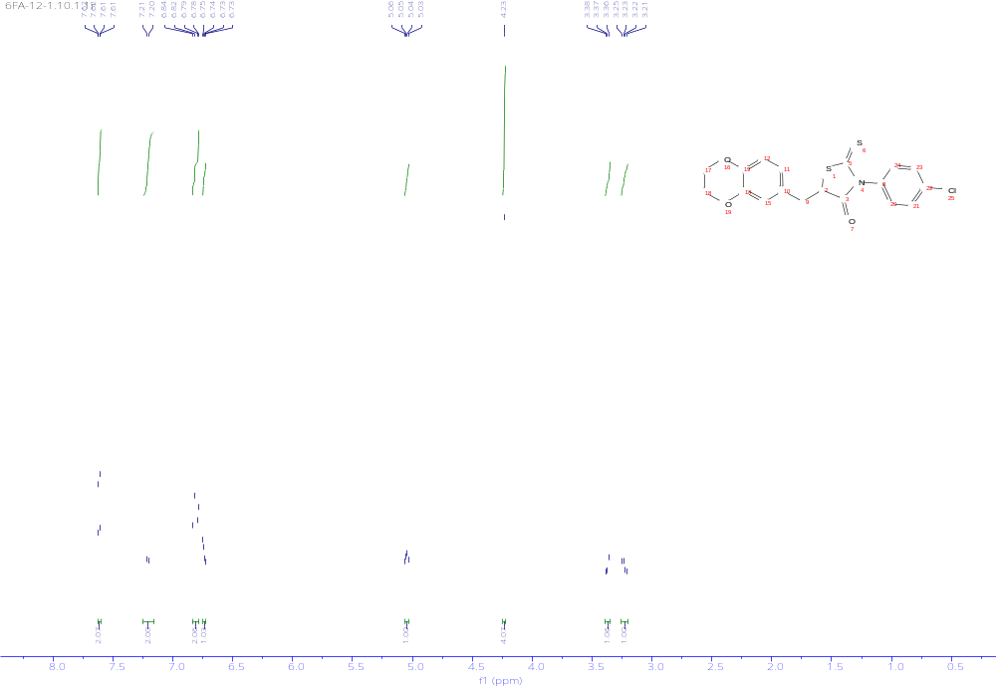
Figure S31. ¹H-NMR spectrum of Compound 4c.
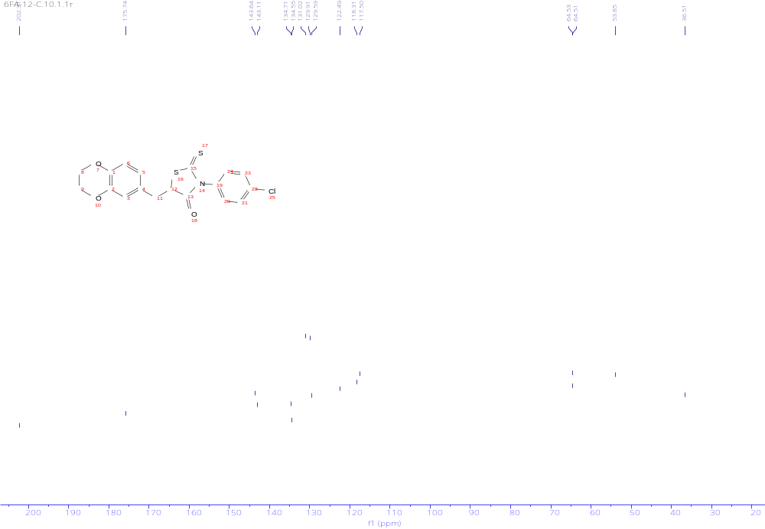
Figure S32. ¹³C-NMR spectrum of Compound 4c.
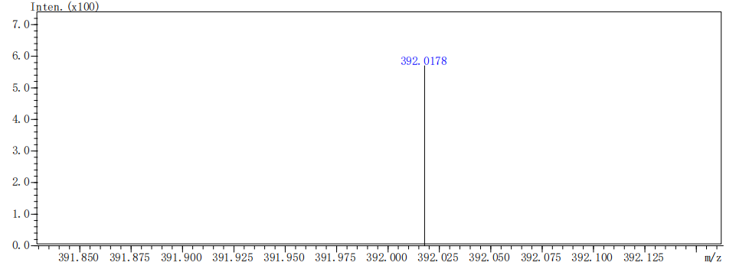
Figure S33. HRMS spectrum of Compound 4c.
3-(4-bromophenyl)-5-((2,3-dihydrobenzo[b][1,4]dioxin-6-yl)methyl)-2-thioxothiazolidin-4-one (4d): yellow solid; yield 21.8%; m.p. 118.8~120.4℃. ¹H NMR (500 MHz, DMSO-d₆) δ 7.77 – 7.72 (m, 2H), 7.19 – 7.09 (m, 2H), 6.88 – 6.77 (m, 2H), 6.74 (dd, J= 8.2, 2.1 Hz, 1H), 5.05 (dd, J = 8.7, 4.6 Hz, 1H), 4.24 (s, 4H), 3.39 – 3.35 (m, 1H), 3.23 (dd, J = 14.0, 8.7 Hz, 1H). ¹³C NMR (125 MHz, DMSO-d₆) δ 202.25, 175.70, 143.63, 143.10, 135.16, 132.88, 131.31, 129.59, 123.16, 122.49, 118.31, 117.50, 64.53, 64.50, 53.87, 36.50. HR-MS (m/z): [M+H]⁺, C₁₈H₁₄BrNO₃S₂ calculated, 435.9671; found, 435.9680.
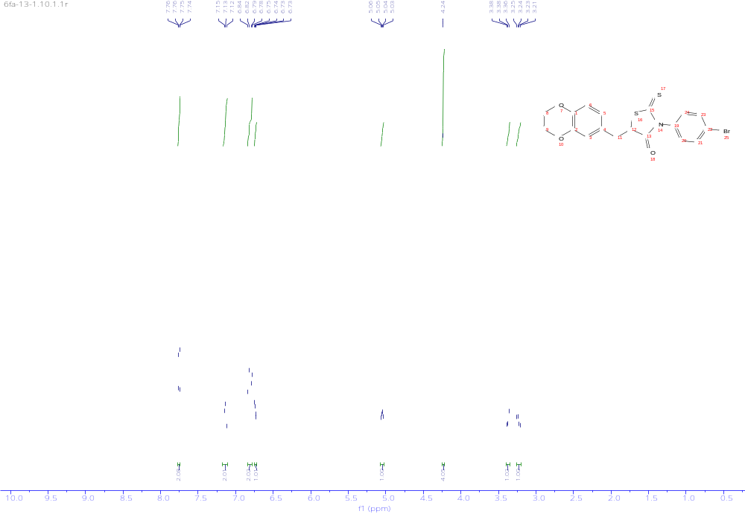
Figure S34. ¹H-NMR spectrum of Compound 4d.
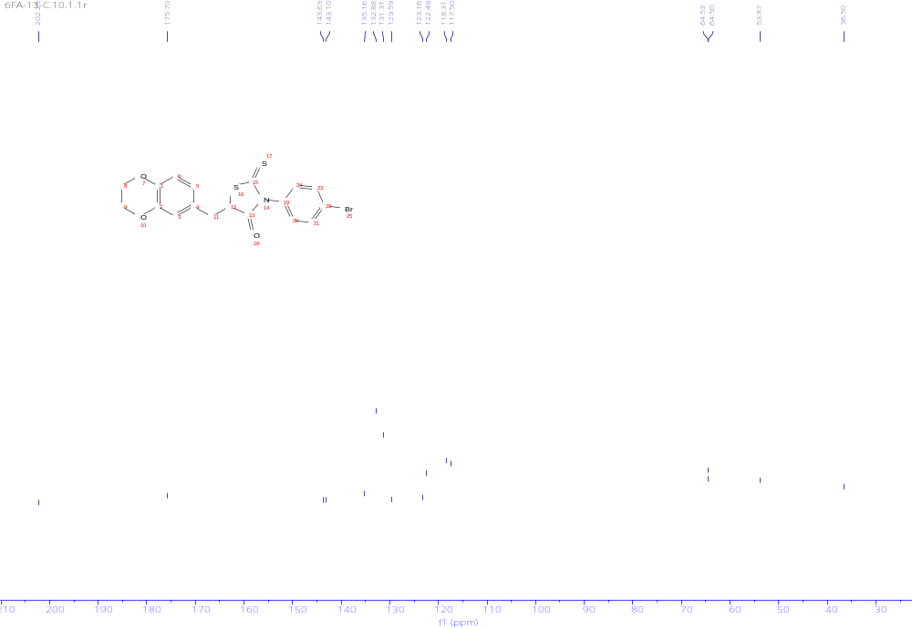
Figure S35. ¹³C-NMR spectrum of Compound 4d.
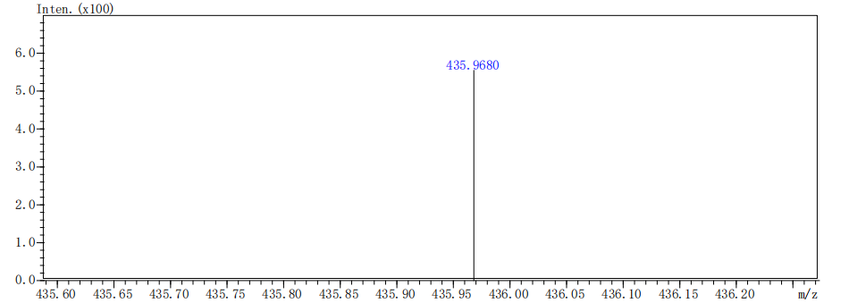
Figure S36. HRMS spectrum of Compound 4d.
5-((2,3-dihydrobenzo[b][1,4]dioxin-6-yl)methyl)-2-thioxo-3-(p-tolyl)thiazolidin-4-one (4e):
yellow solid; yield 19.9%; m.p. 135.6~137.2℃. ¹H NMR (500 MHz, DMSO-d₆) δ 7.37 (d, J = 9.3 Hz, 2H), 7.05 (d, J = 7.6 Hz, 2H), 6.88 (d, J = 8.2 Hz, 1H), 6.84 – 6.77 (m, 2H), 5.11 (dd, J = 8.5, 4.6 Hz, 1H), 4.29 (s, 4H), 3.43 – 3.40 (m, 1H), 3.28 (dd, J = 14.1, 8.5 Hz, 1H), 2.42 (s, 3H). ¹³C NMR (125 MHz, DMSO-d₆) δ 202.53, 175.99, 143.61, 143.09, 139.43, 133.28, 130.27, 129.53, 128.71, 122.55, 118.35, 117.46, 64.53, 53.59, 36.52, 21.25.HR-MS (m/z): [M+H]⁺, C₁₉H₁₇NO₃S₂ calculated, 372.0723; found, 372.0727.
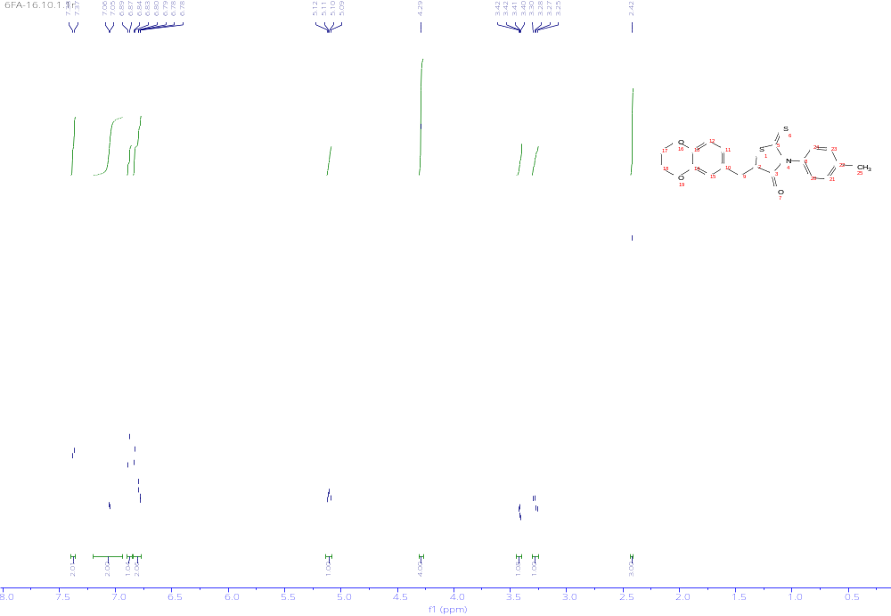
Figure S37. ¹H-NMR spectrum of Compound 4e.
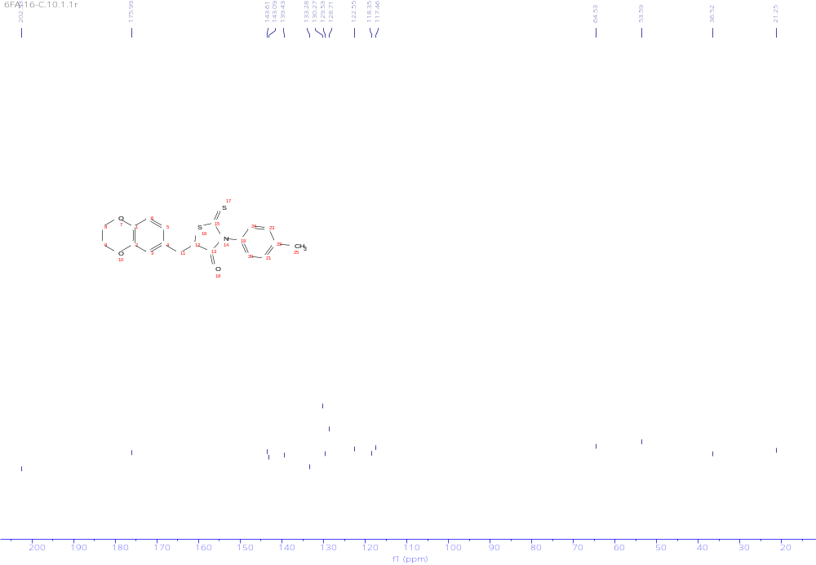
Figure S38. ¹³C-NMR spectrum of Compound 4e.
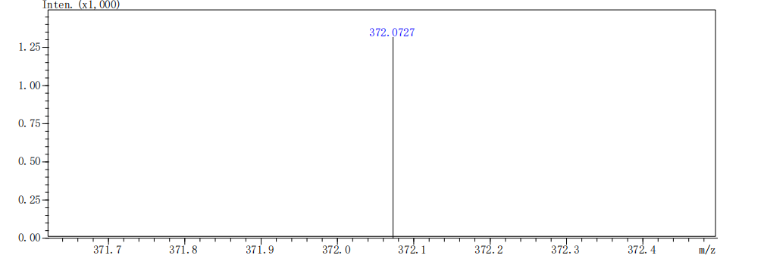
Figure S39. HRMS spectrum of Compound 4e.
5-((2,3-dihydrobenzo[b][1,4]dioxin-6-yl)methyl)-3-(4-methoxyphenyl)-2-thioxothiazolidin-4-one (4f): yellow solid; yield 19.7%; m.p. 139.3~140.8℃. ¹H NMR (500 MHz, DMSO-d₆) δ 7.05 (s, 3H), 6.82 (d, J = 8.2 Hz, 1H), 6.78 (d, J = 2.1 Hz, 1H), 6.74 – 6.62 (m, 2H), 5.03 (dd, J = 8.5, 4.6 Hz, 1H), 4.23 (s, 4H), 3.80 (s, 3H), 3.37 – 3.34 (m, 1H), 3.21 (dd, J = 14.1, 8.6 Hz, 1H). ¹³C NMR (125 MHz, DMSO-d₆) δ 202.73, 176.05, 160.07, 143.61, 143.08, 130.13, 129.57, 128.29, 122.53, 118.34, 117.46, 114.97, 64.53, 55.89, 53.45, 36.53. HR-MS (m/z): [M+H]⁺, C₁₉H₁₇NO₄S₂ calculated, 388.0672; found, 388.0673.
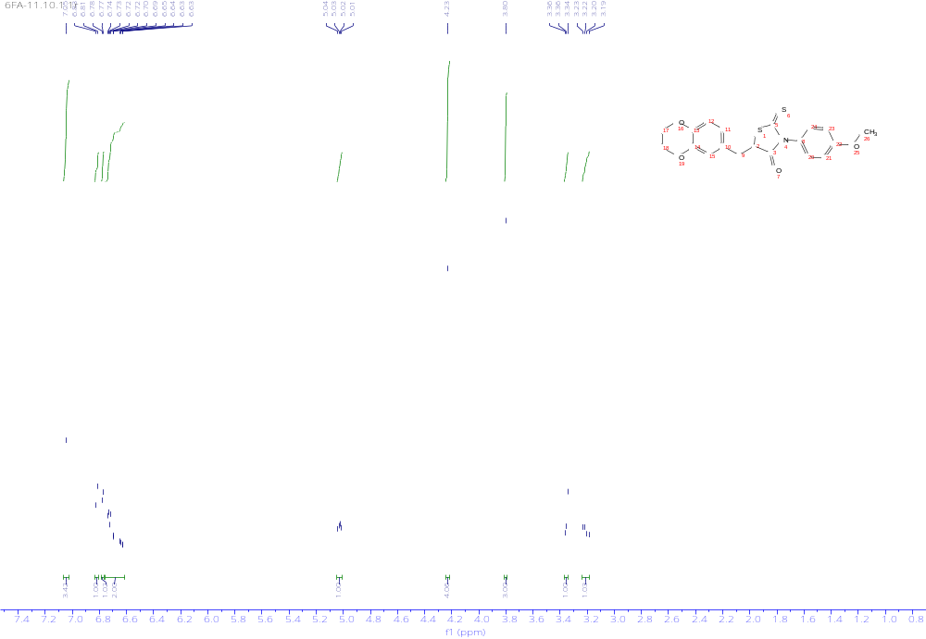
Figure S40. ¹H-NMR spectrum of Compound 4f.
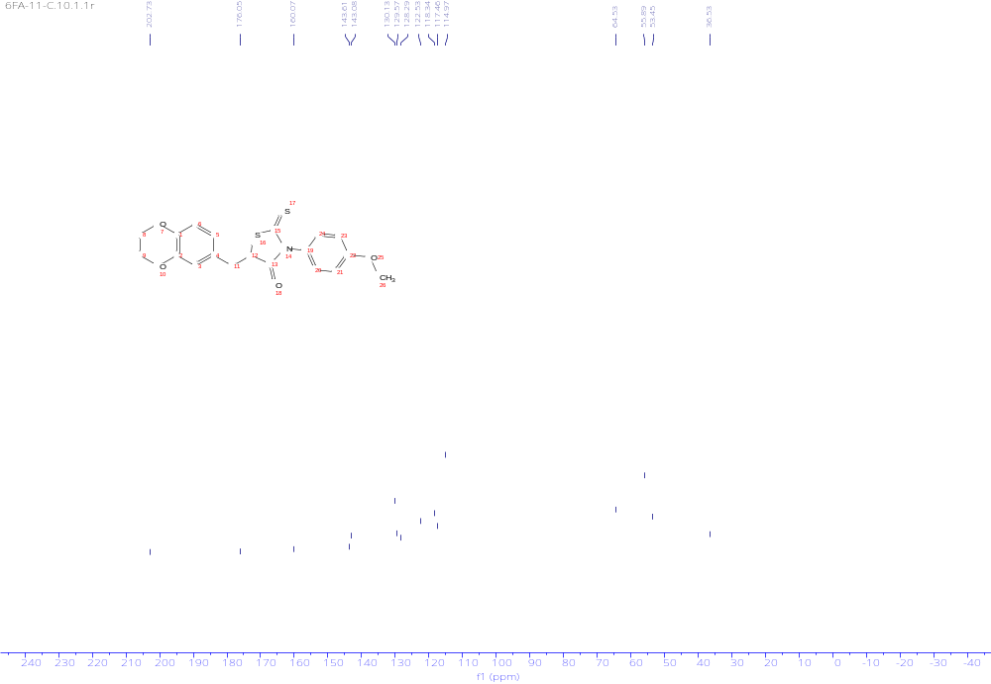
Figure S41. ¹³C-NMR spectrum of Compound 4f.
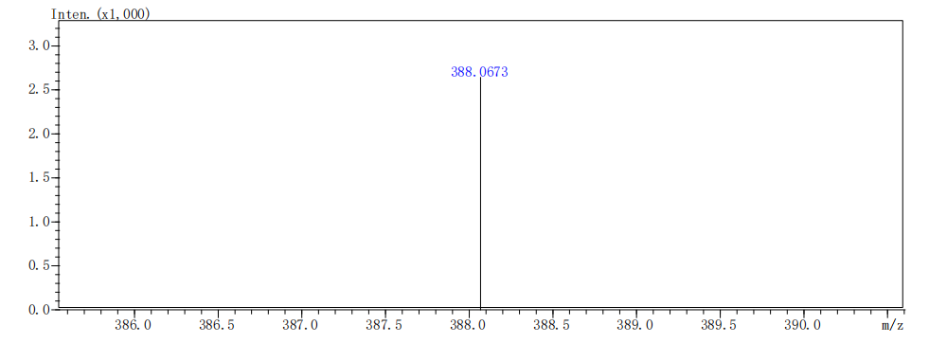
Figure S42. HRMS spectrum of Compound 4f.
5-((2,3-dihydrobenzo[b][1,4]dioxin-6-yl)methyl)-2-thioxo-3-(4-(trifluoromethyl)phenyl) thiazolidin-4-one (4g): yellow solid; yield 22.1%; m.p. 196.7~197.9℃. ¹H NMR (500 MHz, DMSO-d₆) δ 7.95 (d, J = 9.0 Hz, 3H), 7.45 (d, J = 8.0 Hz, 1H), 6.84 (d, J = 8.2 Hz, 1H), 6.80 (d, J = 2.0 Hz, 1H), 6.75 (dd, J = 8.2, 2.1 Hz, 1H), 5.08 (dd, J = 8.8, 4.7 Hz, 1H), 4.24 (s, 4H), 3.38 (dd, J = 14.1, 4.7 Hz, 1H), 3.25 (dd, J = 14.0, 8.8 Hz, 1H). 13C NMR (125 MHz, DMSO-d₆) δ 202.20, 175.69, 143.65, 143.12, 139.51, 130.36, 127.01, 126.68, 122.50, 121.67, 118.31, 117.53, 113.44, 64.53, 54.10, 36.47. HR-MS (m/z): [M+H]⁺, C₁₉H₁₄F₃NO₃S₂ calculated, 426.0440; found, 426.0434.
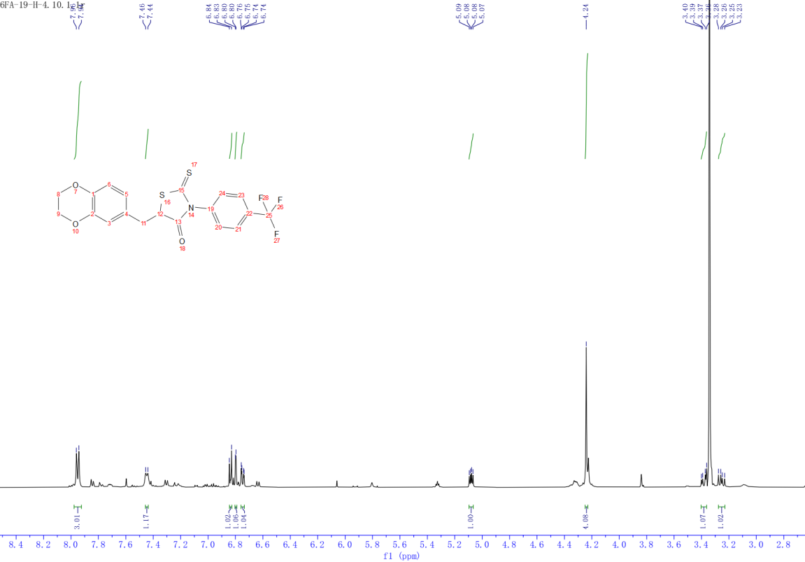
Figure S43. ¹H-NMR spectrum of Compound 4g.
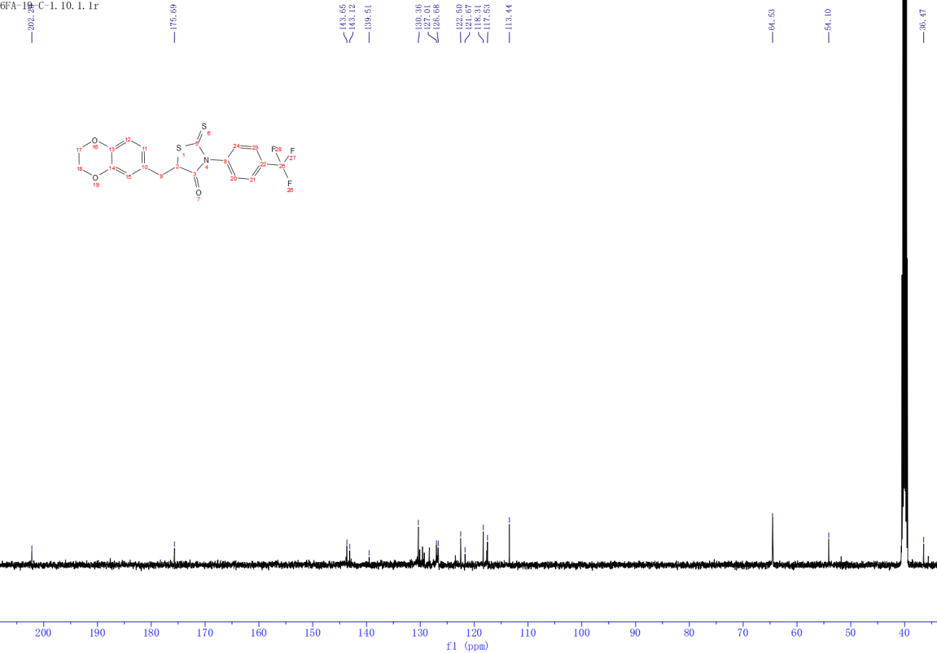
Figure S44. ¹³C-NMR spectrum of Compound 4g.
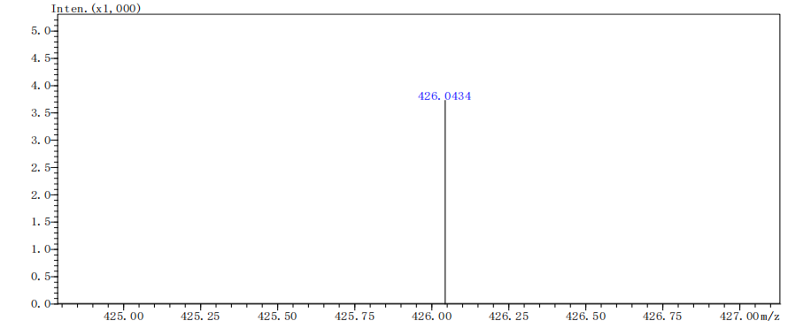
Figure S45. HRMS spectrum of Compound 4g.
3-benzyl-5-((2,3-dihydrobenzo[b][1,4]dioxin-6-yl)methyl)-2-thioxothiazolidin-4-one (4h): yellow solid; yield 19.5%; m.p. 179.2~181.7℃. ¹H NMR (500 MHz, DMSO-d₆) δ 7.31 – 7.25 (m, 3H),
7.08 (dd, J = 7.7, 1.9 Hz, 2H), 6.78 – 6.73 (m, 2H), 6.66 (dd, J = 8.3, 2.1 Hz, 1H), 5.12 – 5.07 (m, 1H), 5.05 – 5.00 (m, 2H), 4.21 (s, 4H), 3.31 (d, J = 4.6 Hz, 1H), 3.13 (dd, J = 14.2, 8.3 Hz, 1H). 13C NMR (125 MHz, DMSO-d₆) δ 202.01, 176.26, 143.55, 143.04, 135.25, 130.13, 128.86, 127.89, 127.66, 122.59, 118.48, 117.45, 64.46, 52.76, 47.45, 35.94. HR-MS (m/z): [M+H]⁺, C₁₉H₁₇NO₃S₂ calculated, 372.0723; found, 372.0725
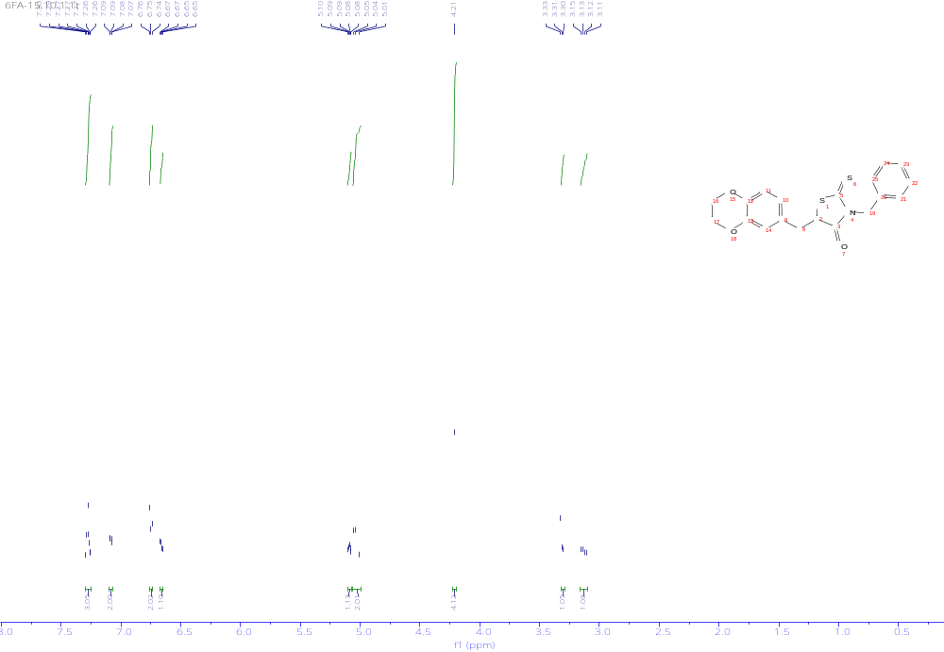
Figure S46. ¹H-NMR spectrum of Compound 4h.
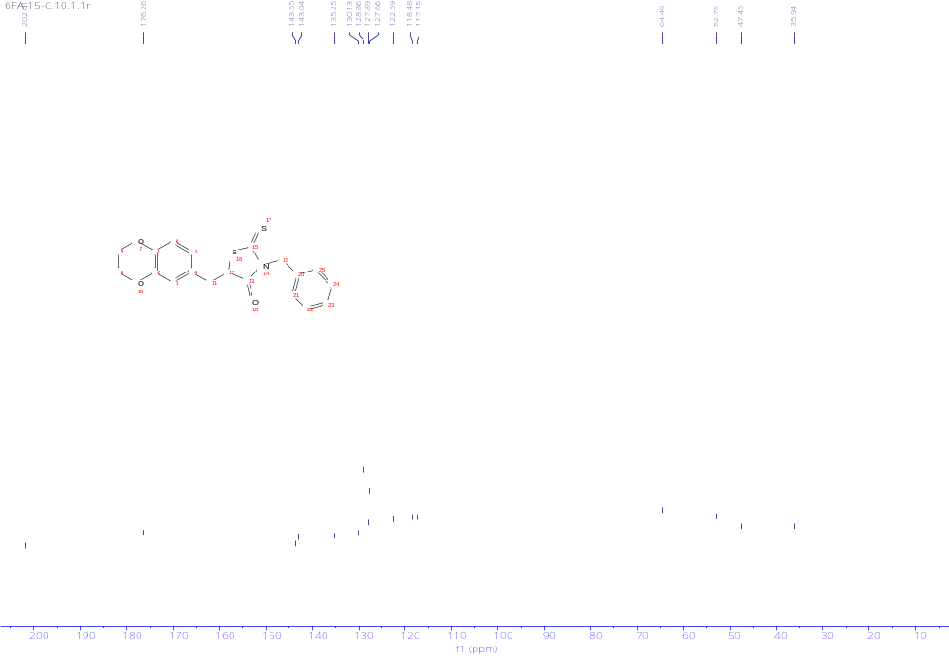
Figure S47. ¹³C-NMR spectrum of Compound 4h.
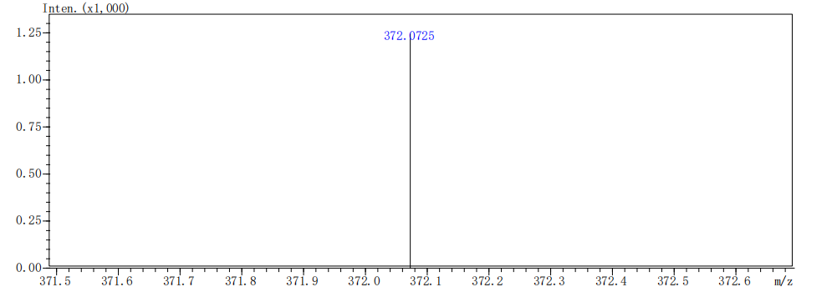
Figure S48. HRMS spectrum of Compound 4h.

