Pancreas Pyroptosis-Directed Catalytic Therapy by Single-Atom Nanozymes with Autodigestion Autodigestion Eradicating for the Management of Acute Pancreatitis
Xiulin Dong^{1,2,3,4,5}, Sijia Hua⁶, Kun Zhang ^{5*}, Jianfeng Yang^{1,2,3,4 *}, Xiaofeng Zhang^{1,2,3,4 *}
¹ Department of Gastroenterology, Affiliated Hangzhou First People’s Hospital, School of Medicine, Westlake University. No. 261 Huansha Road, Hangzhou, 310006, Zhejiang, China
² Key Laboratory of Integrated Traditional Chinese and Western Medicine for Biliary and Pancreatic Diseases of Zhejiang Province, Hangzhou, Zhejiang, China
³ Hangzhou Institute of Digestive Diseases, Hangzhou, Zhejiang, China
⁴ Key Laboratory of Clinical Cancer Pharmacology and Toxicology Research of Zhejiang Province, Hangzhou, Zhejiang, China
⁵ Department of Ultrasound and Central Laboratory, Sichuan Academy of Medical Sciences, Sichuan Provincial People’s Hospital, School of Medicine, University of Electronic Science and Technology of China, No. 32, West Second Section, First Ring Road, Chengdu, 610072, Sichuan, PR China
⁶ Zhejiang University of Chinese Medicine. No. 548 Binwen Road, Binjiang District, Hangzhou, 310053, Zhejiang Province, China.
* Correspondence to Xiaofeng Zhang (zxf837@tom.com), Jianfeng Yang (yangjf3303@sina.com), and Kun Zhang (zhang1986kun@126.com)

Supplementary Materials and Methods
Main materials and reagents
Zinc nitrate hexahydrate (Zn(NO₃)₂·6H₂O, 99%) were purchased from Sigma-Aldrich Company Ltd. Cobalt nitrate hexahydrate (Co(NO₃)₂.6H₂O), hydrogen peroxide (30 wt% in H₂O), dimethyl sulfoxide (DMSO, >99.8%), isopropanol (99.8%), 1,3-diphenylisobenzofuran (DPBF) were obtained by Shanghai Macklin Biochemical Co., Ltd. (China). C18-PEG (2000)-PBA was obtained from Xi'an Ruixi Biological Technology Co., LTD. Rhamnetin (Rh), caerulein (Cae) was purchased from MedChemExpress (Shanghai, China). Fetal bovine serum (FBS), 4’,6-diamidino -2-phenylindole (DAPI) and fluorescein isothiocyanate (FITC) were purchased from Thermo Fisher Scientific (IL, USA). Cell counting Kit-8, Calcein/PI cell viability/cytotoxicity assay kit, JC-1 mitochondrial membrane potential assay kit, LDH cytotoxicity assay kit, BCA protein assay kit, reactive oxygen species assay kit was purchased from Beyotime Institute of Biotechnology (Haimen, China). Lipopolysaccharide (LPS), nigericin sodium salt (Nig), superoxide dismutase assay kit, peroxidase activity test kit, catalase activity test kit were obtained from Merck (USA). Rabbit monoclonal anti-β-actin antibodies (Cat. No. 4970T), horseradish peroxidase (HRP)-conjugated secondary antibody (Cat. No. 7074P2) were bought from Cell Signaling Technology (USA). Anti-GSDMD (Cat. No. ab209845), anti-pro-caspase 1 (Cat. No. ab138483) were obtained from Abcam (MA, USA). Anti-caspase 1 p20 (Cat. No. PA5-99390) was purchased from Invirogen (California, USA). GSDMD (N terminal) (Cat. No. 55651) was purchased from Signalway Antibody (MD, USA). Trypsin assay kit was obtained from Nanjing Jiancheng Bioengineering Institute (Nanjing, China).
Synthesize of cobalt single-atom nanozyme (Co-SAE)
Co-SAE was prepared by the pyrolysis of Co-doped bimetallic MOF (Co@MOF) in an inert N₂ environment. Typically, 0.8733 g of 2-methylimidazole were dissolved in 20 ml methanol in a beaker, forming a transparent solution. Next, 0.0640 g of cobalt nitrate (Co(NO₃)₂·6H₂O) and 0.8032 g of zinc nitrate hexahydrate (Zn(NO₃)₂·6H₂O) were mixed in a beaker containing 10 ml of methanol. The two above solution were then mixed and stirred gently for 1 h, and then the mixture was transferred into a Teflon-lined stainless-steel autoclave, sealed, and heated quickly to 120 °C for 4 h in an oven. After that, the precipitates were collected by centrifugation, washed several times with N,N-Dimethylformamide (DMF) and anhydrous methanol. The obtained Co@MOF were then pleased into a porcelain boat for pyrolysis under 900 °C under a nitrogen atmosphere for 3 h with a heating rate of 5 °C /min, and the final black product was the Co-SAE.
Measurement of SOD, POD, CAT-like activity
The superoxide dismutase assay kit (19160, Sigma), peroxidase activity test kit (MAK092, Merck), catalase activity test kit (MAK092, Merck) were used to detect the SOD, POD, CAT-like activity respectively. In a typical assay, Co-SAE with different concentration was prepared to mix with working solution, according to the manufacturer’s instructions.
Synthesis of Rhamnetin conjugated Co-SAE (Rh@SAE)
To conjugate rhamnetin (Rh) on Co-SAE, Co-SAE was first modified C18-PEG-BPA to obtain phenylboronic acid functional group on Co-SAE. Briefly, 20 mg of Co-SAE and 20 mg of C18-PEG-BPA were dispersed in 10 mL deionized water and stirred for 4 h. Then, PBA-PEG-SAE was collected by centrifugation, washing with deionized water for three times, dissolved in PBS and stored at 4 °C. 4 mL of as- prepared PBA-PEG-SAE (5 mg/mL) were mixed with 100 μL Rh (5 mM) at room temperature for 1 h. In this process, PBA group in PBA-PEG-SAE covalently bond with the hydroxyl groups in Rh through click reaction. After that, the suspension was centrifuged at 12,000 rpm for 10 min, and the precipitate was washed with PBS three times to remove unbound Rh. The finally obtained Rh@SAE were freeze-dried, and stored at -20 °C for further use.
Physical characterization
The morphology and size of Co-SAE were obtained by bright-field TEM and corresponding EDS element mapping images on two field-emission transmission electron microscopes (JEM-F200 and JEM-2100F, JEOL, Japan) with an accelerating voltage of 200 kV. Scanning electron microscope (SEM) images were recorded on a Hitachi S-4800 FESEM at working voltage of 10 kV and working current of 10 A. The crystal phases present in each sample were identified using powder X-ray diffraction (XRD) on a Rigaku Ultima IV diffractometer. The Raman scattering signals were recorded directly on a Raman spectrometer instrument (Renishaw inVia) with an excitation wavelength of 532 nm with the scanning wavenumber range of 500 ∼ 3800 cm⁻¹. X-ray photoelectron spectroscopy (XPS) was performed using a Kratos AXIS Ultra DLD XPS system equipped with a hemispherical energy analyzer. The ICP-MS measurement (7900 ICPMS, Agilent, UK) was employed to characterize the content of metal elements in Co-SAE. Zetasizer (Malvern, UK) was used to acquire the size distribution and ζ-potential of the as-synthesized Co-SAzyme and Rh@SAE.
Electron spin resonance (ESR) measurement
•O₂¯ scavenge was investigated by the ESR spectrum using 5,5-dimethyl-1-pyrroline-N-oxide (DMPO) as trapping agent. As well, the singlet oxygen was derived from TiO₂ under xenon light irradiation (300 W), 2,2,6,6-Tetramethylpiperidine 1-oxyl (TEMP) acted as the trapping agent. The peak intensity was recorded before and after adding Rh@SAE. To evaluate H₂O₂-scavenging capacity, 100 μL Rh@SAE (1 mg/mL) was added to 0.5 mM H₂O₂, and the peak intensity was recorded by using DMPO as trapping agent.
H₂O₂ decomposition assay
Portable dissolved oxygen meter was used to examine the catalytic capacity of Rh@SAE for the production of oxygen from hydrogen peroxide at room temperature. Specifically, 100 μL of Rh@SAE with the concentration of 1 mg/mL was added to 1 mM H₂O₂ solution, and the dissolved oxygen levels were continuously monitored.
Cell culture
MPC-83 (murine pancreatic acinar cells) was cultured with regular growth medium consisting of RPMI 1640 containing 10% (v/v) fetal bovine serum at 37 °C in a wet 5% CO₂ environment. The medium was replaced every 3 days, and the cells were digested by trypsin and resuspended in fresh medium before plating.
Cellular uptake of Rh@SAE
MPC-83 cells were seeded in confocal dishes and cultured overnight. 50 μg/mL Rh@SAE labeled with FITC was added in different time intervals. After incubation with Rh@SAE for 0, 2, 4, and 8 h, the cells were washed by PBS for three times and stained with 4,6-diamino-2-phenylindole (DAPI) for 15 min. The cellular uptake of Rh@SAE was then visualized by confocal laser scanning microscope (CLSM).
Cell viability assay
MPC-83 cells were cultured in 96-well plates (4000 cells per well) overnight. Following this, the cells were treated with SAE and Rh@SAE at the concentration of 10 and 100 μg/mL for 24 h. At the end of incubation, the cultural medium was replaced by 100 μL CCK-8 work solution and co-cultured for 1 h. Finally, the relative viabilities of cells in different groups were calculated by measuring the absorbance of the reaction solution at 450 nm using a microplate reader (n=4 for each group).
Cell live/death detection
MPC-83 cells (10000 cells/well) were inoculated in 48 well plates and grew overnight, followed by the treatment of SAE and Rh@SAE for 24 h. Then the cells were washed by PBS for three times and incubated with fresh serum-free DMEM media containing calcein-AM (one milliliter, 20 μg/mL) and propidium iodide (one milliliter, 15 μg/mL) for 30 min at 37 ◦C. The fluorescence images were captured by a Leica inverted fluorescence microscope immediately.
Intracellular ROS‑scavenging capability
ROS were detected using 2’,7’-dichlorofluorescein diacetate (DCFH-DA), a nonfluorescent compound that could react with intracellular ROS and generate the fluorescent product of dichloro-fluorescein (DCF). The intensity of the DCF fluorescence correlated with the amount of intracellular ROS. MPC-83 cells were seeded in a confocal dishes or 6-well plate and cultured overnight. The cell medium was removed, and then adherent cells were incubated with SAE (50 μg/mL), Rh (10 μM), Rh@SAE (50 μg/mL) for 12 h at 37 °C. After this, oxidative stress was induced by exposing the cells to LPS (500 ng/mL, 3 h) at 37 °C. The adherent cells were then washed with PBS for 3 times, and fed in DCFH-DA solution at 37 °C for 30 min. After the unloaded probe was removed with PBS, the fluorescence intensity of cells was monitored by CLSM and flow cytometry.
Detection of mitochondrial membrane potential
The MPC-83 cells were treated the same way as mentioned in the above section. Cells were then stained by JC-1 mitochondrial membrane potential assay kit according to standard processes. Briefly, cells were washed twice with PBS and incubated with the medium containing 10 μg/mL JC-1 at 37 °C for 20 min. After washing three times with ice-cold PBS, the cells were observed by CLSM at the excitation and emission wavelength of 514 nm and 529 nm for the JC-1 monomer, and 585 nm and 590 nm for JC-1 aggregate.
Western blot analysis
MPC-83 cells in 6-well plates were treated with SAE (50 μg/mL), Rh (10 μM), Rh@SAE (50 μg/mL) for 12 h at 37 °C. After that, the culture media was replaced with fresh medium containing LPS (100 ng/mL), and the cells were cultured for another 3 h, followed by incubation with Nig (10 μM) for 1 h. After washing with PBS twice, cells were collected and lysed in RIPA lysis buffer containing protease inhibitors. The total protein concentration of the lysates was measured using a BCA protein assay kit. An equal amount of protein (30 mg) was then loaded perlane onto SDS-polyacrylamide gels and then transferred to polyvinylidene fluoride membranes. After blocked with 5% bovine serum albumin (BSA) for 2 h at room temperature, the membrane was incubated with the primary antibody including anti-GSDMD antibody, anti-pro-caspase 1 antibody, anti-caspase 1 p20 and anti-β-actin antibody at 4 °C overnight and incubated with the primary antibody at 4 °C overnight. The membranes were then washed and incubated with horseradish peroxidase-conjugated secondary antibody for 1 h at 37 °C, and the immunoreactive bands were visualized using the Tanont High-sig ECL Western Blotting Substrate and captured by a Tanon 4600 chemiluminescent imaging system (Tanon, Shanghai, China).
Estimation of inflammatory cytokines
MPC-83 cells in 6-well plates were treated the same way as mentioned in the experiment of western blot. After that, the media was collected to measure the concentration of pro-inflammatory cytokines including TNF-α, IL-6 and IL-1β by enzyme-linked immune sorbent assay (ELISA) kit (Proteintech).
Lactic dehydrogenase (LDH) assays.
MPC-83 cells stimulated with LPS and Nig after pretreatment with SAE, Rh, Rh@SAE for 12 h were used to detected the release of LDH by the LDH cytotoxicity assay kit according to the manufacturer’s protocols.
In vivo biocompatibility and biodistribution
C57/BL6 mice with an average age of 7 weeks and weight of 18-20 g were purchased from Shanghai SLAC laboratory animal Co., Ltd (Shanghai, China). These mice were randomly divided into 4 groups (n = 4), and were intraperitoneally injected with 200 μL of PBS, SAE (10 mg/kg), Rh (8 mg/kg), Rh@SAE (10 mg/kg). After 3 days, the mice were anesthetized and euthanized. Blood samples were collected for blood biochemical analysis, including alkaline phosphatase (ALP), alanine aminotransferase (ALT), aspartate aminotransferase (AST), blood urea nitrogen (BUN), creatinine (CRE), and the tissues of the heart, liver, spleen, lung, and kidney were harvested and immersed in the 4% paraformaldehyde for hematoxylin and eosin (H&E) staining.
As for the detection of biodistribution, Cae-induced AP mice were intraperitoneally injected with Rh@SAE (10 mg/kg, 200 μL). At 6, 24, and 48 h post administration, the mice were sacrificed, main organs containing heart, liver, spleen, lung, kidney and pancreas were harvested and fixed. The collected organs were then dried, weighed, and digested by trace metal grade nitric acid (69%) solution at 130 °C. After that, all the samples were diluted to 25 mL and filtered through a 0.45 μm membrane. ICP-OES was then used to quantify the uptake amount of Co in different organs.
Mouse model of acute pancreatitis
C57/BL6 mice (male, 6-8 w) were intraperitoneally injection of caerulein (50 μg/kg) once every hour for a total of eight times to induce acute pancreatitis (AP) model. AP mice were randomly divided into the following four groups: (a) PBS, (b) SAE, (c) Rh, (d) Rh@SAE group. Normal mice without any treatment were marked as the untreated group. In the second and sixth caerulein injection, PBS, SAE (10 mg/kg), Rh (8 mg/kg), Rh@SAE (10 mg/kg) were injected intraperitoneally. Peripheral blood and pancreas were collected 4 h after the last injection of caerulein. Pancreatic damage was evaluated by H&E staining and terminal deoxynucleotidyl transferase dUTP nick end labeling (TUNEL) staining. The concentrations of amylase, lipase in the serum of mice were detected by ELISA. The pancreatic tissue homogenate was used to measure TNF-α, IL-1 β and IL-6 by ELISA, and the activity of trypsase was measured by trypsin assay kit. Further, immunohistochemical analysis for pyroptosis markers, including anti- GSDMD (N terminal) (Cat. No. 55651), and anti-caspase 1 (Cat. No. ab138483) were conducted.
Statistical analysis
Results were representative of at least three independently performed experiments. Statistical analysis was performed with Prism software (GraphPad Software, Inc.). Student’s t-test analysis was used to compare difference between two groups, and one-way analysis of variance (ANOVA) was used for multiple comparisons, where *p < 0.05, **p < 0.01, ***P < 0.001 are regarded as significant.
Ethics Approval
All animal experiments were performed according to protocols approved by the Institutional Animal Care and Use Committee of Zhejiang Chinese Medical University [No. SYXK (Zhejiang) 2023-0012].

Supplementary figures
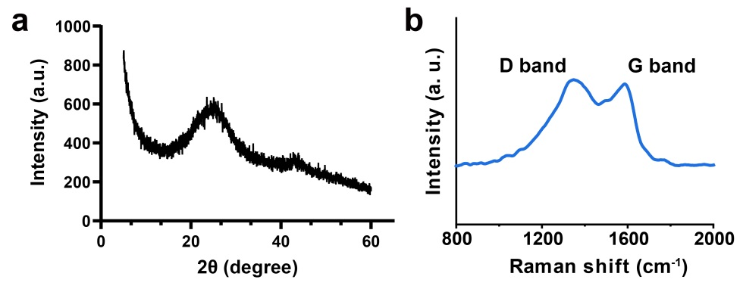
Figure S1. Powder XRD patterns and Raman spectras of Co-SAE.
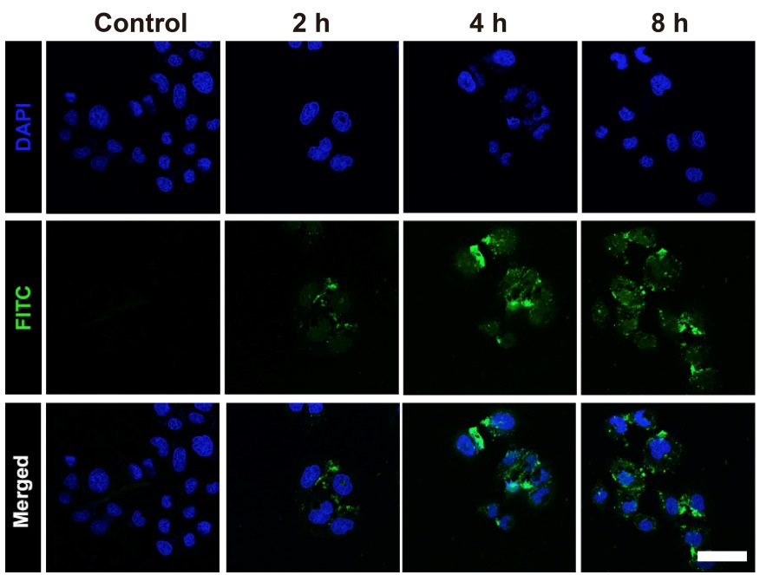
Figure S2. In vitro cellular uptake of FITC-labeled Rh@SAE. Scale bar: 50 μM.
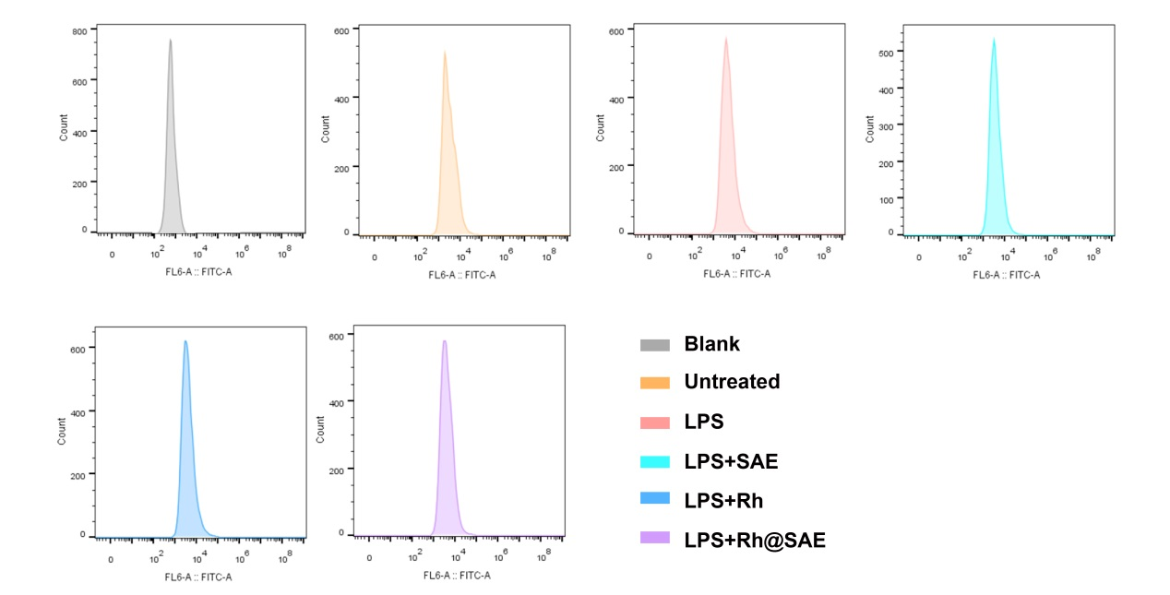
Figure S3. Typical FCM patterns of MPC-83 cells stained with DCFH-DA.

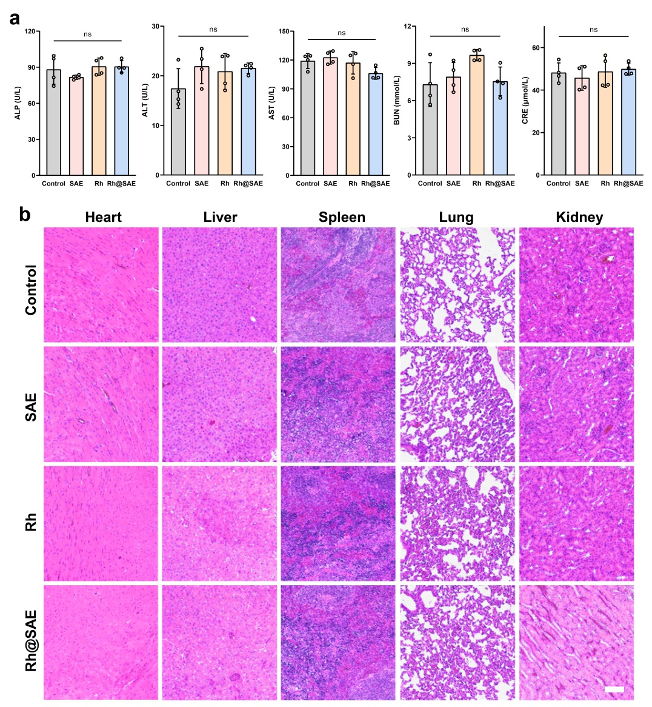
Figure S4. (a) Blood biochemistry data including ALP, ALT, AST, BUN, CRE. Error bars showed the standard deviation (n = 4), ‘ns’-no significance. (b) H&E staining images of normal tissue slices including heart, liver, spleen, lung and kidney harvested from the mice injected with different formulations for 3 days.

