Supplementary Material
Actinomycetes Strain Selection From Maize Rhizosphere With Antagonistic Potential Against Fungal Phytopathogen
Oghoye Priscilla Oyedoh, Ayansina Segun Ayangbenro, *Olubukola Oluranti Babalola

Food Security and Safety Focus Area, Faculty of Natural and Agricultural Sciences, North-West University, Private Bag X2046, Mmabatho 2735, South Africa.
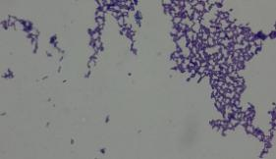
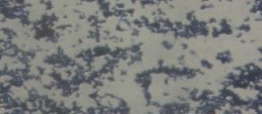
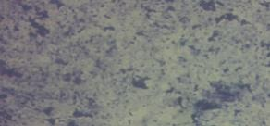
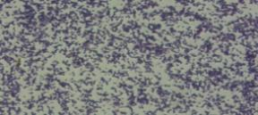
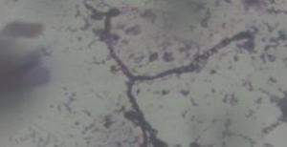
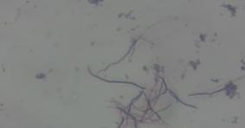
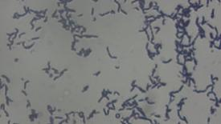
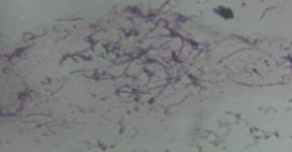
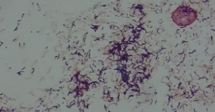
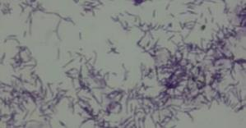
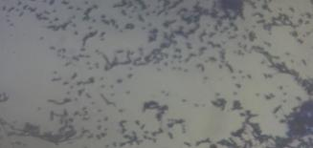
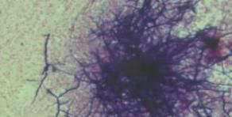
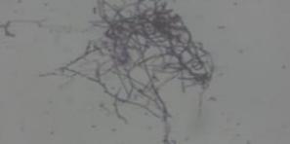
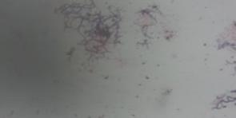
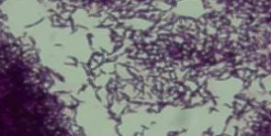
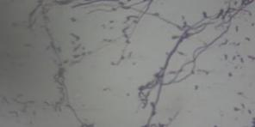
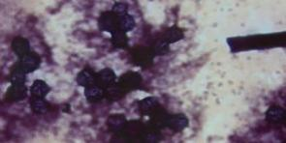
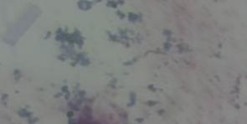
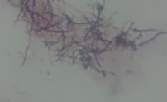
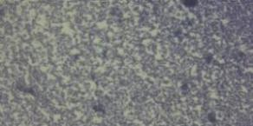
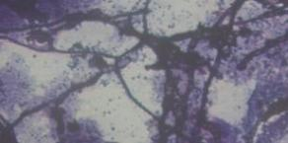
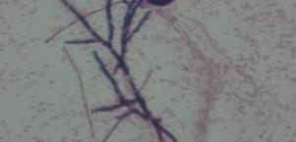
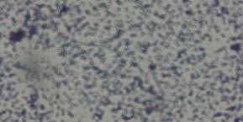
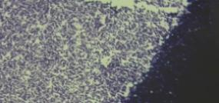
*corresponding author: olubukola.babalola@nwu.ac.za
a)
b)
c)
d)
e)
f)
g)
h
i)
j)
k)
l)
m)
n)
o)
p)
q)
r)
s)
t)
u)
v)
w)
x)

y)

Figure S1 Morphological description of all Actinomycetes isolates: a) connotes isolate code M12, b) connotes M15, c) connotes M80 , d) connotes M81, e) connotes M82, f) connotes M83, g) is M14, h) is M11, i) is M18, j) is M5, k) is M84, l) is M2, m) is M16, n) denotes M85, o) is M1, p) is M10, q) is M88, r) connotes M4, s) is M6, t) connotes M13, u) connotes M8, v) is M7, w) connotes M17, x) is M16 and y) connotes M9
Table S1 Selective biochemical characterization of bacterial isolates
Isolate codes | Catalase | Oxidase | Motility | H₂S utilization | Indole test
M12 | +ve | -ve | -ve | -ve | -ve
M15 | +ve | -ve | -ve | -ve | -ve
M80 | +ve | -ve | -ve | -ve | -ve
M81 | -ve/+ve | -ve | -ve | -ve | -ve
M82 | -ve | -ve | -ve | -ve | -ve
M83 | +ve | -ve | -ve | -ve | -ve
M14 | +ve | -ve | +ve | -ve | -ve
M11 | +ve | -ve | -ve | -ve | -ve
M18 | -ve | -ve | -ve | -ve | -ve
M5 | +ve | -ve | +ve | -ve | -ve
M84 | +ve | -ve | -ve | -ve | -ve
M2 | +ve | -ve | -ve | -ve | -ve
M16 | +ve | -ve | -ve | -ve | -ve
M85 | +ve | -ve | -ve | -ve | -ve
M1 | +ve | -ve | -ve | -ve | -ve
M10 | +ve | -ve | -ve | -ve | -ve
M3 | +ve | -ve | -ve | -ve | -ve
M4 | -ve | -ve | -ve | -ve | -ve
M6 | +ve | -ve | -ve | -ve | -ve
M13 | +ve | -ve | -ve | -ve | -ve
M8 | +ve | -ve | +ve | -ve | -ve
M86 | +ve | -ve | -ve | -ve | -ve
M87 | +ve | -ve | -ve | -ve | -ve
M88 | +ve | -ve | -ve | -ve | -ve
M9 | +ve | -ve | -ve | -ve | -ve

Table S2 Primary screening of isolates against fungal phytopathogens
Putative Actinomycetes Isolates | Zone of Inhibition in cm
Putative Actinomycetes Isolates | C-Z-M | N-B | S-W
M10 | AA | 0.6 | AA
M8 | AA | AA | AA
M9 | AA | 0.4 | 0.4
M5 | 0.2 | AA | A
M1 | 3.0 | 2.9 | A
M17 | NA | 0.6 | NA
M16 | 0.2 | 0.5 | NA
M12 | 0.9 | 1 | 0.7
M14 | NA | NA | 1.5
M15 | AA | AA | AA
M7 | 1.4 | 1.5 | AA
M13 | 0.6 | 0.8 | A
M11 | AAA | AAA | AAA
M88 | NA | 3.0 | NA
M18 | 0.6 | 0.4 | A
M6 | 2.5 | 3.0 | AA
M4 | AA | AA | AA
M2 | 2.5 | 2.0 | A

NA-no activity, A-active, AA-more active, AAA- most active, M-maize, Co-control
(no pretreatment), ch-chemical pretreatment, 7-pH, 10- pH.
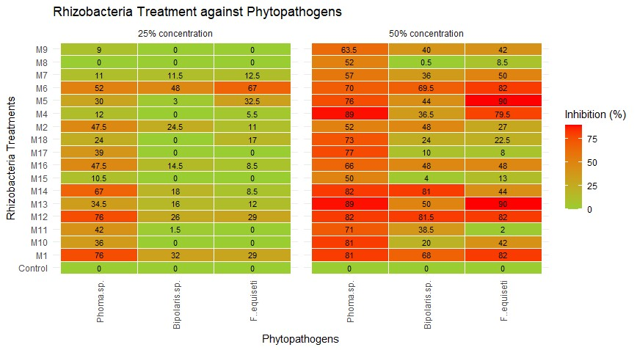

Figure S2 Secondary screening of isolates against fungal phytopathogens
Table S4 Genomic Features of Streptomyces sp.
Genomic Features | Rasttk Report
Based on Contigs
Contig sequence size | 7109246
Number of contigs | 37
GC content | 72.4
Shortest contig | 623
Median sequence size | 87444
Mean sequence size | 78217
Longest contig | 1159449
N50 Value | 563188
L50 value | 5
Based on Scaffold
Scaffold number | 62
Sequence size | 7106836
Shortest contig | 64
Median sequence size | 78217
Mean sequence size | 114626.4
Longest contig | 578559
Scaffold N50 | 220.8kb
Scaffold L50 | 10
Genes
Protein coding regions | 6624
tRNA | 66
Number of subsystem | 315
mRNA | 64
Other genes | 3
Pseudogenes | 113
CRISPR regions | 19
Genomic features | 6688

Table S5 Biosynthetic gene clusters types and predicted metabolites encoded by Streptomyces sp. OP7 genome with their functional annotation
AntiSMASH regions | Type of BGCs | Most similar cluster (if applicable) |  | Web Server tool | Functional annotation | References
11.1 | NI-siderophore | Desferrioxamin B & E | 100 | antiSMASH | Crosstalk interaction | Su et al. (2024)
 | NRPS-independent siderophore biosynthesis protein |  | 100 | PRISM
 | Siderophore |  | 94 | UniProt
 | Siderophore |  | 100 | NCBI
21.1 | RIPP-like | RIPP: lanthipeptide-Informatipeptin | 42 | antiSMASH | Against strawberry Fusarium wilt | Kim et al. (2019)
 | RIPP-like | Lanthipeptide | 95.8 | UniProt
 | RIPP-like |  | 100 | NCBI
21.2 | Lanthipeptide class III | RIPPs lanthipeptide-SapB | 100 | antiSMASH | Antibacterial  activity | Iftime et al. (2015)
 | Lantipeptide class III/IV | Class III Lanthionine synthetase Lan KC | 100 | PRISM
 | Lan KC (Ser/Thr protein kinase) |  | 98.9 | UnitProt
 | LanKC |  | 99 | NCBI
26.1 | Lanthipeptide class I | Diazaquinomycin H & J | 4 | antiSMASH | Antibacterial activity | Mullowney et al. (2014)
 | Lantipeptide class I | Lantipeptide dehydratase/cyclase |  | PRISM
 | Lantibiotic dehydratase and Lanthionine synthetase C |  | 88 | UnitProt
 | Lantibiotic dehydratase and Lanthionine synthetase C |  | 93.51 | NCBI
26.2 | Type III PKS | PKS-alkylresorcinol | 100 | AntiSMASH | Antimicrobial  Activity | Lasch et al. (2020)
 | Type III PKS |  | 79.2 | UnitProt
 | 3-oxoacyl synthase |  | 96.39 | NCBI
26.3 | Terpene | Terpene-Carotenoid | 54 | antiSMASH | Antifungal activity | Ghanem et al. (2022)
 | Phytoene synthase |  | 88.3 | UnitProt
 | Lycopene cyclase |  | 96.45 | NCBI | Antifungal activity against Fusarium wilt | Abdel-Aziz et al. (2021)
27.1 | NI-siderophore |  | 54 | antiSMASH
 | Luc A/C family siderophore |  | 88.3 | UnitProt
 | Luc A/C siderophore B protein |  | 99 | NCBI
27.2 | Terpene | Terpene-Geosmin | 100 | antiSMASH | Antifungal agents | Pérez-Corral et al. (2020)
 | Terpene synthase |  | 95.7 | UnitProt
 | Germacradienol/Geosmin synthase |  | 98.33 | NCBI
27.3 | RiPP-like |  | 81 | antiSMASH
 | DUF692 domain containing protein |  | 97.05 | NCBI
28.1 | Terpene | Terpene-Albaflavenone | 100 | antiSMASH | Antifungal activity | Yao et al. (2021)
 | Polyketide beta-ketoacyl synthase WhiE.KS |  | 96.4 | UnitProt
 | Epi-isozizaene synthase |  | 98.9 | NCBI
33.1 | Type II polyketide | Polyketide-Spore pigment | 83 | antiSMASH
 | Pentangular polyphenol | Type II PKS cyclase (tetracenomycins) |  | PRISM | Antibacterial  activity | Xing et al. (2021)
 | Glycosyl transferase |  | 83 | UnitProt
 | β-ketoacyl synthase |  | 99.3 | NCBI
34.1 | Type II polyketide oligosaccharide | Type II PKS + oligosaccharide: Grincamycin | 82 | antiSMASH | Antibacterial activity | Yang et al. (2020)
 | PKS type II cyclase | Augucyclines |  | PRISM
 | 3 ketoacyl ACP synthase β |  | 86.9 | UnitProt
 | β- ketoacyl synthase family |  | 97 | NCBI
5.1 | Ectoine | Ectoine | 100 | antiSMASH | Antifungal activity | Xiong et al. (2024)
 | Ectoine | Ectoine synthase |  | PRISM
 | L-ectoine synthase |  | 99.2 | UnitProt
 | Ectoine synthase |  | 99.2 | NCBI
8.1 | Terpene | Terpene-hopene | 53 | antiSMASH | Antifungal activity | Bhat et al. (2024)
 | Squalene synthase (HPnD) | phytoene | 95.3 | UnitProt
 | Squalene/hopene cyclase |  | 97.8 | NCBI
9.1 | Type I PKS, NRPS, others | NRP; PKS-polyoxypeptin | 48 | antiSMASH | Antifungal activity | Bobek et al. (2022)
 | Piperazic acid synthase, NRP | PKS, NRP-Nosiheptide, frenolicin |  | PRISM
 | Type I PKS, NRPS protein/aminoacid adenylation domain-containing protein |  | 76.6 | UnitProt
 | Acyl transferase, type 1 synthase for narbonolide and phenolphthiocerol |  | 95.08 | NCBI
18.2 | Butyrolactone | Cyclic depsipeptide (NRP) and Trans-AT (PKS): Griseoviridin & fijimycin A | 8 | antiSMASH | Antifungal activity | Wang et al. (2023)
 | Type II PKS cyclase butyrolactone | Tylosin, mithramycin, lactonamycin, lankacidin, lankamycin, virginiamycin, showdomycin |  | PRISM
 | ScbA/BarX family gamma butyrolactone biosynthesis protein |  | 98.2 | UnitProt
 | NRPS |  | 97.9 | NCBI

Table S6 The pangenome overview

 | Genome | Genes | Genes in homologs | Genes in singletons | Homolog families | G₁ | G₂ | G₃ | G₄
G₁ | Streptomyces ginkgonis | 6383 | 5880 | 503 | 5734 | 3540 | 3153 | 3224 | 3146
G₂ | Streptomyces sp. DH-12 | 5248 | 3791 | 1457 | 3540 | 3153 | 5216 | 4875 | 4775
G₃ | Streptomyces sp. OP7 | 6668 | 5786 | 882 | 5628 | 3224 | 4875 | 5734 | 5398
G₄ | Streptomyces tendae | 6565 | 5488 | 1077 | 5216 | 3146 | 4775 | 5398 | 5628

