Supplementary information
Fig. S1 Frequency distributions and correlation coefficients of thousand-kernel weight (TKW) (a), kernel length (KL) (b) and kernel width (KW) (c) of the JM120 × JM325 recombinant inbred line population among five environments (E1 to E5).

Fig. S2 A QTL map of QTkw.cau-3DL controlling thousand-kernel weight (a) and kernel length (b) constructed using the phenotypic data collected from multiple environments. The black line represents the logarithm of the odd (LOD) threshold of 2.5.
Supplementary Figure 1
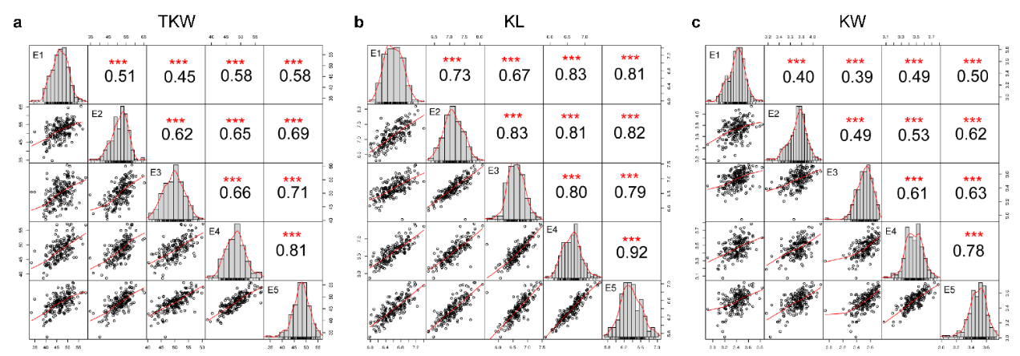

Supplementary Figure 2
