Article title: Foraging roots and their associated microbes slow the decay of belowground litters in a temperate hardwood forest

Supporting Methods:

Root Litter Preparation: Species-specific root litter was collected in September of 2017 by tracking root branching networks back to either oak or maple trees. A total of 12 branching networks were collected per species. Roots were cleaned and 1st and 2nd order (absorptive) roots were separated from transportive roots using stream order classification. Absorptive roots were dried to a constant mass at 60ºC for 48 hours and placed in their respective litter bags.

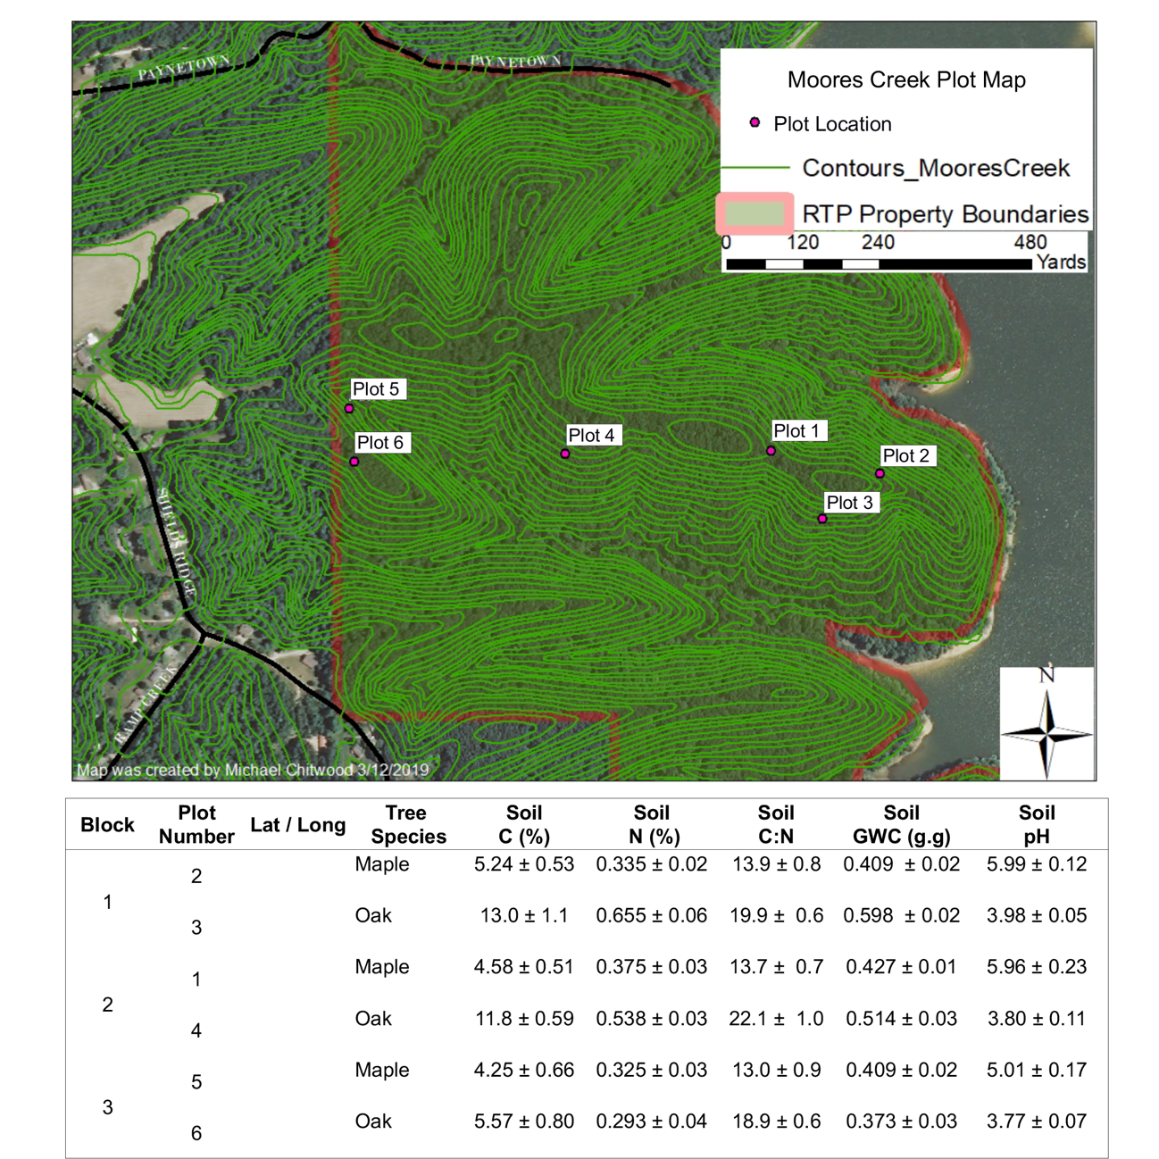
Supporting Figures:

Figure S1. Plot locations at Moores Creek and initial soil conditions (May 2018). Soil measurements include soil carbon (C), nitrogen (N), and gravimetric water content (GWC) as well as soil pH. Measurements are presented as mean values ± SE (n=3).

Supporting Tables:

Table S1. Effects of bag environment or additional layer of mesh on root mass remaining. Soil gravimetric water content (GWC) was included to control for soil moisture differences among plots.

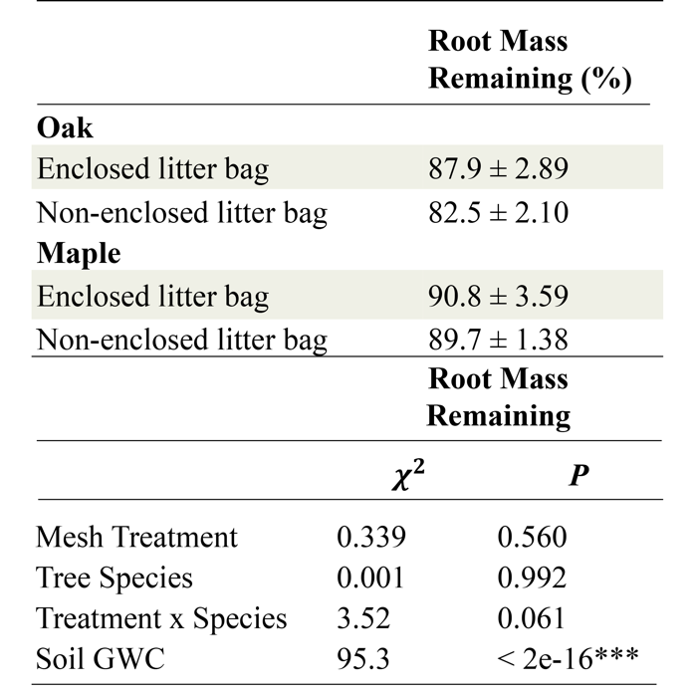

Table S2. Percentage of roots that recovered after pruning in root bags with and without litter 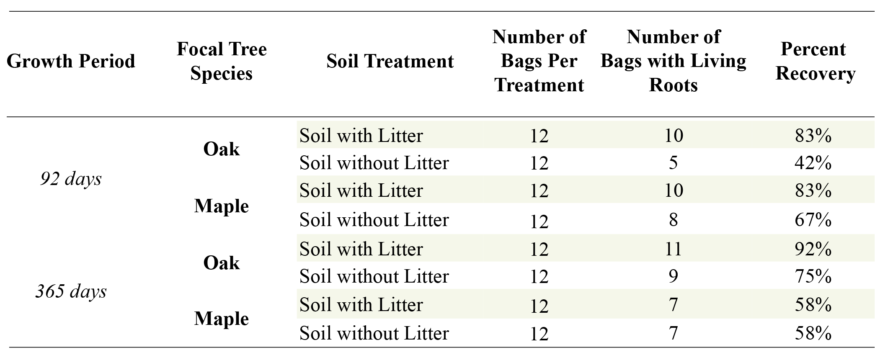

Table S3. ANOVA table for Root Trait LME Models

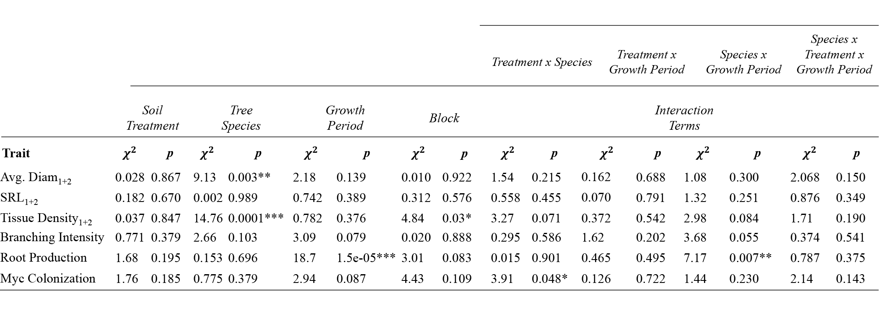

Table S4. Mean values for root growth rate, root length density and mycorrhizal colonization rates ± SE for roots growing in root bags with and without litter additions.

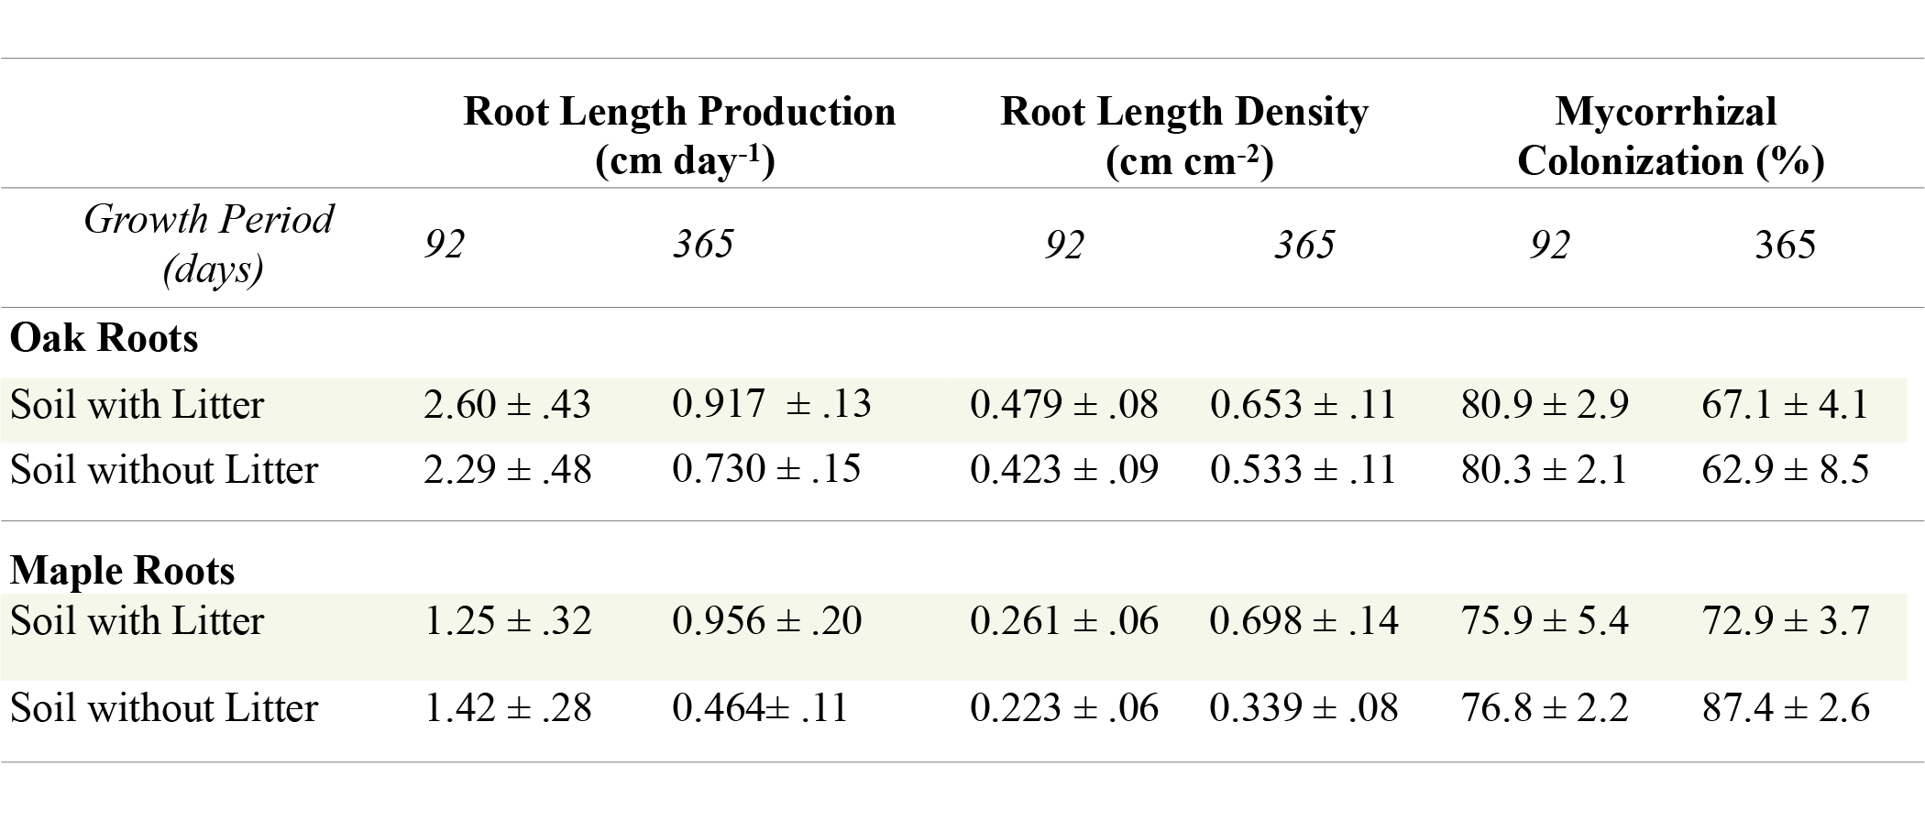

Table S5. Average litter induced changes in root traits after 92 and 365 days of root ingrowth
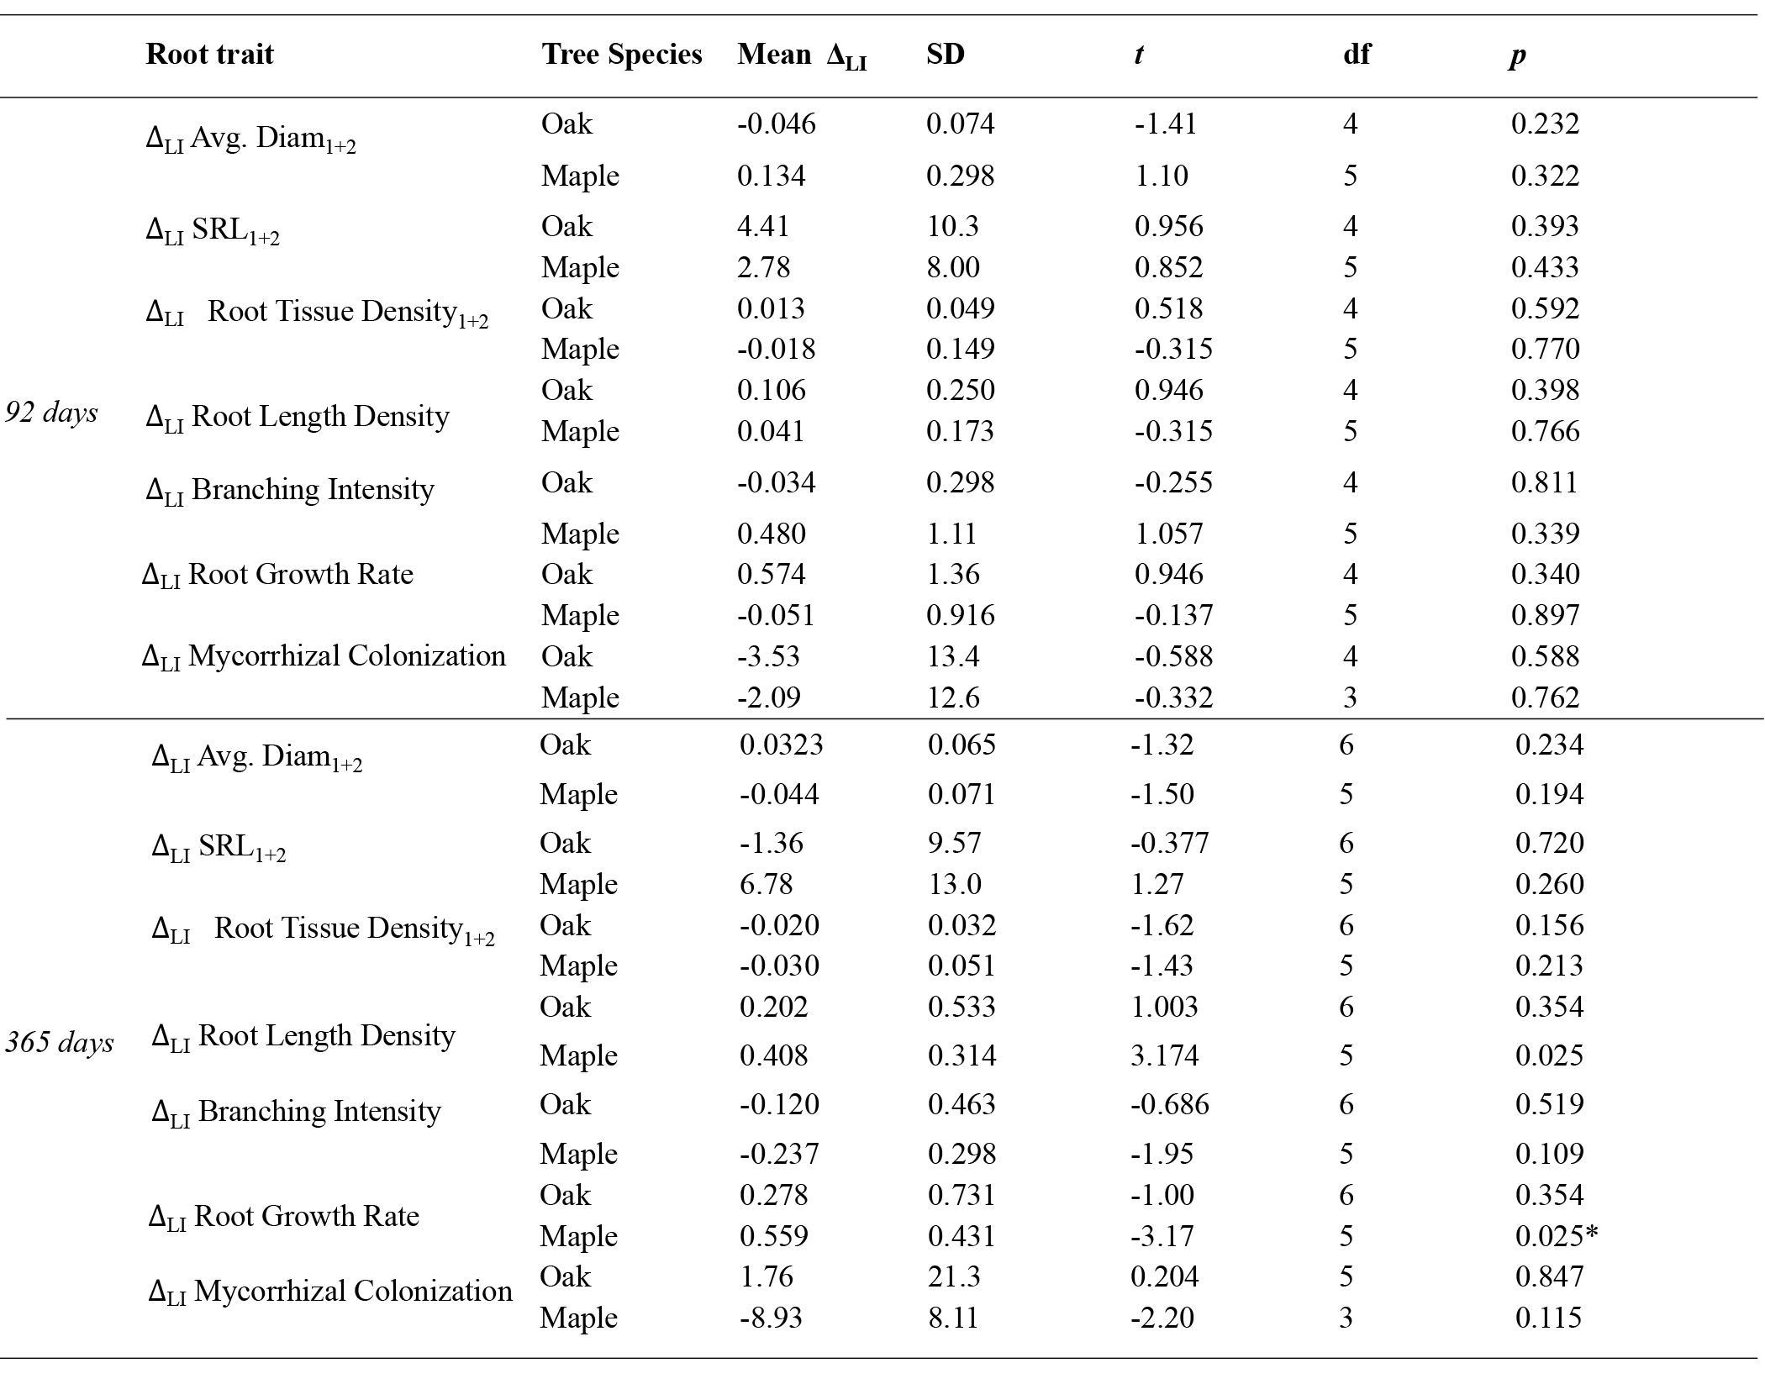

Table S6. Rhizosphere enzymes

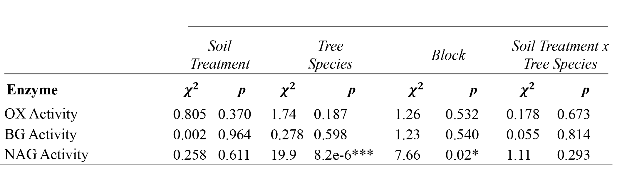

Table S7. Mean values for mass loss and soil volumetric water content (VWC) ± SE for root ingrowth bags (roots present) and root exclusions (roots excluded)

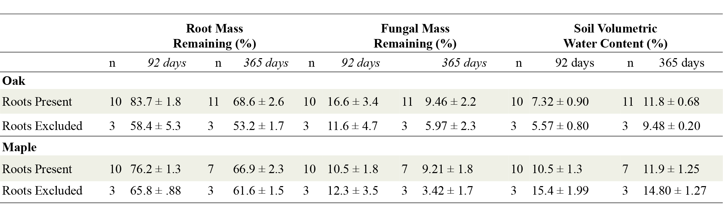

Table S8. ANOVA table for GLME Models
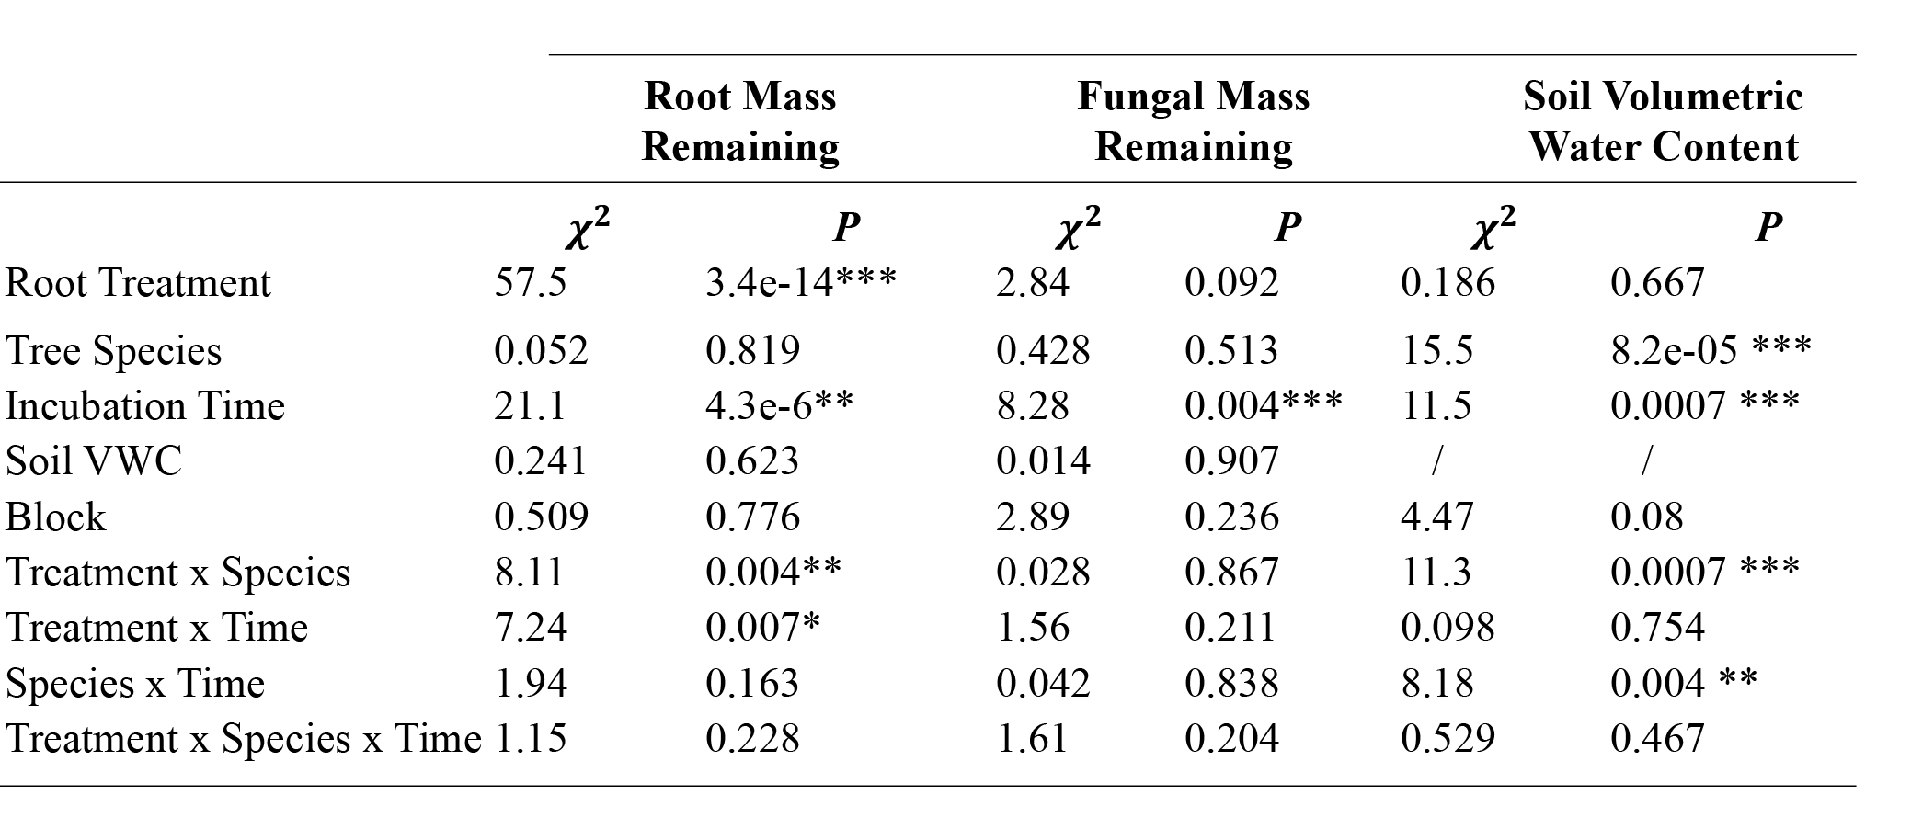

Table S9: Root Induced Changes in Mass Loss and Soil Volumetric Content (VWC) after 92 and 365 days of decay
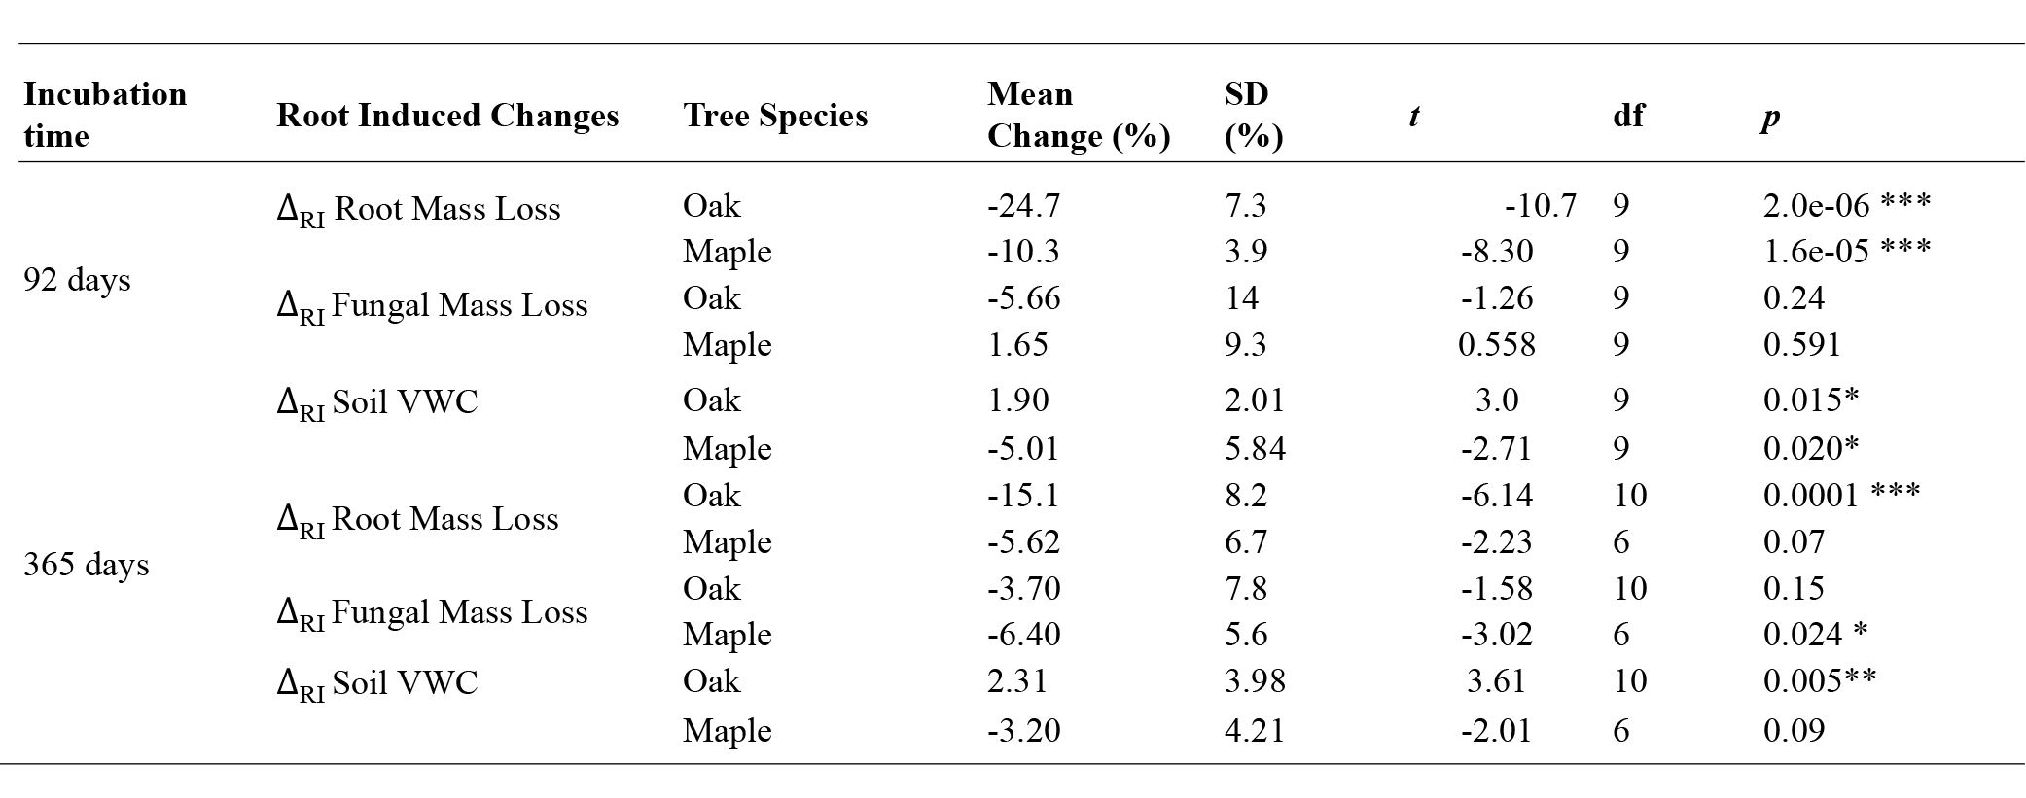
Table S10. ANOVA table for Soil LME Models

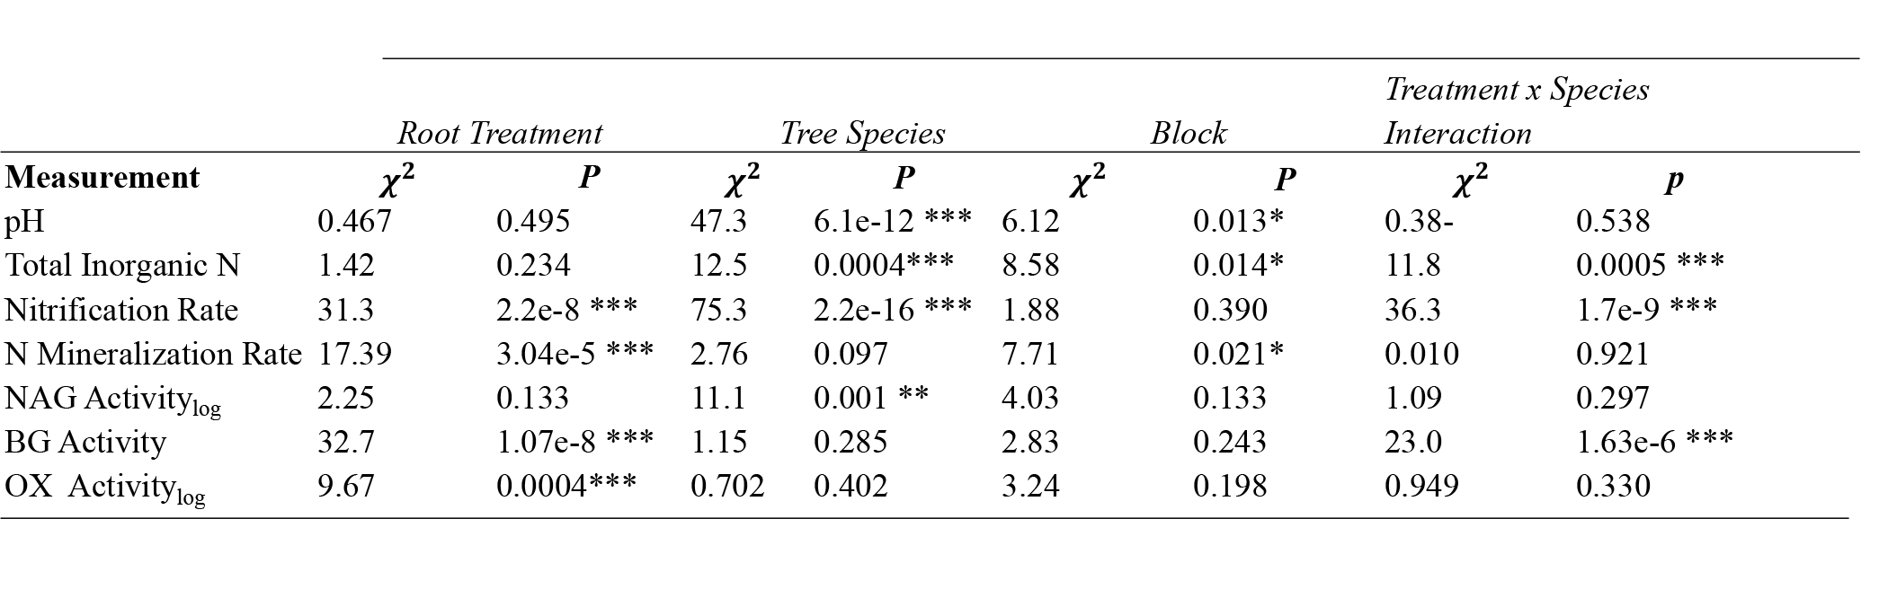

Table S11. Mean values for extracellular enzyme activities ± SE after 365 days in root adjacent and surrounding or litter adjacent soils.

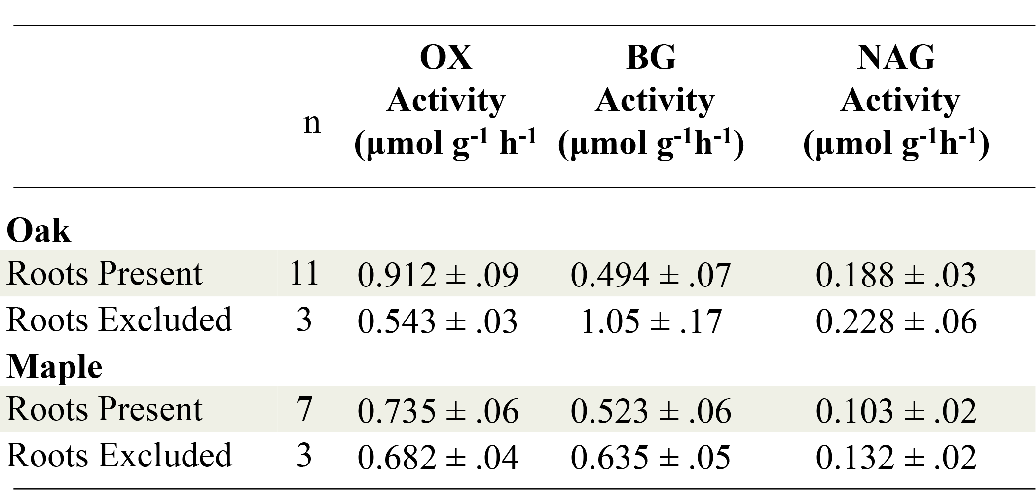

Table S12. Average root induced changes in soil properties after 365 days
