Item | Number | Percent
Complete BUSCOs (C) | 371 | 87.3%
Complete and single-copy BUSCOs (S) | 121 | 28.5%
Complete and duplicated BUSCOs (D) | 250 | 58.8%
Fragmented BUSCOs (F) | 12 | 2.8%
Missing BUSCOs (M) | 42 | 9.9%
Total BUSCO groups searched | 425 | 100%
Table S1 BUSCO evaluation results

Item | Count | Percentage
All | 50,119 | 100.00%
Annotation | 45,550 | 90.88%
Uniprot | 45,226 | 90.24%
Pfam | 40,599 | 81.01%
GO | 33,142 | 66.13%
KEGG | 24,216 | 48.32%
Pathway | 13,959 | 27.85%
KOG | 6,143 | 12.26%
Nr | 45,236 | 90.26%
Table S2 Annotation results of the de novo transcriptome of Stephania yunnanensis

Gene | Source | Accession
Cj6OMT | Coptis japonica | BAB08004.1
NnCNMT | Nelumbo nucifera | AXJ91467.1
Cc6OMT2 | Coptis chinensis | AXC09386
AtCNMT | Arabidopsis thaliana | AAM65762.1
Ec6OMT | Eschscholzia californica | BAM37634.1
CjBBE | Coptis japonica | BAM44344.1
EcBBE | Eschscholzia californica | AAC39358.1
CjNMCH | Coptis japonica | BAB12433.1
PsNMCH | Papaver somniferum | AAF61400.1
Cj4'OMT | Coptis japonica | Q9LEL5.1
Cc4'OMT | Coptis chinensis | ABY75613.1
Ec4'OMT | Eschscholzia californica | BAM37633.1
Ps4'OMT1 | Papaver somniferum | Q7XB11.1
Ps4'OMT1 | Papaver somniferum | Q7XB10.1
CjCYP80G2 | Coptis japonica | BAF80448.1
TtCTS | Thalictrum thalictroides | KAF5177347.1
NnCYP80Q1 | Nelumbo nucifera | XP_010253990.1
PsRNMT | Papaver somniferum | A0A1C9U5X5.1
PsSLS | Papaver somniferum | ABR14720.1
StCYP80G6 | Stephania tetrandra | (Li et al. 2024)
StCYP80Q5 | Stephania tetrandra | (Li et al. 2024)
CjPR10A | Coptis japonica | A2A1A1.2
TfNCS | Thalictrum flavum | AAR22502.1
PsNCS1 | Papaver somniferum | Q4QTJ2.1
PsNCS2 | Papaver somniferum | Q4QTJ1.1
CjCNMT | Coptis japonica | BAB71802.1
Table S3 Functional genes involved in the biosynthesis pathways of BIAs

Primer | Sequence
SyCYP80Q5-1-F | ATGGCAGCAGCGC
SyCYP80Q5-1-R | TTATATAGGTAGATGAGATGTGATG
SyCYP80Q5-3-R | ATGGCAGCAGTACTACTACT
SyCYP80Q5-3-R | TCAGAATATGTGATTGAGTTTGGG
SyCYP80G6-R | ATGGAAGCAGTAGCAGC
SyCYP80G6-R | TTATGCATGCGGAATTCTCAC
Table S4 The PCR primers used in this study

Fig. S1 The two types of aporphines in S. yunnanensis
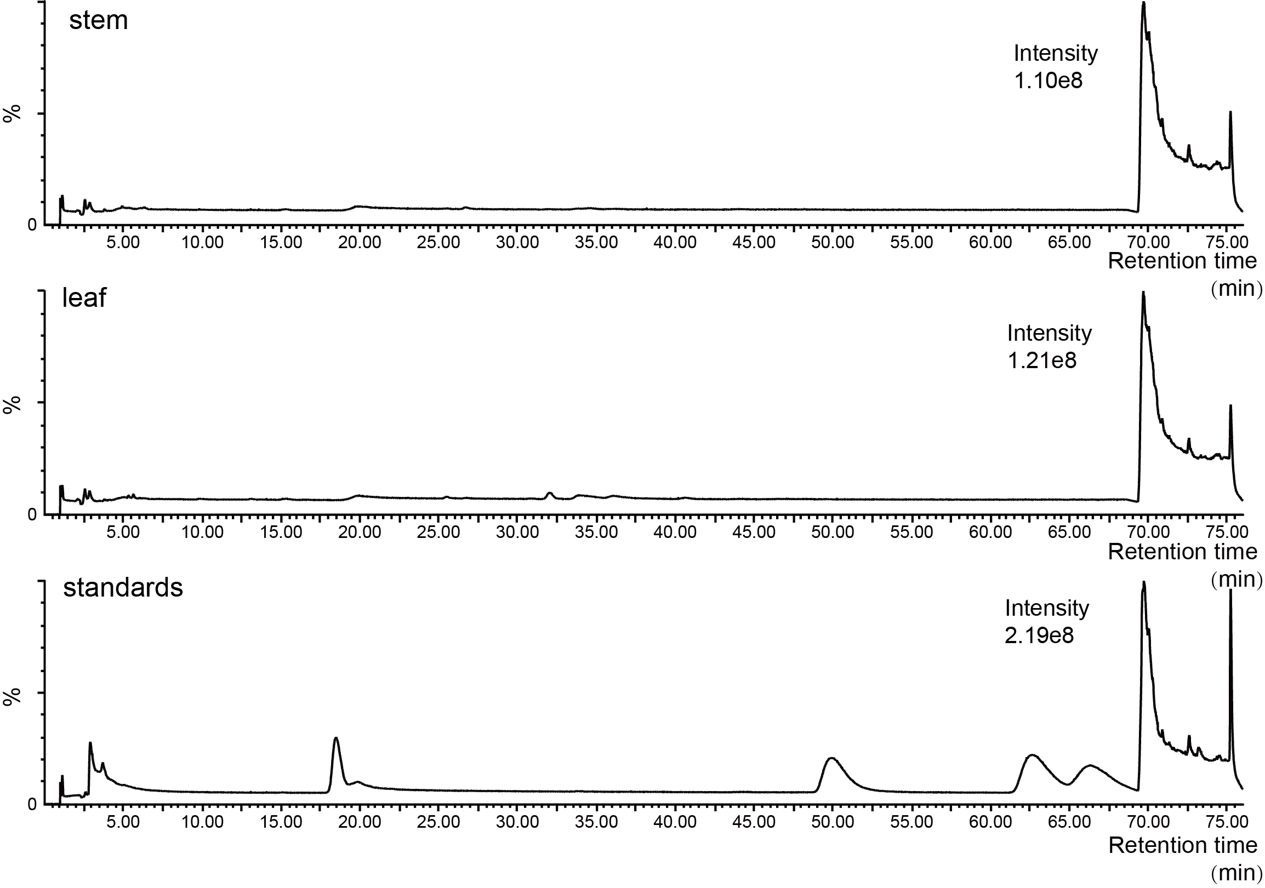
Fig. S2 LC-MS chromatograms of S. yunnanensis stem and leaf, the concentration of all four chemical standards was 0.02 mM

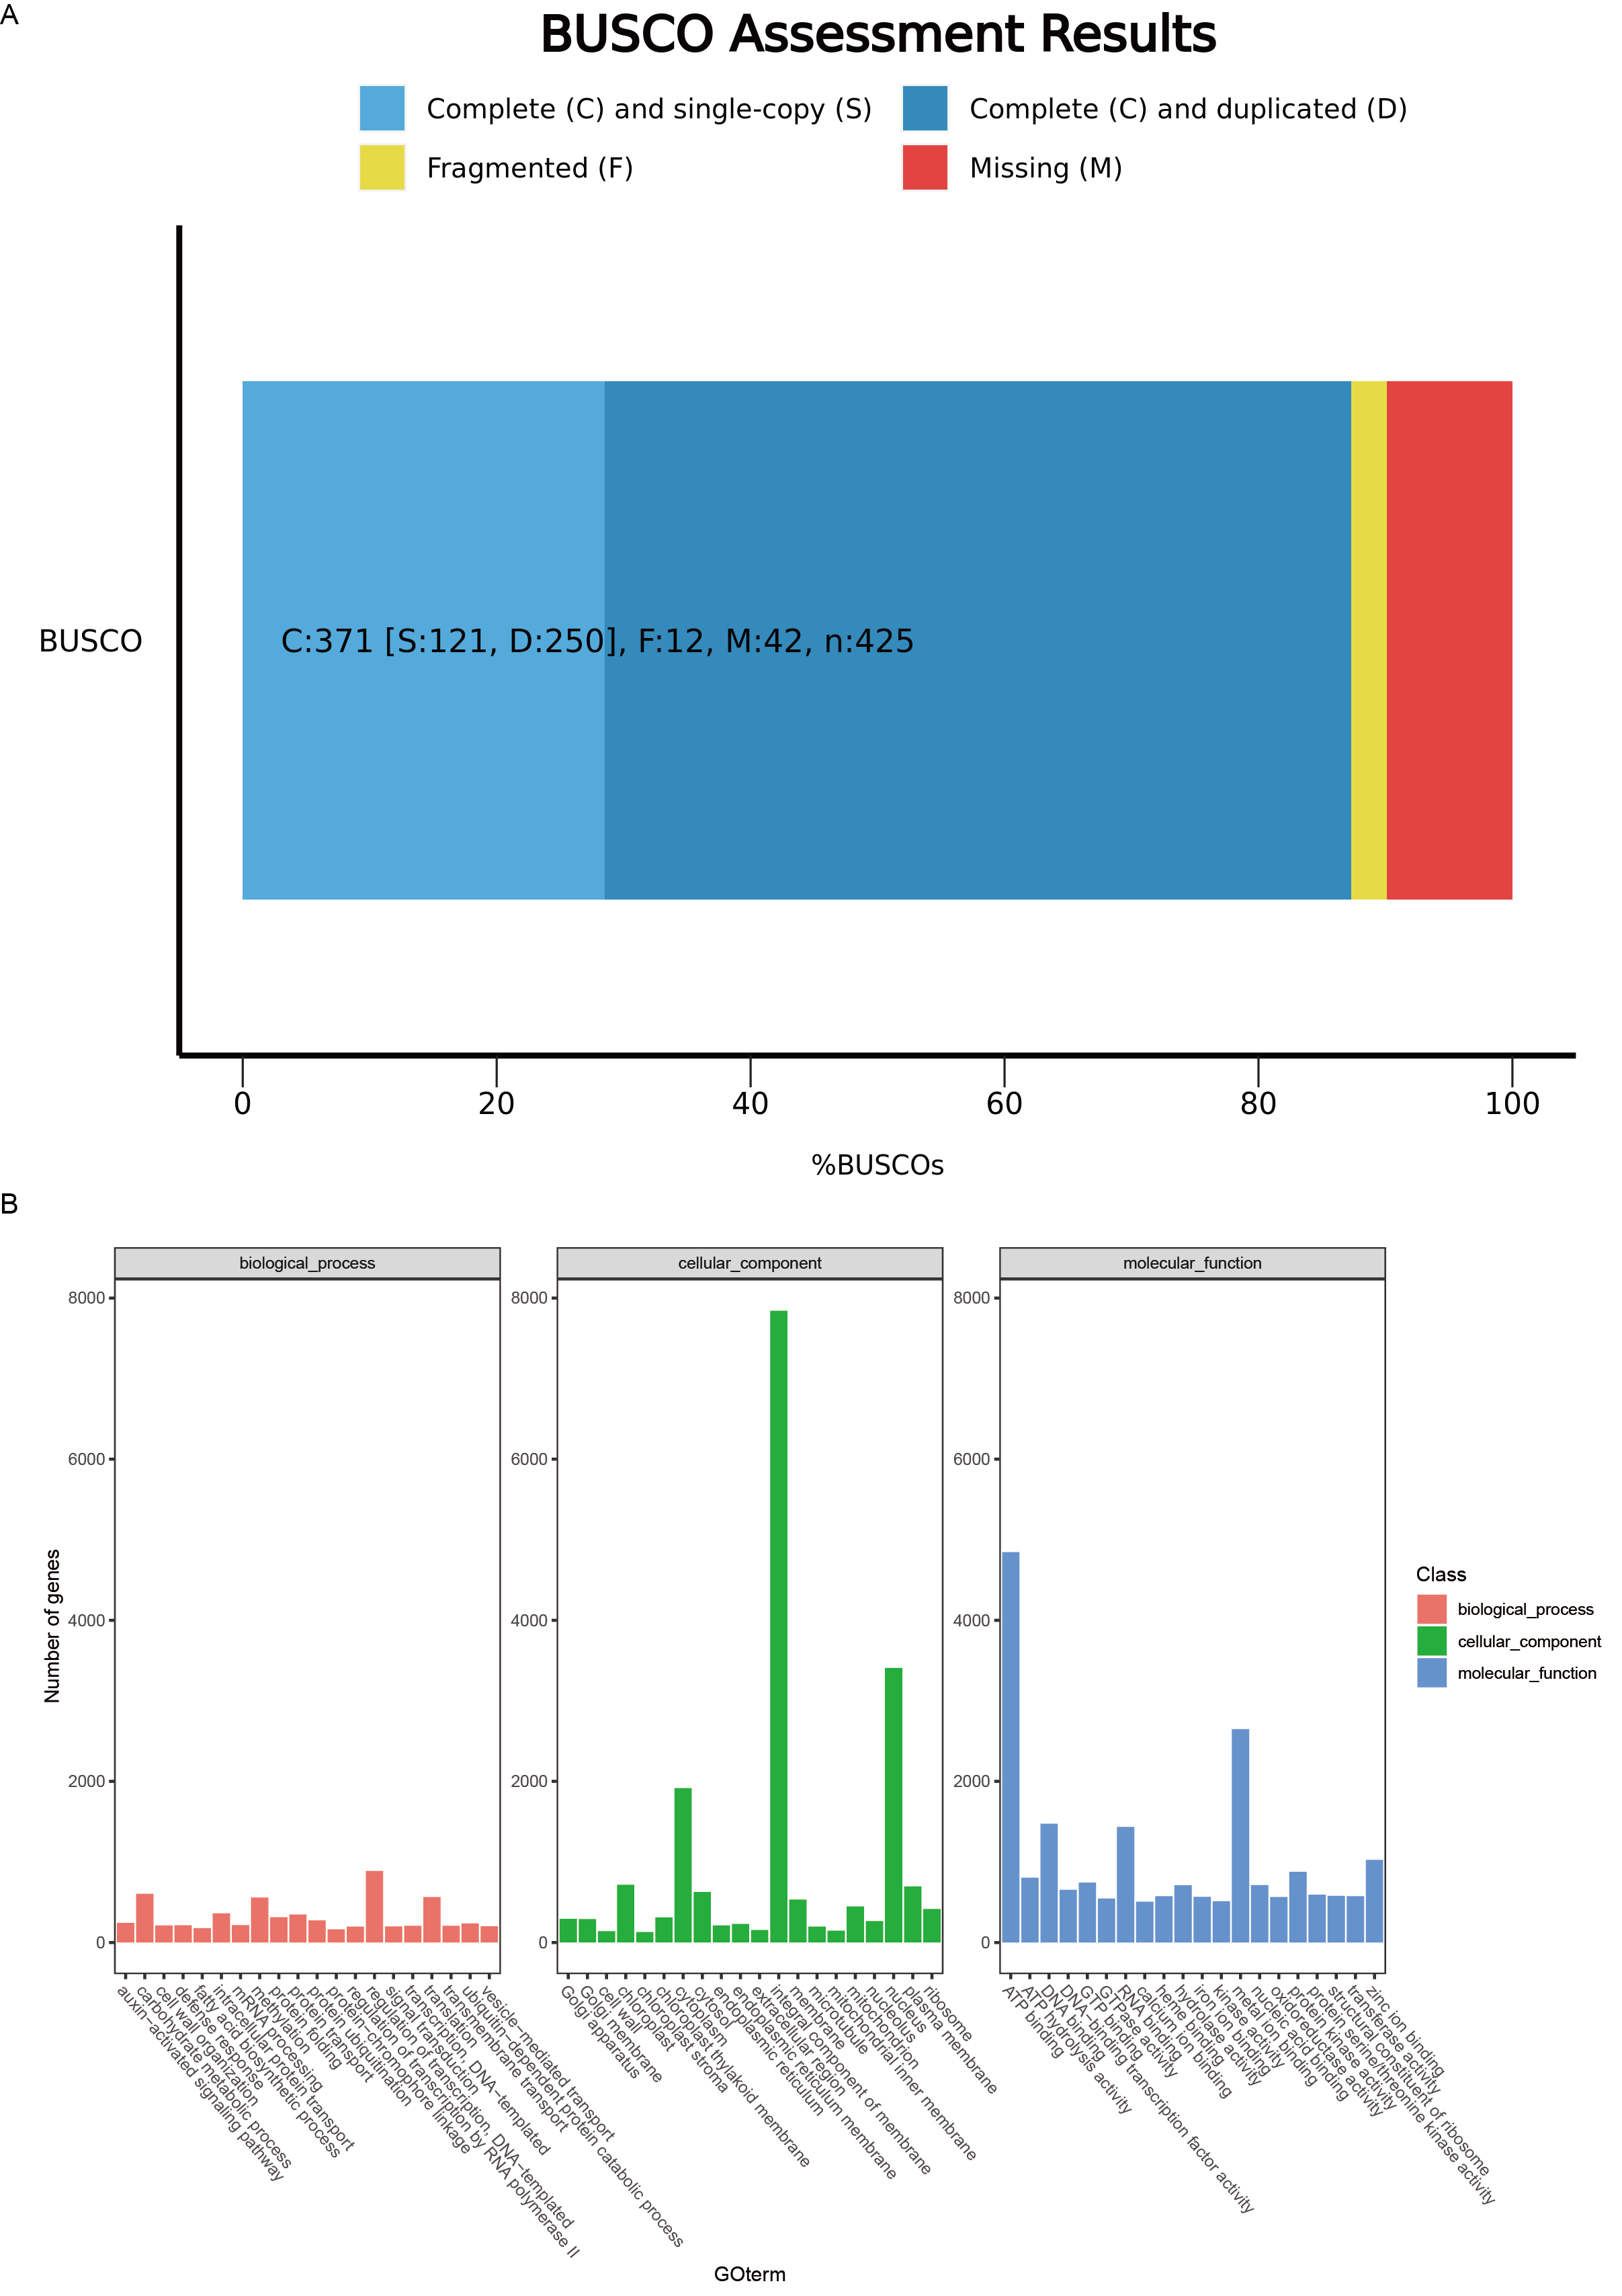
Fig. S3 Analysis of de novo transcriptome. a BUSCO evaluation results of the de novo transcriptome of S. yunnanensis. b GO clustering analysis of the de novo transcriptome of S. yunnanensis

Fig. S4 GO and KEGG pathway enrichment of DEGs of root vs. stem and stem vs. leaf comparisons. Here, SyR, SyS, and SyL represent the roots, stems, and leaves of S. yunnanensis

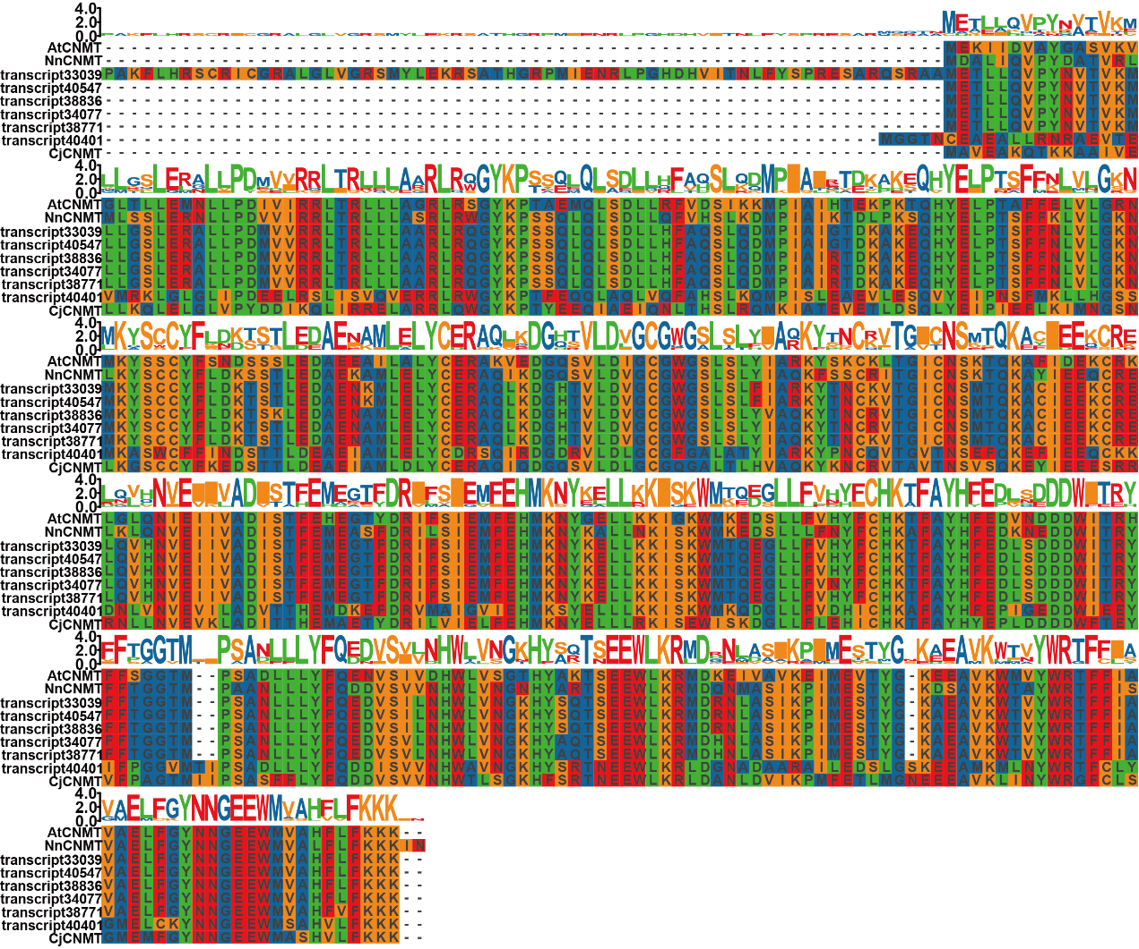
Fig. S5 sequence alignment of candidate CNMTs and reference genes

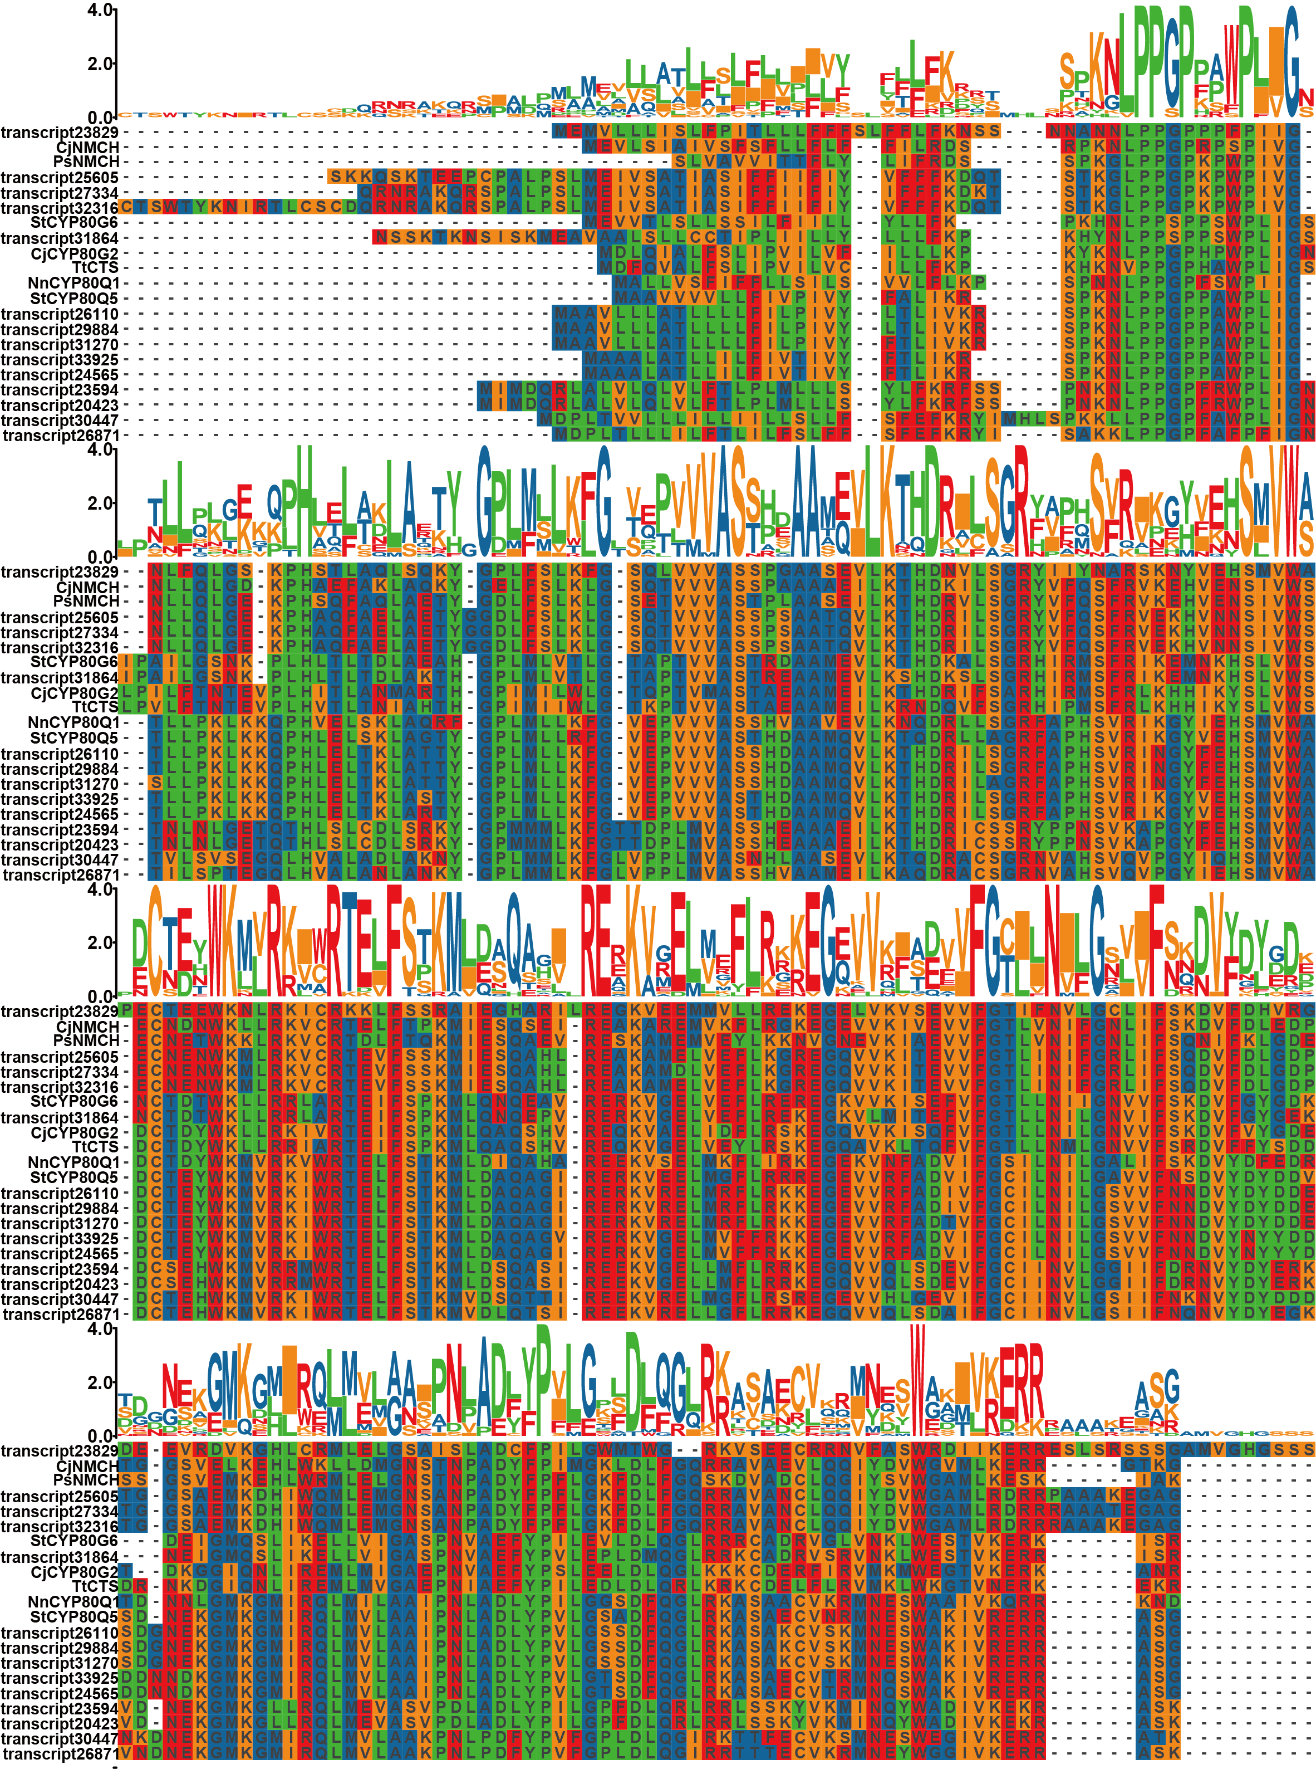
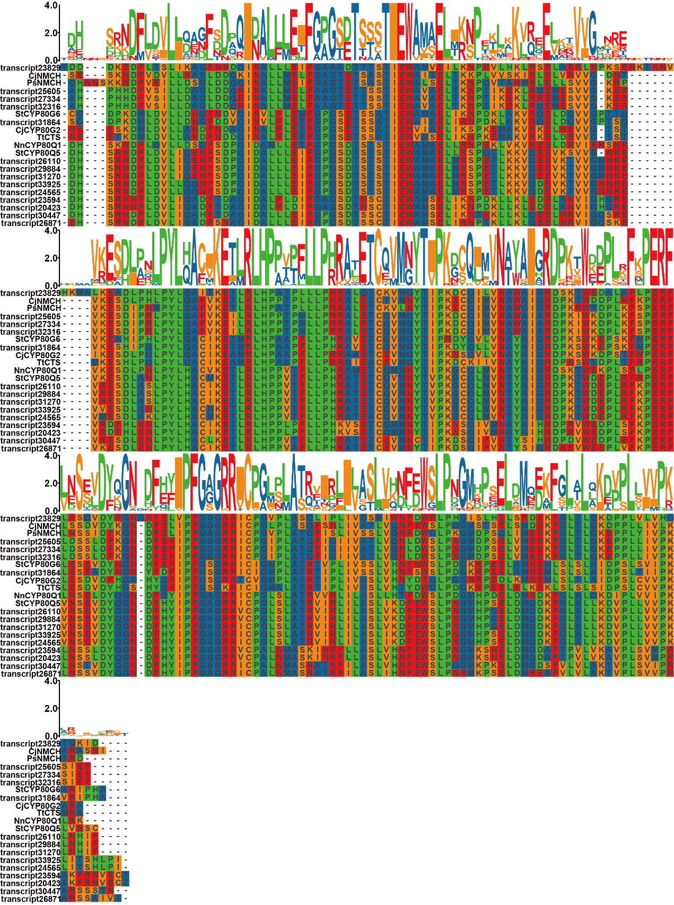
Fig. S6 sequence alignment of candidate CYP80s and reference genes

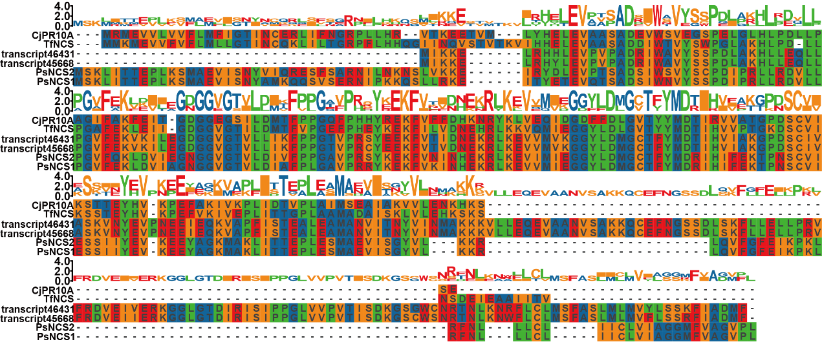
Fig. S7 sequence alignment of candidate NCSs and reference genes

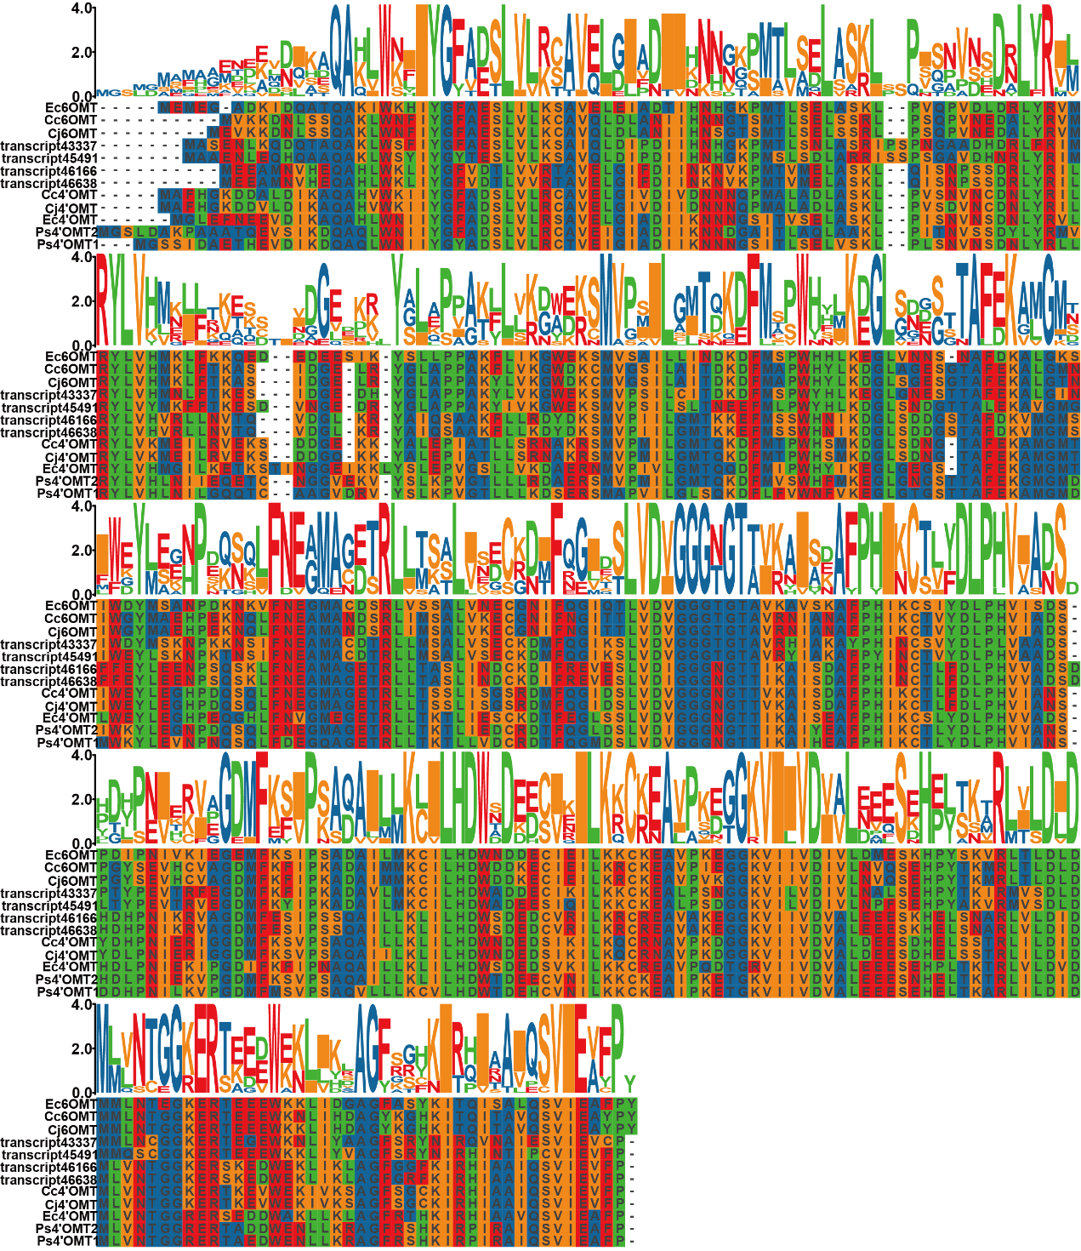
Fig. S8 sequence alignment of candidate OMTs and reference genes

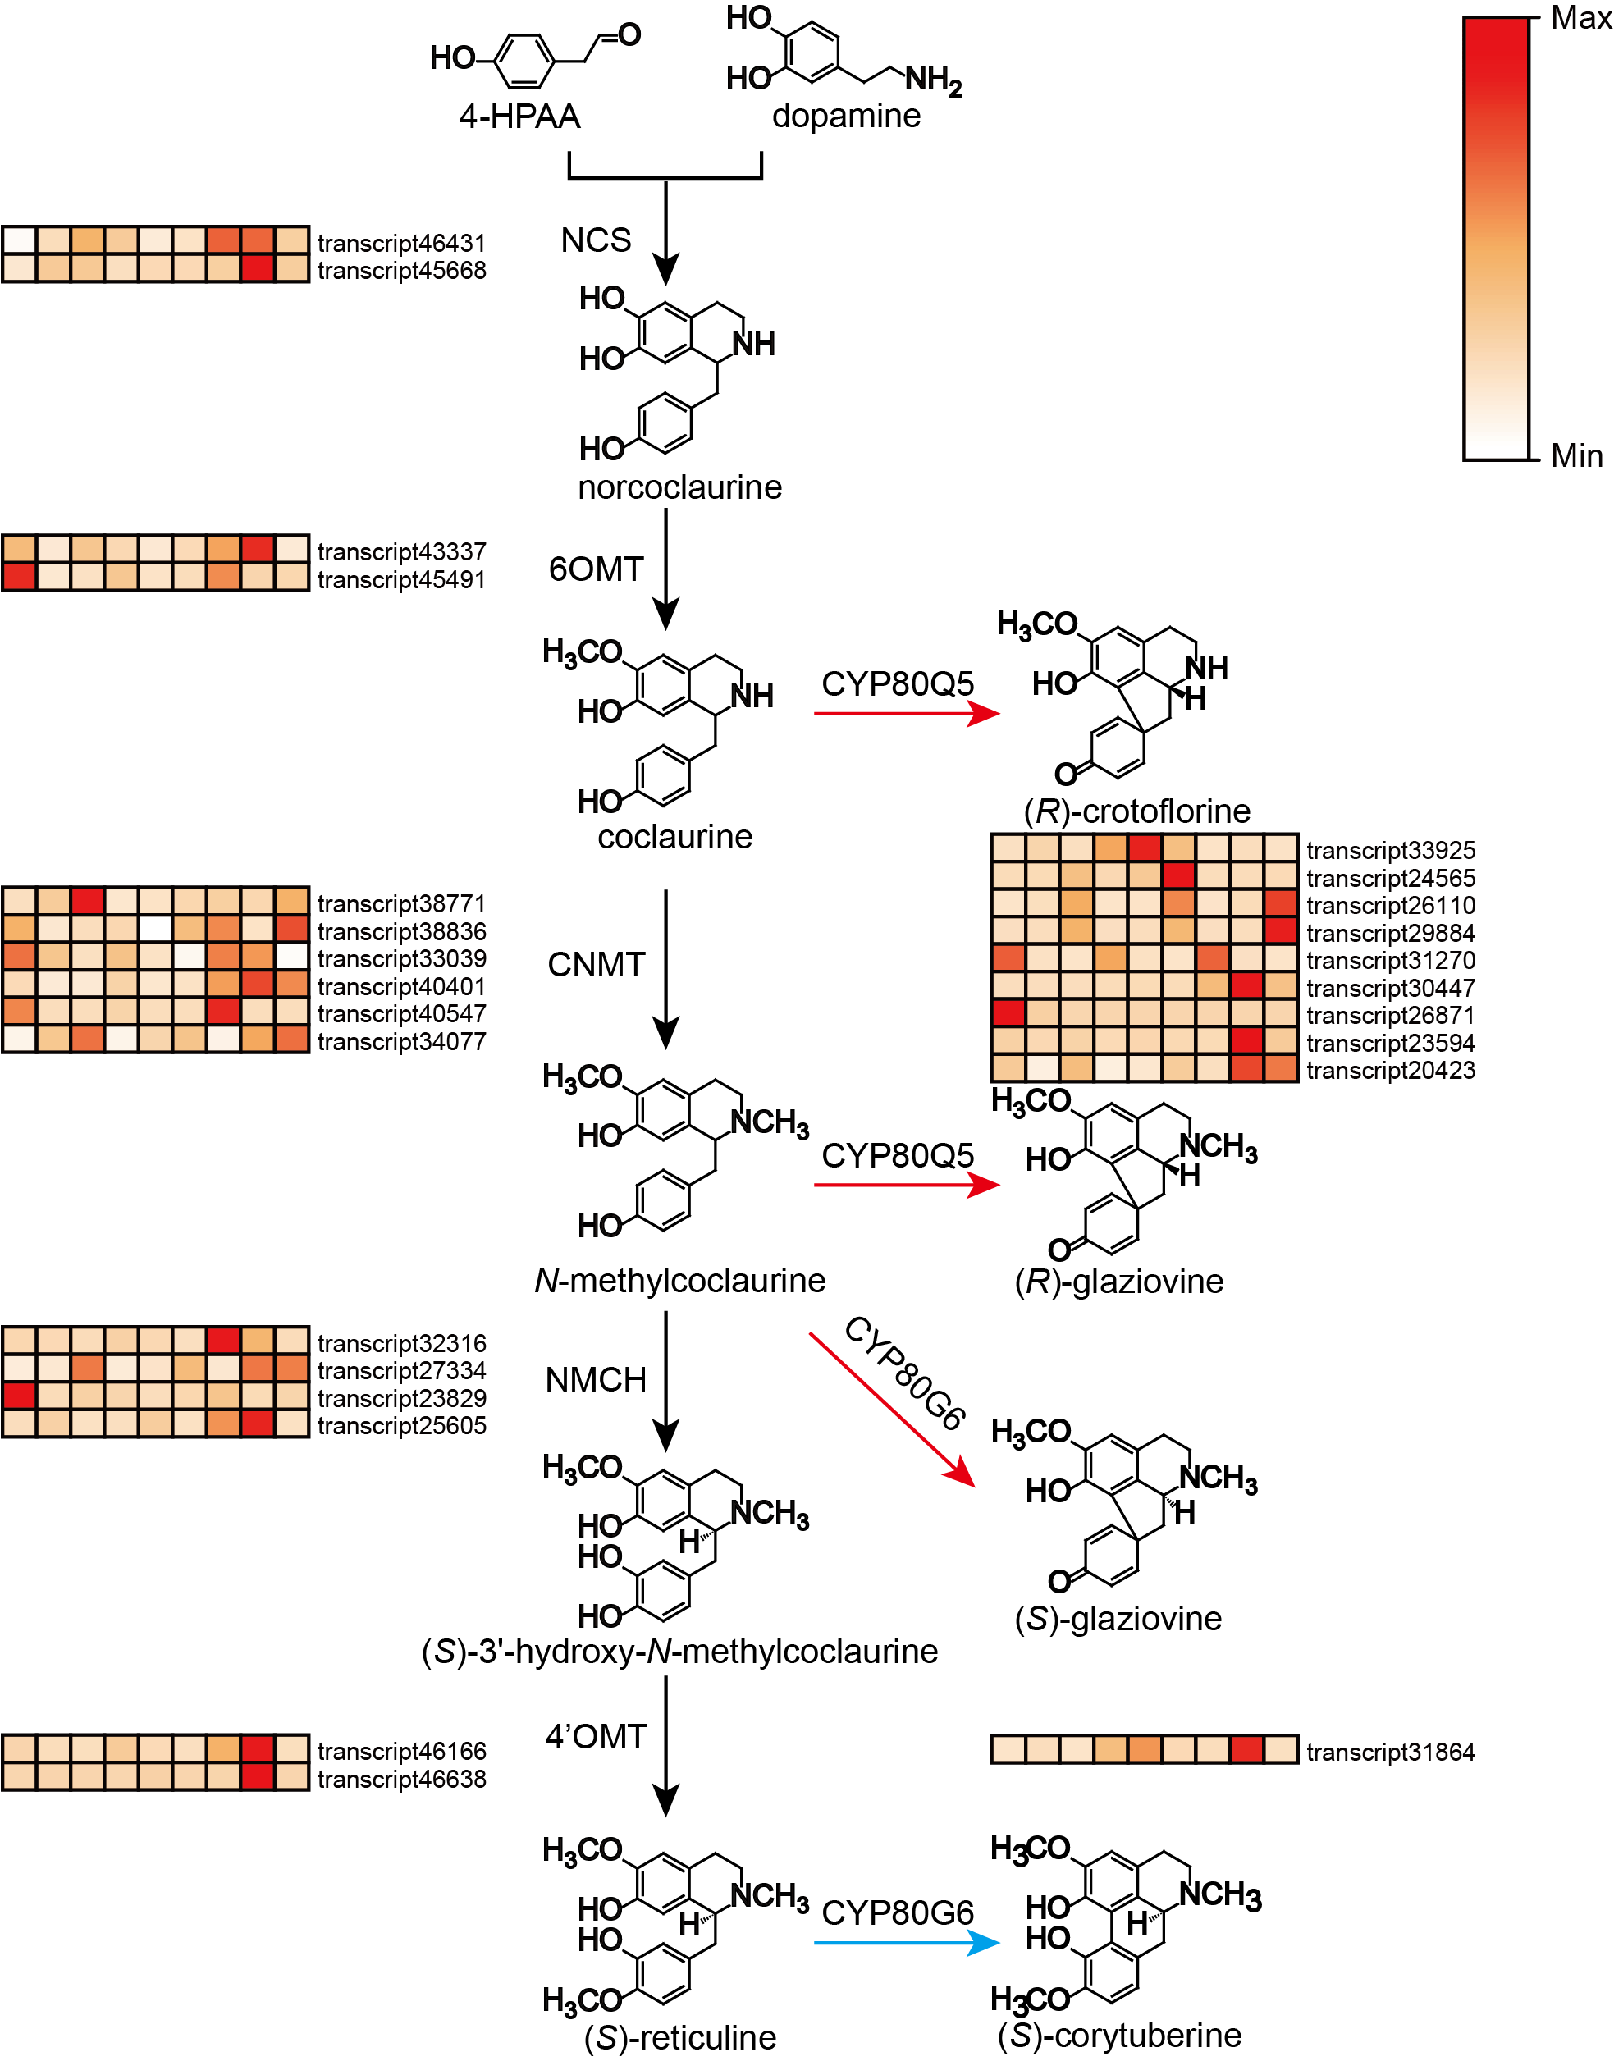
Fig. S9 Expression patterns of candidate transcripts involved in the biosynthesis of BIAs in S. yunnanensis. Putative biosynthetic pathway for BIAs and analysis of gene expression patterns related to BIAs in S. yunnanensis. The expression levels in different samples are indicated by small squares in different colors, the colors indicate the expression levels, with blue representing low expression and red representing high expression. From left to right: leaf 1, leaf 2, leaf 3, stem 1, stem 2, stem 3, root 1, root 2, root 3. The pathway for type Ⅰ aporphines is highlighted in blue, while the pathway for type Ⅱ protoaporphines is highlighted in red

Figure S10 Sequence alignment of SyCYP80Q5-3, SyCYP80Q5-1 and StCYP80Q5

Fig. S11 High-Resolution MS/MS spectrum Fragmentation of Products catalyzed by CYP80s, including a comparison between the products of SyCYP80G6 and CYP80G2 catalyzing (S)-reticuline, b comparison between the two produced of SyCYP80Q5-1 and SyCYP80Q5-3 catalyzing (R)-COC and (R)-NMC, and c comparison between the products of SyCYP80G6 and CYP80G2 catalyzing (S)-NMC

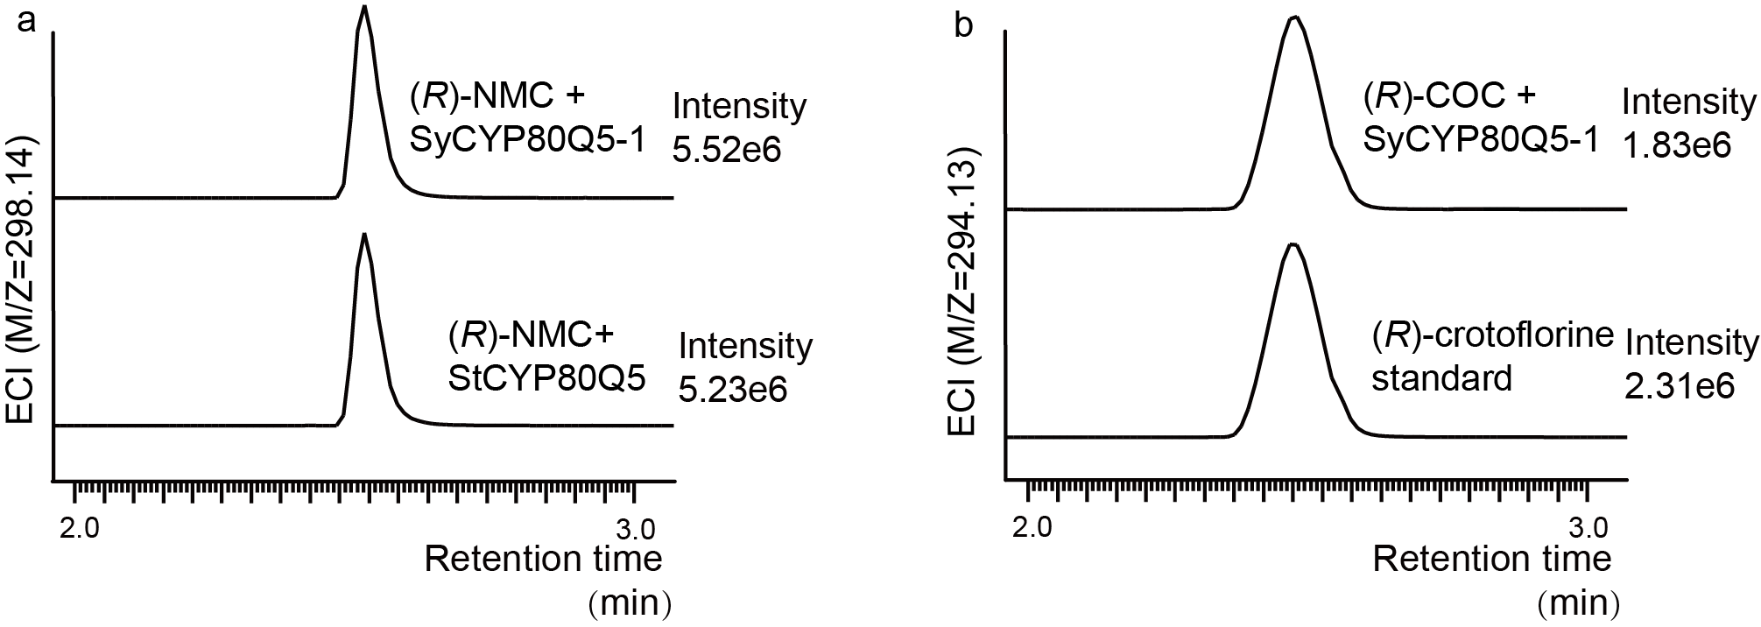
Fig. S12 a comparison between the products of SyCYP80Q5-1 and StCYP80Q5 catalyzing (R)-NMC, and b comparison between (R)-crotoflorine standard and the products of SyCYP80Q5-1

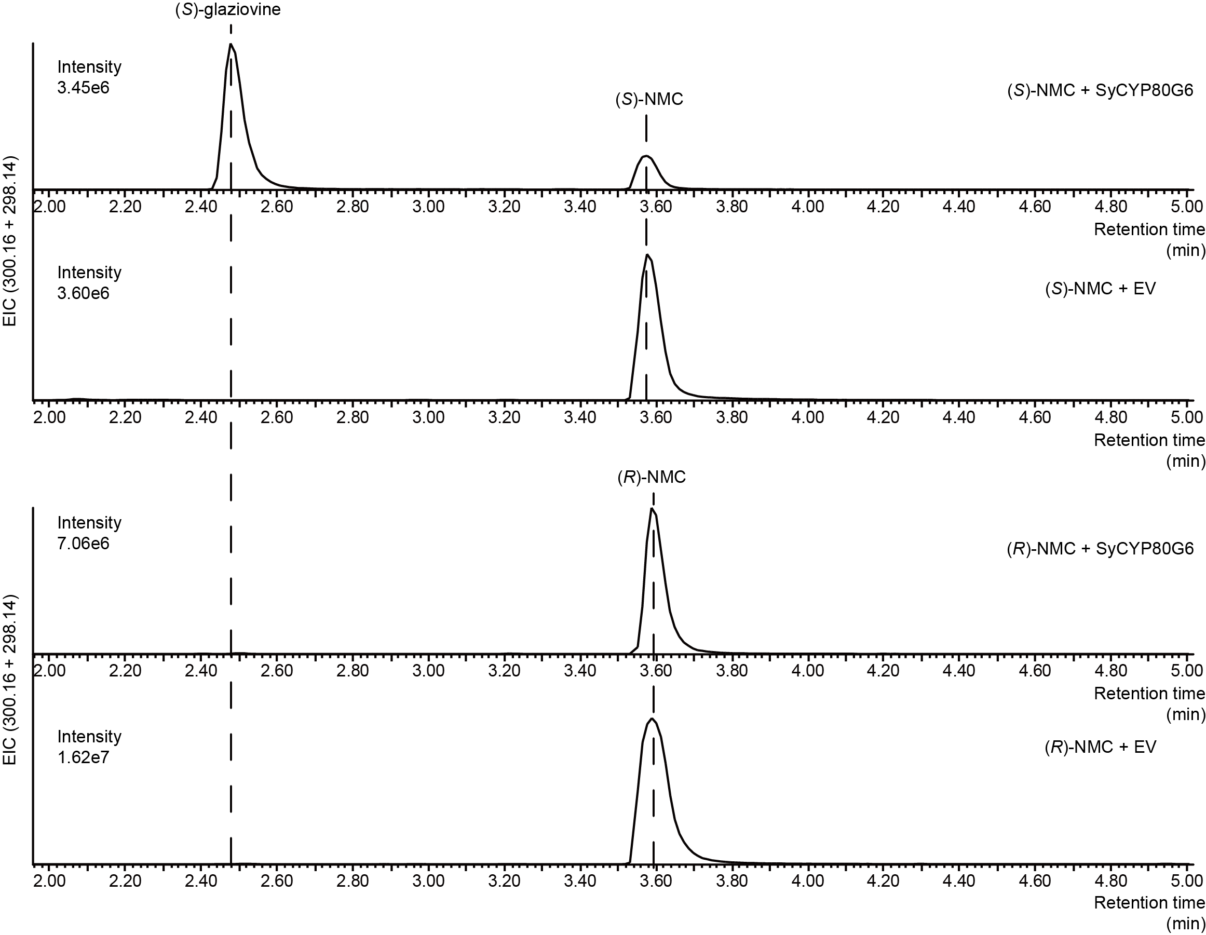
Fig. S13 Reaction of SyCYP80G6 with NMC

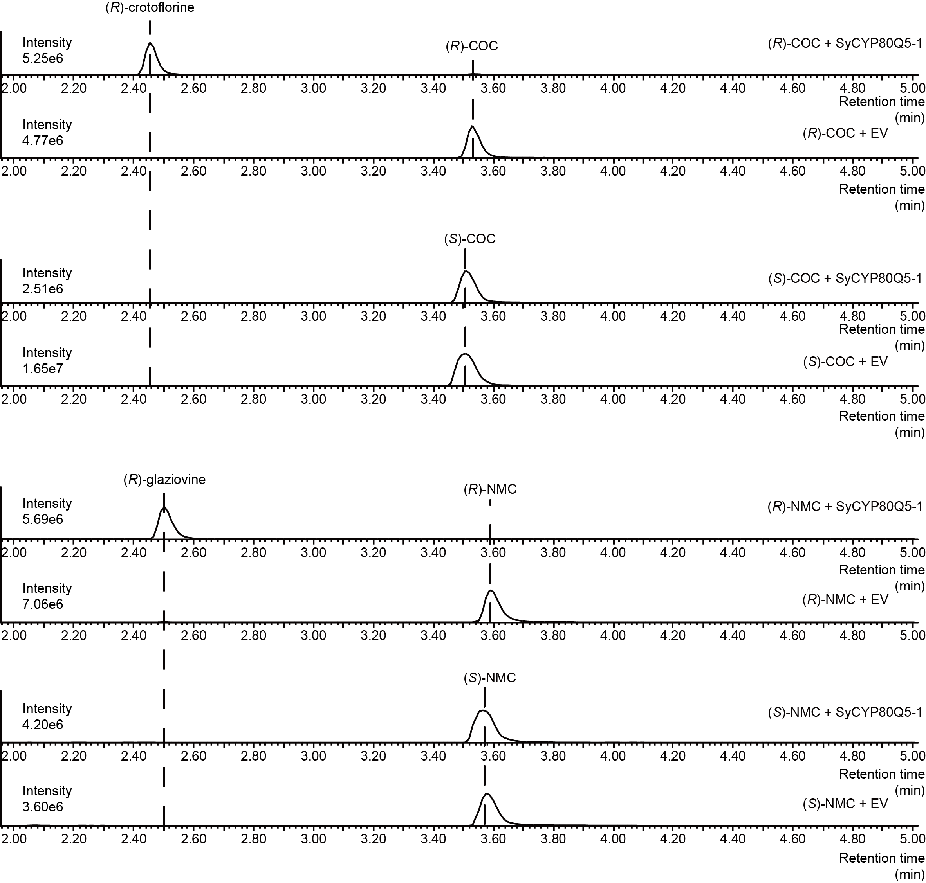
Fig. S14 Reaction of SyCYP80G6 with NMC and COC

