SUPPLEMENTARY FIGURES AND TABLES

SINE Retrotransposons Import Polyadenylation Signals to 3’UTRs in Dog (Canis familiaris)

Jessica D. Choi^{1,2,3}, Lelani A. Del Pinto¹, Nathan B. Sutter¹

¹Department of Biology, La Sierra University, Riverside, CA 92505
²The Jackson Laboratory, Bar Harbor, Maine, USA
³Graduate School of Biomedical Sciences, Tufts University, Boston, Massachusetts, USA

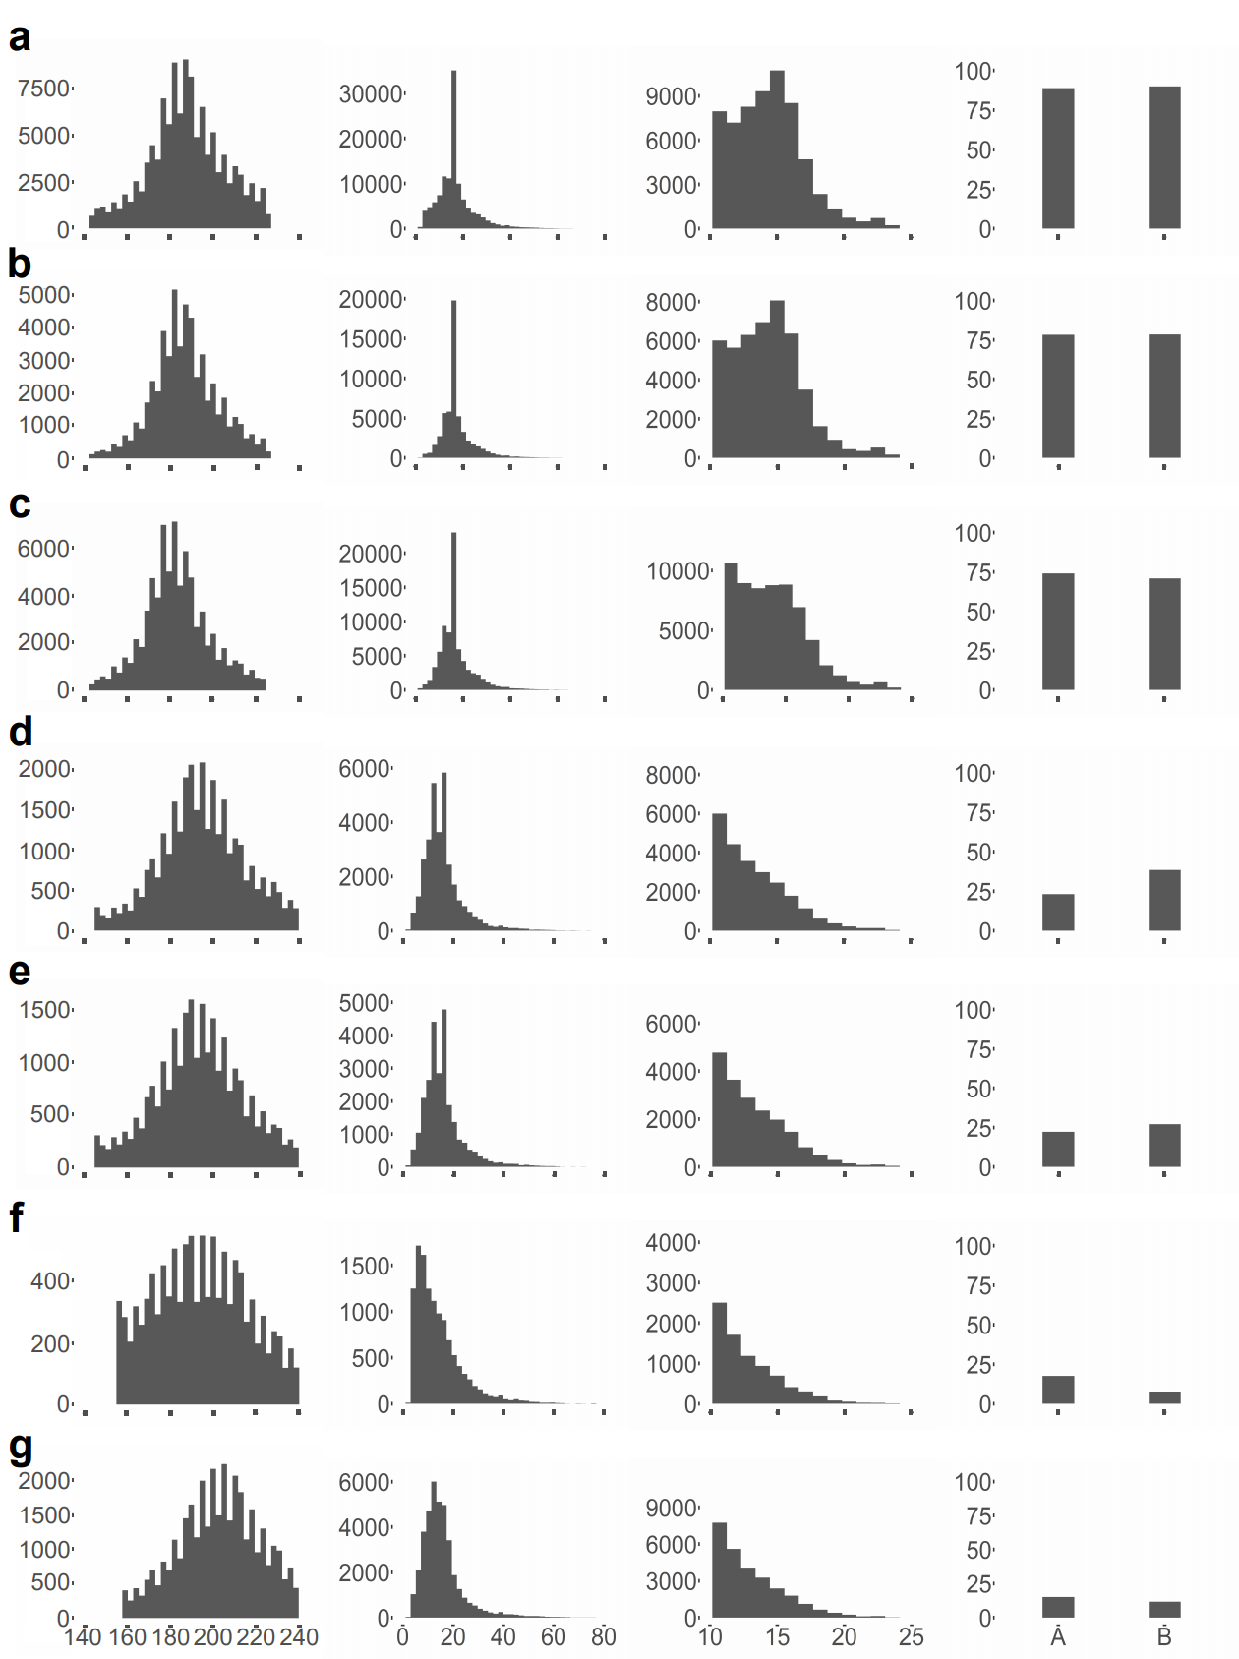

Fig. S1 Annotation of Can-SINE elements from the dog reference genome. Column 1 is length histograms of the sequence identified between TSDs, column 2 is a length histogram for the AT-rich tail sequence, and column 3 is histograms of perfect TSD lengths. All histograms have horizontal axis bp and vertical axis count. Column 4 shows the percentage of the SINEs in which A box and B box sequences were identified. a SINEC_Cf2, b SINEC_Cf3, c SINEC_a2, d SINEC_b1, e SINEC_b2, f SINEC_c1, g SINEC_c2.

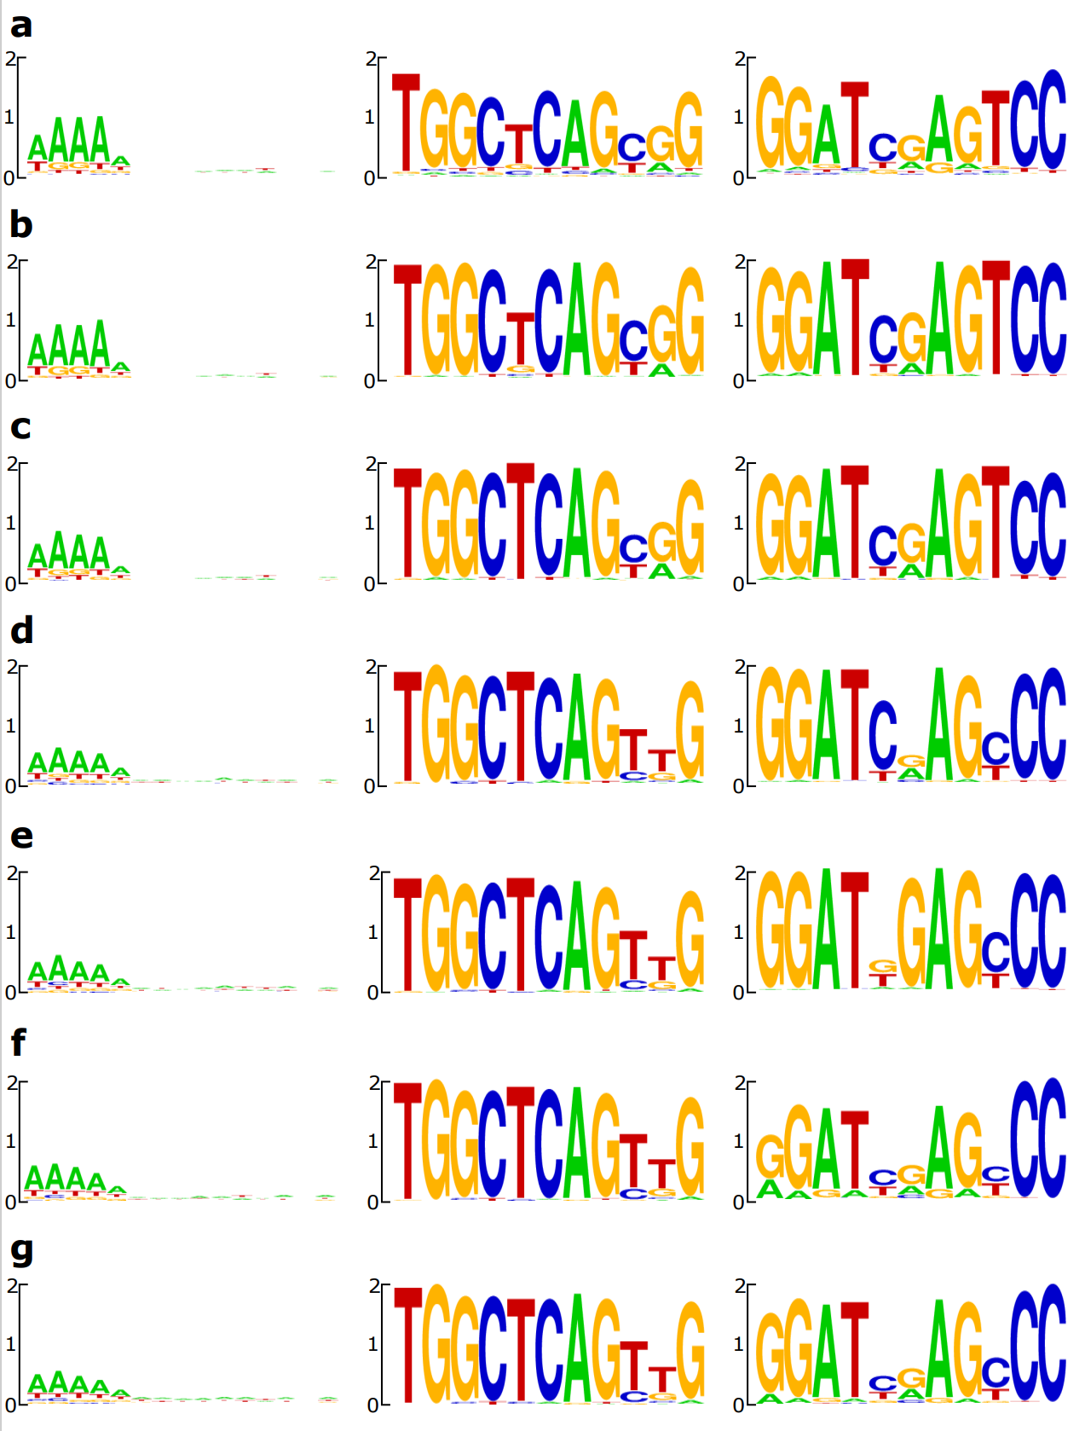

Fig. S2 Sequence logos of Can-SINE types from the dog reference genome. Columns left to right are of sequence logos of the TSD, A box, and B box. a SINEC_Cf2, b SINEC_Cf3, c SINEC_a2, d SINEC_b1, e SINEC_b2, f SINEC_c1, g SINEC_c2.

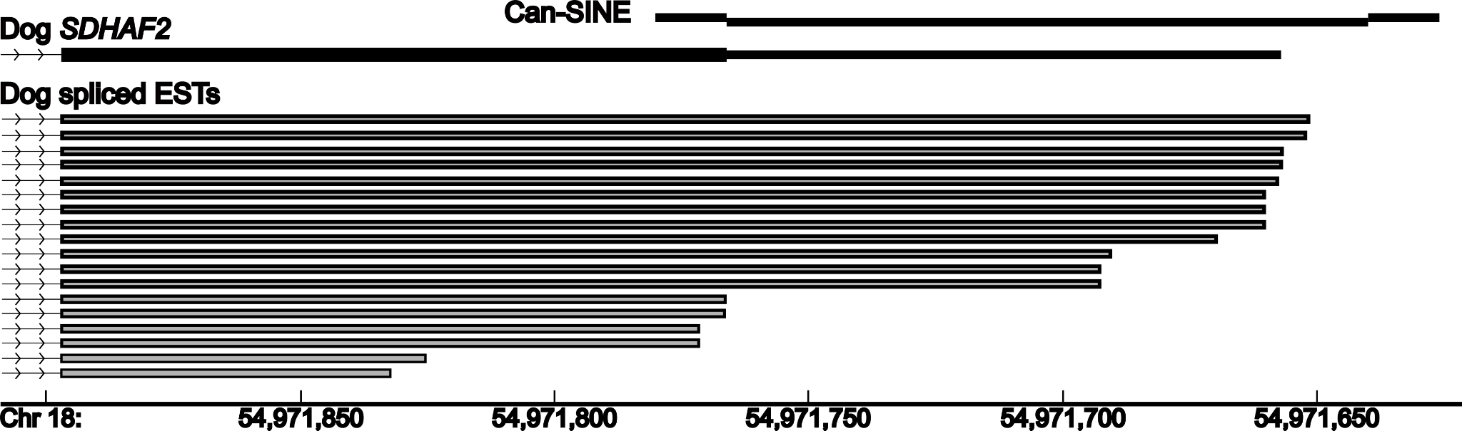

Fig. S3 A sense-oriented SINEC_Cf2 is the entire 3’UTR for the SDHAF2 gene. Dog spliced expressed sequence tags terminate in the modeled 3’UTR. The SINE is annotated in the Repeat track of the UCSC Genome Browser as two separate SINE and simple sequence records but the single base mismatch 15 bp TSDs (shown as offset rectangles) delimit the Can-SINE insertion.

Fig. S4 A sense-oriented SINEC_Cf2 is most of the ~320 bp dog 3’UTR of IL17RA. In the human ortholog the 3’UTR is >5800 bp long. The dog’s single SINE insertion is annotated as three separate records: a head portion, a CT(n) simple repeat, and the AT-rich tail in which AATAAA motifs are found at 19 and 36 bp from the 3’ end of the 3’UTR. A 13 bp TSD starts at the TAAA of the 3’-most AATAAA.

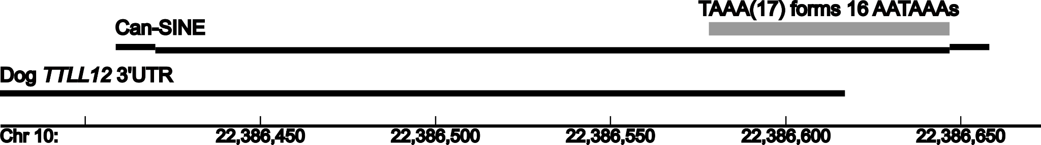

Fig. S5 A sense-oriented young SINEC_Cf is the source of an uninterrupted TAAA(17) STR expansion providing many AATAAA motifs at the 3’ end of the dog TTLL12 3’UTR. A 16 bp perfect target site duplication (shown as offset rectangles) starts immediately after the STR.

SUPPLEMENTARY TABLES

Table S1 Genome-wide counts of 11 PAS motifs in the 3’ ends of 3’UTRs.

Table S2 Counts of 11 PAS motifs in Can-SINE and MIR consensus sequences.

Table S3 The set of all Can-SINEs in sense orientation within 225 bp of 3’UTR 3’ ends that have apparently zero AATAAA motifs are mostly mis-annotated.

Table S4 Genome-wide counts in several mammals and other vertebrates of simple tandem repeats of the form {AAAT, AATA, ATAA, TAAA, ATTT, TATT, TTAT, TTTA}.

Table S5 Confirmation that our intersections python script correctly identifies AATAAA sequences within 3’UTRs. We manually checked 50 random 3’UTRs for each of five AATAAA distances.

Table S6 Genome-wide counts of AATAAAs within retrotransposons near the 3’ end of 3’UTRs. They mostly occur in sense-oriented elements at 4-bp intervals 28, 32, and 36 bp from the 3’ end.

