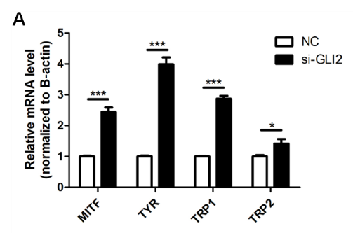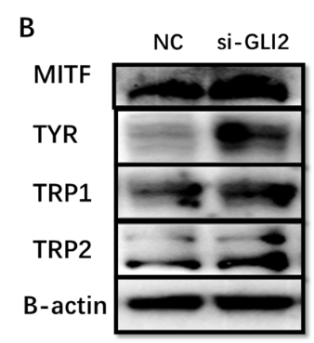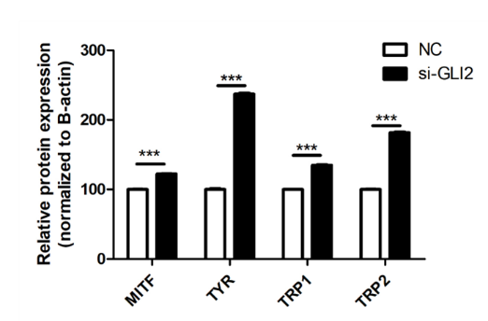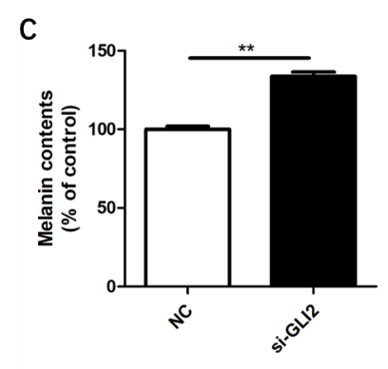
Fig S1. The function of miR-365b-5p predicted target gene GLI2 in human melanocyte. (A). GLI2 siRNA effects on melanogenesis related gene mRNA level in NHEM determined by qPCR. (B). Melanogenesis related gene protein expression increased by GLI2 siRNA in NHEM and detected by Western Blot. Blot analysis by image J. (C). Silencing of MITF repressor GLI2 increased melanin contents in NHEM. (Values are presented as the mean ± SD from n3. Data were analyzed using Student’s un-paired t-test. *, p<0.05; **, p<0.01; ***, p<0.001.)

