Appendix

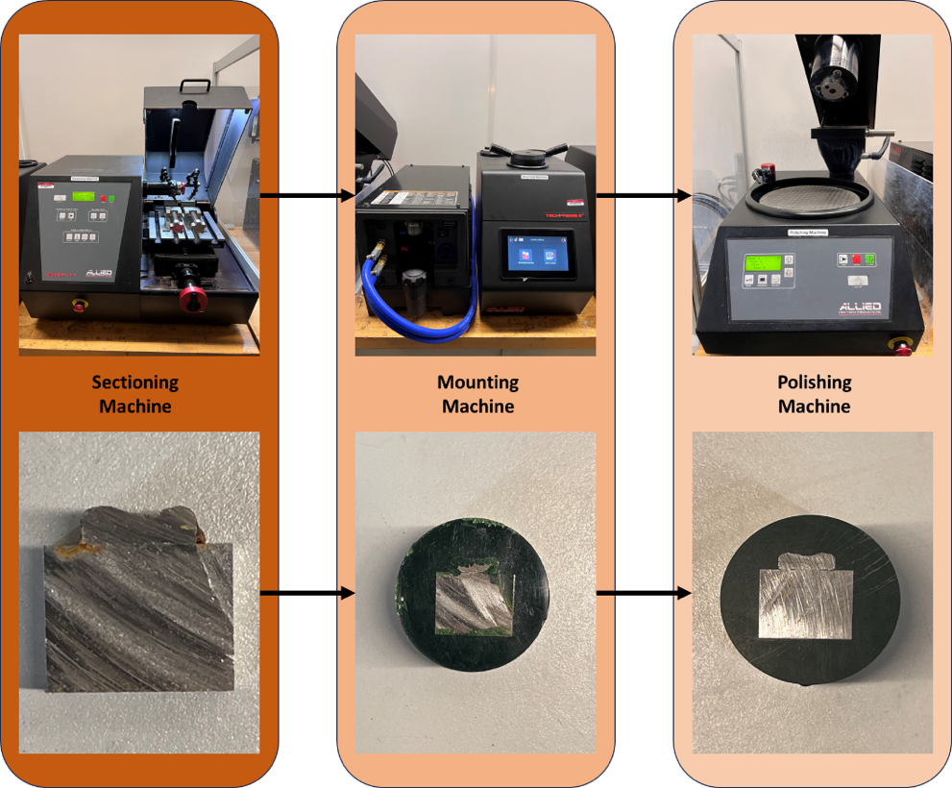
Fig. 10 Sample preparation steps for cross-sectional hardness measurements

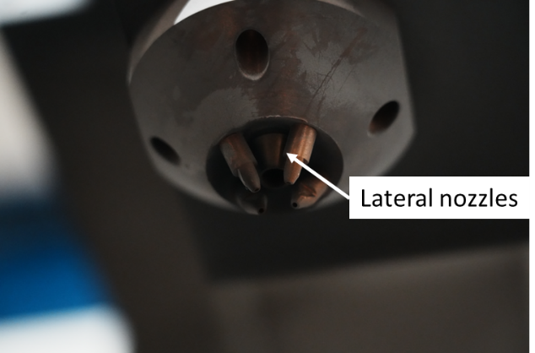
Fig.11 Lateral nozzles of the LDED printer
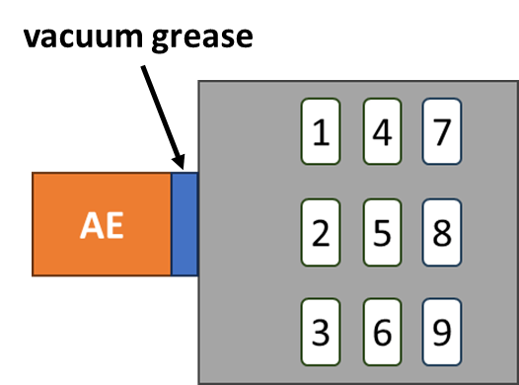
Fig.12 Sample layout for printing
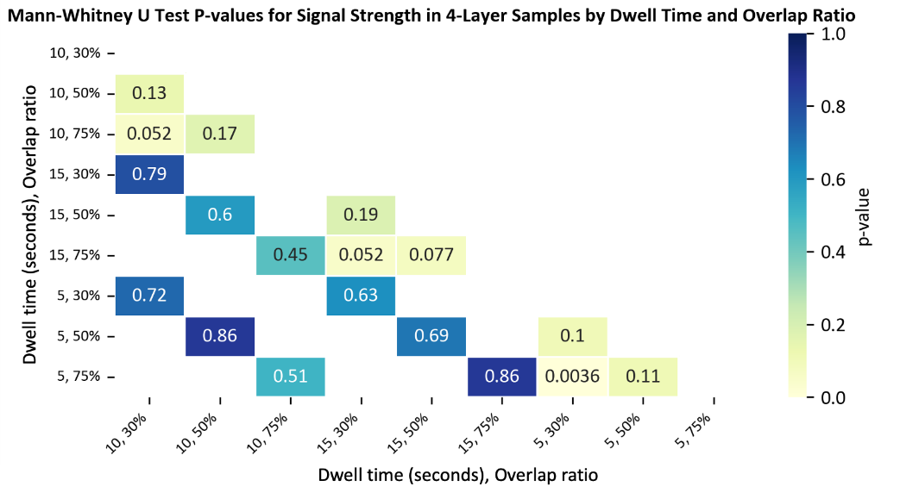
(a)
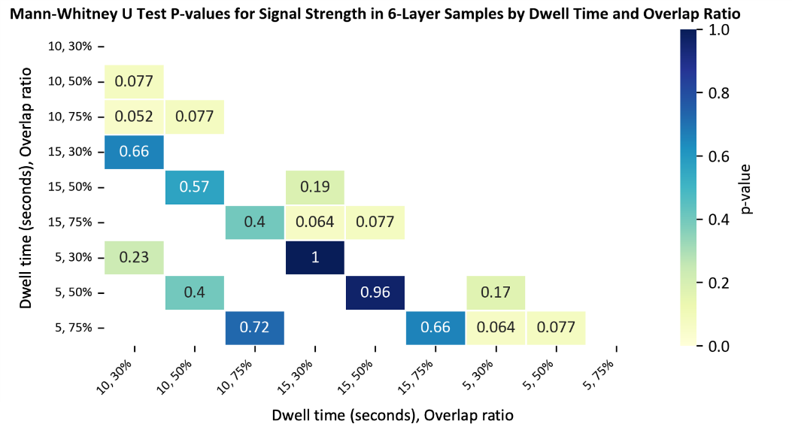
(b)
Fig.13 Mann-Whitney U Test P-Value matrices comparing hardness values between different dwell times and overlap ratios for a sample with a 4-layers b 6-layers
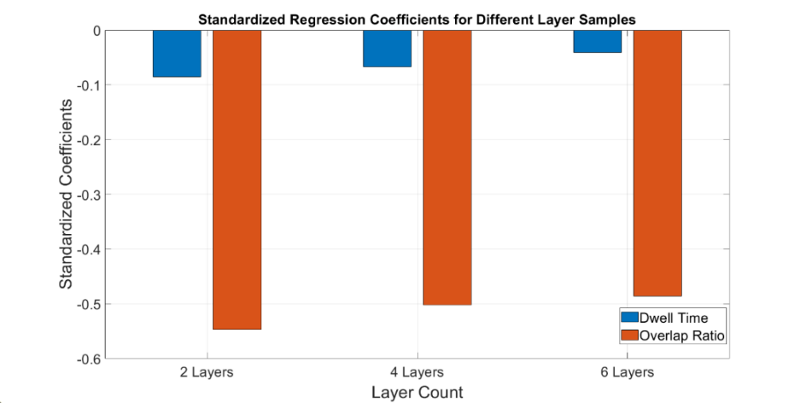
Fig.14 Standardized regression coefficients for different layer samples

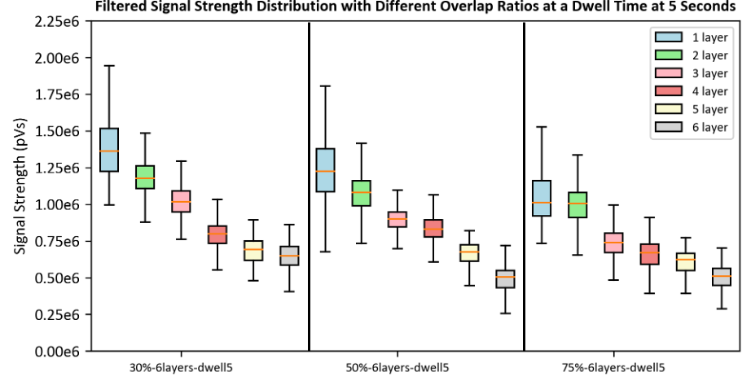
(a)

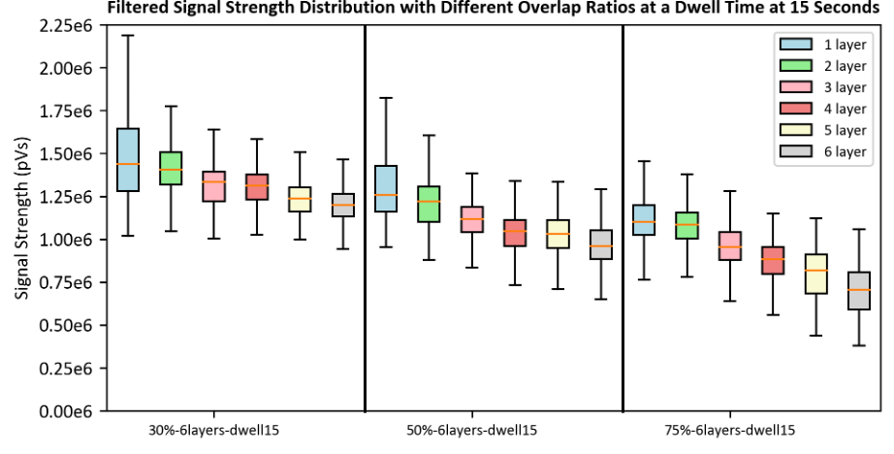
(b)
Fig.15 Signal strength distribution for different overlap ratios in samples with 6 printed layers and a dwell time of a 5 Seconds and b 15 seconds

Table 3: Hyperparameters selected in machine learning models
ML Model | Hyper-parameter | Hardness
SVR | Kernel(K(x)) | rbf
SVR | Regularization(C) | 1.2
GBR | Number of Estimators (n_estimators) | 120
GPR | K(x) | Constant Kernel ( ),  Matern (length scale=2, nu=1.5),  WhiteKernel( )

