Interspecific variation in demographics reveals ecological winners and losers in a highly disturbed coral reef system
Nicholas P. Jones*, Sarah E. Leinbach, David S. Gilliam
National Coral Reef Institute, Halmos College of Arts and Sciences, Nova Southeastern University, 8000 N Ocean Drive, Dania Beach, Florida, 33004, USA
*Corresponding author: Email: nj350@nova.edu

Supplementary Materials
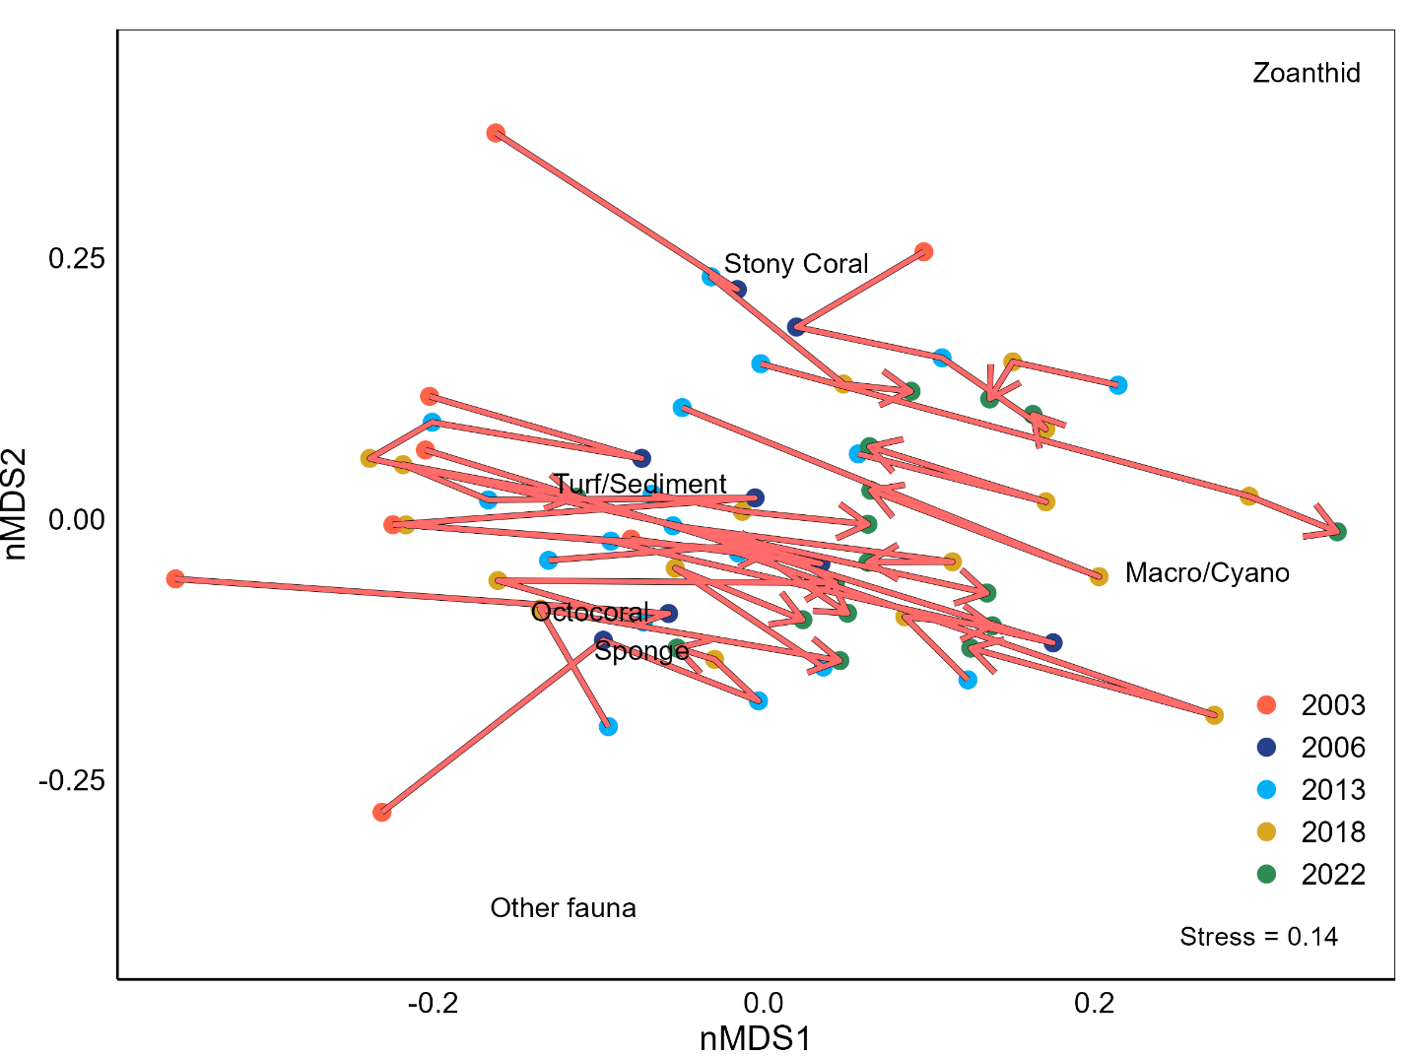
Figure S1. Non-metric multidimensional scaling (nMDS) plot depicting spatiotemporal variation in benthic community structure. Each point represents each site per year and the red line the site trajectory over time. Arrowheads at 2022 and show the direction of temporal change. Similarity is based upon Bray-Curtis similarity matrix after square root transformation.

Table S1. Fitted density models for each species at each life stage. All models were fitted with the fixed effect year and random effect site. Stony coral adult abundance was fitted with the random effect transect nested within site. Distribution was determined from the options: Poisson, negative binomial 1 (linear parameterization where overdispersion increases with phi) and negative binomial 2 (quadratic parameterization where overdispersion decreases with phi). Model validation was conducted as detailed in methods. Conditional R² = variance explained by fixed and random effect. Marginal R² = variance explained by fixed effect only.
Taxa | Species | Life stage | Distribution and (link) | Conditional R² | Marginal R²
Stony coral | Meandrina meandrites | Recruit | Poisson (log) | 0.523 | 0.109
Stony coral | Meandrina meandrites | Adult | Poisson (log) | 0.641 | 0.340
Stony coral | Montastraea cavernosa | Recruit | Nbinom2 (log) | 0.694 | 0.010
Stony coral | Montastraea cavernosa | Adult | Nbinom2 (log) | 0.778 | 0.066
Stony coral | Porites astreoides | Recruit | Poisson (log) | 0.612 | 0.057
Stony coral | Porites astreoides | Adult | Poisson (log) | 0.944 | 0.018
Stony coral | Siderastrea siderea | Recruit | Nbinom2 (log) | 0.847 | 0.070
Stony coral | Siderastrea siderea | Adult | Poisson (log) | 0.798 | 0.110
Octocoral | Antillogorgia americana | Recruit | Nbinom2 (log) | 0.768 | 0.154
Octocoral | Antillogorgia americana | Adult | Nbinom1 (log) | 0.403 | 0.043
Octocoral | Eunicea flexuosa | Recruit | Poisson (log) | 0.486 | 0.199
Octocoral | Eunicea flexuosa | Adult | Nbinom2 (log) | 0.854 | 0.007
Octocoral | Gorgonia ventalina | Recruit | Nbinom2 (log) | 0.625 | 0.116
Octocoral | Gorgonia ventalina | Adult | Poisson (log) | 0.713 | 0.033

Table S2. Results from Permanova for benthic community structure, using Type III sum of squares based on 9999 permutations of residuals under a reduced model: Model structure = Year (fixed), Site (Fixed).
Source | Df | SS | Pseudo-F | P(perm) | Unique Permutations | Square root - Estimates of components of variation
Year | 19 | 1677.8 | 30.084 | 0.0001 | 9872 | 5.5076
Site | 17 | 5220.8 | 93.609 | 0.0001 | 9871 | 9.3332
Site x Year | 235 | 37292 | 139.54 | 0.0001 | 9694 | 4.5763

Table S3. Fitted models for size structure analyses. All models initially selected from candidate models: Species * Year + (1|Site), Species + Year (1|Site), Species (1|Site), Year + (1|Site) and (1|Site). Stony coral mean diameter indicated excessive dispersion despite fitting variance structure and each species was modelled independently. Stony corals and octocorals were analyzed separately. Variance structure indicates whether any additional dispersion parameters or temporal autocorrelation structures were added to the fitted model. Conditional R² = variance explained by fixed and random effect. Marginal R² = variance explained by fixed effect only.
Metric | Species/Taxa | Fitted Model | Distribution and (link) | Variance Structure | Conditional R² | Marginal R²
Mean diameter | Montastraea cavernosa | Year + (1|Site) | Gamma(log) | None | 0.514 | 0.053
Mean diameter | Siderastrea siderea | Year + (1|Site) | Gamma(log) | None | 0.801 | 0.116
Mean diameter | Porites astreoides | Year + (1|Site) | Gamma(log) | None | 0.093 | 0.015
Mean diameter | Meandrina meandrites | Year + (1|Site) | Gamma(log) | None | 0.531 | 0.373
Mean height | Octocorals | Species x Year + (1|Site) | Gamma(log) | Species level dispersion parameter; ar1 autocorrelation structure | 0.094 | 0.047
Skewness | Stony corals | Species x Year + (1|Site) | Gaussian(identity) | Species level dispersion parameter | 0.384 | 0.303
Skewness | Octocorals | Species + Year + (1|Site) | Gaussian(identity) | None | 0.226 | 0.064
Coefficient of variation | Stony corals | Species x Year + (1|Site) | Gaussian(identity) | Species level dispersion parameter; ar1 autocorrelation structure | 0.281 | 0.215
Coefficient of variation | Octocorals | Species + Year + (1|Site) | Gaussian(identity) | Species level dispersion parameter | 0.226 | 0.116
Kurtosis | Stony corals | Species x Year + (1|Site) | Gamma(log) | Species level dispersion parameter; ar1 autocorrelation structure | 0.373 | 0.337
Kurtosis | Octocorals | Species + Year + (1|Site) | Gamma(log) | Species level dispersion parameter | 0.213 | 0.068

