Supplementary Information

Thresholding Algorithm
The thresholding algorithm determines the set of implementable functions of a receptron and calculates the thresholds needed to implement a chosen function. More formally, given the set of analog outputs for all input combinations, $S=\{S_{W}(\vec{x}) ∀ \vec{x}\}$ the thresholding algorithm determines $I$, the set of functions that can be implemented using a double-threshold element on the weighted outputs, and $(t_{L},t_{H})$ to implement a specific $i∈I$. We will restrict to the relevant case of three input bits (3-bit), but the algorithm is easily generalizable to different number of inputs.
In short summary, the algorithm first determines the set $I$ by mapping the base-2 nialpdromes according to the effective ordering of the outputs. Once the implementable functions are established, it determines the threshold values as the average of the two outputs that are separated by threshold. The great advantage given by this algorithm is that it doesn’t require testing several thresholds by applying them to the system: the estimation can be done at the software level. The next subsections will describe the algorithm in detail.

Implementable Functions with Natural Ordering
The algorithm works by determining the implementable functions in a particular ordering, which can be done once and for all, and then mapping the set of implementable functions to a general ordering.
Suppose the outputs have a natural ordering, i.e. the output values are ordered, from lowest to highest as:
$$S_{W}\left(0,0,0\right)<S_{W}\left(0,0,1\right)<S_{W}\left(0,1,0\right)<…<S_{W}\left(1,1,1\right)$$ | (A1)
where the outputs must be all distinguishable, hence I enforce the strict inequality. This is a very particular ordering, indicated as $R_{Nat}$, in which the ranking of the outputs matches the ranking of the inputs.
We can estimate the implementable functions $i∈I$ when the outputs are arranged in a natural ordering as they possess some particular properties: their binary representation has its “1”s placed consecutively (Fig. S-1)). Examples of these functions include:
$$f= { 1}_{dec}={00000001}_{bin}^{ }$$
$${f= 3}_{dec}={00000011}_{bin}^{ }$$
$$f={ 60}_{dec}{=00111100}_{bin}^{ }$$
$$f={120}_{dec}= {01111000}_{bin}^{ }$$
where the subscript $⋅_{dec}$ indicates that the function is in decimal representation, while the $⋅_{bin}$ stands for the binary representation of the function: its truth table.
Note how the “1” in the binary representation are grouped together, as all the outputs in between the two thresholds are mapped to binary 1. For example, the following functions are not implementable with double threshold and natural ordering:
$$f={143}_{dec}={10001111}_{bin}^{ }$$
$${f=204}_{dec}={11001100}_{bin}^{ }$$
$$f={238}_{dec}{=11101110}_{bin}^{ }$$
The implementable functions for outputs arranged in natural ordering can be easily constructed with a nested loop: a first index determines the location of the rightmost 1 in the binary representation, which is equivalent to fixing the lower threshold $t_{L}$, while the second index (strictly larger than the first) will determine the location of the leftmost 1 in the digital output, which is equivalent to moving $t_{H}$ with respect to the first, to include more and more outputs as represented in Figure S-1.
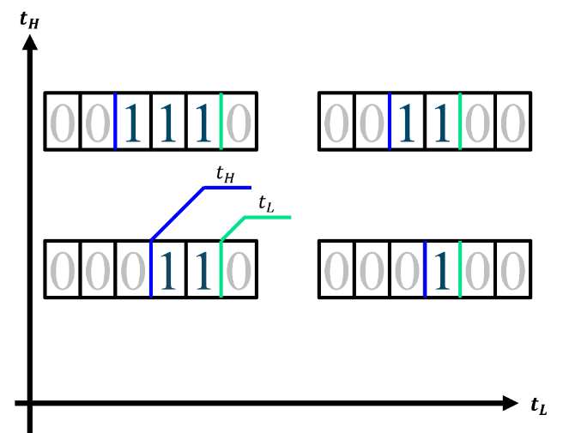
Figure S-1: Construction method of base-2 nialpdromes, $np-dromes_{2}$, interpreted as the effect of a double-thresholding process on naturally ordered outputs.

The implementable functions with natural ordering of the outputs belong to a specific series of numbers:
0, 1, 2, 3, 4, 6, 7, 8, 12, 14, 15, 16, 24, 28, 30, 31, 32, 48, 56, 60, 62, 63, 64, 96, 112, 120, 124, 126, 127, 128, 192, 224, 240, 248, 252, 254, 255.
I.e., (base-2) nialpdromes, indicated as $np-dromes_{2}$. As the set of implementables only depends on the ordering of the outputs, we have drawn the association:
$$I(R_{Nat})⊂np-dromes_{2}$$

Cardinality of Implementable Functions
With respect to the number of implementable functions, i.e. the cardinality of the set $|I|$, we can consider the general scenario of distinct outputs, i.e., $S_{W}\left(\vec{x}\right)≠S_{W}\left(\vec{y}\right)∀\vec{x}≠\vec{y}$. All thresholds laying between the same two outputs produce the same digital result and are thus equivalent (see the white squares enclosed by black lines in Figure S-2 (b)). We therefore always have a limited number of positions available for the thresholds to produce different functions: the spaces in between outputs, plus the positions below the lowest and above the highest (Fig. S-2 (a)), a total of $2^{n}+1$ “slots” for n bits. The number of implementable functions is then equivalent to the number of elements into the “upper” triangular matrix in Fig S-2 (b).
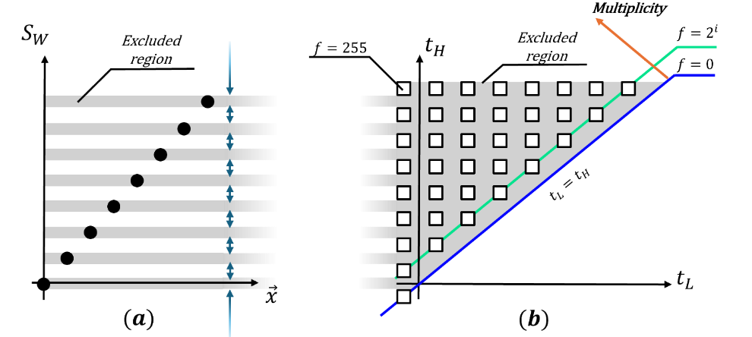
Figure S-2: (a) Outputs as a function of the input for the case of natural ordering. The threshold must be separated from the output, hence the exclusion regions filled in grey, while blue arrows indicate the possible disjunct intervals where thresholds are meaningful. (b) Allowed values for the combinations of lower ($t_{L}$) and upper ($t_{H}$) thresholds are represented in threshold space as white regions surrounded by black squares. Each couple of threshold values comprised in the same square leads to the same function. The possible analog values for threshold pairs lie in the top-left half of the plane due to the requirement $t_{H}≥t_{L}$. The values along the anti-diagonal (blue line) would lead to the same function $f=0$ regardless of $t_{L}$, thus it must be counted only once (here the bottom-left corner), while the $2^{nd}$ anti-diagonal (green line) gives rise to singular functions (i.e., functions for which the Boolean representation only has a single 1). Multiplicity of the generated function increases perpendicularly to the anti-diagonal.

Thus, for $n$ inputs the number of implementable functions with a double thresholding on a given set of analog outputs is:
$$\left|I_{n}\right|=\left(2^{n}+1\right)2^{n-1}+1$$ | (A2)
Where the “+1” comes from counting $f=0$ null function (obtained from the diagonal, see Fig. S-2 (b)) and the rest is obtained trivially from the well-known formula (due to Gauss) to compute the sum of a series of increasing numbers. For the case $n=3$ used throughout the main article body and in particular for the experimental confirmation, the number of implementable functions for distinguishable outputs is $\left|I_{3}\right|=37$.

If some of the outputs are not distinguishable, the number of available spaces will be reduced together with the number of possible functions. Formally, if, out of the $2^{n}$ outputs only $d≤2^{n}$ are distinct, the implementable functions are in total:
$$\left|I(d)\right|=\frac{\left(d+1\right)d}{2}+1$$ | (A3)
The definition of distinct clearly depends on the specific implementation of the algorithm in practice, both in terms of analog output measurement and the circuit generating the threshold. The outputs are considered distinct if and only if they are measured as separated by the measuring circuitry, i.e. an Analog to Digital Converter (ADC) and the selected thresholds can be implemented by the Digital to Analog Converter (DAC). As a rule of thumb, we can approximate the outputs by their representation of the least sensitive element between the ADC used for measures and the DAC used for threshold selection.

Implementable Functions with Non-natural Ordering
While the cardinality of the set of implementable functions is proven to be insensitive on the specific ordering of outputs, its elements are not. In general, the outputs will have a different ordering than the natural one: we can now focus on the second part of the problem, that is the determination of implementable functions for a general, non-natural ordering.
There are two alternative ways for the solution: one is based on the direct bit-mapping of $np-dromes_{2}$ to the appropriate set in case of non-natural ordering; alternatively, we can construct the equivalent of $np-dromes_{2}$ using the same procedure of Fig. S-1 and Fig S-2. I will describe both approaches briefly, starting with the bit-mapping one.
The key idea of the bit-mapping approach is that the double thresholding produces groups of “1”s in the output. The peculiarity of natural ordering is that the order of the outputs matches the one of the inputs, thus the groups of “1”s are visible in the binary representation of the function. In general, for a non-natural ordering, the double-threshold will still generate groups of “1”s for neighboring outputs, but this will not manifest itself in grouped “1”s in the binary representation.
For example, consider that we start with $(t_{L}, t_{H})$ below the lowest analog output and then progressively increase $t_{H}$: this will fix a “1” in correspondence of the lowest analog output and add more and more “1”s as the upper threshold is raised. In general, for non-natural ordering the lowest analog value is not the one generated by the first input, but by the $i$-th input combination. This means that the fixed “1” (due to the fact that $t_{L}$ is below the lowest) will not be in correspondence of the LSB but in general in another location. In other words, for a different ordering of the outputs we just need to map every bit of the binary representation of nialpdromes to the corresponding bit as dictated by the real ordering of the outputs.
Formally, the determination of the implementable functions for an arbitrary ordering starts with the base-2 nialpdromes, finds the ranking of outputs and its inverse function, defined as:
$$r^{-1}\left(a\right)=(i,j,k)$$ | (A4)
which determines the input combination $(i,j,k)$ that is associated with the $a$-th ranking, $a∈[1;8]$, $i,j,k∈\{0,1\}$.
The inverse ranking function, applied to each bit of the nialpdromes, determines the correct decimal representation of the function. For example, if the lowest output is the one corresponding to $(0,1,0)$ (rather than the one associated with $(0,0,0)$ of natural ordering), then the bit which was the LSB in natural ordering has to become the bit associated with $(0,1,0)$.
In formulae:
$$I(R)=bitmap\left(I(R_{Nat})\right)=bitmap\left(np-dromes_{2}\right)$$ | (A5)
where
$$bitmap\left(x\right)=\sum_{i=0}^{n-1}{bit\left(x,i\right)⋅2^{r^{-1}(i)}}$$ | (A6)
$bit(x,i)$ is the i-th bit of the number x, with the convention that the 0-th bit is the LSB, the 7-th is the MSB for a 8-bit number. Equations (A5) and (A6) describe a binary factorization of the decimal representation of the function obtained for natural ordering and a refactorization with different coefficients which are dictated by the ordering.
Alternatively, we can simply construct the equivalent of nialpdromes, filling “1”s into the binary representation of the function according to the ranking of the outputs: this means that, unlike the natural ordering case, we will add “1”s for neighboring outputs (in terms of ranking), which are not nearby in their bit position.
To illustrate this, consider a simpler case of two digital inputs and a specific, non-natural ordering of the outputs such as:
$$S_{W}\left(0,0\right)<S_{W}\left(1,0\right)<S_{W}\left(0,1\right)<S_{W}\left(1,1\right)$$ | (A7)
This case is represented in Figure S-3, which reproduces the procedure of Figure S-2 (b) for non-natural orderings as the one in Equation (A7).
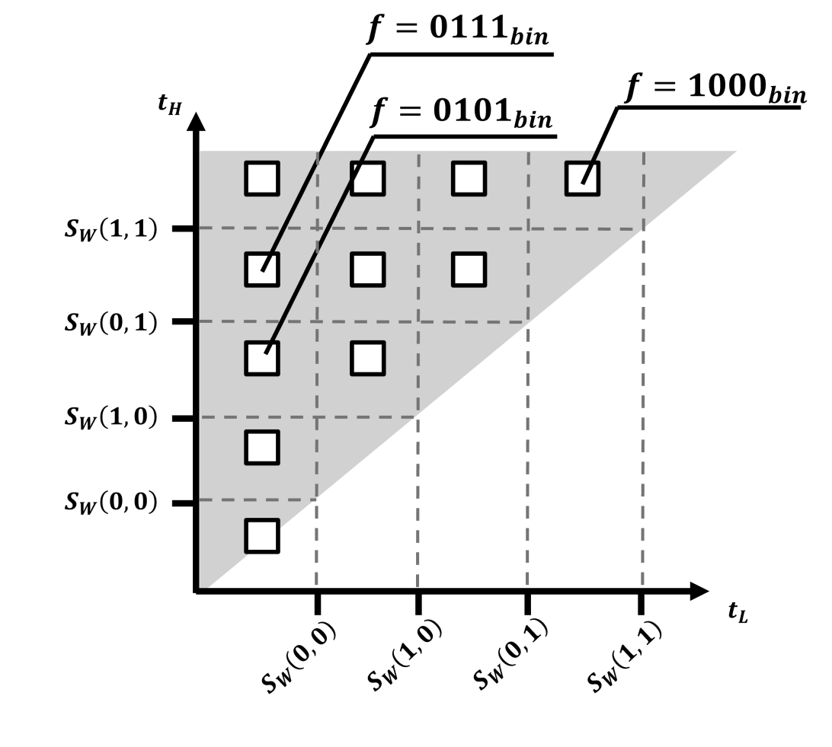
Figure S-3: Possible threshold values and their associated output for the case of 2 input bits in a non-natural ordering captured by Equation (A7).

If we focus on the first column of dots, moving the upper threshold higher by one place will add a 1 in the position corresponding to the next output in terms of their relative ordering, which in this case adds a 1 in the second position (indices start from 0). This clearly shows how the ones that appear in the binary representation are not clustered, but the procedure of Fig. S-2 remains valid in the more general case. This approach can be implemented with a double iteration algorithm: an external cycle regulates the position of the lower threshold with respect to the outputs ranking, the internal cycle increases the upper threshold while the lower is fixed. This double iteration is equivalent to navigating the points in Fig. S-3 starting from the bottom corner moving vertically upwards and then horizontally to the next column, which is once again traversed from the bottom to the top.
Note that this procedure only requires to know the ranking of the outputs, rather than their exact analog values: this is indicative of the fact that the set of implementables depends on $R$ rather than directly on $W$.
In other words:
$W≠W^{'}↛ I(W)≠I(W^{'})$
$$R=R^{'}↔ I\left(R\right)=I(R^{'})$$
Equations (A5) and (A6) in fact only rely on $r\left(i\right)∀i$ and its inverse function $r^{-1}$ to determine $I$, hence it is evident that a change in W that does not traduce in a change in $R$ will have no practical effect on $I$, i.e., that different weight configurations that give rise to the same ordering will result in exactly the same set of implementable functions.

Determining the Thresholds
Once we know the function is implementable, it is straightforward to calculate the pair of thresholds that implement that function: as anticipated, the threshold can be easily set to lie in between the two outputs that it needs to separate.
Once again, let us start from the case of natural ordering. Due to their generation process, where $t_{H}≥t_{L}$, we can arrange nialpdromes (or their equivalent depending on the relative ordering) in an “upper-triangular” matrix:

$$np-dromes_{2}=\left[\begin{matrix}255 & 254 & 252 & 248 & 240 & 234 & 192 & 128 \\ 127 & 126 & 124 & 120 & 112 & 96 & 64 & \\ 63 & 62 & 60 & 56 & 48 & 32 & & \\ 31 & 30 & 28 & 24 & 16 & & & \\ 15 & 14 & 12 & 8 & & & & \\ 7 & 6 & 4 & & & & & \\ 3 & 2 & & & & & & \\ 1 & & & & & & & \\ 0 & & & & & & & \end{matrix}\right]$$

Where the row index is related to the position of the upper threshold and the column index is related to the position of the lower threshold. This is equivalent to associating every squared region in the threshold plane of Fig. S-2 (b) with the function it implements.
The thresholds to be applied are then indicated by the position in the matrix. For natural ordering, an element in position $\left(i,j\right), i,j=0,…7$ can be implemented by setting the couple of thresholds:
$$t_{H}=\frac{\left(S_{W}\left(8-i\right)+S_{W}\left(7-i\right)\right)}{2}$$ | (A9)
$$t_{L}=\frac{\left(S_{W}\left(7-j\right)+S_{W}\left(6-j\right)\right)}{2}$$ | (A10)
where $S_{W}\left(i\right)$ is the output corresponding to the i-th input combination and with the boundary conditions:
$$S_{W}\left(8\right)=Highest possible threshold$$ | (A11)
$$S_{W}\left(-1\right)=Lowest possible threshold$$ | (A12)
These formulae ensure that the threshold is always in the midpoint between outputs, maximizing its stability against noise. Different combinations of the same analog values are also possible if other considerations come into play: e.g. if noise is inversely proportional to the magnitude of $S_{W}$ one might shift the threshold closer to the upper output. In general, Equations (A9) - (A12) indicate which outputs take part in the threshold calculation, whatever the function applied to determine its exact positioning.
In the general case of non-natural ordering, one simply needs to map the $a-th$ output in terms of ranking to the input that generated it, analogous to the case of bitmapping. Formulae (A9) and (A10) are updated to:
$$t_{H}=\frac{\left(S_{W}{(r}^{-1}\left(8-i\right))+S_{W}(r^{-1}\left(7-i\right))\right)}{2}$$ | (A13)
$$t_{L}=\frac{\left(S_{W}\left(r^{-1}(7-j\right))+S_{W}{(r}^{-1}\left(6-j\right))\right)}{2}$$ | (A14)
In other words, the threshold is still in between the third and fourth outputs (in terms of ranking), but the third and fourth outputs are not the ones corresponding to the third and fourth inputs, so they must be mapped, just like the bits. In the case of finite resolution, a rounding function may be applied to all the analog values, depending on the resolution of the DAC that sets the thresholds.

Orderings for Sub- and Super-Linear Receptrons
The previous discussion clarified the crucial role of orderings, rather than analog outputs, in determining the set of implementable functions. Hence, the difference in the PDIF for the super- and sub-linear Receptrons (see Section 2 in the main body) can be visualized in terms of different possible orderings that are generated for the outputs in these two scenarios (Fig. S-4). For the super-linear TLG (orange dots in Fig. S-4) the possible rankings are rather limited: rephrasing the previous considerations in terms of orderings,
$$r_{Super}\left(0,0,0\right)=1 ∀ W$$
$$r_{Super}\left(1,1,1\right)=8 ∀ W$$
In addition to these constraints, however, there also exist some correlations between the rankings associated with different input combinations, such that their values are not independent. E.g., the (2,6) scatterplot in Figure S-4 shows that $4≤r_{W}\left(1,0,1\right)≤7$ , but if $r_{W}\left(0,0,1\right)=5,$ then only two values are possible for $r_{W}\left(1,0,1\right)$ which is either 6 or 7. This is an indication of further restrictions on the possible relative ordering of the analog outputs which turns into the non-implementability of Boolean functions, besides functions in the upper half of the circle and odd ones. For the sub-linear Receptron (blue dots in Fig. S-4), instead, the wide majority of pairs of rankings are filled. Even in this case few are missing: e.g. in the first column (row) where we see that $1≤r_{W}\left(0,0,0\right)≤5$ since the highest rankings will always be associated to the input combinations $\left(1,0,0\right), (0,1,0)$ and $\left(0,0,1\right).$ Similarly, for all other columns the ranking “1” is completely absent as in the case of sub-linearity too we have that
$$r_{Sub}\left(0,0,0\right)=1 ∀ W$$
justifying the asymmetry between even and odd functions which survives for this scenario as well (Fig. 2 outermost circle in the main body of the article).
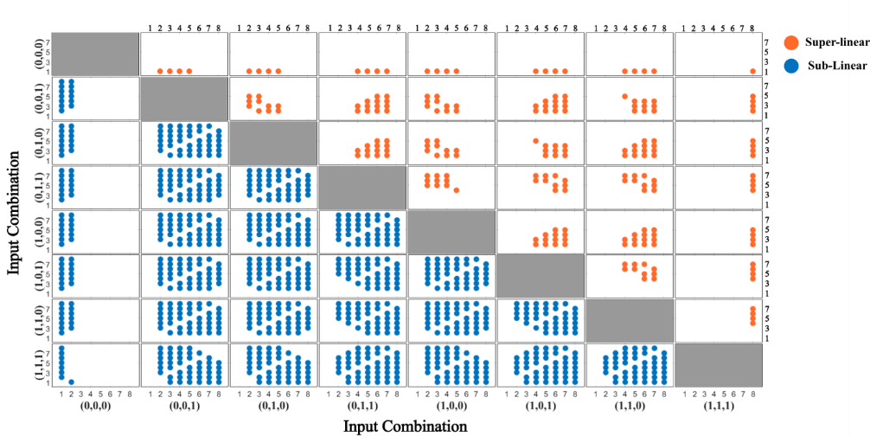
Figure S-4: Matrix of scatterplots of the possible rankings $r_{W}\left(\vec{x}\right)$ for both super-linear (orange dots) and sub-linear (blue dots) Receptrons observed cumulating the data of ${10}^{5}$ configurations of weights. In particular, the (i,j)-scatterplot contains the possible rankings of the analog output of the i-th input combination versus the possible rankings associated to the j-th input combination (with the usual convention that the first row is the top one, the first column the left). Notice that each cell (matrix element) contains at most 64-8=56 dots related to 8x8 possible ranking (irrespective of the infinitely many analog values of the outputs) and the bisectors are always empty because they represent the case of equal ranking, which is of course forbidden (since the outputs wouldn’t be distinguishable).

General Features of Implementable Functions
Besides the peculiar features arising from the different types of non-linear weighting, it is natural to ask ourselves if, in a general scenario, the double-thresholding algorithm generates an unbiased set of implementable functions, i.e. a set that uniformly (according to some metric) covers the space $B_{n}$ of Boolean functions of n-bit.
We have already discussed the rarity of odd functions within $I$ (see Section 2 in the article body), stemming from the fact that
$$S_{W}\left(0,0,0\right)=0 ∀W↔r_{W}\left(0,0,0\right)=1 ∀W$$
such that even functions are the majority ($∼76\%$) of the functions composing $I$.
In addition to this effect, the double thresholding is not uniform with respect to the multiplicity of the functions (i.e., the number of “1”s in the binary representation of the function). While the scarcity of odd functions is a direct consequence of the constraints of the weighting medium, this latter effect related to the multiplicity is irrespective of the ordering and only depends on the features of double thresholding. We can count the number of functions with a given multiplicity which happen to be the number of elements along the $i-$th anti-diagonal in threshold space (Fig. S-2 (b)). This is because each anti-diagonal is characterized by a fixed separation, in terms of number of outputs that lie between the lower and upper threshold. For this reason, all functions along the anti-diagonal have the same multiplicity. Note that for non-natural ordering only the decimal representation of the function in a specific place will change, but not its multiplicity (see for example Fig. S-3).
We can count the functions of a given multiplicity, as proposed in the following table.
Multiplicity | Number of implemented | Percentage over total number of functions with that multiplicity
0 | 1 | 100%
1 | 8 | 100%
2 | 7 | 25%
3 | 6 | 10.71%
4 | 5 | 7.14%
5 | 4 | 7.14%
6 | 3 | 10.71%
7 | 2 | 25%
8 | 1 | 100%
Table S-1: number of implementable functions within the set $I$ with a given multiplicity and fraction of the total number of functions with given multiplicity in the set $B_{3}$ of all 3-bit Boolean functions.

From Table S-1 it is evident that functions with multiplicity $m=4$ or 5, are the rarest with respect to all Boolean functions of a given multiplicity.

Complexity of the Thresholding Algorithm
The proposed thresholding algorithm was implemented in C++. In view of increasing the number of Receptrons and bits managed at the same time, we verified the scaling of the thresholding algorithm with respect to the number of Receptrons which need to be thresholded. The thresholding algorithm complexity is mainly due to the necessity of ranking of the outputs to estimate both the implementable functions and the thresholds. In its current implementation, the sorting algorithm is a basic selection sort, but much better options are available in terms of scalability).
The execution time scales with number of receptrons (thus number of outputs that need to be sorted, which scale as $8⋅n_{receptrons}$) as shown in Fig. S-5.
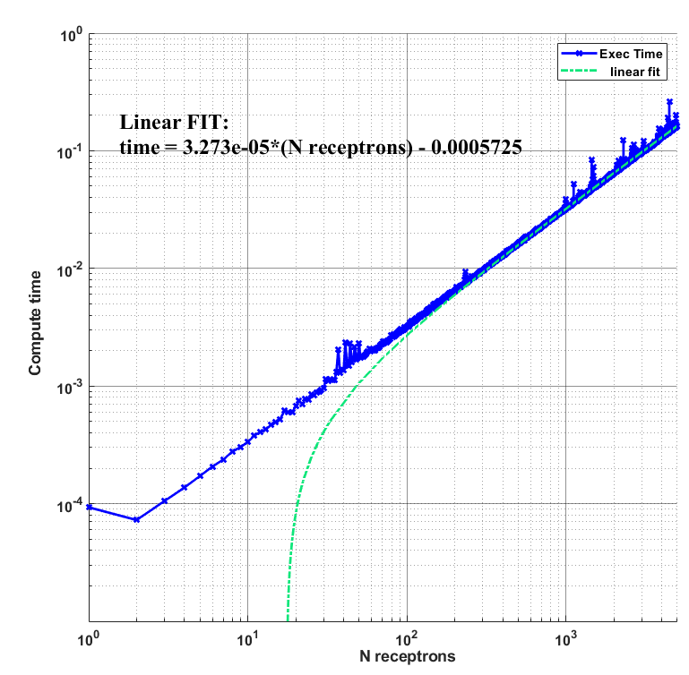
Figure S-5: Execution time (blue curve) for the thresholding algorithm as a function of the number of receptrons thresholded, in double logarithmic-scale and the linear fit (green dash-dotted curve), whose equation is indicated on the side. The scaling estimation was done with a computer execution of the same software: the same test performed on an Arduino may differ in the value of the scaling constants.

The observed scaling is linear up to more than 1000 receptrons, confirming the scalability of the algorithm and, thus, its ease of use. This completes the description of the functioning of the thresholding algorithm, starting with the receptron’s analog outputs to the determination of the implementable functions, and the thresholds needed to implement them.

Bibliography

1. Steinbach, B. & Lang, C. Exploiting functional properties of boolean functions for optimal multi-level design by bi-decomposition. Artif Intell Rev 20, (2003).
2. Karp, R. M. Functional Decomposition and Switching Circuit Design. Journal of the Society for Industrial and Applied Mathematics 11, (1963).
3. Steinbach, B. & Posthoff, C. Boolean differential calculus. Synthesis Lectures on Digital Circuits and Systems 12, (2017).
4. Roth, J. P. & Karp, R. M. Minimization Over Boolean Graphs. IBM J Res Dev 6, (2010).

I will stick to the convention that for the binary representation of inputs, outputs and truth tables the LSB is the rightmost bit.
https://oeis.org/search?q=a023758&language=english&go=Search. One can categorize numbers based on the ordering of their digits. Katadromes for example are numbers whose digits are in strict decreasing order. Base-10 Katadromes are 0,1,2…9,10,20,21,30,31,32,40,41,42,43,… For Metadromes the order is strict ascending (1,…9,12,13,14…23,24,25..), Plaindromes are nondecreasing, nialpdromes are nonincreasing: in base 10 they are 1,…9,10,11,20,21,22,…. So nialpdromes in base 2 have digits that cannot increase again after reaching a 0; e.g., 1100 is a nialpdromes (the leading 0s do not matter) but 1101 is not since the fourth-digit is increased with respect to the previous one.
I.e., one of the two outputs will be set to 0 and the other to 1 by the threshold.
This can also be stated by saying that the bitmapping from the nialpdromes to a general set preserves the multiplicity.

