Supplementary material
List of variables extracted for each paper: Title of the publication, Open access status, Number of citations, Link, Altmetric Id (Internal number assigned to each journal), Altmetric attention score, Number of the pages that have shared on Facebook, Number of blogs that have mentioned the publication, Number of the accounts that have shared on Google+, Number of the news sources that have mentioned the publication, Number of the posts (any online document that links to one or more research objects) that have mentioned the publication, Number of Reddit threads posted about this publication, Number of the twitter accounts that have tweeted this publication, Number of the tweets that have tweeted this publication, Number of the Youtube/Vimeo channels, The sum of all "cited by" entries, Total Reader Counts, Readers in citeulike, Readers in Mendeley, Readers in Connotea, Author names, Author affiliations, Correspondence address, Journal name, Volume, Issue, Number of first and last pages, Date of publication, Key words, Emtree key words, Mentioned drugs’ tradenames, Mentioned drugs’ manufacturers, Mentioned devices’ tradenames, Mentioned devices’ manufacturers, CAS registry numbers, Mentioned clinical trial number, Embase classification, Embase accession ID, Article and summary language, Medline PMID, DOI, Months since publication

Supplementary table 1. Descriptive statistics of input data subdivided by year of publication for the indicators of the AAS
Score
Year | Minimum | 1st quantile | Median | Mean | 3rd quantile | Maximum | Standard deviation
2015 | 0.250 | 0.750 | 1.750 | 6.181 | 4.500 | 562.170 | 24.31668
2016 | 0.25 | 0.50 | 1.6 | 15.41 | 7 | 1462.88 | 80.81072
2017 | 0.25 | 0.50 | 1.75 | 23.89 | 7 | 776.85 | 92.29607
2018 | 0.25 | 0.50 | 2 | 14.45 | 7.20 | 1854.68 | 74.54609
2019 | 0.25 | 0.75 | 2.6 | 13.79 | 9.2 | 920.02 | 51.42658
TOT | 0 | 9.00 | 18.00 | 28.07 | 33.00 | 3033 | 70.02872
Citations
2015 | 0 | 14 | 25 | 39.33 | 46 | 920 | 60.99417
2016 | 0 | 12 | 23 | 36.55 | 41 | 3033 | 97.81127
2017 | 0 | 10 | 19 | 26.95 | 33 | 729 | 34.55298
2018 | 0 | 9 | 15 | 23.23 | 27 | 284 | 27.5739
2019 | 0 | 6 | 12 | 18.87 | 22 | 212 | 22.19405
TOT | 0 | 9.00 | 18.00 | 28.07 | 33.00 | 3033 | 55.18834

Supplementary Table 2. Normality distribution test results (Spearman Rho Correlation Coefficient)
Year | Total Citations and Mass Media | Total Citations and Feeds | Total Citations and Facebook | Total Citations and Twitter Posts | Total Citations and Twitter Accounts | Total Citations and Number of Posts
2015 | 0.1453297 | 0.0726928 | not significant | 0.09647303 | 0.1818401 | 0.1798512
2016 | 0.178741 | 0.12423 | 0.09305418 | 0.1102097 | 0.2072298 | 0.2101813
2017 | 0.1634914 | 0.1042128 | 0.1745217 | 0.205667 | 0.2694481 | 0.2740715
2018 | 0.1876344 | 0.07460391 | 0.08840299 | 0.1836629 | 0.2059895 | 0.1862542
2019 | 0.1594913 | 0.1625993 | 0.1983207 | 0.2354925 | 0.268253 | 0.2657675

Supplementary Table 3 - Values of the Spearman Test. Rho Correlation Coefficient and p-value, between the total number of citations and the AAS, and its indicators.
Year | Mass Media |  | Feeds |  | Facebook |  | Twitter Posts |  | Twitter  Accounts |  | Number  of Posts
 | rho | p-value | rho | p-value | rho | p-value | rho | p-value | rho | p-value | rho | p-value
2015 | 0.15 | < 0.001 | 0.07 | <0.05 | 0.09 | <0.05 | 0.10 | < 0.01 | 0.17 | < 0.001 | 0.18 | < 0.001
2016 | 0.19 | < 0.001 | 0.12 | <0.05 | 0.11 | <0.05 | 0.11 | < 0.01 | 0.21 | < 0.001 | 0.21 | < 0.001
2017 | 0.16 | < 0.001 | 0.10 | <0.05 | 0.18 | <0.05 | 0.21 | < 0.01 | 0.27 | < 0.001 | 0.27 | < 0.001
2018 | 0.20 | < 0.001 | 0.07 | <0.05 | 0.09 | <0.05 | 0.19 | < 0.01 | 0.22 | < 0.001 | 0.20 | < 0.001
2019 | 0.16 | < 0.001 | 0.17 | <0.05 | 0.20 | <0.05 | 0.23 | < 0.01 | 0.26 | < 0.001 | 0.27 | < 0.001

Supplementary Table 4. Results of the Spearman Test. Rho Correlation Coefficient and p-value, between the total number of citation and the Altmetric Score, and its indicators, discriminating between “Main Population” and “Outliers”.
 | Facebook |  | Twitter Posts |  | Twitter Accounts |  | Number  of Posts
 | rho | p-val | rho | p-val | rho | p-val | rho | p-val
Main Population | 0.26 | <0.001 | 0.56 | <0.001 | 0.76 | <0.001 | 0.73 | <0.005
Outliers | 0.23 | <0.001 | 0.13 | <0.001 | 0.61 | <0.001 | 0.59 | <0.001

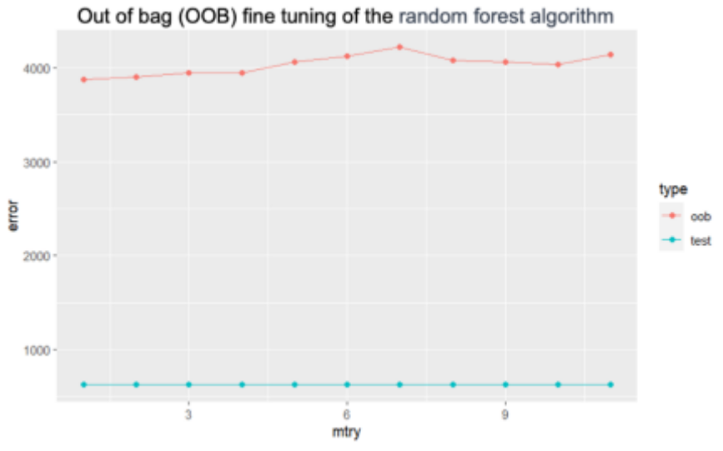
Supplementary Figure 1. Random forest model fine tuning - test error vs number of variables at each split
OOB: Out of bag; mtry: parameter which determines the number of variables randomly selected at each split of a decision tree within the random forest algorithm; error: test error.
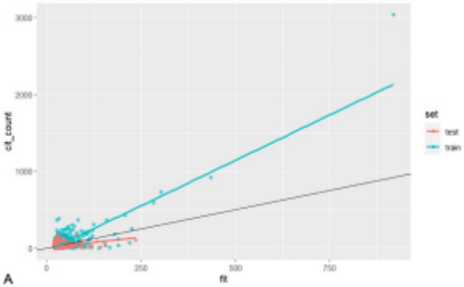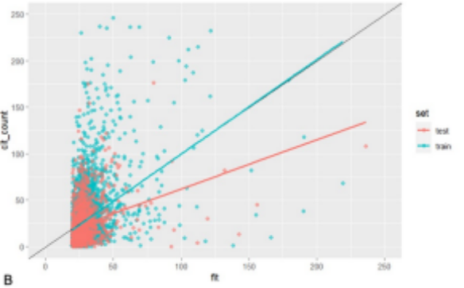
Supplementary Figure 2 – Random Forest Model results; In panels A and B we explore how well the model explains the relationship between the independent and the dependent variables (Fit Vs. Number of citations) within two different value ranges.

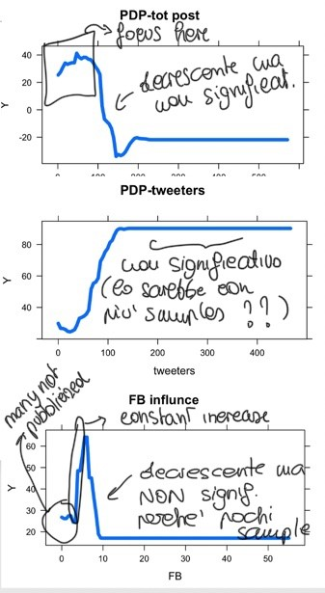
Supplementary Figure 3. Partial dependence plots. Illustration of the marginal effect of Facebook and Twitter Posts on the predicted outcome of the Boosted Regression Tree model.

