SUPPORTING INFORMATION
Enhanced Photocatalytic Performance of Non-stoichiometric WO_{3-x} Nanocrystals Via Near-Infrared Localized Surface Plasmon Resonance
Mohsen Zafari, Fatemeh Shariatmadar Tehrani*
Faculty of Physics, Semnan University, POBOX:35195-363, Semnan, Iran
* f_tehrani@semnan.ac.ir

Table of Contents
1. Images of WO_{3-x} Nanocrystals 2
2. EDX analysis 2
3. Free Carrier Density Calculations 4
3.1 The Mie-Gans theory 4
4. Deconvoluted PL spectra of WO_{3-x} Nanocrystals 6
5. photocatalytic degradation of Methylene Blue 8

Images of WO_{3-x} Nanocrystals

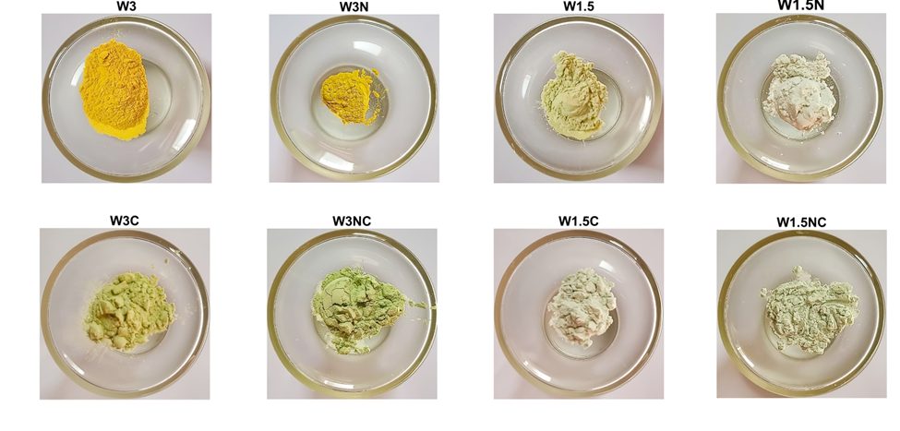
Figure S1. Images of samples synthesized by acidification method (i.e.W3, W3N, W1.5, and W1.5N) and their calcined samples - 400°C for 2 h - (i.e.W3C, W3NC, W1.5C, and W1.5NC)

EDX analysis
Table S1. Elemental composition of the samples based on EDX analysis.
Sample | O (at%) | W (at%) | Calculated Composition
W3 | 65.6 | 27.2 | W₂₇O₆₅ (~WO_{2.41})
W3N | 70.8 | 24.6 | W₂₅O₇₁ (~WO_{2.87})
W1.5 | 70.7 | 25.1 | W₂₅O₇₁ (~WO_{2.82})
W1.5N | 69.9 | 23.7 | W₂₄O₇₀ (~WO_{2.95})
W3C | 57.2 | 32.5 | W₃₂O₅₇ (~WO_{1.76})
W3NC | 71.8 | 24.9 | W₂₅O₇₂ (~WO_{2.88})
W1.5C | 68.4 | 26.9 | W₂₇O₆₈ (~WO_{2.54})
W1.5NC | 68.9 | 25.8 | W₂₅O₆₉ (~WO_{2.67})

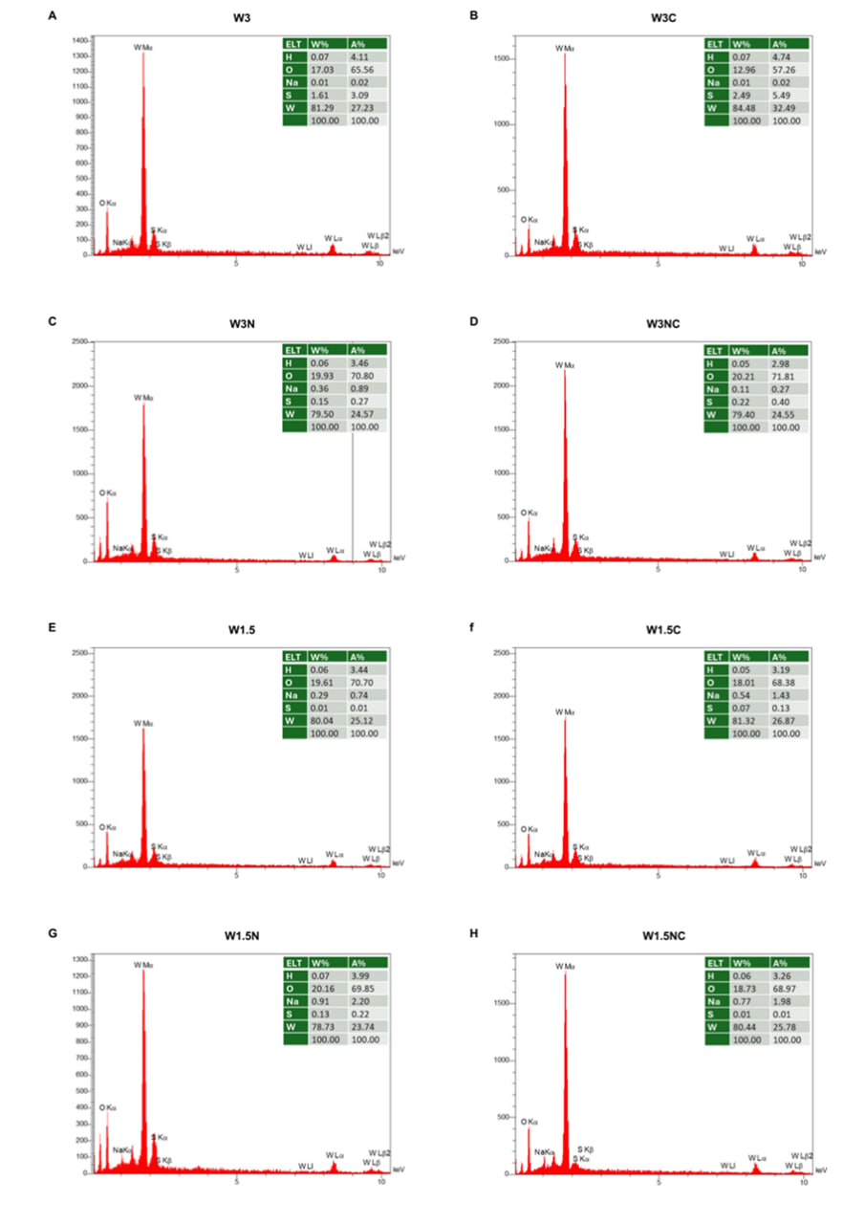
Figure S2. EDX spectra of WO_{3-x} nanocrystals.

Free Carrier Density Calculations

The Mie-Gans theory
We simulated the absorption spectrum of nanocrystals using Equation 1, the parameters defined in Equations 2-7, and the assumptions noted in the work of Manthiram et al [1]. The calculated stoichiometry of WO_{3-x} nanocrystals shows a higher oxygen deficiency than predicted from XRD analysis (see Tables 1 and S2). This could explain the unprecedentedly high free carrier density of our synthesized nanocrystals. We should also mention that the calculated oxygen deficiency showed a lower percentage of oxygen vacancies than the EDX analysis in most cases. This difference may be due to the aspect ratio of WO_{3-x} calculated from FESEM images (see Tables S1 and S2).
Table S2. LSPR peak, $γ$, $ω_{p}$, and free carrier density of ${WO}_{3-x}$ nanocrystals calculated from predict the LSPR spectrum by using the Mie-Gans theory.
Sample | $$λ_{LSPR}(nm)$$ | $$γ$$  $$(eV)$$ | $$ω_{p}$$  $$(eV)$$ | $$N_{e}$$  $$({cm}^{-3})$$ | Oxygen Deficiency  (%) | Calculated  Composition
W3 | --- | -- | -- | -- | -- | --
W3N | --- | -- | -- | -- | -- | --
W1.5 | 1246 | 1.08 | 2.55 | 5.62 ×10²¹ | 5.01 | WO_{2.85}
W1.5N | 1213 | 1.23 | 2.77 | 6.67 ×10²¹ | 5.95 | WO_{2.82}
W3C | 1899 | 2.21 | 4.00 | 1.38 ×10²² | 12.35 | WO_{2.63}
W3NC | 1769 | 2.70 | 4.84 | 2.03 ×10²² | 18.07 | WO_{2.46}
W1.5C | 1771 | 1.86 | 3.44 | 1.03 ×10²² | 9.15 | WO_{2.73}
W1.5NC | 1728 | 2.01 | 3.69 | 1.18 ×10²² | 10.55 | WO_{2.68}

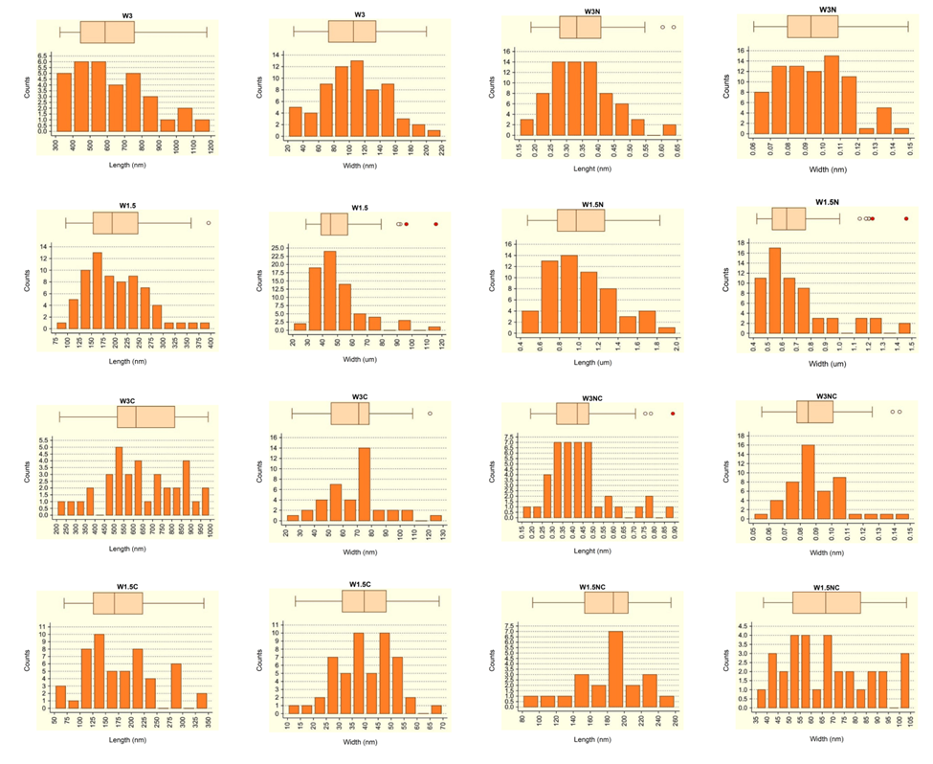Figure S3. Histograms of WO_{3-x} nanocrystals (length and width).

Table S3. Aspect ratio calculated for WO_{3-x} nanocrystals.
Sample | length | Width |  | Aspect ratio (R)
W3 | 628.78 | 104.52 | nm | 6.02
W3N | 0.3484 | 0.0953 | µm | 3.66
W1.5 | 200.81 | 49.89 | nm | 4.03
W1.5N | 1.0305 | 0.7081 | µm | 1.46
W3C | 638.10 | 68.59 | nm | 9.30
W3NC | 0.7303 | 0.0896 | µm | 8.82
W1.5C | 178.32 | 40.29 | nm | 4.43
W1.5NC | 179.79 | 67.50 | nm | 2.66

Deconvoluted PL spectra of WO_{3-x} Nanocrystals
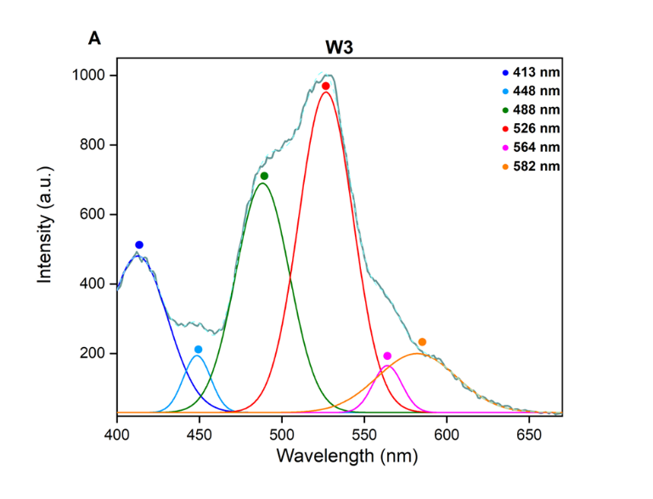 | 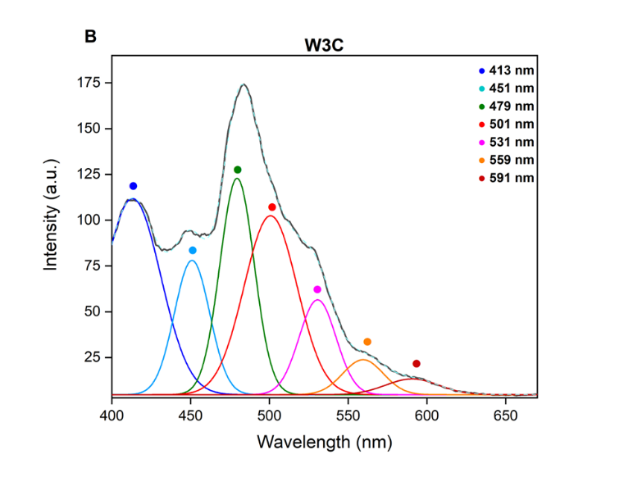
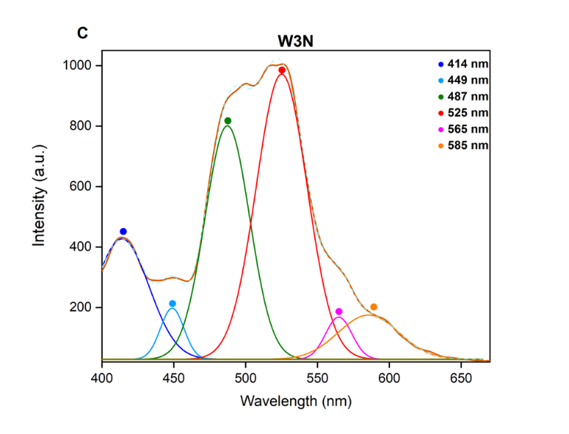 | 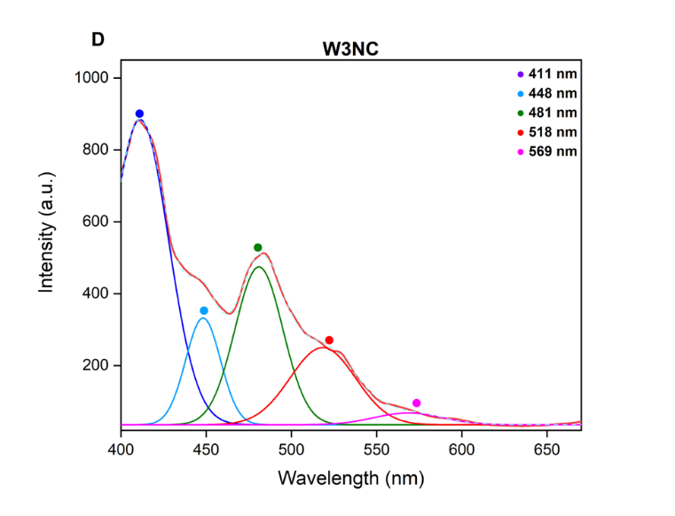
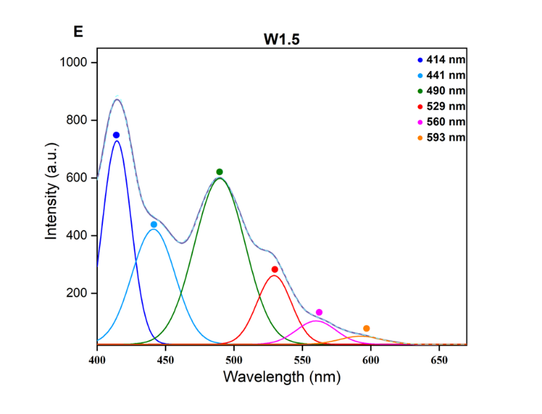 | 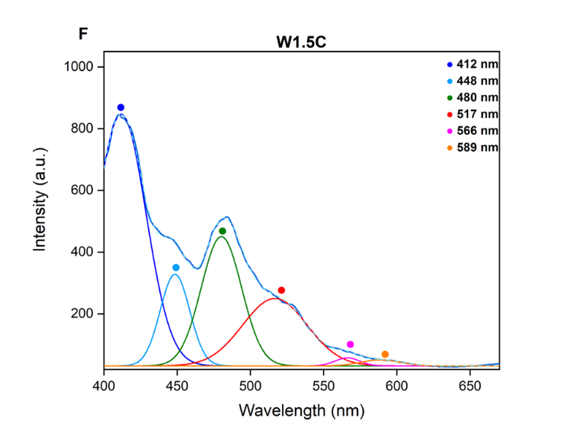
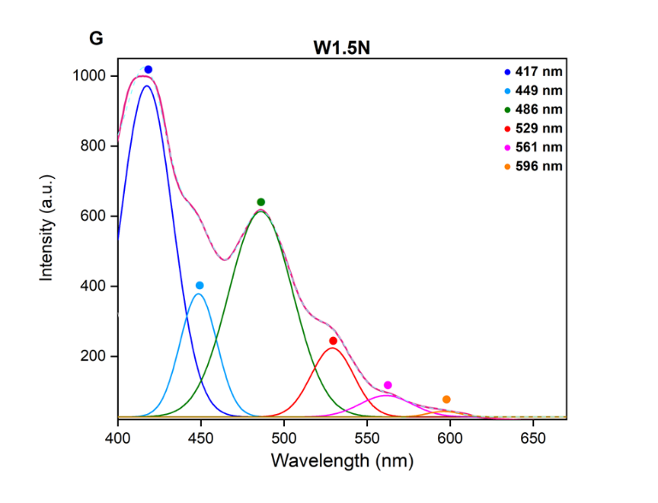 | 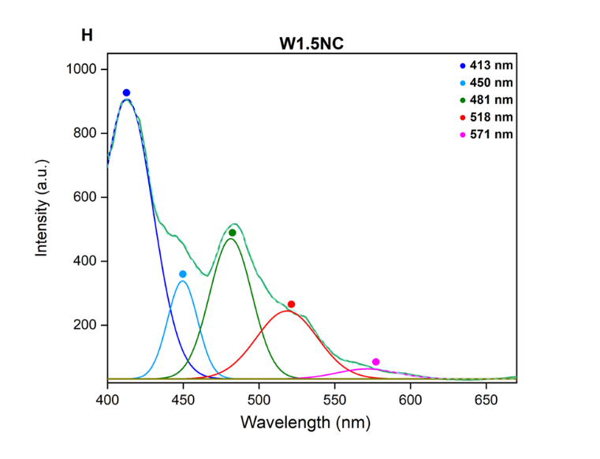
Figure S4. Deconvoluted PL spectra of (a) W3, (b) W3C, (c) W3N, (d) W3NC, (e) W1.5, (f) W1.5C, (g) W1.5N, and (h) W1.5NC.

photocatalytic degradation of Methylene Blue

Table S4. The degradation efficiencies and apparent rate constants of the photocatalysts.
Photocatalyst | Light source | Reaction time (min) | Rate constant k (min⁻¹) | degradation (%) | reference
WO₃ | 300-W Xenon | 240 | 0.00286 | 40.5 | [2]
Au-WO₃ | 300-W Xenon | 240 | 0.01150 | 68.0 | [2]
WS₂ monolayer | 15-W visible-light | 120 | 0.01716 | ∼80.0 | [3]
WO₃⋅H₂O | 300-W Xenon | 30 | 0.00056 | ∼12.9 | [4]
WO₃/TiO₂ | 9-W visible-light | 120 | 0.00197 | 27.0 | [5]
WO₃/TiO₂ | 9-W UV-light | 120 | 0.01800 | 90.0 | [5]
WO₃/SiO₂ | 65-W visible-light | 120 | 0.01300 | 91.0 | [6]
WO₃ | 300-W Xenon | 90 | 0.00130 | 15.4 | [7]
WR1(WO₃ + 10 mg GO) | 300-W Xenon | 90 | 0.00280 | 31.4 | [7]
WR2(WO₃ + 20 mg GO) | 300-W Xenon | 90 | 0.00410 | 46.4 | [7]
WR3(WO₃ + 30 mg GO) | 300-W Xenon | 90 | 0.00730 | 82.2 | [7]
WO₃ nanorod (WR) | 50-W tungsten | 60 | 0.00550 | 13.4 | [8]
WO₃ | 72-W halogen | 420 | 0.00250 | ∼98.0 | [9]
W3 | 100-W Xenon | 125 | 0.00196 | 19.0 | This work
W3N | 100-W Xenon | 125 | 0.00439 | 38.0 | This work
W1.5 | 100-W Xenon | 125 | 0.00592 | 49.8 | This work
W1.5N | 100-W Xenon | 125 | 0.00809 | 60.3 | This work
W3C | 100-W Xenon | 125 | 0.00288 | 28.8 | This work
W3NC | 100-W Xenon | 125 | 0.00501 | 42.8 | This work
W1.5C | 100-W Xenon | 125 | 0.00882 | 64.4 | This work
W1.5NC | 100-W Xenon | 125 | 0.01228 | 75.7 | This work

Reference:
[1] Manthiram K, Alivisatos AP. Tunable Localized Surface Plasmon Resonances in Tungsten Oxide Nanocrystals. J Am Chem Soc 2012;134:3995–8. https://doi.org/10.1021/ja211363w.
[2] Yang X, Fu H, Wang W, Xiong S, Han D, Deng Z, et al. Enhanced solar light photocatalytic performance based on a novel Au-WO3@TiO2 ternary core–shell nanostructures. Appl Surf Sci 2020;505:144631. https://doi.org/10.1016/j.apsusc.2019.144631.
[3] Thakur D, Sharma M, Vaish R, Balakrishnan V. WS ₂ Monolayer for Piezo–Phototronic Dye Degradation and Bacterial Disinfection. ACS Appl Nano Mater 2021;4:7879–87. https://doi.org/10.1021/acsanm.1c01202.
[4] Tang J, Meng R, Xue Y, Zhang S, Li Q. Fabrication of a novel Ag3PO4/WO3·H2O composite with enhanced visible light photocatalytic performance for the degradation of methylene blue and oxytetracycline. Inorg Chem Commun 2021;132:108792. https://doi.org/10.1016/j.inoche.2021.108792.
[5] Yang L, Si Z, Weng D, Yao Y. Synthesis, characterization and photocatalytic activity of porous WO3/TiO2 hollow microspheres. Appl Surf Sci 2014;313:470–8. https://doi.org/10.1016/j.apsusc.2014.05.230.
[6] Sharma S, Basu S. Highly reusable visible light active hierarchical porous WO3/SiO2 monolith in centimeter length scale for enhanced photocatalytic degradation of toxic pollutants. Sep Purif Technol 2020;231:115916. https://doi.org/10.1016/j.seppur.2019.115916.
[7] Ramar V, Balasubramanian K. Reduced Graphene Oxide/WO ₃ Nanorod Composites for Photocatalytic Degradation of Methylene Blue under Sunlight Irradiation. ACS Appl Nano Mater 2021;4:5512–21. https://doi.org/10.1021/acsanm.1c00863.
[8] Joice MRS, David TM, Wilson P. WO ₃ Nanorods Supported on Mesoporous TiO ₂ Nanotubes as One-Dimensional Nanocomposites for Rapid Degradation of Methylene Blue under Visible Light Irradiation. J Phys Chem C 2019;123:27448–64. https://doi.org/10.1021/acs.jpcc.9b05647.
[9] DePuccio DP, Botella P, O’Rourke B, Landry CC. Degradation of Methylene Blue Using Porous WO ₃ , SiO ₂ –WO ₃ , and Their Au-Loaded Analogs: Adsorption and Photocatalytic Studies. ACS Appl Mater Interfaces 2015;7:1987–96. https://doi.org/10.1021/am507806a.

