SUPPORTING INFORMATION
Anti-fibrillation Effect of Gold Nanoparticles Conjugated with Boswellic Acid on α-synuclein
Masoumeh Gharb¹, Farima Mozafari², Payam Arghavani¹, Ali Akbar Saboury¹, and Gholamhossein Riazi^{1,*}
¹ Institute of Biochemistry and Biophysics, University of Tehran, Tehran 14176-14335, Iran
² School of Chemical Engineering, University of Birmingham, Birmingham, B15 2TT, UK

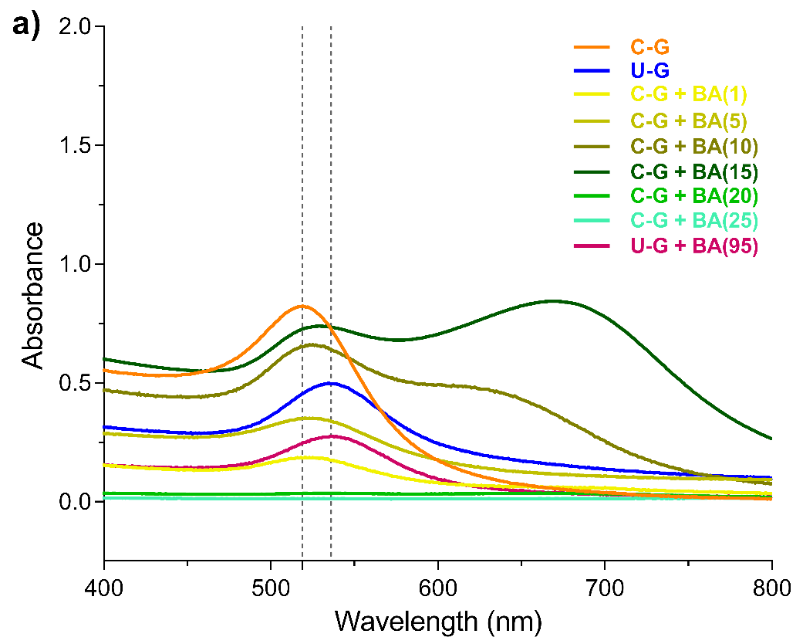
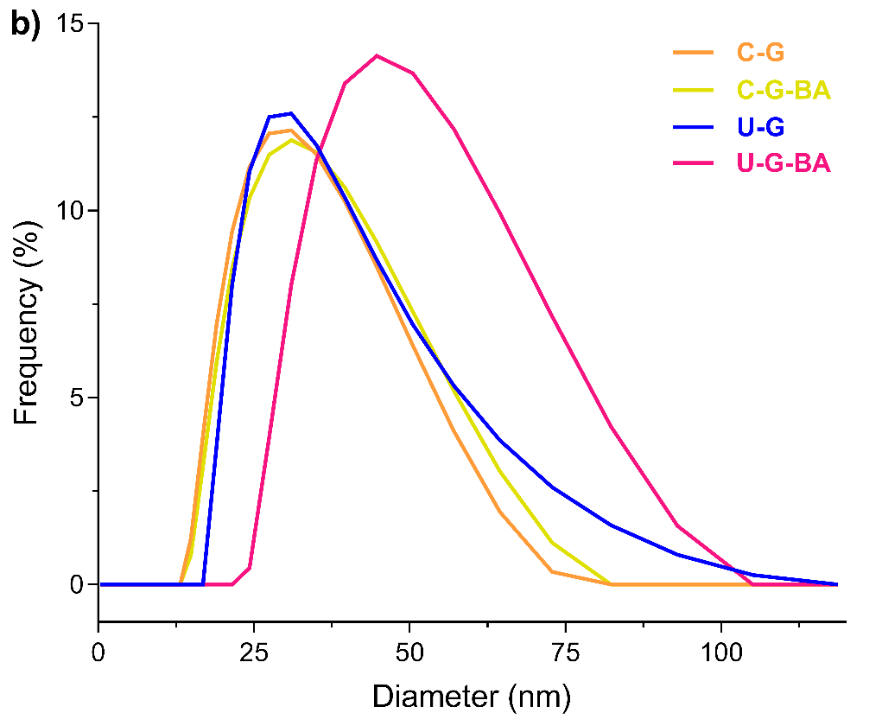
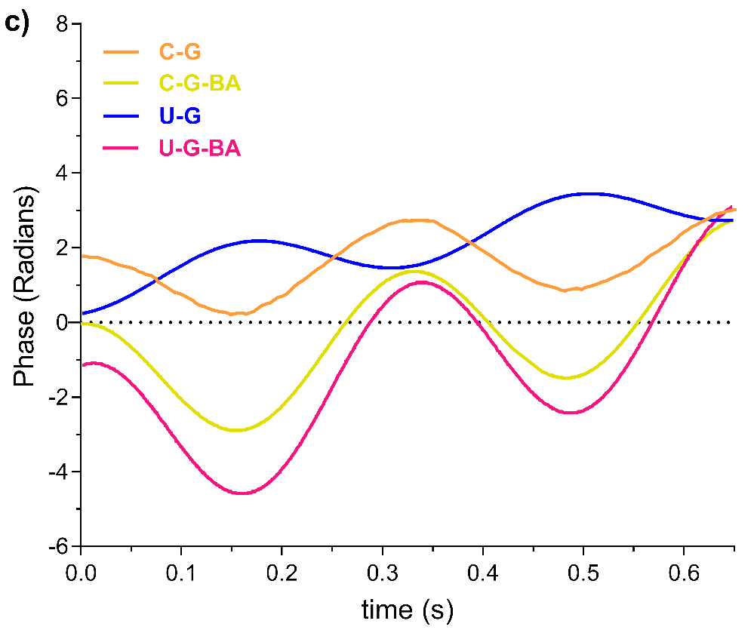

Supplementary Figure 1. (a) UV−vis absorption spectra distribution, (b) histograms of size, (c) zeta potential of the phase diagram of GNP and GNP-BA.
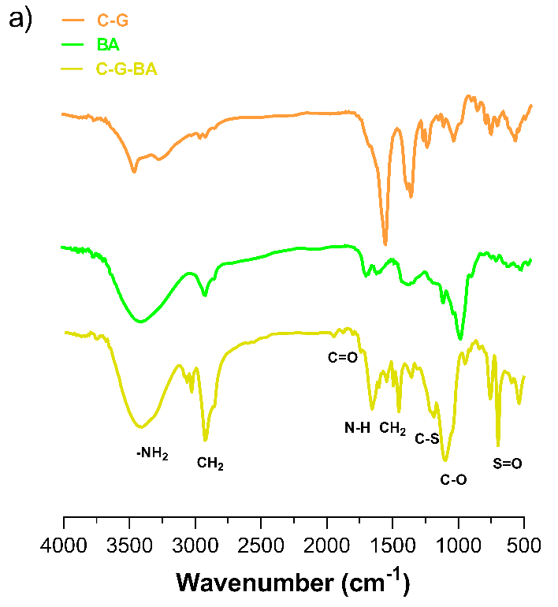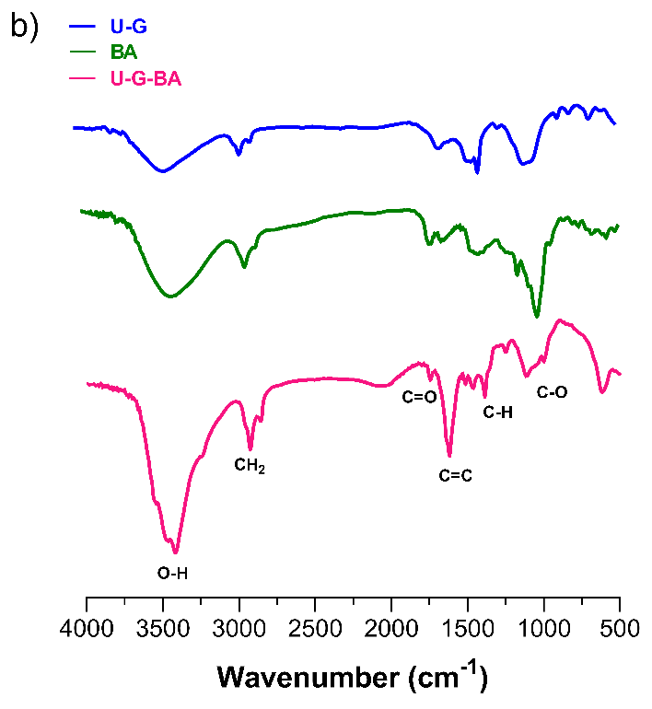
Supplementary Figure 2. FT-IR spectra of (a) C-G, BA, and C-G-BA and (b) U-G, BA, and U-G-BA.

