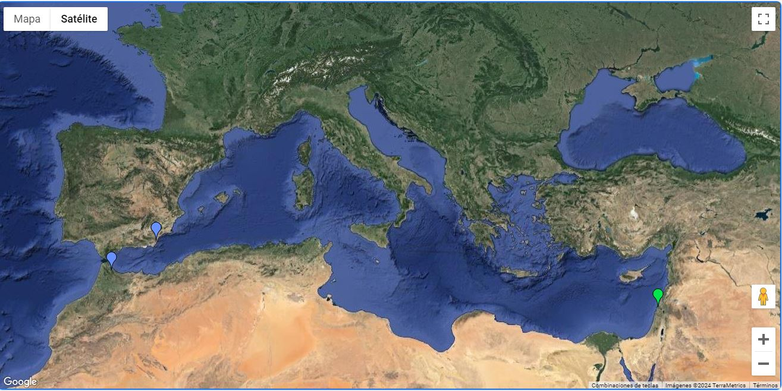Supplementary Fig. 1. Map representation of the two groups formed by SAMOVA analysis.
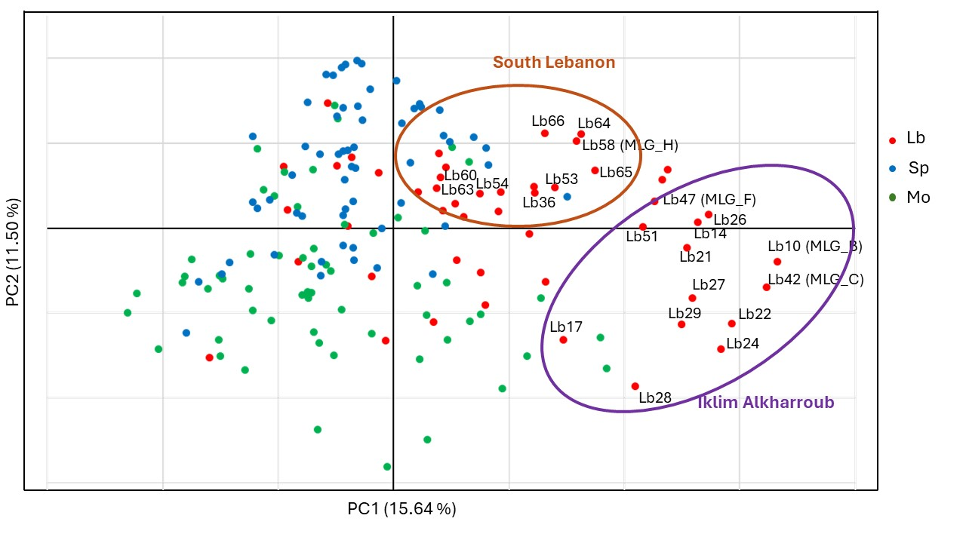
Supplementary Fig. 2. PCoA plot representing the Lebanese individuals. The local varieties grouped are indicated (southern Lebanon in orange and Iklim Alkharroub in violet). Individuals from Lebanon (red), Morocco (green) and Spain (blue) are represented by a solid circle (●).

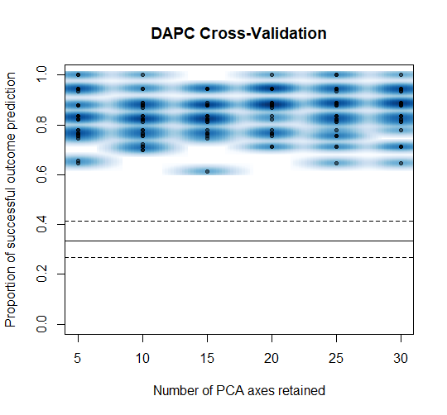
Supplementary Fig. 3. DAPC cross validation plot: the X-axis and the Y-axis indicate the number of PCs retained and the proportion of successful outcome prediction, respectively.

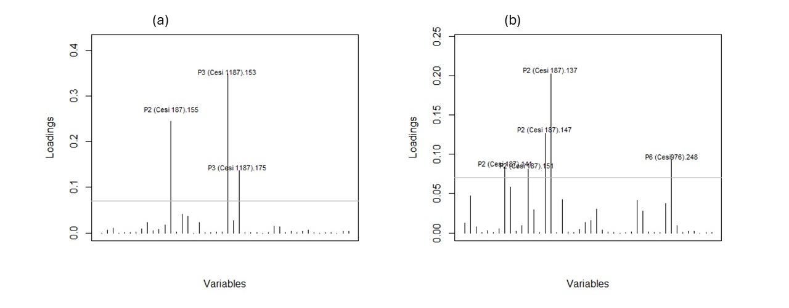Supplementary Fig. 4. Contribution of alleles to the first (LD1, a) and second (LD2, b) components of the DAPC. EST-SSR markers are included between brackets and number next to the marker indicates the allele.

