Tables

Table 1: Learners' and Teachers' Average Reliability Statistics from the Closed-form Questionnaire
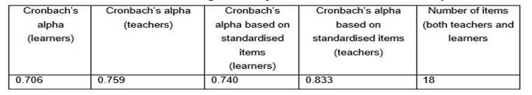

Table 2: Items in the Questionnaire and Descriptive Statistics related to Teachers
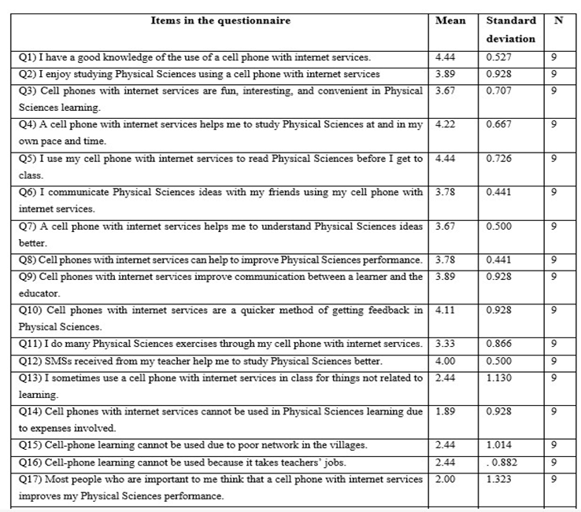

Table 3: Consolidated Quantitative Results for Teachers
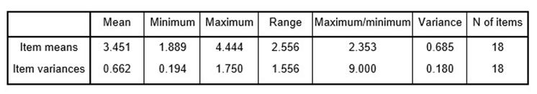

Table 4: Group Statistics
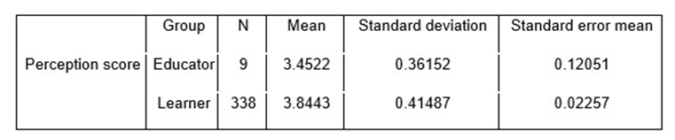

Table 5: T-test Comparison of Learners' and Teachers' Perceptions of Smartphone Use
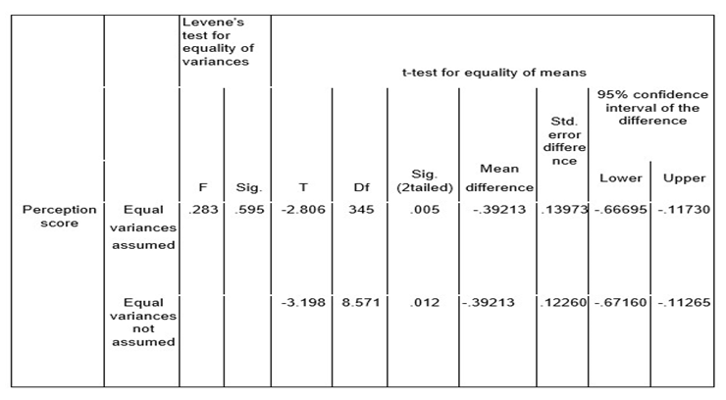

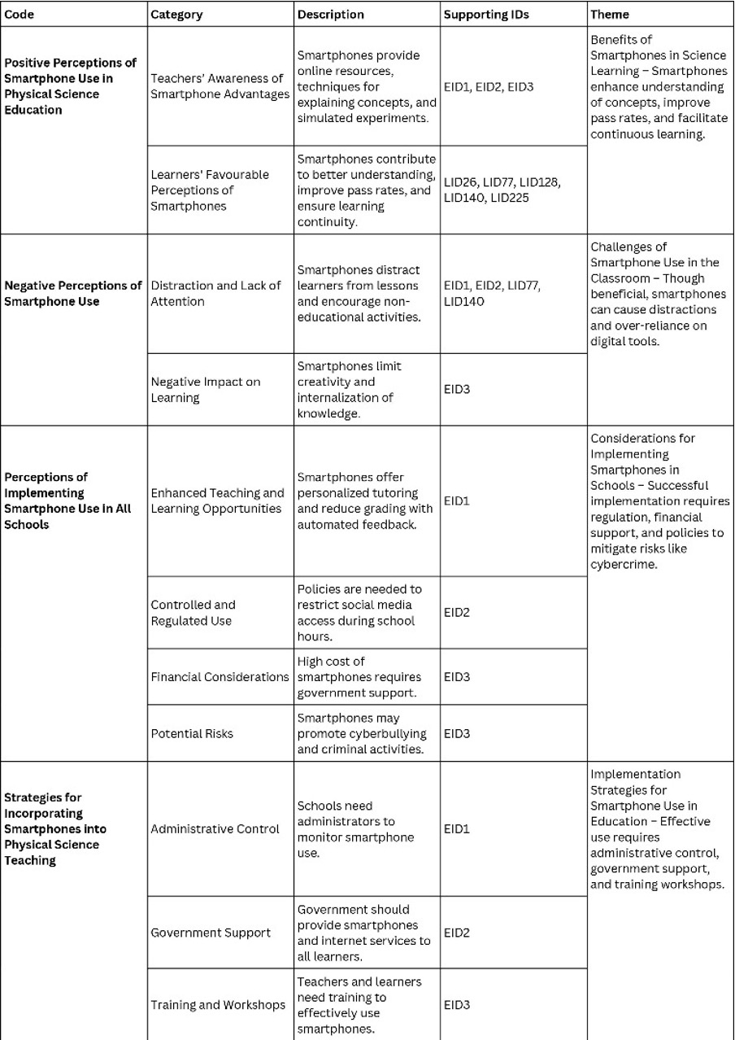
Table 6: Codes, categories and themes about perceptions of smartphone use

