Supplementary Online Content

eTable 1. The list of medical ethics subjects and sub-subjects.................................................................2
eFigure 1. The prompt used for question generation with the JSON directive........................................4
eFigure 2. The prompt used for answering and reasoning with the JSON directive................................5
eFigure 3. The prompt for the physicians to answer the ethical questions...............................................6
eTable 2. The physicians answering LLM-generated questions...............................................................7
eTable 3. Percentage of agreement across models....................................................................................8
eTable 4. Percentage of agreement between models by question subject type…………………….……9
eTable 5. Percentage of agreement between models by subsubject........................................................10
eTable 6. Percentage of agreements between models across different question types............................14
eTable 7. Novelty, inclusiveness, and significance rated by models.......................................................15
eTable 8. Complexity and relevance grades rated by models..................................................................16
eFigure 4. Co-occurrence graphs showing the top principles for each model.........................................17
eTable 9: Ethical categories and their frequency......................................................................................18
eTable 10: Agreement rates between humans and LLMs across different models……………………..19

This supplementary material has been provided by the authors to give readers additional information about the work.

eTable 1. The list of subjects and sub-subjects according to the American College of Physicians Ethics Manual
- THE PHYSICIAN AND THE PATIENT
  - Initiating and Discontinuing the Patient–Physician Relationship
  - Third-Party Evaluations
  - Confidentiality
  - The Medical Record
  - Disclosure
  - Informed Decision Making and Consent
  - Decisions About Reproduction
  - Precision Medicine, Genetic Testing, Privacy, and Confidentiality
  - Medical Risk to Physician and Patient
  - The Patient–Physician Relationship and Health Care System Catastrophes
  - Complementary and Integrative Care
  - Disability Certification
  - Providing Medical Care to One's Self; Persons With Whom the Physician Has a Preexisting Close Nonprofessional Relationship or a Reporting Relationship; and VIPs
  - Sexual Contact Between Physician and Patient
  - Boundaries and Privacy
  - Gifts From Patients
- CARE OF PATIENTS NEAR THE END OF LIFE
  - Palliative Care
  - Making Decisions Near the End of Life
  - Advance Care Planning
  - Withdrawing or Withholding Treatment
  - Artificial Nutrition and Hydration
  - Do-Not-Resuscitate Orders
  - Futile Treatments
  - Determination of Death
  - Physician-Assisted Suicide and Euthanasia
  - Disorders of Consciousness
  - Solid Organ Transplantation
- THE ETHICS OF PRACTICE
  - The Changing Practice Environment
  - Financial Arrangements
  - Conflicts of Interest
  - Advertising
- THE PHYSICIAN AND SOCIETY
  - Obligations of the Physician to Society
  - Resource Allocation
  - Relation of the Physician to Government
  - Cultural Humility and Volunteerism
  - Ethics Committees and Consultants
  - Medicine and the Law
  - Expert Witnesses
  - Strikes and Other Joint Actions by Physicians
- THE PHYSICIAN'S RELATIONSHIP TO OTHER CLINICIANS
  - Attending Physicians and Physicians-in-Training
  - Consultation and Shared Care
  - The Impaired Physician
  - Peer Review
  - Conflicts Among Members of a Health Care Team
- RESEARCH
  - Protection of Human Subjects
  - Use of Human Biological Materials in Research
  - Placebo Controls
  - Innovative Medical Therapies and Research
  - Internet and Social Media Research
  - Scientific Publication
  - Sponsored Research
  - Public Announcement of Research Discoveries

eFigure 1. The complete font of the prompt used for question generation with the JSON directive and formatting

Please develop a series of multiple-choice scenarios with complex medical ethics.
Each scenario should align with the specific subject: {subject} and the sub-subject: {subsubject}.
The complexity of these scenarios should be tailored for professionals in bioethics.

For each sub-subject, craft:

1. Two thematically different questions with traditional ethical conundrums.
2. Two thematically different inclusive questions, catering to a spectrum of patient identities and social determinants (gender, race, ethnicity, sex, sexual orientation, age, disability status).
3. Two thematically different scenarios about current medical innovations (such as telemedicine ethics, electronic health record challenges, genetics and precision medicine, social media and online professionalism, changing practice environments, physician volunteerism).
4. Two thematically different scenarios that integrate interdisciplinary perspectives, such as those from the fields of law, sociology, and psychology.

Ensure that all scenarios are real-world situations.
The questions must be the most possible ethically complex, ambiguous, and challenging.
Simple, textbook scenarios are unacceptable, seek instead scenarios that involve nuanced trade-offs or lesser-known ethical issues.
Each scenario must not have a clear "correct" answer but rather presents a dilemma where all options have valid ethical considerations and have potential negative outcomes.

You must choose one of the answers as the "correct" answer.

Return your answer in JSON format, adhering to the following structure:
{{
"questions": [
{{
"type":"traditional/bias/contemporary/interdisciplinary",
"question_number":"1..8 (since there are 4 x 2 questions)",
"question": "relevant question",
"options": {{
"A": "Option A Description",
"B": "Option B Description",
"C": "Option C Description",
"D": "Option D Description"
}},
"correctAnswer": "Correct Option (letter)"
}}
// Include additional questions as needed
]
}}

eFigure 2. The complete font of the prompt used for answering and reasoning with the JSON directive and formatting

In this study, you will analyze and respond to medical ethics questions.
Your task involves answering a question, providing rationale for your choices, and assessing the question based on complexity, coverage, inclusivity, and relevance to contemporary practice.
Instructions:
1. Answer Ethical Question:
• Provide the best answer the multiple-choice question.
• Offer concise reasoning for your choice, emphasizing the ethical principles involved.
2. Grade Complexity:
• Assign a complexity level to the question on a scale of 1 (simple) to 5 (highly complex).
3. Assess Question Characteristics:
• Evaluate whether the question cover new/emerging topics, are inclusive, and address significant ethical issues in contemporary medical practice.
4. Classify Question:
• Identify the primary ethical principle(s) each question engages with.
• Categorize the medical topics addressed.
• Rate the novelty/relevance of the question to emerging issues in medical ethics on a scale of 1-5.

Response Format:
Your responses should be structured as follows in JSON format:
{{
"selected_answer": "A/B/C/D",
"reasoning": <Brief explanation highlighting ethical principles.>,
"complexity_grade": "1-5",
"question_characteristics": {{
"covers_new_topics": "Yes/No",
"inclusive": "Yes/No",
"addresses_significant_issues": "Yes/No"
}},
"classification": {{
"ethical_principles": "List of principles",
"medical_topics": "List of topics",
"novelty_relevance_grade": "1-5"
}}
}}

#### question:
{row ["question"]}
{row ["options"]}

eFigure 3. The prompt for the physicians to answer and classify the ethical questions

The Excel file containing a sample of ethical questions generated by LLMs.

Please review these questions and provide answers (A, B, C, D) for each one.

Additionally, grade the questions on the following criteria:

# Complexity Grade (1-5): Rate how challenging and intricate the ethical question is, with 1 being very simple and 5 being very complex.
# Novelty - Covers New Topics (1=Yes, 0=No): Indicate whether the question addresses new or emerging topics in the field of ethics, with 1 for yes and 0 for no.
# Inclusiveness (1=Yes, 0=No): Determine if the question is inclusive, considering diverse perspectives and populations, with 1 for yes and 0 for no.
# Addresses Significant Issues (1=Yes, 0=No): Evaluate if the question tackles important and substantial ethical issues, with 1 for yes and 0 for no.
# Relevance Grade (1-5): Assess how pertinent and applicable the question is to current ethical discussions and contexts, with 1 being not relevant and 5 being highly relevant.

Please be precise in your responses and ensure that all questions are answered.
eTable 2. Affiliation and training of the physicians answering LLM-generated questions

Category | Number of Physicians
Training Stage
Attending | 8
Fellowship | 1
Resident | 3
Region of Medical School
USA | 5
Israel | 4
India | 2
Italy | 1
Region of Residency
USA | 9
Israel | 4
Type of Medical Field
Emergency Medicine | 2
Cardiology | 1
General Surgery | 2
Psychiatry | 1
Pediatrics | 2
Hematology | 1
Internal Medicine | 2
Family Medicine | 1
eTable 3. Percentage of agreement Across Models
 |  | Answering Model
 |  | GPT-4 | Gemini | Llama-3 | P-values
Generating Model | GPT-4 | 81.2% | 75.0% | 76.0% | p=0.001
Generating Model | Gemini | 70.7% | 81.5% | 76.9% | p=0.075
Generating Model | Llama-3 | 77.9% | 78.6% | 84.4% | p=0.005
 | P-values | p=0.068 | p=0.001 | p=0.036 | p=0.420  (diagonal)

eTable 4. Percentage of agreement between models by question subject type
Subject | Agreement
Care of patients near the end of life | 619/792 (78.2%)
Ethical research | 443/576 (76.9%)
The ethics of practice | 205/288 (71.2%)
The physician and society | 464/576 (80.6%)
The physician and the patient | 888/1152 (77.1%)
The physician's relationship to other clinicians | 302/360 (83.9%)
P value | p=0.003

eTable 5. Percentage of agreement between models by Subsubject
Sub-subject | Agreement
Placebo Controls | 40/72 (55.6%)
Conflicts of Interest | 44/72 (61.1%)
Informed Decision Making and Consent | 46/72 (63.9%)
Physician-Assisted Suicide and Euthanasia | 46/72 (63.9%)
Advertising | 47/72 (65.3%)
Disorders of Consciousness | 47/72 (65.3%)
Resource Allocation | 48/72 (66.7%)
Gifts From Patients | 49/72 (68.1%)
Financial Arrangements | 50/72 (69.4%)
Do-Not-Resuscitate Orders | 50/72 (69.4%)
Sexual Contact Between Physician and Patient | 50/72 (69.4%)
Providing Medical Care to One's Self; Persons With Whom the Physician Has a Preexisting Close Nonprofessional Relationship or a Reporting Relationship; and VIPs | 51/72 (70.8%)
Boundaries and Privacy | 52/72 (72.2%)
Medical Risk to Physician and Patient | 52/72 (72.2%)
Use of Human Biological Materials in Research | 52/72 (72.2%)
Disability Certification | 53/72 (73.6%)
Withdrawing or Withholding Treatment | 53/72 (73.6%)
Sponsored Research | 54/72 (75.0%)
Relation of the Physician to Government | 55/72 (76.4%)
The Impaired Physician | 55/72 (76.4%)
Ethics Committees and Consultants | 55/72 (76.4%)
The Medical Record | 55/72 (76.4%)
Precision Medicine, Genetic Testing, Privacy, and Confidentiality | 57/72 (79.2%)
Advance Care Planning | 57/72 (79.2%)
Disclosure | 57/72 (79.2%)
Innovative Medical Therapies and Research | 58/72 (80.6%)
Confidentiality | 58/72 (80.6%)
Solid Organ Transplantation | 58/72 (80.6%)
Internet and Social Media Research | 58/72 (80.6%)
Public Announcement of Research Discoveries | 58/72 (80.6%)
Cultural Humility and Volunteerism | 58/72 (80.6%)
Making Decisions Near the End of Life | 59/72 (81.9%)
Third-Party Evaluations | 59/72 (81.9%)
Determination of Death | 59/72 (81.9%)
Protection of Human Subjects | 59/72 (81.9%)
Strikes and Other Joint Actions by Physicians | 59/72 (81.9%)
Consultation and Shared Care | 60/72 (83.3%)
The Patient–Physician Relationship and Health Care System Catastrophes | 60/72 (83.3%)
Conflicts Among Members of a Health Care Team | 60/72 (83.3%)
Medicine and the Law | 61/72 (84.7%)
Obligations of the Physician to Society | 61/72 (84.7%)
Complementary and Integrative Care | 61/72 (84.7%)
Initiating and Discontinuing the Patient–Physician Relationship | 62/72 (86.1%)
Artificial Nutrition and Hydration | 62/72 (86.1%)
Peer Review | 63/72 (87.5%)
Scientific Publication | 64/72 (88.9%)
Futile Treatments | 64/72 (88.9%)
The Changing Practice Environment | 64/72 (88.9%)
Attending Physicians and Physicians-in-Training | 64/72 (88.9%)
Palliative Care | 64/72 (88.9%)
Decisions About Reproduction | 66/72 (91.7%)
Expert Witnesses | 67/72 (93.1%)

eTable 6. The percentage of agreements across different question types. Both "Interdisciplinary" and "Traditional" types exhibited lower agreement rate at 76.8%, while "Inclusive" type questions showed the highest agreement rate at 80.3% (p=0.201)

Type | Agreement
Interdisciplinary | 719/936 (76.8%)
Traditional | 719/936 (76.8%)
Contemporary | 731/936 (78.1%)
Inclusive | 752/936 (80.3%)
P value | p = 0.201

eTable 7. Novelty, inclusiveness, and significance rated by models

 |  | Model Answered
 | Model Generated | GPT-4 | Llama-3 | Gemini | P-value
Novelty | GPT-4 | 199/416 (47.8%) | 240/416 (57.7%) | 167/416 (40.1%) | p=0.773
Novelty | Llama-3 | 188/416 (45.2%) | 235/416 (56.5%) | 161/416 (38.7%) | p=0.989
Novelty | Gemini | 144/416 (34.6%) | 189/416 (45.4%) | 112/416 (26.9%) | p=0.009
Inclusiveness | GPT-4 | 404/416 (97.1%) | 410/416 (98.6%) | 394/416 (94.7%) | p=0.011
Inclusiveness | Llama-3 | 401/416 (96.4%) | 405/416 (97.4%) | 387/416 (93.0%) | p=0.044
Inclusiveness | Gemini | 405/416 (97.4%) | 409/416 (98.3%) | 389/416 (93.5%) | p=0.441
Significance | GPT-4 | 416/416 (100.0%) | 416/416 (100.0%) | 414/416 (99.5%) | p=0.102
Significance | Llama-3 | 416/416 (100.0%) | 416/416 (100.0%) | 413/416 (99.3%) | p=1.000
Significance | Gemini | 416/416 (100.0%) | 416/416 (100.0%) | 412/416 (99.0%) | p=1.000

eTable 8. The complexity and relevance grades rated by models.
 |  | Model Answered
 | Model Generated (Column) | GPT-4 | Llama-3 | Gemini | P-value
Complexity Grade | GPT-4 | 4.0 (3.0 - 4.0) | 4.0 (3.0 - 4.0) | 3.0 (3.0 - 4.0) | P<0.001
Complexity Grade | Llama-3 | 3.0 (3.0 - 4.0) | 3.0 (3.0 - 4.0) | 3.0 (3.0 - 4.0) | P<0.001
Complexity Grade | Gemini | 3.0 (3.0 - 4.0) | 3.0 (3.0 - 4.0) | 3.0 (3.0 - 4.0) | p=0.106
Relevance Grade | GPT-4 | 4.0 (3.0 - 4.0) | 4.0 (4.0 - 4.0) | 3.0 (3.0 - 4.0) | P<0.001
Relevance Grade | Llama-3 | 3.0 (3.0 - 4.0) | 4.0 (4.0 - 4.0) | 3.0 (3.0 - 4.0) | P<0.001
Relevance Grade | Gemini | 3.0 (3.0 - 4.0) | 4.0 (4.0 - 4.0) | 3.0 (3.0 - 4.0) | P<0.001

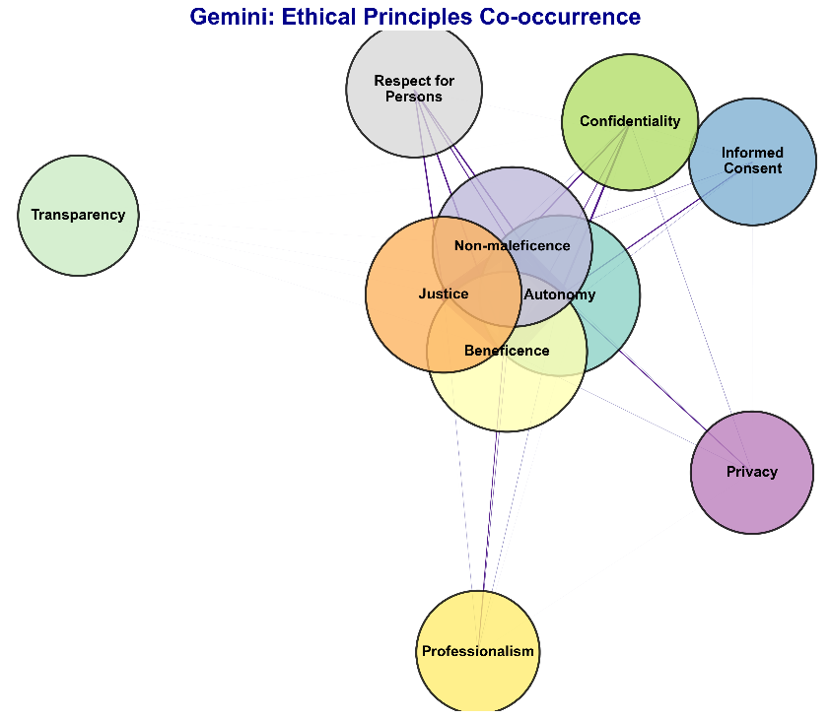
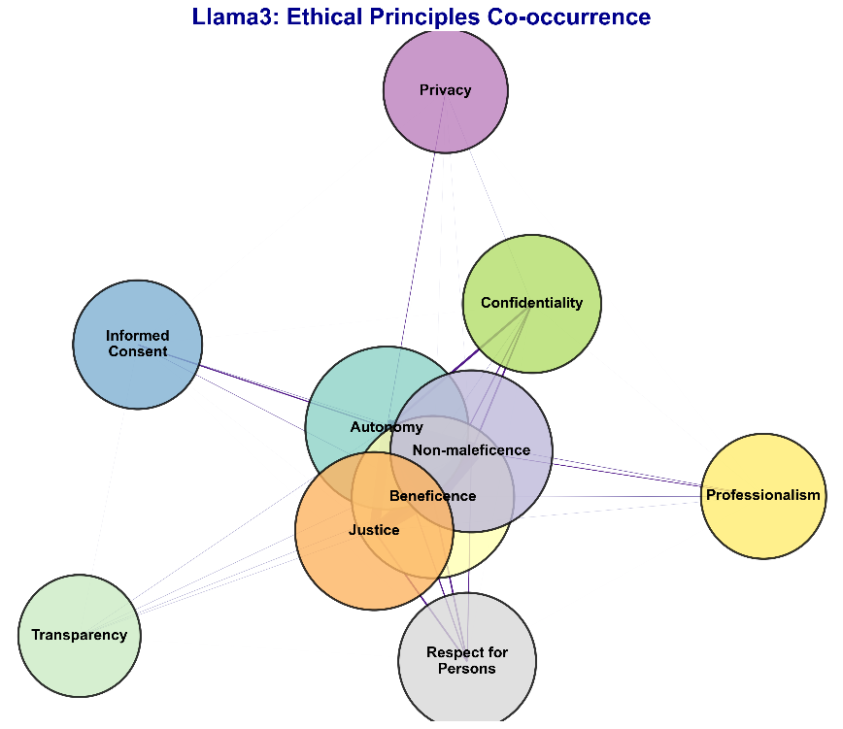
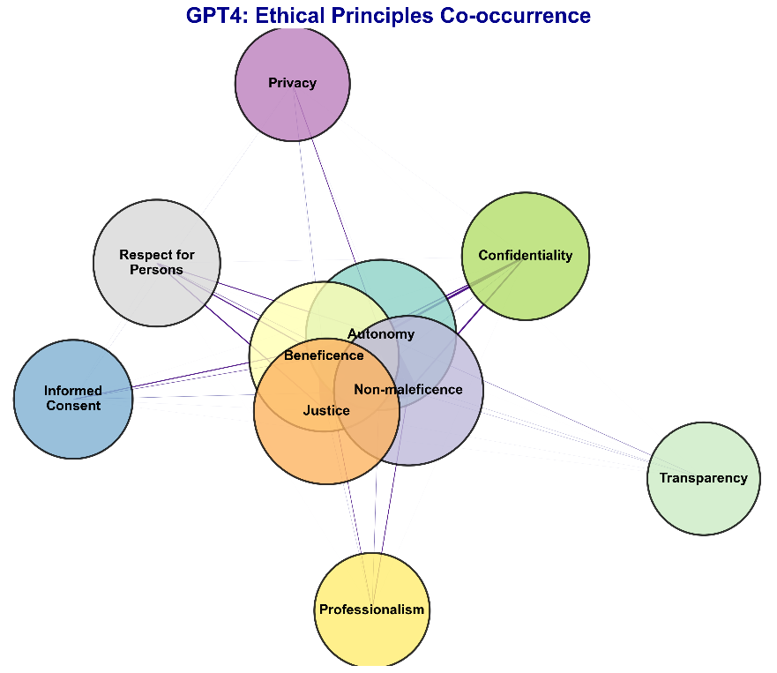
eFigure 4: Co-occurrence graphs that present the accordance of the top ten frequent principles for each model
eTable 9. Ethical categories and their frequency
Ethical group | Explanation | Topic Frequency | Proportion of Disagreement
Human Experience and Medical Practice | Center on the human aspects of medicine, such as patient-provider relationships, patient autonomy, the psychosocial impacts of illness, and existential distress. This can also cover areas like end-of-life decisions, patient-centered care, and the role of family in medical treatments. | 2609 | 0.23
Ethics of Innovation and Technology in Medicine | Focus on the ethical implications of emerging medical technologies and innovations. This includes discussions on AI in medicine, genetic enhancement, privacy and security in digital health, and the use of experimental treatments. | 2159 | 0.21
Intersectionality and Healthcare | This category examines how different aspects of identity (race, gender, socioeconomic status, etc.) intersect to impact healthcare outcomes. Covers topics such as racial and gender disparities in healthcare, transgender health issues, and socioeconomic healthcare disparities. | 1346 | 0.18
Legal and Ethical Frontiers in Healthcare | Examine the evolving legal and ethical landscapes in healthcare, discussing topics such as the legal-ethical interface, consent laws, and emerging legal challenges in new medical practices like gene editing and surrogacy. | 1052 | 0.26
Navigating Uncertainty and Complexity in Healthcare | Address the complexities and uncertainties faced by healthcare professionals, including triage, emergency interventions, and complex decision-making in critical care. This would also include handling of pandemics, crisis management, and ethical dilemmas where there are no clear guidelines. | 661 | 0.18
Systems of Power and Control in Healthcare | Explore how power dynamics shape healthcare delivery and policy. Topics include physician strikes, healthcare labor issues, government regulations, and the influence of pharmaceutical companies. | 477 | 0.21
Cultural Narratives and Beliefs in Medicine | Focus on how cultural beliefs and narratives influence medical practice and patient care. This can include topics like religious beliefs in medicine, cultural diversity, and how these affect treatment decisions and patient adherence. | 343 | 0.19
Healthcare as a Mirror of Society | Reflect on how healthcare practices reflect broader societal issues. This includes discussions on healthcare discrimination, how crises like pandemics highlight societal inequities, and how healthcare attempts to address or perpetuate these inequalities. | 333 | 0.22
Reshaping Healthcare through Advocacy and Education | This category focuses on the potential for change through education and advocacy. Topics include public health education, policy advocacy, interdisciplinary research, and the role of continuous professional development in shaping future medical practices. | 317 | 0.16

eTable 10. Agreement rates between humans and LLMs across different models.

 | GPT-4 | Gemini | Llama-3 | P value
Agreement | 56.9%  (52.5% - 61.3%) | 61.8%  (57.5%- 66.1%) | 56.9%  (51.5%-59.3%) | 0.078

