Supplementary Materials:
Figure S1: The influent samples contain more bacteria than the effluent samples.
Figure S2: The samples from the two WWTPs, show similar clustering in Principal Coordinate Analysis based on a Bray-Curtis dissimilarity matrix.
Figure S3. The relative abundance of different bacterial taxonomies between effluent grab and composite sampling.
Table S1: The Mann-Whitney U test with Benjamini & Hochberg correction was used to test differences in effluent composite (group 1) and grab (group 2) samples on class, order and family taxonomy levels.

Supplementary data
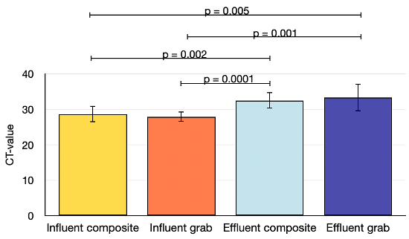
Figure S1. The influent samples contain more bacteria than the effluent samples. We quantified both composite and grab samples from influent and effluent using semi-quantitative 16S V3-V4 PCR. Each group consisted of eight samples, and the error bars indicate the standard deviation. The lines on the graph show statistically significant differences, with the p-values from the two-tailed Student’s t-test.

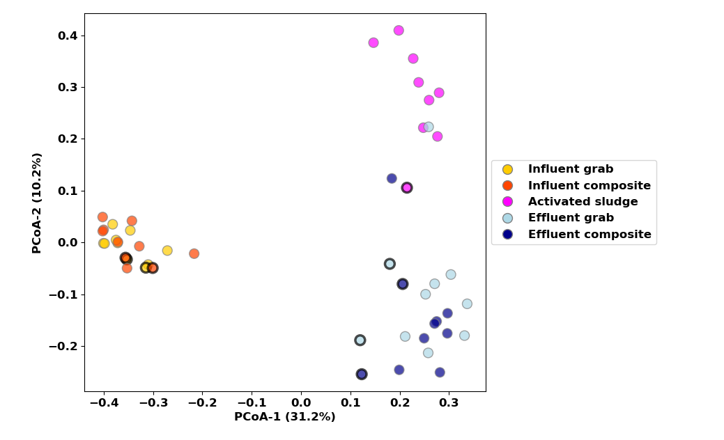Figure S2. The samples from the two WWTPs show similar clustering in Principal Coordinate Analysis based on a Bray-Curtis dissimilarity matrix. The two axes explain 41.4% of the total variance. In the scatter plot, the WWTP2 samples are represented by thick black edges, while narrow black edges represent the WWTP1 samples.
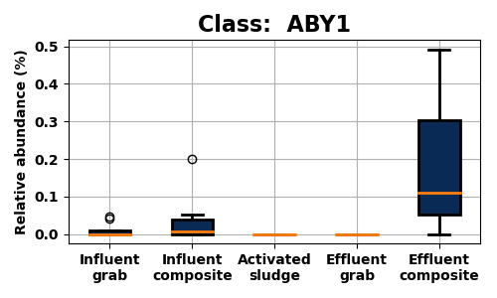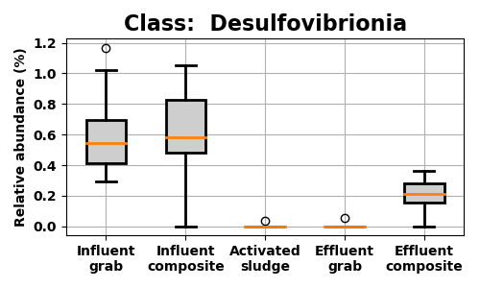
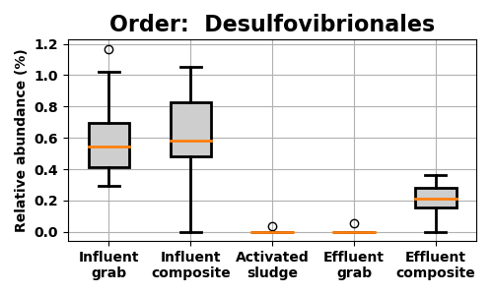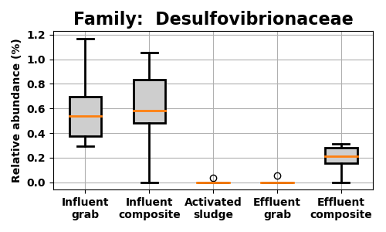

Figure S3. The relative abundance of different bacterial taxonomies between effluent grab and composite sampling. The box plots show classes, orders, and families with significant differences and median counts higher than 0.1% in at least one of the sample groups. The header indicates the taxonomy level and the name of the bacterial group. Bacterial groups belonging to the Desulfobacterota are shown in grey, while the ABY1 class, a member of the Patescibacteria phylum, is represented in dark blue.

Table S1. The Mann-Whitney U test with Benjamini & Hochberg correction was used to test differences in effluent composite samples on bacterial class, order and family taxonomy levels.

Taxonomy | Name | p-value
Class | ABY1 | 0.0162
Class | Desulfovibrionia | 0.0246
Order | Desulfovirionales | 0.0252
Family | Desulfovibrionaceae | 0.0355

