Supplementary Tables
Supplementary Table.1 Fluorescent labeled monoclonal antibodies used for sorting of T cell subsets
 | FITCª | PE^{b} | ECD^{c} | PC5^{d} | PC7e
Tube 1 | CD3 | NK | CD19 | HLA-DR | CD69
Tube 2 | CD45RA | CD45RO | CD4 | CD8 | CD25
Tube 3 | CD29 | CD28 | CD4 | CD8 | -

a：FITC：fluorescein isothiocyanate; b：PE：Phycoerythrin; c：ECD：PE-TexasRed; d：PC5：Phycoerythrin-anthocyanin 5; e：PC7：Phycoerythrin-anthocyanin 7

Supplementary Figures
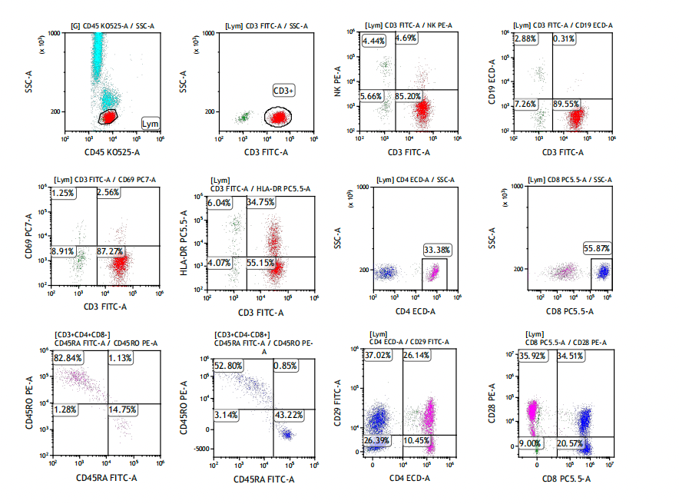
Supplementary Figure1. Flow analysis of peripheral blood lymphocyte subsets.
Supplementary Figure2. Cross-sectional analysis of the prognostic value of CD3-CD19+ proprotion.
The Kaplan-Meier (KM) survival curves for patients with CD3-CD19+ proprotion
that were higher than the clinical normal values, within the clinical normal range, and lower than the clinical normal values during the first to the twelfth （A-L) chemotherapy cycles.
Supplementary Figure3. Cross-sectional analysis of the prognostic value of CD4+CD29+ proprotion.
The Kaplan-Meier (KM) survival curves for patients with CD4+CD29+ proprotion
that were higher than the clinical normal values, within the clinical normal range, and lower than the clinical normal values during the first to the twelfth （A-L) chemotherapy cycles.
Supplementary Figure4. Cross-sectional analysis of the prognostic value of CD4+CD45RO+/CD4+ ratio.
The Kaplan-Meier (KM) survival curves for patients with CD4+CD45RO+/CD4+ ratios that were higher than the clinical normal values, within the clinical normal range, and lower than the clinical normal values during the first to the twelfth （A-L) chemotherapy cycles.
Supplementary _Data_CSV. Testing dara for the online application of prognosis model

Annotation:
 | time | CRP | IL6 | CEA | CA199 | CD4CD45RACD4 | CD4CD45ROCD4 | CD3CD19 | CD4CD29
Unit | months | ng/L | pg/ml | ng/ml | U/ml | % | % | % | %
Full  name | / | / | / | / | / | CD4+CD45RA+/CD4+ | CD4+CD45RO+/CD4+ | CD3-CD19+ | CD4+CD29+

