Supplementary Information

List of Contents
Supplementary file 1: Search strategy
Supplementary file 2: Quality evaluation criteria of included literatures
Supplementary file 3: Characteristics of the included studies
Supplementary file 4: Risk of bias assessment of the included studies

Supplementary file 1. Search strategy in selective databases.

Database | Search Term | Results
PubMed | #1: "gastrointestinal stromal tumors"[MeSH Terms] OR ("gastrointestinal"[All Fields] AND "stromal"[All Fields] AND "tumors"[All Fields]) OR "gastrointestinal stromal tumors"[All Fields] OR ("gastrointestinal"[All Fields] AND "stromal"[All Fields] AND "tumor"[All Fields]) OR "gastrointestinal stromal tumor"[All Fields] OR ("gastrointestinal stromal tumors"[MeSH Terms] OR ("gastrointestinal"[All Fields] AND "stromal"[All Fields] AND "tumors"[All Fields]) OR "gastrointestinal stromal tumors"[All Fields]) OR (("gastrics"[All Fields] OR "stomach"[MeSH Terms] OR "stomach"[All Fields] OR "gastric"[All Fields]) AND ("mesenchym"[All Fields] OR "mesenchymal"[All Fields] OR "mesenchymalized"[All Fields] OR "mesenchymally"[All Fields] OR "mesenchymals"[All Fields] OR "mesenchymes"[All Fields] OR "mesoderm"[MeSH Terms] OR "mesoderm"[All Fields] OR "mesenchyme"[All Fields]) AND ("cysts"[MeSH Terms] OR "cysts"[All Fields] OR "cyst"[All Fields] OR "neurofibroma"[MeSH Terms] OR "neurofibroma"[All Fields] OR "neurofibromas"[All Fields] OR "tumor s"[All Fields] OR "tumoral"[All Fields] OR "tumorous"[All Fields] OR "tumour"[All Fields] OR "neoplasms"[MeSH Terms] OR "neoplasms"[All Fields] OR "tumor"[All Fields] OR "tumour s"[All Fields] OR "tumoural"[All Fields] OR "tumourous"[All Fields] OR "tumours"[All Fields] OR "tumors"[All Fields])) OR ("mesothelioma"[MeSH Terms] OR "mesothelioma"[All Fields] OR "mesotheliomas"[All Fields] OR "mesothelioma, malignant"[MeSH Terms] OR ("mesothelioma"[All Fields] AND "malignant"[All Fields]) OR "malignant mesothelioma"[All Fields]) OR (("gastrointestinal"[All Fields] OR "gastrointestinally"[All Fields] OR "gastrointestine"[All Fields]) AND ("mesenchym"[All Fields] OR "mesenchymal"[All Fields] OR "mesenchymalized"[All Fields] OR "mesenchymally"[All Fields] OR "mesenchymals"[All Fields] OR "mesenchymes"[All Fields] OR "mesoderm"[MeSH Terms] OR "mesoderm"[All Fields] OR "mesenchyme"[All Fields]) AND ("cysts"[MeSH Terms] OR "cysts"[All Fields] OR "cyst"[All Fields] OR "neurofibroma"[MeSH Terms] OR "neurofibroma"[All Fields] OR "neurofibromas"[All Fields] OR "tumor s"[All Fields] OR "tumoral"[All Fields] OR "tumorous"[All Fields] OR "tumour"[All Fields] OR "neoplasms"[MeSH Terms] OR "neoplasms"[All Fields] OR "tumor"[All Fields] OR "tumour s"[All Fields] OR "tumoural"[All Fields] OR "tumourous"[All Fields] OR "tumours"[All Fields] OR "tumors"[All Fields]) AND ("tissue s"[All Fields] OR "tissues"[MeSH Terms] OR "tissues"[All Fields] OR "tissue"[All Fields])) OR (("gastrointestinal tract"[MeSH Terms] OR ("gastrointestinal"[All Fields] AND "tract"[All Fields]) OR "gastrointestinal tract"[All Fields]) AND ("mesenchym"[All Fields] OR "mesenchymal"[All Fields] OR "mesenchymalized"[All Fields] OR "mesenchymally"[All Fields] OR "mesenchymals"[All Fields] OR "mesenchymes"[All Fields] OR "mesoderm"[MeSH Terms] OR "mesoderm"[All Fields] OR "mesenchyme"[All Fields]) AND ("cysts"[MeSH Terms] OR "cysts"[All Fields] OR "cyst"[All Fields] OR "neurofibroma"[MeSH Terms] OR "neurofibroma"[All Fields] OR "neurofibromas"[All Fields] OR "tumor s"[All Fields] OR "tumoral"[All Fields] OR "tumorous"[All Fields] OR "tumour"[All Fields] OR "neoplasms"[MeSH Terms] OR "neoplasms"[All Fields] OR "tumor"[All Fields] OR "tumour s"[All Fields] OR "tumoural"[All Fields] OR "tumourous"[All Fields] OR "tumours"[All Fields] OR "tumors"[All Fields])) OR ("gastrointestinal stromal tumors"[MeSH Terms] OR ("gastrointestinal"[All Fields] AND "stromal"[All Fields] AND "tumors"[All Fields]) OR "gastrointestinal stromal tumors"[All Fields] OR ("gastrointestinal"[All Fields] AND "stromal"[All Fields] AND "sarcoma"[All Fields]) OR "gastrointestinal stromal sarcoma"[All Fields]) OR ("gastrointestinal stromal tumors"[MeSH Terms] OR ("gastrointestinal"[All Fields] AND "stromal"[All Fields] AND "tumors"[All Fields]) OR "gastrointestinal stromal tumors"[All Fields] OR ("gastrointestinal"[All Fields] AND "stromal"[All Fields] AND "neoplasm"[All Fields]) OR "gastrointestinal stromal neoplasm"[All Fields]) OR ("gastrointestinal stromal tumors"[MeSH Terms] OR ("gastrointestinal"[All Fields] AND "stromal"[All Fields] AND "tumors"[All Fields]) OR "gastrointestinal stromal tumors"[All Fields] OR ("gastrointestinal"[All Fields] AND "stromal"[All Fields] AND "neoplasms"[All Fields]) OR "gastrointestinal stromal neoplasms"[All Fields]) OR (("gastrointestinal"[All Fields] OR "gastrointestinally"[All Fields] OR "gastrointestine"[All Fields]) AND ("leydig cell tumor"[MeSH Terms] OR ("leydig"[All Fields] AND "cell"[All Fields] AND "tumor"[All Fields]) OR "leydig cell tumor"[All Fields] OR ("interstitial"[All Fields] AND "cell"[All Fields] AND "neoplasm"[All Fields]) OR "interstitial cell neoplasm"[All Fields])) OR (("gastrointestinal"[All Fields] OR "gastrointestinally"[All Fields] OR "gastrointestine"[All Fields]) AND ("interstitial cell tumour"[All Fields] OR "leydig cell tumor"[MeSH Terms] OR ("leydig"[All Fields] AND "cell"[All Fields] AND "tumor"[All Fields]) OR "leydig cell tumor"[All Fields] OR ("interstitial"[All Fields] AND "cell"[All Fields] AND "tumor"[All Fields]) OR "interstitial cell tumor"[All Fields])) | 40049
PubMed | #2: "high"[All Fields] AND ("malign"[All Fields] OR "malignance"[All Fields] OR "malignances"[All Fields] OR "malignant"[All Fields] OR "malignants"[All Fields] OR "malignities"[All Fields] OR "malignity"[All Fields] OR "malignization"[All Fields] OR "malignized"[All Fields] OR "maligns"[All Fields] OR "neoplasms"[MeSH Terms] OR "neoplasms"[All Fields] OR "malignancies"[All Fields] OR "malignancy"[All Fields]) AND ("potential"[All Fields] OR "potential s"[All Fields] OR "potentialities"[All Fields] OR "potentiality"[All Fields] OR "potentially"[All Fields] OR "potentials"[All Fields] OR "potentiate"[All Fields] OR "potentiated"[All Fields] OR "potentiates"[All Fields] OR "potentiating"[All Fields] OR "potentiation"[All Fields] OR "potentiations"[All Fields] OR "potentiative"[All Fields] OR "potentiator"[All Fields] OR "potentiators"[All Fields])) OR ("high"[All Fields] AND ("malign"[All Fields] OR "malignance"[All Fields] OR "malignances"[All Fields] OR "malignant"[All Fields] OR "malignants"[All Fields] OR "malignities"[All Fields] OR "malignity"[All Fields] OR "malignization"[All Fields] OR "malignized"[All Fields] OR "maligns"[All Fields] OR "neoplasms"[MeSH Terms] OR "neoplasms"[All Fields] OR "malignancies"[All Fields] OR "malignancy"[All Fields]) AND ("potential"[All Fields] OR "potential s"[All Fields] OR "potentialities"[All Fields] OR "potentiality"[All Fields] OR "potentially"[All Fields] OR "potentials"[All Fields] OR "potentiate"[All Fields] OR "potentiated"[All Fields] OR "potentiates"[All Fields] OR "potentiating"[All Fields] OR "potentiation"[All Fields] OR "potentiations"[All Fields] OR "potentiative"[All Fields] OR "potentiator"[All Fields] OR "potentiators"[All Fields])) OR ("high"[All Fields] AND ("carcinogen s"[All Fields] OR "carcinogenes"[All Fields] OR "carcinogenic"[All Fields] OR "carcinogenically"[All Fields] OR "carcinogenicities"[All Fields] OR "carcinogenicity"[All Fields] OR "carcinogenity"[All Fields] OR "carcinogenous"[All Fields] OR "carcinogens"[Pharmacological Action] OR "carcinogens"[MeSH Terms] OR "carcinogens"[All Fields] OR "carcinogen"[All Fields]) AND ("potential"[All Fields] OR "potential s"[All Fields] OR "potentialities"[All Fields] OR "potentiality"[All Fields] OR "potentially"[All Fields] OR "potentials"[All Fields] OR "potentiate"[All Fields] OR "potentiated"[All Fields] OR "potentiates"[All Fields] OR "potentiating"[All Fields] OR "potentiation"[All Fields] OR "potentiations"[All Fields] OR "potentiative"[All Fields] OR "potentiator"[All Fields] OR "potentiators"[All Fields])) OR ("high"[All Fields] AND ("degenerative"[All Fields] OR "degeneratively"[All Fields] OR "degeneratives"[All Fields]) AND ("potential"[All Fields] OR "potential s"[All Fields] OR "potentialities"[All Fields] OR "potentiality"[All Fields] OR "potentially"[All Fields] OR "potentials"[All Fields] OR "potentiate"[All Fields] OR "potentiated"[All Fields] OR "potentiates"[All Fields] OR "potentiating"[All Fields] OR "potentiation"[All Fields] OR "potentiations"[All Fields] OR "potentiative"[All Fields] OR "potentiator"[All Fields] OR "potentiators"[All Fields])) OR ("high"[All Fields] AND ("malign"[All Fields] OR "malignance"[All Fields] OR "malignances"[All Fields] OR "malignant"[All Fields] OR "malignants"[All Fields] OR "malignities"[All Fields] OR "malignity"[All Fields] OR "malignization"[All Fields] OR "malignized"[All Fields] OR "maligns"[All Fields] OR "neoplasms"[MeSH Terms] OR "neoplasms"[All Fields] OR "malignancies"[All Fields] OR "malignancy"[All Fields]) AND ("disease progression"[MeSH Terms] OR ("disease"[All Fields] AND "progression"[All Fields]) OR "disease progression"[All Fields] OR "progression"[All Fields] OR "progress"[All Fields] OR "progressed"[All Fields] OR "progresses"[All Fields] OR "progressing"[All Fields] OR "progressions"[All Fields] OR "progressive"[All Fields] OR "progressively"[All Fields] OR "progressives"[All Fields]) AND ("potential"[All Fields] OR "potential s"[All Fields] OR "potentialities"[All Fields] OR "potentiality"[All Fields] OR "potentially"[All Fields] OR "potentials"[All Fields] OR "potentiate"[All Fields] OR "potentiated"[All Fields] OR "potentiates"[All Fields] OR "potentiating"[All Fields] OR "potentiation"[All Fields] OR "potentiations"[All Fields] OR "potentiative"[All Fields] OR "potentiator"[All Fields] OR "potentiators"[All Fields])) OR ("high"[All Fields] AND ("malign"[All Fields] OR "malignance"[All Fields] OR "malignances"[All Fields] OR "malignant"[All Fields] OR "malignants"[All Fields] OR "malignities"[All Fields] OR "malignity"[All Fields] OR "malignization"[All Fields] OR "malignized"[All Fields] OR "maligns"[All Fields] OR "neoplasms"[MeSH Terms] OR "neoplasms"[All Fields] OR "malignancies"[All Fields] OR "malignancy"[All Fields]) AND ("transform"[All Fields] OR "transformability"[All Fields] OR "transformable"[All Fields] OR "transformant"[All Fields] OR "transformants"[All Fields] OR "transformation"[All Fields] OR "transformations"[All Fields] OR "transformed"[All Fields] OR "transforms"[All Fields]) AND ("potential"[All Fields] OR "potential s"[All Fields] OR "potentialities"[All Fields] OR "potentiality"[All Fields] OR "potentially"[All Fields] OR "potentials"[All Fields] OR "potentiate"[All Fields] OR "potentiated"[All Fields] OR "potentiates"[All Fields] OR "potentiating"[All Fields] OR "potentiation"[All Fields] OR "potentiations"[All Fields] OR "potentiative"[All Fields] OR "potentiator"[All Fields] OR "potentiators"[All Fields])) OR ("high"[All Fields] AND ("malign"[All Fields] OR "malignance"[All Fields] OR "malignances"[All Fields] OR "malignant"[All Fields] OR "malignants"[All Fields] OR "malignities"[All Fields] OR "malignity"[All Fields] OR "malignization"[All Fields] OR "malignized"[All Fields] OR "maligns"[All Fields] OR "neoplasms"[MeSH Terms] OR "neoplasms"[All Fields] OR "malignancies"[All Fields] OR "malignancy"[All Fields]) AND ("biological evolution"[MeSH Terms] OR ("biological"[All Fields] AND "evolution"[All Fields]) OR "biological evolution"[All Fields] OR "evolution"[All Fields] OR "evolution s"[All Fields] OR "evolutional"[All Fields] OR "evolutions"[All Fields] OR "evolutive"[All Fields] OR "evolutivity"[All Fields]) AND ("potential"[All Fields] OR "potential s"[All Fields] OR "potentialities"[All Fields] OR "potentiality"[All Fields] OR "potentially"[All Fields] OR "potentials"[All Fields] OR "potentiate"[All Fields] OR "potentiated"[All Fields] OR "potentiates"[All Fields] OR "potentiating"[All Fields] OR "potentiation"[All Fields] OR "potentiations"[All Fields] OR "potentiative"[All Fields] OR "potentiator"[All Fields] OR "potentiators"[All Fields])) OR ("high"[All Fields] AND ("malign"[All Fields] OR "malignance"[All Fields] OR "malignances"[All Fields] OR "malignant"[All Fields] OR "malignants"[All Fields] OR "malignities"[All Fields] OR "malignity"[All Fields] OR "malignization"[All Fields] OR "malignized"[All Fields] OR "maligns"[All Fields] OR "neoplasms"[MeSH Terms] OR "neoplasms"[All Fields] OR "malignancies"[All Fields] OR "malignancy"[All Fields]) AND ("conversion"[All Fields] OR "conversions"[All Fields]) AND ("potential"[All Fields] OR "potential s"[All Fields] OR "potentialities"[All Fields] OR "potentiality"[All Fields] OR "potentially"[All Fields] OR "potentials"[All Fields] OR "potentiate"[All Fields] OR "potentiated"[All Fields] OR "potentiates"[All Fields] OR "potentiating"[All Fields] OR "potentiation"[All Fields] OR "potentiations"[All Fields] OR "potentiative"[All Fields] OR "potentiator"[All Fields] OR "potentiators"[All Fields])) OR ("high"[All Fields] AND ("malign"[All Fields] OR "malignance"[All Fields] OR "malignances"[All Fields] OR "malignant"[All Fields] OR "malignants"[All Fields] OR "malignities"[All Fields] OR "malignity"[All Fields] OR "malignization"[All Fields] OR "malignized"[All Fields] OR "maligns"[All Fields] OR "neoplasms"[MeSH Terms] OR "neoplasms"[All Fields] OR "malignancies"[All Fields] OR "malignancy"[All Fields]) AND ("lesion"[All Fields] OR "lesion s"[All Fields] OR "lesional"[All Fields] OR "lesions"[All Fields]) AND ("potential"[All Fields] OR "potential s"[All Fields] OR "potentialities"[All Fields] OR "potentiality"[All Fields] OR "potentially"[All Fields] OR "potentials"[All Fields] OR "potentiate"[All Fields] OR "potentiated"[All Fields] OR "potentiates"[All Fields] OR "potentiating"[All Fields] OR "potentiation"[All Fields] OR "potentiations"[All Fields] OR "potentiative"[All Fields] OR "potentiator"[All Fields] OR "potentiators"[All Fields])) | 160233
PubMed | #3: #1 AND #2 | 1612
Web of Science | #1: ALL=(gastrointestinal stromal tumor OR gastrointestinal stromal tumors OR gastric mesenchymal tumor OR mesothelioma OR gastrointestinal mesenchymal tumor tissue OR gastrointestinal tract mesenchymal tumor OR gastrointestinal stromal sarcoma OR gastrointestinal stromal neoplasm OR gastrointestinal stromal neoplasms OR gastrointestinal interstitial cell neoplasm OR gastrointestinal interstitial cell tumor) | 44862
Web of Science | #2: ALL=(high malignant potential OR high malignancy potential OR high carcinogenic potential OR high degenerative potential OR high malignant progression potential OR high malignant transformation potential OR high malignant evolution potential OR high malignant conversion potential OR high malignant lesion potential) | 53750
Web of Science | #3: #1 AND #2 | 1151
Embase | #1: 'gastrointestinal stromal tumor'/exp OR 'gastrointestinal stromal tumor' OR (gastrointestinal AND stromal AND ('tumor'/exp OR tumor)) OR 'gastrointestinal stromal tumors'/exp OR 'gastrointestinal stromal tumors' OR (gastrointestinal AND stromal AND ('tumors'/exp OR tumors)) OR 'gastric mesenchymal tumor' OR (gastric AND mesenchymal AND ('tumor'/exp OR tumor)) OR 'mesothelioma'/exp OR mesothelioma OR 'gastrointestinal mesenchymal tumor tissue' OR (gastrointestinal AND mesenchymal AND ('tumor'/exp OR tumor) AND ('tissue'/exp OR tissue)) OR 'gastrointestinal tract mesenchymal tumor' OR (gastrointestinal AND ('tract'/exp OR tract) AND mesenchymal AND ('tumor'/exp OR tumor)) OR 'gastrointestinal stromal sarcoma'/exp OR 'gastrointestinal stromal sarcoma' OR (gastrointestinal AND stromal AND ('sarcoma'/exp OR sarcoma)) OR 'gastrointestinal stromal neoplasm'/exp OR 'gastrointestinal stromal neoplasm' OR (gastrointestinal AND stromal AND ('neoplasm'/exp OR neoplasm)) OR 'gastrointestinal stromal neoplasms' OR (gastrointestinal AND stromal AND ('neoplasms'/exp OR neoplasms)) OR 'gastrointestinal interstitial cell neoplasm' OR (gastrointestinal AND interstitial AND ('cell'/exp OR cell) AND ('neoplasm'/exp OR neoplasm)) OR 'gastrointestinal interstitial cell tumor' OR (gastrointestinal AND interstitial AND ('cell'/exp OR cell) AND ('tumor'/exp OR tumor)) | 71211
Embase | #2: 'high malignant potential' OR (high AND malignant AND ('potential'/exp OR potential)) OR 'high malignancy potential' OR (high AND ('malignancy'/exp OR malignancy) AND ('potential'/exp OR potential)) OR 'high carcinogenic potential' OR (high AND carcinogenic AND ('potential'/exp OR potential)) OR 'high degenerative potential' OR (high AND degenerative AND ('potential'/exp OR potential)) OR 'high malignant progression potential' OR (high AND malignant AND ('progression'/exp OR progression) AND ('potential'/exp OR potential)) OR 'high malignant transformation potential' OR (high AND malignant AND ('transformation'/exp OR transformation) AND ('potential'/exp OR potential)) OR 'high malignant evolution potential' OR (high AND malignant AND ('evolution'/exp OR evolution) AND ('potential'/exp OR potential)) OR 'high malignant conversion potential' OR (high AND malignant AND ('conversion'/exp OR conversion) AND ('potential'/exp OR potential)) OR 'high malignant lesion potential' OR (high AND malignant AND ('lesion'/exp OR lesion) AND ('potential'/exp OR potential)) | 64031
Embase | #3: #1 AND #2 | 1632
Cochrane | #1: “gastrointestinal stromal tumor” OR “Gastrointestinal Stromal” OR “Gastrointestinal Stromal Neoplasm” OR “Stromal Neoplasm, Gastrointestinal” OR “Gastrointestinal Stromal Tumor” OR “Tumors, Gastrointestinal Stromal” OR “Gastrointestinal Stromal Neoplasms” OR “Neoplasms, Gastrointestinal Stromal” OR “Stromal Tumors, Gastrointestinal” OR “Stromal Neoplasms, Gastrointestinal” OR “Stromal Tumor, Gastrointestinal” OR “Tumor, Gastrointestinal Stromal” OR “Gastrointestinal Stromal Sarcoma” | 1324
Cochrane | #2: "high malignant potential" OR "high malignancy potential" OR "high carcinogenic potential" OR "high degenerative potential" OR "high malignant progression potential" OR "high malignant transformation potential" OR "high malignant evolution potential" OR "high malignant conversion potential" OR "high malignant lesion potential" | 723
Cochrane | #3: #1 AND #2 | 56
Total number |  | 4451
Time | April 22, 2024
Language restriction | English

Supplementary file 2: Quality evaluation criteria of included literatures

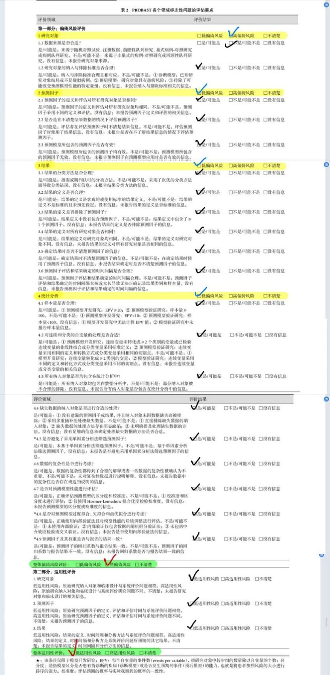
Fig. 1 Chen, T. ‘s paper quality evaluation

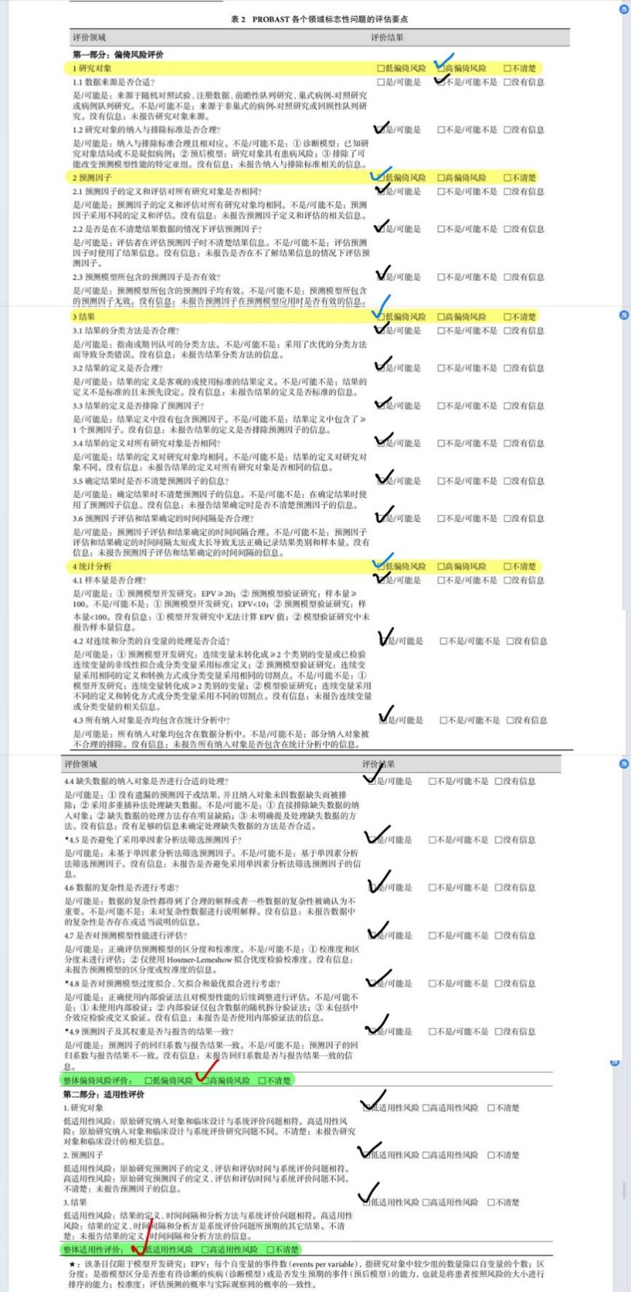
Fig. 2 Ren, C. ‘s paper quality evaluation

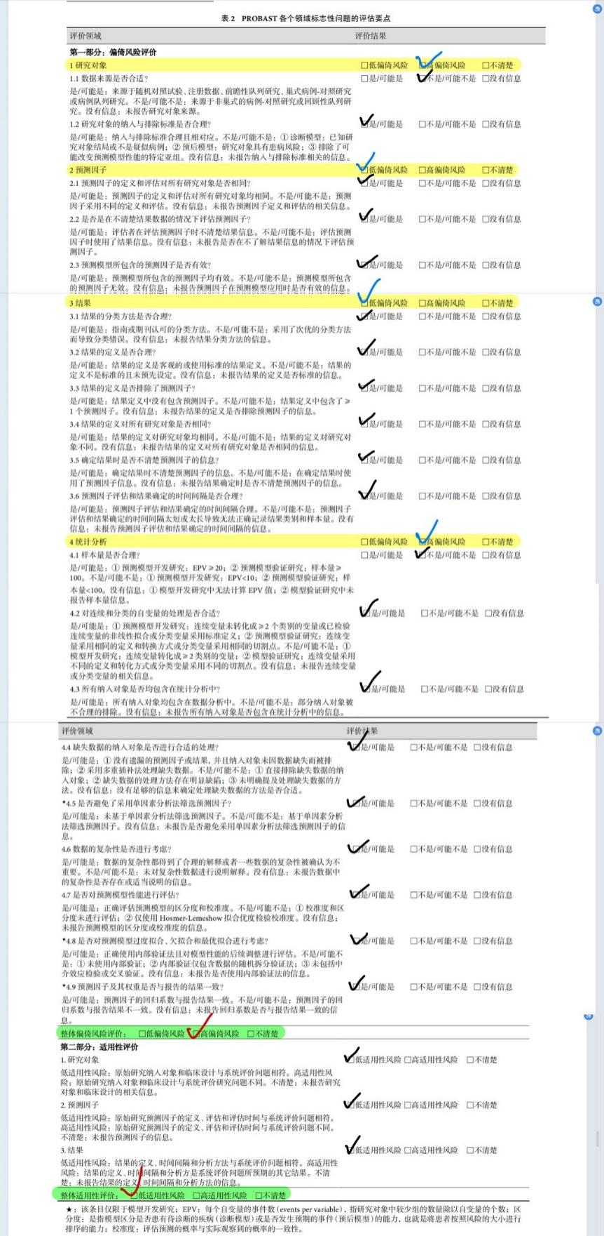
Fig. 3 Li, C. ‘s paper quality evaluation

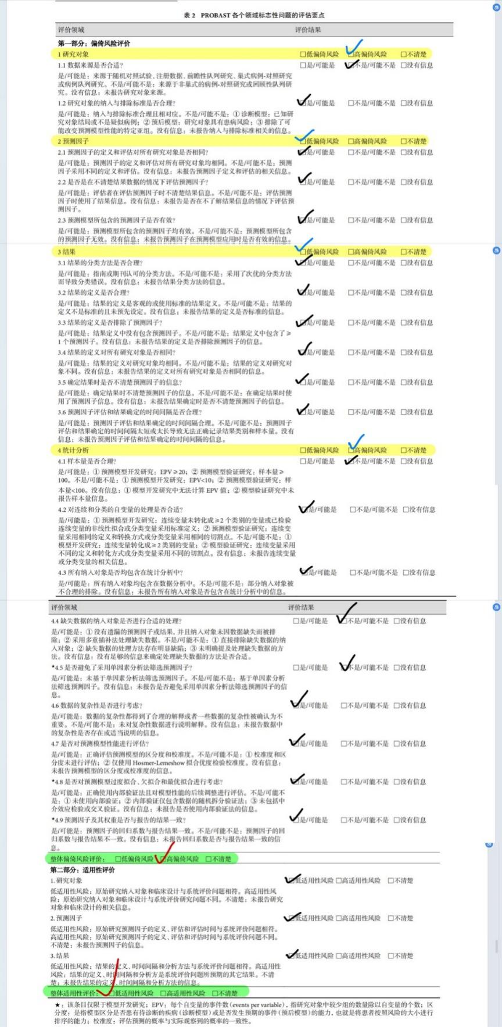
Fig. 4 Sun, X. F. ‘s paper quality evaluation

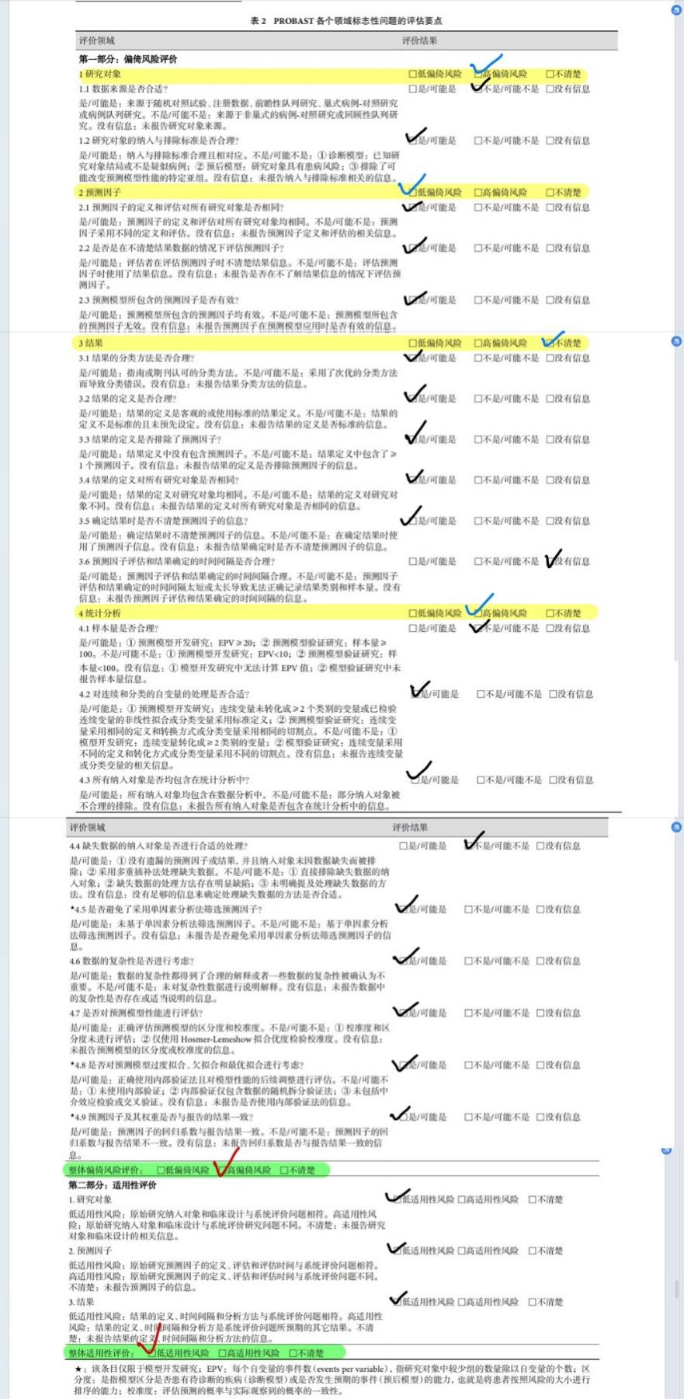
Fig. 5 Liu, L. ‘s paper quality evaluation

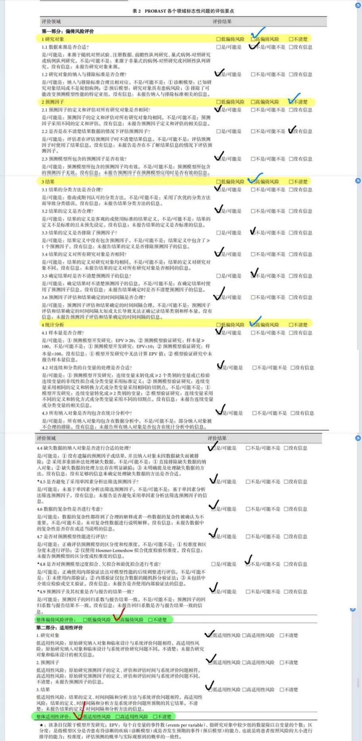
Fig. 6 Liu, Z. ‘s paper quality evaluation

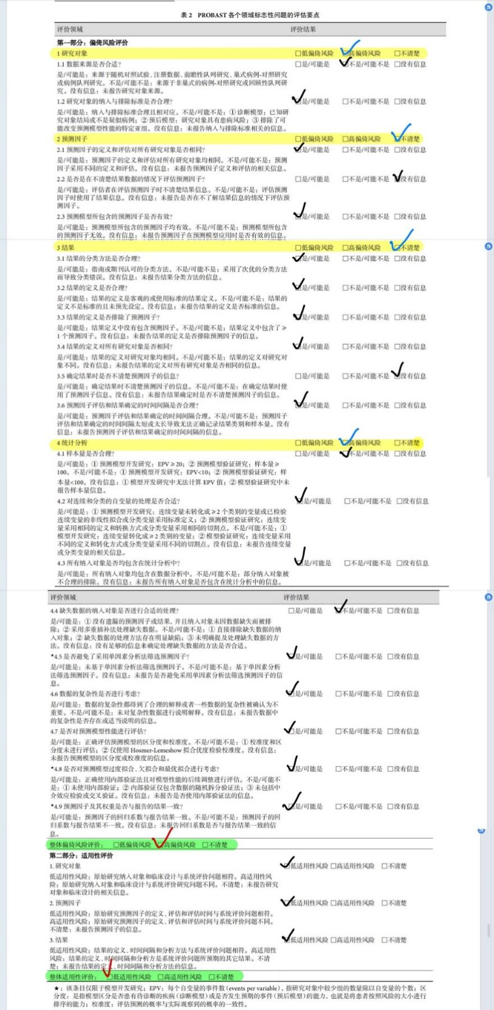
Fig. 7 Xiaoxuan Jia ‘s paper quality evaluation

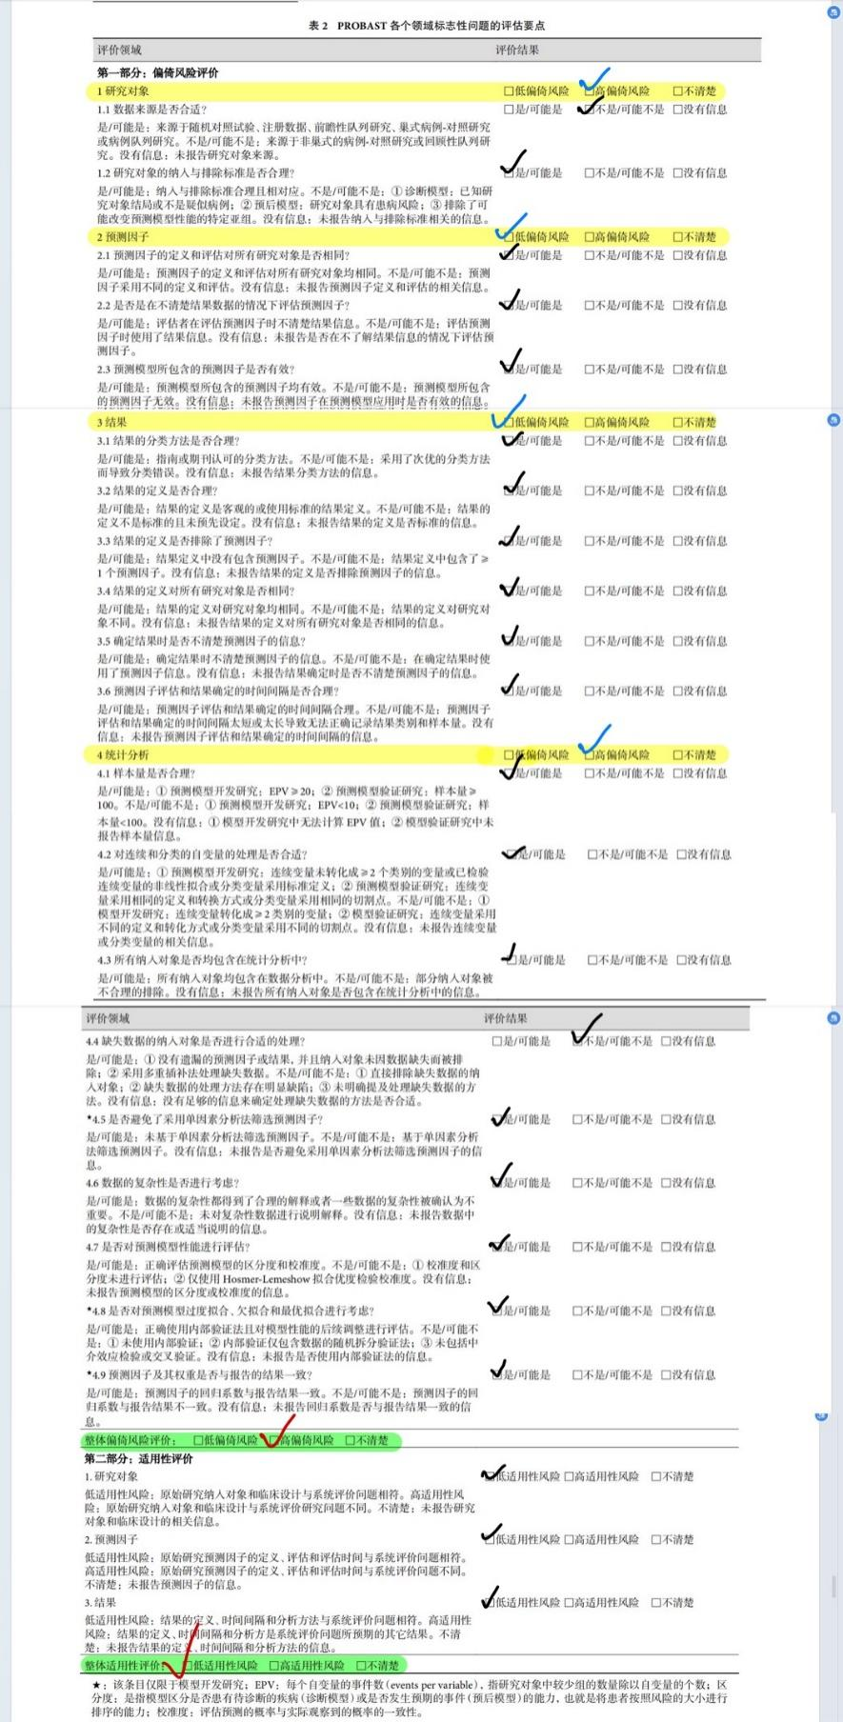
Fig. 8 Caiyue Ren ‘s paper quality evaluation

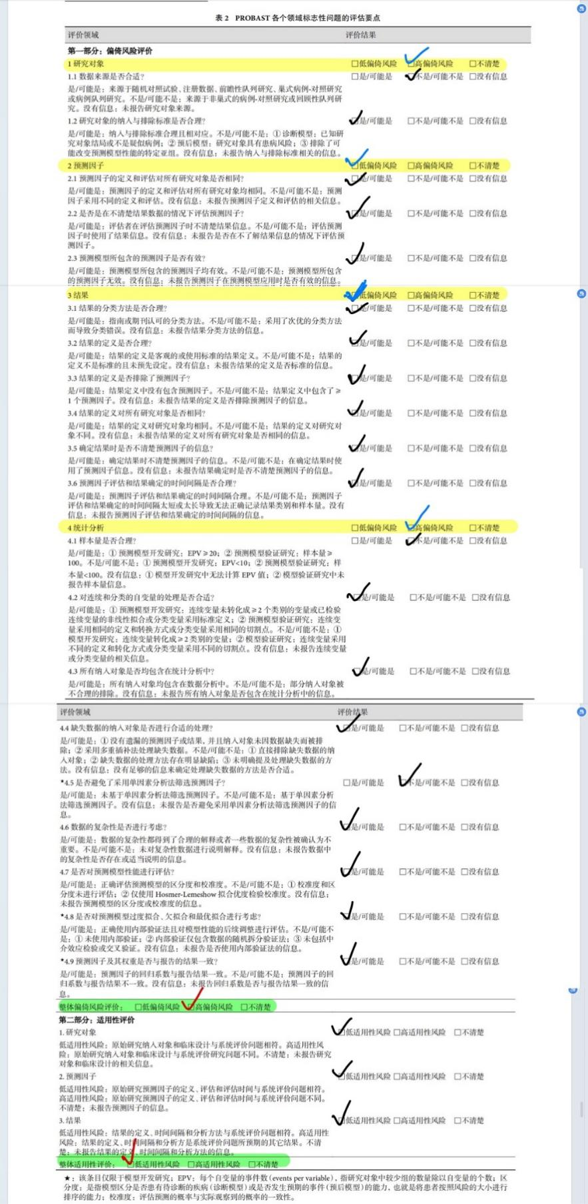
Fig. 9 Cui Zhang ‘s paper quality evaluation

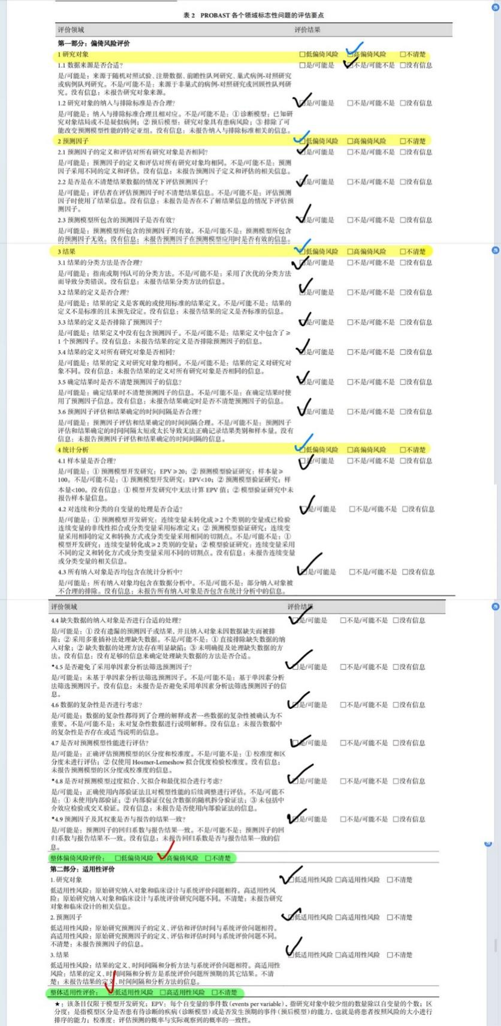
Fig. 10 Weiqun Ao ‘s paper quality evaluation

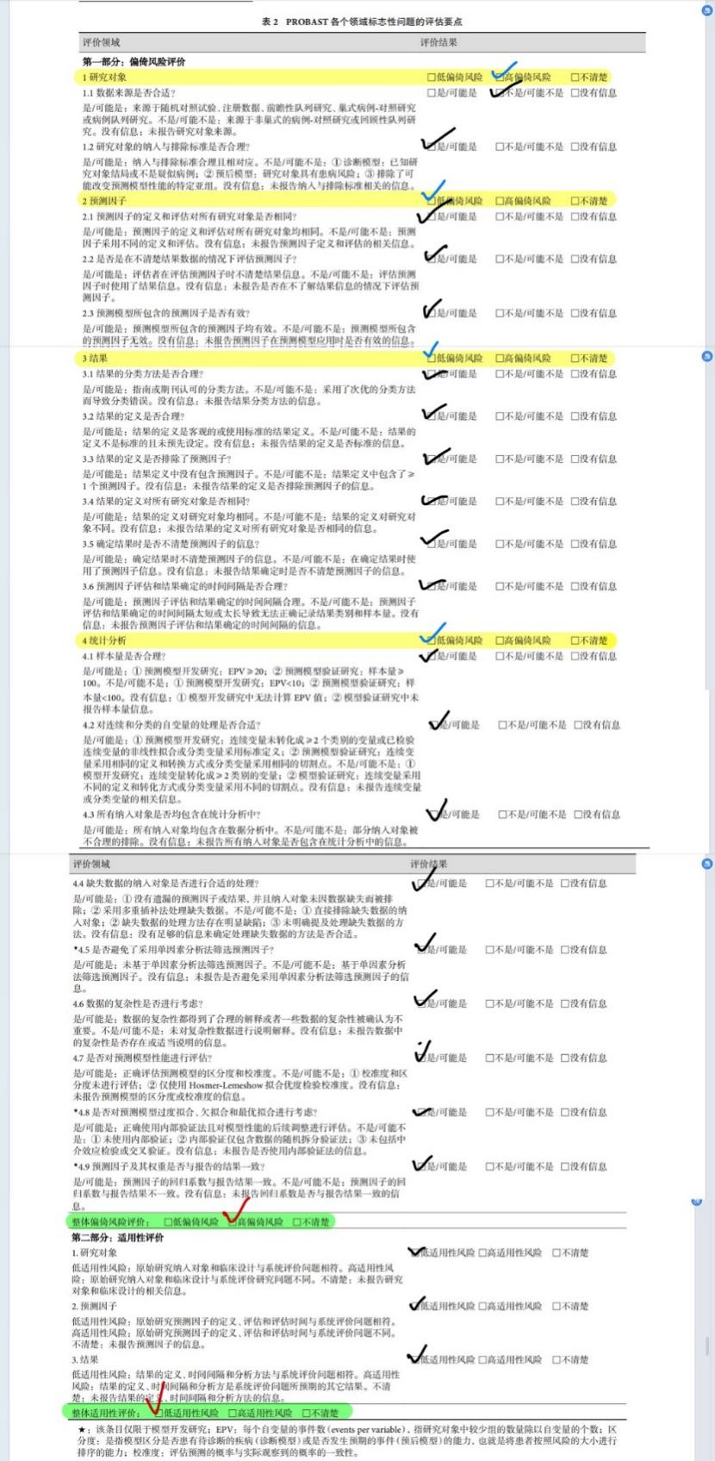
Fig. 11 Hairui Chu ‘s paper quality evaluation

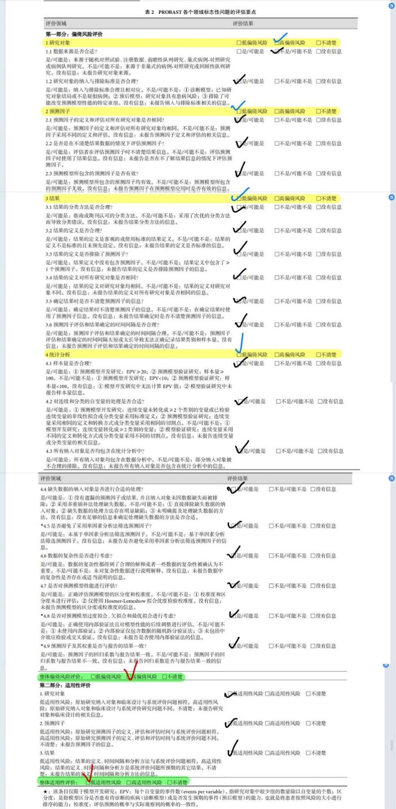
Fig. 12 Chao Wang ‘s paper quality evaluation

Supplementary file 3: Characteristics of the included studies

Study | County | Study design | No.patients in the train set | No.patients in the test set | Technique used for feature selection | Types of machine learning | Data source
Chen, T.(2019) | China | Retro | 130 | 92 | Relief | SVM,LR,LR,LR | Multiple institution
Caiyue Ren(2019) | China | Retro | 117 | 51 | LASSO | LR,LR | Single institution
Chao Wang(2019) | China | Retro | 233 | 100 | stepwise backward | LR | Single institution
Ren, C.(2020) | China | Retro | 308 | 132 | LASSO | LR | Single institution
Li, C.(2021) | China | Retro | 167 | 39 | forward likelihood ratio (LR) | LR | Single institution
Weiqun Ao(2021) | China | Retro | 165 | 71 | LASSO | LR,LR | Single institution
Hairui Chu(2021) | China | Retro | 205 | 87 | LASSO | LR | Single institution
Sun, X. F.(2022) | China | Retro | 69 | 34 | stepwise backward | LR,XGboost,linear regression | Single institution
Liu, L.(2023) | China | Retro | 179 | 79 | LASSO | LR | Single institution
Xiaoxuan Jia(2023) | China | Retro | 74 | 37 | LASSO | QDA | Multiple institution
Cui Zhang(2023) | China | Retro | 161 | 148 | stepwise regression | LR,GDBT | Multiple institution
Liu, Z.(2024) | China | Retro | 345 | 149 | stepwise backward | LR | Single institution

Supplementary file 4: Risk of bias assessment of the included studies

Author | Year | Risk of bias |  |  |  | Overall risk of bias rating | Overall applicability rating
 |  | Participants | Predictors | Outcome | Analysis
Chen, T. | 2019 | high | low | low | low | high | low
Ren, C. | 2020 | high | low | low | low | high | low
Li, C. | 2021 | high | low | low | high | high | low
Sun, X. F. | 2022 | high | low | low | high | high | low
Liu, L. | 2023 | high | low | unclear | high | high | low
Liu, Z. | 2024 | high | unclear | high | high | high | low
Xiaoxuan Jia | 2023 | high | unclear | unclear | high | high | low
Caiyue Ren | 2019 | high | low | low | high | high | low
Cui Zhang | 2023 | high | low | low | high | high | low
Weiqun Ao | 2021 | high | low | low | low | high | low
Hairui Chu | 2021 | high | low | low | low | high | low
Chao Wang | 2019 | high | low | low | low | high | low

