Appendix 1. Supplementary tables and figures.

Supplementary Tables
Table S1. Outcomes in the per-protocol cohort. Values are median [IQR] or mean (SD).
 | Overall  (n = 23) | Control  (n = 8) | Non-mentored prehabilitation  (n = 9) | Mentored prehabilitation  (n = 6)
Activity counts
Total activity count | 7,287,085 [5767559 to 9150332] | 6,294,369 [4,835,907 to 7,686,356] | 8,152,160 [5,772,748 to 10,526,867] | 7,493,204 [6,679,555 to 8,585,958]
EQ-5D-5L Health Scores
Baseline | 80.00 [67.50 to 95.00] | 82.50 [78.75 to 91.25] | 95.00 [65.00 to 95.00] | 70.00 [55.00 to 73.75]
Pre-operative | 80.00 [72.50 to 92.50] | 92.50 [84.75 to 99.25] | 80.00 [75.00 to 90.00] | 67.50 [65.00 to 77.50]
Postoperative | 80.00 [67.50 to 92.50] | 80.00 [50.00 to 91.25] | 85.00 [75.00 to 95.00] | 77.50 [67.50 to 83.75]
DASI Scores
Baseline | 50.20 [40.08 to 58.20] | 50.45 [49.01 to 58.20] | 50.70 [36.70 to 58.20] | 43.83 [38.76 to 54.89]
Pre-operative | 41.45 [31.20 to 50.45] | 44.70 [35.01 to 52.58] | 34.70 [30.20 to 58.20] | 39.08 [31.08 to 42.39]
TUAG Scores (s)
Baseline | 9.45 (2.37) | 10.04 (3.38) | 9.46 (1.90) | 8.66 (1.29)
Pre-operative | 9.35 (1.45) | 9.66 (1.30) | 9.51 (1.76) | 8.60 (1.13)
Gait speed (m/s)
Baseline | 1.16 (0.23) | 1.14 (0.25) | 1.11 (0.21) | 1.28 (0.21)
Pre-operative | 6.27 (23.54) | 14.58 (38.15) | 1.13 (0.22) | 1.19 (0.13)
Leg muscle strength
Baseline Force (kg) | 19.73 [14.60 to 22.44] | 16.48 [14.18 to 22.31] | 22.23 [18.70 to 22.57] | 18.40 [15.14 to 21.13]
Pre-operative Force (kg) | 19.40 [18.00 to 23.70] | 19.38 [17.31 to 21.98] | 18.76 [18.05 to 22.99] | 22.60 [19.40 to 23.70]
Baseline Peak Force (sec) | 4.24 [3.74 to 4.61] | 4.13 [3.60 to 4.52] | 4.24 [3.97 to 4.52] | 4.40 [3.32 to 4.61]
Pre-operative Peak Force (sec) | 3.79 [3.47 to 4.33] | 3.72 [3.60 to 4.47] | 3.94 [2.75 to 4.10] | 3.79 [3.70 to 4.20]

Table S2. Odd ratios (OR) for complications across patient groups. Adjusted OR includes adjustments for patient age, gender, aneurysm size and the presence of cardiovascular, respiratory comorbidities.

 | Unadjusted OR (95% CI) | Adjusted OR (95% CI)
Control | Reference
Non-mentored Prehabilitation | 1.00 (0.106 - 9.483) | 1.175 (0.056 - 26.4)
Mentored Prehabilitation | 0.50 (0.022 - 5.914) | 0.856 (0.030 - 19.6)

Table S3. EQ-5D-5L subdomain changes after intervention.
 | Overall  (n = 43) | Control  (n = 14) | Non-mentored prehabilitation  (n = 14) | Mentored prehabilitation  (n = 15) | p value
Pain |  |  |  |  | 0.515
Deterioration | 9 (20.9) | 1 ( 7.1) | 4 ( 28.6) | 4 (26.7)
Improvement | 7 (16.3) | 2 (14.3) | 2 ( 14.3) | 3 (20.0)
Neutral | 24 (55.8) | 10 (71.4) | 8 ( 57.1) | 6 (40.0)
Missing | 3 ( 7.0) | 1 ( 7.1) | 0 ( 0.0) | 2 (13.3)
Mobility |  |  |  |  | 0.042
Deterioration | 7 (16.3) | 0 ( 0.0) | 2 ( 14.3) | 5 (33.3)
Improvement | 5 (11.6) | 2 (14.3) | 0 ( 0.0) | 3 (20.0)
Neutral | 28 (65.1) | 11 (78.6) | 12 ( 85.7) | 5 (33.3)
Missing | 3 ( 7.0) | 1 ( 7.1) | 0 ( 0.0) | 2 (13.3)
Anxiety/Depression |  |  |  |  | 0.740
Deterioration | 12 (27.9) | 5 (35.7) | 3 ( 21.4) | 4 (26.7)
Improvement | 9 (20.9) | 3 (21.4) | 4 ( 28.6) | 2 (13.3)
Neutral | 19 (44.2) | 5 (35.7) | 7 ( 50.0) | 7 (46.7)
Missing | 3 ( 7.0) | 1 ( 7.1) | 0 ( 0.0) | 2 (13.3)
Usual Activity |  |  |  |  | 0.320
Deterioration | 6 (14.0) | 1 ( 7.1) | 2 ( 14.3) | 3 (20.0)
Improvement | 5 (11.6) | 2 (14.3) | 0 (0.0) | 3 (20.0)
Neutral | 29 (67.4) | 10 (71.4) | 12 (85.7) | 7 (46.7)
Missing | 3 ( 7.0) | 1 ( 7.1) |  | 2 (13.3)
Self-Care |  |  |  |  | 0.179
Deterioration | 2 ( 4.7) | 0 ( 0.0) | 0 (0.0) | 2 (13.3)
Improvement | 3 ( 7.0) | 1 ( 7.1) | 0 (0.0) | 2 (13.3)
Neutral | 35 (81.4) | 12 (85.7) | 14 (100.0) | 9 (60.0)
Missing | 3 ( 7.0) | 1 ( 7.1) |  | 2 (13.3)

Table 3. Secondary Outcomes: Incidence of postoperative complications. Values are number (proportion).
 | Intention-to-treat cohort  (n = 43) | Per-protocol cohort  (n = 23)
Any complication | 5 (12.2%) | 2 (8.7%)
Cardiovascular complications | 1 (2.4%) | 1 (4.3%)
Respiratory complications | 5 (12.2%) | 2 (8.7%)
Renal complications | 1 (2.4%) | 1 (4.3%)

Supplementary Figures
Figure S1: Activity counts in the Per Protocol cohort.
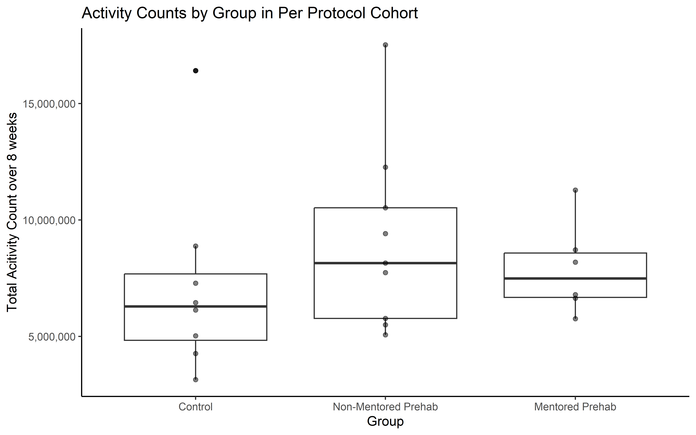

Figure S2: EQ-5D-5L Overall Health Scores in the Per Protocol cohort.
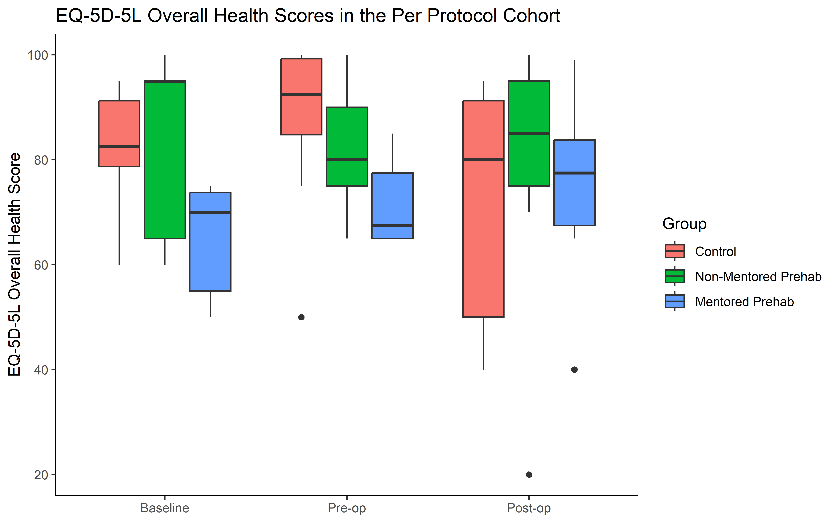

Figure S3: Graph to demonstrate rate of recruitment.

