1D Modelling and Diagnostics of Cold Capacitively Coupled Radio-Frequency Argon Plasma
Sharona Atlas^{1,2}, Shani Har Lavan¹, Amir Kaplan², Avi Lerer¹, Illya Rozenberg¹, and Joshua H. Baraban¹
¹ Department of Chemistry, Ben-Gurion University of the Negev, P.O. Box 653, Beer-Sheva, 84105, Israel
² Department of Chemical Engineering, Nuclear Research Center Negev (NRCN), P.O Box 9001, Beer-Sheva, 84190, Israel

E-mail: jbaraban@bgu.ac.il

Supporting information

Table of contents:
 | Page
- Quantitative multivariate analysis – model A description | 2
- Theoretical modeling using finite elements method – model B description | 3
- Optical emission spectroscopy results and observed trends | 6
- Model A results | 8
- Model B results | 12

1. Quantitative multivariate analysis – model A description

Our experiments matrix includes 82 experiments with different working conditions, as described in Table SI-2. Some of the experiments (low gas flow and low power) were not taken into the model, so the model matrix is the internal one in this table. Additional experiments were done to verify the model.

Table SI-1: Gas pressure correlated to gas flow
Gas flow, SCCM | Gas pressure,  mTorr
10 | 75
20 | 120
30 | 158
40 | 192
50 | 225
60 | 255
70 | 286
80 | 316
90 | 346
100 | 376

Table SI-2: Experiments matrix
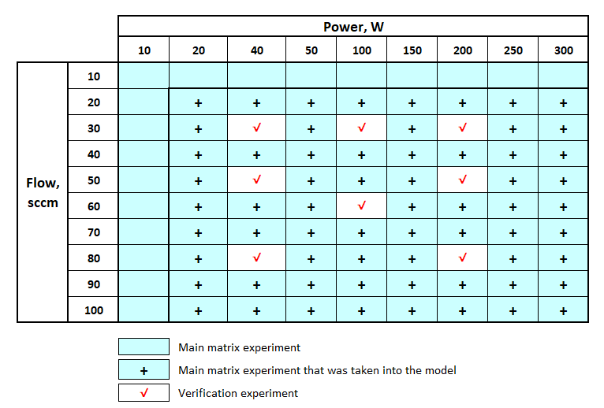

Table SI-3: Models A coefficients and parameters impact on intensity
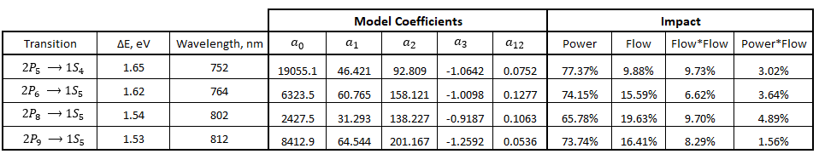

Table SI-4: Verification experiments for model A
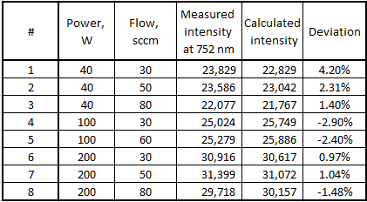

2. Theoretical modeling using finite elements method - model B description
The model equations are based on the Drift Diffusion interface, the Electrostatic interface and the Heavy Species Transport interface [63].
The equation that governs the electron transport is:
- $\frac{∂n_{e}}{∂t}+ ∇∙Γ_{e}= R_{e}∙\left(u∙∇\right)n_{e}$
Definition of the electron flux vector:
- $Γ_{e}= -\left(μ_{e}∙E\right)n_{e}-D_{e}∙∇n_{e}$
Rate of change of the electron energy density:
- $\frac{∂n_{e}}{∂t}+∇∙Γ_{e}+E∙Γ_{e}=S_{en}∙\left(u∙∇\right)n_{e}+(Q+ Q_{gen})/q$
Definition of the electron energy flux vector:
- $Γ_{ε}= -\left(μ_{ε}∙E\right)n_{e}-D_{ε}∙∇n_{ε}$
Electric field:
- $E= -∇V$
Electrostatic equation:
- $∇∙D= ρ_{q}$
Where:
D is the electric displacement field, C/m²
ρ_{q} is the volumetric charge density, SI unit: C/m³
E is the electric field: V/m
V is the electric potential, V
u is the neutral fluid velocity vector, m/s
n_{e} is the electron density, 1/m³
$Γ_{e}$ is the electron flux vector, 1/(m²⋅s)
q is the is the electron charge, C
R_{e} is electron rate expression, 1/(m³⋅s)
S_{en} is the energy loss/gain due to inelastic collisions, V/(m³⋅s)
Q is external heat sources, W/m³
$Q_{gen}$ is a generalized heat source, W/m³
$w_{i}$is the electron energy, V

The Druyvesteyn EEDF:
- $f\left(ε\right)= {2φ}^{-3/2}β_{1}exp\left[-{\left(\frac{εβ_{2}}{φ}\right)}^{2}\right]$ , where:
Computing rate coefficients, k_{k}, for the electron collisions reactions is done according to the equation:
- $k_{k}=γ\int_{0}^{∞}{εσ_{k}\left(ε\right)f\left(ε\right)de}$ , where: $γ=\sqrt{2q{/m}_{e}}$
Where:
σ_{k} is the cross section for reaction k
k_{k} is the constant rate for reaction k
$m_{e}$ is the electron mass, kg
$ω_{i}$ is mass fraction of species $i$

Assuming a reacting flow consists of k = 1, …, Q species and j = 1, …, N reactions, the equation for the first Q-1 species is given by:
- $ρ\frac{∂}{∂t}\left(ω_{k}\right)+ ρ\left(u∙∇\right)ω_{k}= ∇∙j_{k}+ R_{k}$
- $\sum{ω_{i}}=1$
Where:
$ρ$ is the density of the mixture
$ω_{k}$ is the mass fraction of the $k$^{th} species
$j_{k}$ is the diffusive flux vector
$R_{k}$ is the rate expression for species $k$, kg/(m³⋅s)
The diffusive flux vector is defined as:
- $j_{k}=ρω_{k}V_{k}$
Where:
$V_{k}$ is the multicomponent diffusion velocity for species k.
$V_{k}$ is calculated assuming property of “Mixture Averaged” in the Diffusion Model:

- $V_{k}=D_{k,m}\frac{∇ω_{k}}{ω_{k}}+D_{k,m}\frac{∇M_{n}}{M_{n}}+D_{k}\frac{T∇T}{T}-z_{k}μ_{k,m}E$
Where:
$D_{k,m}$ is the mixture averaged diffusion coefficient, m²/s
$M_{n}$ is the mean molar mass of the mixture, kg/mol
T is the gas temperature, K
$D_{k}^{T}$ is the thermal diffusion coefficient for species k
$z_{k}$ is the charge number for species k, m²/(V⋅s)
$μ_{k,m}$ is the charge number for species k, m²/(V⋅s)

The mixture averaged diffusion coefficient, $D_{k,m}$ for species k is defined as:
- $D_{k,m}=\frac{1-ω_{k}}{\sum_{k=1}^{Q}{x_{j}/D_{kj}}}$
And the mean molar mass:

- $\frac{1}{M_{n}}=\sum_{k=1}^{Q}{\frac{ω_{k}}{M_{k}}}$

The mole fraction for species k, is computed from the mass fraction of species k and the mean molar mass:
- $x_{k}=\frac{ω_{k}}{M_{k}}M_{n}$

The mixture averaged mobility $μ_{k,m}$ is computed using Einstein’s relation:

- $μ_{k,m}=\frac{{qD}_{k,m}}{k_{B}T}$
Where:
$k_{B}$ is Boltzmann constant, J/K and q is the unit charge, C.

Computational mesh – element size along the reactor length
The mesh is divided to 450 computational elements. The size of the elements is set according to a linear growth function, where the smallest size is near the electrodes, and the largest size is at the center of the plasma.
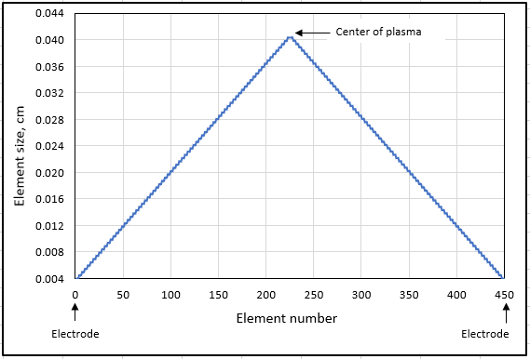
Figure SI-1: Computational mesh – element size

4. OES results and observed trends
Figures SI-2 to SI-4 show the spectrum at different working conditions:
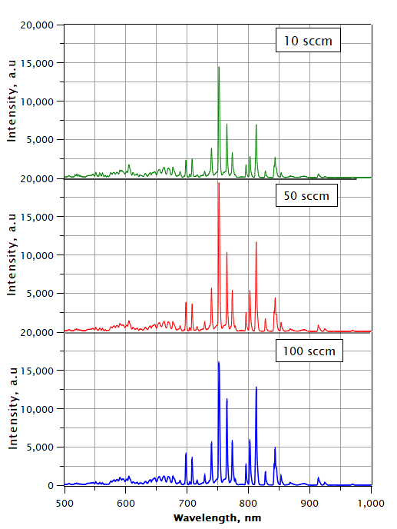
Figure SI-2: OES spectrum at plasma power of 10 W and gas flow of 10 sccm, 50 sccm and 100 sccm

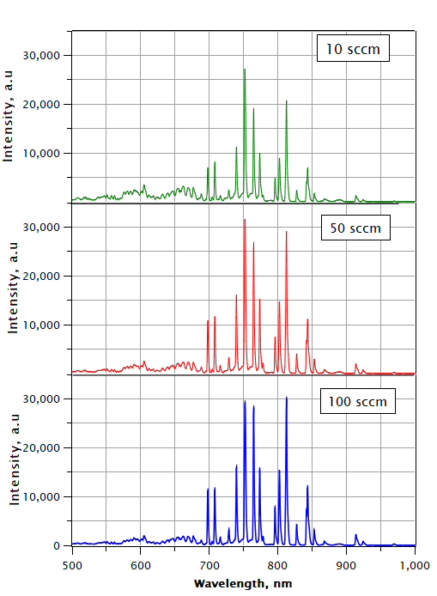
Figure SI-3: OES spectrum at plasma power of 200 W and gas flow of 10 sccm, 50 sccm and 100 sccm

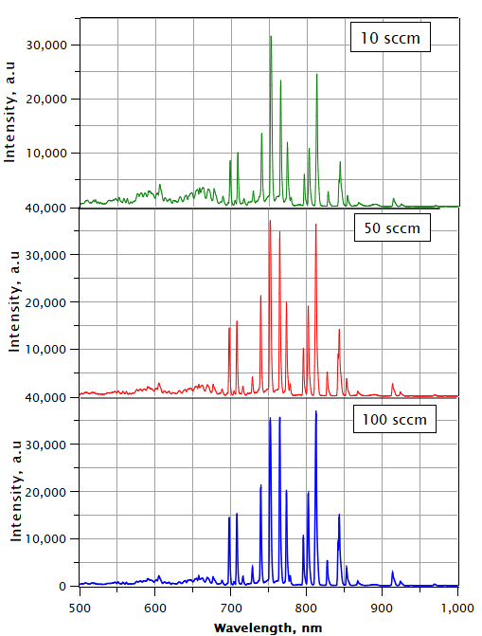
Figure SI-4: OES spectrum at plasma power of 300 W and gas flow of 10 sccm, 50 sccm and 100 sccm

Figure SI-5: General overview – Intensity of specific Ar I peak as a function of plasma power and gas flow rate

5. Model A results

Figure SI-6: Pareto analysis of parameters in predicted intensity

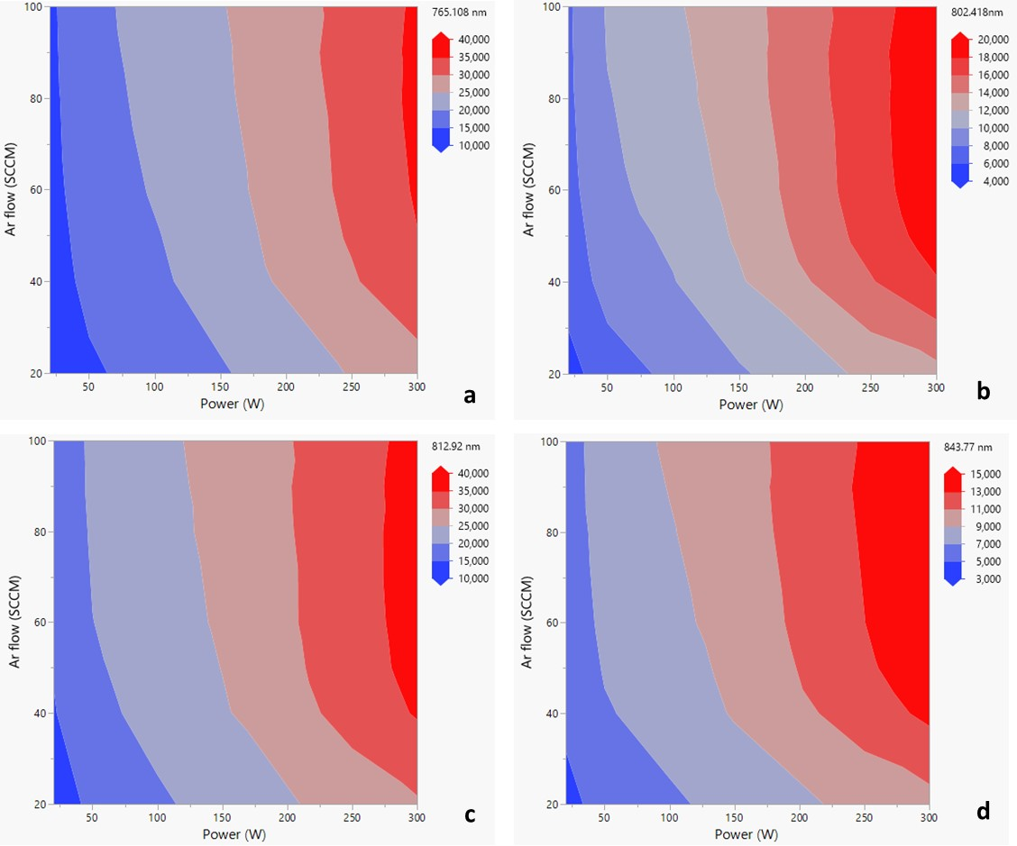
Figure SI-7: Contour plot for (a) 765.108nm; (b) 802.418 nm; (c) 812.92 nm; (d) 843.77 nm

Dynamic Contour Profiler
Model A is presented below as a contour profiler, so that any desirable intensity can be set and the working conditions designed to achieve this intensity. In Figure SI-12 the desirable intensity of 752 nm was set to at least 25,000 a.u. and 32,000 maximum as arbitrary criterions for this example. The area filled in white color represents the working conditions window. Any combination of flow rate and plasma power within this area will give the desirable outcome. Outside of this area (labelled with red) the desired intensity is not achieved. This tool can also give information on the confidence interval when choosing working conditions, i.e., how “close” we are to the edge of the contour or how deep we are inside the working window area. The “deeper” we are, the higher the model confidence that the desired target will be met.
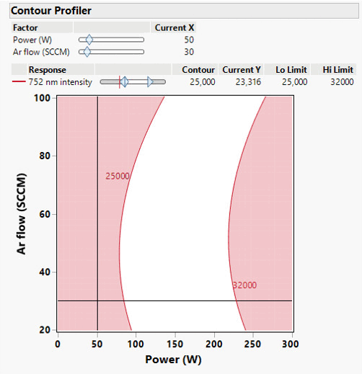
SI-8: Contour profiler - dynamic visualization
(Attached is animation file)
Dynamic Prediction Profiler
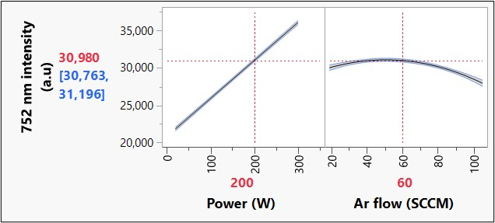
SI-9: (a) Prediction profiler for intensity of 752 nm peak – static visualization
The calculated value for 200 W and 60 sccm is 30,980 a.u and it is within the confidence interval of 30,763 to 31,196 a.u. The black line in the center is the model line and the two blue lines on the sides represent 95% confidence interval of the mean response. The uncertainty band along the curves is very narrow, pointing to a small error.

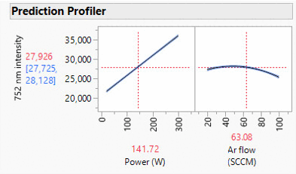

SI-9: (b) Prediction profiler for intensity of 752 nm peak – dynamic visualization
(Attached is animation file)

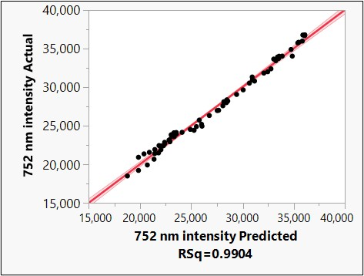

Figure SI-10: Actual by predicted 752 nm intensity

P value is small enough (<0.001) to indicate very convincing significance of the model (very strong evidence against the null hypothesis).

6. Model B results
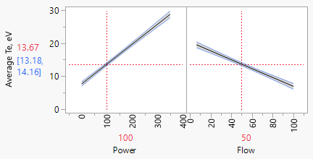
a
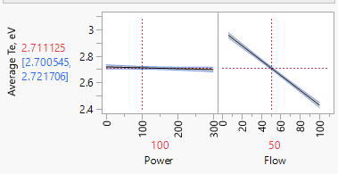
b
Figure SI-11: Prediction of electron temperature as function of plasma power and gas flow (a) entire plasma gap; (b) bulk region

Figure SI-12: Pareto analysis of parameters in predicted electron temperature

