Supporting Information

Optical assessment of lignin-containing nanocellulose films under extended sunlight exposure

Rustem Nizamov^{1#}, Joice Kaschuk^{2,3,4#*}, Yazan Al Haj⁵, Mikael Nyberg¹, Monireh Imani^{3,6}, Eva Pasquier³, Orlando Rojas^{3,4}, Tiffany Abitbol⁷, Jaana Vapaavuori⁵, Kati Miettunen¹
1. Department of Mechanical and Materials Engineering, Faculty of Technology, University of Turku, Turku, FI-20500 Finland
2. Physical Chemistry and Soft Matter, Wageningen University and Research, 6708 WE, Wageningen, The Netherlands.
3. Department of Bioproducts and Biosystems, School of Chemical Engineering, Aalto University, Vuorimiehentie 1, 02150 Espoo, Finland
4. Department of Chemical and Biological Engineering, The University of British Columbia, 2360 E Mall, V6T 1Z3, Vancouver - BC, Canada.
5. Department of Chemistry and Materials Science, School of Chemical Engineering, Aalto University, Kemistintie 1, 02150 Espoo, Finland.
6. Mirka Ltd., Pensalavägen 210, FI-66850 Jeppo, Finland
7. Institute of Materials, School of Engineering, École Polytechnique Fédérale de Lausanne (EPFL), 1015, Switzerland.
# contributed equally to this work.
* Correspondent author: joice.kaschuk@wur.nl
KEYWORDS: stability, optoelectronics, mechanical properties, UV protection, biobased solar cells.
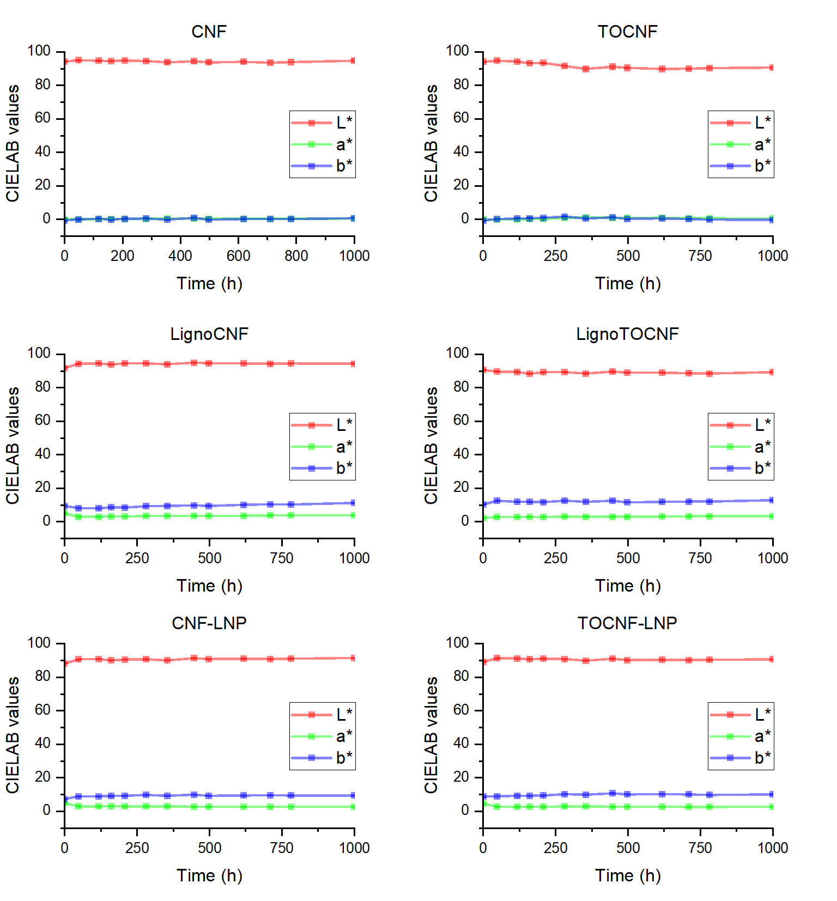
Figure S 1 - Variation of CIELAB values over time for nanocellulose films with standard deviation. The plots show the changes in lightness (L*), green-red component (a*), and blue-yellow component (b*) during a 1000-hour accelerated aging test. The L* value represents lightness ranging from black (0) to white (100), a* indicates the green to red spectrum, and b* indicates the blue to yellow spectrum. Error bars represent the standard deviation for three distinct regions of each film, ensuring uniformity in the data.

Table S 1 – Thicknesses of the NC films
Sample | Thickness (μm)
CNF | 40±1
LignoCNF | 60±2
CNF-LNP | 50±1
TOCNF | 40±2
LignoTOCNF | 80±5
TOCNF-LNP | 50±1

Table S 2 - Quantitative analysis of color alterations in the PVC samples covered by NC films, showing both ΔRGB and ΔL* after 1000 h of exposure to artificial sunlight.
 | CNF | TOCNF | LignoCNF | LignoTOCNF | CNF-LNP | TOCNF-LNP
ΔRGB | 64 ± 24 | 81.3 ± 6.1 | 9.1 ± 7.7 | 8.9 ± 4.6 | 11.7 ± 6.5 | 12 ± 7.8
ΔL* | -7 ±2.9 | -9.5 ± 1.8 | -1.1 ± 1.2 | -1.1 ± 0.9 | -1.4 ± 0.8 | -1.4 ± 1.1

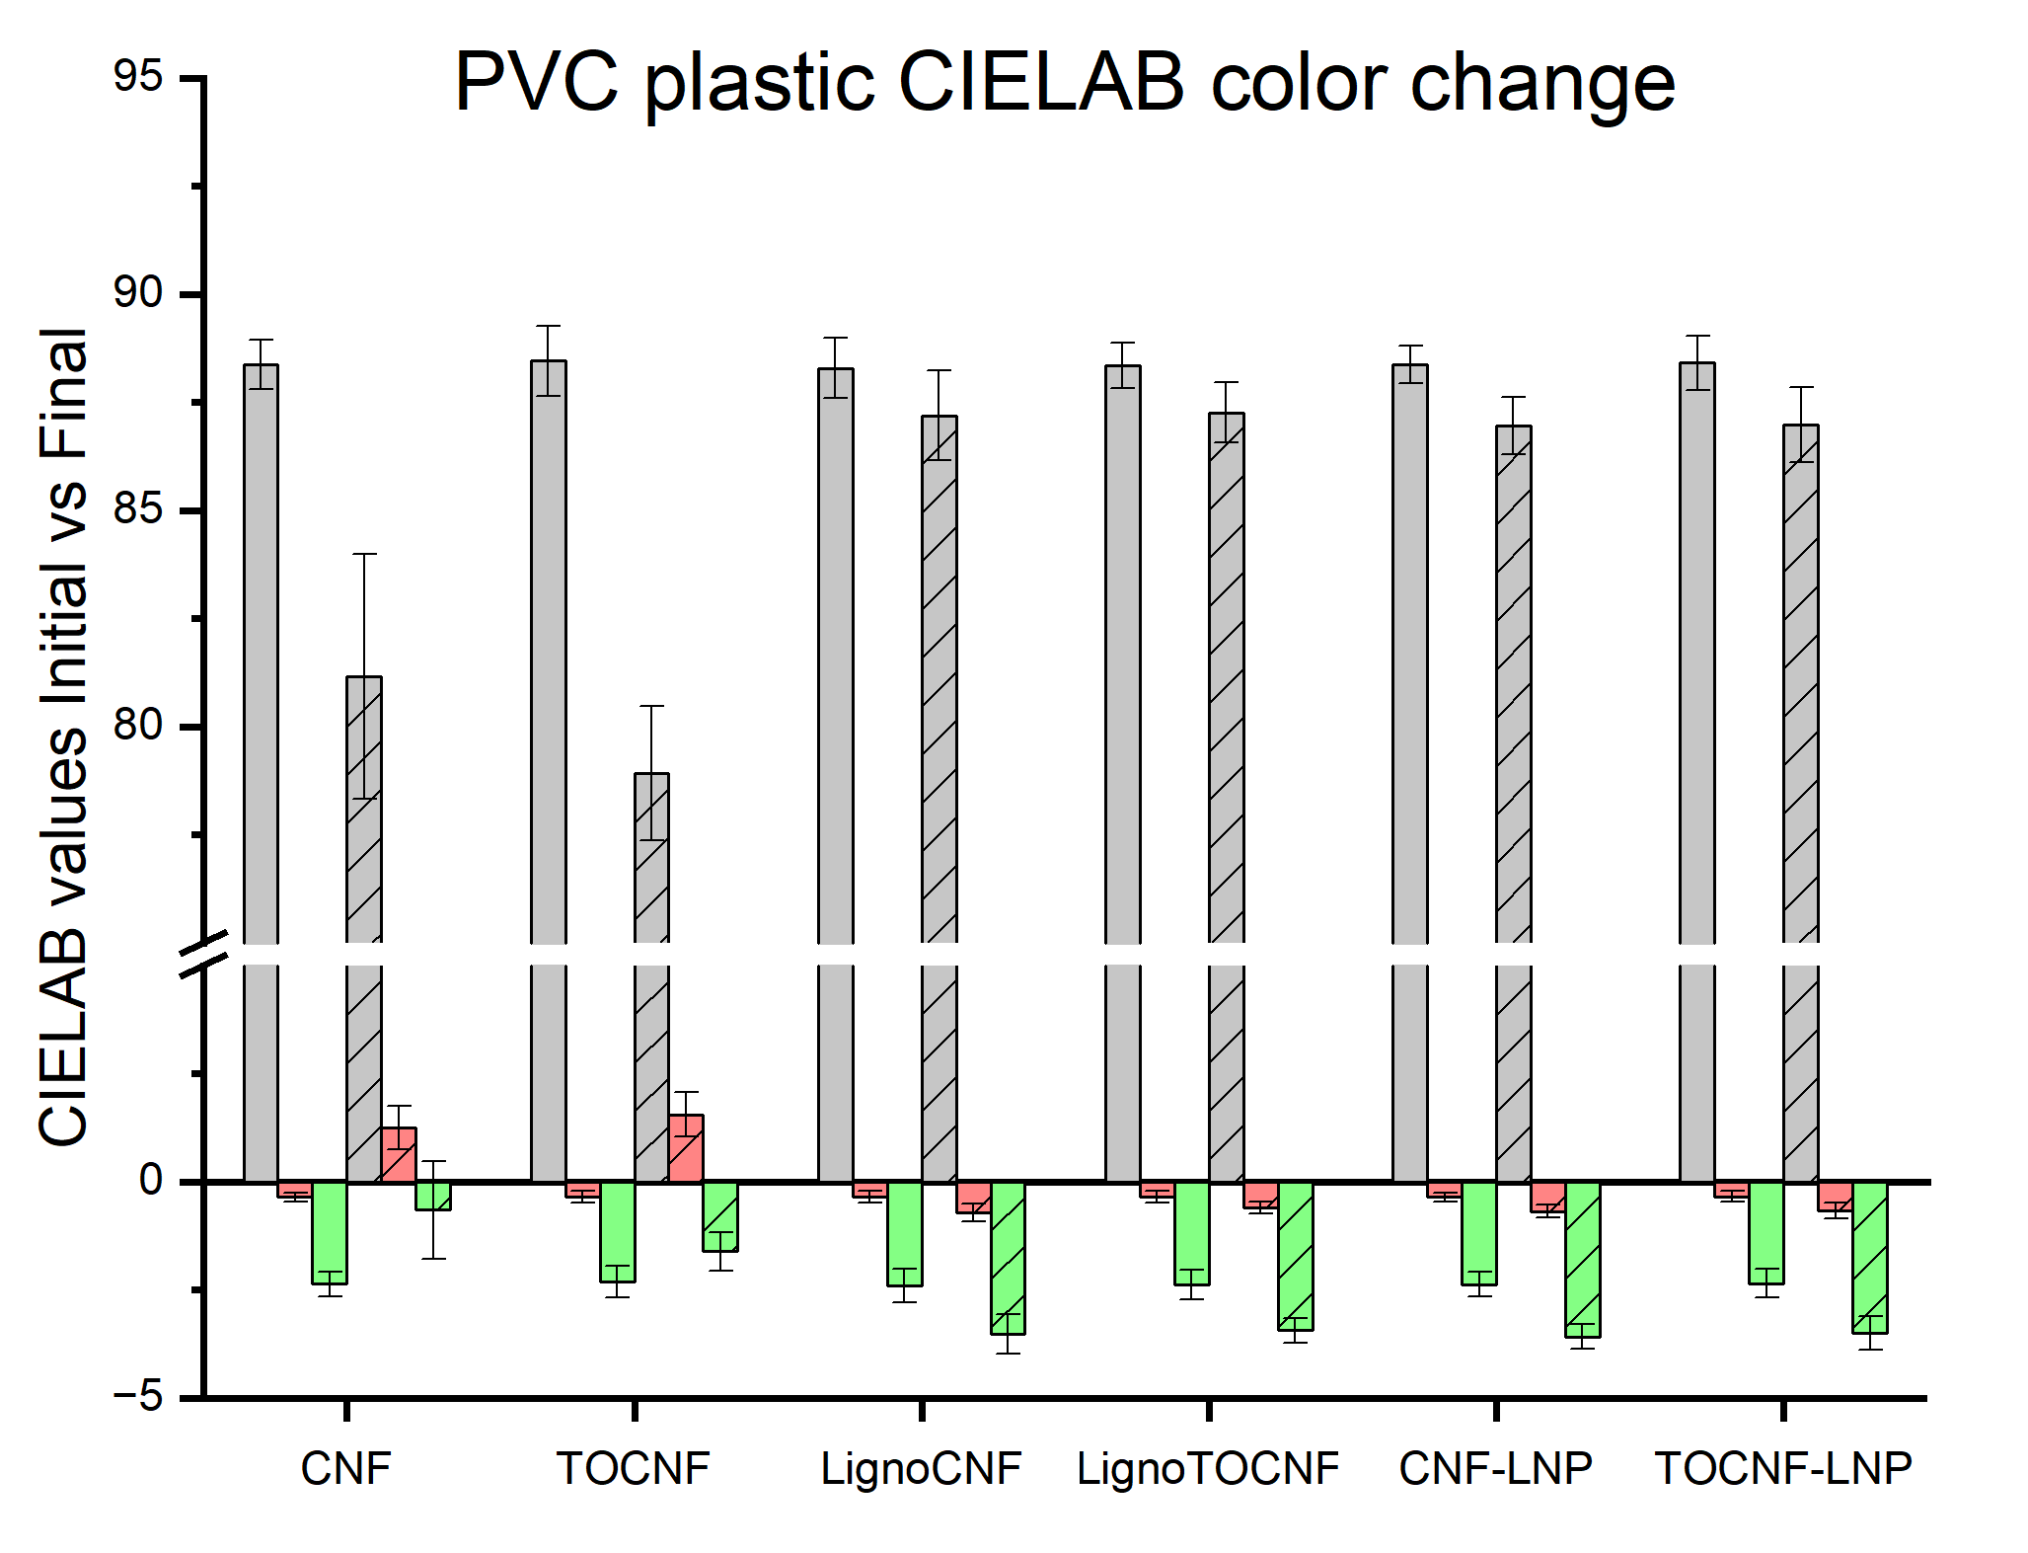
Figure S 2 - Changes in CIELAB color values for PVC plastic samples covered by various nanocellulose (NC) films before and after 1000 hours of exposure to artificial sunlight. The data is represented for different NC films: CNF, TOCNF, LignoCNF, LignoTOCNF, CNF-LNP, and TOCNF-LNP. The bar graph shows the CIELAB values for L* (gray), a* (red), and b* (green) for each sample. The initial values are solid bars, while the final values after exposure are hatched bars. Error bars represent the standard deviation across three distinct regions of each sample, providing insight into the uniformity of color changes.

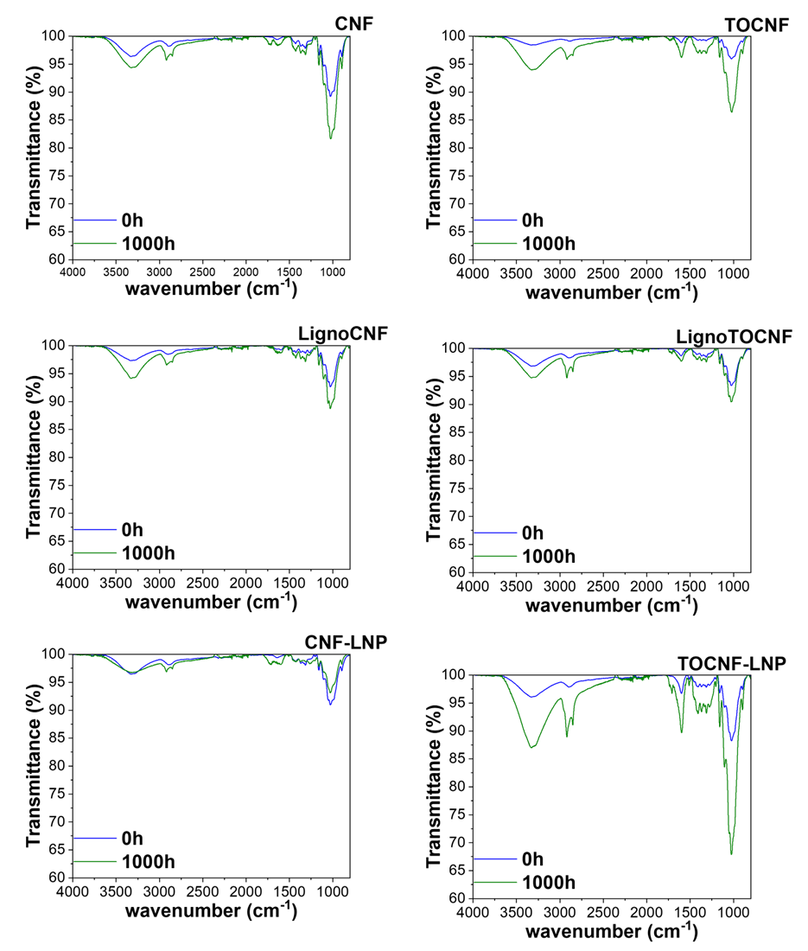
Figure S 3 - FTIR spectra of nanocellulose films before and after light exposure

