Supplementary material

Low-level Viremia Increases the Risk of Diabetes Mellitus in People with HIV in China: A 7-Year Retrospective Longitudinal Cohort Study

Contents

Supplementary material 1
Supplementary figure 1. Exclusion Flowchart of Study Participants. 2
Supplementary table 2. Cox regression for the association between VL groups and DM, stratified by sex and age. 3
Supplementary table 3. Association between VL groups and DM, after matching for sex and age, stratified by sex and age. 4

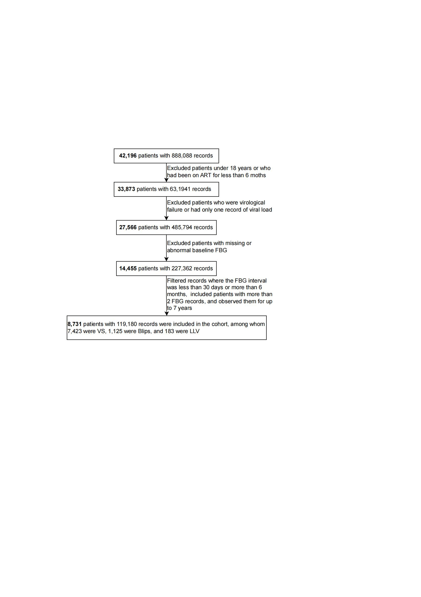

Supplementary figure 1. Exclusion Flowchart of Study Participants. Abbreviations: ART, antiretroviral therapy; FBG, fasting blood glucose; VS, viral suppression; Blips, transient episodes low-level viremia; LLV, persistent low-level viremia.

Supplementary table 2. Cox regression for the association between VL groups and DM, stratified by sex and age.
 | Enrollment VL groups | cHR(95%CI) | P
Stratified by sex
Male (N=5949)
 | VS | Ref.
 | Blips | 1.40(1.17,1.66) | <0.001
 | LLV | 1.65(1.15,2.37) | <0.001
Female (N=2782)
 | VS | Ref.
 | Blips | 1.38(1.03,1.85) | 0.030
 | LLV | 1.81(0.86,3.83) | 0.120
Stratified by age
Age:18-34 (N=2686)
 | VS | Ref.
 | Blips | 1.20(0.79,1.88) | 0.421
 | LLV | 0.57(0.08,4.03) | 0.569
Age:35-49 (N=2696)
 | VS | Ref.
 | Blips | 1.43(1.08,1.88) | 0.011
 | LLV | 2.24(1.26,3.98) | 0.006
Age:>=50 (N=3349)
 | VS | Ref.
 | Blips | 1.24(1.02,1.50) | 0.030
 | LLV | 1.25(0.84,1.87) | 0.277

Supplementary table 3. Association between VL groups and DM, after matching for sex and age, stratified by sex and age.
 | Enrollment VL groups | cHR(95%CI) | P
Stratified by sex
Male (N=1902)
 | VS | Ref.
 | LV | 1.30(1.05,1.62) | 0.015
Female (N=714)
 | VS | Ref.
 | LV | 1.14(0.78,1.65) | 0.500
Stratified by age
Age:18-34 (N=650)
 | VS | Ref.
 | LV | 0.99(1.01,1.75) | 0.979
Age:35-49 (N=704)
 | VS | Ref.
 | LV | 1.72(1.18,2.51) | 0.005
Age:>=50 (N=1262)
 | VS | Ref.
 | LV | 1.16(0.92,1.46) | 0.208

