Database  Appendix S1: Search Strategy per Database | Search Strategy
Pubmed/Medline  (189) | ("radioembolic"[All Fields] OR "radioembolisation"[All Fields] OR "radioembolization"[All Fields] OR "radioembolizations"[All Fields] OR ("radioembolic"[All Fields] OR "radioembolisation"[All Fields] OR "radioembolization"[All Fields] OR "radioembolizations"[All Fields]) OR ("sirtuins"[MeSH Terms] OR "sirtuins"[All Fields] OR "sirt"[All Fields]) OR "selective internal radiation therapy"[All Fields] OR "TARE"[All Fields] OR "transarterial radioembolization"[All Fields] OR "yttrium-90 radioembolization"[All Fields] OR "Y-90 radioembolization"[All Fields] OR "Y90 radioembolization"[All Fields] OR "intra-arterial radiotherapy"[All Fields] OR "microsphere radioembolization"[All Fields] OR (("target"[All Fields] OR "targetability"[All Fields] OR "targetable"[All Fields] OR "targeted"[All Fields] OR "targeting"[All Fields] OR "targetings"[All Fields] OR "targets"[All Fields] OR "targetted"[All Fields] OR "targetting"[All Fields]) AND ("radioembolic"[All Fields] OR "radioembolisation"[All Fields] OR "radioembolization"[All Fields] OR "radioembolizations"[All Fields]) AND ("therapeutics"[MeSH Terms] OR "therapeutics"[All Fields] OR "therapies"[All Fields] OR "therapy"[MeSH Subheading] OR "therapy"[All Fields] OR "therapy s"[All Fields] OR "therapys"[All Fields])) OR "Y-90 resin microspheres"[All Fields] OR "Y-90 glass microspheres"[All Fields] OR "Yttrium-90 resin microspheres"[All Fields] OR "Yttrium-90 glass microspheres"[All Fields] OR "yttrium radioisotopes"[All Fields]) AND ("hepatocellular carcinoma"[All Fields] OR "HCC"[All Fields] OR "liver cancer"[All Fields] OR "liver neoplasms"[All Fields] OR "hepatic carcinoma"[All Fields] OR "primary liver cancer"[All Fields] OR "hepatocellular cancer"[All Fields] OR "primary hepatic carcinoma"[All Fields]) AND ("durvalumab"[Supplementary Concept] OR "durvalumab"[All Fields] OR ("nivolumab"[MeSH Terms] OR "nivolumab"[All Fields] OR "nivolumab s"[All Fields]) OR ("pembrolizumab"[Supplementary Concept] OR "pembrolizumab"[All Fields]) OR ("tremelimumab"[Supplementary Concept] OR "tremelimumab"[All Fields]) OR ("atezolizumab"[Supplementary Concept] OR "atezolizumab"[All Fields]) OR ("sintilimab"[Supplementary Concept] OR "sintilimab"[All Fields]) OR ("ipilimumab"[MeSH Terms] OR "ipilimumab"[All Fields]) OR ("pembrolizumab"[Supplementary Concept] OR "pembrolizumab"[All Fields] OR "keytruda"[All Fields]) OR ("atezolizumab"[Supplementary Concept] OR "atezolizumab"[All Fields] OR "tecentriq"[All Fields]) OR ("durvalumab"[Supplementary Concept] OR "durvalumab"[All Fields] OR "imfinzi"[All Fields]) OR ("nivolumab"[MeSH Terms] OR "nivolumab"[All Fields] OR "opdivo"[All Fields] OR "nivolumab s"[All Fields]) OR "tyvyt"[All Fields] OR ("ipilimumab"[MeSH Terms] OR "ipilimumab"[All Fields] OR "yervoy"[All Fields]) OR "immune checkpoint inhibitor"[All Fields] OR "immune checkpoint inhibitors"[All Fields] OR "adoptive cell therapy"[All Fields] OR "adoptive immunotherapy"[All Fields] OR "cellular adoptive immunotherapy"[All Fields] OR "immune checkpoint blockade therapy"[All Fields] OR "PD-L1 inhibitors"[All Fields] OR "PD-1 inhibitors"[All Fields] OR "programmed cell death 1 receptor"[All Fields] OR "CTLA-4 inhibitors"[All Fields] OR "CTLA-4 antigen"[All Fields] OR "cytotoxic T-lymphocyte antigen 4"[All Fields] OR ("immunotherapy"[MeSH Terms] OR "immunotherapy"[All Fields] OR "immunotherapies"[All Fields] OR "immunotherapy s"[All Fields]) OR "monoclonal antibodies"[All Fields] OR "monoclonal antibody"[All Fields] OR "immunomodulating agent"[All Fields] OR "immunomodulating agents"[All Fields] OR "poly adp ribose polymerase inhibitors"[All Fields] OR "poly adp ribose polymerase inhibitor"[All Fields] OR "T-cell transfer therapy"[All Fields])
Embase  (219) | (radioembolization:ti,ab,kw OR radioembolisation:ti,ab,kw OR sirt:ti,ab,kw OR 'selective internal radiation therapy':ti,ab,kw OR tare:ti,ab,kw OR 'transarterial radioembolization':ti,ab,kw OR 'yttrium-90 radioembolization':ti,ab,kw OR 'y-90 radioembolization':ti,ab,kw OR 'y90 radioembolization':ti,ab,kw OR 'intra-arterial radiotherapy':ti,ab,kw OR 'microsphere radioembolization':ti,ab,kw OR 'targeted radioembolization therapy':ti,ab,kw OR 'y-90 resin microspheres':ti,ab,kw OR 'y-90 glass microspheres':ti,ab,kw OR 'yttrium-90 resin microspheres':ti,ab,kw OR 'yttrium-90 glass microspheres':ti,ab,kw OR 'yttrium radioisotopes':ti,ab,kw) AND ('hepatocellular carcinoma':ti,ab,kw OR hcc:ti,ab,kw OR 'liver cancer':ti,ab,kw OR 'liver neoplasms':ti,ab,kw OR 'hepatic carcinoma':ti,ab,kw OR 'primary liver cancer':ti,ab,kw OR 'hepatocellular cancer':ti,ab,kw OR 'primary hepatic carcinoma':ti,ab,kw) AND (durvalumab:ti,ab,kw OR nivolumab:ti,ab,kw OR pembrolizumab:ti,ab,kw OR tremelimumab:ti,ab,kw OR atezolizumab:ti,ab,kw OR sintilimab:ti,ab,kw OR ipilimumab:ti,ab,kw OR keytruda:ti,ab,kw OR tecentriq:ti,ab,kw OR imfinzi:ti,ab,kw OR opdivo:ti,ab,kw OR tyvyt:ti,ab,kw OR yervoy:ti,ab,kw OR 'immune checkpoint inhibitor':ti,ab,kw OR 'immune checkpoint inhibitors':ti,ab,kw OR 'adoptive cell therapy':ti,ab,kw OR 'adoptive immunotherapy':ti,ab,kw OR 'cellular adoptive immunotherapy':ti,ab,kw OR 'immune checkpoint blockade therapy':ti,ab,kw OR 'pd-l1 inhibitors':ti,ab,kw OR 'pd-1 inhibitors':ti,ab,kw OR 'programmed cell death 1 receptor':ti,ab,kw OR 'ctla-4 inhibitors':ti,ab,kw OR 'ctla-4 antigen':ti,ab,kw OR 'cytotoxic t-lymphocyte antigen 4':ti,ab,kw OR immunotherapy:ti,ab,kw OR 'monoclonal antibodies':ti,ab,kw OR 'monoclonal antibody':ti,ab,kw OR 'immunomodulating agent':ti,ab,kw OR 'immunomodulating agents':ti,ab,kw OR 'poly (adp-ribose) polymerase inhibitors':ti,ab,kw OR 'poly adp ribose polymerase inhibitor':ti,ab,kw OR 't-cell transfer therapy':ti,ab,kw)
Web of Science  (168) | ((TS=((radioembolization OR radioembolisation OR SIRT OR “selective internal radiation therapy” OR TARE OR “transarterial radioembolization” OR “yttrium-90 radioembolization” OR “Y-90 radioembolization” OR “Y90 radioembolization” OR “intra-arterial radiotherapy” OR “microsphere radioembolization” OR “targeted radioembolization therapy” OR “Y-90 resin microspheres” OR “Y-90 glass microspheres” OR “Yttrium-90 resin microspheres” OR “Yttrium-90 glass microspheres” OR “yttrium radioisotopes”) )) AND TS=((“hepatocellular carcinoma” OR HCC OR “liver cancer” OR “liver neoplasms” OR “hepatic carcinoma” OR “primary liver cancer” OR “hepatocellular cancer” OR “primary hepatic carcinoma”))) AND TS=((durvalumab OR nivolumab OR pembrolizumab OR tremelimumab OR atezolizumab OR Keytruda OR tecentriq OR imfinzi OR opdivo OR “immune checkpoint inhibitor” OR “immune checkpoint inhibitors” OR “adoptive cell therapy” OR “adoptive immunotherapy” OR “cellular adoptive immunotherapy” OR “immune checkpoint blockade therapy” OR “PD-L1 inhibitors” OR “PD-1 inhibitors” OR “programmed cell death 1 receptor” OR “CTLA-4 inhibitors” OR “CTLA-4 antigen” OR “cytotoxic T-lymphocyte antigen 4” OR immunotherapy OR “monoclonal antibodies” OR “monoclonal antibody” OR “immunomodulating agent” OR “immunomodulating agents” OR “poly (ADP-ribose) polymerase inhibitors” OR “poly adp ribose polymerase inhibitor” OR “T-cell transfer therapy”))
Cochrane Library  (26) | (radioembolization OR radioembolisation OR SIRT OR “selective internal radiation therapy” OR TARE OR “transarterial radioembolization” OR “yttrium-90 radioembolization” OR “Y-90 radioembolization” OR “Y90 radioembolization” OR “intra-arterial radiotherapy” OR “microsphere radioembolization” OR “targeted radioembolization therapy” OR “Y-90 resin microspheres” OR “Y-90 glass microspheres” OR “Yttrium-90 resin microspheres” OR “Yttrium-90 glass microspheres” OR “yttrium radioisotopes”) AND (“hepatocellular carcinoma” OR HCC OR “liver cancer” OR “liver neoplasms” OR “hepatic carcinoma” OR “primary liver cancer” OR “hepatocellular cancer” OR “primary hepatic carcinoma”) AND (durvalumab OR nivolumab OR pembrolizumab OR tremelimumab OR atezolizumab OR sintilimab OR ipilimumab OR Keytruda OR tecentriq OR imfinzi OR opdivo OR tyvyt OR yervoy OR “immune checkpoint inhibitor” OR “immune checkpoint inhibitors” OR “adoptive cell therapy” OR “adoptive immunotherapy” OR “cellular adoptive immunotherapy” OR “immune checkpoint blockade therapy” OR “PD-L1 inhibitors” OR “PD-1 inhibitors” OR “programmed cell death 1 receptor” OR “CTLA-4 inhibitors” OR “CTLA-4 antigen” OR “cytotoxic T-lymphocyte antigen 4” OR immunotherapy OR “monoclonal antibodies” OR “monoclonal antibody” OR “immunomodulating agent” OR “immunomodulating agents” OR “poly (ADP-ribose) polymerase inhibitors” OR “poly adp ribose polymerase inhibitor” OR “T-cell transfer therapy”)

Appendix S2: Risk of Bias

- Risk of bias summary for non-randomized studies (ROBINS-I)

Study | Bias due to confounding | Bias in selection of participants | Bias in classification of interventions | Bias due to deviations from intended interventions | Bias due to missing data | Bias in measurement of outcomes | Bias in selection of the reported result | Overall risk of bias judgment
De La Torre-Aláez M 2022 | moderate | low | low | moderate | low | moderate | low | moderate
Lee YB 2023 | moderate | low | low | low | low | moderate | low | moderate
Marinelli B 2020 | moderate | moderate | low | low | low | low | moderate | moderate
Tai D 2021 | moderate | low | low | low | low | low | low | moderate
Villalobos A 2023 | serious | moderate | low | low | low | moderate | moderate | serious
Yu S 2024 | moderate | low | low | low | low | moderate | low | moderate
Zhan C 2020 | moderate | moderate | low | low | low | low | moderate | moderate

Appendix S3: Subgroup Analysis

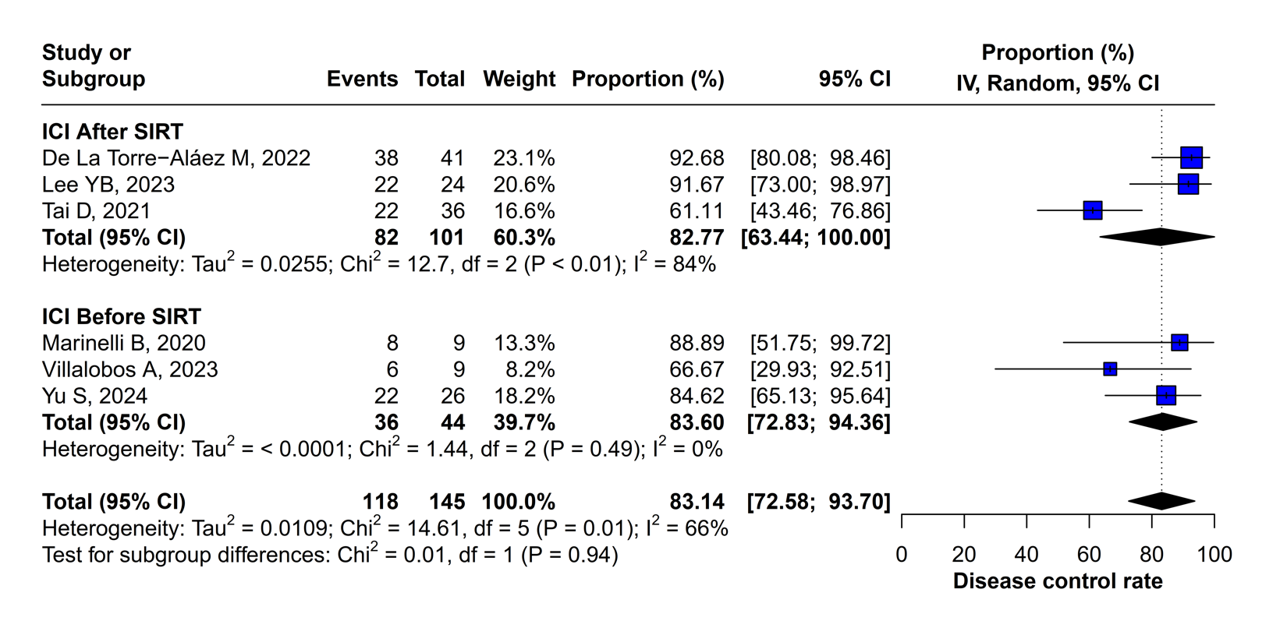
b.
a.

Figure 1. Forest plot for the subgroup analysis of the proportion of DCR, including (a) ICI after SIRT and (b) ICI before SIRT.

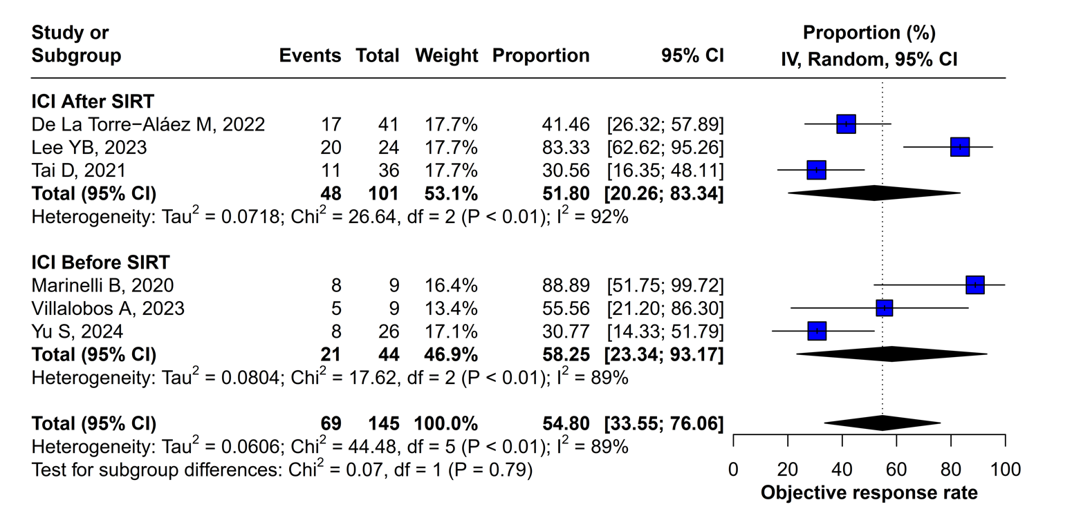
b.
a.

Figure 2. Forest plot for the subgroup analysis of the proportion of ORR, including (a) ICI after SIRT and (b) ICI before SIRT.

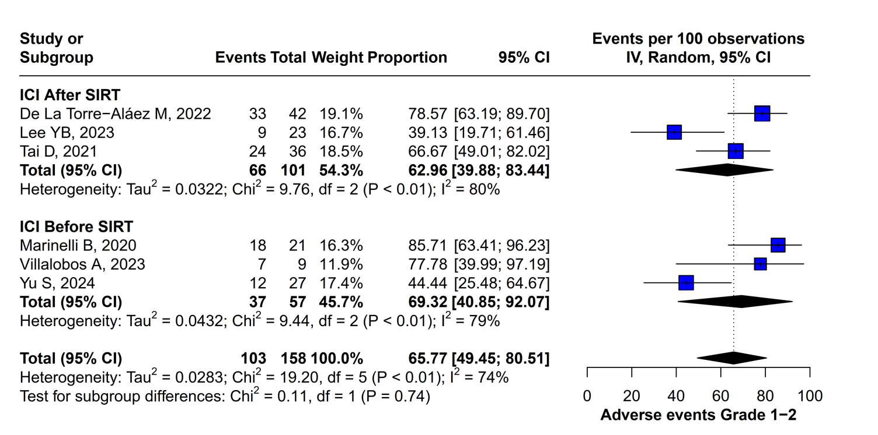
a.
b.

Figure 3. Forest plot for the subgroup analysis of the proportion of AEs grades 1-2, including (a) ICI after SIRT and (b) ICI before SIRT.

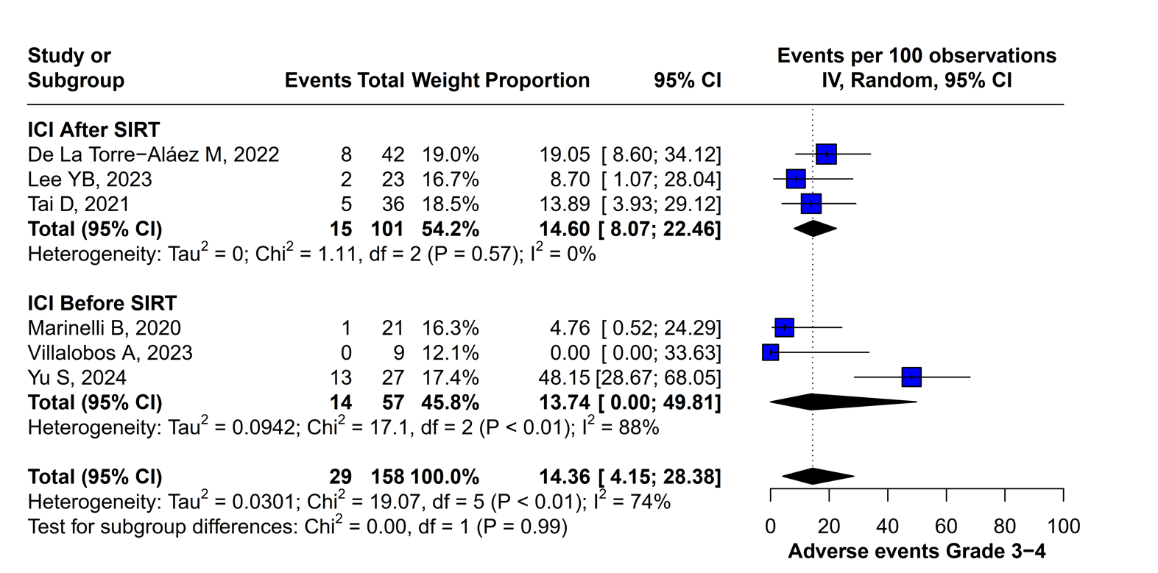
b.
a.

Figure 4. Forest plot for the subgroup analysis of the proportion of AEs grades 3-4, including (a) ICI after SIRT and (b) ICI before SIRT.

