Supplementary Materials
Supplementary Tables
Supplementary Table 1. Basic characteristics of participants stratified by the olfactory function group.
 | Olfactory Function Groupª |  | P-value
 | hyposmic | normosmic | P-value
 | N=207 | N=1174 | P-value
Male | 79 (38.2) | 552 (47.0) | 0.022
Age, mean (SD), y | 80.77 (4.98) | 78.10 (4.41) | <0.001
BMI^{b}, mean (SD), (kg/m²) | 23.30 (3.65) | 23.87 (3.74) | 0.039
Illiterate | 107 (58.2) | 487 (43.3) | <0.001
Married | 107 (55.4) | 725 (64.5) | 0.02
Smoker | 46 (24.6) | 272 (24.2) | 0.969
Drinker | 73 (39.0) | 400 (35.5) | 0.394
Stroke | 14 (6.8) | 97 (8.3) | 0.553
Diabetes | 29 (14.0) | 146 (12.4) | 0.607
Hypertension | 89 (43.0) | 517 (44.0) | 0.839
Glucose, mean (SD), mmol/l | 5.76 (2.40) | 5.63 (1.62) | 0.323
B-CSIT score, mean (SD) | 0.00 (0.00) | 13.77 (3.33) | <0.001
Mild cognitive impairment | 129 (75.0) | 719 (65.2) | 0.014
ª Data are expressed as No. (%) unless otherwise indicated.
^{b} The body mass index is the weight in kilograms divided by the square of the height in meters.

Supplementary Figures
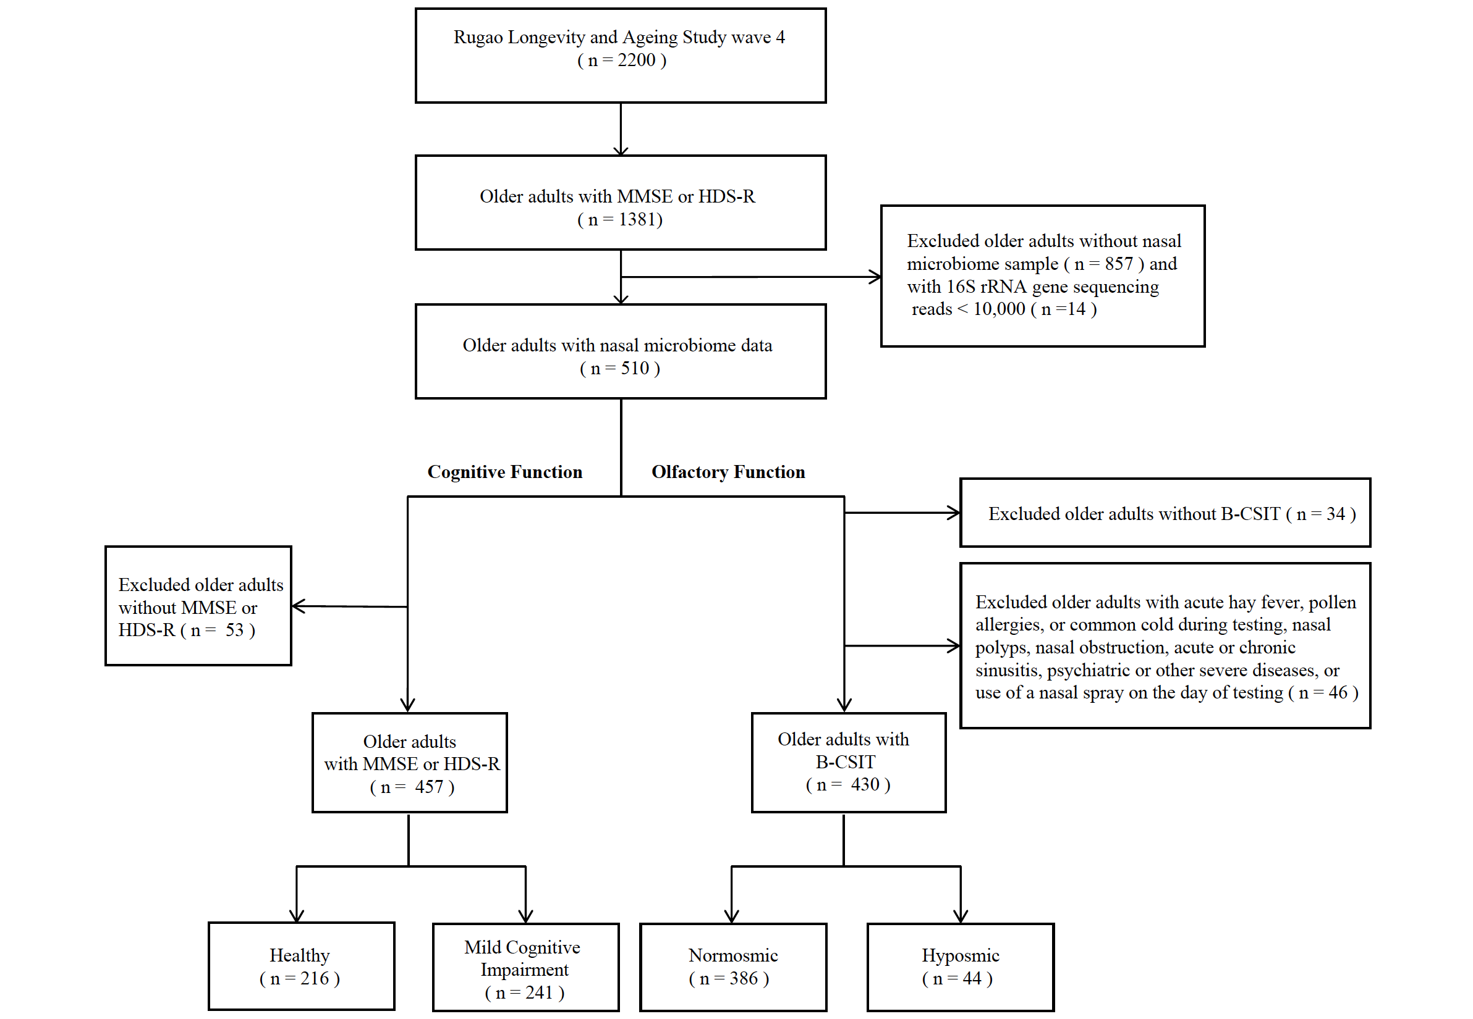
Supplementary Figure 1. Study design. To associate the nasal microbiome with olfactory and cognitive functions, we included 1381 older adults with MMSE or HDS-R scores in the RLAS cohort. Exclusions were made for those without nasal microbiome samples (n = 857) and with fewer than 10,000 16S rRNA gene sequencing reads (n = 14), resulting in 510 participants with available nasal microbiome data. Consequently, 457 participants had available MMSE or HDS-R data, while 430 had B-CSIT data. Based on cognitive assessment, 216 participants were classified as healthy, whereas 241 were identified as having mild cognitive impairment. In terms of olfactory function, 386 participants were categorized as normosmic, and 44 as hyposmic.

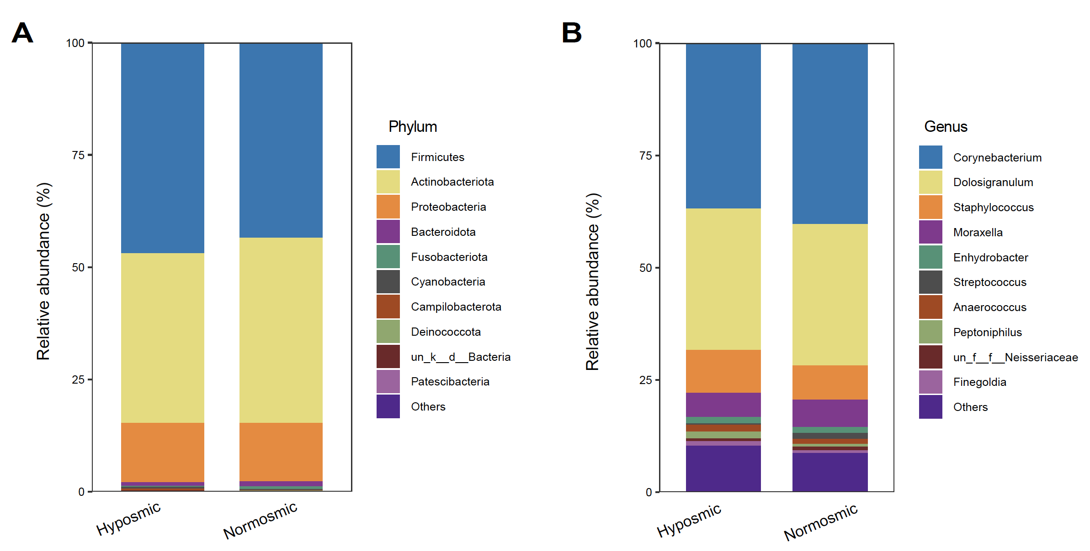
Supplementary Figure 2. Nasal Microbiota Composition between hyposmic and normosmic groups. (A) At the phylum level, the nasal microbiota of the participants primarily comprises Firmicutes, Actinobacteriota, and Proteobacteria. (B) At the genus level, the nasal microbiota of the subjects is mainly composed of Corynebacterium, Dolosigranulum and Staphylococcus.

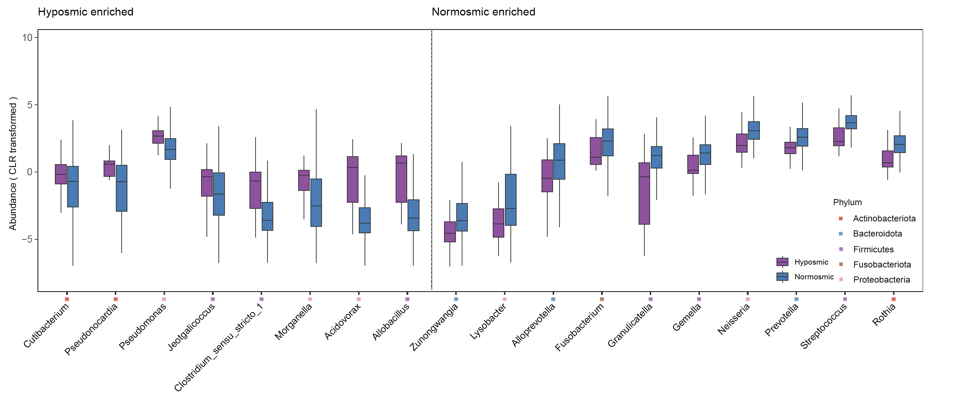
Supplementary Figure 3. The relative abundances (CLR transformed) of 18 genera identified as differentially abundant according to olfactory function.

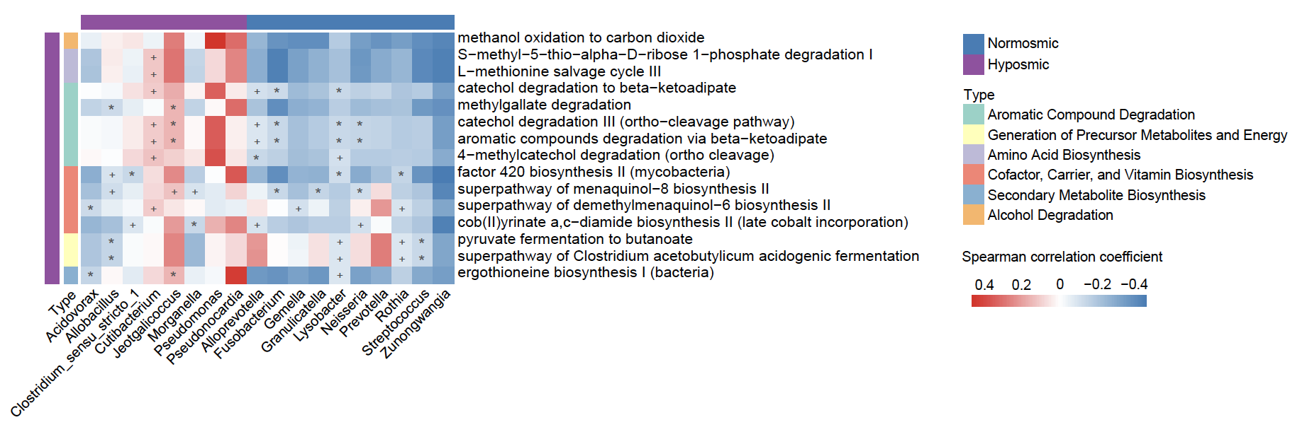
Supplementary Figure 4. Spearman correlations among the differentially abundant genera and predicted pathways in the hyposmic and normosmic groups. Significant results were indicated by + (FDR < 0.05) or * (FDR < 0.01).

