Supplementary Material
Supplementary Figure 1.
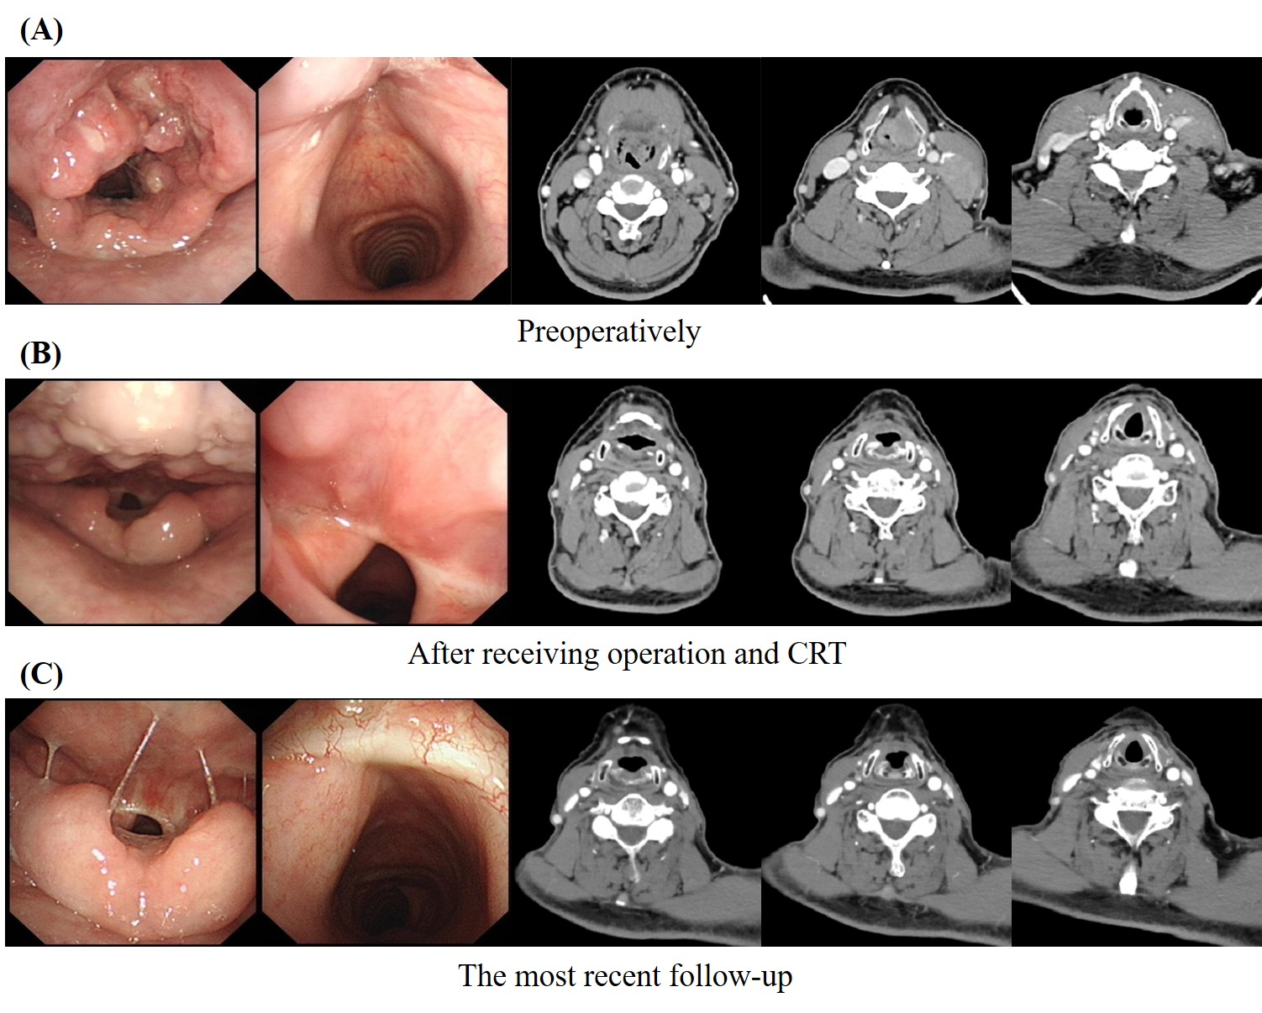
Laryngeal carcinoma (T3N3MO) (case 1) in the adjuvant immunotherapy group. (A) Initial CT scans and endoscopic view of laryngeal carcinoma preoperatively. (B) Complete response (CR) under treatment with operation and RCT by RECIST criterion. (C) The latest CT scans and endoscopic view revealed no signs of tumor progression.

Supplementary Figure 2.
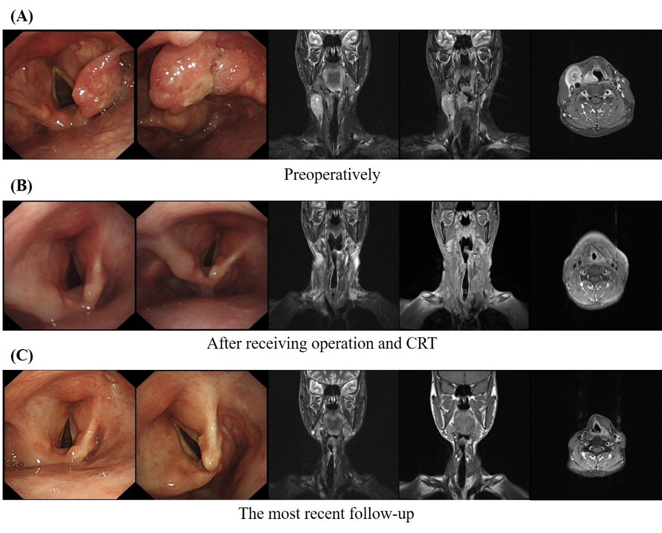
Hypopharyngeal carcinoma (T2N3MO) (case 2) in the adjuvant immunotherapy group. (A) Initial MRI scans and endoscopic view of hypopharyngeal carcinoma preoperatively. (B) Complete response (CR) under treatment with operation and RCT by RECIST criterion. (C) The latest MRI scans and endoscopic view revealed no signs of tumor progression.

Supplementary Figure 3.
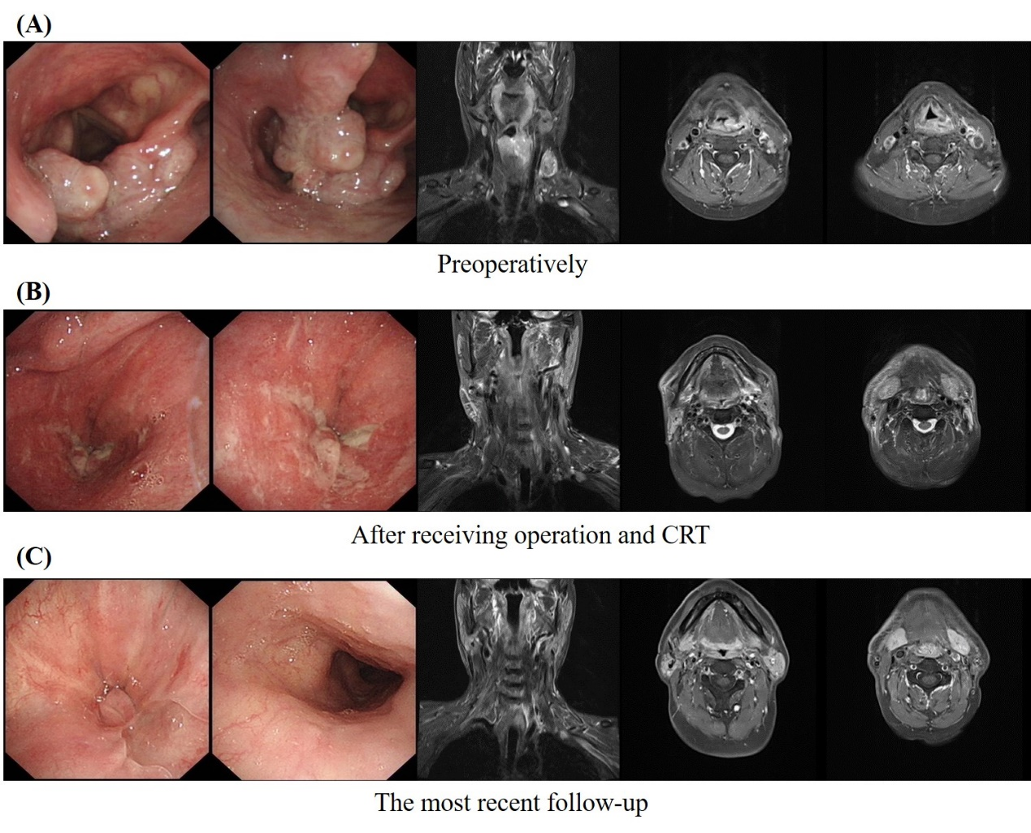
Hypopharyngeal carcinoma (T3N3MO) (case 3) in the adjuvant immunotherapy group. (A) Initial MRI scans and endoscopic view of hypopharyngeal carcinoma preoperatively. (B) Complete response (CR) under treatment with operation and RCT by RECIST criterion. (C) The latest MRI scans and endoscopic view revealed no signs of tumor progression.

