Supplement Figure S1
(A) 6 NSC datasets with the Immport database UMAP quality verification. (B) The volcano plot of immune-related DEGs obtained from edgeR analysis. (C) The heatmap of immune-related DEGs obtained from edgeR analysis. (D) The volcano plot of immune-related DEGs obtained from DESEq2 analysis. (E) The heatmap plot of immune-related DEGs obtained from DESEq2 analysis.
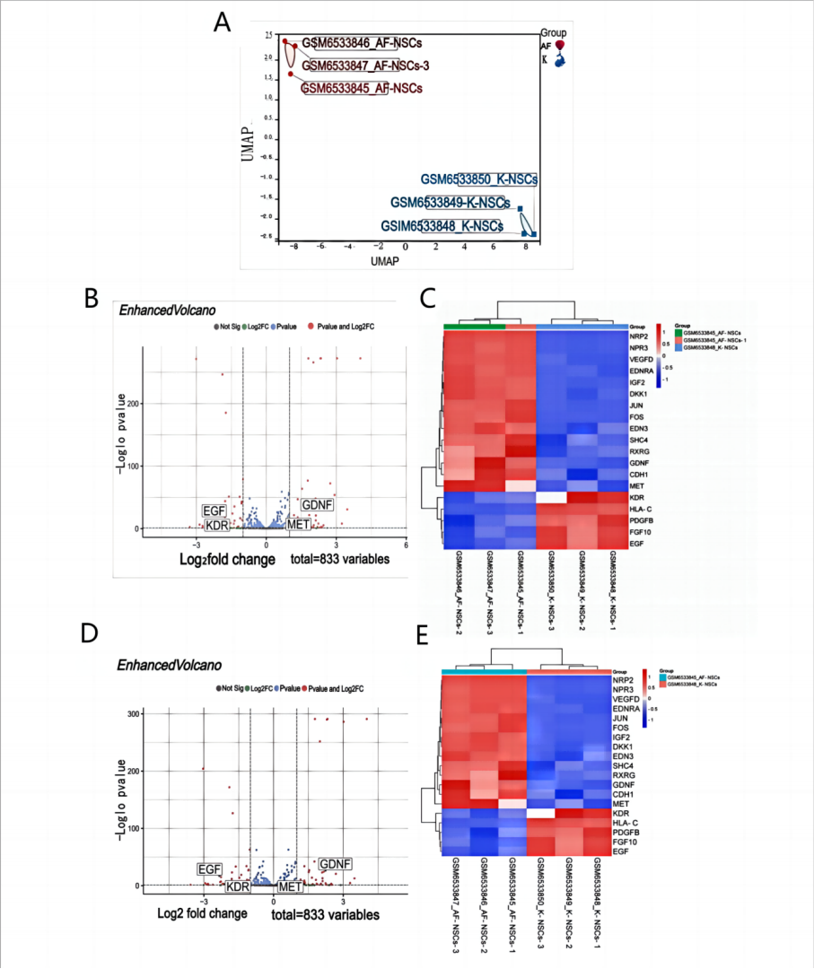
Supplement Figure S2
(A) Venn diagram of the intersection of 3 GLD-NSC immune differentially expressed genes obtained by three differential analysis methods, limma.edgeR and DESEq2, and the intersection result is the red part of Figure s2b. (B) Venn diagram of 6 groups of GLD-NSC data (green), immune gene set data (blue), and the intersection of 61 GLD-NSC immune differentially expressed genes (red) obtained by taking the results of three differential analysis methods, limma.edgeR and DESEq2. (C) K-means analysis of protein network interactions of 37 GLD-NSC key immune genes. (D) The top 5 ranked genes for 12 different topological analysis methods.
