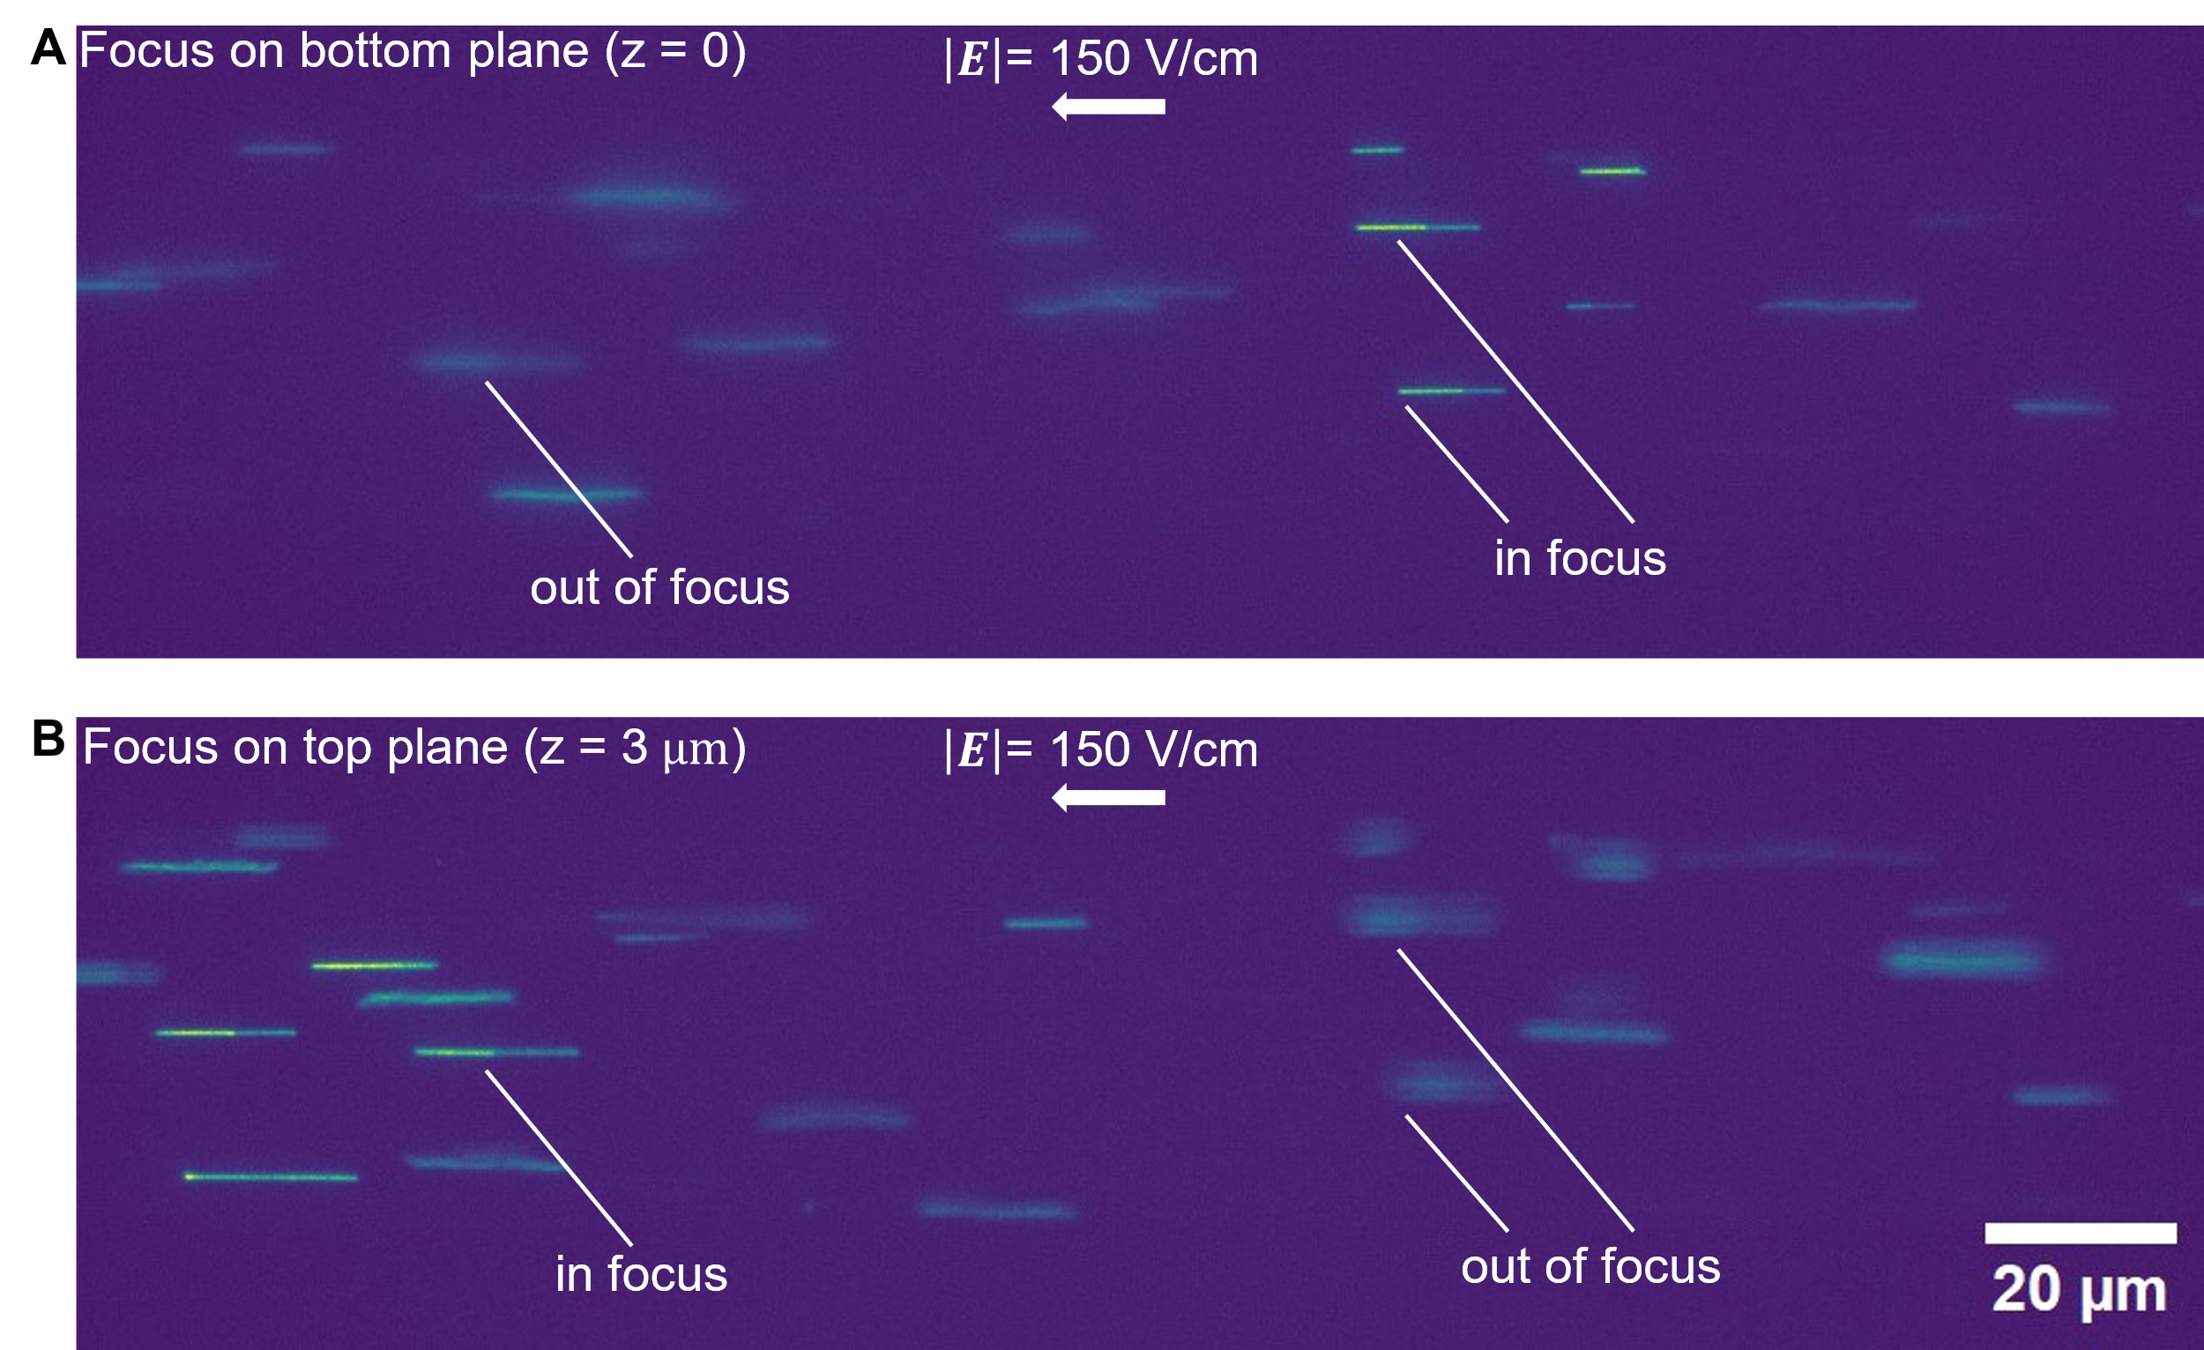

Extended Data Fig. 1 | DNA vertex-pinning at bottom and top surface of a 3 μm deep channel under axial electric field strength of 150 V/cm. (A) The image shows vertex-pinned DNA at the bottom surface, which is thermally grown thermal oxide. (B) The image shows vertex-pinned DNA top surface, which is anodically bonded borosilicate glass. (A) and (B) are two consecutive images from one realization. The depth of field is estimated to be 0.7 μm.

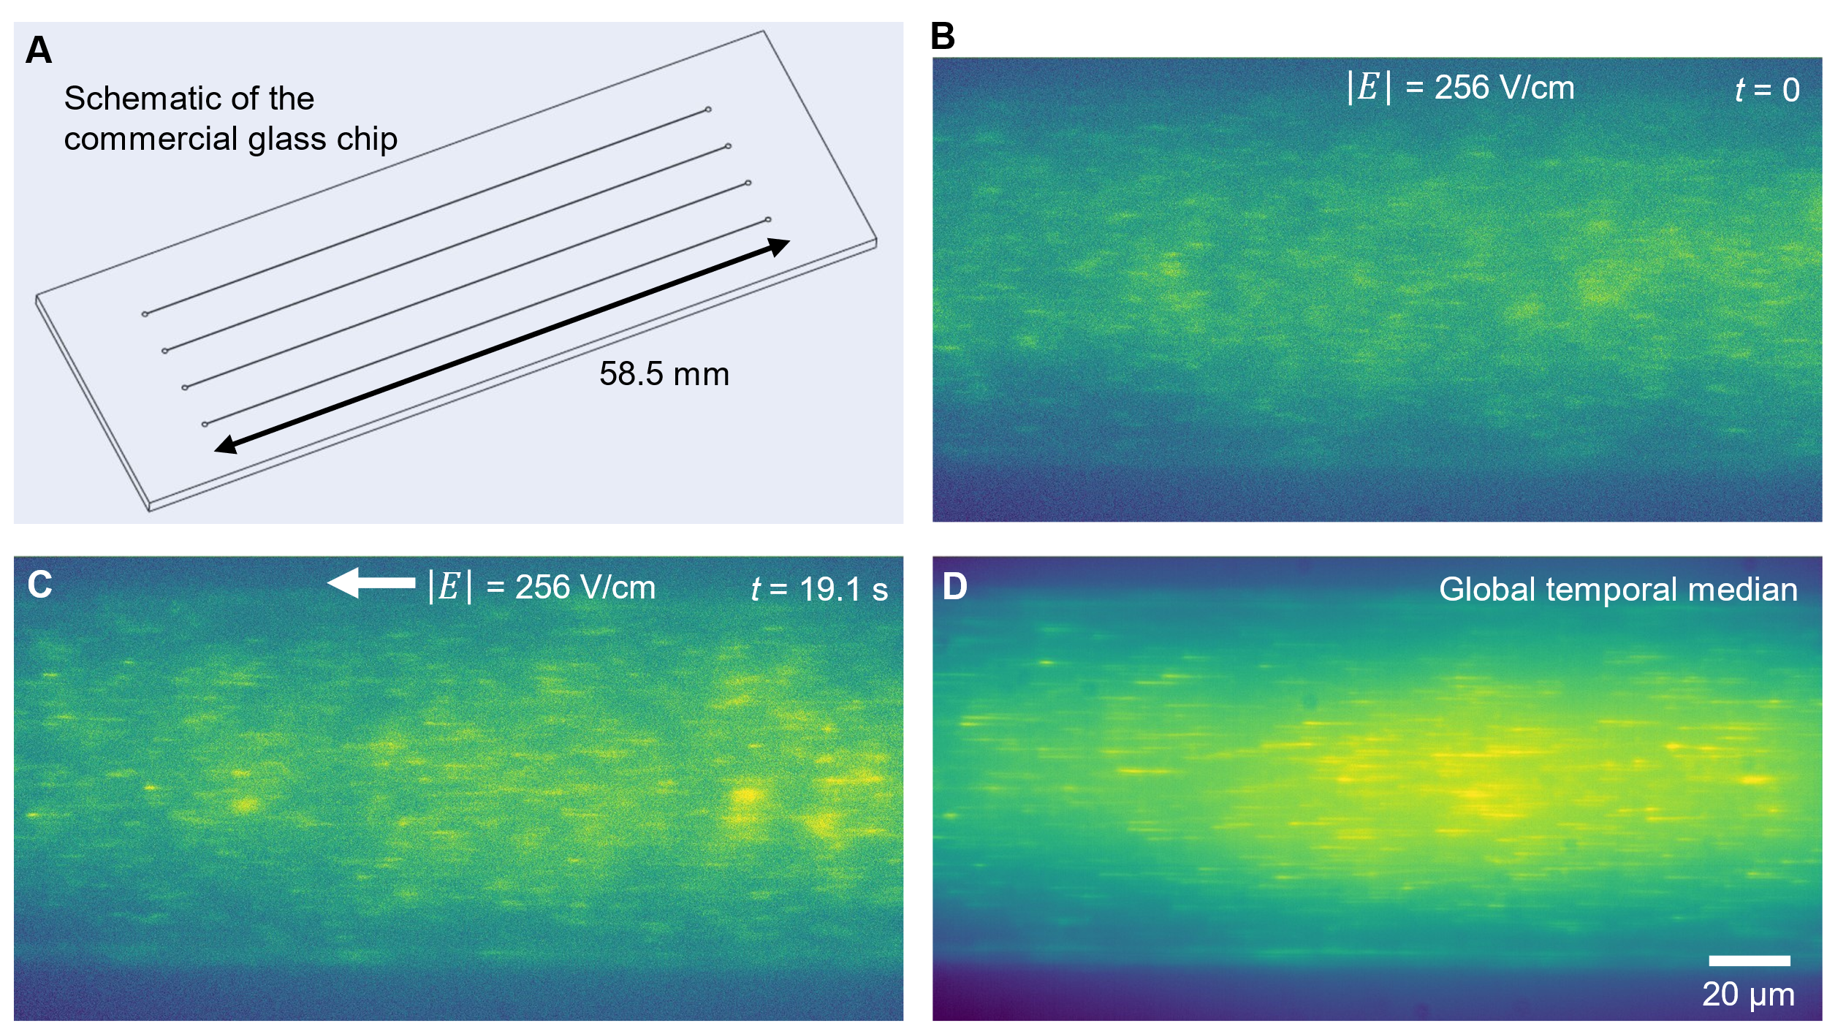

Extended Data Fig. 2 | Vertex-pinned, single-molecule DNA in a 37 μm deep commercial glass microfluidic channel filled with a linear polymer solution and subject an axial electric field. (A) Schematic of the commercial glass chip purchased from Microfluidic ChipShop. On each chip, four 58.5 mm long parallel glass channels are fabricated and sealed with 210 μm lids. Both substrate and cover are fused silica glass. (B to C) Consecutive, epifluorescence raw images of DNA electromigrate through 37 μm deep commercial glass channel. The depth of field is estimated to be around 1 μm, and most DNA are out of focus. In the background near to the wall surface, vertex-pinned DNA can be observed. See Movie S10 for more details. (D) Global temporal median of the image sequence. The image amplifies the vertex-pinned DNA at the wall. See Movie S10 for more details.

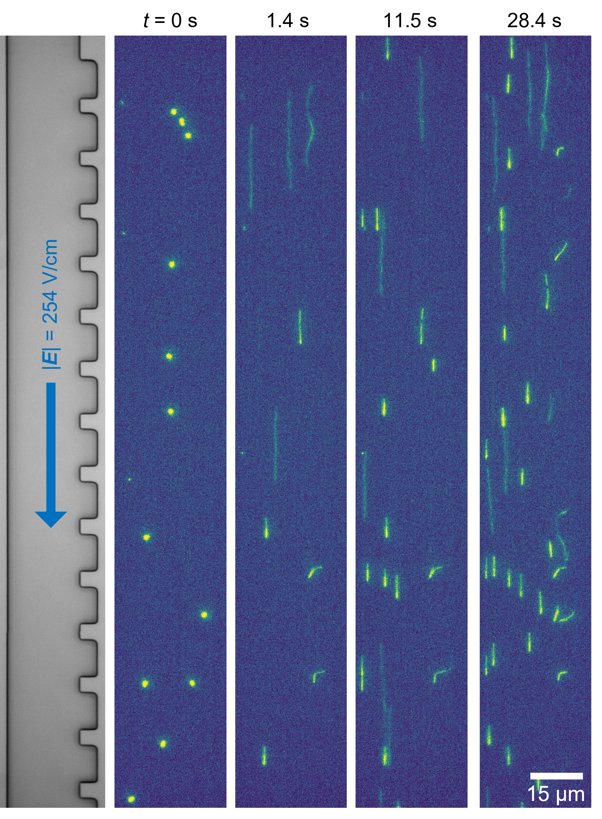

Extended Data Fig. 3 | Vertex-pinned, single-molecule 20 kbp DNA in a 0.9 μm deep microfluidic channel filled with a linear polymer buffer solution and subject to an applied axial electric field. Wide-field, consecutive raw images of single-molecule DNA pinning upon application of 254 V/cm. Solution was 4 pM of YOYO-1 labeled 20 kbp DNA in 1$×$TBE buffer with 2% w/w 1300 kDa PVP and 4% v/v β-mercaptoethanol. Raw images are shown for t = 0, 1.4, 11.5 and 28.4 s. The faint lines in the background are due to streaking of 20 kbp DNA under fast electromigration.

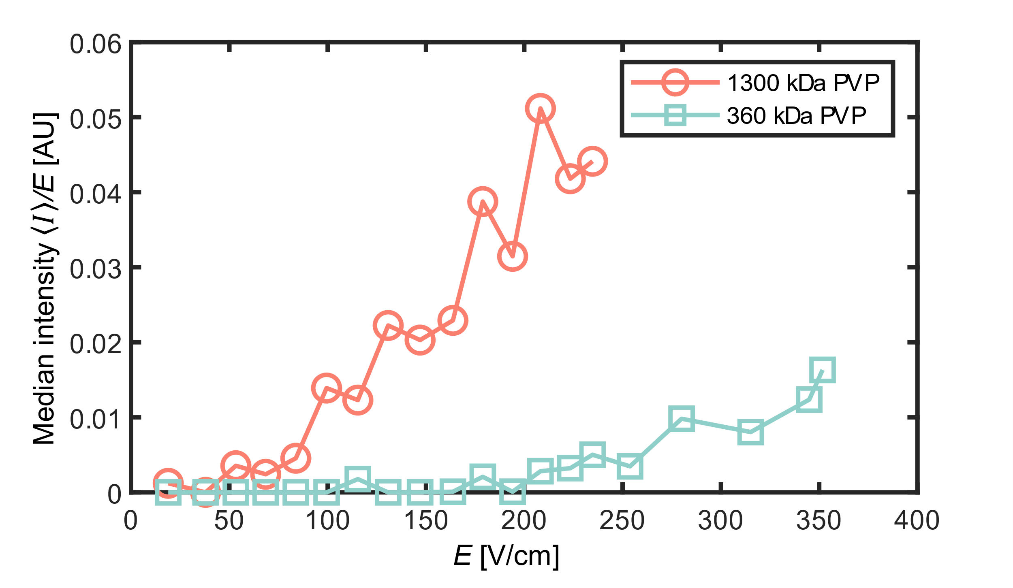

Extended Data Fig. 4 | Experimental quantification of the amount of vertex-pinned, single-molecule DNA as a function of field strength. Median intensity of each realization of applying electric field for 30 s are plotted on the ordinate versus the axial electric field strength of each realization on the absicca. These data are comparable to that of Figure 3B in the main text. Here, unlike Figure 3B, the integrated intensity of pinned DNA was normalized by the applied axial field strength. All data are 4 pM of YOYO-1 labeled $λ$-DNA (48.5 kbp) in 1$×$TBE buffer with 4% v/v β-mercaptoethanol. The orange curve and green curve show experiments of using sample of adding 2% w/w concentration of PVP with MWs of 1300 and 360 kDa, respectively.

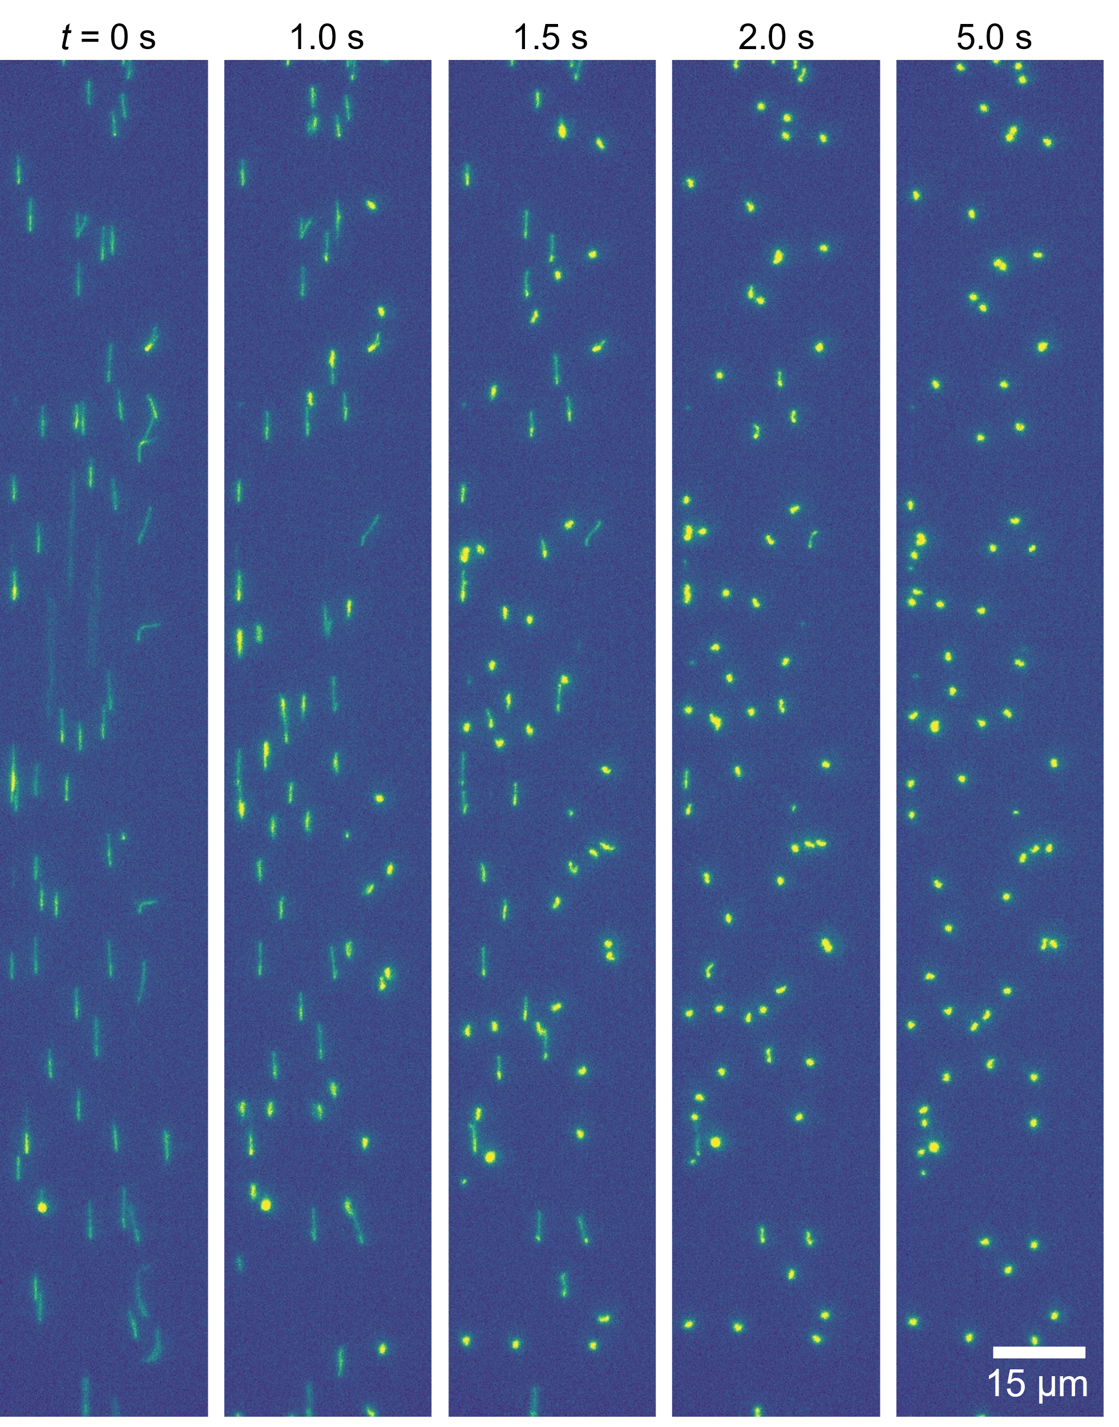

Extended Data Fig. 5 | Relaxation dynamics of vertex-pinned, single-molecule 20 kbp DNA. Example sequence of raw epifluorescence microscopy images of pinned DNA immediately after deactivation of the applied electric field (at t = 0 s).

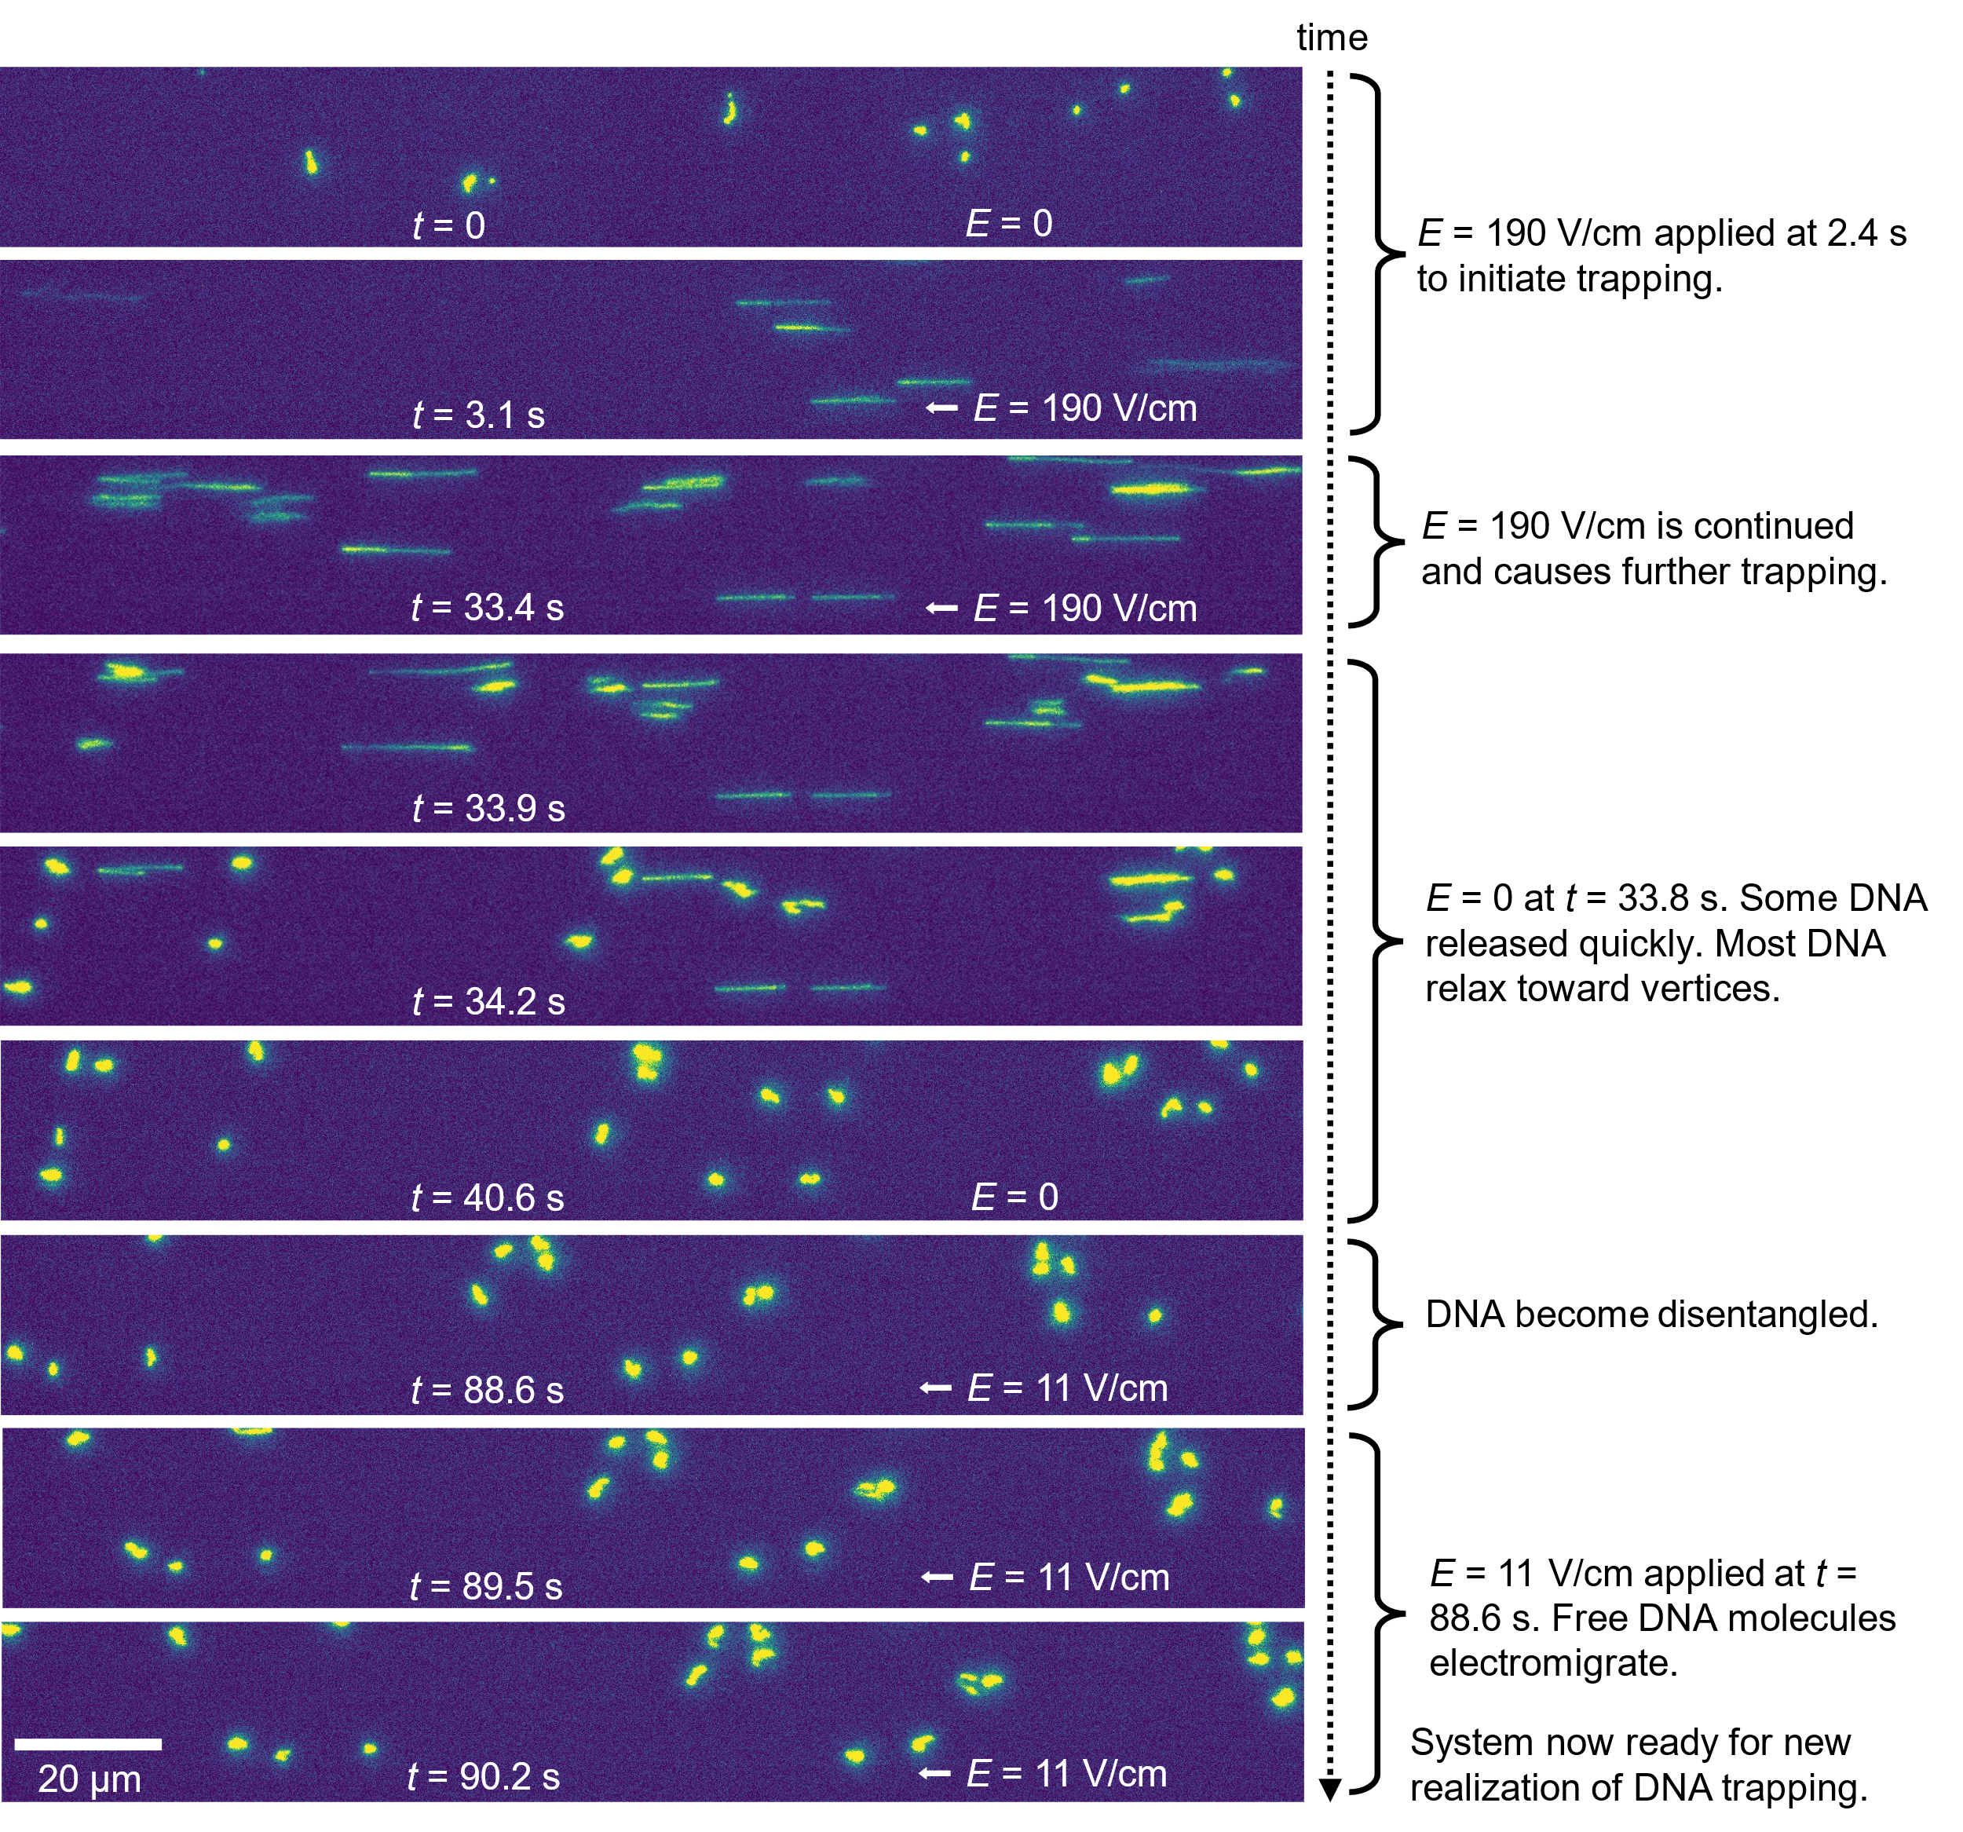

Extended Data Fig. 6 | Representative cycle of DNA vertex-pinning, relaxation, disentanglement, and free electromigration. Consecutive (top to bottom) images of single-molecule DNA. DNA molecules are initially in expected random coil shapes. E = 190 V/cm was applied at t = 2.4 s to initiate vertex pinning. E deactivated at t = 33.8 s. Most DNA relaxed toward vertices. After about 50 s, more than 95% of DNA became unpinned from the wall. At t = 88.6 s, a relatively low axial electric field of 11 V/cm was applied to electromigrate away previously vertex-pinned DNA molecules. Note the displacements of correlated patterns across the last three images.

