Supporting Information for
Vertex pinning and stretching of single molecule DNA in a linear polymer solution
Kunlin Maª, Caleb J. Samuelª, Soumyadeep Paulª, Fereshteh L. Memarian^{b}, Gabrielle Vukasin^{b}, Armin Darvish^{b}, Juan G. Santiagoª*
ª Department of Mechanical Engineering, Stanford University, Palo Alto, CA 94305.
^{b} Robert Bosch LLC, Research & Technology Center, Sunnyvale, CA 94085.

* Corresponding author: Juan G. Santiago
Email: juans@stanford.edu

This file includes:

Supporting text
Figures S1 to S6
Legends for Movies S1 to S10
SI References

Other supporting materials for this manuscript include the following:

Movies S1 to S10

Supporting Information Text

S1 Methods
S1.1 Image processing for quantification of amount of vertex pinned DNA
All data in the image data in this section was acquired using the aforementioned water immersion 60$×$ objective (OLYMPUS UPlanApo) with a numerical aperture (NA) of 1.2. The camera here was Hamamatsu Orca-Flash 4.0LT sCMOS camera. This camera has a sensor pixel size of 6.5 by 6.5 $μm$. The pixel size in image plane was approximately 0.11 by 0.11 $μm$ per pixel. The camera acquired 20 frame per second (fps) with an exposure time of 49 ms. Each realization’s raw TIFF sequences were imported into MATLAB for image analysis. Each 30 s sequence consisted of 600 images. First, we applied a moving (temporal) median operation. This moving median replaces the pixel value of each image with the median value of the same pixel across a small number of previous and subsequent images. This operation has the effect of enhancing and retaining approximately stationary image data (pinned, stretched DNA) and rejecting moving objects (electromigrating DNA). The highest applied electric fields of 363 V/cm were associated with the highest DNA velocities. Hence, each median operation considered only a three-image group (i.e., each image pixel value was replaced by the median among the previous frame, current frame, and preceding frame). The median operation for lower applied electric fields (slower moving DNA) used a progressively larger number of images within each group. We considered a maximum of 21 frames for the lowest applied fields of 19 V/cm. The top subplot of Figure 3A (of the main paper) shows an example frame obtained from the moving median image sequence. See especially Movie S8 for a comparison between raw video versus moving median video, and note how the image data from stationary objects (pinned DNA) are enhanced. Next, we used Bradley’s method to perform local mean-based adaptive thresholding on the moving median image sequences³¹. To this end, we used the MATLAB command adaptthresh with a sensitivity parameter of 0.45 followed by imbinarize to obtain binarized images for each frame. The pixel values of the binarized images were set to zero below the threshold and to unity above the threshold. Next, we identified and stored the data for the thresholded pixel coordinates via the MATLAB command find. We then performed an alpha shape operation on the binarized image in order to efficiently reject non-DNA image noise from the analysis. Alpha shape is a generalization of the concept of convex hull identification and is a subset of Delaunay triangulation ¹⁶. The alpha shape method is widely used for pattern recognition in computational graphics to identify the relatedness (via proximity) of points on a graph³². To obtain the alpha shapes, we used the binarized pixel coordinates and an alpha radius of 2.5 as inputs to the MATLAB command alphaShape. We then projected the resulting alpha shapes onto a binary mask. The binary mask was first dilated and then eroded with the same 10-pixel long streamwise line as a structuring element (again to favor even field-aligned and pinned DNA images). After erosion, our algorithm obtained alpha shape bounding masks. The alpha shape method successfully reduced background noise caused by adaptive thresholding. The alpha shape operation and the dilation and erosion also smoothed the noisy edges of the identified objects. The middle sub-image of Figure 3A (of the main paper) shows an example of the resulting mask. At each time frame, the binarized mask was used on the moving median image to obtain a sequence of thresholded moving median images. The bottom sub-image of Figure 3A shows an example of the resulting operation between the alpha-shape-bounded mask and one of the median images. The (original, unchanged) intensity of detected DNA within the resulting thresholded images was then integrated spatially to acquire a scalar signal which varied with time at the frame rate of 20 fps. We term this scalar $〈I〉$ in Figure 3 of the main paper and in the discussions and figures below.

S1.2 Image processing for analysis of relaxation of vertex-pinned DNA
This section describes the image processing analyses performed to obtain the DNA relaxation data shown in Figures 4B, 4C and 4D of the main text. First, TIFF sequences were gaussian filtered temporally with a three-frame filter using MATLAB built-in function imgaussfilt3. Then, we followed the same method explained above to obtain alpha shape bounding masks for videos of DNA relaxation, except we did not include dilation followed by erosion in order to best preserve DNA shape. Once we obtained the bounding masks, we used the MATLAB command bwconncomp followed by regionprops to determine morphological and location properties of distinct connected regions inside the alpha shape bounding mask. In an effort to remove image noise and very small DNA fragments from remaining in the following analyses, we removed connected regions with total intensity less than 100,000 and 20,000 for 48.5 and 20 kbp DNA sample, respectively. These thresholds were designed to remove objects with significantly less intensity than largely intact pieces of DNA. To remove image noise and very small DNA fragments from remaining in the following analyses, we removed connected regions with integrated intensity values which were lower than 2.5 standard deviations from the mean. Figures S4A to S4C and Figures S4F to S4H show examples of the aforementioned image processing procedures for vertex-pinned DNA before and during relaxation. Then, again using the MATLAB command regionprops, we fitted an ellipse to each remaining region. These ellipses had the same normalized second central moments as the regions to which they were fit. Examples of the ellipses fitted to various pieces of DNA can be seen in Figure 4B. For each realization of DNA relaxation at each frame after electric field was turned off, we then had a collection of fitted ellipses ideally representing the shape of various pieces of DNA at that given time for that given realization. Figures S4D to S4E and S4I to S4J show examples of the aforementioned island identification and major axes estimation. Figures S4D and S4E show an example for vertex-pinned DNA before relaxation while Figures S4I and S4J show an example for vertex-pinned DNA during relaxation. The ellipses approximation is shown in red curves, and the major axes are shown in green lines. From this collection of fitted ellipses, we recorded the following two values: the mean length of the fitted ellipses’ major axis, which we used as the characteristic length of DNA during relaxation; and the standard deviation of major axis length for fitted ellipses. The resulting analyses are shown in Figure 4C and 4D for one and two standard deviations. The black line shows the characteristic length, and the blue and green shaded regions represent data with one or two standard deviations of the mean major axis length. The only difference between the relaxation analyses of 48.5 and 20 kbp DNA was the threshold chosen to remove selected regions we believed to be DNA fragments or image noise. Figures S5A to S5J shows the same image processing for 20 kbp DNA data as described above of Figure S4A to S4J for 48.5 kbp DNA data.
In addition to Figure 4, we include two raw epifluorescence videos of 48.5 and 20 kbp DNA relaxing (Movie S3 and S4) and another processed video of approximately 300 superposed images of DNA relaxing for 48.5 kbp DNA (see Movie S9). To generate superposed images of DNA relaxing for Movie S9, we first obtained alpha shape bounding masks as described previously after the electric field was turned off. Next, we used MATLAB command regionprops to remove regions with less than 50,000 total integrated intensity. After this, we used the MATLAB command bwlabel to identify and label distinct connected regions inside the alpha shape bounding mask. For each region, we then used find command to generate a list of pixels within that region. From this list, we estimated the most “upstream” pixel as the vertex-pinned point, as well as the median pixel location in the spanwise direction. We then applied the alpha shape bounding mask to the original image so that each previously identified region had its original intensity values. We then added the original image intensities within these alpha shape regions for each time in the relaxation images.

S1.3 Colocalization analyses of multiple realizations of DNA vertex-pinning
To further analyze the repeatability of DNA pinning sites, we performed colocalization analysis based on the data from Figs. 5A, 5B and 5C in the main text. Fig. 6 shows the resultant colocalization scatter plots and the respective computed Pearson correlation coefficients. To create these plots, we first read two raw TIFF image data (for example Figs. 5A and 5B) into arrays in MATLAB. These images were registered such that individual pixel locations were the same across realizations. For each pixel, we store image data in a two-dimensional intensity histogram where the horizontal axis value corresponds to the intensity value from the first realization image(abscissa) and the vertical axis value corresponds to the other second realization image (ordinate). The 2D histograms obtained thusly are shown in false color in Figure 5A, 5B and 5C for each pair of raw images. The Pearson correlation coefficients (PCC) are calculated based on the correlation data³⁰. The PCC values are respectively 0.30, 0.25 and 0.22 for the three plots shown. These correlation values and the shape of the correlation diagram indicate that the data have very poor colocalization of features. The lowest intensities (bottom left region) are correlated across realizations because they represent the background signal (image regions where there is no DNA). The low colocalization counts at the high intensity range suggest poor correlation of DNA trapping sites between realizations.
As a comparison case, we performed the same colocalization analysis for three images taken from a single realization. Figure S6A shows three raw epi-fluorescence images from one realization of DNA vertex-pinning under high electric field. The first and the second sub-panels are 5 s apart and the second, and the third sub-panel is 2 s after the second. Figures S6B and S6C show the colocalization scatter plot comparing DNA trapping at t₁ = 21 s to t₂ = 26 s, and at t₂ = 26 s to t₃ = 28 s. Note the strong correlation along the diagonal of these plots and compare these to Fig. 5 and Fig. 6 in the main manuscript. The computed PCC values here are 0.81 and 0.86, respectively, indicating a high degree of spatial correlation. These comparisons are further evidence that the trapping sites for DNA vertex pinning are uncorrelated across different realizations.

S1.4 Spatial averaging intensity
In the main text and SI, the symbol $〈⋯〉$ is used to indicate a spatial averaging over all pixels within a two-dimensional region. For example, to indicate spatial integration of intensity values of a raw image or two-dimensional correlation. For a quantity $q$ for each time frame, the spatial averaged value is then denoted as
$$\begin{aligned}〈q〉=\frac{1}{N_{x}N_{y}}\sum_{i=1}^{N_{x}}{\sum_{j=1}^{N_{y}}{q_{ij}}},\#\left(1\right)\end{aligned}$$
where $N_{x}$ and $N_{y}$ indicate the pixel number in the horizontal and vertical directions, respectively.

S1.5 Estimation of the magnitude of the axial electric field
The electric field measurements reported in this work were determined from ionic current measurements and measurements of the local channel cross section. We measured the conductivity of the buffer as described previously using a commercial conductivity meter (Orion VersaStar Pro Advanced Electrochemistry Meter, ThermoScientifc). We measured the current during the experiments via a Keithley 2400 SourceMeter. The transverse depth of the channel was measured via a profilometer as 0.9 μm. The channel spanwise width was determined from bright field images as we show in as the left most subplot in Figure 1C. This width was 20 μm. Assuming ionic current is dominant, the axial electric field strength is related to the current through Ohmic law:
$$\begin{aligned}j=σE,\#\left(2\right)\end{aligned}$$
where $j$ is the current density and $σ$ is the conductivity of the buffer. We divided the measured current, $I$, by the estimated cross-sectional area, $A$, to obtain the current density, $j$. Then, we estimate the electric field strength by $E=j/σ$.

S2. Materials
S2.1 Contour length of PVP and DNA of multiple MWs
We note that unstained $λ$-DNA (48.5 kbp) and 20 kbp DNA have reported contour lengths of approximately 16 and 6.6 $μm$, respectively. When λ-DNA and 20 kbp DNA are stained with YOYO-1 dye, their full contour length is extended to be approximately 21 and 8.7 μm, respectively³³. PVP of MWs of 10, 58, 360, and 1300 kDa have contour lengths of approximately 25, 145, 900, and 3250 nm, respectively^{34,35}.

S2.2 Range of DNA sizes for vertex-pinning
We have used the aforementioned method to trap DNA of sizes of 48.5, 20, 10, and 1 kbp under sufficiently high electric fields (data not shown). However, we do not know the minimum size of DNA that can be vertex pinned since we cannot acquire clear visualization of smaller sizes of DNA.

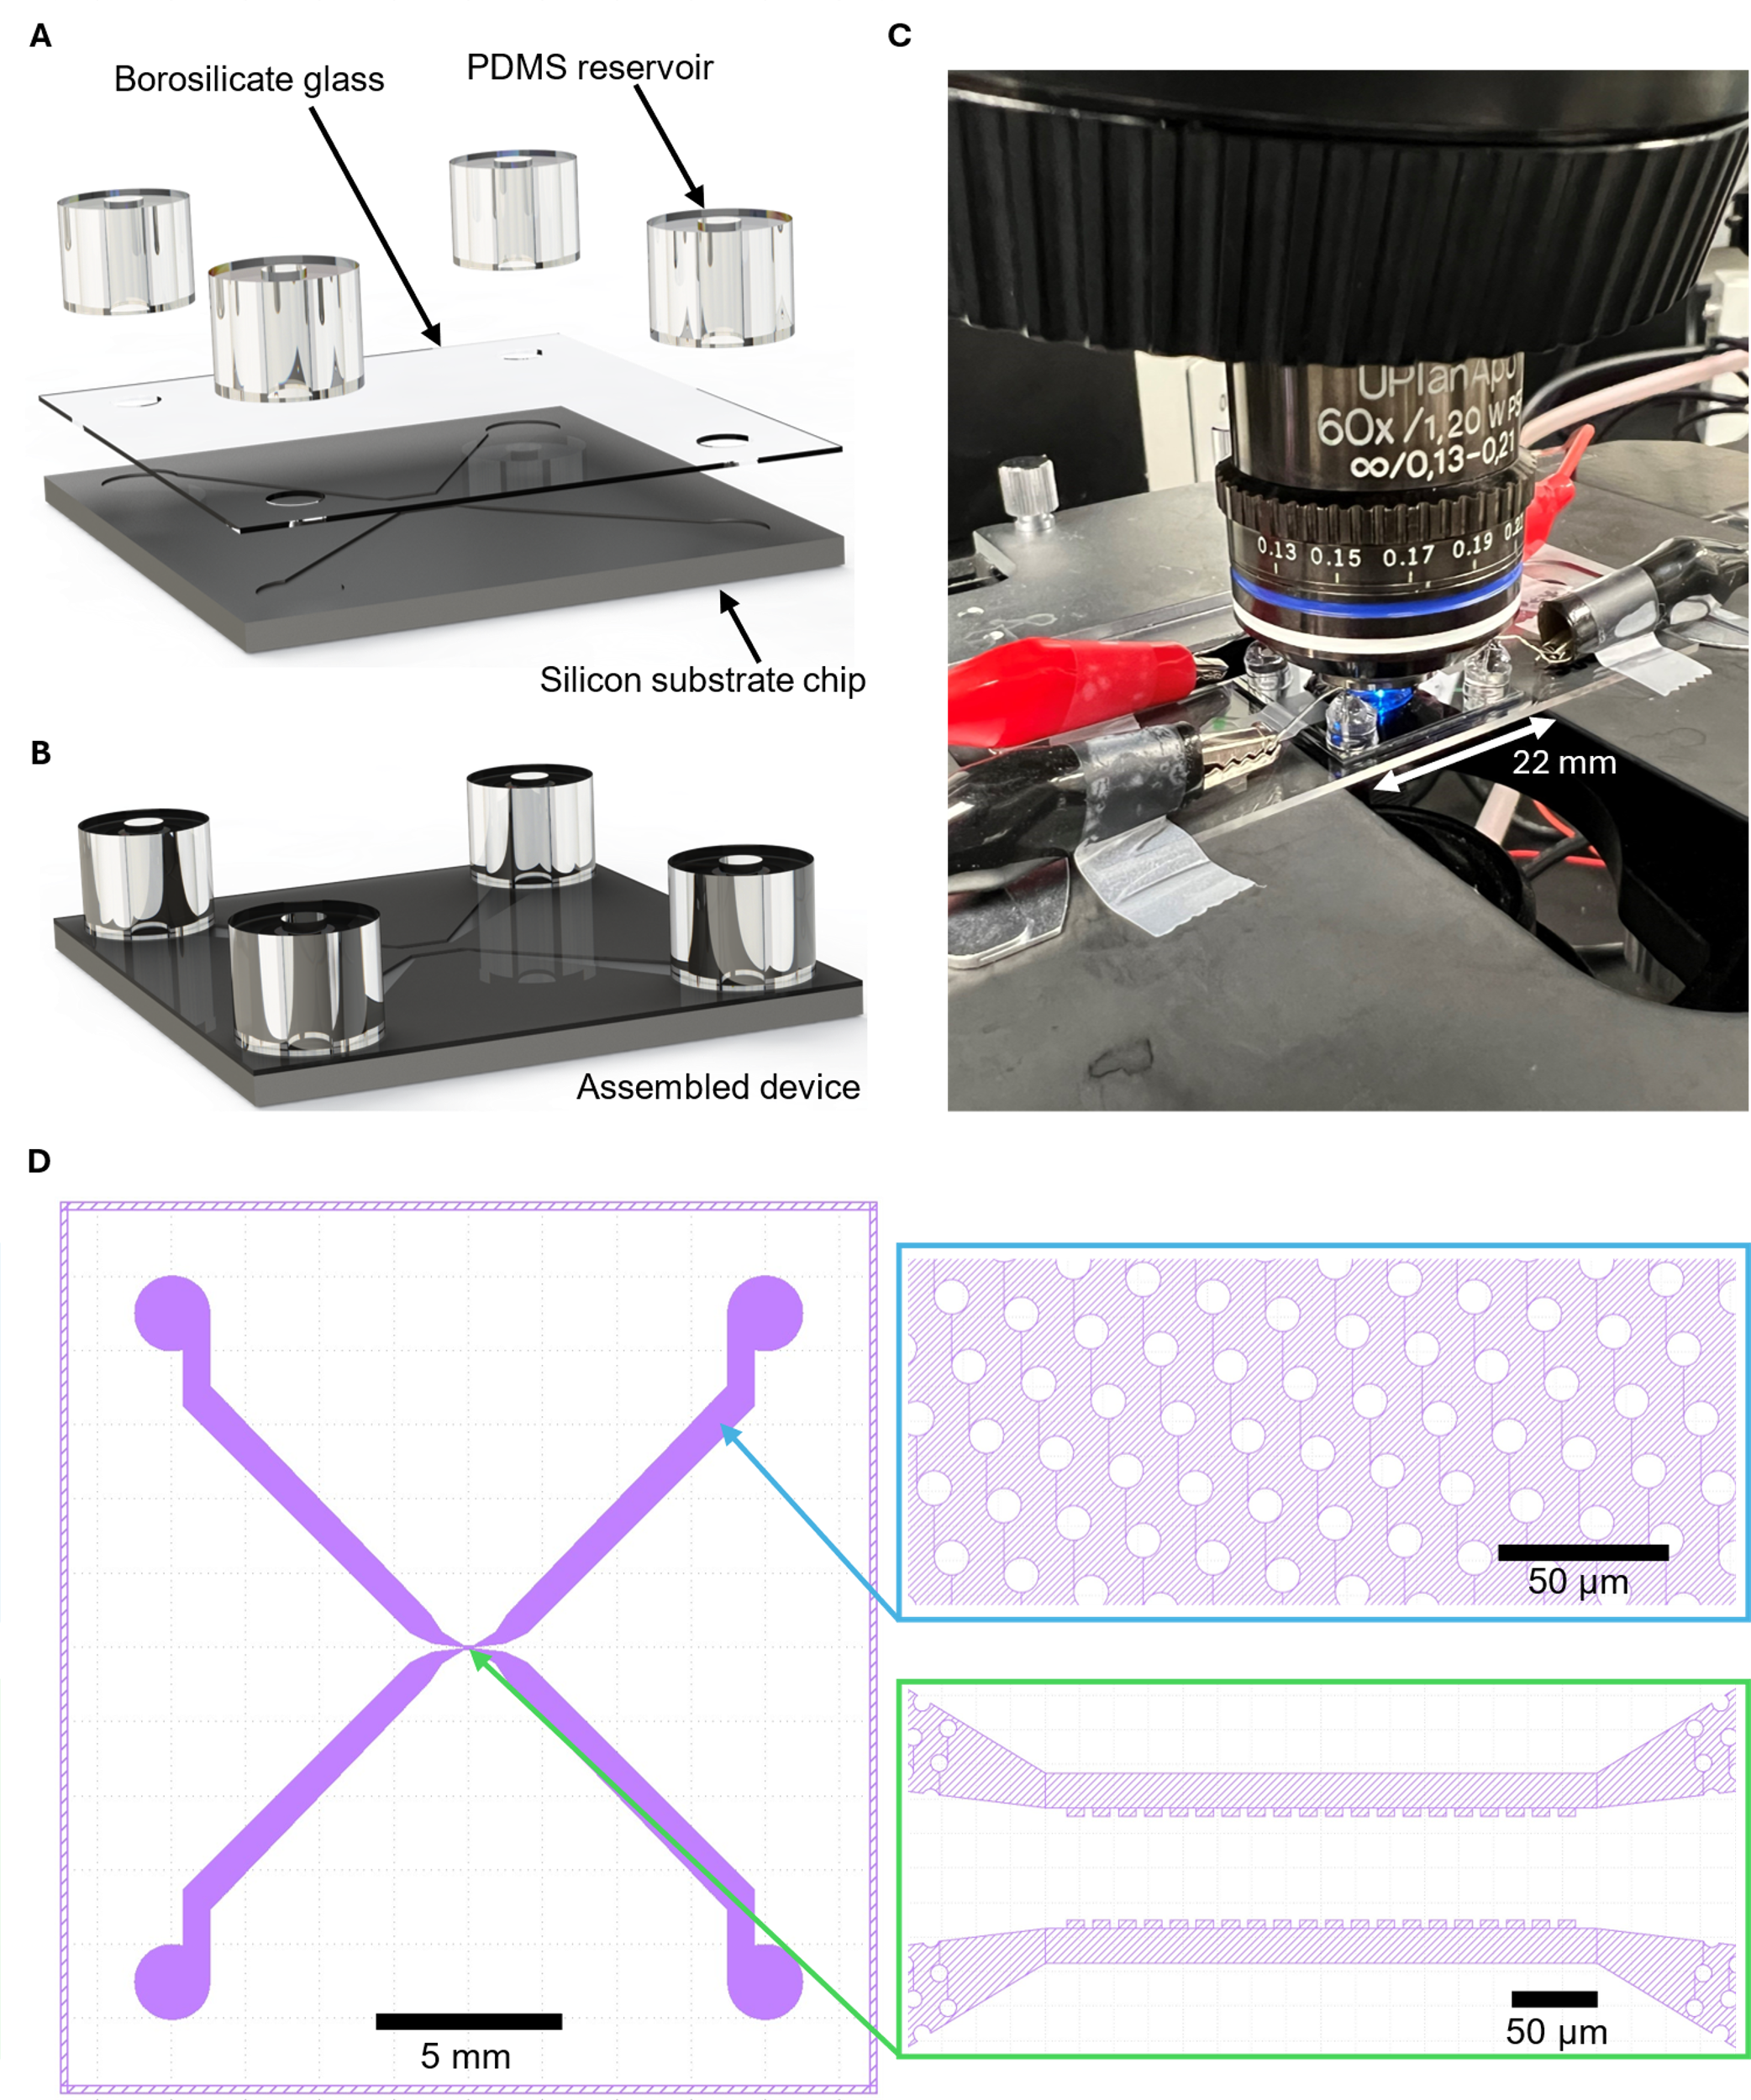

Fig. S1 | Custom microfluidic device and apparatus. (A) Pieces of PDMS reservoirs, 170 μm thick borosilicate glass and silicon substrate chips are shown as the three major components of the custom microfluidic device. (B) Assembled custom microfluidic device. Borosilicate glass was anodically bonded to the silicon substrate chip and then PDMS reservoirs were plasma bonded to the borosilicate glass. (C) The assembled custom microfluidic device was taped to a glass slide and then visualized via a water immersion 60$×$ objective of numerical aperture of 1.2. The illumination source is a blue LED. Platinum electrodes were inserted into the reservoir filled with liquid. (D) The layout of whole silicon substrate chips and zoomed in images of two regions are shown. The center region has castellation features near one side. The large microchannel regions leading to reservoirs have posts arrays of diameter of 10 μm. The posts array is designed to support the anodically bonded borosilicate glass.

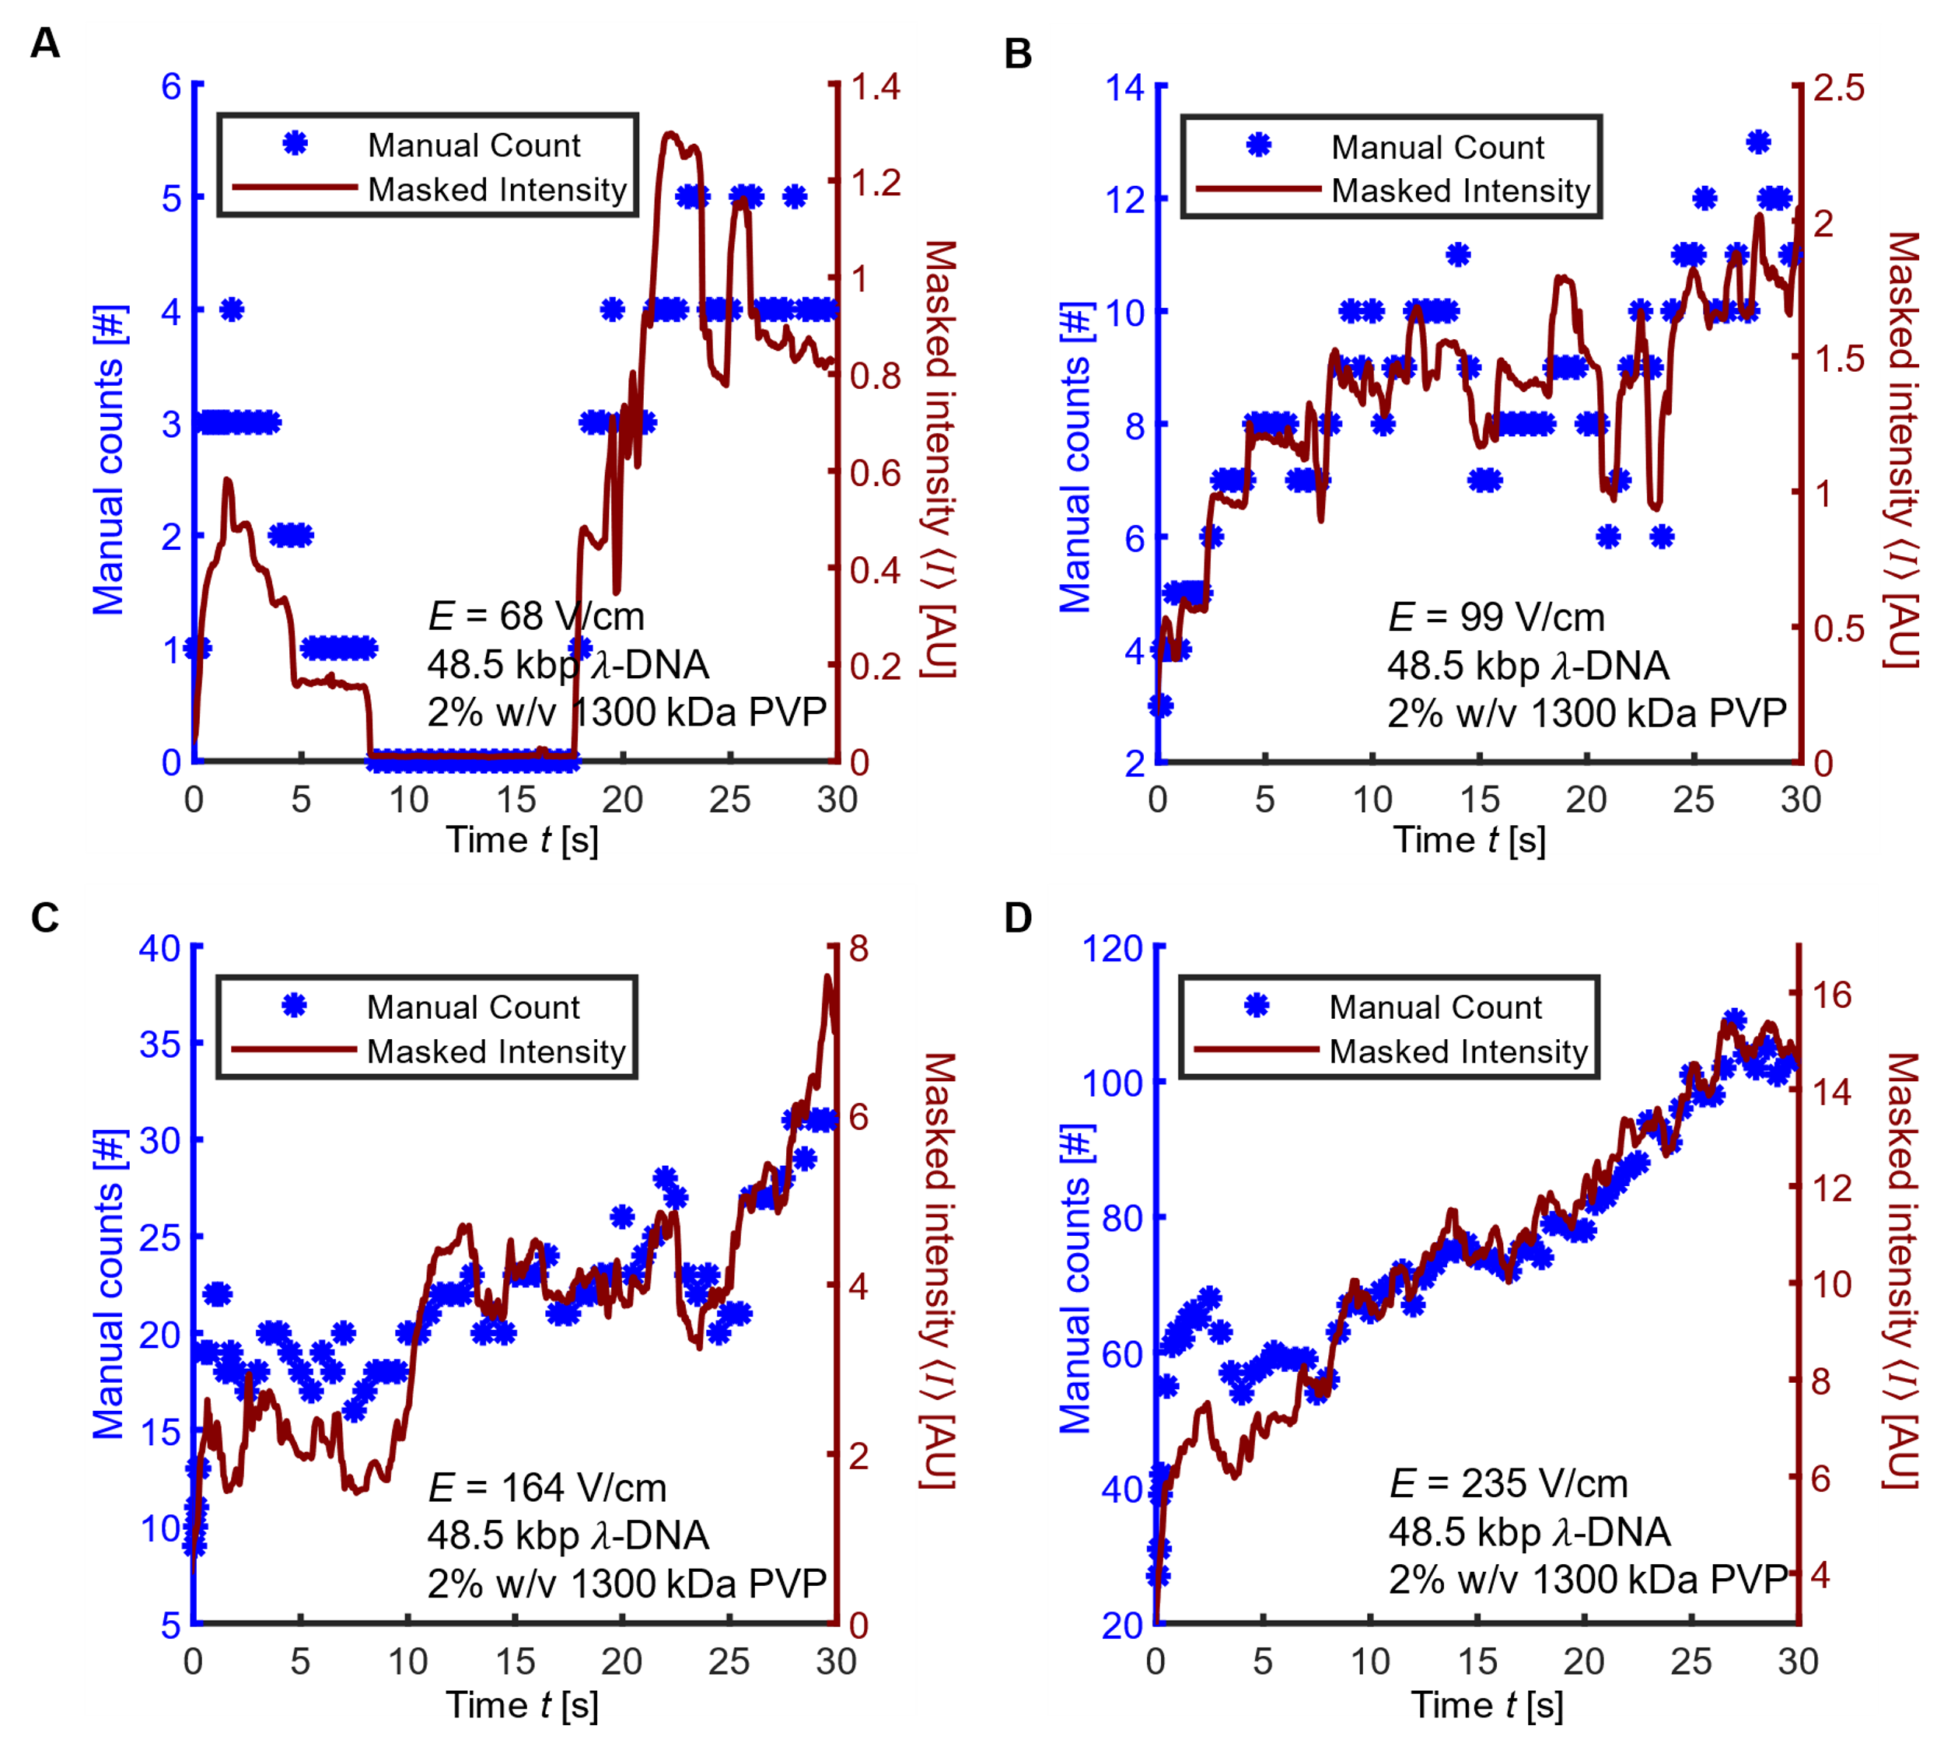

Fig. S2 | Comparison between area-averaged alpha-shape-bounded intensity $〈I〉$ versus results from manual counting of molecules. (A to D) Red curves show the alpha shape bounding intensity versus time for electric field strength of 18, 99, 164, and 235 V/cm, respectively. Blue scatter points show the manual counting of each entangled DNA at the corresponding time step for electric field strength of 18, 99, 164 and 235 V/cm, respectively. All data are 4 pM of YOYO-1 labeled λ-DNA (48.5 kbp) in 1$×$TBE buffer with 4% v/v β-mercaptoethanol added with 1300 kDa PVP polymer. The alpha shape bounding intensity versus time have trends that are similar to the manual counting results.

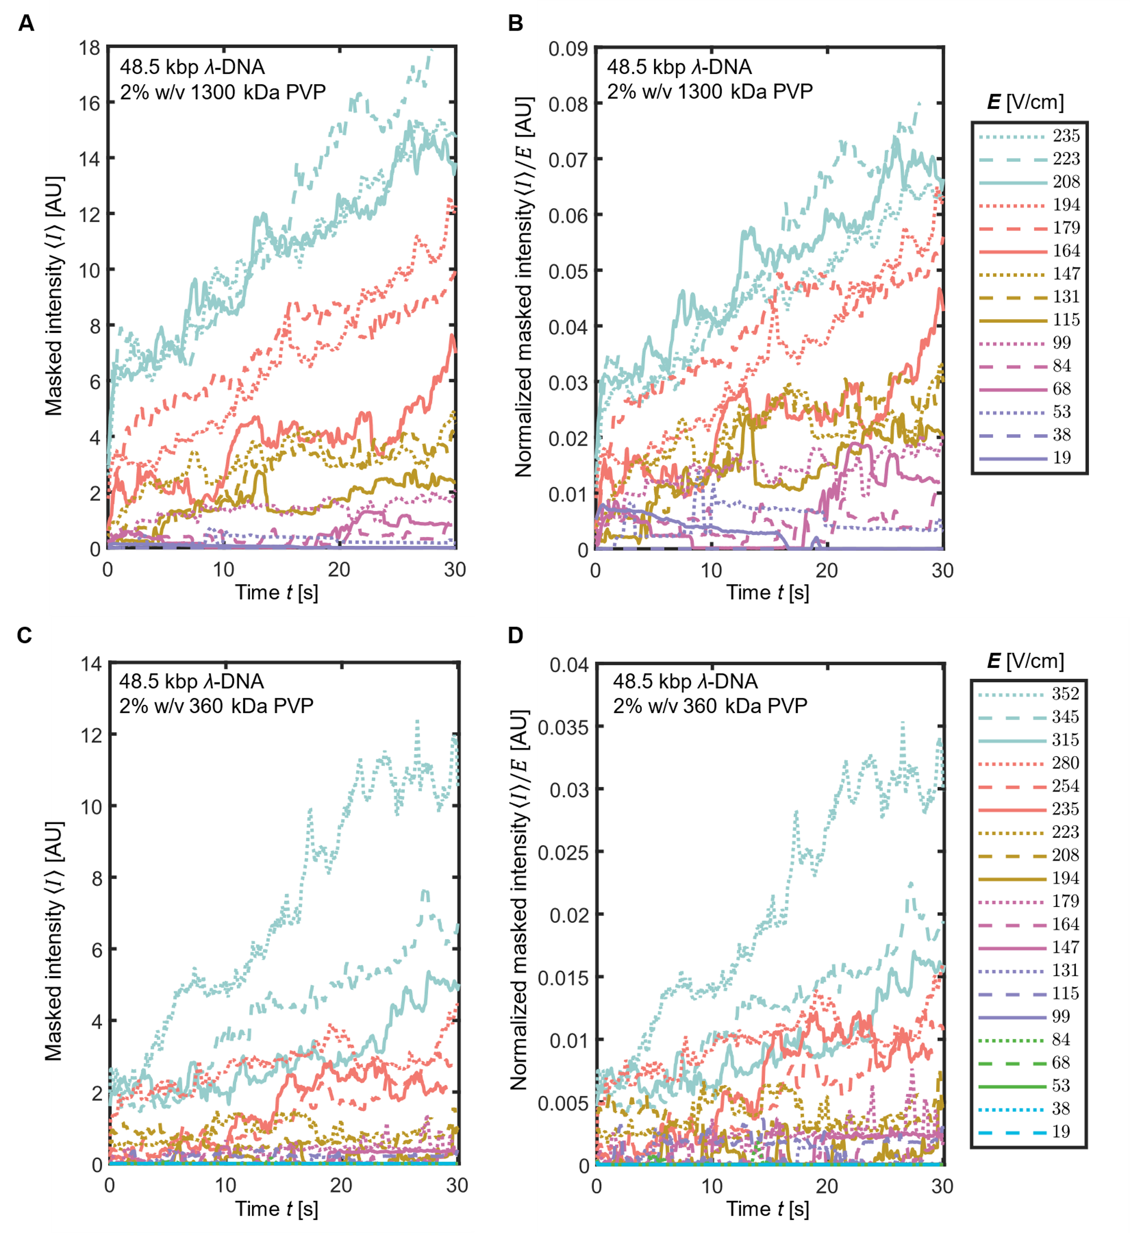

Fig. S3 | Additional experimental quantification of the amount of vertex-pinned, single-molecule DNA as a function of time and field strength. (A to D) Alpha shape bounding masked intensity versus time are shown for realizations performed at multiple respective electric fields. All data are 4 pM of YOYO-1 labeled λ-DNA (48.5 kbp) in 1$×$TBE buffer with 4% v/v β-mercaptoethanol. (A and B) have an addition of 2% w/w 1300 kDa PVP polymer in the buffer and (C and D) have an addition of 2% w/w 360 kDa PVP polymer in the buffer. Intensity in (B and D) are normalized by the applied axial electric field strength for each realization.

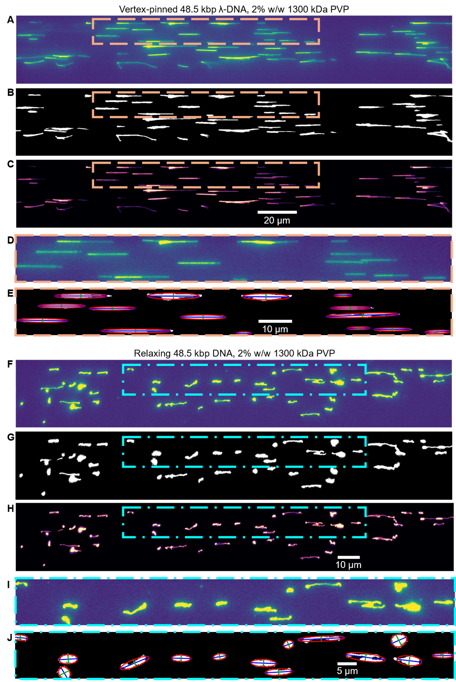

Fig. S4 | Summary of automated image processing used to quantify 48.5 kbp DNA relaxation. (A) Example image of vertex-pinned DNA before relaxation. (B) Binarized image of (A) after adaptive thresholding and alpha shape operation. (C) Image was obtained by integrating (A) with the mask in (B). (D) Zoomed in image of (A). (E) Example image to show the auto detection of each island. The red curve shows the result of ellipse shape approximation. The blue lines and the green lines show the major and secondary axis of each approximated ellipse shape, respectively. (F to J) Images showing the same procedure as from (A) to (E), except for the image was chosen during the DNA relaxation process.

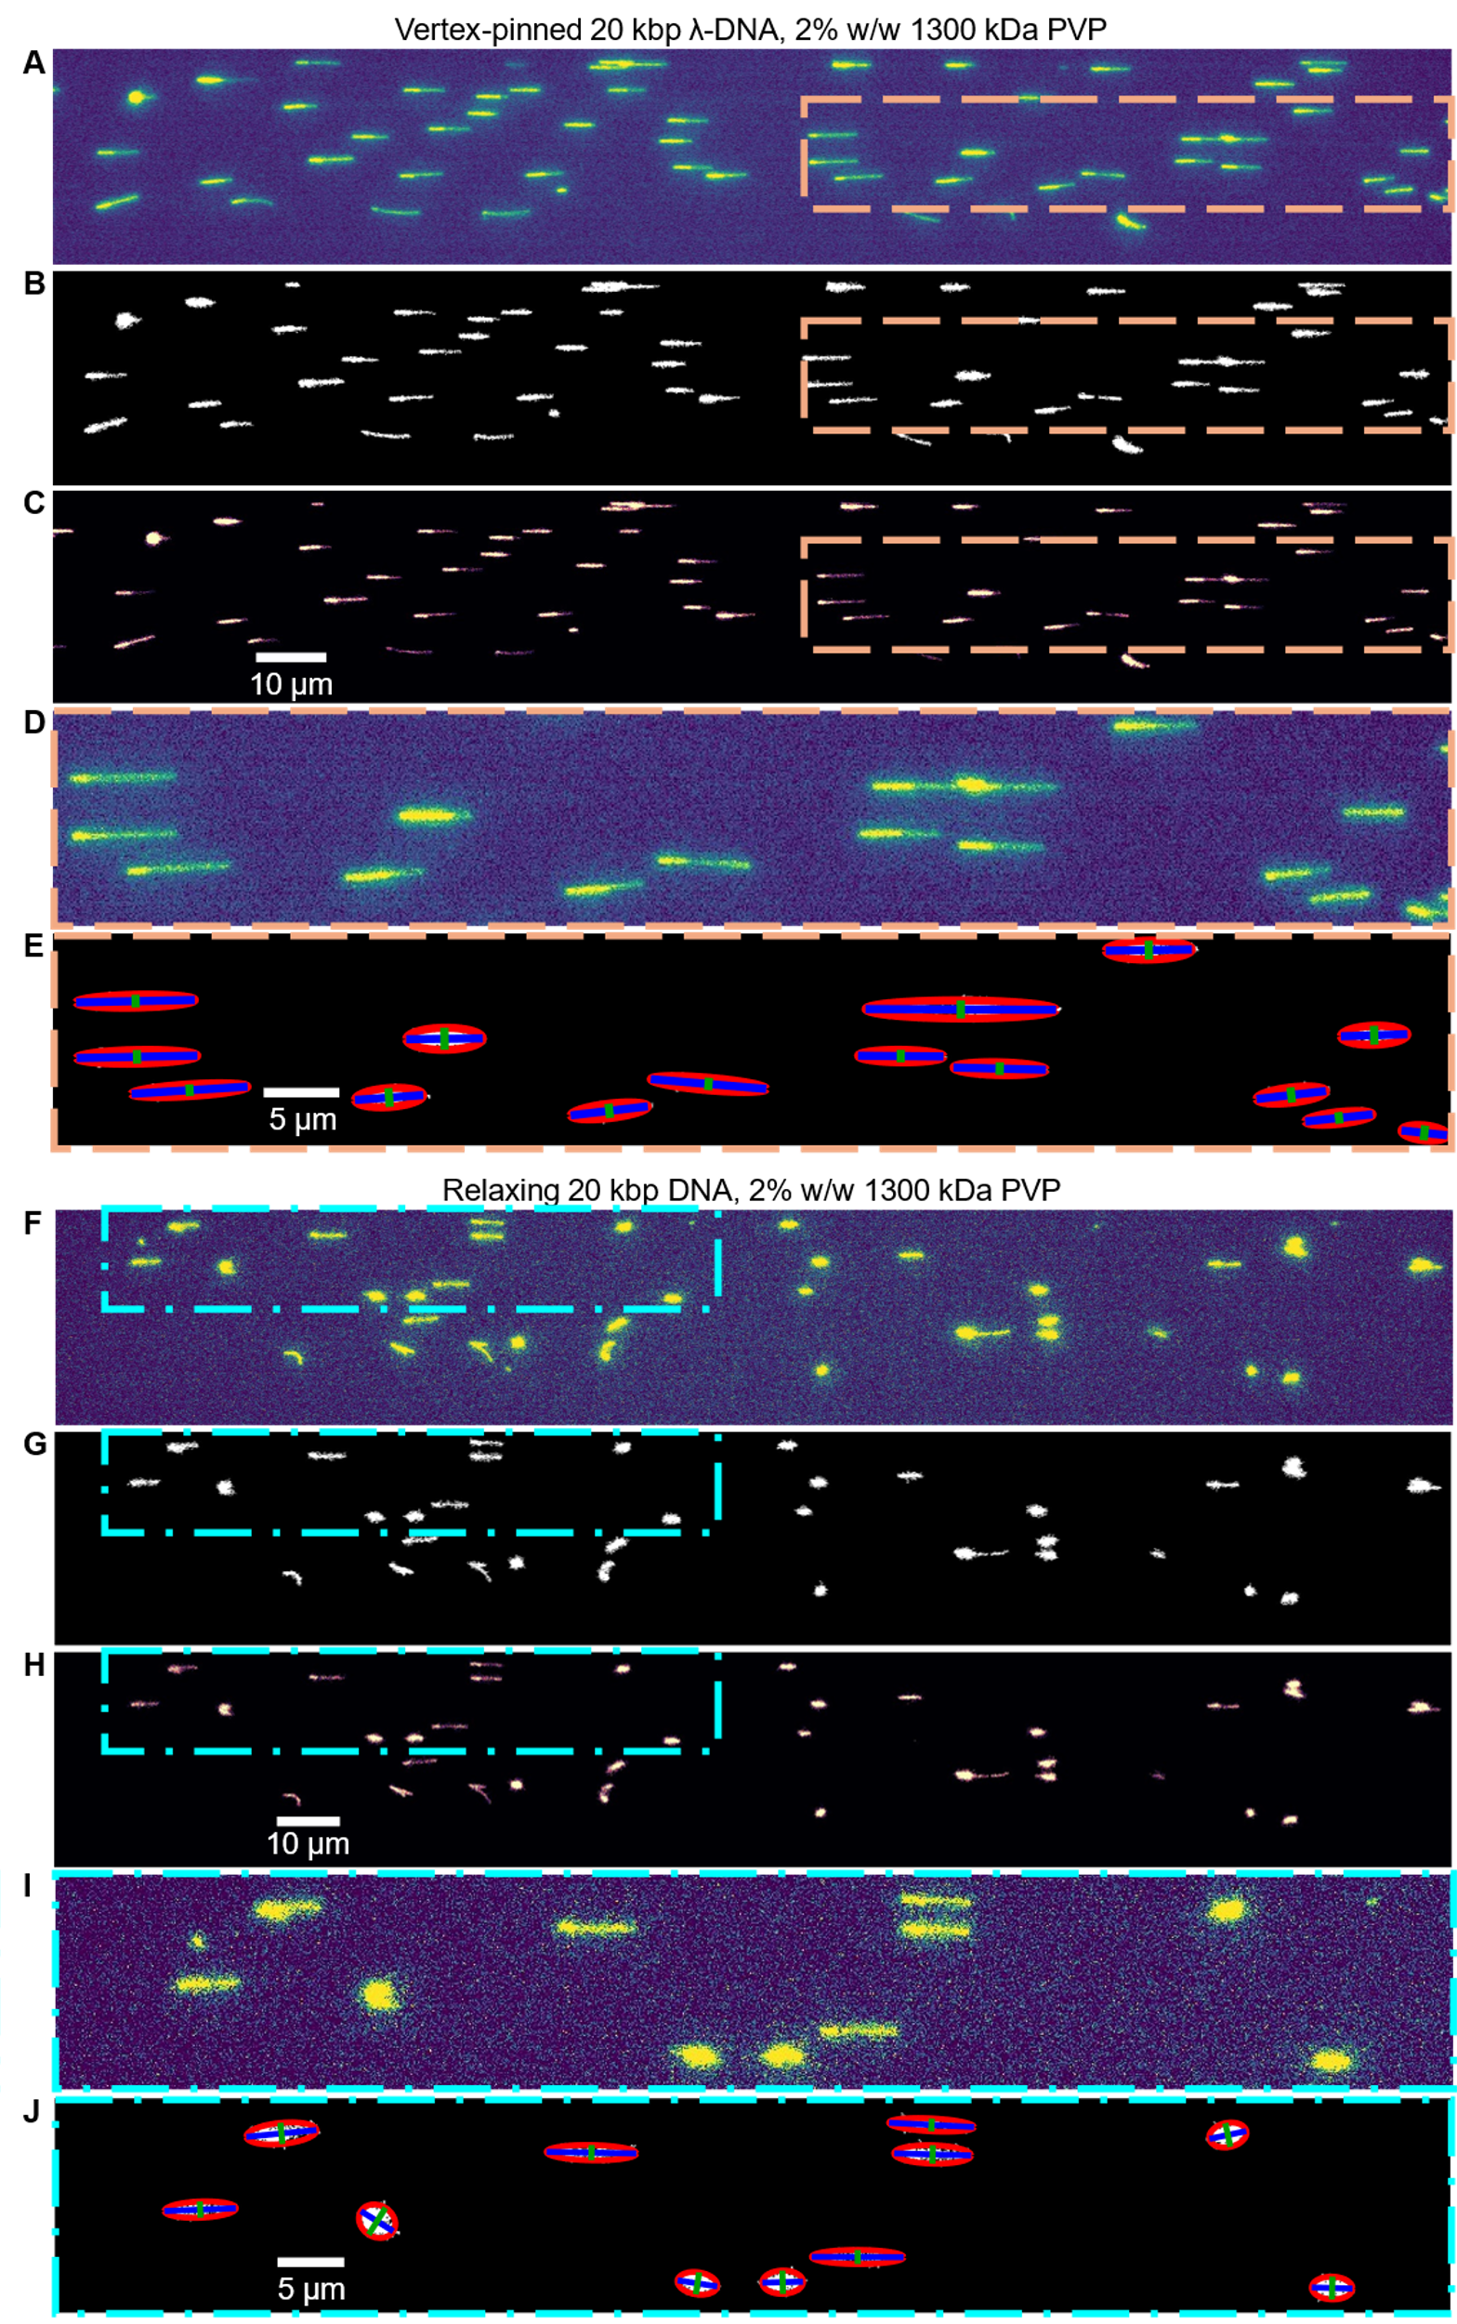

Fig. S5 | Summary of automated image processing used to quantify 20 kbp DNA relaxation. (A) Example image of vertex-pinned DNA before relaxation. (B) Binarized image of (A) after adaptive thresholding and alpha shape operation. (C) Image was obtained by integrating (A) with the mask in (B). (D) Zoomed in image of (A). (E) Example image to show the auto detection of each island. The red curve shows the result of ellipse shape approximation. The blue lines and the green lines show the major and secondary axis of each approximated ellipse shape, respectively. (F to J) Images showing the same procedure as from (A) to (E), except for the image was chosen during the DNA relaxation process.

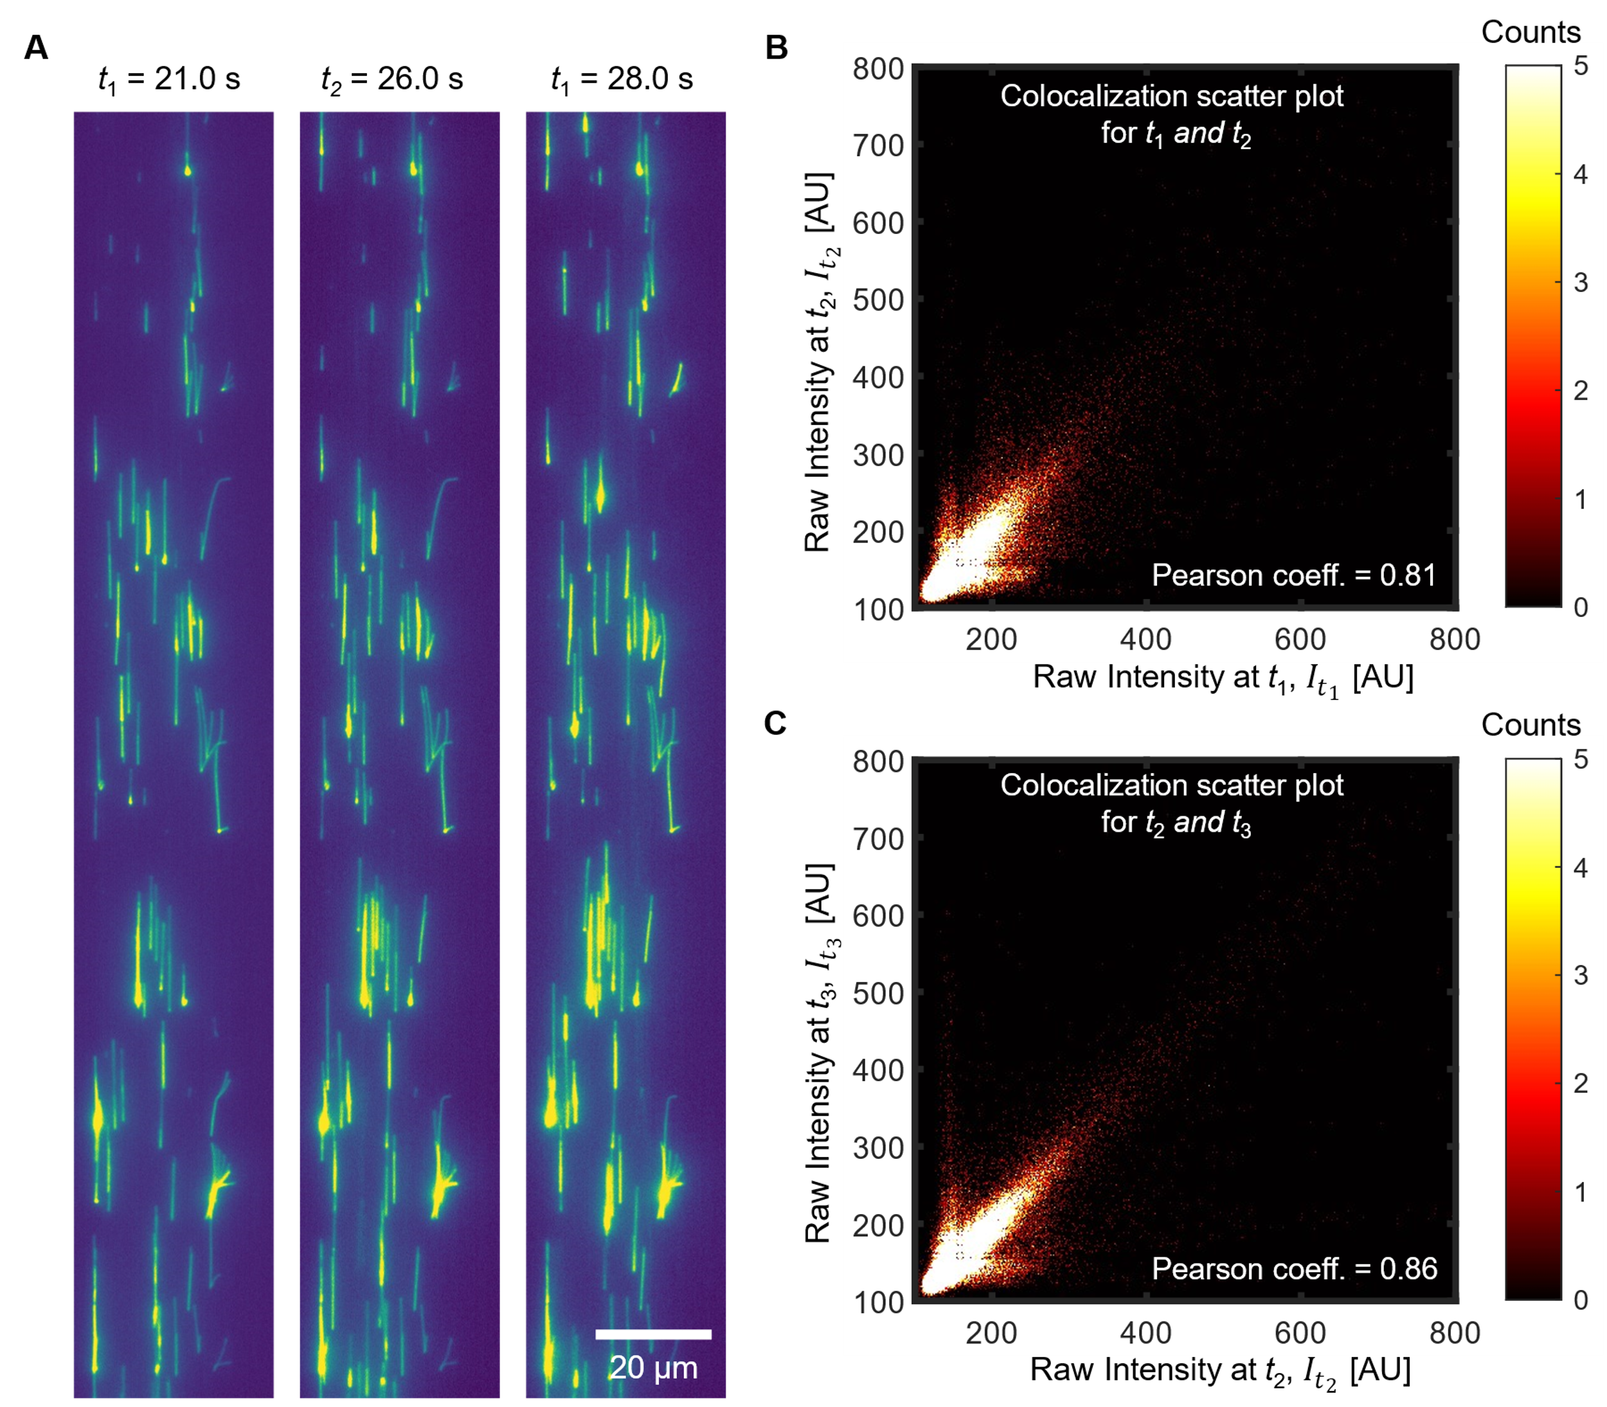

Fig. S6 | Colocalization analysis of image intensity of vertex-pinned DNA across three consecutive images from one realization. (A) Three raw consecutive epi-fluorescence images are shown for a single realization of DNA vertex-pinning experiments. The first sub-panel and the second sub-panel are 5 s apart. The second and third sub-panels are 2 s apart. (B to C) The colocalization scatter plots (correlation diagrams) compare each consecutive image pair. The computed Pearson correlation coefficients values for the two time-sequenced image pairs are 0.81 and 0.86, respectively.

Movie S1 (separate file).
Video was acquired with fluorescently labeled $λ$-DNA (48.5 kbp) migration in 1$×$TBE buffer with 4% v/v $β$-mercaptoethanol and addition of 2% w/w 1300 kDa PVP. The DNA molecules were subjected to an axial electric field of 68.5 V/cm from right to left, which was the approximate electric field strength suggested by Figure 3. The channel had a geometry as shown in Figure S1D and had a depth of 0.9 μm. The raw video was shown on the top part of the video. The moving median video was shown on the bottom part of the video and was processed as described in the section “Image processing for quantification of amount of vertex pinned DNA”. Note how the intensity data from stationary objects (pinned DNA) are enhanced while the intensity from moving objects were suppressed.

Movie S2 (separate file).
Video was acquired with fluorescently labeled $λ$-DNA (48.5 kbp) migration in 1$×$TBE buffer with 4% v/v $β$-mercaptoethanol and addition of 2% w/w 360 kDa PVP. The DNA molecules were subjected to an axial electric field of 179 V/cm from right to left, which was the approximate electric field strength suggested by Figure 3. The channel had a geometry as shown in Figure S1D and had a depth of 0.9 μm. The raw video was shown on the top part of the video. The moving median video was shown on the bottom part of the video and was processed as described in the section “Image processing for quantification of amount of vertex pinned DNA”. Note how the intensity data from stationary objects (pinned DNA) are enhanced while the intensity from moving objects were suppressed.

Movie S3 (separate file).
Video was acquired with fluorescently labeled $λ$-DNA (48.5 kbp) migration in 1$×$TBE buffer with 4% v/v $β$-mercaptoethanol and addition of 2% w/w 1300 kDa PVP. An electric field of 194 V/cm was applied from t = 0 to 9.6 s to allow DNA to be vertex-pinned and the electric field was turned off afterward to allow DNA to relax and disentangle. Some of the vertex-pinned DNA relaxed toward the trapping point, and some of the vertex-pinned DNA was quickly released from the trapping point. Note after switching off the electric field, some cloud shape DNA molecules entered the field of view by electromigration without trapping.

Movie S4 (separate file).
Video was acquired with fluorescently labeled 20 kbp DNA migration in 1$×$TBE buffer with 4% v/v $β$-mercaptoethanol and addition of 2% w/w 1300 kDa PVP. An electric field of 235 V/cm was applied from t = 0 to 9.6 s to allow DNA to be vertex-pinned and the electric field was turned off afterward to allow DNA to relax and disentangle. Some of the vertex-pinned DNA relaxed toward the trapping point, and some of the vertex-pinned DNA was quickly released from the trapping point. Note after switching off the electric field, some cloud shape DNA molecules entered the field of view by electromigration without trapping.

Movie S5 (separate file).
Video was acquired with fluorescently labeled $λ$-DNA (48.5 kbp) migration in 1$×$TBE buffer with 4% v/v $β$-mercaptoethanol and addition of 2% w/w 1300 kDa PVP. Two isolated channels of geometry as shown in Figure S1D were imaged and both had a depth of 0.9 μm. Samples in both branches were the same, but DNA in top branch was driven by pressure driven flow only and the DNA in bottom branch was driven by electric fields only. The applied electric field at the bottom branch was initially 410 V/cm for DNA vertex-pinning and then canceled to zero to allow DNA to relax and disentangle over around 50 s. Next, 12 V/cm of electric field was applied to clear out the previously trapped DNA molecules and introduced new ones.

Movie S6 (separate file).
Video was acquired with fluorescently labeled $λ$-DNA (48.5 kbp) migration in 1$×$TBE buffer with 4% v/v $β$-mercaptoethanol and addition of 2% w/w 1300 kDa PVP. The DNA molecules were subjected to an axial electric field suddenly increased from 10 V/cm to 140 V/cm. The channel was an approximately 2.2 cm long straight channel with a cross-section of 40 μm wide and 3 μm deep. The depth of field was estimated to be 0.7 μm. The focal plane was adjusted during the experiment to show DNA vertex-pinning at top and bottom surfaces.

Movie S7 (separate file).
Video was acquired with fluorescently labeled $λ$-DNA (48.5 kbp) migration in 1$×$TBE buffer with 4% v/v $β$-mercaptoethanol and addition of 2% w/w 1300 kDa PVP. Two isolated channels of geometry as shown in Figure S1D were imaged and both had a depth of 0.9 μm. Samples in both branches were the same, but DNA in top branch was driven by pressure driven flow only and the DNA in bottom branch was driven by electric fields only. The applied electric field at the bottom branch was switching between 190 V/cm and 0 V/cm to demonstrate DNA vertex-pinning at sufficiently high electric field comparing to no vertex-pinning under pressure driven flow.

Movie S8 (separate file).
Video was acquired with fluorescently labeled $λ$-DNA (48.5 kbp) migration in 1$×$TBE buffer with 4% v/v $β$-mercaptoethanol and addition of 2% w/w 1300 kDa PVP. The DNA molecules were subjected to an axial electric field of 147 V/cm from right to left. The channel had a geometry as shown in Figure S1D and had a depth of 0.9 μm. The raw video was shown on the top part of the video. The moving median video was shown on the bottom part of the video, and was processed as described in the section “Image processing for quantification of amount of vertex pinned DNA”. Note how the intensity data from stationary objects (pinned DNA) are enhanced while the intensity from moving objects were suppressed.

Movie S9 (separate file).
Superposing of approximately 300 DNA during relaxation after being vertex-pinned. The trapping point (vertex) was superposed, and the direction of DNA molecules were aligned. The detail image processing procedure was discussed in the SI. The sample used is fluorescently labeled $λ$-DNA (48.5 kbp) in 1$×$TBE buffer with 4% v/v $β$-mercaptoethanol and addition of 2% w/w 1300 kDa PVP.

Movie S10 (separate file).
Video was acquired with fluorescently labeled $λ$-DNA (48.5 kbp) migration in 1$×$TBE buffer with 4% v/v $β$-mercaptoethanol and addition of 2% w/w 1300 kDa PVP. The DNA molecules were subjected to an axial electric field of 256 V/cm from right to left. The channel had a geometry as described by Extended Data Fig. 2 and had a width of 100 μm and a depth of 37 μm, approximately. The channel was all made by glass. Clouds of DNA molecules were electromigrated while some DNA molecules were vertex pinned in the background.

SI References

31. Bradley, D. & Roth, G. Adaptive Thresholding using the Integral Image. J. Graphics Tools 12, 13–21 (2007).
32. Liang, J., Edelsbrunner, H., Fu, P., Sudhakar, P. V. & Subramaniam, S. Analytical shape computation of macromolecules: I. molecular area and volume through alpha shape. Proteins: Structure, Function, and Bioinformatics 33, 1–17 (1998).
33. Kim, Y. et al. Nanochannel confinement: DNA stretch approaching full contour length. Lab on a Chip 11, 1721–1729 (2011).
34. Minatti, E., Norwood, D. P. & Reed, W. F. Surfactant/Polymer Assemblies. 2. Polyelectrolyte Properties. Macromolecules 31, 2966–2971 (1998).
35. Castillo-Fernandez, O. et al. Electrokinetic DNA transport in 20 nm-high nanoslits: Evidence for movement through a wall-adsorbed. ELECTROPHORESIS 32, 2402–2409 (2011).

