Supplementary Table 1 Overall survival rates among patients by TTFields therapy cohort
 | TTFields  (n=109) | No TTFields  (n=99)
1-year OS, % (95% CI) | 81 (74-88) | 73 (64-82)
2-year OS, % (95% CI) | 43 (34-54) | 31 (23-42)
3-year OS, % (95% CI) | 24 (16-34) | 21 (14-31)
4-year OS, % (95% CI) | 21 (14-31) | 16 (10-27)
5-year OS, % (95% CI) | 17 (11-28) | 12 (6-23)
6-year OS, % (95% CI) | 17 (11-28) | 3 (0-18)
7-year OS, % (95% CI) | 17 (11-28) | NA
8-year OS, % (95% CI) | 17 (11-28) | NA

Supplementary Figure 1 Survival among patients surviving ≥2 years by TTFields therapy cohort
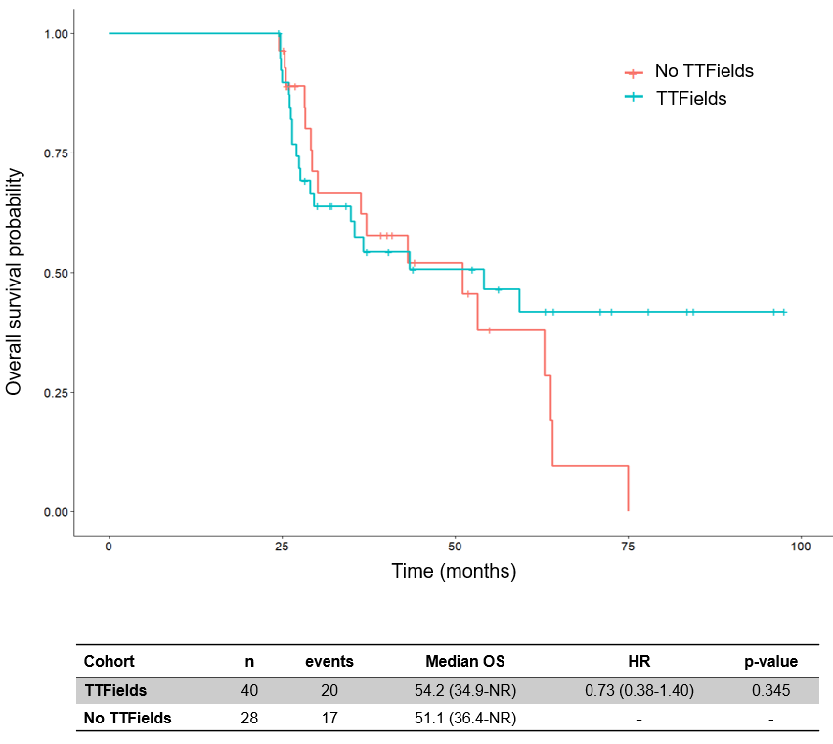

Supplementary Figure 2 Duration of TTFields treatment as a function of device usage rate

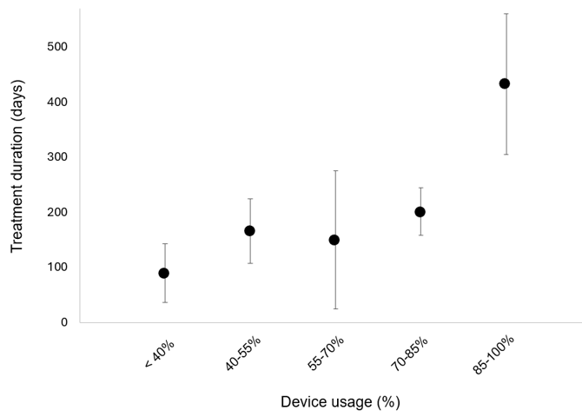

Supplementary Table 2 Patient characteristics for ≥75% and <75% usage cohorts, unmatched and matched datasets
 | Unmatched |  |  | Matched
 | ≥75% usage  (n=46) |  | <75% usage  (n=55) | ≥75% usage  (n=34) |  | <75% usage  (n=34)
Age, y
Median (range) | 62 (37-84) |  | 59 (27-85) | 61 (37-75) |  | 60 (27-74)
Sex
Men | 19 (41) |  | 40 (73) | 17 (50) |  | 21 (62)
Women | 27 (59) |  | 15 (27) | 17 (50) |  | 13 (38)
Multifocal disease | 2 (4) |  | 4 (7) | 2 (6) |  | 2 (6)
IDH1 Status
Mutated | 0 (0) |  | 0 (0) | 0 (0) |  | 0 (0)
Wildtype | 46 (100) |  | 55 (100) | 34 (100) |  | 34 (100)
Unknown | 0 (0) |  | 0 (0) | 0 (0) |  | 0 (0)
MGMT promoter methylation status
Methylated | 14 (30) |  | 20 (36) | 14 (41) |  | 16 (47)
Unmethylated | 20 (43) |  | 23 (42) | 20 (59) |  | 18 (53)
Unknown | 12 (26) |  | 13 (22) | 0 (0) |  | 0 (0)
Resection status
Gross total resection | 20 (43) |  | 23 (42) | 18 (53) |  | 17 (50)
Sub-total resection | 19 (41) |  | 27 (49) | 12 (35) |  | 14 (41)
Biopsy | 7 (15) |  | 5 (9) | 4 (12) |  | 3 (9)

Supplementary Figure 3 Progression-free survival among TTFields-treated patients by device usage level
