Supplementary information
Hippocampal subfield volume across age, splitting by APOE status (Fig ???). In all subfields, APOE e3/e3 and e3/e4 carriers had highly similar and overlapping trajectories in volume reductions over age. A sharp reduction in volume over age 65 in e4/4 carriers, is seen in the parasubiculum, the presubiculum and the subiculum head and body, and CA1 and CA3 head and CA4 body.
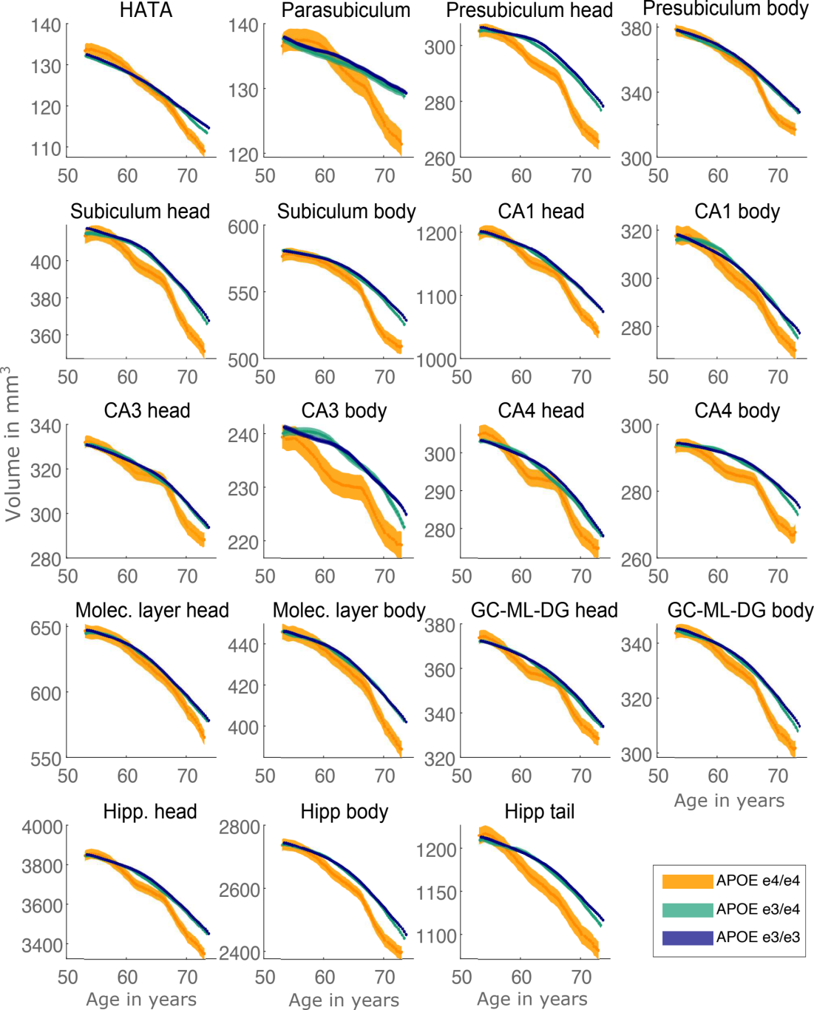
Accelerated age-related volume loss in hippocampal subfields in APOE e4/e4 carriers relative to APOE e3/e4 and APOE e3/e3 carriers.
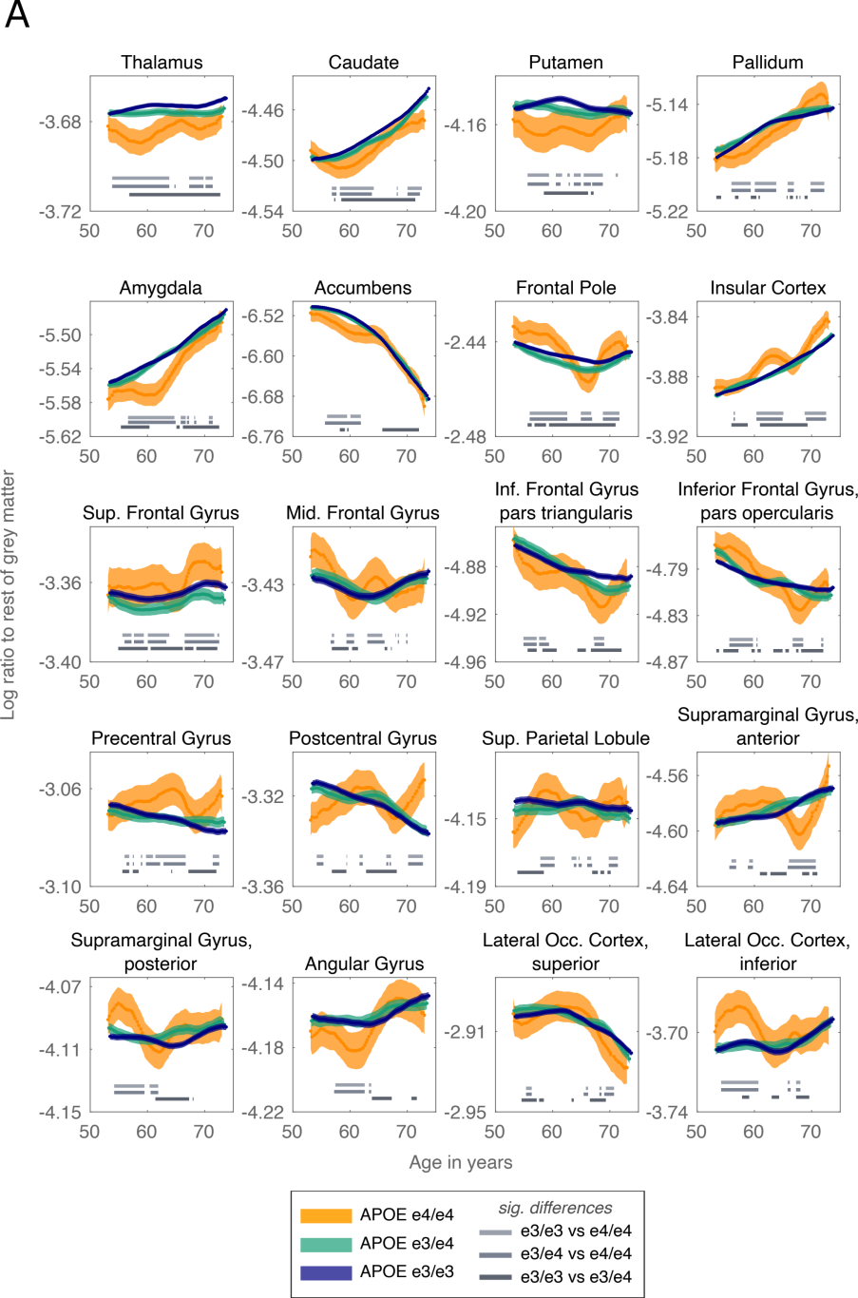
Part A. Control brain regions areas do not show a clear APOE effect. Ratio of control brain regions to the rest of the grey matter. Significant differences between the curves at p<.001 are shown per age window as grey horizontal bars. continued in part B
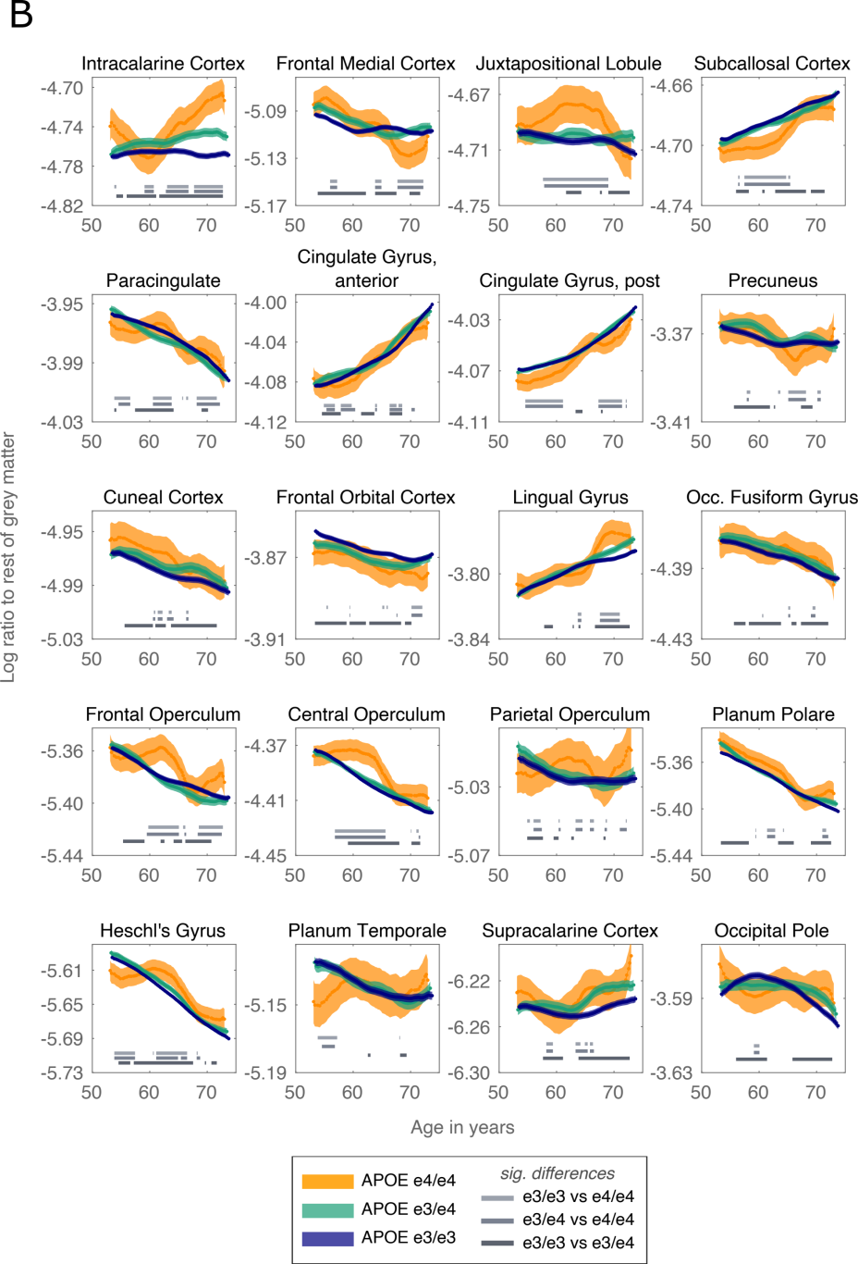
Part B. Further control brain regions areas do not show a clear APOE effect. Ratio of control brain regions to the rest of the grey matter. Significant differences between the curves at p<.001 are shown per age window as grey horizontal bars.
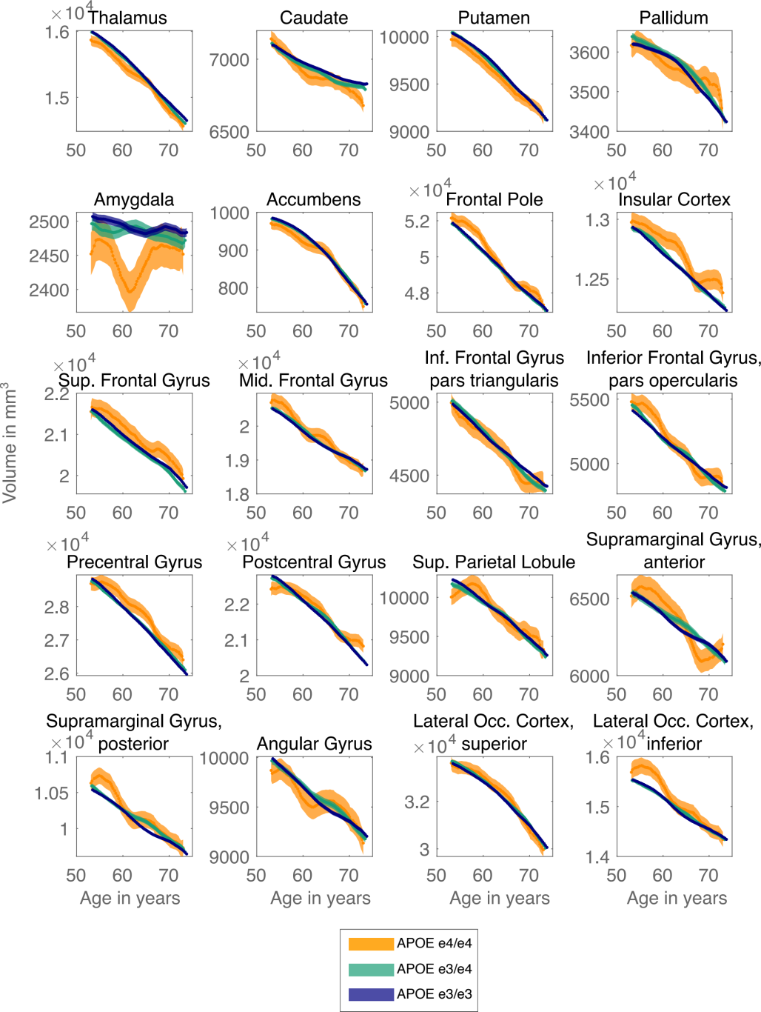
Part A. Volume of control brain areas declines linearly with age, with no clear APOE effect, with the exception of Amygdala. Continued in part B.
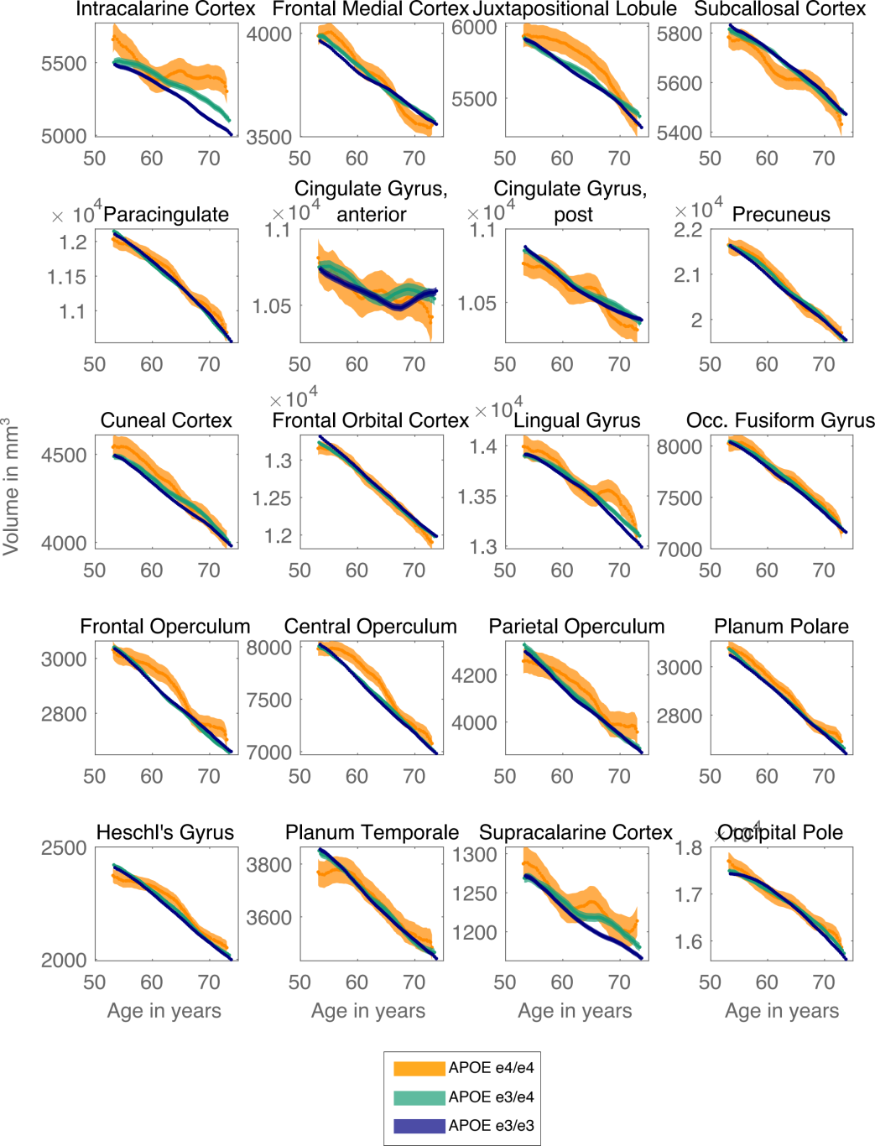
Part B. Volume of further control brain areas declines linearly with age, with no clear APOE effect.

