Supplemental Figures
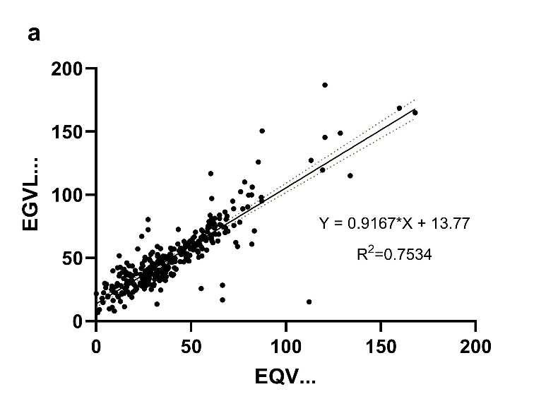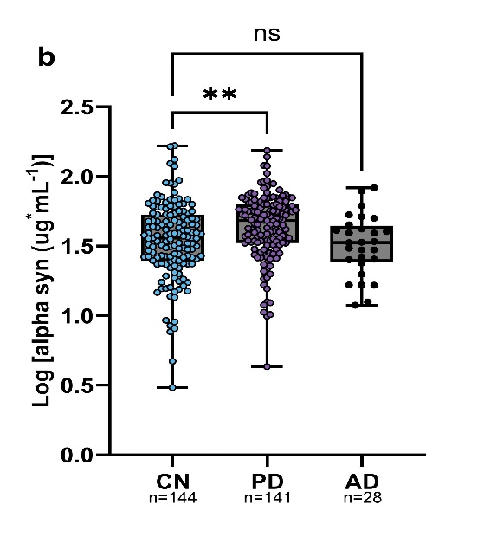
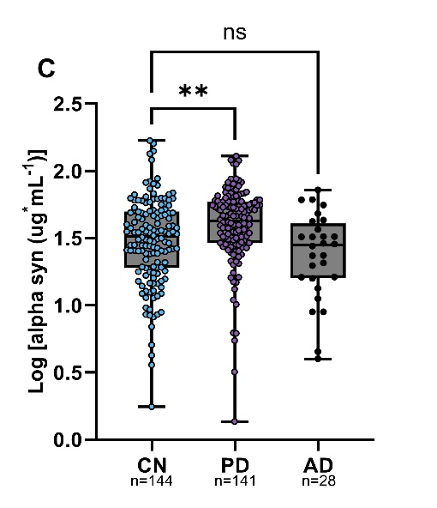
Supplemental Figure 1. α-syn peptides detected show a linear relationship. Scatter plot (a) shows the strong linear relationship between the two detectable α-syn peptides used for quantification (R²=0.753). Dot plot (b) is the log transformed α-syn quantification for the peptide EGVLYGSK that gives a ROC curve with low diagnostic ability (AUC (95% CI) =0.618 (0.553-0.683)). Dot plot (c) is the log transformed α-syn quantification for the peptide EQVTNVGGAVVTGVTAVAQK that gives a ROC curve with low diagnostic ability (AUC (95% CI) =0.623 (0.558-0.688)). ** - p < 0.01 one-way ANOVA and Dennett’s post-hoc analysis

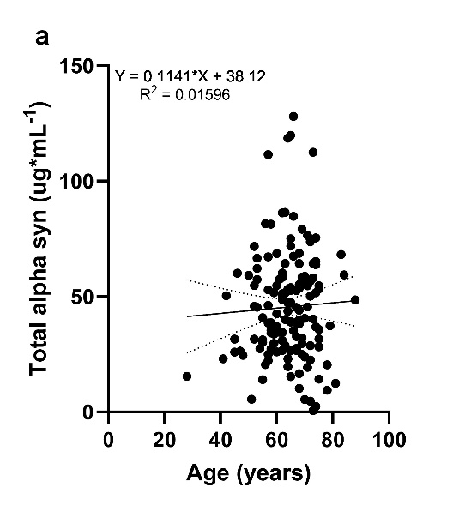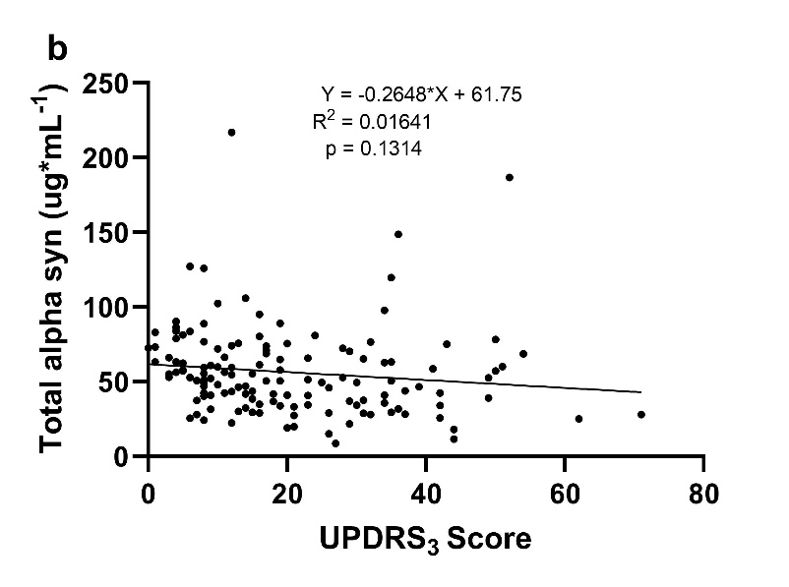
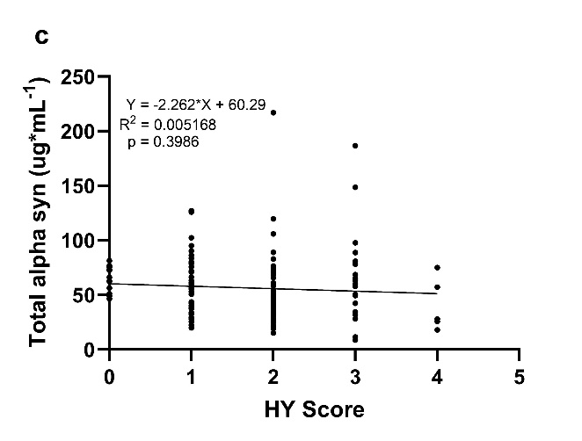
Supplemental Figure 2. Association of age and iPD severity scales to erythrocytic α-syn. Scatter plot (a) shows no association of age to concentration of α-syn (R²=0.015). Scatter plot (b) shows no association of Unified Parkinson’s Disease Rating Scale score to the concentration of α-syn (R²=0.016, p=0.131). Scatter plot (c) shows no association of Hoehn and Yahr score to the concentration of α-syn (R²=0.005, p=0.399).

