Supplementary Figures
(a)
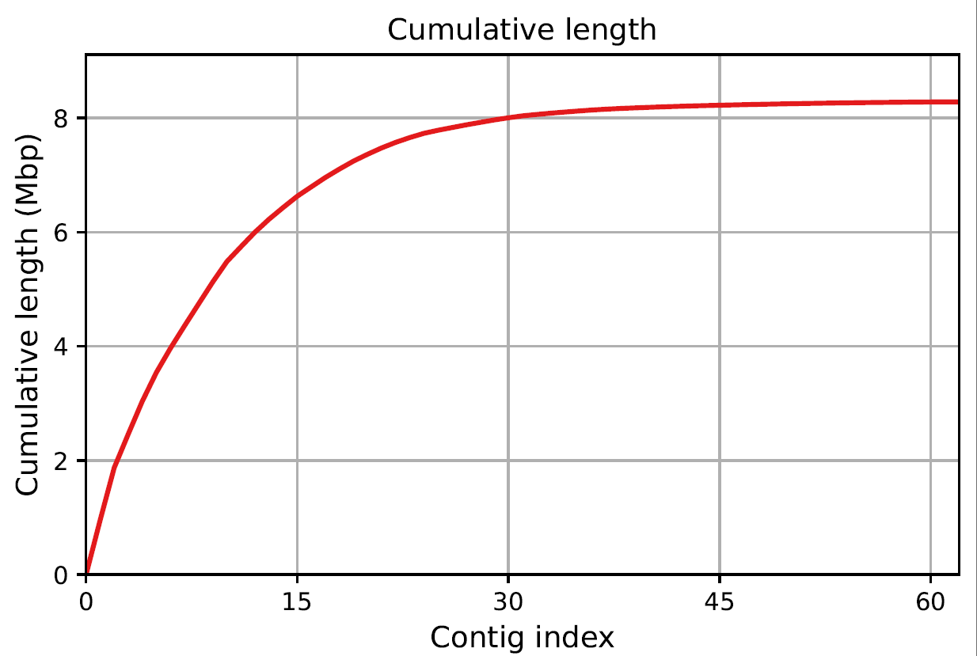
(b)

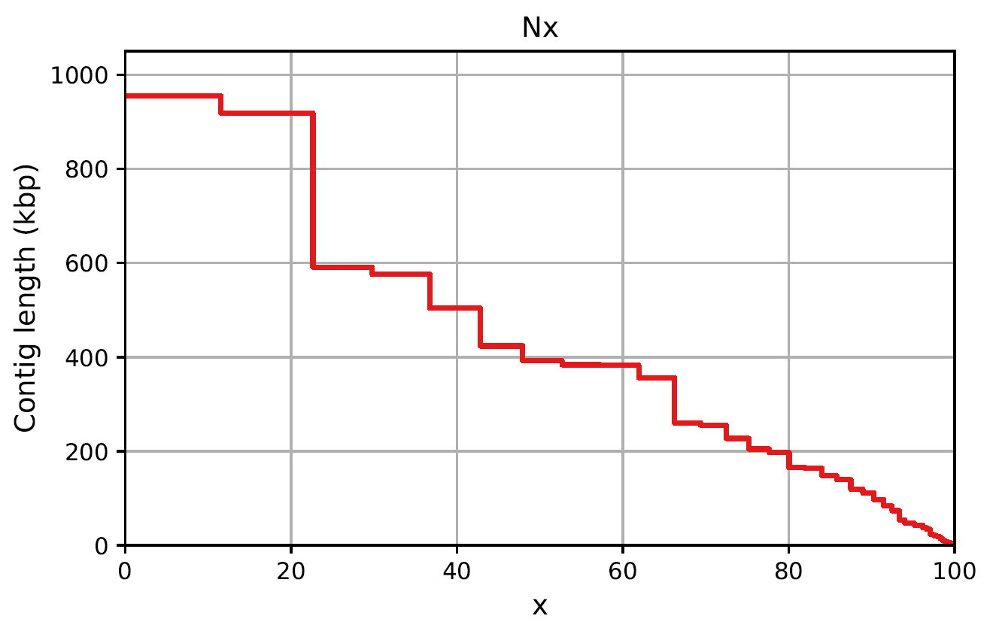
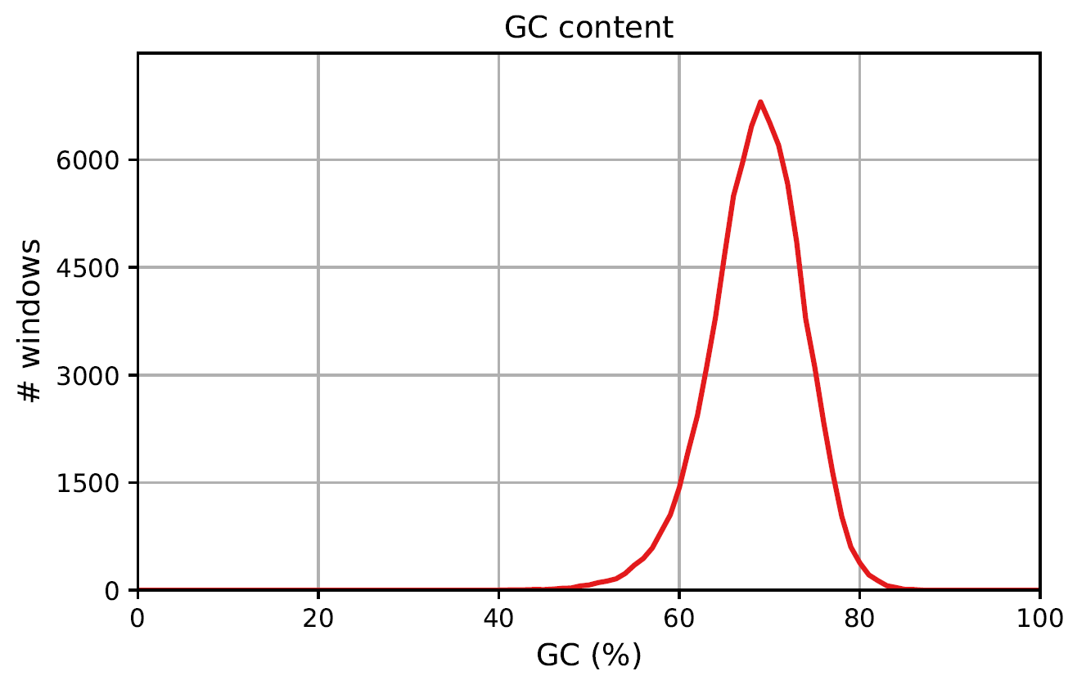
(c)

Figure S1: Bar plots for the A. regifaucium DSM 45072^{T} genome were generated using QUAST v.5.2.0 (https://github.com/ablab/quast) (a) Total genome length, with the y-axis representing the cumulative genome length (Mbp) and the x-axis showing the contig index (b) Nx plot illustrating the distribution of contig lengths (kbp) on the y-axis, with Nx percentages on the x-axis (c) G+C content distribution, with the y-axis representing genomic regions (1000 bp) and the x-axis showing GC%.

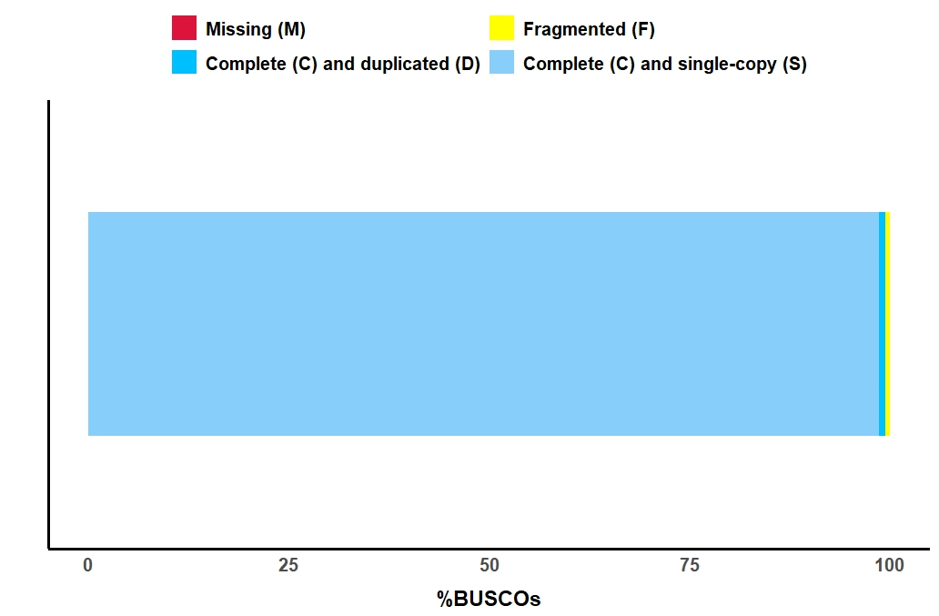
Figure S2: Completeness of the A. regifaucium DSM 45072^{T} genome assembly, assessed using BUSCO v.5.7.1 (https://busco.ezlab.org/). The x-axis represents the percentage of BUSCO groups. The plot shows 356 BUSCO groups, with 98.6% (351) classified as complete and single copy, 0.8% (3) as complete and duplicated, and 0.6% (2) as fragmented.
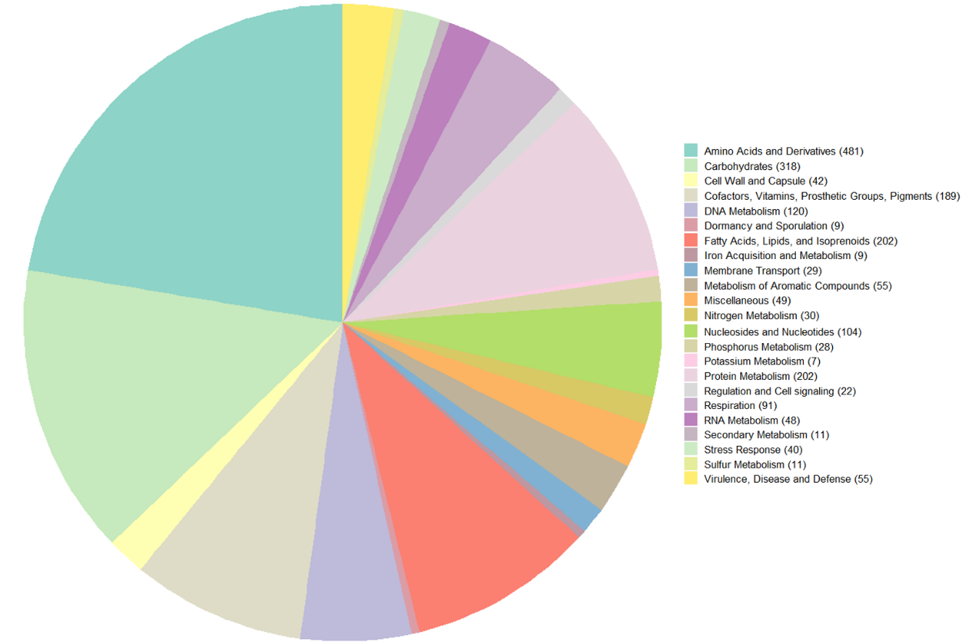
Figure S3: Distribution of subsystem categories identified in the A. regifaucium DSM 45072^{T} genome, generated through the genome annotation using RASTk (https://rast.nmpdr.org/rast.cgi).
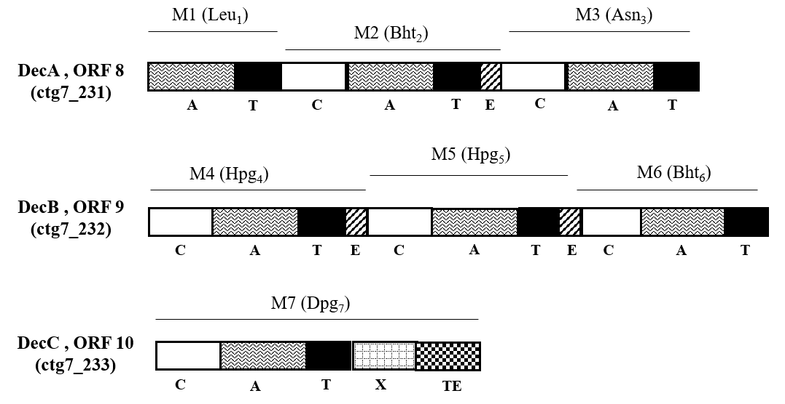

Figure S4: Organization of modules in the NRPS assembly of GPA gene cluster of A. regifaucium DSM 45072^{T}. The domains are: A, adenylation; T, thiolation; C, condensation; E, epimerization; TE, thioesterase.
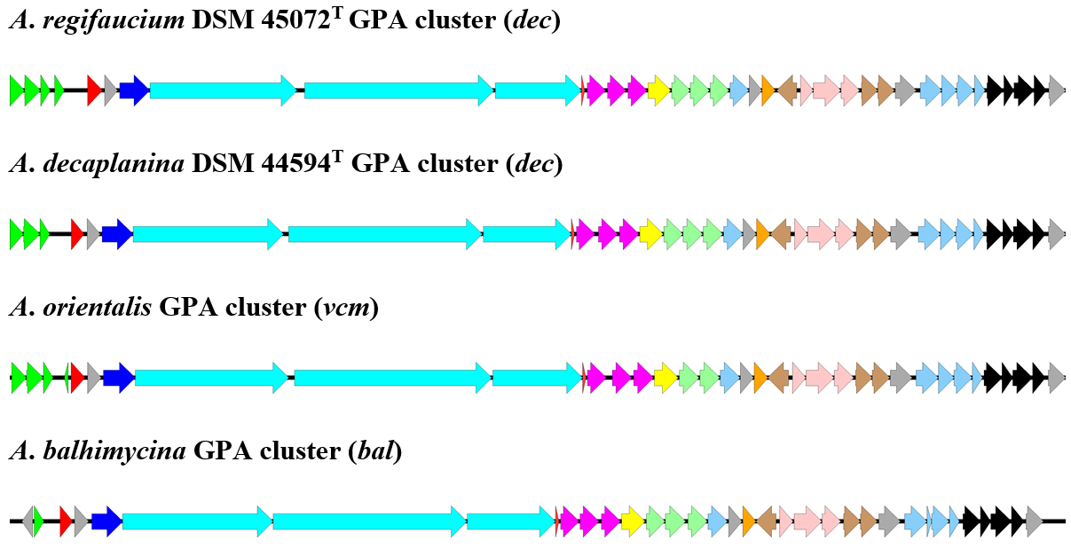
Figure S5: Comparison of dec cluster with previously reported related GPA clusters; vcm of A. orientalis and bal of A. balhimycina.

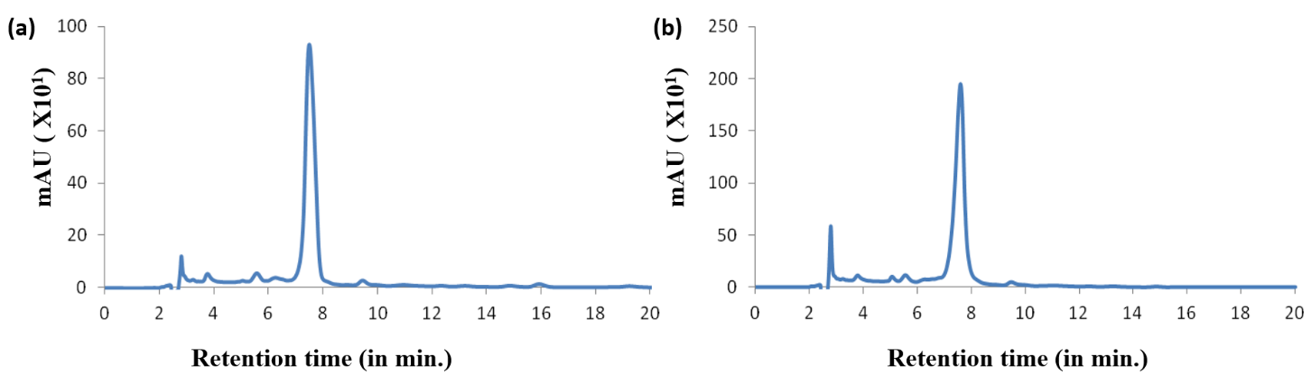
Figure S6: HPLC of methanol extracts of (a) A. regifaucium DSM 45072^{T} and (b) A. decaplanina DSM 44594^{T}.

Supplementary Tables

Table S1: Additional features of A. regifaucium DSM 45072^{T} using QUAST v.5.2.0 (https://github.com/ablab/quast).
Features
# contigs | 62
# contigs (>= 0 bp) | 62
# contigs (>= 1000 bp) | 62
# contigs (>= 5000 bp) | 48
# contigs (>= 10000 bp) | 38
# contigs (>= 25000 bp) | 31
# contigs (>= 50000 bp) | 25
Largest contig | 954818
Total length | 8283019
Total length (>= 0 bp) | 8283019
Total length (>= 1000 bp) | 8283019
Total length (>= 5000 bp) | 8239615
Total length (>= 10000 bp) | 8167127
Total length (>= 25000 bp) | 8037572
Total length (>= 50000 bp) | 7784991
N50 | 392513
N90 | 111374
auN | 467430
L50 | 7
L90 | 21
GC (%) | 68.5
Mismatches
# N's per 100 kbp | 1.11
# N's | 92

Table S2: BLAST hits (https://blast.ncbi.nlm.nih.gov/) for 16S rRNA partial sequence (percentage identity ≥ 98.5%-99% and query coverage ≥ 95%).
Species | Query Cover | E value | Percentage identity | Accession
Amycolatopsis orientalis IMSNU 20058 | 96% | 0 | 99.59 | NR_042104.1
Amycolatopsis japonica MG 417-CF 17 | 98% | 0 | 99.26 | NR_025561.1
Amycolatopsis lurida IMSNU 20057 | 98% | 0 | 99.06 | NR_042040.1
Amycolatopsis decaplanina DSM 44594 | 96% | 0 | 98.98 | NR_025562.1
Amycolatopsis azurea IMSNU 20053 | 96% | 0 | 98.84 | NR_042103.1
Amycolatopsis orientalis IFO 12806 | 97% | 0 | 98.71 | NR_115645.1
Amycolatopsis keratiniphila subsp. nogabecina | 97% | 0 | 98.71 | NR_025563.1

Table S3: Secondary metabolite biosynthetic gene clusters predicted using antiSMASH v.3.0 for A. regifaucium DSM 45072^{T} (http://www.secondarymetabolites.org).
# cluster | Type | Homologous known gene cluster | % similarity with known homologous gene cluster | Size (in kb)
1 | Terpene | Carotenoid | 36 | 21,481
2 | Type2PKS | Lysolipin | 52 | 51,116
3 | Oligosaccharide | Polyketomycin | 13 | 27,756
4 | Terpene | Sioxanthin | 25 | 21,157
5 | T1PKS | Endophenazines | 8 | 45,267
6 | Other | - | - | 43,953
7 | Other KS | Rifamycin | 7 | 50,402
8 | Type1PKS | Kanamycin | 1 | 44,202
9 | Other | Kedarcidin | 1 | 42,786
10 | Other | Thioviridamide | 10 | 44,064
11 | Arylpolyene | Kinamycin | 5 | 41,151
12 | NRPS-T3PKS | Balhimycin | 89 | 94,924
13 | Lassopeptide | Chalcomycin | 4 | 22,509
14 | Other | Chartreusin | 15 | 40,686
15 | T1PKS Bacteriocin | Kedarcidin | 12 | 48,649
16 | NRPS-T3PKS | - | - | 22,999
17 | Ectoine | Ectoine | 100 | 10,389
18 | Type1PKS | Neocarzinostatin | 26 | 45,453
19 | T1PKS-beta-lactam | Neocarzinostatin | 100 | 47,338
20 | Bacteriocin NRPS | Scabichelin | 60 | 56,715
21 | NRPS | Mirubactin | 78 | 57,303
22 | Type1PKS | Kanamycin | 1 | 47,454
23 | Butyrolactone | Tomaymycin | 11 | 10,770
24 | NRPS-T1PKS | Bleomycin | 9 | 60,870
25 | Terpene | Azinomycin B | 4 | 21,136
26 | NRPS | Coelibactin | 45 | 61,062
27 | Lantipeptide | Erythreapeptin | 100 | 22,825
28 | Terpene | 2-methylisoborneol | 100 | 21,145
29 | Lantipeptide |  |  | 23,374
30 | Other | Dynemicin BSGC | 6 | 43,803
31 | Amglyccycl | Kedarcidin BSGC | 1 | 21,277
32 | NRPS | Esmeraldin | 8 | 94,039
33 | Other, KS-T1PKS | - | - | 46,104
34 | Bacteriocin | - | - | 6352

Table S4: Result of antibiosis assays of culture broths and extracts of A. regifaucium DSM 45072^{T} against test cultures (+ zones of inhibition, - no zone of inhibition).
Test strains | MTCC accession number | Neomycin  (30 μg/disc) (control) | Vancomycin (30 μg/disc)  (control) | A. regifaucium  DSM 45072^{T}  cell free supernatant | A. regifaucium  DSM 45072^{T}  (extract)
M. luteus | MTCC 106^{T} | + | + | + | +
S. aureus | MTCC 96 | + | + | + | +
S. epidermidis | MTCC 435 | + | + | + | +
B. subtilis | MTCC 441 | + | + | + | +
E. faecalis | MTCC 439 | + | + | + | +
E. coli | MTCC 2939 | + | - | - | -
P. aeroginosa | MTCC 2453^{T} | + | - | - | -
C. albicans | MTCC 227 | - | - | - | -

Table S5: Genes identified in the putative kigamicin biosynthetic gene clusters of A. regifaucium DSM 45072^{T}.
ORF no. | Locus tag from  A. regifaucium  DSM 45072^{T} | Putative function | Size in bp | Lysolipin | Xantholipin
1 | ctg1_158 | β-KS alpha | 1262 | + | +
2 | ctg1_159 | Polyketide Cyclase (cupin) | 425 | + | +
3 | ctg1_160 | Polyketide Cyclase | 335 | + | +
4 | ctg1_161 | Short-chain dehydrogenase/reductase SDR | 716 | + | +
5 | ctg1_162 | PadR family transcription regulator | 620 | + | +
6 | ctg1_163 | SchA/CurD | 383 | + | +
7 | ctg1_164 | FAD dependent monoxygenase | 1604 | + | +
8 | ctg1_165 | Major facilitator superfamily permease | 1526 | + | +
9 | ctg1_166 | Short-chain dehydrogenase/reductase SDR | 737 | + | +
10 | ctg1_167 | SchA/CurD | 380 | +
11 | ctg1_168 | 3-hydroxyisobutyrate dehydrogenase | 881 | + | +
12 | ctg1_169 | Hypothetical | 458 | + | +
13 | ctg1_170 | β-keto acyl synthase (CLF) | 1262 | + | +
14 | ctg1_171 | ACP | 260 | + | +
15 | ctg1_172 | Polyketide Cyclase | 467 | + | +
16 | ctg1_173 | Hypothetical | 470 | + | +
17 | ctg1_174 | Short-chain dehydrogenase/reductase SDR | 752 | + | +
18 | ctg1_175 | Monooxygenase | 332 | + | +
19 | ctg1_176 | Monooxygenase | 314 | + | +
20 | ctg1_177 | Monooxygenase | 1256 | + | +
21 | ctg1_178 | Transcription regulator, SARP family | 1940 | + | +
22 | ctg1_179 | Glycosyltransferase | 1146 | + | -
23 | ctg1_180 | Drug resistance transporter | 1406 | + | +
24 | ctg1_181 | Ferrodoxin | 230 | + | +
25 | ctg1_182 | Cytochrome dependent monooxygenase | 1256 | + | +
26 | ctg1_183 | O-methyltransferase | 1043 | + | +
27 | ctg1_184 | Aminotransferase | 1049 | + | +
28 | ctg1_185 | Short-chain dehydrogenase/reductase SDR | 749 | + | +
29 | ctg1_186 | Short-chain dehydrogenase/reductase SDR | 761 | + | +
30 | ctg1_187 | Cytochrome dependent monooxygenase | 1184 | + | +
31 | ctg1_188 | Hypothetical | 1418 | + | +
32 | ctg1_189 | Asparagine synthase | 1856 | + | -

Table S6: Comparison of replicates of genes identified in the putative kigamicin biosynthetic gene clusters of A. regifaucium DSM 45072^{T} with nearest homologs.
Genes for enzymes | A. regifaucium DSM 45072^{T} | Lysolipin | Xantholipin
KSα | + | + | +
KSβ | + | + | +
ACP | + | + | +
Cyclase | 3 | 3 | 3
Methyltransferases | 1 | 6 | 3
Glycosyltransferase | 1 | 1 | -
Halogenase | - | + | +
Monooxygenases | 6 | 8 | 9
Reductases | 6 | 7 | 6
Transcription regulator | 2 | 5 | 3
Amidotransferase | + | + | -
ORFs | 32 | 46 | 58
Size (kb) | 31 | 42 | 52

