Supplemental Figures and Tables for
Large herbivore functional guilds and soil carbon storage in a semi-arid southern African landscape

Urmila B. Mallick, Kaggie Orrick, Gaseitsiwe Masunga, Oswald J. Schmitz

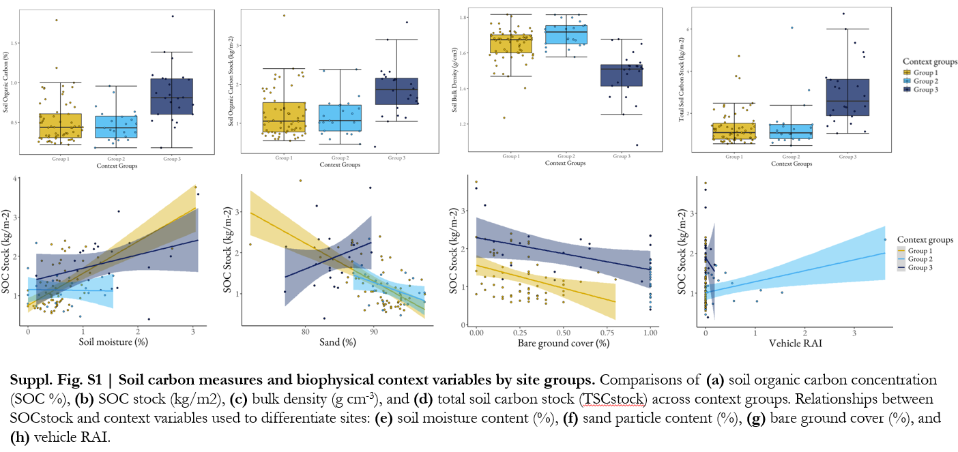
Fig. S1 | Soil carbon measures and biophysical context variables by site groups. Comparisons of (a) soil organic carbon concentration (SOC %), (b) SOC_{stock} (kg/m2), (c) bulk density (g cm⁻³), and (d) total soil carbon stock (TSC_{stock}) across context groups. Relationships between SOC_{stock} and context variables used to differentiate sites: (e) soil moisture content (%), (f) sand particle content (%), (g) bare ground cover (%), and (h) vehicle RAI.
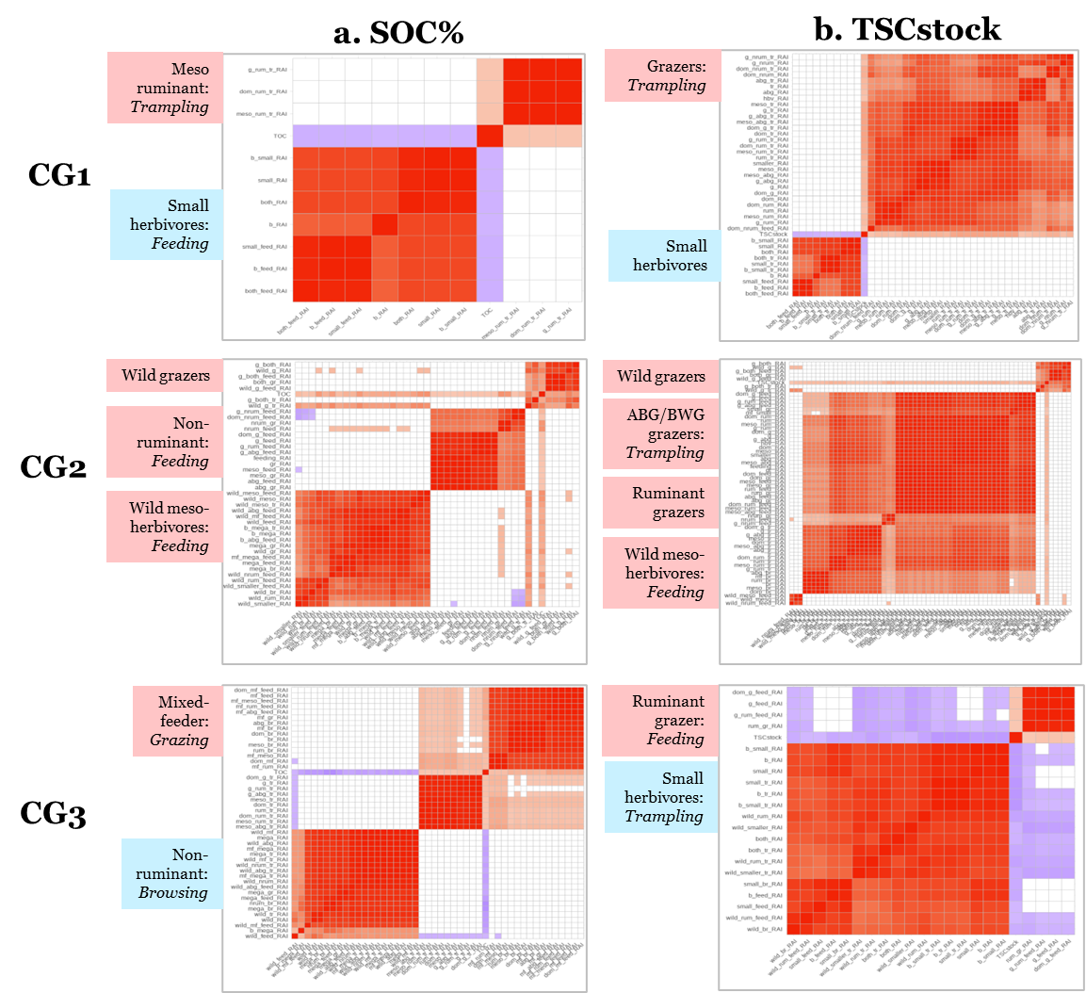
Fig. S2 | LH functional trait groups most strongly correlated with (a) SOC% and (b) TSC_{stock} by context group.

Table S1. Raw sighting counts and daily Relative Activity Indices (RAI) for vehicles and LH species classifications across CT8-North, CT8-South, and MPNP sites.
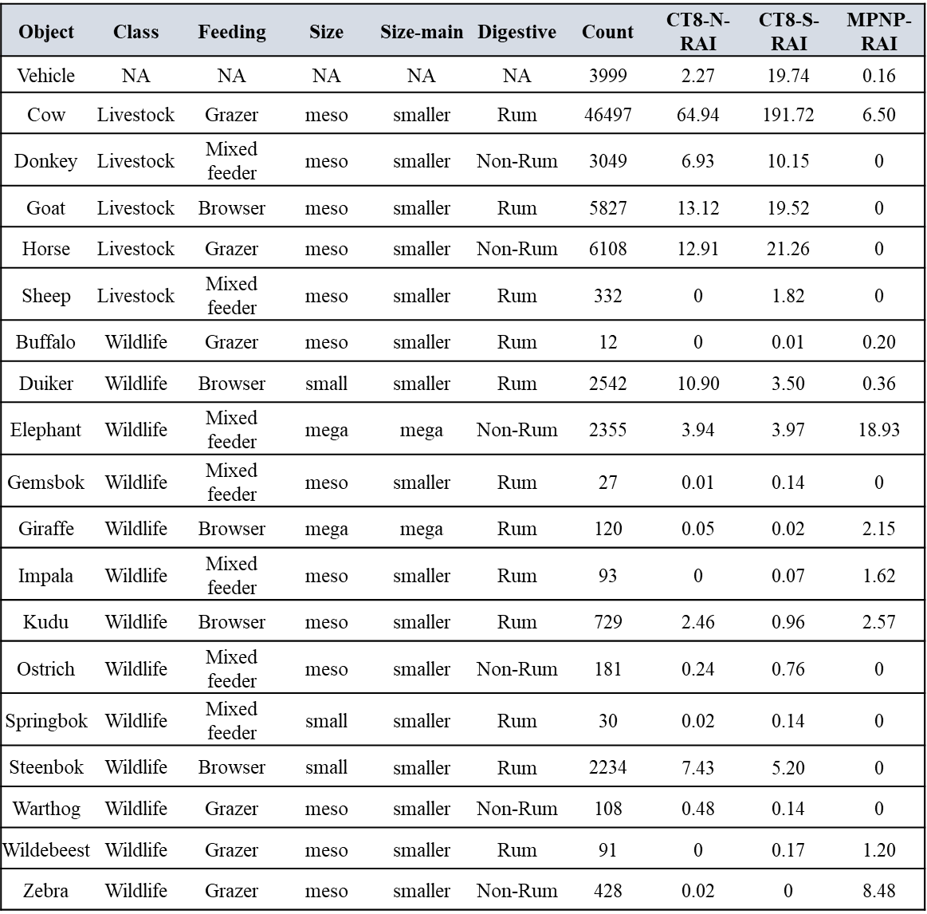

Table S2. Results of generalized linear model performed to evaluate bulk density for selected sites.
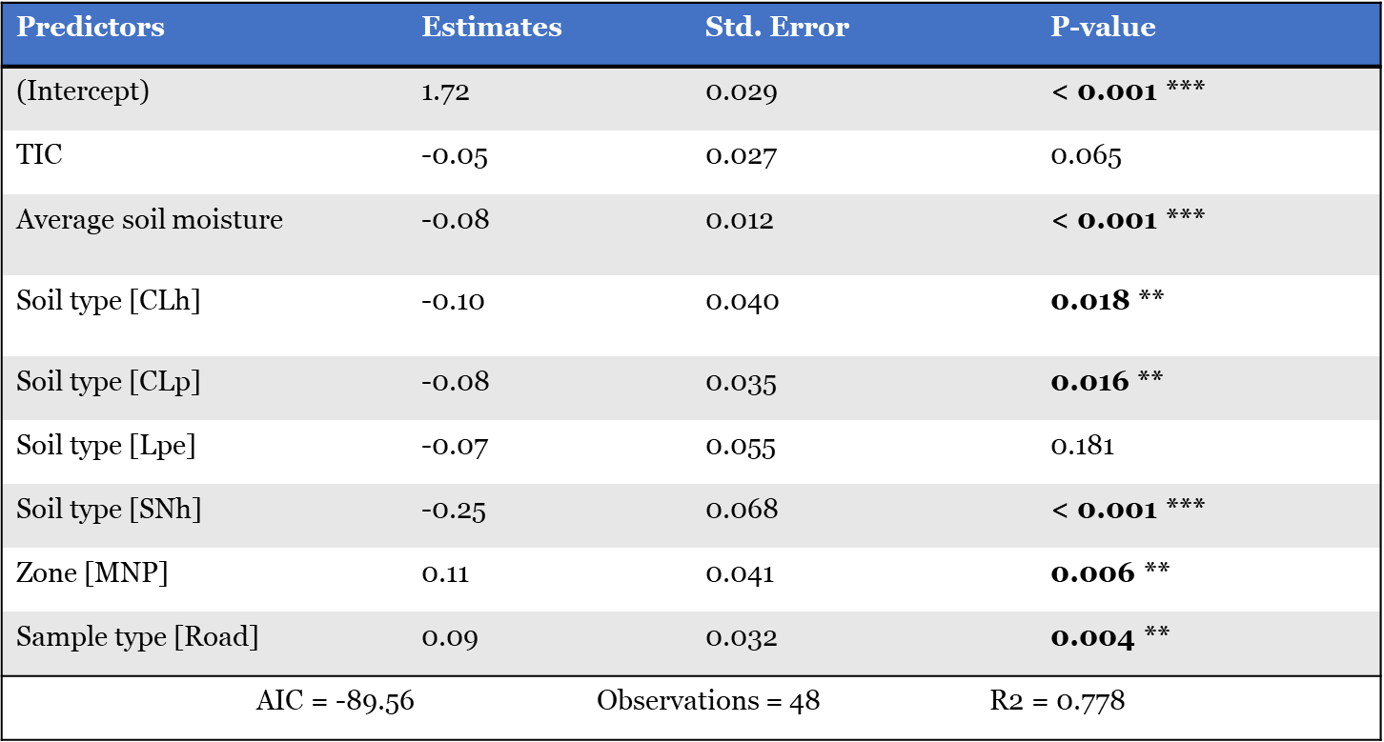

Table S3. Results of linear models explaining soil organic carbon concentration (SOC%) and total soil carbon stock (TSC_{stock}) for the three context groups.
