Supplementary Materials

Patient | $$Y_{visit}$$ |  |  |  |  |  | $$Y_{patient}$$
Patient | Baseline | C1D1 | C2D1 | C3D1 | C4D1 | EOT | $$Y_{patient}$$
1 | 0 | 0 | 1 | 0 | 0 | 1 | 2
2 | 0 | 1 | 0 | 1 | 0 | 1 | 3
3 | 0 | 0 | 1 | 0 | 0 | 0 | 1
4 | 0 | 0 | 0 | 0 | 0 | 0 | 0
5 | 1 | 1 | 1 | 1 | 0 | 0 | 4
 |  |  |  |  |  |  | $$Y_{site}=10$$
Table E.1: Example of recurrent events.

Patient | $$Y_{visit}$$ |  |  |  |  |  | $$Y_{patient}$$
Patient | Baseline | C1D1 | C2D1 | C3D1 | C4D1 | EOT | $$Y_{patient}$$
1 | 0 | 0 | 0 | 0 | 0 | 0 | 0
2 | 0 | 0 | 0 | 1 | - | - | 1
3 | 0 | 0 | 1 | - | - | - | 1
4 | 0 | 1 | - | - | - | - | 1
5 | 1 | - | - | - | - | - | 1
 |  |  |  |  |  |  | $$Y_{site}=5$$
Table E.2: Example of non-recurrent events not limited to baseline.

Patient | $$Y_{visit}$$ |  |  |  |  |  | $$Y_{patient}$$
Patient | Baseline | C1D1 | C2D1 | C3D1 | C4D1 | EOT | $$Y_{patient}$$
1 | 0 | - | - | - | - | - | 0
2 | 0 | - | - | - | - | - | 0
3 | 0 | - | - | - | - | - | 0
4 | 1 | - | - | - | - | - | 1
5 | 1 | - | - | - | - | - | 1
 |  |  |  |  |  |  | $$Y_{site}=2$$
Table E.3: Example of non-recurrent events limited to baseline.

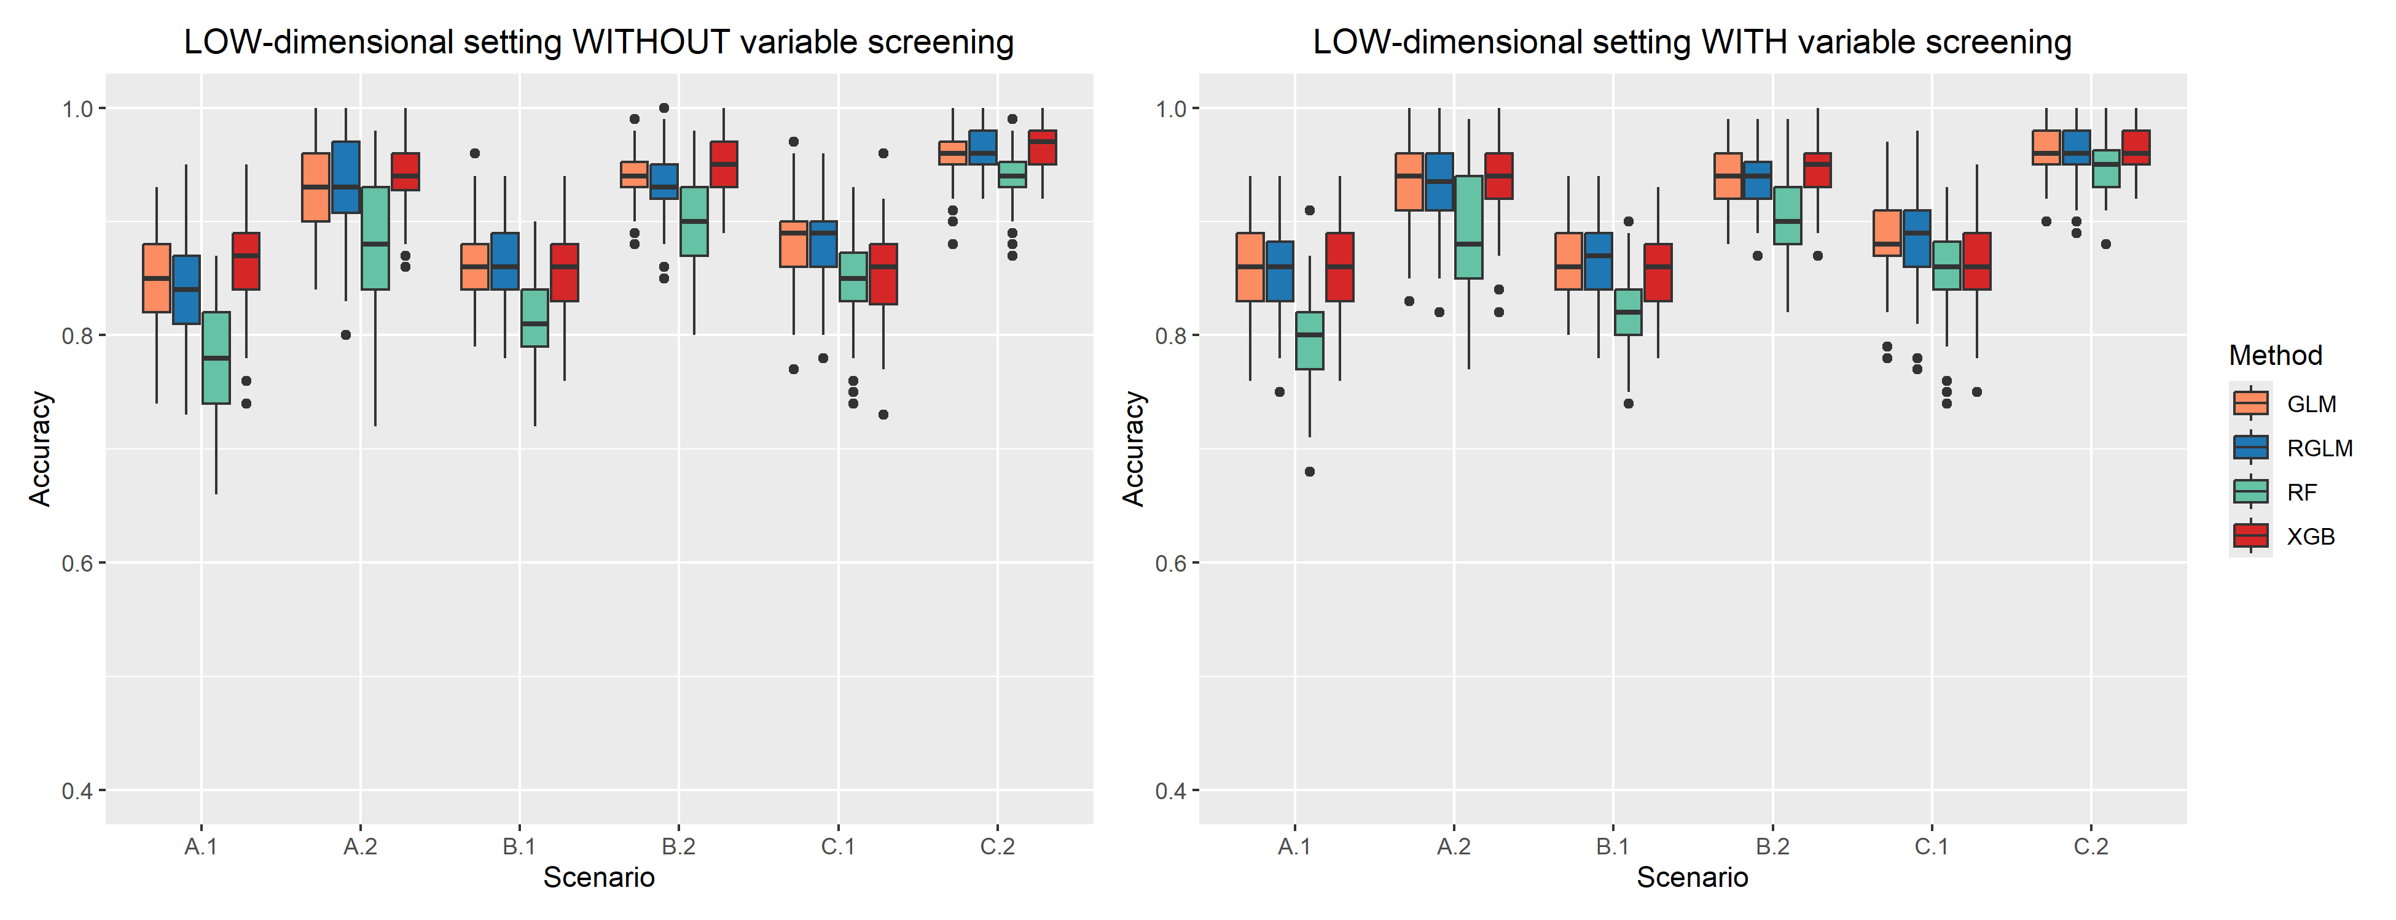
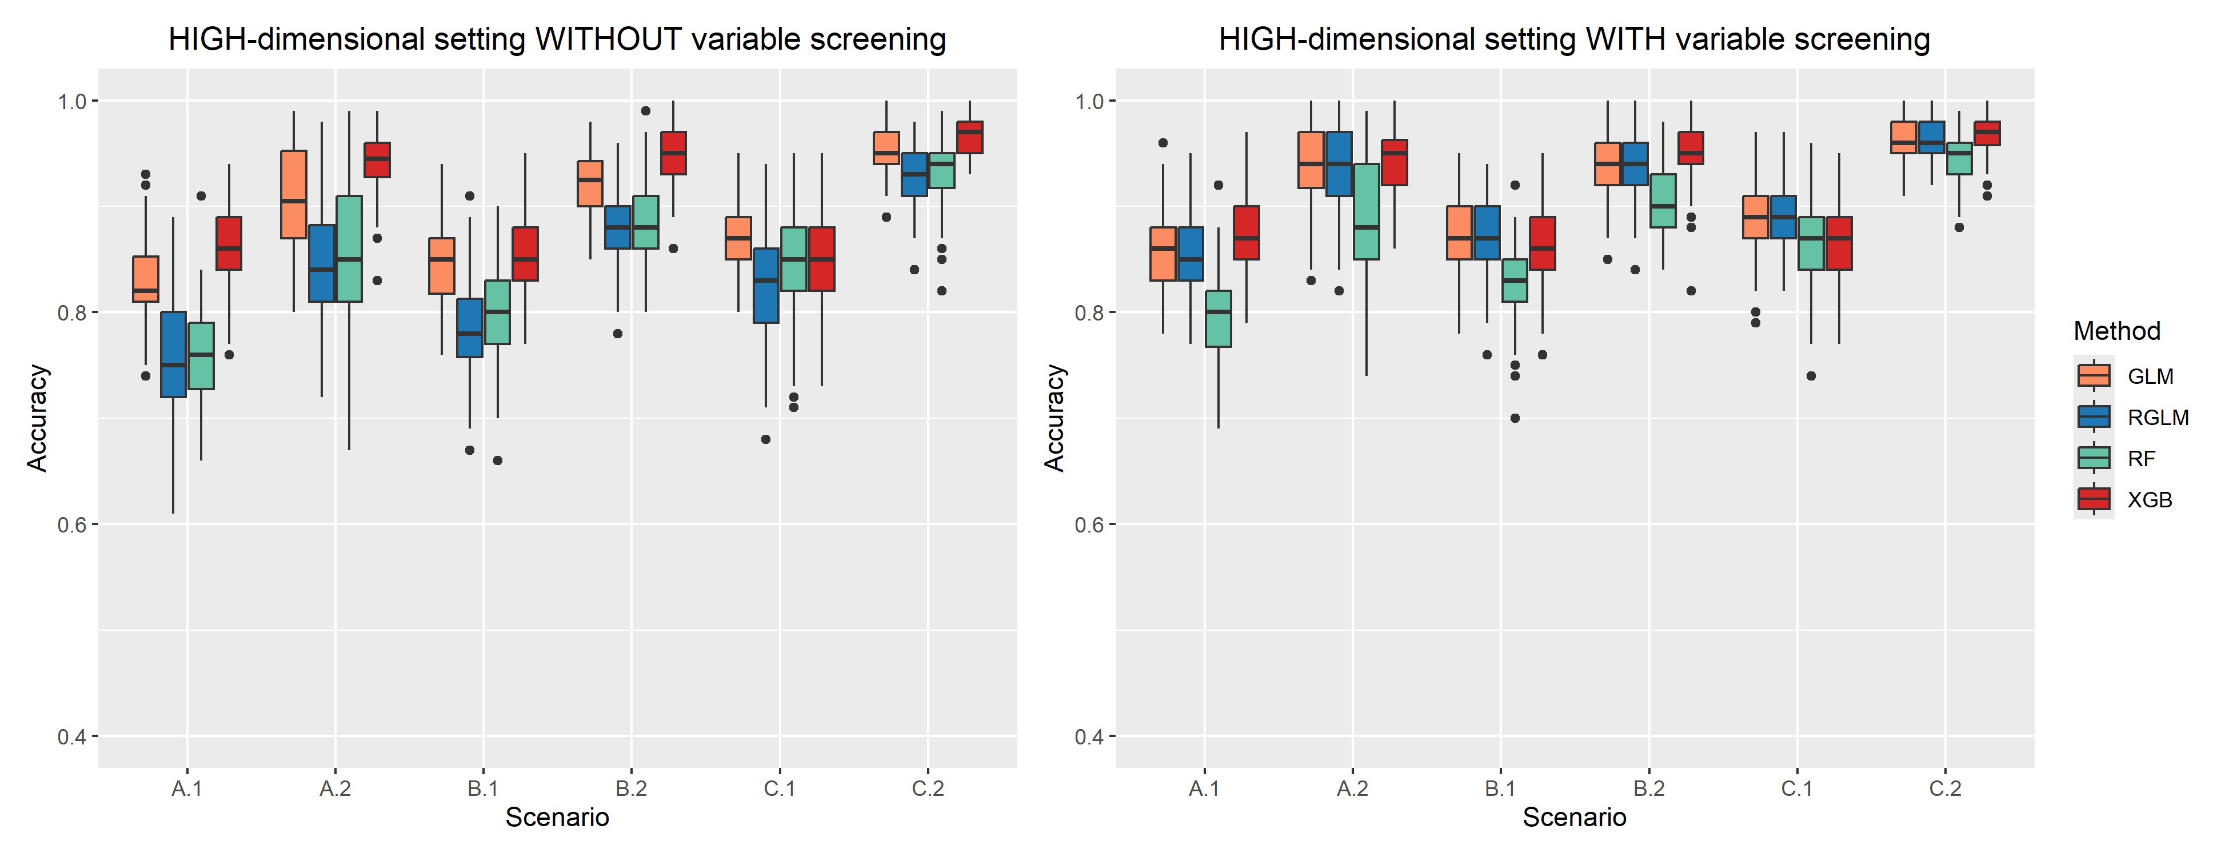
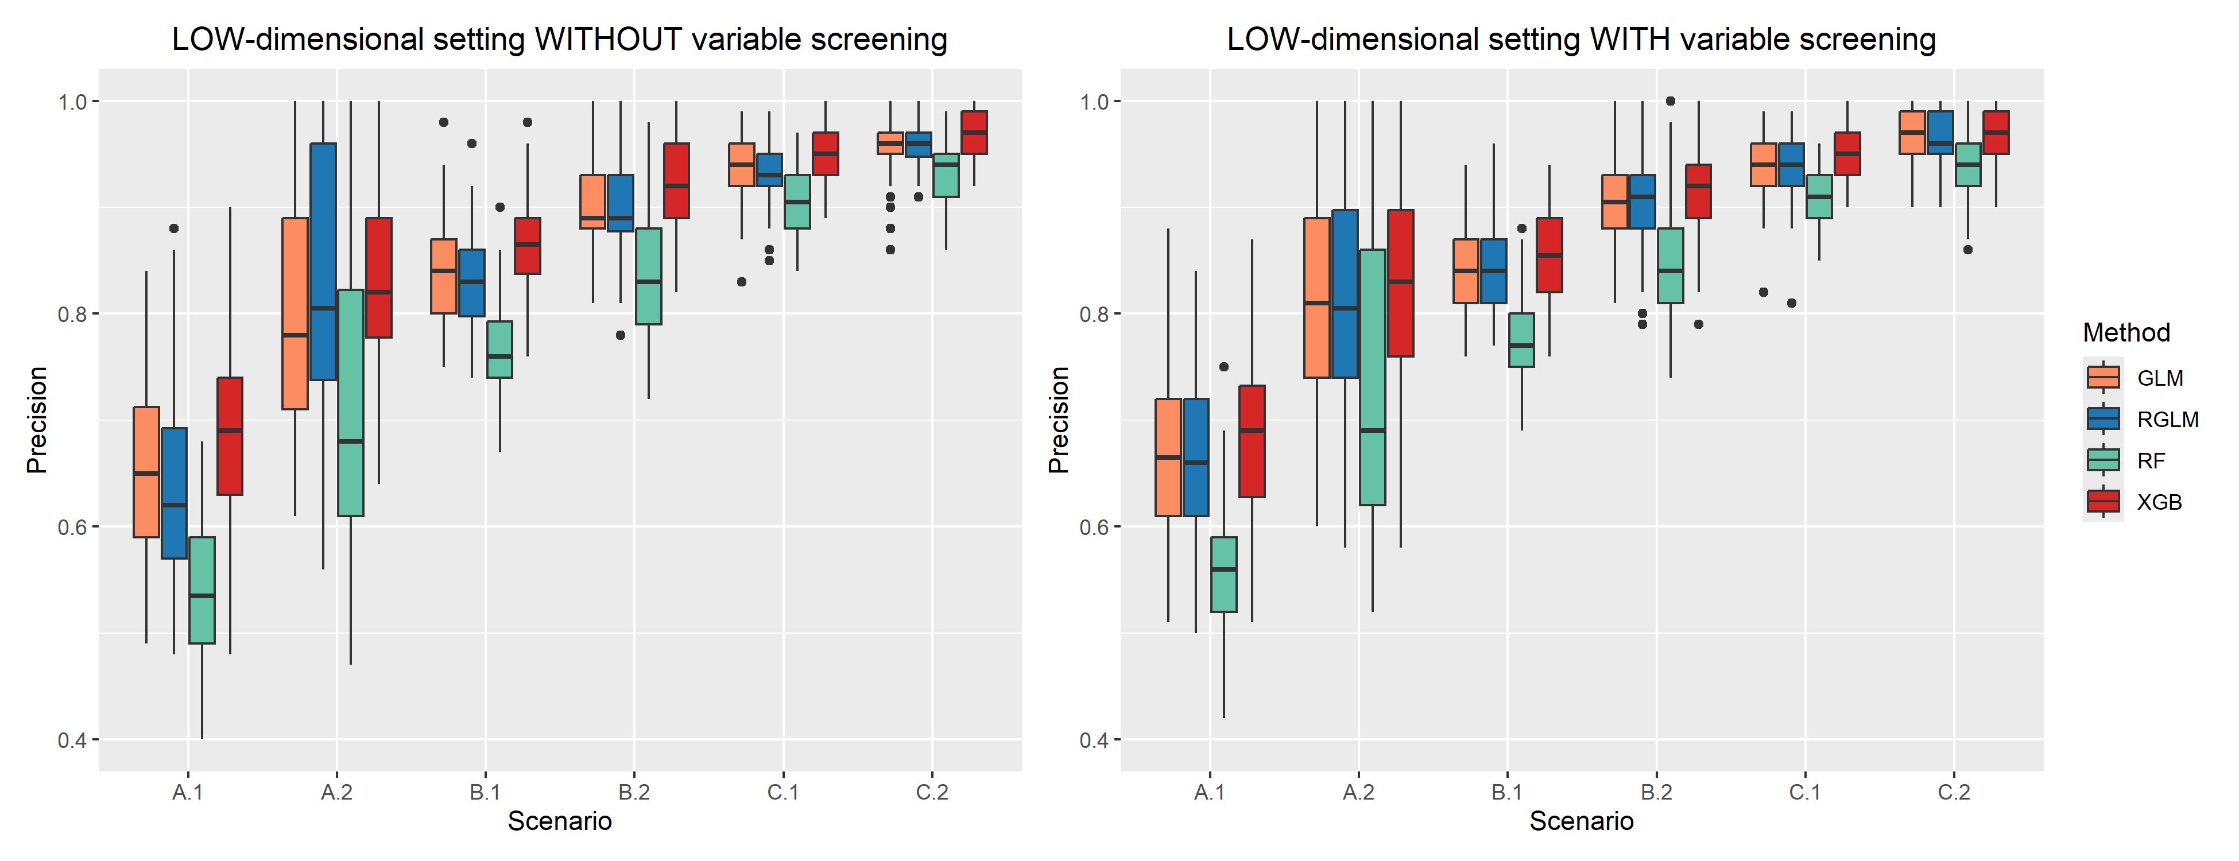
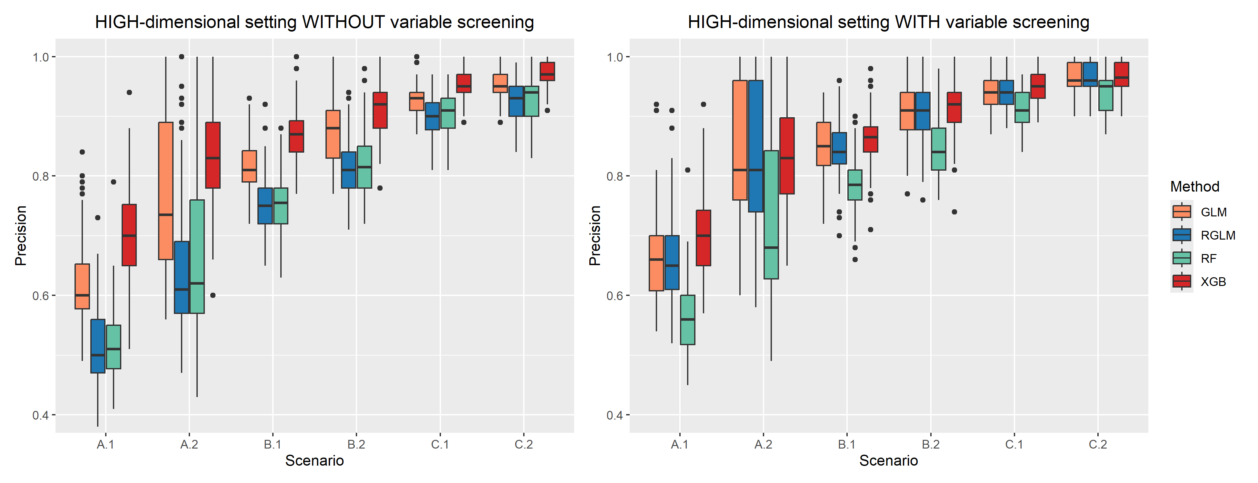
Figure E.1: Accuracy and precision of the GLM, RGLM, RF and XGB methods under different scenarios. The upper panel shows results for low-dimensional setting p=80, and the lower panel shows results for high-dimensional setting p=800. In the scenario names, ‘A’, ‘B’, ‘C’ indicate that 25%, 50%, 75% of the validation and testing sets are used to generate abnormal sites. The numbers ‘1’ and ‘2’ correspond to ratios 0.75 and 0.5 that are used to create over reported response $y_{site}^{-}$.
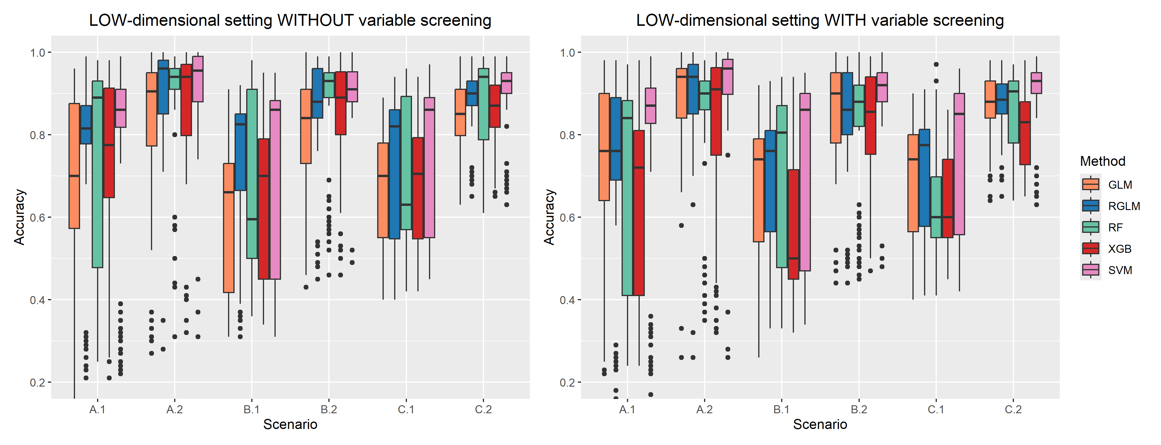
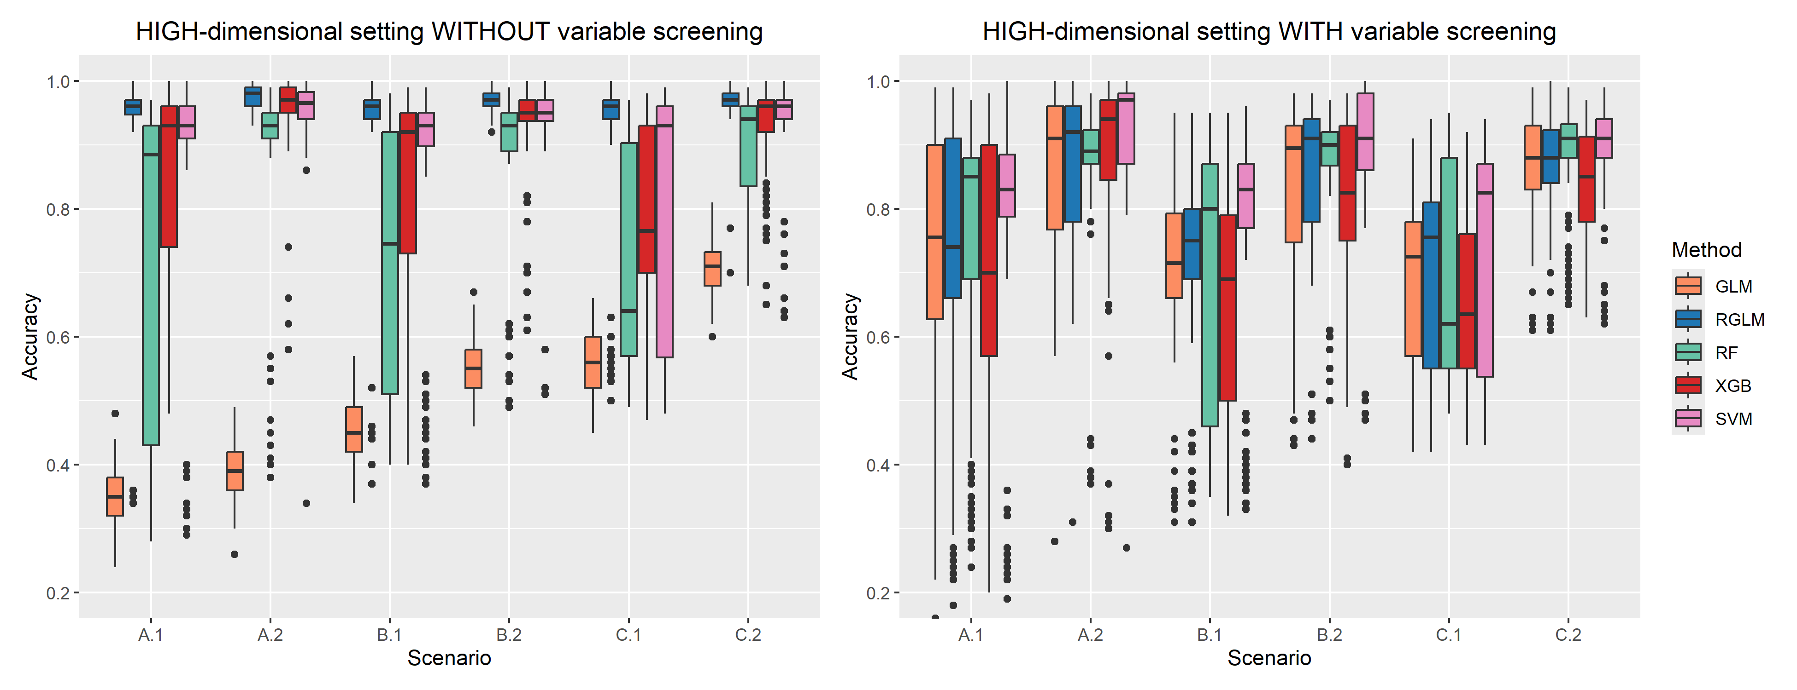
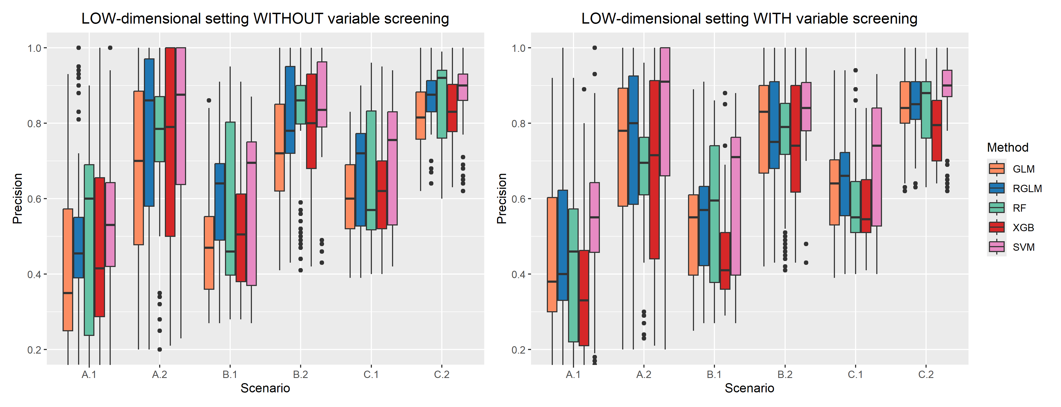
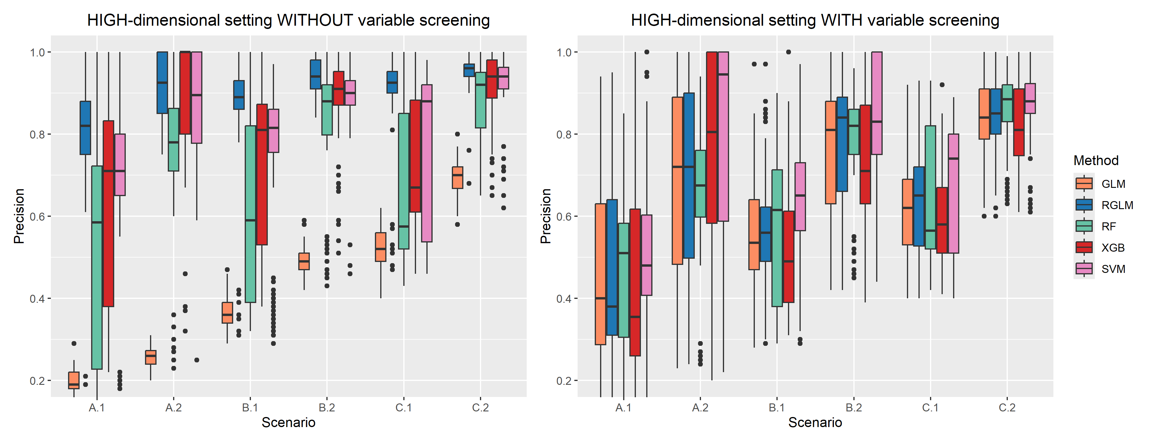
Figure E.2: Accuracy and precision of the GLM, RGLM, RF, XGB, and SVM methods under different scenarios. The upper panel shows results for low-dimensional setting p=80, and the lower panel shows results for high-dimensional setting p=800. In the scenario names, ‘A’, ‘B’, ‘C’ indicate that 25%, 50%, 75% of the validation and testing sets are used to generate abnormal sites. The numbers ‘1’ and ‘2’ correspond to probabilities 0.25 and 0.5 that are used to create under reported response $y_{site}^{+}$.
Scenario | GLM |  |  | RGLM |  |  | RF |  |  | XGB
Scenario | $$F_{1}$$ | PPV | TPR | $$F_{1}$$ | PPV | TPR | $$F_{1}$$ | PPV | TPR | $$F_{1}$$ | PPV | TPR
A.1 | 0.68 | 0.54 | 0.93 | 0.61 | 0.45 | 0.93 | 0.59 | 0.50 | 0.73 | 0.68 | 0.52 | 1.00
A.2 | 0.65 | 0.52 | 0.87 | 0.52 | 0.39 | 0.8 | 0.47 | 0.33 | 0.80 | 0.55 | 0.44 | 0.73
B.1 | 0.83 | 0.77 | 0.90 | 0.82 | 0.74 | 0.93 | 0.78 | 0.66 | 0.97 | 0.83 | 0.72 | 0.97
B.2 | 0.77 | 0.71 | 0.83 | 0.75 | 0.71 | 0.8 | 0.75 | 0.62 | 0.93 | 0.78 | 0.70 | 0.87
C.1 | 0.80 | 0.81 | 0.78 | 0.85 | 0.82 | 0.89 | 0.85 | 0.79 | 0.91 | 0.86 | 0.83 | 0.89
C.2 | 0.72 | 0.76 | 0.69 | 0.72 | 0.76 | 0.69 | 0.79 | 0.75 | 0.84 | 0.80 | 0.80 | 0.80
D | 0.85 | 0.74 | 1.00 | 0.84 | 0.72 | 1.00 | 0.73 | 0.57 | 1.00 | 0.83 | 0.79 | 0.87
Table E.4: $F_{1}$ score, precision, and TPR of GLM, RGLM, RF, and XGB under different scenarios. In the scenario names, ‘A’, ‘B’, ‘C’, indicate that 25%, 50%, 75% of the validation and testing sets are used to generate abnormal sites, and ‘D’ represent the zero scenario. The numbers ‘1’ and ‘2’ correspond to ratios 0.5 and 0.25. Bold numbers indicate the best performance for each given scenario.

Scenario | GLMNET |  |  | RGLM |  |  | RF |  |  | XGB |  |  | SVM
Scenario | $$F_{1}$$ | PPV | TPR | $$F_{1}$$ | PPV | TPR | $$F_{1}$$ | PPV | TPR | $$F_{1}$$ | PPV | TPR | $$F_{1}$$ | PPV | TPR
A.1 | 0.95 | 1.00 | 0.91 | 0.92 | 0.85 | 1.00 | 0.87 | 0.83 | 0.91 | 1.00 | 1.00 | 1.00 | 0.95 | 1.00 | 0.91
A.2 | 0.92 | 1.00 | 0.85 | 0.89 | 0.86 | 0.92 | 0.93 | 0.87 | 1.00 | 0.96 | 1.00 | 0.92 | 1.00 | 1.00 | 1.00
B.1 | 1.00 | 1.00 | 1.00 | 0.95 | 0.93 | 0.96 | 0.88 | 0.96 | 0.82 | 0.98 | 1.00 | 0.96 | 0.98 | 1.00 | 0.96
B.2 | 1.00 | 1.00 | 1.00 | 0.97 | 0.94 | 1.00 | 0.95 | 0.96 | 0.93 | 1.00 | 1.00 | 1.00 | 1.00 | 1.00 | 1.00
C.1 | 0.95 | 1.00 | 0.9 | 0.96 | 0.98 | 0.95 | 0.95 | 0.93 | 0.98 | 0.98 | 1.00 | 0.95 | 0.95 | 1.00 | 0.90
C.2 | 1.00 | 1.00 | 1.00 | 0.97 | 1.00 | 0.93 | 0.98 | 0.98 | 0.98 | 0.98 | 1.00 | 0.96 | 1.00 | 1.00 | 1.00
D | 1.00 | 1.00 | 1.00 | 1.00 | 1.00 | 1.00 | 0.98 | 0.95 | 1.00 | 1.00 | 1.00 | 1.00 | 1.00 | 1.00 | 1.00
Table E.5: $F_{1}$ score, precision, and TPR of GLM, RGLM, RF, XGB, and SVM under different scenarios. In the scenario names, ‘A’, ‘B’, ‘C’, indicate that 25%, 50%, 75% of the validation and testing sets are used to generate abnormal sites, and ‘D’ represent the all scenario. The numbers ‘1’ and ‘2’ correspond to probabilities 0.5 and 0.75. Bold numbers indicate the best performance for each given scenario.

