Changes in the phyllosphere and rhizosphere of a cloud forest tree fern along an elevation gradient
Authors: Mariana Vélez-Múnera¹, Morena Avitia², Eria A. Rebollar³, Santiago Ramírez-Barahona¹
Affiliations:
¹Departamento de Botánica, Instituto de Biología, Universidad Nacional Autónoma de México, Ciudad de México, México
² Laboratorio Nacional de Ciencias de la Sostenibilidad (LANCIS), Instituto de Ecología, Universidad Nacional Autónoma de México, Ciudad de México, México
³ Centro de Ciencias Genómicas, Universidad Nacional Autónoma de México, Cuernavaca, Morelos, México
Supplementary material

- Supplementary tables
Table S1. Number of samples used in the analysis by sample type and microbial community.
- Supplementary figures
Fig. S1 Principal Coordinate Analysis (PCoA) of bacterial and fungal communities of the tree fern Cyathea fulva across elevation.
Fig. S2 Venn diagrams of shared and unique bacterial and fungal genera in the microbiome of the tree fern Cyathea fulva (Cyatheaceae) by sample type.
Fig. S3 Changes in measured environmental variables across elevation plots.

Supplementary data
Supplementary data 1. Metadata to bacterial samples, including information about the host individual, number of reads per sample and Shannon Index per sample.
Supplementary data 2. Metadata to fungal samples, including information about the host individual, number of reads per sample and Shannon Index per sample.
Supplementary data 3. Taxonomy of the core microbial communities by sample type.
Supplementary materials
Supplementary tables
Table S1. Number of samples used in the analysis by sample type and microbial community.
 | Bacteria | Fungi | Total
Phyllosphere | 13 | 15 | 28
Rhizosphere | 15 | 14 | 29
Soil | 5 | 5 | 10
Total | 33 | 34 | 67

Supplementary figures
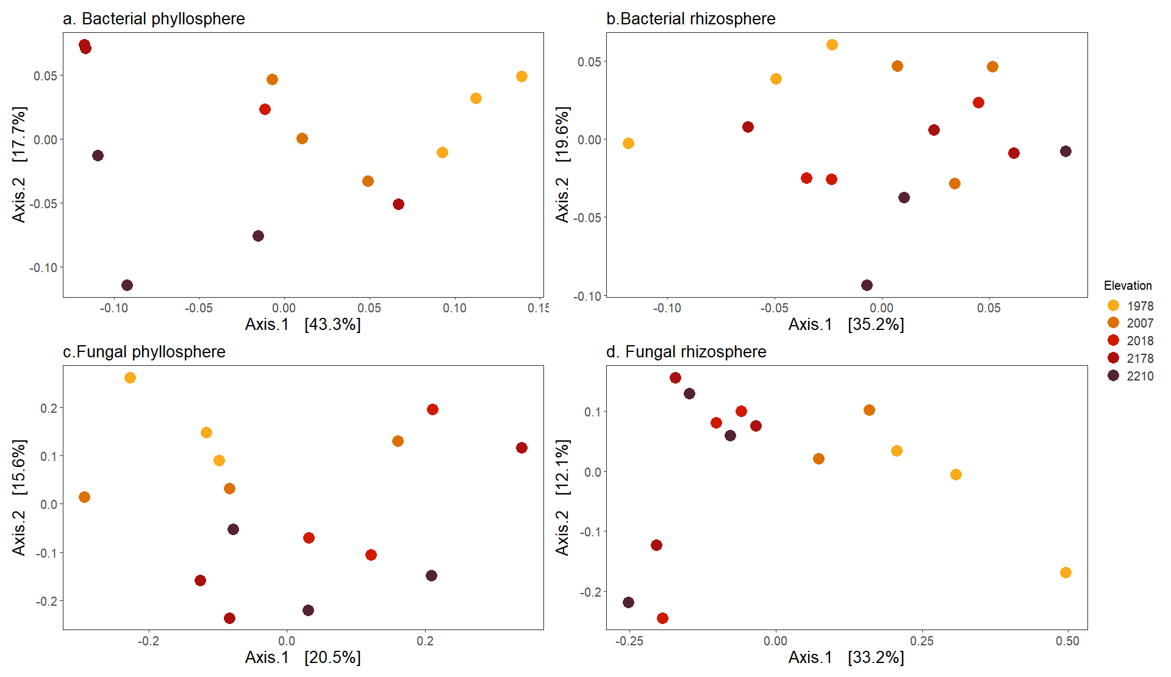
Fig. S1 Principal Coordinate Analysis (PCoA) of bacterial and fungal communities of the tree fern Cyathea fulva across elevation. Ordination of pairwise community dissimilarities for bacteria (a, b) and fungi (c, d) based on Unweighted UniFrac distances for the phyllosphere (a, c) and the rhizosphere (b, d). Percentage variation explained by each PCoA is indicated on the axes. Colors indicate different elevations (masl).

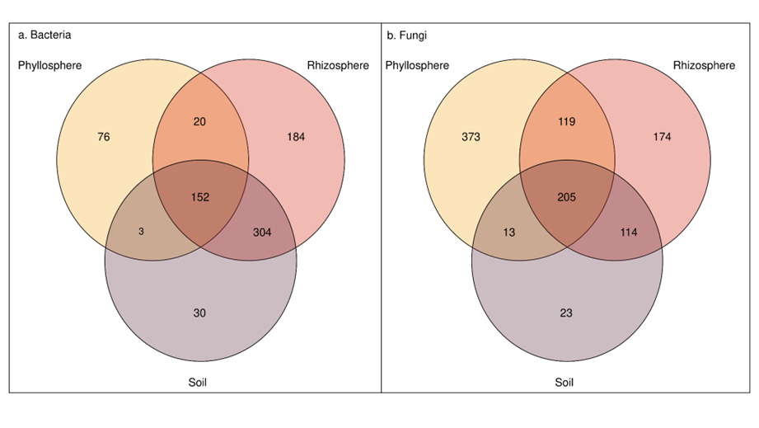
Fig. S2 Venn diagrams of shared and unique bacterial and fungal genera in the microbiome of the tree fern Cyathea fulva (Cyatheaceae) by sample type. Number of unique and shared genera between the phyllosphere, rhizosphere and soil, both for bacteria (a) and fungi (b)

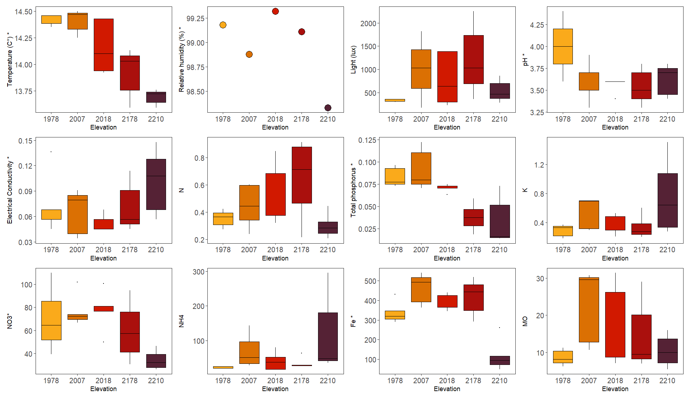

Fig. S3 Changes in measured environmental variables across elevation plots. Box plots showing variation across elevation plots for those variables that had statistically significant differences across elevations (p < 0.05). The asterisks denote variables that also showed statistically significant correlations with elevation (r > 0.35, p < 0.05).

