Supplementary Information

Evidential Deep Learning for Guided Drug-Target Interaction Prediction
Yanpeng Zhao ^{a †}, Yuting Xing ^{b †}, Yixin Zhang ^{a †}, Yifei Wang ª, Chengkun Wu^{d, e}, Shangze Li ª, Huiyan Xu ^{a, c}, Tianyu Han ^{a, c}, Hongyang Zhang ^{a, c}, Ziyi Liu ^{a, c}, Guowei Zhou ^{a, f}, Mengfan Li ª, Xuanze Wang ª, Zhengshan Chen ª, Ruijiang Li ª, Lianlian Wu^{a, f}, Dongsheng Zhao ª, Song He ª *, Xiaochen Bo ª *
a Academy of Military Medical Sciences, Beijing 100850, China
b Defense Innovation Institute, Beijing 100071, China
c Shanghai Key Laboratory of Power Station Automation Technology, School of Mechatronics Engineering and Automation, Shanghai University, Shanghai 200444, China
d Laboratory of Digitizing Software for Frontier Equipment, National University of Defense Technology, Changsha 410073, China
e National Key Laboratory of Parallel and Distributed Computing, National University of Defense Technology, Changsha 410073, China
f Academy of Medical Engineering and Translational Medicine, Tianjin University, Tianjin 300072, China
____________
* Corresponding authors.
E-mail addresses: S. He (hes1224@163.com) and X. Bo (boxiaoc@163.com; boxc@bmi.ac.cn)
† These authors contributed equally to this work.

1 Data profile
Table S1 Information of datasets used in the DTI prediction
Datasets | Protein | Drug | Interaction | Positive | Negative
DrugBank | 4085 | 6148 | 33 062 | 16 531 | 16 531
Davis | 379 | 68 | 25 772 | 7320 | 18 452
KIBA | 225 | 2068 | 116 350 | 22 154 | 94 196

2 Additional Results
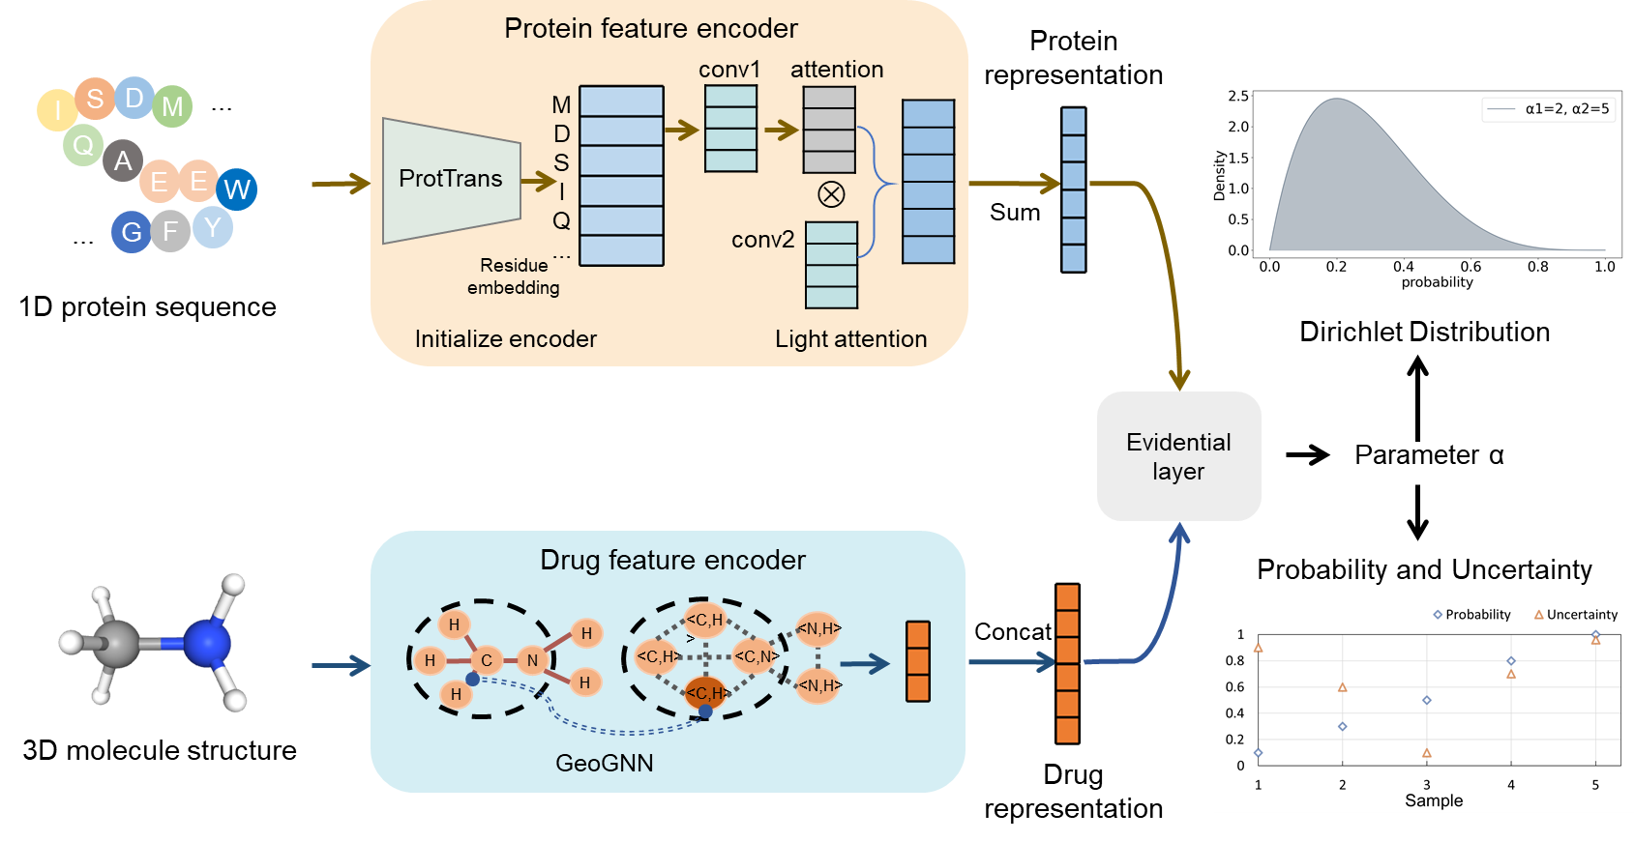
Fig. S1 The flowchart of Evidential DTI w/o drug 2D. Given a drug-target pair as input, the protein feature encoder utilizes the pre-trained model ProtTrans for initial target representation, further refined by a light attention (LA) module. The drug feature encoder learns the drug's 2D topology representations. For the 2D graph, the initial representation is derived from the pre-trained model MG-BERT and processed by a 1DCNN neural network. The target and drug representations are concatenated and fed into the evidence layer, which outputs parameter α to calculate prediction probability and corresponding uncertainty.

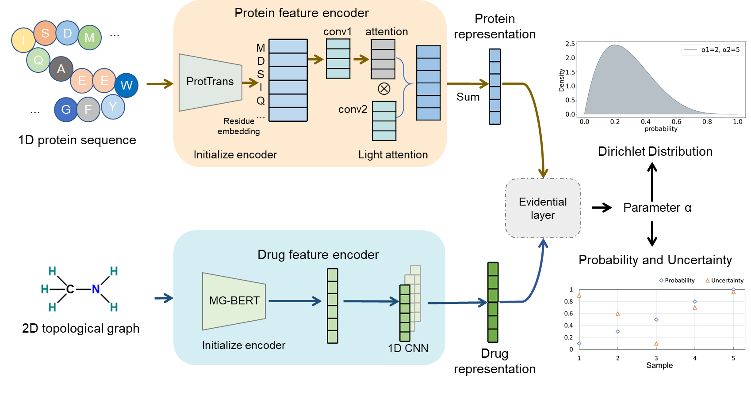
Fig. S2 The flowchart of Evidential DTI w/o drug 3D. Given a drug-target pair as input, the protein feature encoder utilizes the pre-trained model ProtTrans for initial target representation, further refined by a light attention (LA) module. The drug feature encoder learns the 3D structure representations. For the 3D structure, the representations were obtained via the GeoGNN module. The target and drug representations are concatenated and fed into the evidence layer, which outputs parameter α to calculate prediction probability and corresponding uncertainty.

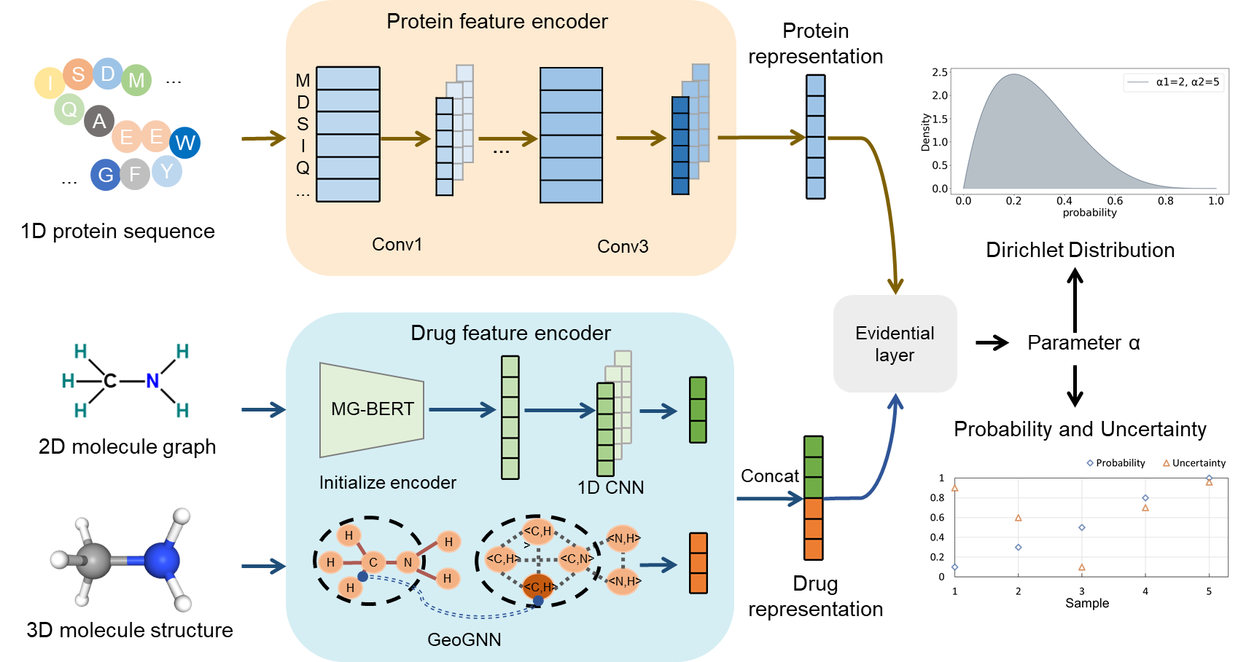
Fig. S3 The flowchart of Evidential DTI-Protein Integer. Given a drug-target pair as input, the protein feature encoder utilizes the integer coding and a CNN for feature extraction. The drug feature encoder learns the drug's 2D topology and 3D structure representations. For the 2D graph, the initial representation is derived from the pre-trained model MG-BERT and processed by a 1DCNN neural network. For the 3D structure, the representations were obtained via the GeoGNN module. The target and drug representations are concatenated and fed into the evidence layer, which outputs parameter α to calculate prediction probability and corresponding uncertainty.
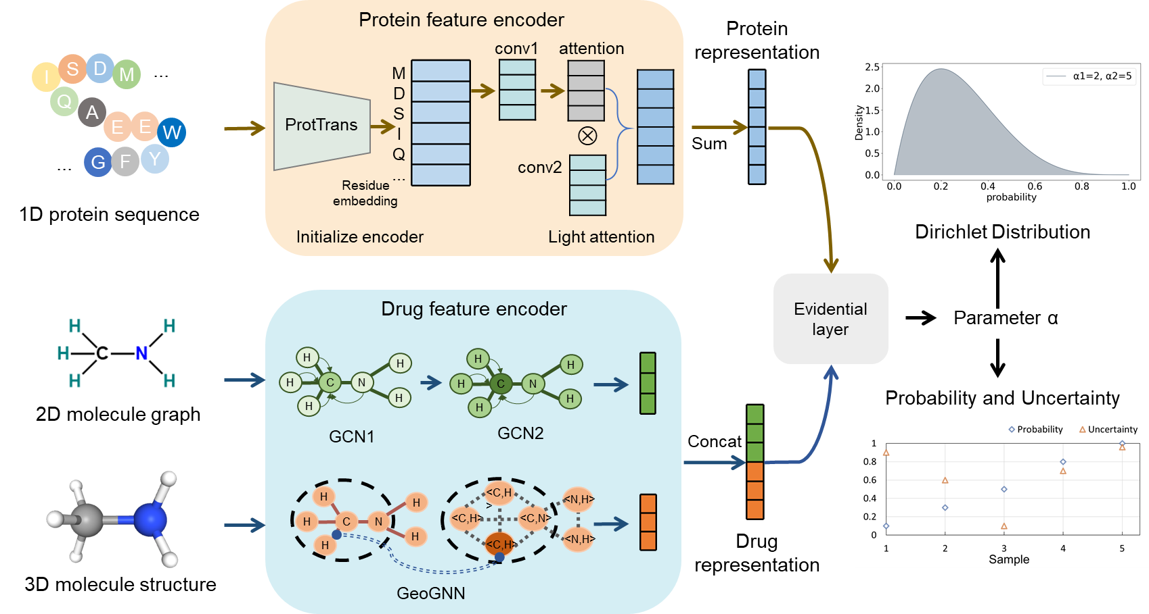
Fig. S4 The flowchart of Evidential DTI-Drug 2D GCN. Given a drug-target pair as input, the protein feature encoder utilizes the integer coding and a CNN for feature extraction. The drug feature encoder learns the drug's 2D topology and 3D structure representations. For the 2D graph, the molecule representation is learned via a two-layer GCN. For the 3D structure, the representations were obtained via the GeoGNN module. The target and drug representations are concatenated and fed into the evidence layer, which outputs parameter α to calculate prediction probability and corresponding uncertainty.

Table S2 Performance on the DrugBank, KIBA, Davis datasets with single-dimensional features and multidimensional feature fusion strategies
Dataset | Strategies | Accuracy | Recall | Precision | MCC | F1 | AUC | AUPR
DrugBank | Evidential DTI | 82.02  (0.4) | 82.28  (1.0) | 81.90  (0.5) | 64.29  (1.0) | 82.09  (0.7) | 88.87  (0.7) | 88.45  (0.15)
DrugBank | Evidential DTI w/o drug 3D | 81.67  (0.2) | 80.90  (0.3) | 81.53  (0.3) | 63.42  (0.7) | 81.20  (0.6) | 88.04  (0.6) | 88.39  (0.5)
DrugBank | Evidential DTI w/o drug 2D | 80.40  (0.2) | 81.32  (0.6) | 80.36  (0.5) | 60.79  (0.7) | 80.83  (0.3) | 86.83  (0.6) | 85.54  (0.8)
KIBA | Evidential DTI | 91.27  (0.7) | 70.77  (1.6) | 80.90  (1.3) | 70.44  (0.7) | 75.48  (0.8) | 93.57  (0.3) | 83.03  (0.9)
KIBA | Evidential DTI w/o drug 3D | 90.99  (0.1) | 70.75  (1.0) | 78.53  (0.6) | 69.12  (0.8) | 74.43  (0.8) | 91.30  (0.4) | 81.73  (1.3)
KIBA | Evidential DTI w/o drug 2D | 90.34  (0.3) | 67.49  (1.3) | 77.99  (1.2) | 66.81  (1.4) | 72.37  (1.2) | 92.19  (0.5) | 80.45  (1.5)
Davis | Evidential DTI | 87.40  (0.7) | 72.93  (1.6) | 81.17  (1.3) | 68.40  (0.7) | 76.81  (0.8) | 92.10  (0.3) | 85.07  (0.9)
Davis | Evidential DTI w/o drug 3D | 87.06  (1.2) | 75.80  (1.5) | 77.93  (3.7) | 67.89  (3.0) | 76.82  (2.2) | 91.68  (0.4) | 84.12  (1.7)
Davis | Evidential DTI w/o drug 2D | 87.02  (0.6) | 73.69  (2.2) | 79.10  (3.0) | 67.45  (1.7) | 76.26  (1.4) | 91.82  (0.8) | 84.35  (2.0)
Table S3 Performance on the DrugBank, KIBA, Davis datasets with the architectures that use pre-trained models for feature extraction and architectures that do not use pre-trained models
Dataset | Architecture | Accuracy | Recall | Precision | MCC | F1 | AUC | AUPR
DrugBank | Evidential DTI | 82.02  (0.4) | 82.28  (1.0) | 81.90  (0.5) | 64.29  (1.0) | 82.09  (0.7) | 88.87  (0.7) | 88.45  (0.15)
DrugBank | Evidential DTI-Protein Integer | 80.90  (0.3) | 79.66  (1.4) | 81.79  (1.8) | 61.86  (0.5) | 80.69  (0.2) | 88.16  (0.2) | 88.03  (0.4)
DrugBank | Evidential DTI-Drug 2D GCN | 73.27  (0.9) | 68.36  (4.3) | 75.86  (0.7) | 46.82(1.6) | 71.84  (2.1) | 79.37  (1.7) | 79.23  (3.1)
KIBA | Evidential DTI | 91.27  (0.7) | 70.77  (1.6) | 80.90  (1.3) | 70.44  (0.7) | 75.48  (0.8) | 93.57  (0.3) | 83.03  (0.9)
KIBA | Evidential DTI-Protein Integer | 90.91  (0.4) | 69.74  (1.8) | 78.89  (3.6) | 68.73  (1.5) | 73.98  (1.0) | 90.82  (0.5) | 81.65  (1.0)
KIBA | Evidential DTI-Drug 2D GCN | 90.45  (0.1) | 67.48  (1.8) | 78.61  (1.6) | 67.16  (0.3) | 72.60  (0.4) | 92.02  (0.3) | 80.54  (0.1)
Davis | Evidential DTI | 87.40  (0.7) | 72.93  (1.6) | 81.17  (1.3) | 68.40  (0.7) | 76.81  (0.8) | 92.10  (0.3) | 85.07  (0.9)
Davis | Evidential DTI-Protein Integer | 85.53  (1.0) | 72.07  (1.6) | 75.67  (2.8) | 63.87(2.6) | 73.82  (2.0) | 91.09  (0.6) | 82.95  (2.2)
Davis | Evidential DTI-Drug 2D GCN | 86.99  (1.1) | 72.39  (1.9) | 79.77  (3.5) | 67.17(3.3) | 75.89  (2.5) | 91.85  (0.5) | 84.60  (2.5)

Table S4 Comparison of OFR between evidential-based framework and probability-based framework on DrugBank, KIBA and Davis dataset at different thresholds
Dataset | framework | OFR
Dataset | framework | 0.1 | 0.09 | 0.08 | 0.07 | 0.06 | 0.05 | 0.04 | 0.03 | 0.02 | 0.01
DrugBank | uncertainty | 15.01  (0.6) | 14.72  (0.6) | 14.38  (0.7) | 14.05  (0.7) | 13.54  (0.5) | 12.72  (0.1) | 11.20  (0.3) | 9.28  (0.3) | 7.64  (0.2) | 4.78  (0.6)
DrugBank | probability | 11.20  (3.5) | 11.07  (3.4) | 10.83  (3.5) | 10.64  (3.5) | 10.19  (3.1) | 10.09  (2.7) | 9.92  (2.7) | 9.26  (2.7) | 8.88  (2.4) | 7.59  (2.5)
KIBA | uncertainty | 5.02  (0.5) | 4.72  (0.5) | 4.37  (0.5) | 4.08  (0.5) | 3.71  (0.4) | 3.36  (0.4) | 2.95  (0.5) | 2.33  (0.4) | 1.58  (0.2) | 0.78  (0.2)
KIBA | probability | 3.28  (0.7) | 3.16  (0.6) | 2.98  (0.5) | 2.81  (0.5) | 2.66  (0.5) | 2.49  (0.4) | 2.26  (0.4) | 1.96  (0.4) | 1.72  (0.3) | 1.42  (0.2)
Davis | uncertainty | 7.35  (0.4) | 7.03  (0.5) | 6.59  (0.4) | 6.16  (0.4) | 5.53  (0.4) | 4.78  (0.6) | 3.74  (0.5) | 2.75  (0.8) | 1.95  (0.9) | 0.80  (0.6)
Davis | probability | 5.58  (0.1) | 5.28  (0.1) | 5.07  (0.2) | 4.78  (0.3) | 4.46  (0.4) | 3.97  (0.3) | 3.50  (0.3) | 3.17  (0.2) | 2.60  (0.4) | 2.15  (0.3)

Table S5 Prediction of two levatinib analogues from open patents on 11 potential targets using evidential DTI
Drug patent ID | Target name | Uniport id | Rank | PRED | TRUE
LYD-2-45 | FGFR2 | P21802 | 1 | 1 | 1
LYD-2-45 | FGFR1 | P11362 | 2 | 1 | 1
LYD-2-45 | Flt4 | P35916 | 3 | 1 | 1
LYD-2-45 | Kit | P10721 | 4 | 1 | 1
LYD-2-45 | Met | P08581 | 5 | 1 | 0
LYD-2-45 | Ret | P07949 | 6 | 1 | 1
LYD-2-45 | EGFR | P00533 | 7 | 1 | 0
LYD-2-45 | PDGFβ | P01127 | 8 | 0 | 1
LYD-2-45 | Flt1 | P17948 | 9 | 1 | 1
LYD-2-45 | FGFR3 | P22607 | 10 | 1 | 1
LYD-2-45 | PDGFα | P16234 | 11 | 1 | 1
LYD-2-49 | Kit | P10721 | 1 | 1 | 1
LYD-2-49 | Flt4 | P35916 | 2 | 1 | 1
LYD-2-49 | Flt1 | P17948 | 3 | 1 | 1
LYD-2-49 | EGFR | P00533 | 4 | 1 | 0
LYD-2-49 | Ret | P07949 | 5 | 1 | 1
LYD-2-49 | FGFR1 | P11362 | 6 | 1 | 1
LYD-2-49 | FGFR2 | P21802 | 7 | 1 | 1
LYD-2-49 | Met | P08581 | 8 | 1 | 0
LYD-2-49 | FGFR3 | P22607 | 9 | 1 | 1
LYD-2-49 | PDGFβ | P01127 | 10 | 0 | 1
LYD-2-49 | PDGFα | P16234 | 11 | 1 | 1

Table S6 Top 5 pairs of potential TKIs predicted by Evidential DTI to have interactions with known tyrosine kinase targets with lowest uncertainty
Compound | Target predicted by Evidential DTI | Rank | Probability (Uncertainty) | Targets reported in the literature
RG 14620 | SRC | 1 | 98.37  (0.0327) | -
Tyrphostin 9 | KIT/ SCFR | 2 | 98.14  (0.0373) | -
GSK180736A | KIT/ SCFR | 3 | 98.08  (0.0384) | -
NS309 | SRC | 4 | 98.03  (0.0393) | -
Tolimidone | SRC | 5 | 97.94  (0.0412) | SRC (MLR-1023 Is a Potent and Selective Allosteric Activator of Lyn Kinase In Vitro That Improves Glucose Tolerance In Vivo)
Table S7 IC50/EC50 values of compounds with the lowest uncertainty against Flt3 and FAK
Compound | Flt3 |  |  | FAK
Compound | Rank | Probability (Uncertainty) | IC50 / EC50(nM)ª | Rank | Probability (Uncertainty) | IC50 / EC50(nM)ª
Tyrphostin 9 | 1 | 97.90 (0.0419) | 1610 | 1 | 97.69 (0.0461) | 22.83
GSK180736A | 2 | 97.85 (0.0429) | >10000 | 2 | 97.65 (0.0469) | >10000
Vodobatinib | 3 | 97.69 (0.0461) | 382.5 | 7 | 97.04 (0.0591) | >10000
BIX02188 | 4 | 97.60 (0.0480) | >10000 | 3 | 97.58 (0.0484) | >10000
PKG drug G1 | 5 | 97.60 (0.0481) | >10000 | 5 | 97.22 (0.0555) | >10000
ST 271 | 6 | 97.53 (0.0494) | >10000 | 4 | 97.31 (0.0537) | 16.35
Flumatinib mesylate | 9 | 97.13 (0.0573) | >10000 | 6 | 97.18 (0.0564) | 70.28
ª Values are the means of three replicates

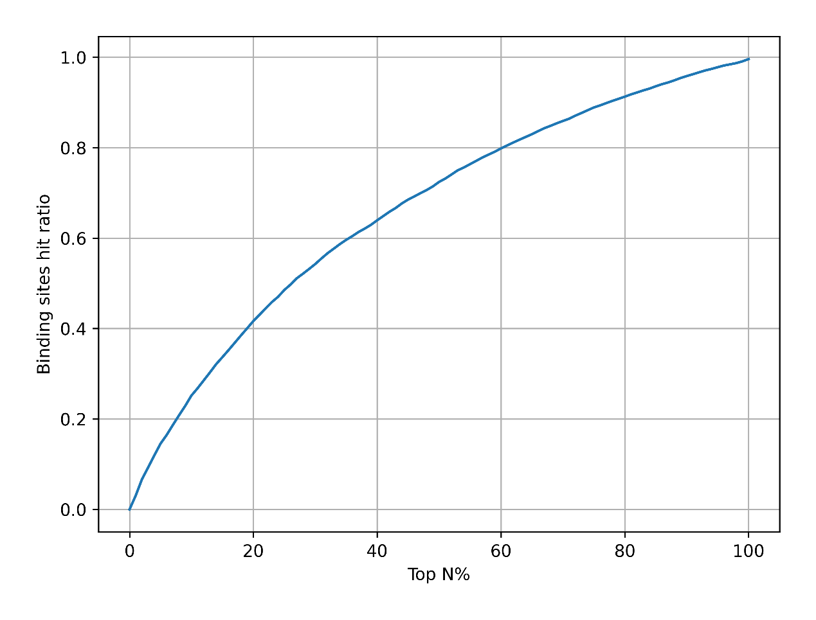
Fig S5 Binding sites hit ratio of residues with higher attention to the binding site at different thresholds

3 Supplemental Experimental Procedures
- Evaluation metrics
First, a few relevant definitions are introduced:
TP (True-Positive) represents the number of samples that are actually positive cases and are determined as positive cases by the classifier.
FP (False-Positive) represents the number of samples that are actually negative cases but are determined as positive cases by the classifier.
FN (False-Negative) represents the number of samples that are actually positive cases but are determined as negative cases by the classifier.
TN (True-Negative) represents the number of samples that are actually negative cases and are determined as negative cases by the classifier.
Accuracy
Accuracy represents the ratio between the correctly predicted samples and the total samples:
$$\operatorname{Accuracy}{=}\frac{\operatorname{TP}{+}TN}{\operatorname{TP}{+}\operatorname{FP}{+}\operatorname{TN}{+}FN}$$
Precision
Precision is an important evaluation metric, especially in binary classification problems, that measures the accuracy of positive predictions made by a model. It's a measure of how many of the instances predicted as positive are actually positive.
$$\operatorname{Precision}{=}\frac{TP}{\operatorname{TP}{+}FP}$$

Recall
Recall, also known as sensitivity or true positive rate, is an important evaluation metric in classification that measures the ability of a model to correctly identify all positive instances.
$$\operatorname{Recall}{=}\frac{TP}{\operatorname{TP}{+}FN}$$

F1 score
The macro algorithm calculates Precision and Recall by first calculating Precision and Recall for each category and then taking the average.
$$\text{F1}=2⋅\frac{\operatorname{precision}{⋅}recall}{\operatorname{precision}{+}recall}$$

AUC
The evaluation indicator AUC stands for Area Under the Curve. The curve refers to the Receiver Operating Characteristic (ROC) curve, which plots the true positive rate (sensitivity) against the false positive rate (1 - specificity) for various classification thresholds.
Sensitivity (also known as recall or true positive rate): Sensitivity measures the proportion of actual positive instances correctly identified by the model.
$$\operatorname{Sensitivity}{=}\frac{TP}{\operatorname{TP}{+}FN}$$

Specificity: Specificity measures the proportion of actual negative instances correctly identified by the model.
$$\operatorname{Specificity}{=}\frac{TN}{\operatorname{TN}{+}FP}$$
The AUC value ranges from 0 to 1, where a higher value indicates better performance. A perfect classifier would have an AUC of 1, while a random or ineffective classifier would have an AUC close to 0.5.
AUPR
The evaluation indicator AUPR stands for Area Under the Precision-Recall Curve. It is an evaluation metric used to assess the performance of classification models, particularly in scenarios where imbalanced class distribution is present or when the focus is on the positive class.
Unlike AUC, which is based on the Receiver Operating Characteristic (ROC) curve, AUPR is based on the Precision-Recall curve. The Precision-Recall curve plots the precision (positive predictive value) against the recall (sensitivity) for different classification thresholds.
The AUPR value ranges from 0 to 1, with a higher value indicating better performance. A perfect classifier would have an AUPR of 1, while a random or ineffective classifier would have an AUPR close to the proportion of positive instances in the dataset.
OFR
To examine whether Evidential DTI can reduce the percentage of false high-confidence predictions relative to traditional classification models, we defined "high confidence predictions" as samples with $p^{i}>1-T$ or $p^{i}<T$, where T is a threshold between 0-0.1. The "overconfidence false sample rate" (OFR) was further defined as the percentage of samples with high confidence forecasts for which $p^{i}>1-T$and $y^{i}=0$ or$p^{i}<T$ and $y^{i}=1$:

$$OFR=\frac{\sum_{i}{1(\left(p^{i}>1-T and y^{i}=0\right) or \left(p^{i}<T and y^{i}=1\right))}}{\sum_{i}{1(\left(p^{i}>1-T\right) or \left(p^{i}<T\right))}}$$

- Training details
Hyperparameter optimization search space
Table S8 Hyperparameter searching space of Evidential DTI
Parameter | Range
Epoch | 500
batch | 32
optim | adam
learning rate | 5e-4
weight_decay | 1.0e-5
dropout | 0.3
Target feature convolution kernel size | 9
Target attention convolution kernel size | 9
Target readout MLP layers | 1
Target readout MLP hidden dimension | 256
Drug 2D feature convolution layers | 2
Drug 2D feature convolution kernel size | 3
Drug 2D readout MLP layers | 2
Drug 2D readout MLP hidden dimension | [1024,128]
Drug 3D GNN model | [GAT, GNNTransformer]
Drug 3D GNN layers | [4, 6, 8]
heads | [1, 4]
Drug 3D GNN embed dim | 64
Drug 3D readout MLP layers | 2
Drug 3D readout MLP hidden dimension | [1024, 128]
DTI readout MLP layers | 4
DTI readout MLP hidden dimension | [1024,1024,512,2]
Final activation | softplus

