Supplementary Material

Supplementary Tab. 1 Results of the Gaussian mixture model fit of the SBR histograms and resulting thresholds for the separation of the 5 regional categories. All values are given for putamen/caudate respectively.
 | In-house 1 | In-house 2 | External 1 | External 2
Mean „normal“ (M₁) | 1.615/2.631 | 1.769/ 2.829 | 1.100/ 1.691 | 1.514/2.465
SD „normal“ (SD₁) | 0.345/0.542 | 0.413/ 0.777 | 0.348/ 0.510 | 0.327/0.475
Mean „reduced“ (M₂) | 0.636/ 1.545 | 0.546/ 1.580 | 0.486/ 1.156 | 0.622/1.421
SD „reduced“ (SD₂) | 0.185/ 0.458 | 0.251/ 0.463 | 0.142/ 0.274 | 0.186/0.422
Threshold normal vs. borderline | 1.175/ 2.179 | 1.230/ 2.190 | 0.872/1.530 | 1.093/2.018
Threshold borderline vs. moderate reduction | 0.978/ 2.042 | 1.008/2.046 | 0.796/1.463 | 0.946/1.912
Threshold moderate vs. strong reduction | 0.716/ 1.729 | 0.651/1.688 | 0.577/1.251 | 0.705/1.591
Threshold strong reduction vs. (almost) missing | 0.558/ 1.389 | 0.445/1.362 | 0.441/1.023 | 0.547/1.262

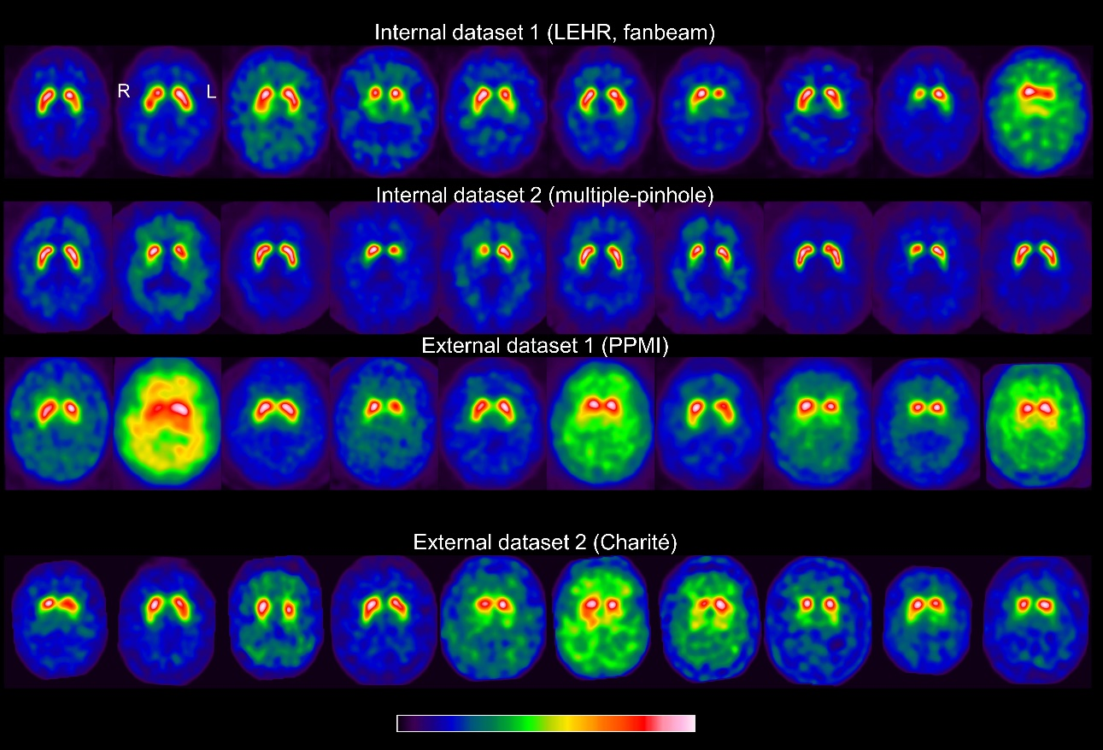
Supplementary Fig. 1 Ten randomly selected images from each of the 4 datasets.

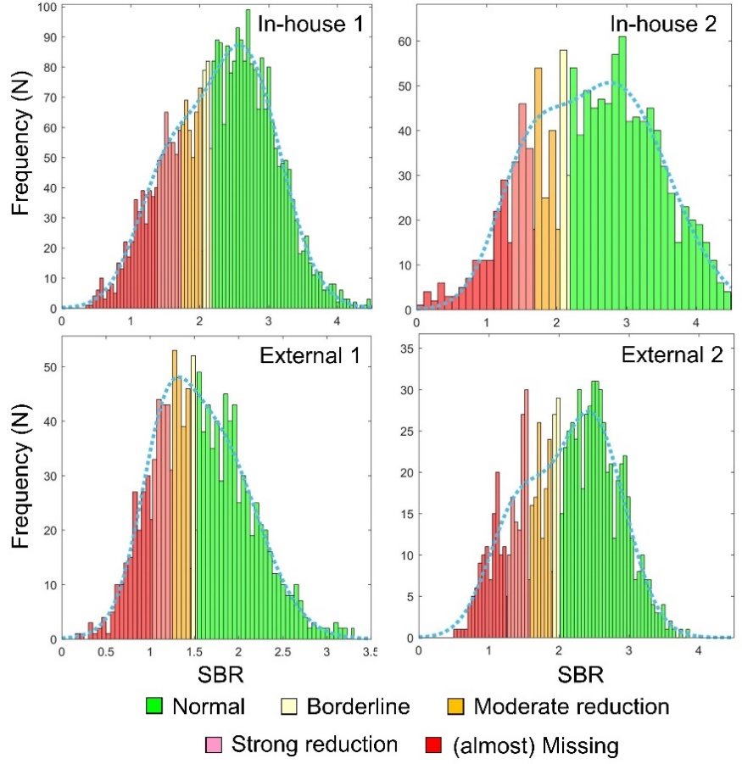
Supplementary Fig. 2 Automatic generation of the reference standard for the categorical 5-level score in the caudate based on the fit of a Gaussian mixture model to the histogram of the caudate specific binding ratio (SBR). This was performed separately for each dataset.

