Elucidating altered neural molecular mechanisms in mice using transcriptomics underlying metabolic disorders induced cognitive and depressive disorders

Sachin Singh¹, Nitesh Kumar Singh¹, SriVidya Kottappali¹, Unis Ahmad Bhat¹, Divya Tej Sowpati¹, Sumana Chakravarty^{2,3}, Arvind Kumar*^{1,2}

¹CSIR-Center for Cellular and Molecular Biology, Hyderabad, India; ²Academy of Scientific & Innovative Research (AcSIR), Ghaziabad, India; ³CSIR-Indian Institute of Chemical Technology, Tarnaka, Hyderabad, India

*Corresponding author
Arvind Kumar, PhD
Epigenetics & Neuropsychiatric Disorders Laboratory
CSIR- Centre for Cellular and Molecular Biology (CCMB)
Uppal Road, Habsiguda, Hyderabad - 500007, Telangana State (TS), India
Email: akumar@ccmb.res.in; arvindk567@gmail.com

Arvind Kumar: ORCID number: 0000-0003-2879-3826

Running title: Neural molecular mechanisms in metabolic disorder induced neuropsychiatric disorders

Supplementary Figure legends
FigS1: Measurement of the various parameters including body weight, biochemical parameters, and test for neuropsychiatric disorders at 6 weeks of age before starting the experiments (a) Body weight (b) Glucose (c) Cholesterol (d) Triglycerides (e) Novel Object Recognition Test (NORT) was performed to rule out the presence of the cognitive abnormalities (f) Elevated Plus Maze Test (EPM) was performed to rule out the presence of the anxiety-like behavior (g) Forced swim Test (FST) (h) Novel Object Recognition Test (NORT) Recognition Index (RI%) (i) Novel Object Recognition Test (NORT) Discrimination Index (DI%).
FigS2: Effect of the 60 % high fructose diet on the DEGs of the prefrontal cortex region of the (HfrUST) in comparison to the control (CoUST) mice. (a) Gene Ontology (GO) and (b) Kyoto Encyclopedia of the Genes and Genome (KEGG) pathway analysis was performed on the Differentially Expressed Genes (DEGs). The Y-axis represents the number of pathways and the X-axis represents the enriched terms. The size of the circle is directly proportional to the proportion of the annotated gene to all genes in that pathway and color intensity indicates the −log10 (p-value) of GO terms. (c) The Venn diagram showed the exclusive and overlap of DEGs, on comparison between different groups (p<0.05 and log 2-fold change is set at 0.3).
FigS3: Ingenuity pathway analysis of the upregulated transcriptomic profile of the (HfrST vs HFrUST) showed, various factors responsible for metabolic disorder-associated neuropsychiatric disorders.
FigS4: Ingenuity pathway analysis of the upregulated transcriptomic profile of the (HfrST vs HfrUST) showed various factors changed under inflammatory conditions induced due to the High fructose diet along with stress.
FigS5: Ingenuity pathway analysis of the downregulated transcriptomic profile was performed between High fructose Unstress (HfrUST) versus High fructose stress (HfrST).The network includes cytokines and chemokines such as IL2, IL1B, IL6, IL7R, and Ccl19, and also players of innate immune response like Tlr8
FigS6:Comparison of pathways altered in (HfrST vs HfrUST) and (CoSt vs CoUST), generated by Ingenuity Pathway Analysis (IPA).
FigS7:The Ingenuity Pathway Analysis of the transcriptomic data of the High fructose Unstress (HfrUST) and Control Unstress (CoUS) inflammatory network which showed the upregulation of the various cytokines including Interleukin 6 (IL6), Interleukin 1B, Interleukin 11 receptor Alpha (IL11 RA), Pro-inflammatory cytokine C-X-C motif chemokine 10 (CXCL10), Chemokine (C-C motif) ligand 8, Thymic stromal lymphopoietin(TSLP) is an IL-7-like cytokine etc.
FigS8: The Ingenuity Pathway Analysis of the transcriptomic data of the High fructose Unstress (HfrUST) and Control Unstress (CoUS). Ibuprofen targets including inhibiting Acetylcholinesterase(ACHE), Mitogen-activated protein Kinase-14 (MAK14), Cytokines-activated nuclear IKKalpha-FAT10 (CHUK), cyclooxygenase, Catenin beta-1 (CTNB), Nuclear factor kappa B (NFkB), Prostaglandin-endoperoxide synthasePTGS2 and aspirin pathways.

Supplementary Figures:
FigS1
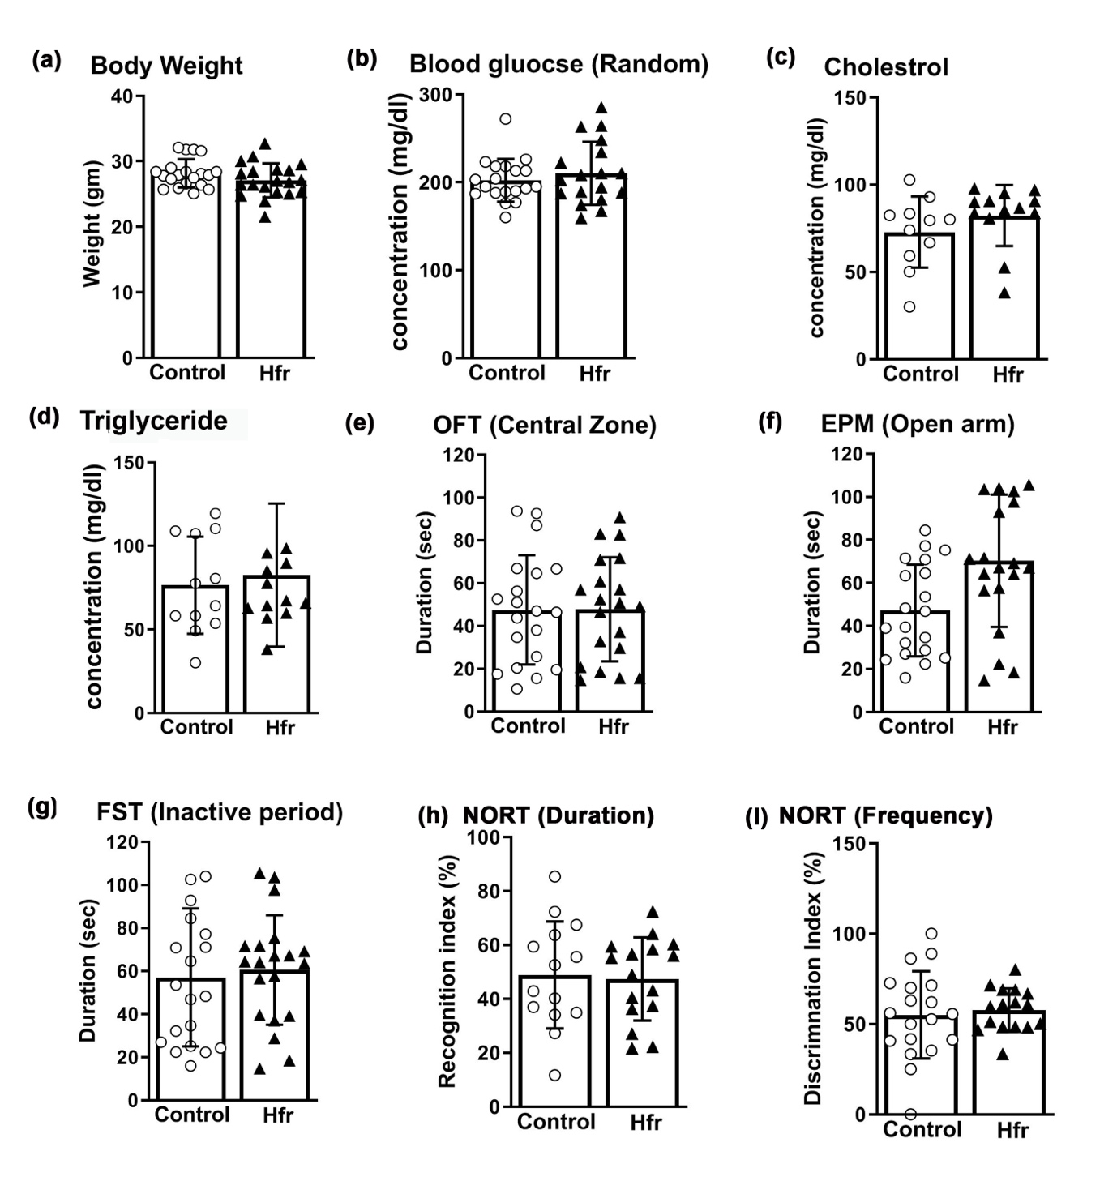
Fig.S1: Measurement of the various parameters including body weight, biochemical parameters, and test for neuropsychiatric disorders at 6 weeks of age before starting the experiments (a) Body weight (b) Glucose (c) Cholesterol (d) Triglycerides (e) Novel Object Recognition Test (NORT) was performed to rule out the presence of the cognitive abnormalities (f) Elevated Plus Maze Test (EPM) was performed to rule out the presence of the anxiety-like behavior (g) Forced swim Test (FST) (h) Novel Object Recognition Test (NORT) Recognition Index (RI%) (i) Novel Object Recognition Test (NORT) Discrimination Index (DI%).

FigS2
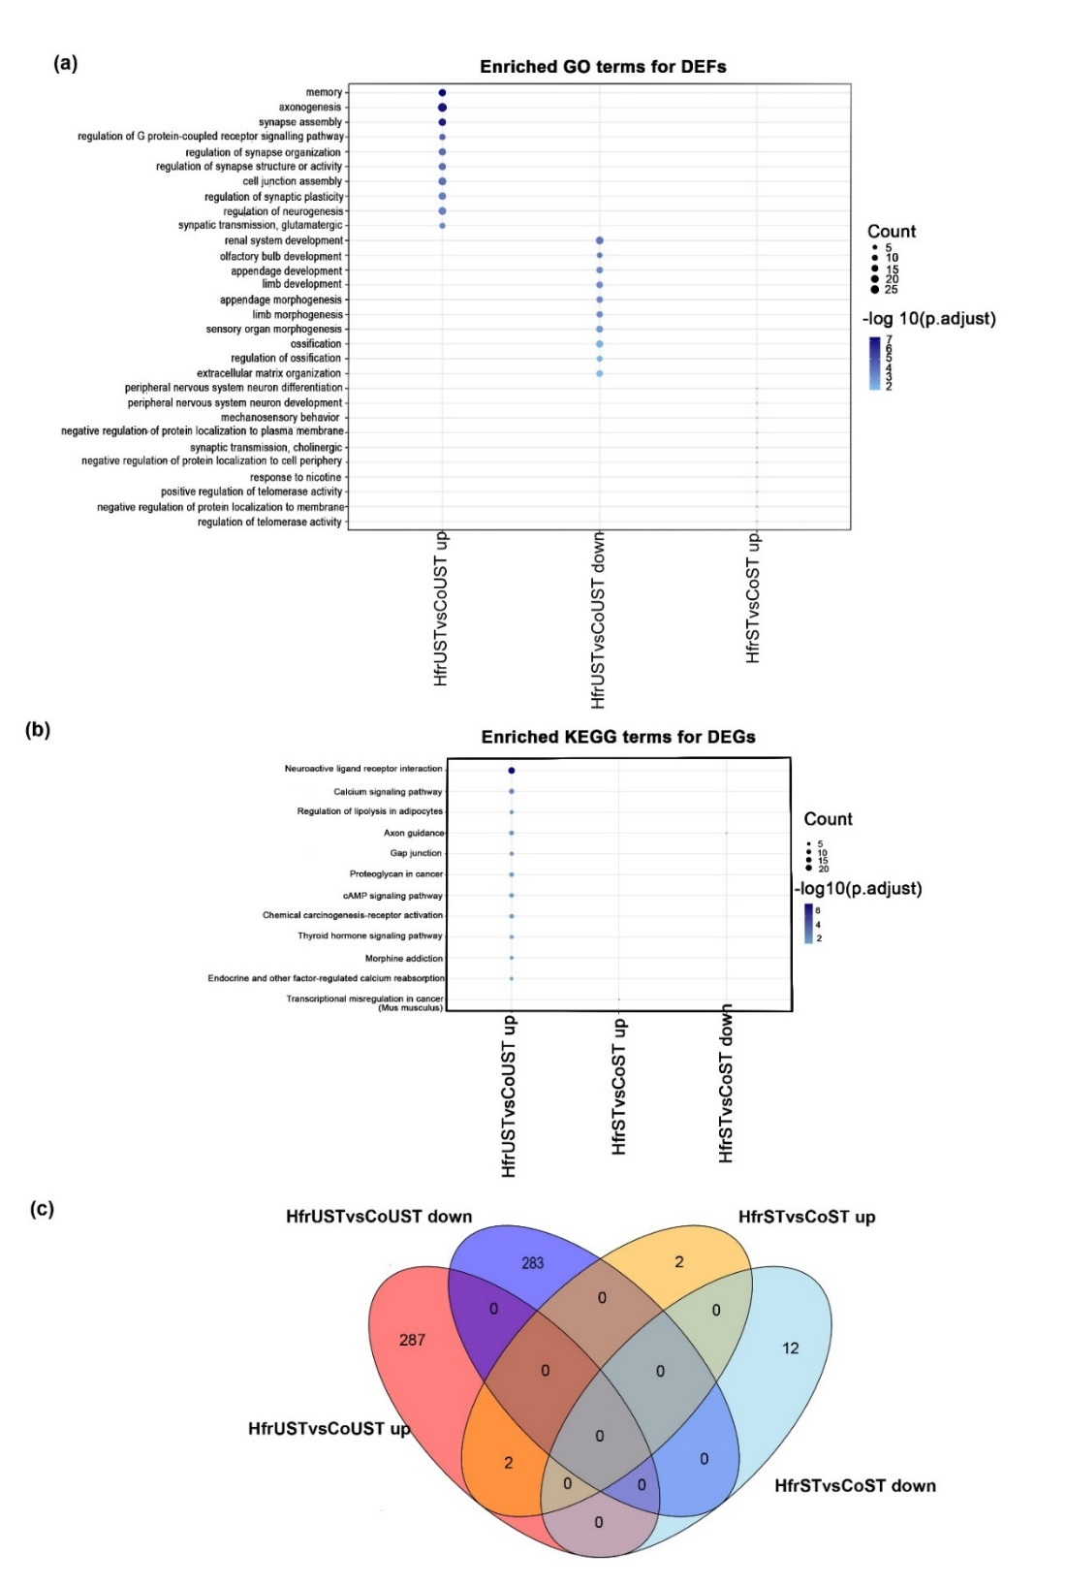

FigS2: Effect of the 60 % high fructose diet on the DEGs of the prefrontal cortex region of the (HfrUST) in comparison to the control (CoUST) mice. (a) Gene Ontology (GO) and (b) Kyoto Encyclopedia of the Genes and Genome (KEGG) pathway analysis was performed on the Differentially Expressed Genes (DEGs). The Y-axis represents the number of pathways and the X-axis represents the enriched terms. The size of the circle is directly proportional to the proportion of the annotated gene to all genes in that pathway and color intensity indicates the −log10 (p-value) of GO terms. (c) The Venn diagram showed the exclusive and overlap of DEGs, on comparison between different groups (p<0.05 and log 2-fold change is set at 0.3).

FigS3

FigS3: Ingenuity pathway analysis of the upregulated transcriptomic profile of the (HfrST vs HFrUST) showed, various factors responsible for metabolic disorder-associated neuropsychiatric disorders.

FigS4
FigS4: Ingenuity pathway analysis of the upregulated transcriptomic profile of the (HfrST vs HfrUST) showed various factors changed under inflammatory conditions induced due to the High fructose diet along with stress.

FigS5

FigS5: Ingenuity pathway analysis of the downregulated transcriptomic profile was performed between High fructose Unstress (HfrUST) versus High fructose stress (HfrST).The network includes cytokines and chemokines such as IL2, IL1B, IL6, IL7R, and Ccl19, and also players of innate immune response like Tlr8

FigS6

FigS6:Comparison of pathways altered in (HfrST vs HfrUST) and (CoSt vs CoUST), generated by Ingenuity Pathway Analysis (IPA).

FigS7
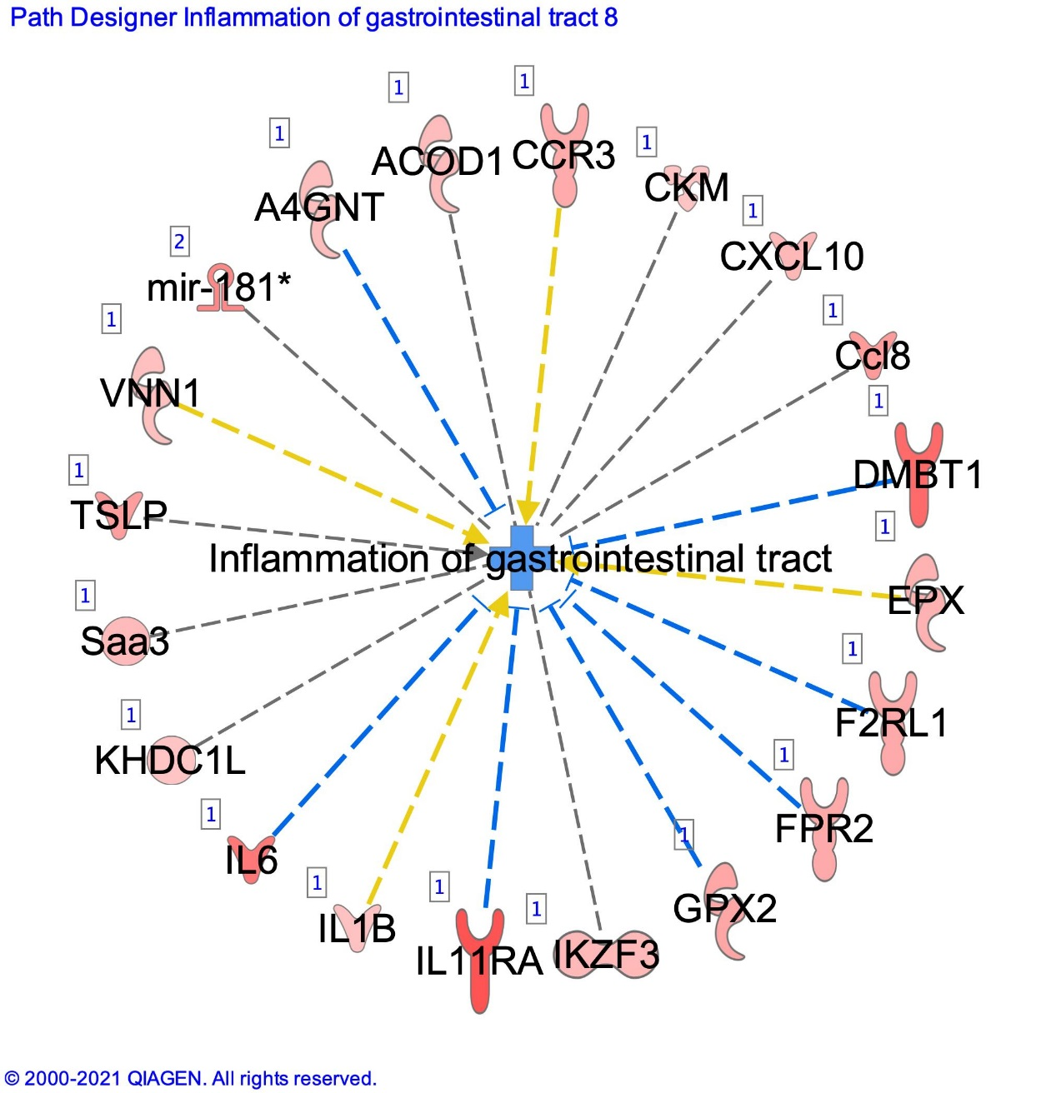

FigS7:The Ingenuity Pathway Analysis of the transcriptomic data of the High fructose Unstress (HfrUST) and Control Unstress (CoUS) inflammatory network which showed the upregulation of the various cytokines including Interleukin 6 (IL6), Interleukin 1B, Interleukin 11 receptor Alpha (IL11 RA), Pro-inflammatory cytokine C-X-C motif chemokine 10 (CXCL10), Chemokine (C-C motif) ligand 8, Thymic stromal lymphopoietin(TSLP) is an IL-7-like cytokine etc.

FigS8

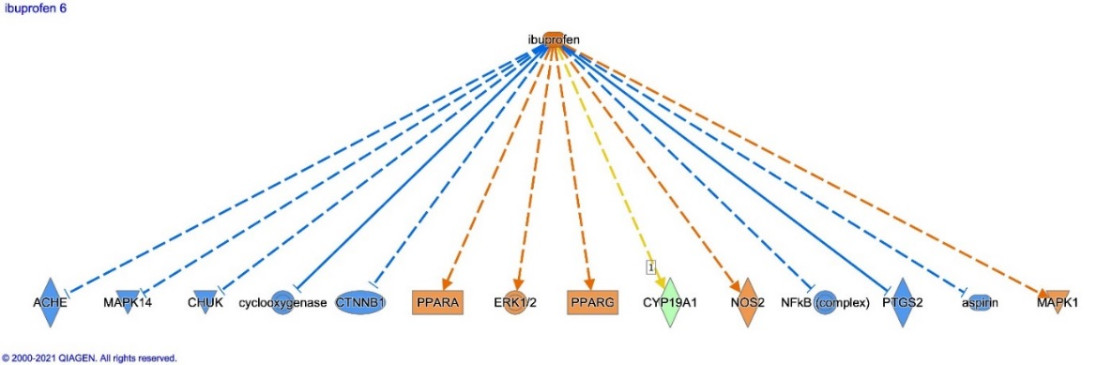

FigS8: The Ingenuity Pathway Analysis of the transcriptomic data of the High fructose Unstress (HfrUST) and Control Unstress (CoUS). Ibuprofen targets including inhibiting Acetylcholinesterase(ACHE), Mitogen-activated protein Kinase-14 (MAK14), Cytokines-activated nuclear IKKalpha-FAT10 (CHUK), cyclooxygenase, Catenin beta-1 (CTNB), Nuclear factor kappa B (NFkB), Prostaglandin-endoperoxide synthasePTGS2 and aspirin pathways

S. No. | Pathways | Genes | Up/Down | Implication
1. | GABA Metabolism | Gad1 | down | Psychiatric disorders
2. | Wnt Signaling | Gsk3β | down | Type 2 diabetes and cancer
3. | Innate immunity | Tlr4 | up | Neuronal degeneration
4. | Neuroinflammation | Nlrp3 | up | Neuronal degeneration
5. | Vasculogenesis | Vegf | down | Neuro degeneration
6. | Neuroinflammation | Cxcl12 | up | Psychiatric Disorders
7. | Cell Proliferation | Nestin | up | Psychiatric Disorders
8. | Neurotransmitter trafficking | Slc6 | down | Depression
9 | Cytokine signaling | Tnfrs8 | up | Psychiatric Disorders
10 | Neuronal cell proliferation | Sox9 | up | Psychiatric Disorders
11 | Transcription factor | Crebp | up | Synaptic plasticity
Supplementary Table S1: Hfr diet induces perturbation in the expression pattern of the genes implicated in various pathways.

Table S2: A comparative analysis of the transcriptome data of (HfrST vs HfrUST) with publically available transcriptomic data from the hippocampus (Meng et al., 2016)
The list of common genes observed between (HfrST vs HfrUST); Meng, et al., also conducted a similar type of the study using fructose-induced metabolic dysregulation and brain dysfunction (Meng et al., 2016)
S.No | Gene Symbol | Change | Gene Name | Function | References
1 | Zfp36 (UP) | Up | Zinc finger protein 36 | Suppress Inflammation, regulate glycolytic enzyme Enolase-2 through mRNA decay | (Cicchetto et al., 2023)
2 | Cox17 | up | Cytochrome C Oxidase Copper Chaperone COX17 | Mitochondrial Respiratory chain | (Takahashi et al., 2002)
3. | Zic2 | up | Zinc finger protein | Transcriptional activator | (Xu et al., 2021)
4. | Foxc2 | up | Forkhead Box C2 | Cell proliferation and differentiation Glioblastoma) | (Li et al., 2013)
5. | Slco1c1 | up | Solute Carrier Organic Anion Transporter Family Member 1C1 | Anion transport across the membrane
6 | Clk1 | up | CDC2-like kinase 1 | Promote energy expenditure through browning in adipose tissue. | (Wang et al., 2021)
7 | Pnisr | up | PNN-interacting serine/arginine-rich protein
8 | Sox18 | up | SRY-related HMG-box | It is a transcription factor that plays a role in angiogenesis | (Downes & Koopman, 2001)
9 | Arhgap29 | up | Rho GTPase Activating Protein 29
10 | Ddit4 | up | DNA-damage-inducible transcript 4 | Cell steaminess and autophagy | (Ho et al., 2020)
11 | Srsf5 | Up | arginine/serine-rich 5 | Srsf5 is a Splicing factor, it regulates mRNA splicing | (Zhang et al., 2021)
12 | Hes5 | Up | Hes Family BHLH Transcription Factor 5 | It is a transcription factor, it regulates cell proliferation and differentiation | (Ohtsuka, Sakamoto, Guillemot, & Kageyama, 2001)
13 | Tnfsf10 | Up | tumor necrosis factor | It plays a role in neuronal inflammation. However, overexpression results the cognitive loss . | (Cantarella et al., 2015)
14 | Ets1 | Up | EtS family | It is a transcription factor, It regulates cell proliferation. | (Vishnoi et al., 2022)
15 | Tek | Up | TEK tyrosine kinase | It plays a central role in vascular stability, it is a transmembrane receptor that plays a crucial role in signaling pathways upon stimuli by angiopoietins | (Liu et al., 2010)
16 | Synpo2 | Up | Synaptopodin 2
17 | Clec14a | Up | C-type lectin/C-type lectin-like domain | Loss of the Clec14 induces the of Vegfsignaling, and Neuronal inflammation | (Kim et al., 2020)
18 | Adamts15 | Up | a disintegrin and metalloproteinase with thrombospondin motifs | Synaptic plasticity in neurodegenerative disease states | (Gottschall & Howell, 2015)
19 | Jag1 | Up | Jagged1 | It is a cell surface ligand that plays a crucial role in the Notch signaling pathway. it plays a role in hippocampal-dependent memory formation | (Marathe, Jaquet, Annoni, & Alberi, 2017)
20 | Lama5 | Up | Laminin subunit alpha-5 | It is responsible for maintaining the blood-brain barrier | (Gautam, Miner, & Yao, 2019)
21 | Plekhf1 | Down | pleckstrin homology and FYVE domain containing 1) | Apoptosis through the lysosomal–mitochondrial pathways.
22 | Txnip | Down | thioredoxin-binding protein | Important regulator of glucose and lipid metabolism in various ways | (Alhawiti, Al Mahri, Aziz, Malik, & Mohammad, 2017; Brignull et al., 2013)
23 | Polr3e | Down | RNA polymerase III subunit | Innate immunity
24 | Cmklr1 | Down | Chemokine-like receptor 1 | It acts as a receptor for the Aβ Plaques, over-expression of these genes results in the accumulation of the plaque and neuronal cell death. | (Peng et al., 2015)
25 | Serpine1 | Down | serine-type endopeptidase inhibitor activity | Glial cell proliferation and differentiation | (Seker et al., 2019)
26 | Gch1 | Down | GTP cyclohydrolase-1 (GTPCH-І) | Activation of the immune response | (Larbalestier et al., 2022)
27 | Edn1 | Down | Endothelin 1 | It is implicated in regulating blood pressure, and neuroinflammation. | (D'Orléans-Juste, Akide Ndunge, Desbiens, Tanowitz, & Desruisseaux, 2019)
28 | Klf15 | Down | Krüppel-like factor 15 | It is a transcription factor, which is responsible for increased glucose sensitivity | (Du, Rosenfield, & Qin, 2009)
29 | Asb4 | Down | Ankyrin Repeat And SOCS Box Containing 4 | Asb4 improves glucose homeostasis in the brain,  Asb4 deficiency increased mark food intake in the mice | (Kayashima et al., 2023)
30 | Cebpd | Down | CCAAT/enhancer-binding protein delta | It is a transcription factor, in cell proliferation, differentiation, cell death, metabolism | (Ko, Chang, & Wang, 2015)
31 | Sgk1 | Down | Serum/glucocorticoid regulated kinase 1 | It Regulates ion channels, enzymes (GSK3β), and transcription factors (FOXO3a). Implicated in diabetes, obesity | (Lang, Görlach, & Vallon, 2009)
32 | Crispld2 | Down | Cysteine Rich Secretory Protein LCCL Domain Containing 2 | It is circulating adipokine, which may play a role in the onset of the MeS | (Jackson et al., 2019)
33 | Slco4a1 | Down | Solute carrier organic anion transporter |  | (Ayka & Şehirli, 2020)
34 | Dio2 | Down | Iodothyronine Deiodinase 2 | Play a minor role in the early onset of diabetes | (Nair et al., 2012)
35 | Nfkbia | Down | Nuclear factor-kappa-B inhibitor | Metabolic syndrome and inflammation | (Cai & Liu, 2012)
36 | Tsc22d3 | Down | TSC22 Domain Family Member 3 | Transcriptional regulator: Directly suppresses NFkB and another pro-inflammatory mediator, and is also implicated in stress-induced perturbed glucose metabolism | (Tertil et al., 2018)
37 | Net1 | Down | Netrin1 | Pro-angiogenic, anti-apoptotic, and anti-inflammatory properties | (Toque et al., 2017)

Table S3: Top down-regulated gene between CoST vs CoUST (Log₂ 0.3-fold change)
Ensemble ID | log2 Fold Change | Symbol | Gene Name
ENSMUSG00000067571 | -8.12 | Ms4a15 | membrane-spanning 4-domains, subfamily A, member 15
ENSMUSG00000001023 | -7.84 | S100a5 | S100 calcium binding protein A5
ENSMUSG00000032446 | -6.59 | Eomes | eomesodermin
ENSMUSG00000021337 | -5.92 | Scgn | secretagogin, EF-hand calcium binding protein
ENSMUSG00000053441 | -5.44 | Adamts19 | a disintegrin-like and metallopeptidase (reprolysin type) with thrombospondin type 1 motif, 19
ENSMUSG00000018581 | -4.66 | Dnah11 | dynein, axonemal, heavy chain 11
ENSMUSG00000036131 | -4.55 | Frmd7 | FERM domain containing 7
ENSMUSG00000011171 | -3.78 | Vipr2 | vasoactive intestinal peptide receptor 2
ENSMUSG00000001444 | -3.52 | Tbx21 | T-box 21
ENSMUSG00000000214 | -3.49 | Th | tyrosine hydroxylase
ENSMUSG00000026822 | -3.42 | Lcn2 | lipocalin 2
ENSMUSG00000004655 | -3.11 | Aqp1 | aquaporin 1
ENSMUSG00000060284 | -3.04 | Sp7 | Sp7 transcription factor 7
ENSMUSG00000021803 | -2.78 | Cdhr1 | cadherin-related family member 1
ENSMUSG00000048562 | -2.54 | Sp8 | trans-acting transcription factor 8
ENSMUSG00000084908 | -2.54 | NA | NA
ENSMUSG00000024871 | -2.54 | Doc2g | double C2, gamma
ENSMUSG00000096883 | -2.52 | Shisa8 | shisa family member 8
ENSMUSG00000074006 | -2.44 | Omp | olfactory marker protein
ENSMUSG00000005892 | -2.43 | Trh | thyrotropin-releasing hormone
ENSMUSG00000024175 | -2.37 | Tekt4 | tektin 4
ENSMUSG00000050370 | -2.31 | Ch25h | cholesterol 25-hydroxylase
ENSMUSG00000050010 | -2.28 | Shisa3 | shisa family member 3
ENSMUSG00000026308 | -2.25 | Klhl30 | kelch-like 30
ENSMUSG00000042607 | -2.22 | Asb4 | ankyrin repeat and SOCS box-containing 4
ENSMUSG00000020140 | -2.18 | Lgr5 | leucine-rich repeat-containing G protein-coupled receptor 5
ENSMUSG00000002228 | -2.06 | Ppm1j | protein phosphatase 1J
ENSMUSG00000003657 | -2.06 | Calb2 | calbindin 2
ENSMUSG00000038718 | -1.97 | Pbx3 | pre B cell leukemiahomeobox 3
ENSMUSG00000090698 | -1.94 | Apold1 | apolipoprotein L domain containing 1
ENSMUSG00000074934 | -1.93 | Grem1 | gremlin 1, DAN family BMP antagonist
ENSMUSG00000042622 | -1.91 | Maff | v-mafmusculoaponeuroticfibrosarcoma oncogene family, protein F (avian)
ENSMUSG00000020160 | -1.90 | Meis1 | Meishomeobox 1
ENSMUSG00000040373 | -1.90 | Cacng5 | calcium channel, voltage-dependent, gamma subunit 5
ENSMUSG00000023067 | -1.84 | Cdkn1a | cyclin-dependent kinase inhibitor 1A (P21)
ENSMUSG00000042501 | -1.81 | Cpa6 | carboxypeptidase A6
ENSMUSG00000042793 | -1.80 | Lgr6 | leucine-rich repeat-containing G protein-coupled receptor 6
ENSMUSG00000028862 | -1.79 | Map3k6 | mitogen-activated protein kinase kinasekinase 6
ENSMUSG00000028370 | -1.78 | Pappa | pregnancy-associated plasma protein A
ENSMUSG00000030223 | -1.77 | Ptpro | protein tyrosine phosphatase, receptor type, O
ENSMUSG00000066058 | -1.74 | Cldn19 | claudin 19
ENSMUSG00000037411 | -1.69 | Serpine1 | serine (or cysteine) peptidase inhibitor, clade E, member 1
ENSMUSG00000069372 | -1.67 | Ctxn3 | cortexin 3
ENSMUSG00000045288 | -1.63 | Ush1g | USH1 protein network component sans
ENSMUSG00000002831 | -1.61 | Plin4 | perilipin 4
ENSMUSG00000071637 | -1.61 | Cebpd | CCAAT/enhancer binding protein (C/EBP), delta
ENSMUSG00000056313 | -1.61 | Tim | transcriptional and immune response regulator
ENSMUSG00000021367 | -1.56 | Edn1 | endothelin 1
ENSMUSG00000030708 | -1.54 | Dnajb13 | DnaJ heat shock protein family (Hsp40) member B13
ENSMUSG00000038745 | -1.54 | Nlrp6 | NLR family, pyrin domain containing 6
ENSMUSG00000030043 | -1.54 | Tacr1 | tachykinin receptor 1
ENSMUSG00000028539 | -1.50 | Artn | artemin
ENSMUSG00000027654 | -1.50 | Fam83d | family with sequence similarity 83, member D
ENSMUSG00000044258 | -1.49 | Ctla2a | cytotoxic T lymphocyte-associated protein 2 alpha
ENSMUSG00000034533 | -1.49 | Scn10a | sodium channel, voltage-gated, type X, alpha
ENSMUSG00000024222 | -1.48 | Fkbp5 | FK506 binding protein 5
ENSMUSG00000024215 | -1.47 | Spdef | SAM pointed domain containing ets transcription factor
ENSMUSG00000071537 | -1.43 | Klrg2 | killer cell lectin-like receptor subfamily G, member 2
ENSMUSG00000025938 | -1.43 | Slco5a1 | solute carrier organic anion transporter family, member 5A1
ENSMUSG00000048572 | -1.43 | Tmem252 | transmembrane protein 252
ENSMUSG00000040170 | -1.42 | Fmo2 | flavin containing monooxygenase 2
ENSMUSG00000002289 | -1.42 | Angptl4 | angiopoietin-like 4
ENSMUSG00000021303 | -1.41 | Gng4 | guanine nucleotide-binding protein (G protein), gamma 4
ENSMUSG00000038843 | -1.41 | Gcnt1 | glucosaminyl (N-acetyl) transferase 1, core 2
ENSMUSG00000053626 | -1.39 | Tll1 | tolloid-like
ENSMUSG00000033107 | -1.38 | Rnf125 | ring finger protein 125
ENSMUSG00000049892 | -1.38 | Rasd1 | RAS, dexamethasone-induced 1
ENSMUSG00000002020 | -1.35 | Ltbp2 | latent transforming growth factor beta binding protein 2
ENSMUSG00000068859 | -1.35 | Sp9 | trans-acting transcription factor 9
ENSMUSG00000004328 | -1.33 | Hif3a | hypoxia-inducible factor 3, alpha subunit
ENSMUSG00000037095 | -1.32 | Lrg1 | leucine-rich alpha-2-glycoprotein 1
ENSMUSG00000002910 | -1.34 | Arrdc2 | arrestin domain containing 2
ENSMUSG00000029755 | -1.29 | Dlx5 | distal-less homeobox 5
ENSMUSG00000031654 | -1.29 | Cbln1 | cerebellin 1 precursor protein
ENSMUSG00000027377 | -1.28 | Mall | mal, T cell differentiation protein-like
ENSMUSG00000021025 | -1.27 | Nfkbia | nuclear factor of kappa light polypeptide gene enhancer in B cells inhibitor, alpha
ENSMUSG00000069911 | -1.27 | Insyn2b | inhibitory synaptic factor family member 2B
ENSMUSG00000033685 | -1.26 | Ucp2 | uncoupling protein 2 (mitochondrial, proton carrier)
ENSMUSG00000063260 | -1.26 | Syt10 | synaptotagmin X
ENSMUSG00000031431 | -1.28 | Tsc22d3 | TSC22 domain family, member 3
ENSMUSG00000039391 | -1.24 | Ccdc81 | coiled-coil domain containing 81
ENSMUSG00000024066 | -1.24 | Xdh | xanthine dehydrogenase
ENSMUSG00000034579 | -1.22 | Pla2g3 | phospholipase A2, group III
ENSMUSG00000041957 | -1.21 | Pkp2 | plakophilin 2
ENSMUSG00000007107 | -1.21 | Atp1a4 | ATPase, Na+/K+ transporting, alpha 4 polypeptide
ENSMUSG00000030353 | -1.20 | Tead4 | TEA domain family member 4
ENSMUSG00000026303 | -1.19 | Mlph | melanophilin
ENSMUSG00000047259 | -1.19 | Mc4r | melanocortin 4 receptor
ENSMUSG00000020732 | -1.18 | Rab37 | RAB37, member RAS oncogene family
ENSMUSG00000024677 | -1.18 | Ms4a6b | membrane-spanning 4-domains, subfamily A, member 6B
ENSMUSG00000050473 | -1.17 | Slc35d3 | solute carrier family 35, member D3
ENSMUSG00000091119 | -1.16 | Ccdc152 | coiled-coil domain containing 152
ENSMUSG00000034765 | -1.16 | Dusp5 | dual specificity phosphatase 5
ENSMUSG00000066108 | -1.15 | Muc5b | mucin 5, subtype B, tracheobronchial
ENSMUSG00000025723 | -1.14 | Nmb | neuromedin B
ENSMUSG00000044786 | -1.14 | Zfp36 | zinc finger protein 36
ENSMUSG00000043168 | -1.13 | Rik | RIKEN cDNA 4930426D05 gene
ENSMUSG00000027931 | -1.11 | Npr1 | natriuretic peptide receptor 1
ENSMUSG00000050105 | -1.11 | Grrp1 | glycine/arginine rich protein 1
ENSMUSG00000000686 | -1.10 | Abhd15 | abhydrolase domain containing 15
ENSMUSG00000027849 | -1.09 | Syt6 | synaptotagmin VI
ENSMUSG00000038059 | -1.09 | Smim3 | small integral membrane protein 3
ENSMUSG00000014158 | -1.09 | Trpv4 | transient receptor potential cation channel, subfamily V, member 4
ENSMUSG00000074170 | -1.07 | Plekhf1 | pleckstrin homology domain containing, family F (with FYVE domain) member 1
ENSMUSG00000070780 | -1.07 | Rbm47 | RNA binding motif protein 47
ENSMUSG00000024778 | -1.07 | Fas | Fas (TNF receptor superfamily member 6)
ENSMUSG00000039634 | -1.07 | Zfp189 | zinc finger protein 189
ENSMUSG00000006445 | -1.06 | Epha2 | Eph receptor A2
ENSMUSG00000013766 | -1.06 | Ly6g6e | lymphocyte antigen 6 complex, locus G6E
ENSMUSG00000007279 | -1.05 | Scube2 | signal peptide, CUB domain, EGF-like 2
ENSMUSG00000037977 | -1.05 | Rik | RIKEN cDNA 6430571L13 gene
ENSMUSG00000020108 | -1.04 | Ddit4 | DNA-damage-inducible transcript 4
ENSMUSG00000066687 | -1.04 | Zbtb16 | zinc finger and BTB domain containing 16
ENSMUSG00000039376 | -1.03 | Synpo2l | synaptopodin 2-like
ENSMUSG00000073154 | -1.03 | Rik | RIKEN cDNA 9330158H04 gene
ENSMUSG00000052384 | -1.03 | Nrros | negative regulator of reactive oxygen species
ENSMUSG00000000125 | -1.02 | Wnt3 | wingless-type MMTV integration site family, member 3
ENSMUSG00000023391 | -1.02 | Dlx2 | distal-less homeobox 2
ENSMUSG00000028413 | -1.02 | B4galt1 | UDP-Gal:betaGlcNAc beta 1,4- galactosyltransferase, polypeptide 1
ENSMUSG00000038393 | -1.02 | Txnip | thioredoxin interacting protein
ENSMUSG00000029754 | -1.01 | Dlx6 | distal-less homeobox 6
ENSMUSG00000021903 | -1.01 | Galnt15 | polypeptide N-acetylgalactosaminyltransferase 15

Table S4: Top Up-regulated genes between CoST vs CoUST (Log2 0.3-fold change)
Ensemble ID | log2FoldChange | Symbol | Gene Name
ENSMUSG00000039304 | 1.96 | Tnfsf10 | tumor necrosis factor (ligand) superfamily, member 10
ENSMUSG00000045903 | 1.58 | Npas4 | neuronal PAS domain protein 4
ENSMUSG00000024986 | 1.46 | Hex | hematopoietically expressed homeobox
ENSMUSG00000044921 | 1.42 | Rassf9 | Ras association (RalGDS/AF-6) domain family (N-terminal) member 9
ENSMUSG00000021624 | 1.39 | Cd180 | CD180 antigen
ENSMUSG00000026354 | 1.26 | Lct | lactase
ENSMUSG00000117684 | 1.23 | 4930449E18Rik | RIKEN cDNA 4930449E18 gene
ENSMUSG00000024793 | 1.19 | Tnfrsf25 | tumor necrosis factor receptor superfamily, member 25
ENSMUSG00000001029 | 1.18 | Icam2 | intercellular adhesion molecule 2
ENSMUSG00000034792 | 1.17 | Gna15 | guanine nucleotide-binding protein, alpha 15
ENSMUSG00000074635 | 1.14 | 3110070M22Rik | RIKEN cDNA 3110070M22 gene
ENSMUSG00000034317 | 1.13 | Trim59 | tripartite motif-containing 59
ENSMUSG00000095193 | 1.13 | Gm20939 | predicted gene, 20939
ENSMUSG00000048001 | 1.09 | Hes5 | hes family bHLH transcription factor 5
ENSMUSG00000062960 | 1.09 | Kdr | kinase insert domain protein receptor
ENSMUSG00000036362 | 1.07 | P2ry13 | purinergic receptor P2Y, G-protein coupled 13
ENSMUSG00000037358 | 1.07 | Dipk2b | divergent protein kinase domain 2B
ENSMUSG00000079363 | 1.04 | Gbp4 | guanylate binding protein 4
ENSMUSG00000041378 | 0.99 | Cldn5 | claudin 5
ENSMUSG00000021822 | 0.99 | Plau | plasminogen activator, urokinase
ENSMUSG00000096753 | 0.92 | Fam181a | family with sequence similarity 181, member A
ENSMUSG00000025993 | 0.91 | Slc40a1 | solute carrier family 40 (iron-regulated transporter), member 1
ENSMUSG00000074634 | 0.89 | Tmem267 | transmembrane protein 267
ENSMUSG00000000567 | 0.87 | Sox9 | SRY (sex determining region Y)-box 9
ENSMUSG00000032035 | 0.86 | Ets1 | E26 avian leukemia oncogene 1, 5' domain
ENSMUSG00000033949 | 0.86 | Trim36 | tripartite motif-containing 36
ENSMUSG00000059588 | 0.86 | Calcrl | calcitonin receptor-like
ENSMUSG00000030237 | 0.83 | Slco1a4 | solute carrier organic anion transporter family, member 1a4

Table S5: Top Down-regulated genes between HfrST vs HfrUST (Log2 0.3-fold change)
Ensemble ID | log2FoldChange | Symbol | Gene Name
ENSMUSG00000042607 | -2.37 | Asb4 | ankyrin repeat and SOCS box-containing 4
ENSMUSG00000090698 | -2.21 | Apold1 | apolipoprotein L domain containing 1
ENSMUSG00000042622 | -2.08 | Maff | v-mafmusculoaponeuroticfibrosarcoma oncogene family, protein F (avian)
ENSMUSG00000056313 | -1.95 | Tcim | transcriptional and immune response regulator
ENSMUSG00000044258 | -1.87 | Ctla2a | cytotoxic T lymphocyte-associated protein 2 alpha
ENSMUSG00000074170 | -1.39 | Plekhf1 | pleckstrin homology domain containing, family F (with FYVE domain) member 1
ENSMUSG00000021025 | -1.38 | Nfkbia | nuclear factor of kappa light polypeptide
ENSMUSG00000028862 | -1.38 | Map3k6 | mitogen-activated protein kinase kinasekinase 6
ENSMUSG00000071637 | -1.30 | Cebpd | CCAAT/enhancer binding protein (C/EBP), delta
ENSMUSG00000049892 | -1.29 | Rasd1 | RAS, dexamethasone-induced 1
ENSMUSG00000037411 | -1.29 | Serpine1 | serine (or cysteine) peptidase inhibitor, clade E, member 1
ENSMUSG00000019970 | -1.28 | Sgk1 | serum/glucocorticoid regulated kinase 1
ENSMUSG00000033450 | -1.26 | Tagap | T cell activation Rho GTPase activating protein
ENSMUSG00000047259 | -1.24 | Mc4r | melanocortin 4 receptor
ENSMUSG00000046223 | -1.23 | Plaur | plasminogen activator, urokinase receptor
ENSMUSG00000039634 | -1.21 | Zfp189 | zinc finger protein 189
ENSMUSG00000044786 | -1.19 | Zfp36 | zinc finger protein 36
ENSMUSG00000023067 | -1.16 | Cdkn1a | cyclin-dependent kinase inhibitor 1A (P21)
ENSMUSG00000037580 | -1.16 | Gch1 | GTP cyclohydrolase 1
ENSMUSG00000024521 | -1.14 | Pmaip1 | phorbol-12-myristate-13-acetate-induced protein 1
ENSMUSG00000020108 | -1.14 | Ddit4 | DNA-damage-inducible transcript 4
ENSMUSG00000038059 | -1.09 | Smim3 | small integral membrane protein 3
ENSMUSG00000002910 | -1.06 | Arrdc2 | arrestin domain containing 2
ENSMUSG00000031431 | -1.05 | Tsc22d3 | TSC22 domain family, member 3
ENSMUSG00000038393 | -1.05 | Txnip | thioredoxin interacting protein
ENSMUSG00000033107 | -1.04 | Rnf125 | ring finger protein 125
ENSMUSG00000006445 | -1.02 | Epha2 | Eph receptor A2
ENSMUSG00000021367 | -1.01 | Edn1 | endothelin 1
ENSMUSG00000064360 | -0.99 | ND3 | NADH dehydrogenase subunit 3
ENSMUSG00000033685 | -0.99 | Ucp2 | uncoupling protein 2 (mitochondrial, proton carrier)
ENSMUSG00000097711 | -0.97 | Gm5523 | glyceraldehyde-3-phosphate dehydrogenase pseudogene
ENSMUSG00000038745 | -0.96 | Nlrp6 | NLR family, pyrin domain containing 6
ENSMUSG00000041957 | -0.94 | Pkp2 | plakophilin 2
ENSMUSG00000024066 | -0.92 | Xdh | xanthine dehydrogenase
ENSMUSG00000037188 | -0.90 | Grhl3 | grainyhead-like transcription factor 3
ENSMUSG00000024222 | -0.84 | Fkbp5 | FK506 binding protein 5
ENSMUSG00000039911 | -0.83 | Spsb1 | splA/ryanodine receptor domain and SOCS box containing 1
ENSMUSG00000020424 | -0.83 | Castor1 | cytosolic arginine sensor for mTORC1 subunit 1
ENSMUSG00000050234 | -0.82 | Gja4 | gap junction protein, alpha 4
ENSMUSG00000026303 | -0.82 | Mlph | melanophilin
ENSMUSG00000028967 | -0.81 | Errfi1 | ERBB receptor feedback inhibitor 1
ENSMUSG00000016526 | -0.81 | Dyrk3 | dual-specificity tyrosine-(Y)-phosphorylation regulated kinase 3
ENSMUSG00000038550 | -0.80 | Cart | circadian-associated repressor of transcription
ENSMUSG00000044583 | -0.80 | Tlr7 | toll-like receptor 7
ENSMUSG00000034640 | -0.78 | Tiparp | TCDD-inducible poly(ADP-ribose) polymerase
ENSMUSG00000040093 | -0.7 | Bmf | BCL2 modifying factor
ENSMUSG00000038963 | -0.78 | Slco4a1 | solute carrier organic anion transporter family, member 4a1
ENSMUSG00000048572 | -0.77 | Tmem252 | transmembrane protein 252
ENSMUSG00000031825 | -0.77 | Crispld2 | cysteine-rich secretory protein LCCL domain containing 2
ENSMUSG00000051243 | -0.72 | Islr2 | immunoglobulin superfamily containing leucine-rich repeat 2
ENSMUSG00000028413 | -0.71 | B4galt1 | UDP-Gal:betaGlcNAc beta 1,4- galactosyltransferase, polypeptide 1
ENSMUSG00000018143 | -0.70 | Mafk | v-mafmusculoaponeuroticfibrosarcoma oncogene family, protein K (avian)
ENSMUSG00000028645 | -0.68 | Slc2a1 | solute carrier family 2 (facilitated glucose transporter), member 1
ENSMUSG00000021365 | -0.68 | Nedd9 | neural precursor cell expressed, developmentally down-regulated gene 9
ENSMUSG00000024053 | -0.68 | Emilin2 | elastin microfibrilinterfacer 2
ENSMUSG00000052384 | -0.66 | Nrros | negative regulator of reactive oxygen species
ENSMUSG00000030087 | -0.66 | Klf15 | Kruppel-like factor 15
ENSMUSG00000068240 | -0.65 | Uba52 | ubiquitin A-52 residue ribosomal protein fusion product 1
ENSMUSG00000045954 | -0.64 | Cavin2 | caveolae associated 2
ENSMUSG00000042190 | -0.63 | Cmklr1 | chemokine-like receptor 1
ENSMUSG00000029570 | -0.62 | Lfng | LFNG O-fucosylpeptide 3-beta-N-acetylglucosaminyltransferase
ENSMUSG00000028211 | -0.62 | Trp53inp1 | transformation related protein 53 inducible nuclear protein 1
ENSMUSG00000022952 | -0.62 | Runx1 | runt-related transcription factor 1
ENSMUSG00000050592 | -0.62 | Fam78a | family with sequence similarity 78, member A
ENSMUSG00000022528 | -0.61 | Hes1 | hes family bHLH transcription factor 1
ENSMUSG00000049791 | -0.61 | Fzd4 | frizzled class receptor 4
ENSMUSG00000005057 | -0.58 | Sh2b2 | SH2B adaptor protein 2
ENSMUSG00000038587 | -0.57 | Akap12 | A kinase (PRKA) anchor protein (gravin) 12
ENSMUSG00000046410 | -0.57 | Kcnk6 | potassium inwardly-rectifying channel, subfamily K, member 6
ENSMUSG00000050423 | -0.56 | Ppp1r3g | protein phosphatase 1, regulatory subunit 3G
ENSMUSG00000032807 | -0.55 | Alox12b | arachidonate 12-lipoxygenase, 12R type
ENSMUSG00000060260 | -0.55 | Pwwp2b | PWWP domain containing 2B
ENSMUSG00000037992 | -0.55 | Rara | retinoic acid receptor, alpha
ENSMUSG00000053553 | -0.54 | 3110082I17Rik | RIKEN cDNA 3110082I17 gene
ENSMUSG00000046593 | -0.54 | Tmem215 | transmembrane protein 215
ENSMUSG00000028128 | -0.53 | F3 | coagulation factor III
ENSMUSG00000032300 | -0.53 | 1700017B05Rik | RIKEN cDNA 1700017B05 gene
ENSMUSG00000028655 | -0.52 | Mfsd2a | major facilitator superfamily domain containing 2A
ENSMUSG00000030022 | -0.52 | Adamts9 | a disintegrin-like and metallopeptidase (reprolysin type) with thrombospondin type 1 motif, 9
ENSMUSG00000031875 | -0.51 | Cmtm3 | CKLF-like MARVEL transmembrane domain containing 3
ENSMUSG00000020614 | -0.51 | Fam20a | family with sequence similarity 20, member A
ENSMUSG00000021215 | -0.50 | Net1 | neuroepithelial cell transforming gene 1

TableS6: Top Up-regulated gene between HfrST vs HfrUST (Log2 0.3-fold change)
Ensemble ID | log2Fold Change | Symbol | Gene Name
ENSMUSG00000025993 | 0.54 | Slc40a1 | solute carrier family 40 (iron-regulated transporter), member 1
ENSMUSG00000000567 | 0.54 | Sox9 | SRY (sex determining region Y)-box 9
ENSMUSG00000001128 | 0.54 | Cfp | complement factor properdin
ENSMUSG00000044317 | 0.54 | Gpr4 | G protein-coupled receptor 4
ENSMUSG00000020385 | 0.54 | Clk4 | CDC like kinase 4
ENSMUSG00000026227 | 0.54 | 2810459M11Rik | RIKEN cDNA 2810459M11 gene
ENSMUSG00000070643 | 0.53 | Sox13 | SRY (sex determining region Y)-box 13
ENSMUSG00000036362 | 0.53 | P2ry13 | purinergic receptor P2Y, G-protein coupled 13
ENSMUSG00000033453 | 0.50 | Adamts15 | a disintegrin-like and metallopeptidase (reprolysin type) with thrombospondin type 1 motif, 15
ENSMUSG00000069184 | 0.50 | Zfp72 | zinc finger protein 72
ENSMUSG00000056854 | 0.48 | Pou3f4 | POU domain, class 3, transcription factor 4
ENSMUSG00000026921 | 0.48 | Egfl7 | EGF-like domain 7
ENSMUSG00000002617 | 0.48 | Zfp40 | zinc finger protein 40
ENSMUSG00000021754 | 0.48 | Map3k1 | mitogen-activated protein kinase kinasekinase 1
ENSMUSG00000019256 | 0.47 | Ahr | aryl-hydrocarbon receptor
ENSMUSG00000097589 | 0.46 | Dleu2 | deleted in lymphocytic leukemia, 2
ENSMUSG00000029401 | 0.46 | Rilpl2 | Rab interacting lysosomal protein-like 2
ENSMUSG00000045822 | 0.45 | Zswim3 | zinc finger SWIM-type containing 3
ENSMUSG00000030031 | 0.44 | Kbtbd8 | kelch repeat and BTB (POZ) domain containing 8
ENSMUSG00000027276 | 0.44 | Jag1 | jagged 1
ENSMUSG00000032902 | 0.44 | Slc16a1 | solute carrier family 16 (monocarboxylic acid transporters), member 1

Table S7: Top downregulated genes between HfrUST vs CoUST (Log2 0.3-fold change)

Ensemble ID | log2Fold Change | Symbol | Gene Name
ENSMUSG00000067571 | -8.15 | Ms4a15 | membrane-spanning 4-domains, subfamily A,
ENSMUSG00000032446 | -6.80 | Eomes | eomesodermin
ENSMUSG00000053441 | -5.63 | Adamts19 | a disintegrin-like and metallopeptidase (reprolysin type) with thrombospondin type 1 motif, 19
ENSMUSG00000018581 | -5.43 | Dnah11 | dynein, axonemal, heavy chain 11
ENSMUSG00000036131 | -4.60 | Frmd7 | FERM domain containing 7
ENSMUSG00000011171 | -4.15 | Vipr2 | vasoactive intestinal peptide receptor 2
ENSMUSG00000060284 | -3.65 | Sp7 | Sp7 transcription factor 7
ENSMUSG00000000214 | -3.55 | Th | tyrosine hydroxylase
ENSMUSG00000024871 | -3.20 | Doc2g | double C2, gamma
ENSMUSG00000074006 | -2.88 | Omp | olfactory marker protein
ENSMUSG00000096883 | -2.84 | Shisa8 | shisa family member 8
ENSMUSG00000050010 | -2.75 | Shisa3 | shisa family member 3
ENSMUSG00000048562 | -2.58 | Sp8 | trans-acting transcription factor 8
ENSMUSG00000005892 | -2.41 | Trh | thyrotropin-releasing hormone
ENSMUSG00000021803 | -2.31 | Cdhr1 | cadherin-related family member 1
ENSMUSG00000020160 | -2.04 | Meis1 | Meishomeobox 1
ENSMUSG00000042501 | -1.95 | Cpa6 | carboxypeptidase A6
ENSMUSG00000038718 | -1.93 | Pbx3 | pre B cell leukemia homeobox 3
ENSMUSG00000028370 | -1.90 | Pappa | pregnancy-associated plasma protein A
ENSMUSG00000020140 | -1.89 | Lgr5 | leucine-rich repeat-containing G protein-coupled receptor 5
ENSMUSG00000002020 | -1.85 | Ltbp2 | latent transforming growth factor beta binding protein 2
ENSMUSG00000003657 | -1.82 | Calb2 | calbindin 2
ENSMUSG00000042793 | -1.78 | Lgr6 | leucine-rich repeat-containing G protein-coupled receptor 6
ENSMUSG00000025938 | -1.65 | Slco5a1 | solute carrier organic anion transporter family, member 5A1
ENSMUSG00000040373 | -1.59 | Cacng5 | calcium channel, voltage-dependent, gamma subunit 5
ENSMUSG00000030223 | -1.58 | Ptpro | protein tyrosine phosphatase, receptor type, O
ENSMUSG00000069911 | -1.53 | Insyn2b | inhibitory synaptic factor family member 2B
ENSMUSG00000030043 | -1.46 | Tacr1 | tachykinin receptor 1
ENSMUSG00000038843 | -1.40 | Gcnt1 | glucosaminyl (N-acetyl) transferase 1, core 2
ENSMUSG00000027931 | -1.38 | Npr1 | natriuretic peptide receptor 1
ENSMUSG00000028197 | -1.38 | Col24a1 | collagen, type XXIV, alpha 1
ENSMUSG00000029755 | -1.38 | Dlx5 | distal-less homeobox 5
ENSMUSG00000053626 | -1.34 | Tll1 | tolloid-like
ENSMUSG00000068859 | -1.24 | Sp9 | trans-acting transcription factor 9
ENSMUSG00000050473 | -1.22 | Slc35d3 | solute carrier family 35, member D3
ENSMUSG00000033082 | -1.22 | Clec1a | C-type lectin domain family 1, member a
ENSMUSG00000045288 | -1.21 | Ush1g | USH1 protein network component sans
ENSMUSG00000029754 | -1.18 | Dlx6 | distal-less homeobox 6
ENSMUSG00000073154 | -1.184 | Rik | RIKEN cDNA 9330158H04 gene
ENSMUSG00000020732 | -1.18 | Rab37 | RAB37, member RAS oncogene family
ENSMUSG00000050105 | -1.16 | Grrp1 | glycine/arginine rich protein 1
ENSMUSG00000074934 | -1.15 | Grem1 | gremlin 1, DAN family BMP antagonist
ENSMUSG00000021303 | -1.13 | Gng4 | guanine nucleotide-binding protein (G protein), gamma 4
ENSMUSG00000023391 | -1.09 | Dlx2 | distal-less homeobox 2
ENSMUSG00000002289 | -1.08 | Angptl4 | angiopoietin-like 4
ENSMUSG00000024598 | -1.0 | Fbn2 | fibrillin 2
ENSMUSG00000043336 | -1.02 | Filip1l | filamin A interacting protein 1-like
ENSMUSG00000002831 | -1.07 | Plin4 | perilipin 4
ENSMUSG00000031654 | -1.06 | Cbln1 | cerebellin 1 precursor protein
ENSMUSG00000019866 | -1.02 | Crybg1 | crystallin beta-gamma domain containing 1
ENSMUSG00000067276 | -0.99 | Capn6 | calpain 6
ENSMUSG00000063260 | -0.98 | Syt10 | synaptotagmin X
ENSMUSG00000019874 | -0.97 | Fabp7 | fatty acid binding protein 7, brain
ENSMUSG00000115783 | -0.97 | Bc1 | Brain cytoplasmic RNA 1
ENSMUSG00000007279 | -0.96 | Scube2 | signal peptide, CUB domain, EGF-like 2
ENSMUSG00000040310 | -0.96 | Alx4 | aristaless-like homeobox 4
ENSMUSG00000009628 | -0.95 | Tex15 | testis expressed gene 15
ENSMUSG00000110218 | -0.92 | Gm20219 | predicted gene, 20219
ENSMUSG00000021754 | -0.92 | Map3k1 | mitogen-activated protein kinase kinasekinase 1
ENSMUSG00000032368 | -0.91 | Zic1 | zinc finger protein of the cerebellum 1
ENSMUSG00000034579 | -0.91 | Pla2g3 | phospholipase A2, group III
ENSMUSG00000048191 | -0.90 | Muc6 | mucin 6, gastric
ENSMUSG00000055612 | -0.88 | Cdca7 | cell division cycle associated with 7
ENSMUSG00000108709 | -0.88 | Rik | RIKEN cDNA 4933431G14 gene
ENSMUSG00000078247 | -0.87 | Airn | antisense Igf2r RNA
ENSMUSG00000025650 | -0.87 | Col7a1 | collagen, type VII, alpha 1
ENSMUSG00000037977 | -0.86 | Rik | RIKEN cDNA 6430571L13 gene
ENSMUSG00000038370 | -0.85 | Pcp4l1 | Purkinje cell protein 4-like 1
ENSMUSG00000033987 | -0.85 | Dnah17 | dynein, axonemal, heavy chain 17
ENSMUSG00000080727 | -0.84 | Rik | RIKEN cDNA C920021L13 gene
ENSMUSG00000100199 | -0.84 | Gm20324 | predicted gene, 20324
ENSMUSG00000024565 | -0.83 | Sall3 | spalt like transcription factor 3
ENSMUSG00000027997 | -0.82 | Casp6 | caspase 6
ENSMUSG00000029862 | -0.82 | Clcn1 | chloride channel, voltage-sensitive 1
ENSMUSG00000021799 | -0.80 | Opn4 | opsin 4 (melanopsin)
ENSMUSG00000085830 | -0.79 | Grin1os | glutamate receptor, ionotropic, NMDA1 (zeta 1), opposite strand
ENSMUSG00000049160 | -0.78 | Tex50 | testis expressed 50
ENSMUSG00000030222 | -0.78 | Rerg | RAS-like, estrogen-regulated, growth-inhibitor
ENSMUSG00000043557 | -0.78 | Mdga1 | MAM domain containing glycosylphosphatidylinositol anchor 1
ENSMUSG00000032420 | -0.77 | Nt5e | 5' nucleotidase, ecto
ENSMUSG00000024376 | -0.76 | Epb41l4a | erythrocyte membrane protein band 4.1 like 4a
ENSMUSG00000042099 | -0.76 | Kank3 | KN motif and ankyrin repeat domains 3
ENSMUSG00000027849 | -0.76 | Syt6 | synaptotagmin VI
ENSMUSG00000015112 | -0.74 | Slc25a13 | solute carrier family 25 (mitochondrial carrier, adenine nucleotide translocator
ENSMUSG00000025243 | -0.74 | Slc6a20b | solute carrier family 6 (neurotransmitter transporter), member 20B
ENSMUSG00000024066 | -0.74 | Xdh | xanthine dehydrogenase
ENSMUSG00000029304 | -0.74 | Spp1 | secreted phosphoprotein 1
ENSMUSG00000100572 | -0.74 | Rik | RIKEN cDNA 2410021H03 gene
ENSMUSG00000023067 | -0.73 | Cdkn1a | cyclin-dependent kinase inhibitor 1A (P21)
ENSMUSG00000046808 | -0.73 | Atp10d | ATPase, class V, type 10D
ENSMUSG00000037962 | -0.73 | Rflna | refilin A
ENSMUSG00000046982 | -0.73 | Tshz1 | teashirt zinc finger family member 1
ENSMUSG00000019856 | -0.72 | Fam184a | family with sequence similarity 184, member A
ENSMUSG00000061143 | -0.71 | Maml3 | mastermind like transcriptional coactivator 3
ENSMUSG00000090063 | -0.71 | Dlx6os1 | distal-less homeobox 6, opposite strand 1
ENSMUSG00000026961 | -0.71 | Lrrc26 | leucine rich repeat containing 26
ENSMUSG00000037820 | -0.71 | Tgm2 | transglutaminase 2, C polypeptide
ENSMUSG00000021136 | -0.71 | Smoc1 | SPARC-related modular calcium binding 1

Table S8: Top Upregulated Gene between HfrUST vs COUST (Log2 0.3-fold change)
Ensemble ID | log2Fold Change | Symbol | Gene Name
ENSMUSG00000091898 | 0.93 | Tnnc1 | troponin C, cardiac/slow skeletal
ENSMUSG00000026354 | 0.88 | Lct | lactase
ENSMUSG00000043659 | 0.76 | Npsr1 | neuropeptide S receptor 1
ENSMUSG00000037474 | 0.71 | Dtl | denticles E3 ubiquitin protein ligase
ENSMUSG00000019768 | 0.68 | Esr1 | estrogen receptor 1 (alpha)
ENSMUSG00000028602 | 0.68 | Tnfrsf8 | tumor necrosis factor receptor superfamily, member 8
ENSMUSG00000029335 | 0.68 | Bmp3 | bone morphogenetic protein 3
ENSMUSG00000025370 | 0.67 | Cdh9 | cadherin 9
ENSMUSG00000059040 | 0.66 | Eno1b | enolase 1B, retrotransposed
ENSMUSG00000054409 | 0.66 | Tmem74 | transmembrane protein 74
ENSMUSG00000020905 | 0.66 | Usp43 | ubiquitin-specific peptidase 43
ENSMUSG00000049630 | 0.65 | C1ql3 | C1q-like 3
ENSMUSG00000090061 | 0.65 | Nwd2 | NACHT and WD repeat domain containing 2
ENSMUSG00000045036 | 0.64 | Tmem232 | transmembrane protein 232
ENSMUSG00000005087 | 0.63 | Cd44 | CD44 antigen
ENSMUSG00000067872 | 0.61 | Ccdc87 | coiled-coil domain containing 87
ENSMUSG00000036218 | 0.60 | Pdzrn4 | PDZ domain containing RING finger 4
ENSMUSG00000021675 | 0.60 | F2rl2 | coagulation factor II (thrombin) receptor-like 2
ENSMUSG00000026730 | 0.60 | Pter | phosphotriesterase related
ENSMUSG00000069305 | 0.60 | Hist1h4n | histone cluster 1, H4n
ENSMUSG00000022309 | 0.59 | Angpt1 | angiopoietin 1
ENSMUSG00000041046 | 0.57 | Ramp3 | receptor (calcitonin) activity modifying protein 3
ENSMUSG00000009376 | 0.56 | Met | met proto-oncogene
ENSMUSG00000045912 | 0.55 | C2cd4c | C2 calcium-dependent domain containing 4C
ENSMUSG00000058897 | 0.53 | Col25a1 | collagen, type XXV, alpha 1
ENSMUSG00000036437 | 0.53 | Npy1r | neuropeptide Y receptor Y1
ENSMUSG00000027955 | 0.52 | Gask1b | golgi associated kinase 1B
ENSMUSG00000046607 | 0.51 | Hrk | harakiri, BCL2 interacting protein (contains only BH3 domain)
ENSMUSG00000028222 | 0.51 | Calb1 | calbindin 1
ENSMUSG00000030905 | 0.51 | Crym | crystallin, mu
ENSMUSG00000040929 | 0.51 | Rfx3 | regulatory factor X, 3 (influences HLA class II expression)
ENSMUSG00000048905 | 0.50 | Rik | RIKEN cDNA 4930539E08 gene
ENSMUSG00000040016 | 0.50 | Ptger3 | prostaglandin E receptor 3 (subtype EP3)
ENSMUSG00000000126 | 0.50 | Wnt9a | wingless-type MMTV integration site family, member 9A
ENSMUSG00000055761 | 0.50 | Nkain3 | Na+/K+ transporting ATPase interacting 3
ENSMUSG00000022360 | 0.50 | Atad2 | ATPase family, AAA domain containing 2
ENSMUSG00000079227 | 0.49 | Ccr5 | chemokine (C-C motif) receptor 5
ENSMUSG00000031673 | 0.49 | Cdh11 | cadherin 11
ENSMUSG00000016087 | 0.49 | Fli1 | Friend Leukemia Integration 1
ENSMUSG00000036510 | 0.49 | Cdh8 | cadherin 8
ENSMUSG00000045441 | 0.49 | Gprin3 | GPRIN family member 3
ENSMUSG00000059173 | 0.49 | Pde1a | phosphodiesterase 1A, calmodulin-dependent
ENSMUSG00000039116 | 0.49 | Adgrg6 | adhesion G protein-coupled receptor G6
ENSMUSG00000051323 | 0.48 | Pcdh19 | protocadherin 19
ENSMUSG00000047904 | 0.47 | Sstr2 | somatostatin receptor 2
ENSMUSG00000043463 | 0.47 | Rab9b | RAB9B, member RAS oncogene family
ENSMUSG00000048004 | 0.47 | Tmem196 | transmembrane protein 196
ENSMUSG00000028753 | 0.46 | Vwa5b1 | von Willebrand factor A domain containing 5B1
ENSMUSG00000036923 | 0.46 | Stox1 | storkhead box 1
ENSMUSG00000048965 | 0.46 | Mrgpre | MAS-related GPR, member E
ENSMUSG00000035431 | 0.46 | Sstr1 | somatostatin receptor 1
ENSMUSG00000041710 | 0.46 | Trpc5 | transient receptor potential cation channel, subfamily C, member 5
ENSMUSG00000015247 | 0.45 | Nipsnap3b | nipsnap homolog 3B
ENSMUSG00000091387 | 0.45 | Gcnt4 | glucosaminyl (N-acetyl) transferase 4, core 2 (beta-1,6-N-acetylglucosaminyltransferase)
ENSMUSG00000034209 | 0.45 | Rasl10a | RAS-like, family 10, member A
ENSMUSG00000032902 | 0.45 | Slc16a1 | solute carrier family 16 (monocarboxylic acid transporters), member 1
ENSMUSG00000048482 | 0.45 | Bdnf | brain-derived neurotrophic factor
ENSMUSG00000050069 | 0.45 | Grem2 | gremlin 2, DAN family BMP antagonist
ENSMUSG00000089809 | 0.44 | Rik | RIKEN cDNA A930011G23 gene
ENSMUSG00000056306 | 0.44 | Sertm1 | serine-rich and transmembrane domain containing 1
ENSMUSG00000059588 | 0.44 | Calcrl | calcitonin receptor-like
ENSMUSG00000041552 | 0.44 | Ptchd1 | a patched domain containing 1
ENSMUSG00000044288 | 0.44 | Cnr1 | cannabinoid receptor 1 (brain)
ENSMUSG00000024256 | 0.43 | Adcyap1 | adenylate cyclase-activating polypeptide 1
ENSMUSG00000030077 | 0.43 | Chl1 | cell adhesion molecule L1-like
ENSMUSG00000051412 | 0.43 | Vamp7 | vesicle-associated membrane protein 7
ENSMUSG00000032417 | 0.43 | Rwdd2a | RWD domain containing 2A
ENSMUSG00000024511 | 0.43 | Rab27b | RAB27B, member RAS oncogene family
ENSMUSG00000036904 | 0.43 | Fzd8 | frizzled class receptor 8
ENSMUSG00000041272 | 0.42 | Tox | thymocyte selection-associated high mobility group box
ENSMUSG00000025986 | 0.42 | Slc39a10 | solute carrier family 39 (zinc transporter), member 10
ENSMUSG00000000567 | 0.42 | Sox9 | SRY (sex determining region Y)-box 9
ENSMUSG00000038630 | 0.42 | Zkscan16 | zinc finger with KRAB and SCAN domains 16
ENSMUSG00000038077 | 0.42 | Kcna6 | potassium voltage-gated channel, shaker-related, subfamily, member 6
ENSMUSG00000038702 | 0.42 | Dsel | dermatan sulfate epimerase-like
ENSMUSG00000067879 | 0.42 | Vxn | vexin
ENSMUSG00000043252 | 0.42 | Tmem64 | transmembrane protein 64
ENSMUSG00000028680 | 0.41 | Plk3 | polo like kinase 3
ENSMUSG00000022773 | 0.41 | Ypel1 | yippee like 1
ENSMUSG00000035456 | 0.41 | Prdm8 | PR domain containing 8
ENSMUSG00000030729 | 0.41 | Pgm2l1 | phosphoglucomutase 2-like 1
ENSMUSG00000022342 | 0.41 | Kcnv1 | potassium channel, subfamily V, member 1
ENSMUSG00000059187 | 0.41 | Tafa1 | TAFA chemokine like family member 1
ENSMUSG00000040855 | 0.41 | Reps2 | RALBP1 associated Eps domain-containing protein 2
ENSMUSG00000001300 | 0.41 | Efnb2 | ephrin B2
ENSMUSG00000028289 | 0.41 | Epha7 | Eph receptor A7
ENSMUSG00000055639 | 0.41 | Dach1 | dachshund family transcription factor 1
ENSMUSG00000048826 | 0.40 | Dact2 | dishevelled-binding antagonist of beta-catenin 2
ENSMUSG00000026344 | 0.40 | Lypd1 | Ly6/Plaur domain containing 1
ENSMUSG00000048483 | 0.40 | Zdhhc22 | zinc finger, DHHC-type containing 22
ENSMUSG00000022636 | 0.40 | Alcam | activated leukocyte cell adhesion molecule
ENSMUSG00000038301 | 0.40 | Snx10 | sorting nexin 10
ENSMUSG00000003746 | 0.40 | Man1a | mannosidase 1, alpha
ENSMUSG00000061654 | 0.40 | Spry3 | sprouty RTK signaling antagonist 3
ENSMUSG00000030898 | 0.40 | Cckbr | cholecystokinin B receptor
ENSMUSG00000045053 | 0.40 | Kcng3 | potassium voltage-gated channel, subfamily G, member 3
ENSMUSG00000002068 | 0.40 | Ccne1 | cyclin E1
ENSMUSG00000033966 | 0.40 | Cdkl4 | cyclin-dependent kinase-like 4
ENSMUSG00000045733 | 0.40 | Sprn | shadow of prion protein
ENSMUSG00000022762 | 0.40 | Ncam2 | neural cell adhesion molecule 2
ENSMUSG00000036362 | 0.40 | P2ry13 | purinergic receptor P2Y, G-protein coupled 13
ENSMUSG00000052087 | 0.39 | Rgs14 | regulator of G-protein signaling 14
ENSMUSG00000000581 | 0.39 | C1d | C1D nuclear receptor co-repressor
ENSMUSG00000071042 | 0.39 | Rasgrp3 | RAS, guanyl releasing protein 3
ENSMUSG00000022528 | 0.39 | Hes1 | hes family bHLH transcription factor 1
ENSMUSG00000000869 | 0.39 | Il4 | interleukin 4
ENSMUSG00000023004 | 0.39 | Tuba1b | tubulin, alpha 1B
ENSMUSG00000052336 | 0.39 | Cx3cr1 | chemokine (C-X3-C motif) receptor 1
ENSMUSG00000022382 | 0.37 | Wnt7b | wingless-type MMTV integration site family, member 7B
ENSMUSG00000071265 | 0.39 | Rik | RIKEN cDNA 1700086L19 gene
ENSMUSG00000007656 | 0.39 | Arpp19 | cAMP-regulated phosphoprotein 19
ENSMUSG00000066760 | 0.39 | Psg16 | pregnancy-specific glycoprotein 16
ENSMUSG00000005148 | 0.39 | Klf5 | Kruppel-like factor 5
ENSMUSG00000037984 | 0.39 | Neurod6 | neurogenic differentiation 6

Table S9: List of the transcription factors between HfrUST vs CoUST
List of the transcription factors between HfrUST vs CoUST
Ensemble ID | log₂FoldChange | Symbol | Gene Name
ENSMUSG00000038932 | 0.56 | Tcfl5 | transcription factor-like 5 (basic helix-loop-helix)
ENSMUSG00000029553 | 0.54 | Tfec | transcription factor EC
ENSMUSG00000050410 | 0.33 | Tcf19 | transcription factor 19
List of the transcription factors between HfrST vs HfrUST
ENSMUSG00000026803 | 0.32 | Ttf1 | transcription termination factor, RNA polymerase I
ENSMUSG00000000782 | 0.27 | Tcf7 | transcription factor 7, T cell specific
ENSMUSG00000023990 | 0.27 | Tfeb | transcription factor EB
List of the transcription factors between CoST vs CoUST
ENSMUSG00000042596 | 0.71 | Tfap2d | transcription factor AP-2, delta
ENSMUSG00000021359 | 0.58 | Tfap2a | transcription factor AP-2, alpha
ENSMUSG00000028640 | 0.46 | Tfap2c | transcription factor AP-2, gamma
ENSMUSG00000006642 | 0.37 | Tcf23 | transcription factor 23
ENSMUSG00000051579 | 0.25 | Tceal8 | transcription elongation factor A (SII)-like 8

Supplementary Table S10: Differentially expressed genes that code for the epigenetic regulators
 | Gene ID | Gene Name/Symbol | Log₂ Fold
HfrUST vs CoUST (Hfr Diet effect)
1 | ENSMUSG00000069305 | Histone H4, H4 | 0.60
2 | ENSMUSG00000029687 | Histone-lysine N-methyltransferase, Ezh2 | -0.51
3 | ENSMUSG00000022360 | ATPase family AAA domain containing protein 2, Atad2 | 0.50
4 | ENSMUSG00000061589 | Histone-lysine N-methyltransferase, H3 lysine-79 specific, Dot1l | -0.33
5 | ENSMUSG00000074671 | TSPY-like 3, Tspyl3 | 0.31
6 | ENSMUSG00000025409 | Methyl-CpG-binding domain protein 6, Mbd6 | -0.43
HfrSt vs HfrUST (Hfr Diet and Stress Effect)
1 | ENSMUSG00000016559 | Histone H3.3, H3-3b | -0.33
2 | ENSMUSG00000018476 | Lysine-specific demethylase 6B, Kdm6b | -0.41
3 | ENSMUSG00000042507 | Mitotic deacetylase-associated SANT domain protein, Mideas | -0.47
CoST vs CoUST (Stress Effect)
1 | ENSMUSG00000016559 | Histone H3.3, H3-3b | -0.56
2 | ENSMUSG00000029478 | Nuclear receptor corepressor 2, Ncor2 | -0.39
3 | ENSMUSG00000061482 | Histone H4, H4f16 | -0.32
4 | ENSMUSG00000063049 | Inhibitor of growth protein 2, Ing2 | 0.32
5 | ENSMUSG00000022360 | ATPase family AAA domain-containing protein 2, Atad2 | 0.66
6 | ENSMUSG00000051627 | Histone H1.4, H1-4 | -0.41
7 | ENSMUSG00000037369 | Lysine-specific demethylase 6A, Kdm6a | 0.31
8 | ENSMUSG00000036181 | Histone H1.2, H1-2 | -0.49
9 | ENSMUSG00000018476 | Lysine-specific demethylase 6B, Kdm6b | -0.53
10 | ENSMUSG00000025050 | Polycomb group RING finger protein 6, Pcgf6 | 0.40
11 | ENSMUSG00000017897 | Eyes absent homolog 2, Eya2 | -0.87
12 | ENSMUSG00000042507 | Mitotic deacetylase associated SANT domain protein, Mideas | -0.62

Table S11 Comparative analysis of the transcriptomic data of the (HfrST vs HfrUST) with publically available transcriptomic data from the hippocampus region (Meng Ying et al.,2016)
The list of common genes observed between (HfrST vs HfrUST) and Meng also conducted a similar study using fructose-induced metabolic dysregulation and brain dysfunction (Meng, Ying et al. 2016)
1. | Zfp36 (UP) | Up | Zinc finger protein 36 | Suppress Inflammation, regulate glycolytic enzyme Enolase 2 through mRNA decay | (Cicchetto, Jacobson et al. 2023)
2 | Cox17 | up | Cytochrome C Oxidase Copper Chaperone COX17 | Mitochondrial Respiratory chain | (Takahashi, Kako et al. 2002)
3. | Zic2 | up | Zinc finger protein | Transcriptional activator | (Xu, Zheng et al. 2021)
4. | Foxc2 | up | Forkhead Box C2 | Cell proliferation and differentiation Glioblastoma) | (Li, Fu et al. 2013)
5. | Slco1c1 | up | Solute Carrier Organic Anion Transporter Family Member 1C1 | The gene plays a role in the Transport of the anion across the membrane
6 | Clk1 | up | CDC2-like kinase 1 | It promotes energy expenditure through browning in adipose tissue. | (Wang, Gao et al. 2021)
7 | Pnisr | up | PNN-interacting serine/arginine-rich protein
8 | Sox18 | up | SRY-related HMG-box | It is a transcription factor that plays a role in angiogenesis | (Downes and Koopman 2001)
9 | Arhgap29 | up | Rho GTPase Activating Protein 29
10 | Ddit4 | up | DNA-damage-inducible transcript 4 | It is responsible for cell steaminess and autophagy | (Ho, Chen et al. 2020)
11 | Srsf5 | Up | arginine/serine-rich 5 | Srsf5 is a Splicing factor, it regulates mRNA splicing | (Zhang, Wang et al. 2021)
12 | Hes5 | Up | Hes Family BHLH Transcription Factor 5 | It is a transcription factor, it regulates cell proliferation and differentiation | (Ohtsuka, Sakamoto et al. 2001)
13 | Tnfsf10 | Up | tumor necrosis factor | It plays a role in neuronal inflammation. However, overexpression results the cognitive loss and | (Cantarella, Di Benedetto et al. 2015)
14 | Ets1 | Up | EtS family | It is a transcription factor, produced in endothelial cells in response to the growth factor. It regulates cell proliferation | (Vishnoi, Ke et al. 2022)
15 | Tek | Up | TEK tyrosine kinase | It plays a central role in vascular stability, it is a transmembrane receptor that plays a crucial role in signaling pathways upon stimuli by angiopoietins | (Liu, Martin et al. 2010)
16 | Synpo2 | Up | Synaptopodin 2
17 | Clec14a | Up | C-type lectin/C-type lectin-like domain | Loss of the Clec14 induces the of Vegfsignaling which results in neuronal inflammation and aggravates tumor formation | (Kim, Lee et al. 2020)
18 | Adamts15 | Up | a disintegrin and metalloproteinase with thrombospondin motifs | The gene participates in synaptic plasticity in neurodegenerative disease states | (Gottschall and Howell 2015)
19 | Jag1 | Up | Jagged1 | It is a cell surface ligand that plays a crucial role in the Notch signaling pathway. it plays a role in hippocampal-dependent memory formation | (Marathe, Jaquet et al. 2017)
20 | Lama5 | Up | Laminin subunit alpha-5 | It is responsible for maintaining the blood-brain barrier | (Gautam, Miner et al. 2019)
21 | Plekhf1 | Down | pleckstrin homology and FYVE domain containing 1) | It modulates the protein content of the plasma membrane and induces apoptosis through the lysosomal–mitochondrial pathways.
22 | Txnip | Down | thioredoxin-binding protein | It functions as an important regulator of glucose and lipid metabolism in various ways | (Brignull, Czimmerer et al. 2013, Alhawiti, Al Mahri et al. 2017)
23 | Polr3e | Down | RNA polymerase III subunit | It is responsible for the activation of the innate immunity
24 | Cmklr1 | Down | Chemokine-like receptor 1 | It acts as a receptor for the Aβ Plaques, over-expression of these genes results in the accumulation of the plaque and neuronal cell death. However, the reduced expression or loss of function improves memory. | (Peng, Yu et al. 2015)
25 | Serpine1 | Down | serine-type endopeptidase inhibitor activity | It plays a role in glial cell proliferation and differentiation | (Seker, Cingoz et al. 2019)
26 | Gch1 | Down | GTP cyclohydrolase-1 (GTPCH-І) | It implicates in the activation of the immune response | (Larbalestier, Keatinge et al. 2022)
27 | Edn1 | Down | Endothelin 1 | It is synthesized by the endothelial cell. It is implicated in regulating blood pressure, neuroinflammation | (D'Orléans-Juste, Akide Ndunge et al. 2019)
28 | Klf15 | Down | Krüppel-like factor 15 | It is a transcription factor, which is responsible for increased glucose sensitivity | (Du, Rosenfield et al. 2009)
29 | Asb4 | Down | Ankyrin Repeat And SOCS Box Containing 4 | Asb4 improves glucose homeostasis in the brain,  Asb4 deficiency increased mark food intake in the mice | (Kayashima, Townley-Tilson et al. 2023)
30 | Cebpd | Down | CCAAT/enhancer-binding protein delta | It is a transcription factor that plays a role in regulating many biological functions including cell proliferation, differentiation, cell death, metabolism | (Ko, Chang et al. 2015)
31 | Sgk1 | Down | Serum/glucocorticoid regulated kinase 1 | This high transcriptional activity regulates ion channels, enzymes (GSK3β), and transcription factors (FOXO3a). Implicated in diabetes, obesity | (Lang, Görlach et al. 2009)
32 | Crispld2 | Down | Cysteine Rich Secretory Protein LCCL Domain Containing 2 | It is circulating adipokine, which may play a role in the onset of the MeS | (Jackson, Griesel et al. 2019)
33 | Slco4a1 | Down | Solute carrier organic anion transporter
34 | Dio2 | Down | Iodothyronine Deiodinase 2 | Play a minor role in the early onset of diabetes | (Nair, Muller et al. 2012)
35 | Nfkbia | Down | Nuclear factor-kappa-B inhibitor | Metabolic syndrome and inflammation | (Cai and Liu 2012)
36 | Tsc22d3 | Down | TSC22 Domain Family Member 3 | Transcriptional regulator: Directly suppresses NFkB and another pro-inflammatory mediator, and is also implicated in stress-induced perturbed glucose metabolism | (Tertil, Skupio et al. 2018)
37 | Net1 | Down | Netrin1 | Pro-angiogenic, anti-apoptotic, and anti-inflammatory properties | (Toque, Fernandez-Flores et al. 2017)

Supplementary Table S12 List of primers used in this study

S.No | Genes | Forward (5’ to 3’) | Reverse (5’ to 3’)
1 | Il6 | TGGAGTACCATAGCTACCTGGA | GGAGAGCATTGGAAATTGGGG
2 | IL18 | CCTTTGAGGCATCCAGGACA | GGGAACAGCCAGTGTTCAGT
3 | Sirt1 | TGACCGATGGACTCCTCACT | ACAAAAGTATATGGACCTATCCGC
4 | Sirt6 | GCACAGCAGCTTCTATCCCA | GTTGCACCAGCTTTTGCTCA
5 | Sirt7 | GCACAGCAGCTTCTATCCCA | GTTGCACCAGCTTTTGCTCA
6 | Bax | AGGCCTCCTCTCCTACTTCG | CCTTTCCCCTTCCCCCATTC
7 | Beclin | TGTGGAAAAGAACCGCAAGG | TCCCGCTGGTACTGAGCTTC
8 | Lars2 | AGTGCTAGCCAATGAGCAGG | GCATCCTGCATGGCCTTTG
9 | Adamts19 | AGACAATGGTGTCCTGCACAA | CTGTCATCATCCACCTTGTTTG
10 | Apold1 | CCGTCCTGAAGGCCAAGATT | AGAAAAACAACGCTGCGTCC
11 | Mmp2 | ACAAGTGGTCCGCGTAAAGT | GTAAACAAGGCTTCATGGGGG
12 | Zfp36 | ATGACCACCACCCTCGTGTC | TTGAGCATCTTGTTACCCTTGC
13 | Gsk3β | GCTGTGTGTTGGCTGAATTGT | CTGCTCCTGGTGAGTCCTTT
14 | Gad1 | GGCCTGAAGATCTGTGGCTT | CCCGTTCTTAGCTGGAAGCA
15 | GluL | GGGGACAAATGCGGAGGTTA | AAAGTCTTCGCACACCCGAT
16 | GABAT | GCCAGGAAGCCTTACCGGAT | TTGTTGAGCAGGTCTTCCCG
17 | CREBP | CCCACACTGTCGAACCATGA | ACAGTCATGTCGTGTGCAGT
18 | ADRA2 | AGCTGCAAGATCAACGACCA | ACGCTTGGCGATCTGGTAAA
19 | VEGF | GCTGCTGTAACGATGAAGCC | TTGACCCTTTCCCTTTCCTCG
20 | SOX9 | GTGCAAGCTGGCAAAGTTGA | TGCTCAGTTCACCGATGTCC
21 | NESTIN | ACCCGGGTCAAGACGCT | CTGATCGACGAGGACCCGC
22 | ZNF7 | ATGACCACCACCCTCGTGTC | TTGAGCATCTTGTTACCCTTGC
23 | HES5 | ATCAACAGCAGCATAGAGCAGC | CGAAGGCTTTGCTGTGTTTCA
24 | Sp7 | GTCCTCTCTGCTTGAGGAAGAA | TCTTTGTGCCTCCTTTCCCC
25 | Nlrp3 | AGAGTGGATGGGTTTGCTGG | CGTGTAGCGACTGTTGAGGT
26 | TLR4 | CCTGACACCAGGAAGCTTGAA | TTCAAGGGGTTGAAGCTCAGAT
27 | TNFRS8 | CTTCAAGCCTTCCCAACGGA | GTGTCGGAGACAACCCTGAG
28 | GFAP | AACCTCCAGATCCGAGAAACCA | ATGACCTCACCATCCCGCAT
29 | CXCL12 | TGACGGTAAACCAGTCAGCC | CGTGCAACAATCTGAAGGGC
30 | Tnf α | ATCGGTCCCCAAAGGGATGA | GGCTACAGGCTTGTCACTCG

