Supplement

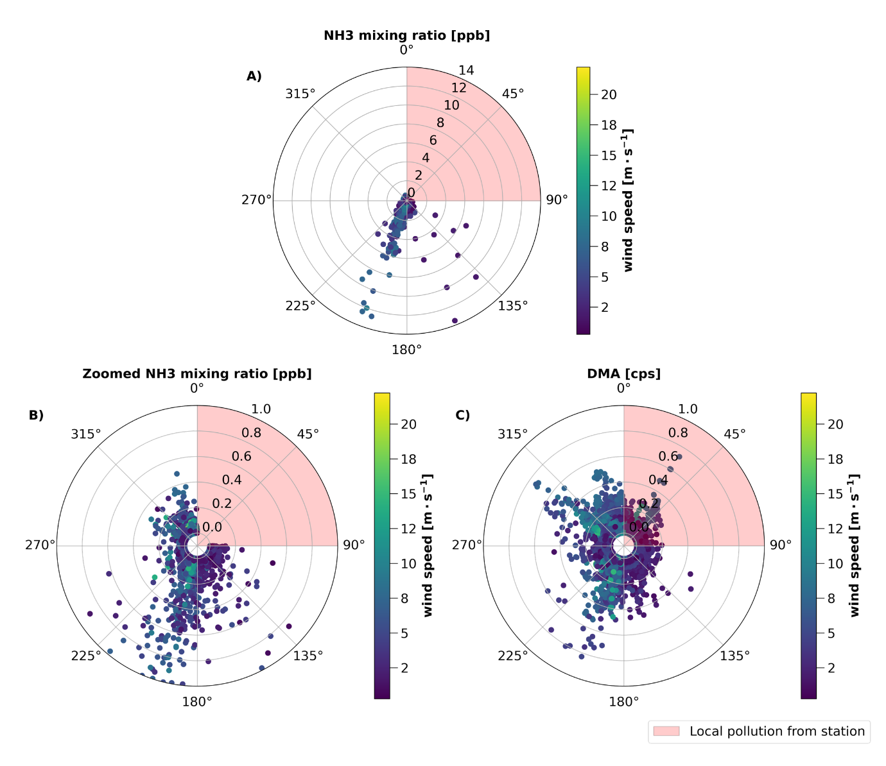
Figure S1. Sources of ammonia and DMA. A) A wind rose of ammonia (NH₃) mixing ratios between 0.01 – 14 ppb according to wind direction and wind speed. This wind rose features the same data as Figure 1 in the main text, however, the mixing ratio axis is not zoomed here to show the full extent of the NH₃ mixing ratios up to 14 ppb. B) A wind rose of NH₃, zoomed to show additional details in the lower range of NH₃ mixing ratios. This is the same figure as presented in Figure 1C. It is included here to provide for comparison purposes. C) A wind rose of dimethylamine (DMA) in ion counts per second (cps) from the ambient ion mode of the CIMS with the MION inlet.

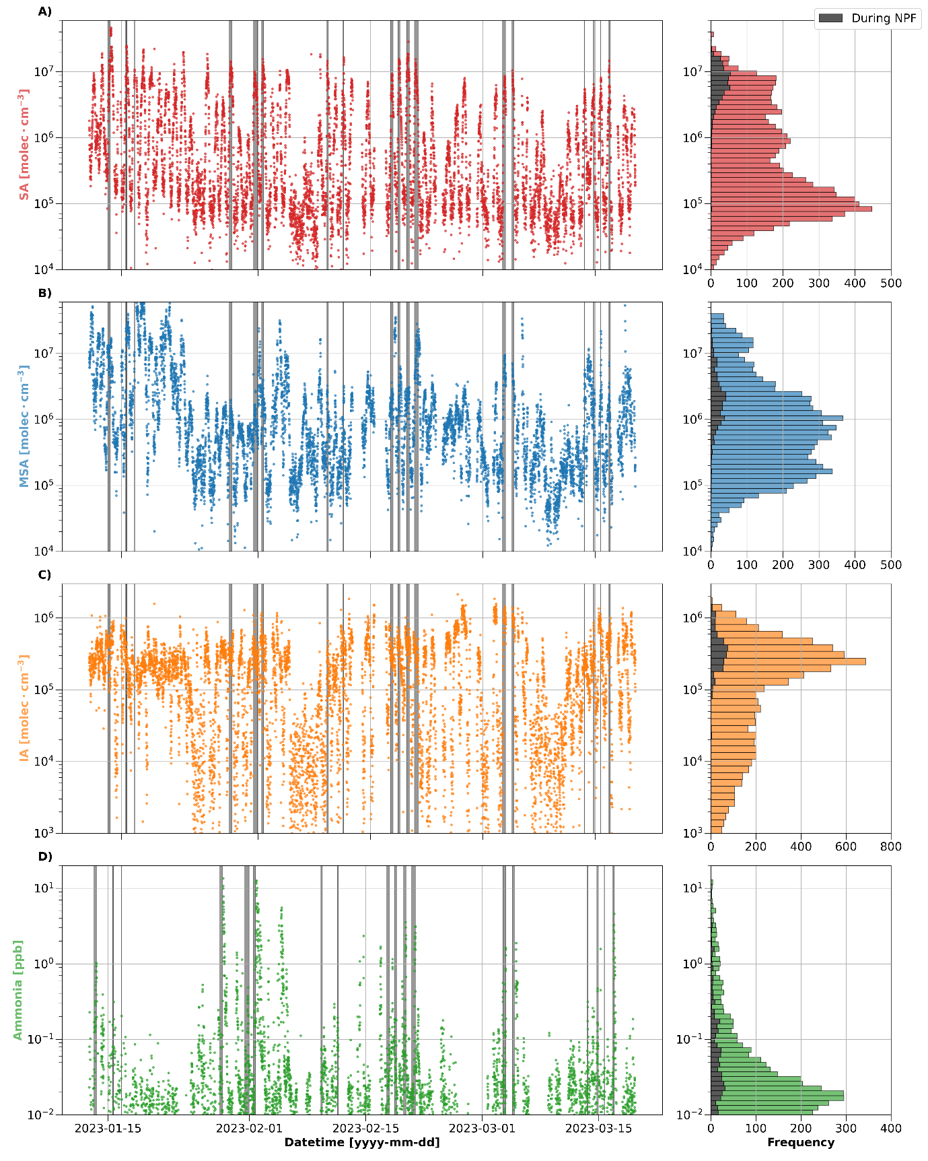
Figure S2. Description of aerosol precursor gas measurements during the campaign. Concentration timeseries at 10-minutes resolution and their corresponding frequency of occurrence are shown for A) sulfuric acid (SA), B) methanesulfonic acid (MSA), C) iodic acid (IA), and D) NH₃. The shaded gray regions on the timeseries plots indicate periods of NPF, and the shaded gray bars on the frequency plots show the concentrations observed during the NPF events.

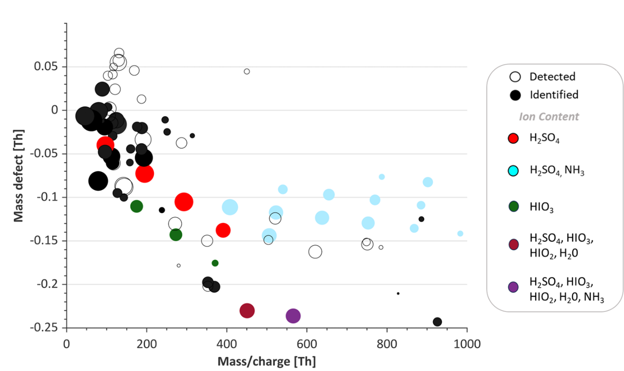

Figure S3. Mass defect plot with sulfuric acid and iodoxyacid clusters. The mass defect for ionic clusters observed during the NPF event observed on March 3, 2023 is shown. In addition to the clusters shown in Figure 3A in the main text, clusters containing sulfuric acid (H₂SO₄) and iodine oxoacids (HIO₃ and HIO₂)¹⁴, shown by the burgundy and purple circles, were observed during this event. Note that gas phase HIO₂ was not reported in our measurements due to concentrations below the detectable limit.

Case Study
Here we provide a further description of the case study on February 1, 2023, presented in Figure 4. At the beginning of the event, between 13:00 to 14:00, the prevailing wind direction was from ~330 degrees, or from the direction of the penguin/cormorant colonies on Cockburn Island, as shown in Figure 4A. Between 14:00 to 15:00, the wind direction changed to the direction of the other nearby penguin colony at ~200 degrees. The growing particle mode, shown by the merged particle number size distribution from the NAIS and DMPS data in Figure 4C, remained consistent before and after the wind changed direction, which suggests that this NPF event was occurring on a regional scale.
The event contributed considerably to particle number concentration above typical background concentrations. The reported particle number concentration, the red line in Figure 4C, shows the concentration of particles > 10 nm, as it was measured with a condensation particle counter with a cutoff diameter, or d50, of 10 nm. During this case study, particle number concentrations exceeded 16 000 #·cm⁻³ between 17:00 to 18:30, whereas the median background particle number concentration during the campaign was below 500 #·cm⁻³.
Approximately 6 hours after the start of the regional NPF event, we started measuring in-situ cloud/fog. The number size distribution of larger particles/droplets, as measured by the CDA and presented in Figure 4B, shows a distinct increase in concentration between 18:50 – 19:45. While the CDA is capable of measuring both particles and droplets in the micron size range, the distinct band in the size distribution during this period is due to the presence of fog, which is apparent in the time series of ambient temperature and dew point temperature shown in Figure 4A. We further observed a drop in the particle number (Figure 4C) and gas phase concentrations of all species (Figure 4D) that coincides with the period of fog. Since cloud/fog droplets act as an efficient sink for gases and particles, this result is expected.
We observed evidence suggesting that these newly formed particles contributed to CCN concentrations and cloud formation during the period of sampling in-situ cloud. First, the CCN number concentrations increased for all supersaturations during this period (Figure 4B). Note that the CCN counter was sampling downstream of the DMA in the DMPS, and therefore, the reported CCN concentrations represent the integrated, size-resolved CCN concentrations obtained during a single scan of the DMPS instead of the total ambient CCN number concentrations. We also observed changes in the size distribution of the DMPS while sampling in fog, as shown in Figure 4C. The number concentration of particles in the Aitken mode increased (> 40 nm), whereas the particle number concentration in the nucleation mode decreased. We expect that the increased Aitken mode particles during this period are cloud droplet residuals, or the particles that result from dried cloud droplets, that have grown larger in diameter via cloud processing by scavenging smaller particles, which is a process that has been demonstrated to yield rapid grown of Aitken mode particles ¹⁰. It is important to note that the DMPS sampled from a total inlet where cloud droplets could enter, and while the DMPS was not operated with a dedicated dryer, the temperature in the measurement container was maintained between 18 – 22 C, such that the aerosol sample was sufficiently dried (relative humidity < 30%) in the inlet prior to size selection in the DMA ¹¹. Moreover, the size range of these Aitken mode particles is consistent with observations of cloud droplet residuals measured using a counter-flow virtual impactor during in-situ cloud measurements in the Arctic ¹². The size of the growing nucleation mode particles suggests that supersaturations within the cloud/fog layer were sufficiently high to activate particles as small as ~30 nm, which also agrees with observations of newly formed particles in the central Arctic during late summer and autumn¹³.
The particle growth by cloud processing was sufficient to improve the detection of their chemical composition with the time-of-flight aerosol chemical speciation monitor (ToF-ACSM) while sampling in fog, as shown in Figure S3. In general, the background particle mass concentration of particles in the size range detectable by the ToF-ACSM (> ~40nm) was too low for consistent chemical composition measurements above the detection limit. During the case study, we observed that aerosol chemical composition was dominated by sulfate and ammonium, which further suggests a strong contribution from marine biogenic sulfur sources and NH₃ from penguins/seabirds. This agrees with the results presented in Asmi et al.¹¹ (2018), which show that there is consistently ammonium present in aerosol composition during summer at Marambio, especially the period between November to January, at high enough concentrations to neutralize particle acidity related to sulfuric acid composition.

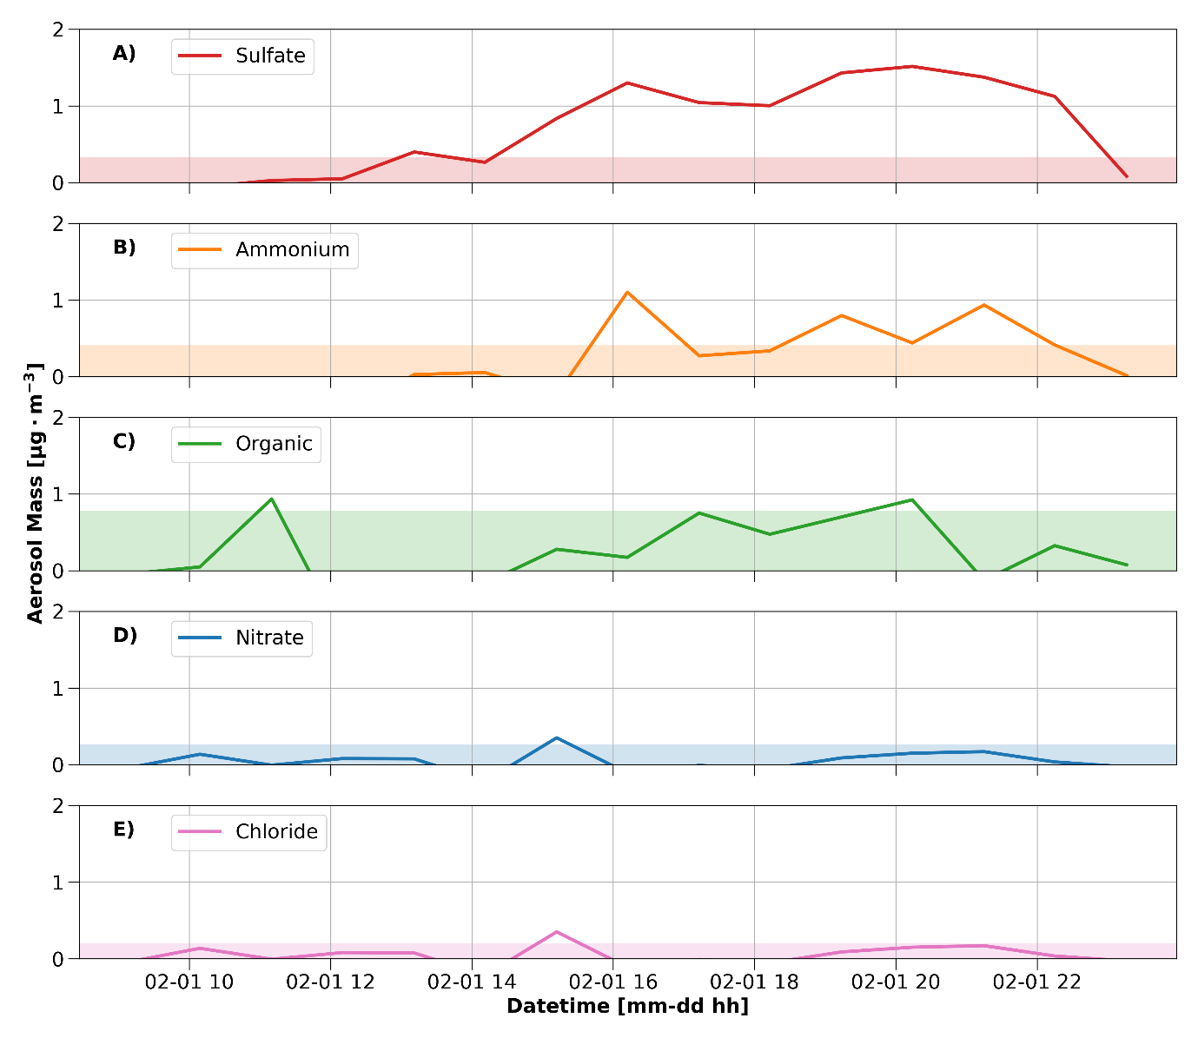
Figure S4. Aerosol mass concentrations during the case study. The mass concentrations of the A) sulfate (red line), B) ammonium (blue line), C) organics (green line), D) nitrate (orange line), and E) chloride (purple line) in the aerosol phase. The detection limits for each species are shown by the shaded region.

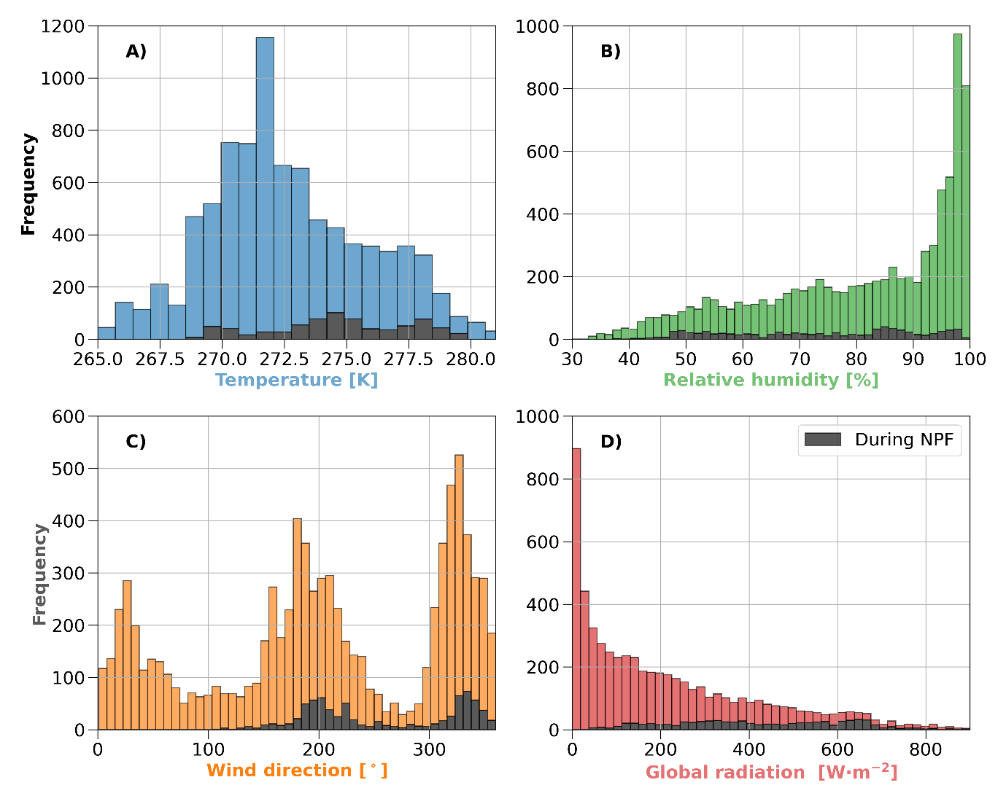
Figure S5. Frequency of meteorological observations during the campaign. The range of conditions and associated frequency of observations are shown for 10-minute averages of A) temperature, B) relative humidity, C) wind direction, and D) global radiation. The shaded gray bars on each plot show the conditions during which NPF were observed.
Ammonia measurements
Instrument overview
NH₃ mixing ratios were measured using a Quantum Cascade Tunable Infrared Laser Differential Absorption Spectrometer (QC-TILDAS, Aerodyne Research, Inc.). The NH₃ QC-TILDAS instrument has been previously described by others^{1,2}, however, since the NH₃ measurement is central to this study, especially at low mixing ratios, we will also include a description of its operating principles here.
A schematic diagram of the NH₃ QC-TILDAS is presented in Figure S6. The instrument uses a rapidly swept quantum cascade laser operating in the mid-infrared. Since every gas absorbs electromagnetic radiation at specific frequencies, a laser is selected to operate in a specific frequency where the target gas absorbs. For NH₃, the laser (SBCW17970, Alpes) emits radiation near the NH₃ absorption peak at 967.3 cm⁻¹. The laser temperature is carefully controlled using a Peltier element to ensure stable output. A laser driver then sweeps the laser current at 2000 hz to produce a series of narrow scans (~1 wavenumber) over the NH₃ absorption region. These scans permit the separation of absorption peaks from other gases that absorb light in the range of the given wavenumber scan. The laser output is then directed into an optical table that precisely guides the laser into a multi-pass absorption cell. A vacuum pump continually draws ambient air through the optical absorption cell at reduced pressure. Mirrors at both ends of the absorption cell reflect the laser light through the cell 238 times, resulting in an absorption path length of 76 m. Upon leaving the optical cell, the laser light is directed into a detector. The detector quantifies the attenuation of the laser light that occurs as the light passes through the optical cell during the wavenumber scan, which is due to the absorption by gas molecules present in the ambient sample air within the cell. The resulting absorption spectra are averaged to obtain either 10 hz or 1 second data, where in this study, we used 1 second data. The number of NH₃ molecules in the optical cell can then be determined according to Beer’s Law:
$$N=\frac{A}{αL}$$
where N is the number of NH₃ molecules, A is the measured absorption, α is the absorption coefficient for NH₃, and L is the optical path length. Using this technique, N is absolute and does not require a separate calibration for concentration retrieval.
There are other challenges for obtaining ambient concentrations that are inherent to all absorption spectrometers: 1) the laser output frequency naturally drifts, typically due to changes in temperature; 2) the laser optical output frequency and power typically is not flat across the scan; 3) there is stray laser light inside the sampling chamber that reaches the detector; and 4) there are optical interferences, called fringes, in the spectra. To relieve the first issue, we carefully control the laser temperature with a Peltier element and stabilized-temperature coolant flow through the laser mount using a thermo-electric recirculating chiller (Thermocube T-Three, Solid State Cooling Systems, Inc.). The chiller also provided coolant to housing of the optics box containing the laser, optical table, and absorption cell to minimize effects due to temperature changes. The coolant temperature was controlled by a software feedback loop between the instrument and the chiller. In addition, the NH₃ QC-TILDAS was placed inside of a housing made of insulating foam. The nonlinearity of the laser frequency across the scan is measured periodically with a germanium etalon. Effects of nonlinearity in the laser output power across the scan are minimized by performing regular “background” measurements, i.e., recording spectra without the presence of absorbing gases (zero-air). The ambient concentration is then determined by applying a quantitative fit to the ratio of the ambient air absorption spectra to background spectra. If interference fringes in the spectra do not drift too quickly, then their effects also can be reduced with background ratios. The background spectra are periodically measured in an automated measurement cycle to determine the baseline for the ambient absorption spectra and to minimize drift in the laser output. For our measurements, we performed a background spectra every 10 minutes.
Data acquisition was performed using the TDLWintel software³. The software controls the hardware components necessary for data collection and performs the spectral analysis to retrieve the mixing ratio of NH₃ from the absorption spectra. The software also controls the schedules for spectroscopic backgrounds, chiller control, and laser temperature control, which are necessary for zeroing the laser and minimizing instrumental drift. The analysis procedure uses the HITRAN database to perform a fitting routine based on the shape of the absorption spectra.
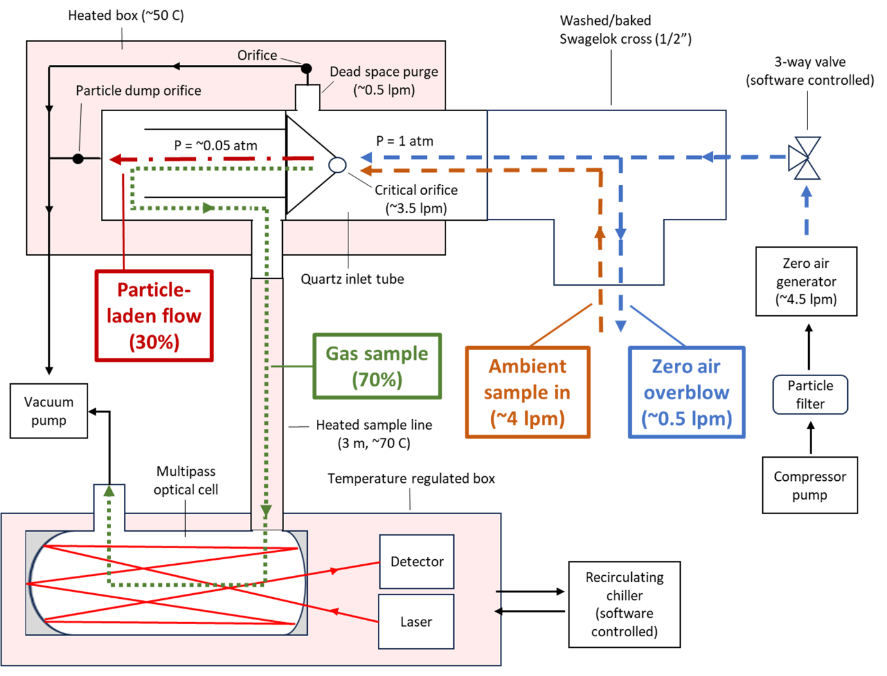
Figure S6. A schematic diagram of the NH₃ QC-TILDAS operated with an inertial inlet. Flow configurations in the inlet and their associated flow rates are shown for ambient sampling (orange dashed line) and zero-air delivery (blue dashed line). The separate paths of the particle-laden flow and the gas sample flow after the critical orifice are shown by the red dashed line and the green dotted line, respectively, with the percentage of each flow denoted. Arrows are included to highlight the flow directions. The red shaded regions indicate components with temperature control or heating. Note that the components are not drawn to scale for the purpose of highlighting key features. The details of the optical table are not included for simplicity, but can be found in McManus et al.⁴

Specialized inlet for sampling ammonia
NH₃, which is notoriously “sticky” on sampling surfaces, requires a specialized inlet for quantitative sampling, especially at very high measurement sensitivity. The inlet used in this study, called an “inertial inlet,” is essentially a virtual impactor in a heated box^{1,5}, and has been previously used for field measurements of NH₃^{2,6} or other “sticky” gases, such as hydrogen chloride⁷. During the campaign, the inertial inlet box temperature was set to 50 C, however, actual temperatures in the inertial inlet were observed to vary between 10 to 20 C due to the cold ambient conditions in Antarctica.
In additional to removing particles before sampling through the optical cell, a process which is necessary for all gas-phase absorption spectrometers, the inertial inlet provides additional features that improve NH₃ sampling, including 1) reducing the pressure of the sample by ~20 times near entrance of the inlet to improve NH₃ transmission; 2) heating the inlet to minimize surface interactions; and 3) providing a way to overblow the sampling inlet with zero-air to clean sampling surfaces prior to performing routine backgrounds of the absorption spectra. After the inertial inlet, the sample gas is directed to the optical cell using a heated sample tube, 3 m in length, heated to 70 C.
The cleanliness of the sampling surfaces impacts the measurement, where dirty sampling surfaces negatively impact the instrument response by increasing NH₃ uptake on surfaces. Over time, the inertial inlet can become dirty during ambient sampling due to accumulation of dust and particles, especially in the ambient pressure region of the quartz tube before the critical orifice. To improve throughput of NH₃ and decrease the memory effect, we cleaned the inlet sampling surfaces (Swagelok tee, quartz inertial inlet tube, and heated sample tube) with ethanol midway through the campaign.

Zero-air source for ammonia
A source of zero-air, or in this case, NH₃ free air, is necessary to obtain the background spectra used to quantify NH₃ mixing ratios. As mentioned, NH₃ mixing ratios are retrieved by comparing the absorption of light in ambient air to background spectra, where the background spectra are obtained at regular intervals while delivering zero-air to the instrument. It is therefore important to have a stable source of NH₃ free air.
A series of laboratory tests were performed prior to the campaign to characterize zero-air sources for NH₃, with a focus on obtaining a reliable zero source for field measurements at high sensitivity. We used liquid nitrogen (LN2) boiloff as a standard for spectroscopic backgrounds of the NH₃ absorption spectra. These spectroscopic backgrounds were compared to zero-air from a commercial zero-air generator (ZA-30, Tisch Environmental). Note that PFA was used for all tubing in contact with zero-air. These tests identified that the zero-air generator is a suitable source of NH₃ free air in our study.
Ambient conditions, including temperature, pressure, and relative humidity, can also affect the interactions with NH₃ on surfaces and impact instrumental backgrounds. As such, it is recommended to use zero-air that maintains a relative humidity that is matched with the ambient air¹. LN2 boil off, while NH₃ free, is very cold and dry, rendering it less suitable to background the spectra for ambient measurements. LN2 can provide a spectroscopic zero, but it may not be desirable for backgrounding the absorption spectra when considering surface effects at such low sensitivity for ambient NH₃ measurements. In contrast, the zero-air generator output is humidity-matched with the ambient air, and thus is more representative in terms of composition and surface interactions of ambient air, and thus, may be more viable as a zero-air source for ambient NH₃ measurements in our study.
Indeed, the conclusions of our zero-air tests are similar to previous studies. Pollack et al.⁶ tested various sources of NH₃ free air to background the spectra in a QC-TILDAS. They used dry ultra-high purity (UHP) air as a spectroscopic zero for NH₃ free air and found that a zero-air generator was also able provide suitable zero-air in comparison to the dry UHP air. They opted to use the dry UHP air for their zero NH₃ source due to the nature of their study, which was less focused on the lowest ranges of NH₃ mixing ratios (< 100 ppt) and was limited by other considerations associated with aircraft measurements⁶. Another study by Moravek et al.² used both a zero-air generator and dry UHP for NH₃ backgrounds in ambient measurements. They compared the instrument response to both zero-air sources and found that humidity of the zero-air source was an important consideration in the instrument’s time response to zero-air. The dry UHP air showed better time response due to less competition between NH₃ and water vapor on adsorption sites on sampling surfaces, whereas the zero-air generator exhibited a slower time response but was more robust against changes in ambient relative humidity².

Ammonia limit of detection
The limit of detection (LOD) of absorption spectrometer measurements are often reported as three times the standard deviation (STD) of the instrumental precision, where different LODs are determined according to integration time from the Allan-Werle variance calculated on measurement data. Averaging is desirable to improve the LOD, as 1 second noise is always greater compared to longer integration times. This is common in the literature^{7,8} and has been applied to previous NH₃ measurements using the QC-TILDAS^{1,6,9}.

Using this approach on our NH₃ data during the campaign, Allan-Werle variances⁸ were calculated using 1-hour long periods of NH₃ signal during the delivery of zero-air every night at 03:00 UTC (midnight local time). Additional backgrounds of the spectra were not performed during these hour-long periods to allow us to investigate the influence of drift on the reported NH₃ mixing ratios. Refer to Figure S7 for a representative example of the calculated Allan-Werle variance and the corresponding measurement data. From these nightly zero periods, we obtained an average noise, based on the STD from the calculated Allan-Werle variances, of 21.3 ppt, 7.2 ppt, and 4.0 ppt for 1, 10, and 100 second integration times, respectively. The integration time with the lowest noise, on average, was 97 seconds, corresponding to an average STD of 3.5 ppt. From this, we can report a LOD for NH₃ of 10.5 ppt when averaging the data over 97 seconds.

We can also report the noise level by considering the root mean square (RMS) directly from the NH₃ signal. For the 1 second data, the average RMS is ~25 ppt during the last 30 seconds of zero-air delivery before background spectra were recorded as part of the regular measurement cycle. The RMS is similar in magnitude to the 1-second noise obtained from the Allan-Werle variance plot.
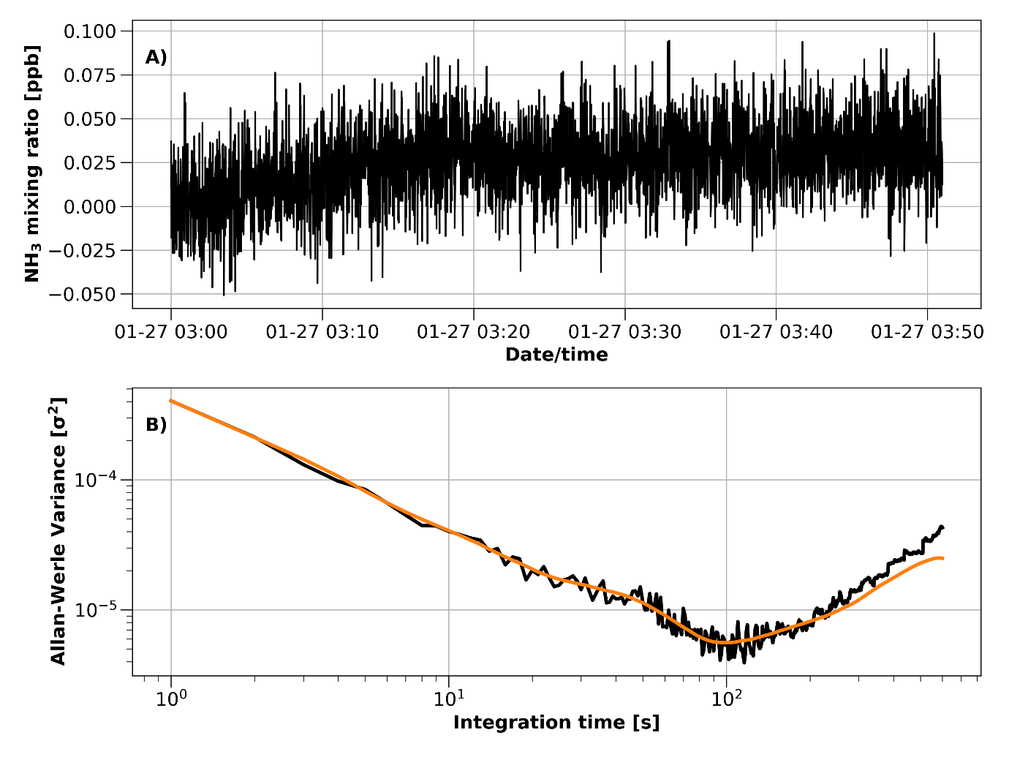
Figure S7. A representative example of the Allan-Werle variance for the NH₃ QC-TILDAS during the campaign. A) The NH₃ mixing ratio measured during 1-hour of zero-air delivery at 03:00 UTC on January 27, 2023. B) The Allan-Werle variance calculated from the measurement data in panel A). In this example, the integration time associated with the minimum Allan-Werle variance is 98 seconds, corresponding to an Allan-Werle variance of 5.6e⁻⁶ and a standard deviation of 2.3 ppt.

It is also important to consider the measurement accuracy of the reported NH₃ mixing ratios, which is affected by instrumental temperature drift and backgrounds performed with residual NH₃ in the spectra. To characterize these effects on the accuracy of our NH₃ measurements, without disentangling the two processes, we evaluated the variation in the reported NH₃ mixing ratio during the last 30 seconds of zero-air delivery before the background spectra were taken. The average NH₃ mixing ratio during these 30 second periods was 26.8 ppt (STD = 51.6 ppt). In this case, we can generally conclude that the accuracy of our reported NH₃ mixing ratios is ± 26.8 ppt, accounting for both instrumental temperature drift and residual NH₃ while performing spectral backgrounds.

The effect of residual NH₃ on the reported mixing ratios while performing spectral backgrounds is dependent on the magnitude of ambient NH₃ dose; higher ambient doses yield higher residual NH₃ in the backgrounds. This is expected, as higher doses of NH₃ lead to a higher degree of NH₃ contamination on sampling surfaces. Measurement accuracy is negatively affected by residual NH₃ in the background spectra after high ambient doses, as the residual NH₃ is then be subtracted from the subsequent ambient measurement data. To account for this, as part of the routine measurement cycle, we collected 40 seconds of NH₃ mixing ratios during zero-air delivery after performing a spectral background before switching to ambient sampling. We used the difference between the average NH₃ mixing ratios during the 30 seconds before and after the background spectra were collected (on zero-air) to determine an offset caused by residual NH₃ in the spectra while backgrounding. This offset was then added to the subsequent reported NH₃ mixing ratios during ambient sampling to correct for the NH₃ signal that was subtracted during the background. To avoid erroneously applying this correction to ambient NH₃ mixing ratios, we only applied the offset correction when the offset exceeded a threshold of 40 ppt. The threshold of 40 ppt was selected as it exceeds the sum of the instrumental LOD and accuracy associated with drift, as described above. Using this criteria, the offset correction was applied to 8% of the total data points, corresponding to an average ambient NH₃ dose of 520 ppt (STD = 1400 ppt) and an average offset of 109 ppt (STD = 94.6 ppt), where the magnitude of the offset increases with ambient NH₃ dose. After applying the offset to periods with high NH₃ doses, we report the NH₃ LOD to be 10.5 ppt ± 26.8 ppt. NH₃ mixing rations below the detection limit were not included in further analyses.

References
1. Ellis, R. A. et al. Characterizing a Quantum Cascade Tunable Infrared Laser Differential Absorption Spectrometer (QC-TILDAS) for measurements of atmospheric ammonia. Atmospheric Meas. Tech. 3, 397–406 (2010).
2. Moravek, A., Singh, S., Pattey, E., Pelletier, L. & Murphy, J. G. Measurements and quality control of ammonia eddy covariance fluxes: a new strategy for high-frequency attenuation correction. Atmospheric Meas. Tech. 12, 6059–6078 (2019).
3. Nelson, D. D., McManus, B., Urbanski, S., Herndon, S. & Zahniser, M. S. High precision measurements of atmospheric nitrous oxide and methane using thermoelectrically cooled mid-infrared quantum cascade lasers and detectors. Spectrochim. Acta. A. Mol. Biomol. Spectrosc. 60, 3325–3335 (2004).
4. McManus, J. B. et al. Pulsed quantum cascade laser instrument with compact design for rapid, high sensitivity measurements of trace gases in air. Appl. Phys. B 92, 387–392 (2008).
5. Roscioli, J. R., Zahniser, M. S., Nelson, D. D., Herndon, S. C. & Kolb, C. E. New Approaches to Measuring Sticky Molecules: Improvement of Instrumental Response Times Using Active Passivation. J. Phys. Chem. A 120, 1347–1357 (2016).
6. Pollack, I. B. et al. Evaluation of ambient ammonia measurements from a research aircraft using a closed-path QC-TILDAS operated with active continuous passivation. Atmospheric Meas. Tech. 12, 3717–3742 (2019).
7. Halfacre, J. W. et al. Using tunable infrared laser direct absorption spectroscopy for ambient hydrogen chloride detection: HCl-TILDAS. Atmospheric Meas. Tech. 16, 1407–1429 (2023).
8. Werle, P., Mücke, R. & Slemr, F. The limits of signal averaging in atmospheric trace-gas monitoring by tunable diode-laser absorption spectroscopy (TDLAS). Appl. Phys. B 57, 131–139 (1993).
9. Moravek, A. et al. Wintertime spatial distribution of ammonia and its emission sources in the Great Salt Lake region. Atmospheric Chem. Phys. 19, 15691–15709 (2019).
10. Kecorius, S. et al. Rapid growth of Aitken-mode particles during Arctic summer by fog chemical processing and its implication. PNAS Nexus 2, pgad124 (2023).
11. Asmi, E. et al. Primary sources control the variability of aerosol optical properties in the Antarctic Peninsula. Tellus B Chem. Phys. Meteorol. 70, 1414571 (2018).
12. Karlsson, L., Krejci, R., Koike, M., Ebell, K. & Zieger, P. A long-term study of cloud residuals from low-level Arctic clouds. Atmospheric Chem. Phys. 21, 8933–8959 (2021).
13. Baccarini, A. et al. Frequent new particle formation over the high Arctic pack ice by enhanced iodine emissions. Nat. Commun. 11, (2020).
14. He, X.-C. et al. Iodine oxoacids enhance nucleation of sulfuric acid particles in the atmosphere. Science 382, 1308–1314 (2023).

