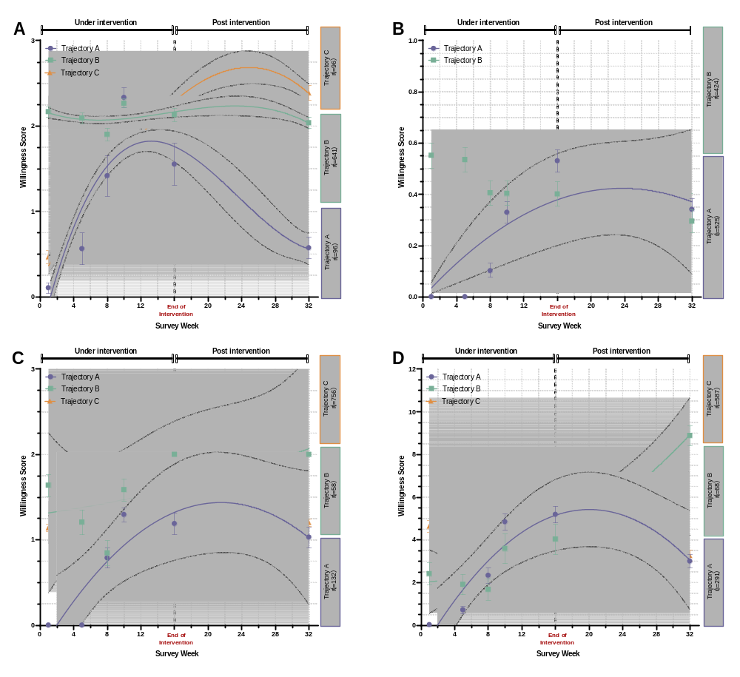
Supplemental Figure 1. Heterogeneity analysis of the multi-group trajectory model with four definitions of respiratory vaccination willingness.
(A) was defined as the number of respiratory vaccines that individuals were willing to receive, ranging from 0 to 3; (B) was defined as the willingness to receive all three respiratory vaccines, ranging from 0 to 1; (C) was defined as willingness to receive all, some, or none of the respiratory vaccines, ranging from 0 to 2; and (D) incorporated additional factors such as family and social support, ranging from 0 to 12. After comparing model fit results, A was selected as the optimal definition strategy for the final analysis.
Supplemental Table 1. The selection process of group trajectory models.
Category | Traj A | Traj B | Traj C | Traj D | Traj E | NBIC | BIC | AIC
1 | Linear | n/a | n/a | n/a | n/a | -9137.13 | -9134.79 | -9127.09
1 | Quadratic | n/a | n/a | n/a | n/a | -9094.24 | -9091.12 | -9080.85
2 | Linear | Linear | n/a | n/a | n/a | -9047.36 | -9042.66 | -9027.27
2 | Linear | Quadratic | n/a | n/a | n/a | -9019.44 | -9013.97 | -8996.01
2 | Quadratic | Linear | n/a | n/a | n/a | -8900.01 | -8894.53 | -8876.57
2 | Quadratic | Quadratic | n/a | n/a | n/a | -8893.08 | -8886.82 | -8866.29
3 | Linear | Linear | Linear | n/a | n/a | -9041.11 | -9034.07 | -9010.97
3 | Linear | Linear | Quadratic | n/a | n/a | -8905.77 | -8897.94 | -8872.29
3 | Linear | Quadratic | Linear | n/a | n/a | -9059.08 | -9051.26 | -9025.60
3 | Linear | Quadratic | Quadratic | n/a | n/a | -9017.52 | -9008.91 | -8980.69
3 | Quadratic | Linear | Linear | n/a | n/a | -8892.02 | -8884.20 | -8858.54
3 | Quadratic | Linear | Quadratic | n/a | n/a | -8895.35 | -8886.75 | -8858.52
3 | Quadratic | Quadratic | Linear | n/a | n/a | -8885.87 | -8877.26 | -8849.04
3 | Quadratic | Quadratic | Quadratic | n/a | n/a | -8896.54 | -8887.16 | -8856.37
4 | Linear | Linear | Linear | Linear | n/a | -9043.76 | -9034.37 | -9003.58
4 | Linear | Linear | Linear | Quadratic | n/a | -8897.96 | -8887.79 | -8854.43
4 | Linear | Linear | Quadratic | Linear | n/a | -8897.96 | -8887.79 | -8854.43
4 | Linear | Linear | Quadratic | Quadratic | n/a | -8920.11 | -8909.16 | -8873.24
4 | Linear | Quadratic | Linear | Linear | n/a | -9047.66 | -9037.49 | -9004.13
4 | Linear | Quadratic | Linear | Quadratic | n/a | -9030.07 | -9019.12 | -8983.19
4 | Linear | Quadratic | Quadratic | Linear | n/a | -9011.82 | -9000.87 | -8964.95
4 | Linear | Quadratic | Quadratic | Quadratic | n/a | -8894.74 | -8883.01 | -8844.52
4 | Quadratic | Linear | Linear | Linear | n/a | -8899.70 | -8889.53 | -8856.18
4 | Quadratic | Linear | Linear | Quadratic | n/a | -8896.55 | -8885.60 | -8849.67
4 | Quadratic | Linear | Quadratic | Linear | n/a | -8894.53 | -8883.58 | -8847.66
4 | Quadratic | Linear | Quadratic | Quadratic | n/a | -8899.49 | -8887.76 | -8849.27
4 | Quadratic | Quadratic | Linear | Linear | n/a | -8894.53 | -8883.58 | -8847.66
4 | Quadratic | Quadratic | Linear | Quadratic | n/a | -8899.49 | -8887.76 | -8849.27
4 | Quadratic | Quadratic | Quadratic | Linear | n/a | -8888.42 | -8876.68 | -8838.19
4 | Quadratic | Quadratic | Quadratic | Quadratic | n/a | -8891.72 | -8879.20 | -8838.15
5 | Linear | Linear | Linear | Linear | Linear | -9056.80 | -9045.07 | -9006.58
5 | Linear | Linear | Linear | Linear | Quadratic | -8906.08 | -8893.56 | -8852.51
5 | Linear | Linear | Linear | Quadratic | Linear | -8911.00 | -8898.48 | -8857.43
5 | Linear | Linear | Linear | Quadratic | Quadratic | -8904.64 | -8891.34 | -8847.72
5 | Linear | Linear | Quadratic | Linear | Linear | -8906.08 | -8893.56 | -8852.51
5 | Linear | Linear | Quadratic | Linear | Quadratic | -8915.19 | -8901.89 | -8858.27
5 | Linear | Linear | Quadratic | Quadratic | Linear | -8902.06 | -8888.76 | -8845.14
5 | Linear | Linear | Quadratic | Quadratic | Quadratic | -8906.08 | -8892.00 | -8845.81
5 | Linear | Quadratic | Linear | Linear | Linear | -8911.00 | -8898.48 | -8857.43
5 | Linear | Quadratic | Linear | Linear | Quadratic | -8915.99 | -8902.69 | -8859.08
5 | Linear | Quadratic | Linear | Quadratic | Linear | -8904.64 | -8891.34 | -8847.72
5 | Linear | Quadratic | Linear | Quadratic | Quadratic | -8906.16 | -8892.08 | -8845.89
5 | Linear | Quadratic | Quadratic | Linear | Linear | -8902.06 | -8888.76 | -8845.14
5 | Linear | Quadratic | Quadratic | Linear | Quadratic | -8906.16 | -8892.08 | -8845.89
5 | Linear | Quadratic | Quadratic | Quadratic | Linear | -8901.46 | -8887.38 | -8841.19
5 | Linear | Quadratic | Quadratic | Quadratic | Quadratic | -8902.83 | -8887.97 | -8839.22
5 | Quadratic | Linear | Linear | Linear | Linear | -8912.75 | -8900.23 | -8859.18
5 | Quadratic | Linear | Linear | Linear | Quadratic | -8910.23 | -8896.93 | -8853.31
5 | Quadratic | Linear | Linear | Quadratic | Linear | -8905.30 | -8892.00 | -8848.38
5 | Quadratic | Linear | Linear | Quadratic | Quadratic | -8912.54 | -8898.46 | -8852.27
5 | Quadratic | Linear | Quadratic | Linear | Linear | -8909.59 | -8896.29 | -8852.67
5 | Quadratic | Linear | Quadratic | Linear | Quadratic | -8893.79 | -8879.71 | -8833.52
5 | Quadratic | Linear | Quadratic | Quadratic | Linear | -8903.98 | -8889.90 | -8843.72
5 | Quadratic | Linear | Quadratic | Quadratic | Quadratic | -8897.00 | -8882.14 | -8833.39
5 | Quadratic | Quadratic | Linear | Linear | Linear | -8907.58 | -8894.28 | -8850.66
5 | Quadratic | Quadratic | Linear | Linear | Quadratic | -8911.68 | -8897.59 | -8851.41
5 | Quadratic | Quadratic | Linear | Quadratic | Linear | -8893.79 | -8879.71 | -8833.52
5 | Quadratic | Quadratic | Linear | Quadratic | Quadratic | -8906.96 | -8892.09 | -8843.34
5 | Quadratic | Quadratic | Quadratic | Linear | Linear | -8903.98 | -8889.90 | -8843.72
5 | Quadratic | Quadratic | Quadratic | Linear | Quadratic | -8900.34 | -8885.47 | -8836.72
5 | Quadratic | Quadratic | Quadratic | Quadratic | Linear | -8895.33 | -8880.47 | -8831.72
5 | Quadratic | Quadratic | Quadratic | Quadratic | Quadratic | -8898.12 | -8882.47 | -8831.15

