Supplementary material
Salinity-driven transmembrane transport of free nitrous acid to enhance inhibition on nitrite-oxidizing bacteria for robust nitritation
Xue-Er Lv¹, Rui Tang^{1,}*, Zi-Hang Ma¹, Rui-Xue Chen¹, Yu Wang¹, Ying An¹, Lu-Man Jiang¹, and Zhen Zhou^{1,}*
¹Shanghai Engineering Research Center of Energy - Saving in Heat Exchange Systems, College of Environmental and Chemical Engineering, Shanghai University of Electric Power, Shanghai 200090, China

*Corresponding author: Rui Tang and Zhen Zhou
E-mail: tangrui@shiep.edu.cn (R. Tang); zhouzhen@shiep.edu.cn (Z. Zhou)

SI-results and discussion
Fig. S1. Ammonium removal efficiency (ARE), and pH changes over a 65-day operation of (a) R_Blank (< 0.2 g Na⁺/L salinity and < 0.008 mg N/L FNA), (b) R_FNA (> 1 mg N/L FNA), (c) R_Salt (3.3 g Na⁺/L salinity), and (d) R_FNA&Salt (3.3 g Na⁺/L salinity and > 1 mg N/L FNA).
Fig. S2. Changes in biomass during the 65-day operation of R_Blank (< 0.2 g Na⁺/L salinity and < 0.008 mg N/L FNA), R_FNA (> 1 mg N/L FNA), R_Salt (3.3 g Na⁺/L salinity), and R_FNA&Salt (3.3 g Na⁺/L salinity and > 1 mg N/L FNA): (a) operational taxonomic units (OTUs) and (b) sludge concentrations. (MLNVSS: mixed liquor nonvolatile suspended solids; MLVSS: mixed liquor volatile suspended solids; R_Blank_n, R_FNA_n, R_Salt_n, and R_FNA&Salt_n indicate the sludge samples collected from the corresponding reactors on day n.).
Fig. S3. Redundancy analysis identified the correlation between functional microbes and environmental stress. (0, 30, and 65 in the legend indicate sludge samples collected on days 0, 30, and 65, respectively).
Fig. S4. Nitrogen loss in R_Blank (< 0.2 g Na⁺/L salinity and < 0.008 mg N/L FNA), R_FNA (> 1 mg N/L FNA), R_Salt (3.3 g Na⁺/L salinity), and R_FNA&Salt (3.3 g Na⁺/L salinity and > 1 mg N/L FNA) during days 60–65. The nitrogen loss was calculated based on the difference of total nitrogen concentrations in the influent and effluent.
Fig. S5. Scanning electron microscopy image of the seed sludge.
Fig. S6. Change in extracellular polymeric substances with operation time in R_Blank (< 0.2 g Na⁺/L salinity and < 0.008 mg N/L FNA), R_FNA (> 1 mg N/L FNA), R_Salt (3.3 g Na⁺/L salinity), and R_FNA&Salt (3.3 g Na⁺/L salinity and > 1 mg N/L FNA).
Fig. S7. Variations in FNA concentrations after 1-h exposure to the salinity gradients of 1.0, 3.3, and 6.0 g Na⁺/L: (a) Initial FNA level and (b) FNA loss.
Fig. S8. Electron paramagnetic resonance spectra for sludge solution at pH 6 and different salinities: (a) 1.0, (b) 3.3, and (c) 6.0 g Na⁺/L. (MLSS = 10 g/L, dissolved oxygen < 1.5 mg/L, temperature = 25.0 ± 2.0 ºC).

Fig. S9. Changes in (a) reactive oxygen species (ROS) level and (b) polyphosphate kinase (PPK) with response to different conditions: < 0.2 g Na⁺/L salinity and < 0.008 mg N/L FNA (R_Blank), > 1 mg N/L FNA (R_FNA), 3.3 g Na⁺/L salinity (R_Salt), and 3.3 g Na⁺/L salinity and > 1 mg N/L FNA (R_FNA&Salt).
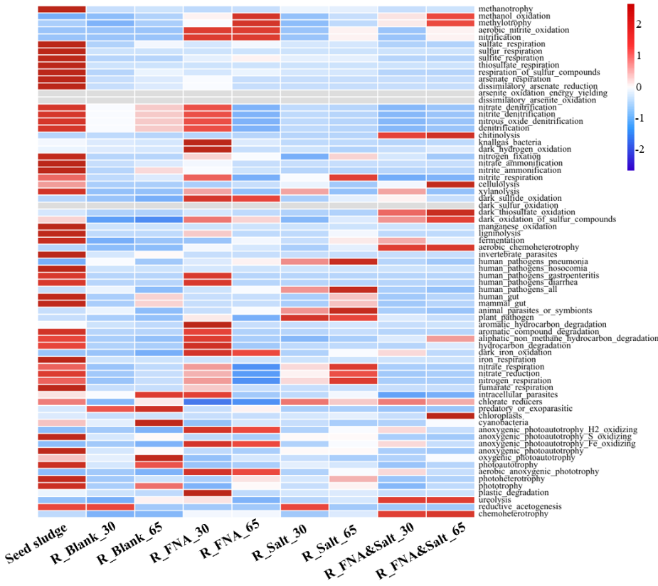
Fig. S10. Functional annotation of prokaryotic taxa based function prediction in four reactors: < 0.2 g Na⁺/L salinity and < 0.008 mg N/L FNA (R_Blank), > 1 mg N/L FNA (R_FNA), 3.3 g Na⁺/L salinity (R_Salt), and 3.3 g Na⁺/L salinity and > 1 mg N/L FNA (R_FNA&Salt).

Fig. S11. Schematic of mainstream nitrogen up-concentration coupled with side-stream nitritation-based nitrogen recovery process. (Two nitrogen recovery pathways were proposed with NaNO₂ and N₂O as the target product, respectively. This process was developed based on our previously proposed nitrate recovery process 1).

Table S1. Concentrations of NH₄⁺-N and salinity in typical wastewater
Wastewater type | NH₄⁺-N (mg/L) | Salinity (g/L) | References
Smelting wastewater | 1000–1400 | 4.7–8.6 (Na⁺) | Tsuneda et al.2
Smelting wastewater | 185 | 4.1 (Na⁺) | Meng et al.3
Landfill leachate | 300–8100 | 1.3–13.0 (Na⁺), 0.6–4.2 (K⁺), 2.4–23.0 (Ca²⁺) | Qian et al.4
Landfill leachate | 1975 | 9.4 (Na⁺) | Yang et al.5
Coke wastewater | 4150 ± 916 | 1.0 ± 0.4 (Na⁺) | Jesús et al.6
Fishery processing wastewater | 288 | 59.8 (Na⁺) | Corsino et al.7
Mustard tuber wastewater | 312 ± 32 | 9.8–19.6 (Na⁺) | Wang et al.8
Flue gas desulfurization wastewater | 231 | 1.0 (Na⁺), 4.9 (Mg²⁺), 0.8 (Ca²⁺) | Cheng et al.9
Flue gas desulfurization wastewater | 335 ± 11 | 7.9 (Na⁺), 8.0 (Mg²⁺), 2.0 (Ca²⁺) | Li et al.10
Concentrated municipal wastewater | 135–208 | 7.5 (Na⁺) | Qin et al.11
Concentrated municipal wastewater | 200–254 | 3.1 (Na⁺) | Zhao et al.12
Real municipal wastewater | 74–1757 | 3.9–11.8(Na⁺) | Malovanyy et al.13

Table S2. Summary of FNA-based NOB inhibition strategies
Strategy | HRTª  (h) | pH | FNA  (mg/L) | FA^{b}  (mg/L) | DO^{c} (mg/L) | Temp.^{d}  (℃) |  | References
FNA + Na⁺ | 24–36 | 6.7–7.5 | 0.11 | - | 1.5–2 |  | 22 ± 2 | Zhao et al.12
FNA + DO + Temp. | 23 | 7.4 ± 0.2 | 0.18 | - | 0.18 |  | 13 ± 0.5 | Zhang et al.14
FNA/FA + step seed | 24 | 5.5 | 1.6–8.9 | 214–312 | 1.0–1.5 |  | 22–30 | Duan et al.15
FNA/FA | 24 | 5.5–8.9 | 3.07 | 210 | 1.5–2 |  | 21 ± 1 | Duan et al.16
FNA | 24 | 4.35 | 2.3 ± 0.6 | - | 4 |  | 21 ± 1 | Xue et al.17
FNA | 36–72 | 5–6 | > 2 | - | > 4 |  | 22–25 | Li et al.18
FNA | 18.7 | 5.5 | 1.54 | - | > 5 |  | 22 ± 2 | Li et al.19
ªhydraulic retention time. ^{b}free ammonia. ^{c}dissolved oxygen. ^{d}temperature.

Table S3. Variations in microbial cell size under different conditions
Microbial shape | Sphere (μm) | Short rod (μm) |  | Long rod (μm)
Microbial shape | Diameter | Length | Diameter | Length | Diameter
Seed sludge | 0.31 ± 0.05 | 0.89 ± 0.18 | 0.33 ± 0.07 | 2.71 ± 0.44 | 0.22 ± 0.07
R_Blank (Day 10) | 0.79 ± 0.07 | - | - | - | -
R_ Blank (Day 50) | 0.62 ± 0.06 | - | - | - | -
R_FNA (Day 10) | 0.68 ± 0.08 | 1.06 ± 0.14 | 0.45 ± 0.01 | - | -
R_FNA (Day 50) | 0.62 ± 0.09 | 1.22 ± 0.07 | 0.30 ± 0.03 | - | -
R_ Salt (Day 10) | 1.02 ± 0.22 | 1.09 ± 0.09 | 0.55 ± 0.18 | - | -
R_ Salt (Day 50) | 0.19 ± 0.05 | 0.50 ± 0.06 | 0.24 ± 0.05 | - | -
R_FNA&Salt (Day 10) | 0.43 ± 0.09 | 0.52 ± 0.05 | 0.26 ± 0.04 | - | -
R_FNA&Salt (Day 50) | 0.32 ± 0.01 | 0.97 ± 0.17 | 0.25 ± 0.07 | - | -

SI-materials and methods
Operation design. Each laboratory-scale membrane bioreactor (MBR) used in this study contained two submerged membrane modules made of polyvinylidene difluoride (Fig. S12). The average pore size of membrane was 22 μm, providing a total effective surface area of 400 cm² for each membrane. To mitigate the membrane fouling, the membrane modules were operated in an intermittent mode, i.e., 2-min relaxation after every 10-min suction. The flux was regulated at 10.4 L/m²/h. Within each reactor, an immersion agitator was installed and operated at 80 rpm to maintain activated sludge in suspension. Transmembrane pressure (TMP) was monitored via a pressure gauge. Once TMP exceeds 35 kPa, a physical cleaning followed by chemical cleaning using 0.5% (v/v) NaClO and 2.5% citric acid solution will be carried out to restore the permeability of membranes.
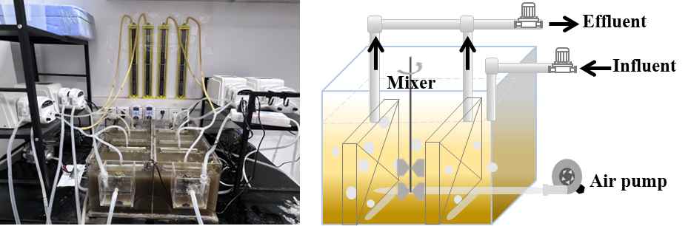
Fig. S12. Four MBRs used in this study and their schematic diagram.
Inoculums. Seeding sludge was collected from a local wastewater treatment plant (Shanghai, China) using an anaerobic/anoxic/oxic process. The influent wastewater characteristics were as follow: Chemical oxygen demand of 142.5 ± 22.3 mg/L, NH₄⁺-N of 25.60 ± 2.33 mg/L, total nitrogen of 29.48 ± 2.18 mg/L, and total phosphorus of 2.17 ± 0.23 mg/L. Prior to inoculation, the sludge was aerated for 24 h to remove residual biodegradable organic matter.

References
1. Qin, Y.; Wang, K.; Zhou, Z.; Yu, S.; Wang, L.; Xia, Q.; Zhao, X.; Zhou, C.; Ye, J.; Wu, Z. Nitrogen recovery from wastewater as nitrate by coupling mainstream ammonium separation with side stream cyclic up-concentration and targeted conversion. Chem. Eng. J. 2023, 455, 140337.
2. Tsuneda, S.; Ogiwara, M.; Ejiri, Y.; Hirata, A. High-rate nitrification using aerobic granular sludge. Water Sci. Technol. 2006, 53 (3), 147-154.
3. Meng, X.; Khoso, S. A.; Jiang, F.; Zhang, Y.; Yue, T.; Gao, J.; Lin, S.; Liu, R.; Gao, Z.; Chen, P.; Wang, L.; Han, H.; Tang, H.; Sun, W.; Hu, Y. Removal of chemical oxygen demand and ammonia nitrogen from lead smelting wastewater with high salts content using electrochemical oxidation combined with coagulation-flocculation treatment. Sep. Purif. Technol. 2020, 235, 116233.
4. Qian, Y.; Hu, P.; Lang-Yona, N.; Xu, M.; Guo, C.; Gu, J.-D. Global landfill leachate characteristics: Occurrences and abundances of environmental contaminants and the microbiome. J. Hazard. Mater. 2024, 461, 132446.
5. Yang, W.; Cheng, L.; Liang, H.; Xu, A.; Li, Y.; Nabi, M.; Wang, H.; Hu, J.; Gao, D. Efficient nitrogen removal from mature landfill leachate by single-stage partial-nitritation anammox using expanded granular sludge bed. J. Environ. Manage. 2023, 344, 118460.
6. Jesús, R.-I.; Laura, M.; Yolanda, F.-N.; Beatriz, S.-P. Removal of PAHs, TSS, oils and fats from ammonium-rich coke wastewater by granular filtration. J. Environ. Manage. 2024, 358, 120812.
7. Corsino, S. F.; Capodici, M.; Morici, C.; Torregrossa, M.; Viviani, G. Simultaneous nitritation-denitritation for the treatment of high-strength nitrogen in hypersaline wastewater by aerobic granular sludge. Water Res. 2016, 88, 329-336.
8. Wang, J. L.; Zhou, J.; Wang, Y. M.; Wen, Y. H.; He, L.; He, Q. Efficient nitrogen removal in a modified sequencing batch biofilm reactor treating hypersaline mustard tuber wastewater: The potential multiple pathways and key microorganisms. Water Res. 2020, 177, 115734.
9. Cheng, Q.; Wu, Y.; Huang, Y.; Li, F.; Liu, Z.; Nengzi, L.; Bao, L. An integrated process of calcium hydroxide precipitation and air stripping for pretreatment of flue gas desulfurization wastewater towards zero liquid discharge. J. Clean. Prod. 2021, 314, 128077.
10. Li, B.; Yun, Y.; Liu, G.; Li, C.; Li, X.; Hilal, M.; Yang, W.; Wang, M. Direct contact membrane distillation with softening pre-treatment for effective reclaiming flue gas desulfurization wastewater. Sep. Purif. Technol. 2021, 277, 119637.
11. Qin, Y.; Wang, K.; Xia, Q.; Yu, S.; Zhang, M.; An, Y.; Zhao, X.; Zhou, Z. Up-concentration of nitrogen from domestic wastewater: A sustainable strategy from removal to recovery. Chem. Eng. J. 2023, 451, 138789.
12. Zhao, Y.; Ab Hamid, N. H.; Reddy, N.; Zheng, M.; Yuan, Z.; Duan, H.; Ye, L. Wastewater primary treatment using forward osmosis introduces inhibition to achieve stable mainstream partial nitrification. Environ. Sci. Technol. 2022, 56 (12), 8663-8672.
13. Malovanyy, A.; Sakalova, H.; Yatchyshyn, Y.; Plaza, E.; Malovanyy, M. Concentration of ammonium from municipal wastewater using ion exchange process. Desalination. 2013, 329, 93-102.
14. Zhang, X.; Wu, P.; Ma, L.; Chen, J.; Wang, C.; Liu, W.; Xu, L. A novel simultaneous partial nitrification and denitratation (SPND) process in single micro-aerobic sequencing batch reactor for stable nitrite accumulation under ambient temperature. Chem. Eng. J. 2021, 425, 130646.
15. Duan, H.; Watts, S.; Zheng, M.; Wang, Z.; Zhao, J.; Li, H.; Liu, P.; Dwyer, J.; McPhee, P.; Rattier, M.; Larsen, E.; Yuan, Z.; Hu, S. Achieving robust mainstream nitrite shunt at pilot-scale with integrated sidestream sludge treatment and step-feed. Water Res. 2022, 223, 119034.
16. Duan, H.; Ye, L.; Wang, Q.; Zheng, M.; Lu, X.; Wang, Z.; Yuan, Z. Nitrite oxidizing bacteria (NOB) contained in influent deteriorate mainstream NOB suppression by sidestream inactivation. Water Res. 2019, 162, 331-338.
17. Xue, Y.; Zheng, M.; Cheng, Z.; Li, S.; Yang, S.; Liu, Y.; Qian, Y.; Huang, X. Dynamic simulation of nitrifying microbial communities for establishing acidic partial nitritation in suspended activated sludge. Environ. Sci. Technol. 2023, 57 (45), 17542-17552.
18. Li, J.; Xu, K.; Liu, T.; Bai, G.; Liu, Y.; Wang, C.; Zheng, M. Achieving stable partial nitritation in an acidic nitrifying bioreactor. Environ. Sci. Technol. 2020, 54 (1), 456-463.
19. Li, S.; Kang, X.; Zuo, Z.; Islam, M. S.; Yang, S.; Liu, Y.; Huang, X. Dynamic pH regulation drives Nitrosomonas for high-rate stable acidic partial nitritation. Water Res. 2024, 262, 122078.

