Online Supplemental Material

Contents
Supplementary Table S1. Prevalence and change in state-level growth indicators from 2006 to 2020 among children under 5 years of age incorporating sampling uncertainty (n=22 states) 2
Supplementary Table S2. Change in development indicators from 2006 to 2020 incorporating sampling uncertainty (n=22 states) 4
Supplementary Table S3. Relative change in social and economic indicators from 2006 to 2015 and 2015 to 2019 for 22 Indian states 6
Supplementary Note 1. Technical Note on state and district boundaries 7
Supplementary Note 2. Protocol for anthropometric assessment 8
Supplementary Fig 1. Flowchart of states and districts included in National Family Health Surveys (2005-2020) 9
Supplementary Fig 2. Scatterplot of annualized changes at state-level between 2006-15 and 2015-19 for child malnutrition (n = 19) 10
Supplementary Fig 3. Scatterplot of annualized changes at state-level between 2006-15 and 2015-19 for development indicators (n = 19) 11
Supplementary Fig 4. Distribution of annualized change of child malnutrition (n = 19) 12
Supplementary Fig 5. Distribution of annualized change for development indicators (n = 19) 13

Supplementary Table S1. Prevalence and change in state-level growth indicators from 2006 to 2020 among children under 5 years of age incorporating sampling uncertainty (n=22 states)
 | 2005*  % (95% CI) | 2015  % (95% CI) | 2019  % (SE) | Annualized change 2006-2015* % (95% CI) | Annualized change 2015-2019* % (95% CI) | Statistical difference between annualized change 2006-2015 and 2015-2019; p<.05 (incorporating sampling uncertainty) | Test for difference in annualized change based on state-level estimates (no sampling uncertainty)^  (n = 19)
All India
Stunting | 46.9  (45.6, 48.3) | 37.0  (36.5, 37.6) | 36.0 | -1.1  (-1.3, -0.9) | -0.3  (-0.5, -0.1) | YES | 178, p <0.01
Wasting | 18.9  (18.0, 19.8) | 21.2  (20.8, 21.7) | 21.7 | 0.3  (0.1, 0.4) | 0.1  (0.0, 0.3) | YES | 126, p = 0.23
Underweight | 41.4  (40.0, 42.8) | 35.1  (34.6, 35.6) | 34.3 | -0.7  (-0.9, -0.5) | -0.2  (-0.4, 0.0) | YES | 182, p <0.01
Overweight | 1.6  (1.3, 1.9) | 1.9  (1.7, 2.0) | 3.8 | 0.0  (-0.0, 0.1) | 0.5  (0.4, 0.5) | YES | 179, p <0.01
Rural
Stunting | 49.7  (48.1, 51.3) | 40.1  (39.5, 40.7) | 38.0 | -1.1  (-1.3, -0.9) | -0.5  (-0.7, -0.3) | YES | 169, p <0.01
Wasting | 20.2  (19.1, 21.3) | 21.5  (21.0, 22.0) | 22.0 | 0.1  (0.0, 0.3) | 0.1  (-0.0, 0.3) | NO | 135, p = 0.11
Underweight | 44.8  (43.2, 46.4) | 37.7  (37.1, 38.2) | 36.2 | -0.8  (-1.0, -0.6) | -0.4  (-0.6, -0.2) | YES | 182, p <0.01
Overweight | 1.1  (0.9, 1.4) | 1.7  (1.5, 1.8) | 3.4 | 0.1  (0.0, 0.1) | 0.4  (0.4, 0.5) | YES | 182, p <0.01
Urban
Stunting | 38.8  (36.5, 41.1) | 29.1  (27.9, 30.4) | 32.0 | -1.1  (-1.4, -0.8) | 0.7  (0.3, 1.1) | YES | 175, p <0.01
Wasting | 15.2  (14.0, 16.5) | 20.5  (19.5, 21.6) | 20.6 | 0.6  (0.4, 0.8) | 0.0  (-0.4, 0.4) | YES | 106, p = 0.68
Underweight | 31.5  (29.4, 33.6) | 28.4  (27.2, 29.7) | 30.1 | -0.3  (-0.6, -0.1) | 0.4  (0.0, 0.8) | YES | 150, p = 0.03
Overweight | 2.9  (2.3, 3.6) | 2.4  (2.0, 2.8) | 4.8 | -0.1  (-0.1, 0.0) | 0.6  (0.5, 0.7) | YES | 165, p <0.01
Data for 2006, 2015, and 2019 come from NFHS-3, NFHS-4, and NFHS-5 Phase 1, respectively. All data are restricted to states included in NFHS-5 Phase 1 for comparability. Child stunting was defined as height-for-age < -2SD, child wasting was defined as weight-for-height < -2SD, child underweight was defined as weight-for-age < -2SD, and child overweight was defined as weight-for-height > 2SD. * Annualized change is mean annual absolute change in prevalence for 22 states reported by NFHS surveys in percentage. 95% CIs were calculated under normal approximation for differences in proportions for NFHS-5 assuming similar standard errors as NFHS-4.
(%) per annum; ^ Paired Wilcoxon Signed-Rank test for 19 states which were available in NFHS-3. Additional details on geographical boundaries are presented in Supplementary Note 1; # POSHAN Abhiyaan target is estimated as prevalence in 2015 minus targeted annual reduction of 2% for stunting and underweight in children. We additionally used a target of 2 pp/y for wasting. 2005 estimates exclude the following areas: DDDN, LK, AN.

Supplementary Table S2. Change in development indicators from 2006 to 2020 incorporating sampling uncertainty (n=22 states)
 | 2006 | 2015 | 2019 | Annualized change 2006-2015* | Annualized change 2015-2019* | Statistical difference between annualized change 2006-2015 and 2015-2019; p<.05 (incorporating sampling uncertainty) | Test for difference in annualized change based on state-level estimates (no sampling uncertainty)^  (n = 19)
Women who are literate (%) | 59.6  (58.22-60.94) | 70.5  (70.08-70.87) | 75.0 | 1.2 (1.1, 1.4) | 1.1 (1.0, 1.3) | NO | 79, p = 0.54
Women with 10 or more years of schooling | 23.8  (22.65-25.00) | 36.3  (35.83-36.80) | 41.4 | 1.4 (1.3, 1.5) | 1.3 (1.1, 1.4) | NO | 23, p < 0.01
Women age 20-24 years unmarried before age 18 years (%)** | 56.0  (54.24-57.70) | 70.8  (70.14-71.54) | 72.1 | 1.6 (1.4, 1.9) | 0.3 (0.1, 0.6) | YES | 33, p = 0.01
Sex ratio at birth for children born in the last five years (females per 1,000 males) | 912.0  (882.16 – 942.65) | 921.5  (905.28-937.91) | 937.1 | 1.1 (-2.7, 4.8) | 3.9 (-1.8, 9.6) | NO | 115, p = 0.44
Population living in households that use an improved sanitation facility | 34.8  (33.09-36.46) | 52.7  (52.07-53.31) | 69.8 | 2.0 (1.8, 2.2) | 4.3 (4.1, 4.5) | YES | 162, p <0.01
Population living in households with an improved drinking-water source (%) | 89.5  (88.42-90.66) | 94.8  (94.6-95.09) | 94.4 | 0.6 (0.5, 0.7) | -0.1 (-0.2, 0.0) | YES | 55, p = 0.11
Population living in households with electricity | 71.1  (69.35-72.96) | 89.1  (88.75-89.40) | 97.7 | 2.0 (1.8, 2.2) | 2.2 (2.0, 2.3) | NO | 37, p = 0.02
Households using clean fuel for cooking (%) | 26.9  (25.09-28.68) | 43.4  (42.84-44.03) | 62.7 | 1.8 (1.6, 2.0) | 4.8 (4.6, 5.0) | YES | 185, p <0.01
Households with any usual member covered under a health insurance or financing scheme (%) | 5.8  (5.24-6.30) | 29.5  (29.10 – 30.00) | 33.3 | 2.6 (2.6, 2.7) | 0.9 (0.8, 1.1) | YES | 84, p = 0.68
Data for 2006, 2015, and 2019 come from NFHS-3, NFHS-4, and NFHS-5 Phase 1, respectively. All data are restricted to states included in NFHS-5 Phase 1 for comparability. * Annualized change is mean annual absolute change in prevalence; ^ Paired Wilcoxon Signed-Rank test for all states available in NFHS-3; Additional details on geographical boundaries are available in Supplementary Note 1.
**reverse coded relative to the survey indicator for the analysis

Supplementary Table S3. Relative change in social and economic indicators from 2006 to 2015 and 2015 to 2019 for 22 Indian states
 | Change 2006 | Change 2015
Women who are literate  (%) | 0.02 | 0.02
Women with 10 or more years of schooling | 0.09 | 0.03
Women age 20-24 years unmarried before age 18 years  (%) | 0.03 | 0.01
Sex ratio at birth for children born in the last five years (females per 1,000 males) | 0.00 | 0.00
Population living in households that use an improved sanitation facility | 0.05 | 0.07
Population living in households with an improved drinking-water source (%) | 0.00 | 0.02
Population living in households with electricity | 0.03 | 0.02
Households using clean fuel for cooking  (%) | 0.06 | 0.09
Households with any usual member covered under a health insurance or financing scheme  (%)⁴ | 0.18 | 0.04

Rate of change (r) is measured as ln(y_{final}) – ln(y_{initial}) = r*[t_{final} – t_{initial}]

Supplementary Note 1. Technical Note on state and district boundaries
Jammu & Kashmir and Ladakh: In October 2019, a former state Jammu & Kashmir
(J&K) was separated into a union territory of the same name and Ladakh (comprising of two districts – Leh and Kargil). NFHS-5 reports estimates for J&K and Ladakh separately. For our state-level analysis using NFHS-4 data, we create survey-weighted estimates separately for Jammu & Kashmir and Ladakh.
Daman & Diu and Dadra & Nagar Haveli: Two union territories Daman & Diu and Dadra & Nagar Haveli which were previously separate have now been combined, and are reported as such. NFHS-5 reports a combined estimate for Daman & Diu and Dadra & Nagar Haveli. We create combined NFHS-4 estimates for Daman & Diu and Dadra & Nagar Haveli using survey weights provided.
Andhra Pradesh and Telangana: The state of Telangana was formed from Andhra Pradesh in June 2014. We use estimates for Andhra Pradesh in NFHS-3 for both states to calculate annualized changes.
Districts from existing districts: Of the 341 districts reporting aggregate data in NFHS-5, 73 were formed from 36 districts by splitting or joining their administrative boundaries. We calculated an unweighted average of NFHS-5 indicators for districts which were formed after NFHS-4 as per their NFHS-4 boundaries.

Supplementary Note 2. Protocol for anthropometric assessment
Anthropometric and biochemical indicators are measured for children under 6 years (0-71 months) residing within the sampled households after informed consent is obtained for different tests separately. SECA 874 U digital scale is used for weighing children. SECA 417 Infantometer is used for measuring length of children under 2 years or less than 85 cm. SECA 213 Stadiometer is used for measuring height. Detailed information on procedure used for anthropometric and biochemical measurement is available for NFHS-4 (1). Information on quality assurance mechanisms adopted is available for NFHS-5 (2).
References:
1. Clinical Anthropometric Biochemical (CAB) Manual. Mumbai: International Institute for Population Sciences; 2014 December 2014. URL: rchiips.org/NFHS/NFHS4/manual/NFHS-4 Biomarker Field Manual.pdf
2. Administrative Procedures in Survey Implementation and Protocols to Ensure Data Quality. 2018. URL: http://rchiips.org/nfhs/NFHS-5sub_presentation.shtml.

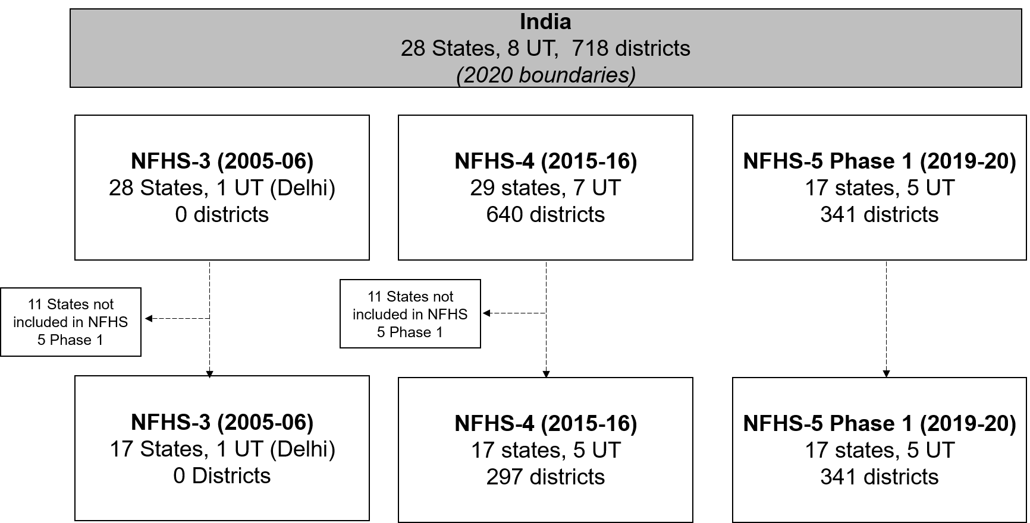
Supplementary Fig 1. Flowchart of states and districts included in National Family Health Surveys (2005-2020)

UT – Union territories are federal territories governed by the Central Government of India based in New Delhi. The list of UTs in 2020 are Andaman & Nicobar Islands, Chandigarh, Dadra & Nagar Haveli and Daman & Diu, Delhi (National Capital Territory), Jammu & Kashmir, Lakshadweep, Ladakh, Puducherry. Additional information on how geographical boundaries changed from 2005 to 2020 are provided in Supplementary Note 1.

Supplementary Fig 2. Scatterplot of annualized changes at state-level between 2006-15 and 2015-19 for child malnutrition (n = 19)
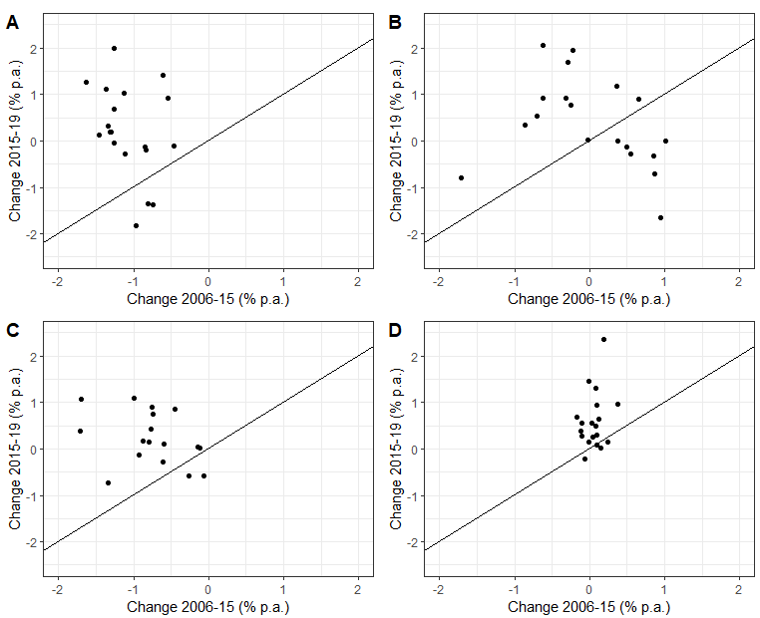
pp: percentage points per annum; A: Stunting; B: Wasting; C: Underweight; D: Overweight

Supplementary Fig 3. Scatterplot of annualized changes at state-level between 2006-15 and 2015-19 for development indicators (n = 19)
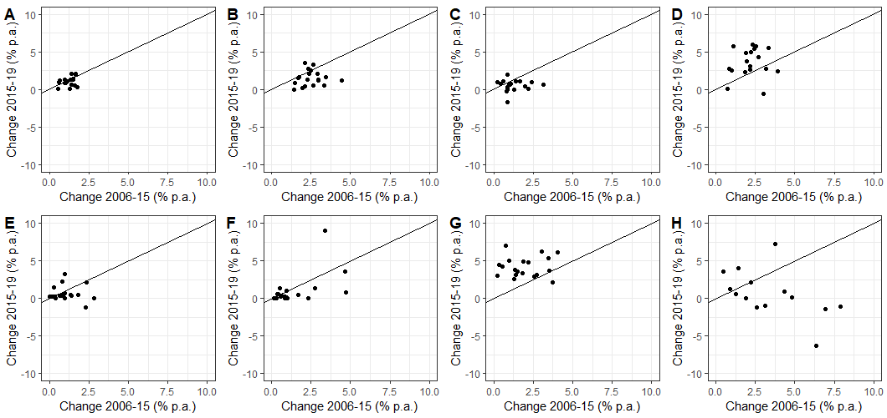
%p.a., annualized percent change (percentage points per annum)
A: Women who are literate (%); B: Women with 10 or more years of schooling; C: Women age 20-24 years unmarried before age 18 years (%); D: Population living in households that use an improved sanitation facility; E: Population living in households with an improved drinking-water source (%); F: Population living in households with electricity; G: Households using clean fuel for cooking (%); H: Households with any usual member covered under a health insurance or financing scheme (%)

Supplementary Fig 4. Distribution of annualized change of child malnutrition (n = 19)
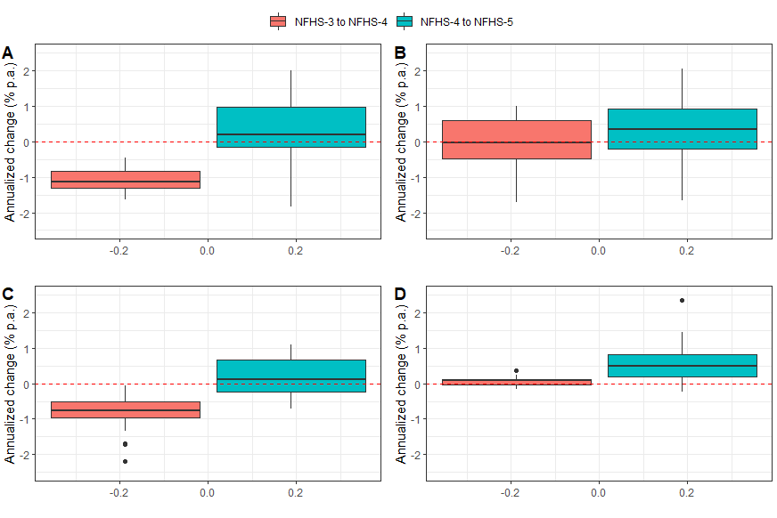
pp: percentage points per annum; A: Stunting; B: Wasting; C: Underweight; D: Overweight

Supplementary Fig 5. Distribution of annualized change for development indicators (n = 19)
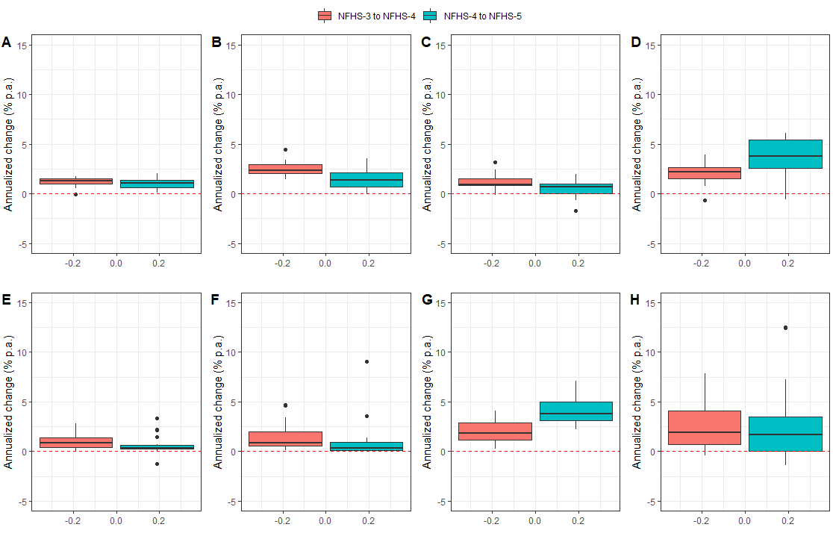
pp: percentage points per annum; A: Stunting; B: Wasting; C: Underweight; D: Overweight
A: Women who are literate (%); B: Women with 10 or more years of schooling; C: Women age 20-24 years unmarried before age 18 years (%); D: Population living in households that use an improved sanitation facility; E: Population living in households with an improved drinking-water source (%); F: Population living in households with electricity; G: Households using clean fuel for cooking (%); H: Households with any usual member covered under a health insurance or financing scheme (%)

