Supplementary Methods
This section covers details of additional methods used in the study.
PathOS annotates variants from sequencing pipelines and presents them within a web application for pathogenic classification prior to its generation of a clinical report. For this study we only consider SNVs and short indels. Although PathOS contains copy number variant data derived from off target alignments³⁹, this has only been captured across a subset of the cohort so not included for analysis. To identify relevant variants from the patient samples, sequenced samples are aligned to the GRCh37 reference genome and variants called using GATK best practice pipelines combined with in-house variant calling software^{40,41}. The called variants are normalised and 3’ shifted using custom software⁸ and Mutalyzer⁴² and annotated using Variant Effect Predictor⁴³ and other sources to enrich annotation for variant curation and pathogenicity classification. A single curated Refseq transcript is selected as representative of the variant locus and used as a basis for consistent calling of variants within gene coding regions. All sequenced samples are quality assessed using FastQC⁴⁴ and variants are filtered for common sequencing artefacts. Curated variants are classified according to ACMG or AMP guidelines for pathogenicity by experienced molecular post docs with specialisation in cancer biology using laboratory SOPs adhering to accredited standards including ISO15189.
Of the variants analysed, curated and stored in PathOS, 69.1% (n=23,255) were clinically reported (see Figure 4). The burden of curation remains as high for the non-reported variants (typically VUS, likely benign and benign) to ensure that they are not false negatives for diagnostic reporting.
In this analysis, the PathOS variant data were compared against four publicly available variant databases COSMIC, ClinVar, GA4GH beacons and VICC. Variants in normalised HGVSg nomenclature were compared to those present within VICC knowledgebase, queried on 1st September 2019²⁹. ClinVar variants were downloaded on 6th September 2019 and matched on HGVSg. COSMIC¹³ variants were downloaded on 11th July 2019 and matched based on HGVSp position and reference allele, not the alternate allele to maximise matching. The Beacon network¹⁷ was also queried for presence of PathOS reported variants via the web service on 1st October 2019 using HGVSg position. If a variant was identified from ClinVar/COSMIC/VICC/Beacons, but not identified through matching the data downloads from the individual resources, the matching variants were consolidated. Beacons serving computationally derived datasets such as CADD⁴⁵, or aggregators of computationally derived datasets (i.e. dbNSFP⁴⁶) were filtered out as they over estimate presence of the variant without the ability to assess its validity. A subset from PathOS variants with no matches in the previously described public resources were submitted to a well-known commercial tertiary analysis platform to assess the value such resources can provide in variant annotation and pathogenic assessment.
Amplicon based assays (n=36) were used throughout the study period and genomic coverage for these assays ranged from 21.9 kilobases (Kb) through to 158.2Kb. Hybrid capture assays (n=8) with larger genomic coverage (421.8Kb – 2,994Kb) from 90-701 genes (see Table 1, Figure S9) are replacing the amplicon assays over time. When creating Table 1, duplicate patient samples (n=80) occurring in multiple analysis groups and assays were excluded from the patient and average counts, to prevent biasing the analysis.
Data analysis and linear modelling were conducted using R 3.5.1. MannKendall tests were conducted using the R package Kendall. Beta coefficients between models were compared by computing a Z-score to test for equality and rejecting at 5% level of significance if there was a difference in the coefficients. To forecast the number of curations per sample per month the Holt-Winters exponential smoothing with trend and without seasonal component was applied¹⁰ using the HoltWinters function in R stats package¹⁰. A two-sample test of equality of proportions with continuity correction was applied to compare percentages using the R function prop.test¹¹. Analysis of variance between groups was conducted using R stats package. Comparisons between mean values were performed with a two-tailed Student’s t-test. A P value of less than 0.05 was considered statistically significant.

Supplemental Figures

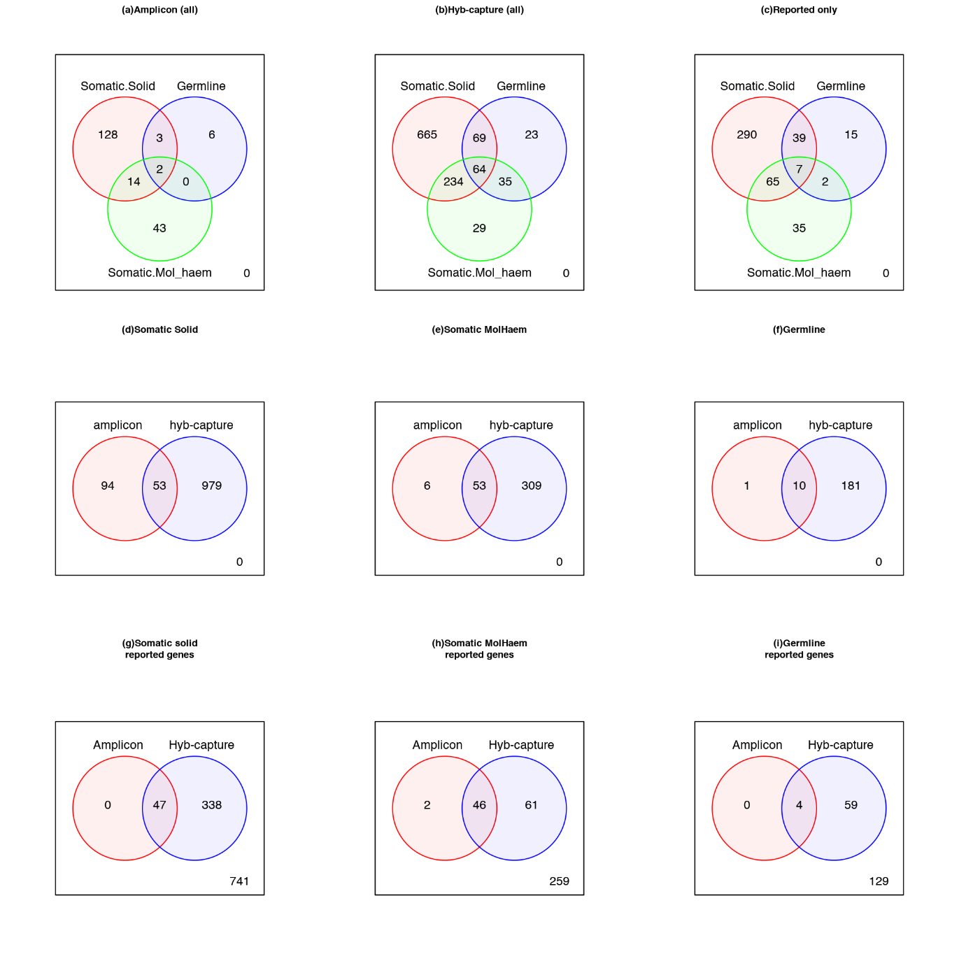Figure S1: Breakdown of numbers of genes in common across each analysis group and assay. (a) all genes surveyed in amplicon assays, (b) all genes surveyed in hyb-capture
assays, (c) genes containing clinically reported variants only across all assays. (d-f) Displays the genes in common between assays (amplicon and hyb-capture) by analysis type. (g-i) Displays the genes containing reported variants in common between assays by analysis types.

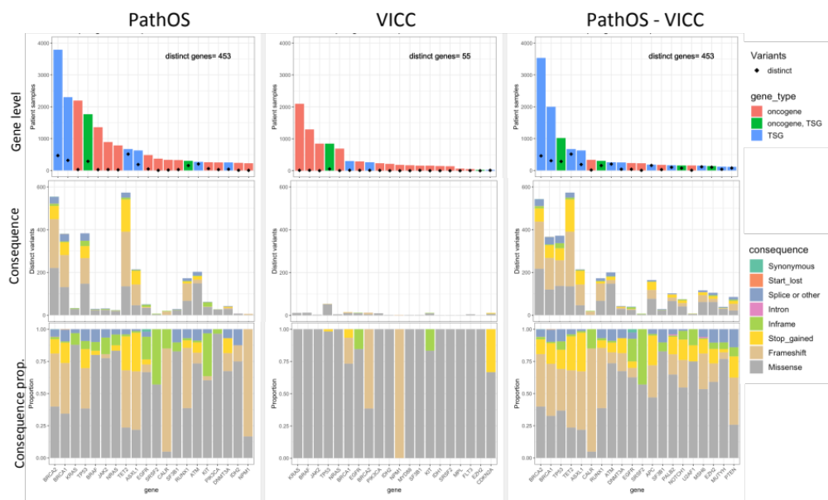
Figure S2: A gene level comparison of consequence between PathOS and VICC. The first column shows the top 20 genes in PathOS. The top row shows the genes coloured by ONC/TSG classification and the black diamond shows the number of distinct variants seen for each gene. The oncogenes have few distinct variants while TSGs and ONC/TSGs have many variants occurring in the gene. This highlights the focal nature of oncogene mutations. The third column shows varinats seen in PathOS after removing corresponding VICC variants showing that common oncogenes appear in VICC but far fewer TSGs and ONC/TSGs.

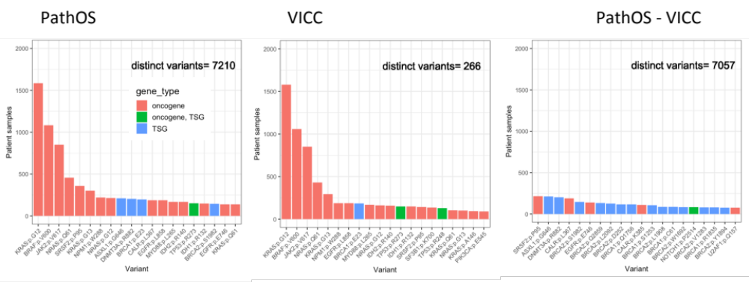
Figure S3: These graphs show compare the top 20 variant loci between PathOS and VICC. The third graph shows the top 20 variant loci in PathOS after removing matching VICC variants. The predominance of TSG genes becomes apparent.

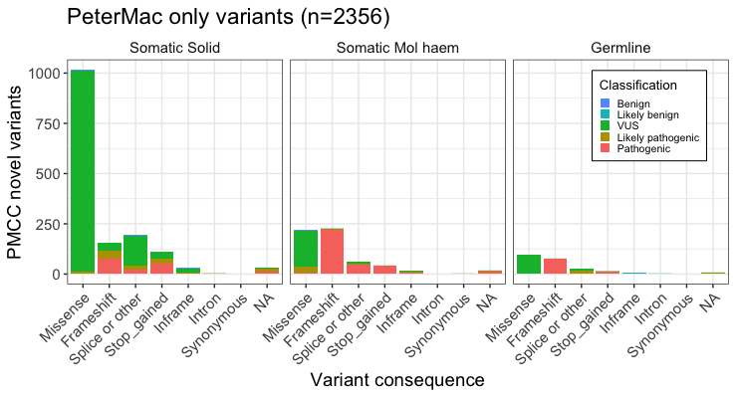
Figure S4: Breakdown of novel variants not matching public cancer variant annotation resources by analysis type (n=2,356). Each variant is classified by functional consequence and coloured by pathogenicity level. Note the high number of somatic, missense, VUS variants.

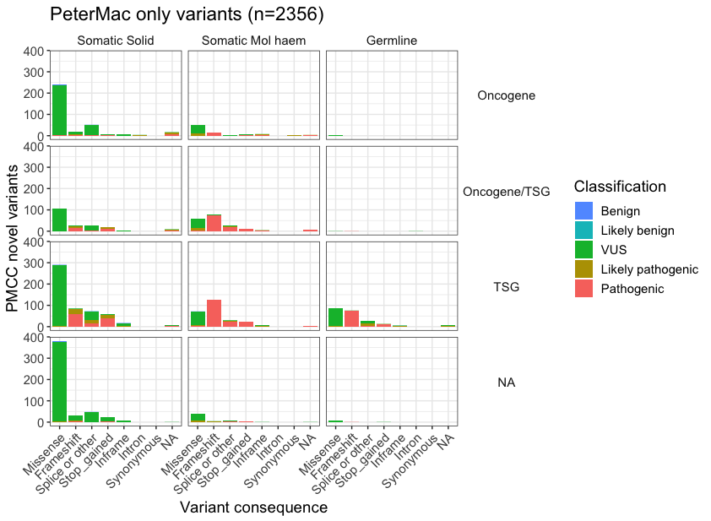
Figure S5: Breakdown of PathOS only variants not matching public cancer variant annotation resources by analysis type (somatic, haematological and germline) (n=2,356). Each variant is classified by functional consequence and coloured by pathogenicity level and separated based on classification of oncogene or TSG.

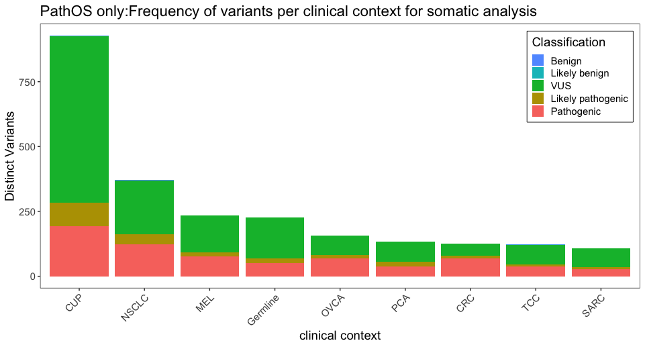
Figure S6: Barplot of somatic solid variants curated by clinical contexts with > 100 variants. CUP=cancer of unknown primary, NSCLC=non-small cell lung cancer, MEL=melanoma, OVCA=ovarian cancer, PCA=prostate cancer, CRC=colorectal cancer, TCC= urothelial carcinoma, SARC=sarcoma.

Figure S7 Comparison of patient counts by gene of reported variants between in-house database (PathOS), COSMIC and ICGC for the patient clinical contexts of melanoma, colorectal and haematological malignancies.

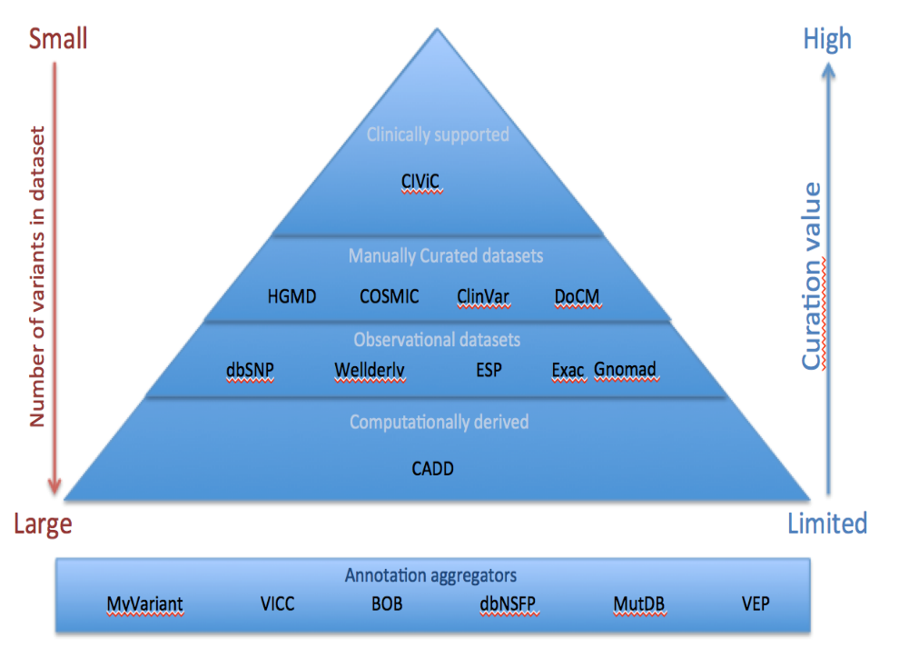
Figure S8: Variant interpretation resources are not all considered equal from a somatic variant curation perspective. Resources with higher curation offer more value than observational or computationally derived resources.

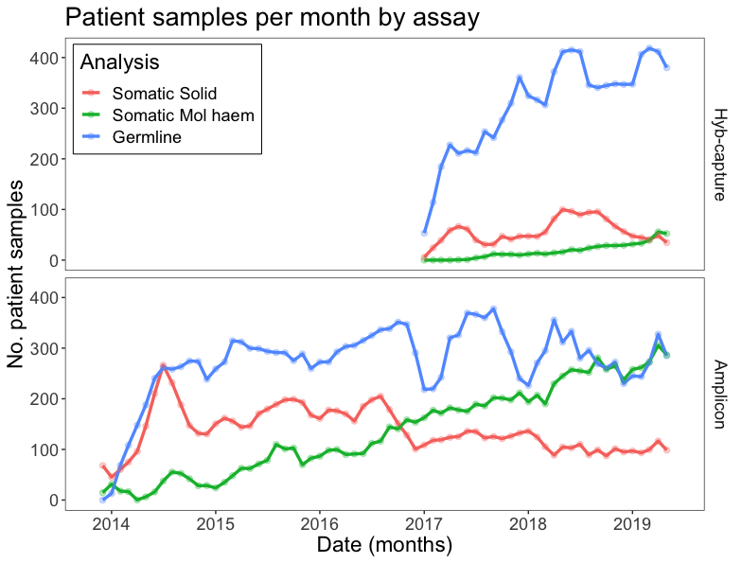
Figure S9: Patient samples analysed per month. A large increase in germline analysis can be observed when hyb-capture assays were implemented in 2017. There is also a steady increase over time in somatic molecular haematology (Mol_haem) samples across both assays. The number of somatic solid samples has remained relatively consistent since 2014 but an increasing number of samples were analysed with hyb-capture assays since 2017. Plotted values are calculated using a three-month rolling average.

Supplemental Tables

Supplementary file: Panel_summary.xlsx
Table S1: Excel worksheet of samples, variants, coverage per panel

Table S2: 24 variants with discordant pathogenicity classifications between CTAP and PathOS

HGVSg | gene | gene_type | consequence | type | CTAP  class | PathOS  class | Analysis Group
chr1:g.45799193dup | MUTYH | TSG | non_synonymous | insertion | VUS | Pathogenic | germline
chr11:g.64577385_64577388dup | MEN1 | TSG | non_synonymous | insertion | VUS | Pathogenic | germline
chr9:g.139391641G>A | NOTCH1 | oncogene, TSG | non_synonymous_nonsense | substitution | VUS | Pathogenic | haem
chr11:g.32413612T>C | WT1 | oncogene, TSG | non_synonymous_splice_site | substitution | VUS | Pathogenic | haem
chr11:g.102207666A>T | BIRC3 | oncogene, TSG | non_synonymous_nonsense | substitution | VUS | Pathogenic | haem
chr19:g.1612366A>T | TCF3 | oncogene, TSG | non_synonymous | substitution | VUS | Pathogenic | haem
chrX:g.133549151G>A | PHF6 | TSG | non_synonymous | substitution | VUS | Pathogenic | haem
chr2:g.136872523dup | CXCR4 | oncogene | non_synonymous | insertion | VUS | Pathogenic | haem
chr1:g.36932112delinsTC | CSF3R | oncogene | non_synonymous | insertion | VUS | Pathogenic | haem
chr4:g.106156113dup | TET2 | TSG | non_synonymous | insertion | VUS | Pathogenic | haem
chr4:g.106190901dup | TET2 | TSG | non_synonymous | insertion | VUS | Pathogenic | haem
chr11:g.32414215dup | WT1 | oncogene, TSG | non_synonymous | insertion | VUS | Pathogenic | haem
chr21:g.36164859dup | RUNX1 | oncogene, TSG | non_synonymous | insertion | VUS | Pathogenic | haem
chr21:g.36171755dup | RUNX1 | oncogene, TSG | non_synonymous | insertion | VUS | Pathogenic | haem
chr21:g.36259204_36259207dup | RUNX1 | oncogene, TSG | non_synonymous | insertion | VUS | Pathogenic | haem
chr1:g.23885707G>A | ID3 | TSG | non_synonymous_nonsense | substitution | VUS | Pathogenic | somatic
chr2:g.141250184A>C | LRP1B | TSG | non_synonymous_nonsense | substitution | VUS | Pathogenic | somatic
chr3:g.47125785G>A | SETD2 | TSG | non_synonymous_nonsense | substitution | VUS | Pathogenic | somatic
chr3:g.47164686G>C | SETD2 | TSG | non_synonymous_nonsense | substitution | VUS | Pathogenic | somatic
chr4:g.55144101G>T | PDGFRA | oncogene | non_synonymous_nonsense | substitution | VUS | Pathogenic | somatic
chr8:g.90993701A>T | NBN | TSG | non_synonymous | substitution | VUS | Pathogenic | somatic
chr9:g.139397732G>T | NOTCH1 | oncogene, TSG | non_synonymous_nonsense | substitution | VUS | Pathogenic | somatic
chr12:g.49428235G>A | KMT2D | oncogene, TSG | non_synonymous_nonsense | substitution | VUS | Pathogenic | somatic
chr16:g.23641608T>A | PALB2 | TSG | non_synonymous_nonsense | substitution | VUS | Pathogenic | somatic

Table S3: Correlation analysis of variant recurrence at the gene level between PathOS and publicly available datasets from ICGC and COSMIC, using Pearson’s Correlation Coefficient and log2 scale
Context | ICGC |  |  | COSMIC
 | Pearson’s r | P-value |  | Pearson’s r | P-value
Melanoma | 0.80 | 2.43E-05 | *** | 0.81 | 0.0001 | ***
Haem | 0.18 | 0.442 |  | 0.63 | 0.003 | ***
Colorectal | 0.74 | 0.0002 | *** | 0.81 | 0.0001 | ***

