Candida and The Gram-positive trio: testing the vibe in the ICU patient microbiome using structural equation modelling of literature derived data.

James C Hurley, MB BS, D Med Sci, M Epi, PhD, FRACP

Supplemental file contents:
Table S1: Observational studies (Benchmark groups) 2 - 6
Table S2: Groups of non-decontamination studies 7- 10
Table S3: Groups of anti-septic studies 11 – 12
Table S4: Groups of TAP studies 13 – 18
Table S5: Groups from anti-fungal studies 19

References 20 – 39
Fig S1. Search, screening, triage and decant of studies and groups 39 - 40
Fig S2 a & b. Candidemia and RT candida count data 41
Fig S3 a & b. Staph aureus; VAP and bacteremia count data 42
Fig S4 a & b. CNS and Enterococcus; bacteremia count data 43
Fig S5 GSEM model 1 (all groups) 44
Fig S6 GSEM model 2 (all groups) 45
Fig S7 GSEM model 3 (excluding groups with ICU-LOS<5 days) 46
Fig S8 GSEM model 4 (excluding groups with ICU-LOS<5 days) 47

Supplemental file abbreviations: TAP = Topical antibiotic prophylaxis; PPAP = Protocolized parenteral antibiotic prophylaxis;

Table S1: Observational studies (Benchmark groups) ª
Author | Year | Ref | Notes | MV | LOS | Patients | VAP |  |  |  | Bacteremia
 |  |  |  | % | d | n | v_sr_n | v_can_n |  | b_sr_n | b_can_n | b_cns_n | b_ent_n
A'court | 1993 | 1 | T | >10 | 12 | 150 | 4 |  |  | 5
Alvarez-Lerma | 1996 | 2 |  | 5to10 | 7 | 6494 | 102
Antonelli | 1994 | 3 |  | >10 | 17 | 124 | 10 | 1
Apostolopoulou | 2003 | 4 |  | >10 | 16 | 175 | 9
Arumugam | 2018 | 5 | T | 5to10 | 7 | 332 | 16
Azoulay | 2006 | 6 |  | >10 | 17 | 589 |  |  |  |  | 4
Azoulay | 2006 | 6 | crf | >10 | 17 | 214 |  |  |  |  | 2
Bailly | 2015 | 7 |  | >10 | 30 | 1491 |  |  |  |  | 11
Bekaert | 2011 | 8 |  | 5to10 | 8 | 4479 | 133
Bercault | 2001 | 9 |  | >10 | 26 | 1144 |  | 2
Bercault_IHT | 2005 | 10 |  | 5to10 | 9 | 118 | 2
Bercault_noINT | 2005 | 10 | I | >10 | 11 | 118 | 2
Berrouane_all | 1998 | 11 |  | >10 | 13 | 565 | 71
Blot 45_64 | 2014 | 12 |  | 5to10 | 8 | 670 | 27
Blot 65_74 | 2014 | 12 |  | 5to10 | 8 | 549 | 22
Blot >74 | 2014 | 12 |  | 5to10 | 8 | 516 | 17
Bochicchio | 2004 | 13 | T | >10 | 13 | 678 | 50
Bonten'94 | 1994 | 14 |  | >10 | 25 | 64 | 3
Boots | 2008 | 15 |  | >10 | 13 | 412 | 32 | 0
Bornstain | 2004 | 16 |  | >10 | 12 | 747 | 17
Borzotta | 1999 | 17 |  | 85 | 5to10 | 459 |  |  |  |  | 7
Braun | 1986 | 18 |  | 100 | 5to10 | 66 | 6
Bregeon | 1997 | 19 |  | 100 | NS | 660 | 34 | 3
Bronchard | 2004 | 20 | T | 100 | >10 | 109 | 26
Cade | 1993 | 21 |  | 98 | >10 | 98 | 13 | 5 |  | 4 | 1 | 1† | 0
Cavalcanti | 2006 | 22 |  | 100 | 5to10 | 190 | 18 | 6
Cenderero | 1999 | 23 |  | 100 | 5to10 | 123 | 9 | 0
Chaari | 2015 | 24 |  | 100 | 5to10 | 175 | 6
Charles | 2005 | 25 |  | 75 | >10 | 36 |  |  |  |  | 0
Charles | 2005 | 25 | crf | 97 | >10 | 56 |  |  |  |  | 1
Chastre | 1998 | 26 |  | 100 | >10 | 243 | 18 | 7
Chevret | 1993 | 27 |  | 100 | 5to10 | 255 | 23 | 4
Combes | 2000 | 28 | T | 100 | >10 | 104 | 4

Table S1 (continued): Observational studies (Benchmark groups)
Author | Year | Ref | Notes | MV | LOS | Patients | VAP |  |  |  | Bacteremia
 |  |  |  | % | d | n | v_sr_n | v_can_n |  | b_sr_n | b_can_n | b_cns_n | b_ent_n
Cook  non-trauma | 2010 | 29 |  | 100 | 5-10 | 2080 | 14 | 4
Cook_trauma | 2010 | 29 | T | 100 | >10 | 511 | 15 | 1
Craven  -medical | 1988 | 30 |  | 100 | 5-10 | 277 | 9 | 1 |  | 4 | 0 | 0† | 1
Craven  -surgical | 1988 | 30 |  | 100 | 5-10 | 521 | 12 | 5 |  | 10 | 3 | 11† | 14
Daschner | 1988 | 31 |  | 100 | 5-10 | 116 | 13 | 4
De waele | 2003 | 32 | crf | 79 | >10 | 28 |  |  |  |  | 0
de_Latorre | 1995 | 33 |  | 100 | >10 | 80 | 3 | 2
de_Santis | 2000 | 34 |  | NS | NS | 713 |  |  |  | 13 | 2 | 17 | 9
de_Santis | 2013 | 34 |  | NS | NS | 1318 |  |  |  | 0 | 3 | 16 | 3
El-Masri | 2004 | 35 |  | NS | >10 | 361 |  |  |  | 24 | 6 | 6† | 2
Ensminger | 2006 | 36 | C | 100 | 5-10 | 92 | 6
Ertugrul | 2006 | 37 |  | 100 | 5-10 | 100 | 12 |  |  | 9 |  | 4 | 0
Esteve | 2007 | 38 |  | 80 | >10 | 404 |  |  |  |  | 0 | 23 | 0
Esteve | 2007 | 38 |  | 78 | >10 | 395 |  |  |  |  | 2 | 15 | 3
Evans | 2010 | 39 |  | 100 | 5-10 | 416 | 40
Ewig | 1999 | 40 |  | 100 | 5-10 | 48 | 5 | 1
Fabian | 1993 | 41 | T | 100 | >10 | 278 | 32
Fagon | 1989 | 42 |  | 100 | >10 | 567 | 17
Ferreira | 2015 | 43 |  | 94 | 5-10 | 2527
Gacouin | 2009 | 44 |  | 100 | >10 | 361 | 21
Garcı´a  -Garmendia | 2001 | 45 |  | 46 | 5-10 | 2640 |  |  |  | 39 | 11 | 46 | 23
Garrouste  -Orgeas | 1997 | 46 |  | 100 | >10 | 86 | 13 | 1
Garrouste  -Orgeas | 2006 | 47 |  | 75 | >10 | 3247 |  |  |  | 46 | 15 | 50† | 17
George | 1998 | 48 |  | 100 | 5-10 | 223 | 8 | 2
Georges | 2000 | 49 |  | 100 | >10 | 135 | 11
Giamarellos-  Bourboulis | 2009 | 50 | T | 100 | >10 | 72 |  | 2 |  | 1 | 3 | 5† | 0
Giard | 2008 | 51 |  | 100 | 5-10 | 7236 | 193
Gruson-95-96 | 2000 | 52 |  | 100 | NS | 1004 | 67
Gruson-97-98 | 2000 | 52 | I | 100 | NS | 1029 | 54
Gruson-99-01 | 2003 | 53 |  | 100 | NS | 823 | 26
Guérin | 1997 | 54 |  | 100 | >10 | 260 | 3 | 0
Gursel | 2010 | 55 |  | 100 | 5-10 | 92 | 13 | 1
Heyland | 1999 | 56 |  | 100 | 5-10 | 1014 | 64 | 26 |  |  | 5
Holzapfel_93 | 1993 | 57 |  | 100 | 5-10 | 300 | 8 |  |  | 6 |  | 22 | 6

Table S1 (continued): Observational studies (Benchmark groups)
Author | Year | Ref | Notes | MV | LOS | Patients | VAP |  |  |  | Bacteremia
 |  |  |  | % | d | n | v_sr_n | v_can_n |  | b_sr_n | b_can_n | b_cns_n | b_ent_n
Huang_1SC | 2013 | 58 |  | NS | <5 | 15816 |  |  |  | 128 | 49 | 54† | 42
Huang_1pre | 2013 | 58 |  | NS | <5 | 23480 |  |  |  | 77 | 38 | 48† | 33
Hugonnet | 2007 | 59 |  | 100 | 5-10 | 936 | 55 | 40 |  | 40
Hyllienmark | 2007 | 60 |  | 100 | <5 | 221 | 2
Hyllienmark | 2013 | 61 | T | 42 | <5 | 135 | 11
Ibáñez | 2000 | 62 |  | 100 | 5-10 | 30 | 3
Ibrahim'00 | 2000 | 63 |  | 100 | 5-10 | 1882 | 143 | 19
Ibrahim'00 | 2000 | 64 |  | 69 | >10 | 4913 |  |  |  | 94 | 41 | 96† | 38
Ibrahim'01 | 2001 | 65 |  | 56 | 5-10 | 880 | 36
Jacobs | 1990 | 66 |  | 100 | >10 | 24 | 2
Jaillette | 2011 | 67 |  | 100 | >10 | 439 | 22
Jensen_HE | 2015 | 68 |  | 66 | 5-10 | 604 |  |  |  |  | 24
Jensen_SOC | 2015 | 68 |  | 67 | 5-10 | 596 |  |  |  |  | 13
Jimenez | 1989 | 69 |  | 100 | 5-10 | 77 | 2
Kautzky | 2014 | 70 |  | 37 | >10 | 35 |  | 1 |  |  | 0
Kautzky | 2014 | 70 | crf | 57 | >10 | 30 |  | 1 |  |  | 2
Ko | 2013 | 71 |  | 100 | >10 | 1453 |  |  |  | 16 |  | 1 | 4
Kollef' 93 | 1993 | 72 |  | 100 | 5-10 | 277 | 9
Kollef '95 | 1995 | 73 |  | 100 | NS | 314 | 17
Kollef '95 | 1995 | 74 |  | 100 | >10 | 300 | 22
Kollef '97 | 1997 | 75 |  | 100 | 5-10 | 521 | 25
Kollef '97_post | 1997 | 76 | C I | 90 | <5 | 327 | 4 | 0 |  | 1 | 3 | 0† | 4
Kollef '97_pre | 1997 | 76 | C | 90 | <5 | 353 | 5 | 1 |  | 5 | 5 | 0† | 1
Koss– N | 2001 | 77 |  | 100 | >10 | 87 | 3 | 10
Koss– P | 2001 | 77 | I | 100 | >10 | 66 | 4 | 3
Kunac | 2014 | 78 |  | 100 | NS | 716 | 62 |  |  | 6 |  | 0†
Laggner | 1989 | 79 |  | 100 | >10 | 32 | 0 | 0 |  | 1 | 0
Lambert | 2011 | 80 |  | NS | 5-10 | 119699 |  |  |  | 462
Laupland | 2002 | 81 |  | NS | 5-10 | 1017 |  |  |  | 18 | 3 | 9† | 3
Laupland | 2004 | 82 |  | 84 | 5-10 | 4473 |  |  |  | 45 | 19 | 28† | 3
León | 2006 | 83 | crf | 95 | >10 | 1699 |  |  |  |  | 58
León | 2009 | 84 | crf | 91 | >10 | 1107 |  |  |  |  | 37
León | 2016 | 85 | crf | 84 | >10 | 233 |  |  |  |  | 11
Lepelletier | 2010 | 86 | T | 100 | >10 | 161 | 34
Li | 2012 | 87 |  | 17 | >10 | 29 |  | 1 |  |  | 0
Li | 2012 | 87 | crf | 40 | >10 | 82 |  | 10 |  |  | 3

Table S1 (continued): Observational studies (Benchmark groups)
Author | Year | Ref | Notes | MV | LOS | Patients | VAP |  |  |  | Bacteremia
 |  |  |  | % | d | n | v_sr_n | v_can_n |  | b_sr_n | b_can_n | b_cns_n | b_ent_n
Luna | 2003 | 88 |  | 100 | 5-10 | 427 | 19 | 2
Luyt | 2005 | 89 |  | 100 | NS | 290 | 12
Magnason | 2008 | 90 |  | 100 | 5-10 | 280 | 1 | 0 |  | 1 | 5 | 9† | 4
Mahul | 1992 | 91 |  | 100 | >10 | 145 | 10 | 3
Makris | 2011 | 92 | I | 100 | >10 | 152 | 3
Markowicz | 2000 | 93 |  | 100 | 5-10 | 744 | 74
Memish | 2000 | 94 |  | 100 | >10 | 202 | 16 | 4
Michel | 2005 | 95 |  | 100 | >10 | 299 | 12
Mitsogianni | 2011 | 96 |  | NS | >10 | 124 |  |  |  | 0 | 1 | 0†
Mitsogianni | 2010 | 96 |  | NS | >10 | 143 |  |  |  | 1 | 0 | 1†
Moine | 2002 | 97 |  | 80 | >10 | 764 | 19 | 2
Montecalvo | 1992 | 98 |  | 100 | 5-10 | 38 |  |  |  | 3 | 1 | 2† | 0
Myny | 2005 | 99 |  | 100 | <5 | 385 | 27
Nguile  -Makao | 2010 | 100 |  | 100 | 5-10 | 2873 | 89
Nielsen | 1992 | 101 |  | 100 | 5-10 | 242 | 5
Nseir | 2005 | 102 |  | 100 | 5-10 | 1241 | 15
Nseir | 2007 | 103 | crf | 100 | >10 | 102 |  |  |  |  | 3
Orsi | 2007 | 104 |  | 98 | >10 | 1741 |  |  |  | 37 | 10 | 61† | 20
Orsi | 2012 | 104 |  | 100 | >10 | 1165 |  |  |  | 4 | 4 | 17† | 10
Osmon | 2003 | 105 |  | 72 | 5-10 | 893 |  |  |  | 29 | 26 | 17† | 19
Outcomerea | 2019 | 106 |  | 100 | 5-10 | 7735 | 258
Papazian | 1996 | 107 |  | 100 | NS | 586 | 20
Petri | 1997 | 108 | crf | 95 | >10 | 409 |  |  |  |  | 3
Potgieter | 1987 | 109 |  | 78 | 5-10 | 250 | 23 | 5
Prowle | 2011 | 110 |  | 69 | 5-10 | 6339 |  |  |  | 88 | 51 | 80† | 56
Ramirez | 2016 | 111 |  | 100 | >10 | 440 | 8 | 0
Rello'91 | 1991 | 112 |  | 100 | 5-10 | 264 | 15 | 1
Rello'92 | 1992 | 113 |  | 80 | 5-10 | 208 | 22
Rello'92 | 1992 | 114 |  | 67 | 5-10 | 161 | 21
Rello'94 | 1994 | 115 |  | 72 | NS | 1650 |  |  |  | 16 | 4 | 21 | 6
Rello'02 | 2002 | 116 |  | 100 | 5-10 | 9080 | 143
Rello'03 | 2003 | 117 |  | 100 | >10 | 99 | 2 | 0
Resende | 2013 | 118 |  | 100 | >10 | 126 | 5 | 0
Reusser | 1989 | 119 |  | 100 | 5-10 | 40 | 6 |  |  | 1 |  | 0 | 0
Rincón  -Ferrari | 2004 | 120 |  | 100 | 5-10 | 310 | 27
Rodrigues | 2009 | 121 |  | 100 | 5-10 | 133 | 11 | 2 |  | 2

Table S1 (continued): Observational studies (Benchmark groups)
Author | Year | Ref | Notes | MV | LOS | Patients | VAP |  |  |  | Bacteremia
 |  |  |  | % | d | n | v_sr_n | v_can_n |  | b_sr_n | b_can_n | b_cns_n | b_ent_n
Rodriguez | 1991 | 122 | T | 100 | >10 | 294 | 37
Ruiz-Santana | 1987 | 123 |  | 100 | 5-10 | 1005 | 12 | 1 |  | 1
Salata | 1987 | 124 |  | 100 | >10 | 51 | 2 | 1 |  | 1
Shahin | 2013 | 125 |  | 100 | 5to10 | 267 | 6 | 3
Sofianou | 2000 | 126 |  | 100 | >10 | 198 | 13
Stéphan | 2006 | 127 | T | 100 | >10 | 175 | 43
Tan | 2016 | 128 |  | 100 | >10 | 618 | 23
Tejada  -Artigas | 2001 | 129 |  | 100 | >10 | 103 | 11 |  |  |  | 0
Thompson | 2008 | 130 |  | NS | 5to10 | 4270 |  |  |  | 74 | 24 | 89 | 68
Timsit | 1996 | 131 |  | 100 | >10 | 387 | 18
Torres | 1990 | 132 |  | 100 | <5 | 322 | 2
Trouillet | 1998 | 133 |  | 100 | >10 | 498 | 52
Urli | 2002 | 134 |  | 95 | >10 | 178 | 40 | 1 |  | 12 | 4 | 11†
Valles | 2007 | 135 |  | 100 | >10 | 60 | 9
Vanhems | 2011 | 136 |  | 100 | 5to10 | 3387 | 137
Verhamme | 2007 | 137 |  | 84 | 5to10 | 4000 | 56 | 6
Violan | 1998 | 138 |  | 100 | >10 | 314 | 26
Warren | 2001 | 139 |  | 28 | <5 | 3163 |  |  |  | 3 | 4 | 18† | 8
Woske | 2001 | 140 |  | 100 | >10 | 103 | 29
Xie | 2011 | 141 |  | 100 | 5to10 | 4155 | 92 | 88
Zahar | 2009 | 142 |  | 100 | 5to10 | 1233 | 51
Table S1 footNotes
Notes; T = Data originating from a study for which the majority of ICU admission were for trauma; C = cardio-thoracic ICU; I = Infection control intervention to entire ICU; crf = group wide candidemia risk factor
MV = percentage of group receiving mechanical ventilation; NS – Not stated; LOS is mean or median length of ICU stay; The ICU-LOS is the ICU length of stay. This is based on surrogate measures including mean (or median) length of MV were taken if the length of ICU LOS was not available in order to generate broad categories of ICU stay of <5 days, 5 to 10 days and >10 days
v _sr_n is the count of Staphylococcus aureus VAP; and v_can_n is the count of Candida isolates from patients with VAP; b_sr_n is the count of Staphylococcus aureus bacteremia; and b_can_n is the count of Candidemia; b_cns_n is the count of coagulative negative Staphylococcus bacteremia (those studies using CDC criteria are indicate by †) and b_ent_n is the count of Enterococcal bacteremia.
Several (n = 43) of these studies were cited in the following source systematic reviews.
- Melsen WG, Rovers MM, Bonten MJM: Ventilator-associated pneumonia and mortality: A systematic review of observational studies. Crit Care Med 2009, 37:2709–2718.
- Safdar N, Dezfulian C, Collard HR, Saint S: Clinical and economic consequences of ventilator-associated pneumonia: a systematic review. Crit Care Med 2005, 33:2184–93.
- Agrafiotis M, Siempos II, Ntaidou TK, Falagas ME. Attributable mortality of ventilator-associated pneumonia: a meta-analysis. Intern J Tub Lung Dis. 2011;15(9):1154-1163.
Table S2: Groups of non decontamination studies ª
Author | Year | Ref | Notes | MV | LOS | Patients | VAP |  |  |  |  | Bacteremia
 |  |  |  | % | d | n | v_sr_n | v_can_n |  | b_sr_n |  |  | b_can_n | b_cns_n |  | b_ent_n
Acosta  -escribano | 2010 | 143 | T | 100 | >10 | 54 | 4 | 1
Acosta  -escribano | 2010 | 143 | T | 100 | >10 | 50 | 8 | 0
Bonten '95 | 1995 | 144 |  | 100 | >10 | 67 | 4 |  |  |  |  | 0
Bonten '95 | 1995 | 144 |  | 100 | >10 | 74 | 7 |  |  |  |  | 0
Cook | 1998 | 145 |  | 100 | 5to10 | 604 | 36 | 11
Cook | 1998 | 145 |  | 100 | 5to10 | 596 | 44 | 19
Daumal | 1999 | 146 |  | 100 | >10 | 174 | 7 | 2
Daumal | 1999 | 146 |  | 100 | 5to10 | 187 | 9 | 6
Djedaini | 1995 | 147 |  | 100 | 5to10 | 68 | 2 | 1
Djedaini | 1995 | 147 |  | 100 | 5to10 | 61 | 0 | 0
Drakulovic | 1999 | 148 |  | 100 | 5to10 | 39 | 0 | 0
Drakulovic | 1999 | 148 |  | 100 | 5to10 | 47 | 4 | 0
Dreyfuss | 1991 | 149 |  | 100 | 5to10 | 28 | 1
Dreyfuss | 1991 | 149 |  | 100 | >10 | 35 | 2
Dreyfuss | 1995 | 150 |  | 100 | 5to10 | 70 | 2
Dreyfuss | 1995 | 150 |  | 100 | >10 | 61 | 0
Driks | 1987 | 151 |  | 100 | >10 | 61 | 0 | 0
Driks | 1987 | 151 |  | 100 | >10 | 69 | 4 | 0
Forestier | 2008 | 152 |  | 100 | >10 | 106 | 11
Forestier | 2008 | 152 |  | 100 | >10 | 102 | 12
Heyland | 1999 | 153 |  | 100 | >10 | 49 | 1 | 0
Heyland | 1999 | 153 |  | 100 | >10 | 46 | 0 | 0
Holzapfel_C | 1999 | 154 |  | 100 | >10 | 200 | 21 | 3 |  |  | 2 | 1 |  |  | 29 |  | 9
Holzapfel_I | 1999 | 154 |  | 100 | >10 | 199 | 7 | 1 |  |  | 2 | 1 |  |  | 22 |  | 5
Kappstein | 1991 | 155 |  | 100 | 5to10 | 49 | 11 | 3
Kappstein | 1991 | 155 |  | 100 | 5to10 | 55 | 9 | 7
Kirschenbaum | 2002 | 156 |  | 100 | >10 | 20 | 1
Kirschenbaum | 2002 | 156 |  | 100 | >10 | 17 | 0
Kirton | 1997 | 157 |  | 100 | >10 | 140 | 6
Kirton | 1997 | 157 |  | 100 | >10 | 140 | 6
Knight | 2009 | 158 |  | 100 | 5to10 | 130 | 0 | 0
Knight | 2009 | 158 |  | 100 | 5to10 | 129 | 1 | 0
Kollef | 2008 | 159 |  | 100 | 5to10 | 743 | 16 | 7
Kollef  _silverETT | 2008 | 159 |  | 100 | 5to10 | 766 | 9 | 5

Table S2 (continued): Groups of non decontamination studies ª
Author | Year | Ref | Notes | MV | LOS | Patients | VAP |  |  |  | Bacteremia
 |  |  |  | % | d | n | v_sr_n | v_can_n | b_sr_n |  | b_can_n | b_cns_n | b_ent_n
Lacherade | 2005 | 160 |  | 100 | >10 | 185 | 18 | 0
Lacherade | 2005 | 160 |  | 100 | >10 | 184 | 16 | 2
Lacherade | 2010 | 161 |  | 100 | >10 | 164 | 8
Lacherade | 2010 | 161 |  | 100 | >10 | 169 | 2
Laueny | 2014 | 162 |  | 100 | >10 | 98 | 17 | 0
Laueny | 2014 | 162 |  | 100 | >10 | 91 | 6 | 0
Lorente '03 | 2003 | 163 |  | 100 | >10 | 114 | 7 | 14
Lorente '03 | 2003 | 163 |  | 100 | >10 | 116 | 8 | 10
Lorente '04 | 2004 | 164 |  | 100 | >10 | 161 | 14 | 2
Lorente '04 | 2004 | 164 |  | 100 | >10 | 143 | 6 | 3
Lorente '05 | 2006 | 165 |  | 100 | >10 | 210 | 10 | 2
Lorente '05 | 2006 | 165 |  | 100 | >10 | 233 | 11 | 1
Lorente '06a | 2005 | 166 |  | 100 | 5to10 | 236 | 8 | 1
Lorente '06a | 2005 | 166 |  | 100 | 5to10 | 221 | 8 | 1
Lorente '06b | 2006 | 167 |  | 100 | >10 | 53 | 2 | 0
Lorente '06b | 2006 | 167 |  | 100 | >10 | 51 | 5 | 0
Lorente '07 | 2007 | 168 |  | 100 | >10 | 140 | 2 | 0
Lorente '07 | 2007 | 168 |  | 100 | >10 | 140 | 8 | 0
Lorente'14 | 2014 | 169 |  | 100 | >10 | 150 | 5
Lorente'14 | 2014 | 169 |  | 100 | >10 | 134 | 1
Manzano | 2008 | 170 |  | 100 | >10 | 63 | 9
Manzano | 2008 | 170 |  | 100 | 5to10 | 64 | 4
Martin | 1993 | 171 |  | 100 | 5to10 | 65 | 0 | 1
Martin | 1993 | 171 |  | 100 | 5to10 | 66 | 1 | 0
Morrow | 2010 | 172 |  | 100 | >10 | 73 | 8 | 0
Morrow | 2010 | 172 |  | 100 | >10 | 73 | 14 | 1
Nseir | 2011 | 173 |  | 100 | 5to10 | 61 | 3
Nseir | 2011 | 173 |  | 100 | >10 | 61 | 1
Pickworth | 1993 | 174 | T | 100 | 5to10 | 44 | 1 | 0
Pneumatikos | 2006 | 175 |  | 100 | >10 | 39 | 2 | 0
Pneumatikos | 2006 | 175 |  | 100 | >10 | 40 | 4 | 0
Prod'hom_A | 1994 | 176 |  | 100 | 5to10 | 81 | 5
Prod'hom_R | 1994 | 176 |  | 100 | 5to10 | 80 | 4
Prod'hom_S | 1994 | 176 |  | 100 | 5to10 | 83 | 2
Reigneir | 2013 | 177 |  | 100 | 5to10 | 227 | 10
Reigneir | 2013 | 177 |  | 100 | 5to10 | 222 | 17

Table S2 (continued): Groups of non decontamination studies ª
Author | Year | Ref | Notes | MV | LOS | Patients | VAP |  |  |  | Bacteremia
 |  |  |  | % | d | n | v_sr_n | v_can_n |  | b_sr_n | b_can_n | b_cns_n | b_ent_n
Rumbak | 2004 | 178 |  | 100 | 5to10 | 60 | 1
Rumbak | 2004 | 178 |  | 100 | >10 | 60 | 5
Ryan_C | 1993 | 179 |  | 100 | 5to10 | 56 | 1
Ryan_S | 1993 | 179 |  | 100 | 5to10 | 58 | 2
Smulders | 2002 | 180 |  | 100 | >10 | 75 | 3 | 1
Smulders | 2002 | 180 |  | 100 | >10 | 75 | 1 | 0
Staudinger | 2010 | 181 |  | 100 | >10 | 75 | 2 | 2
Staudinger | 2010 | 181 |  | 100 | 5to10 | 75 | 2 | 0
Thomachot | 1998 | 182 |  | 100 | >10 | 66 | 7 | 0
Thomachot | 1998 | 182 |  | 100 | >10 | 70 | 8 | 0
Thomachot | 1999 | 183 |  | 100 | >10 | 77 | 8 | 0
Thomachot | 1999 | 183 |  | 100 | >10 | 63 | 7 | 0
Thomachot | 2002 | 184 |  | 100 | 5to10 | 71 | 5
Thomachot | 2002 | 184 |  | 100 | 5to10 | 84 | 7
Valencia | 2007 | 185 |  | 100 | >10 | 69 | 2
Valencia | 2007 | 185 |  | 100 | >10 | 73 | 2
Walaszek | 2017 | 186 |  | 100 | 5to10 | 804 | 4 | 5
Walaszek | 2017 | 186 |  | 100 | 5to10 | 1003 | 2 | 1
Zeng | 2016 | 187 |  | 100 | >10 | 118 | 12 | 2
Zeng | 2016 | 187 |  | 100 | >10 | 117 | 16 | 4

Table S2 footNotes
Notes; T = Data originating from a study for which the majority of ICU admission were for trauma; C = cardio-thoracic ICU; I = Infection control intervention to entire ICU; crf = group wide candidemia risk factor
MV = percentage of group receiving mechanical ventilation; NS – Not stated; LOS is mean or median length of ICU stay, The ICU-LOS is the ICU length of stay. This is based on surrogate measures including mean (or median) length of MV were taken if the length of ICU LOS was not available in order to generate broad categories of ICU stay of <5 days, 5 to 10 days and >10 days
v _sr_n is the count of Staphylococcus aureus VAP; and v_can_n is the count of Candida isolates from patients with VAP; b_sr_n is the count of Staphylococcus aureus bacteremia; and b_can_n is the count of Candidemia; b_cns_n is the count of coagulative negative Staphylococcus bacteremia (those studies using CDC criteria are indicate by †) and b_ent_n is the count of Enterococcal bacteremia.
Several (n = 47) of these studies were cited in the following source systematic reviews.
- Messori A, Trippoli S, Vaiani M, Gorini M, Corrado A: Bleeding and pneumonia in intensive care patients given ranitidine and sucralfate for prevention of stress ulcer: meta-analysis of randomised controlled trials. BMJ 2000, 321:1103–1106.
- Huang J, Cao Y, Liao C, Wu L, Gao F: Effect of histamine-2-receptor antagonists versus sucralfate on stress ulcer prophylaxis in mechanically ventilated patients: a meta-analysis of 10 randomized controlled trials. Crit Care 2010, 14:R194.
- Alhazzani W, Almasoud A, Jaeschke R, Lo BW, Sindi A, Altayyar S, Fox-Robichaud A: Small bowel feeding and risk of pneumonia in adult critically ill patients: a systematic review and meta-analysis of randomized trials. Crit Care 2013, 17:R127.
- Melsen WG, Rovers MM, Bonten MJM: Ventilator-associated pneumonia and mortality: A systematic review of observational studies. Crit Care Med 2009, 37:2709–2718.
- Safdar N, Dezfulian C, Collard HR, Saint S: Clinical and economic consequences of ventilator-associated pneumonia: a systematic review. Crit Care Med 2005, 33:2184–93.
- Han J, Liu Y. Effect of ventilator circuit changes on ventilator-associated pneumonia: a systematic review and meta-analysis. Respiratory care, 2010; 55: 467-474.
- Subirana M, Solà I, Benito S: Closed tracheal suction systems versus open tracheal suction systems for mechanically ventilated adult patients. Cochrane Database Syst Rev 2007, 4: CD004581;
- Siempos II, Vardakas KZ, Kopterides P, Falagas ME. Impact of passive humidification on clinical outcomes of mechanically ventilated patients: A meta-analysis of randomized controlled trials. Crit Care Med 2007; 35: 2843-51;
- Muscedere J, Rewa O, McKechnie K, Jiang X, Laporta D, Heyland DK. Subglottic secretion drainage for the prevention of ventilator-associated pneumonia: a systematic review and meta-analysis. Crit Care Med 2011; 39:1985–1991.
- Delaney A, Gray H, Laupland KB, Zuege DJ. Kinetic bed therapy to prevent nosocomial pneumonia in mechanically ventilated patients: a systematic review and meta-analysis. Crit Care 2006; 10:R70;
- Sud S, Friedrich JO, Taccone P, Polli F, Adhikari NK, Latini R, Gattinoni L. Prone ventilation reduces mortality in patients with acute respiratory failure and severe hypoxemia: systematic review and meta-analysis. Inten Care Med 2010; 36(4); 585-599.
- Siempos II, Vardakas KZ, Falagas ME. Closed tracheal suction systems for prevention of ventilator-associated pneumonia. Brit J Anaesthesia, 2008; 100(3): 299-306.

Table S3: Groups of anti-septic studies ª
Author  & regimen | Year | Ref | Notes | MV | LOS | Patients | VAP |  |  |  | Bacteremia
 |  |  |  | % | d | n | v_sr_n | v_can_n |  | b_sr_n | b_can_n | b_cns_n | b_ent_n
Bellissimo-  Rodrigues | 2014 | 188 |  | 76 | >10 | 127 |  | 1
Bellissimo-  Rodrigues  Chlx | 2014 | 188 |  | 77 | >10 | 127 |  | 0
Bleasdale | 2007 | 189 |  | 35 | <5 | 445 |  |  |  | 1 | 1 | 15†
Bleasdale  Chlx | 2007 | 189 |  | 36 | <5 | 391 |  |  |  | 0 | 0 | 3†
Cabov | 2010 | 190 |  | 57 | 5to10 | 30 | 2 |  |  | 2 |  | 0 | 0
Cabov | 2010 | 190 |  | 77 | 5to10 | 30 | 0 |  |  | 0 |  | 0 | 0
Caruso | 2009 | 191 |  | 100 | >10 | 132 | 5 | 3
Caruso Sal | 2009 | 191 |  | 100 | >10 | 130 | 1 | 0
Climo | 2013 | 192 |  | NS | 5to10 | 1398 |  |  |  | 42 | 16 | 34† | 26
Climo  Chlx(BW) | 2013 | 192 |  | NS | 5to10 | 1410 |  |  |  | 24 | 7 | 15† | 19
Fourrier | 2000 | 193 |  | 100 | >10 | 30 | 3 | 1 |  | 1 | 0 | 1† | 0
Fourrier Chlx | 2000 | 193 |  | 100 | >10 | 30 | 0 | 0 |  | 0 | 0 | 1† | 0
Fourrier | 2005 | 194 |  | 100 | >10 | 114 | 2 | 0 |  | 0 | 0 | 2† | 1
Fourrier Chlx | 2005 | 194 |  | 100 | >10 | 114 | 1 | 0 |  | 1 | 0 | 3† | 0
Huang_2pre | 2013 | 58 |  | NS | <5 | 15218 |  |  |  | 70 | 56 | 43† | 37
Huang_3pre | 2013 | 58 |  | NS | <5 | 17356 |  |  |  | 80 | 59 | 116† | 44
Huang_2TD | 2013 | 58 |  | NS | <5 | 24752 |  |  |  | 106 | 63 | 42† | 45
Huang_3UD | 2013 | 58 |  | NS | <5 | 26024 |  |  |  | 92 | 62 | 36† | 50
Koeman | 2006 | 195 |  | 100 | >10 | 130 | 5 | 1
Koeman  -Chlx | 2006 | 195 |  | 100 | >10 | 127 | 2 | 3
Koeman  ChlxC | 2006 | 195 |  | 100 | >10 | 128 | 5 | 4
Kollef | 2006 | 196 |  | 100 | >10 | 347 | 25 | 6
Kollef  Iseganan | 2006 | 196 |  | 100 | >10 | 362 | 17 | 0
Lorente | 2012 | 197 |  | 100 | 5to10 | 219 | 4 | 0
Lorente Chlx | 2012 | 197 |  | 100 | 5to10 | 217 | 4 | 0
Mori | 2006 | 198 |  | 100 | 5to10 | 414 | 5 | 2
Mori PVI | 2006 | 198 |  | 100 | 5to10 | 1248 | 7 | 1
Noto | 2015 | 199 |  | NS | <5 | 4852 |  |  |  | 15 | 6 | 37† | 9
Noto  Chlx(BW) | 2015 | 199 |  | NS | <5 | 4488 |  |  |  | 16 | 2 | 36† | 10
Seguin | 2006 | 200 |  | 100 | >10 | 31 | 7
Seguin | 2006 | 200 |  | 100 | >10 | 31 | 7
Seguin-PVI | 2006 | 200 | T | 100 | >10 | 36 | 3

Table S3 (continued): Groups of anti-septic studies ª
Author  & regimen | Year | Ref | Notes | MV | LOS | Patients | VAP |  |  |  | Bacteremia
 |  |  |  | % | d | n | v_sr_n | v_can_n |  | b_sr_n | b_can_n | b_cns_n | b_ent_n
Seguin | 2014 | 201 |  | 100 | >10 | 72 | 11
Seguin-PVI | 2014 | 201 |  | 100 | >10 | 78 | 14
Swan | 2016 | 202 |  | 57 | 5to10 | 164 | 2 | 1 |  | 0 |  | 1 | 0
Swan  Chlx(BW) | 2016 | 202 |  | 69 | 5to10 | 161 | 1 | 0 |  | 0 |  | 0† | 0
Wittekamp  Chlx | 2018 | 203 |  | 100 | 5to10 | 2108 |  |  |  | 25 | 22 | 117 | 32
Table S3: Footnotes
Notes; T = Data originating from a study for which the majority of ICU admission were for trauma; C = cardio-thoracic ICU; I = Infection control intervention to entire ICU; crf = group wide candidemia risk factor
MV = percentage of group receiving mechanical ventilation; NS – Not stated; LOS is mean or median length of ICU stay; The ICU-LOS is the ICU length of stay. This is based on surrogate measures including mean (or median) length of MV were taken if the length of ICU LOS was not available in order to generate broad categories of ICU stay of <5 days, 5 to 10 days and >10 days
v _sr_n is the count of Staphylococcus aureus VAP; and v_can_n is the count of Candida isolates from patients with VAP; b_sr_n is the count of Staphylococcus aureus bacteremia; and b_can_n is the count of Candidemia; b_cns_n is the count of coagulative negative Staphylococcus bacteremia (those studies using CDC criteria are indicate by †) and b_ent_n is the count of Enterococcal bacteremia.
Several (n = 5) of these studies were cited in the following source meta-analyses.
- Chan EY, Ruest A, Meade MO, Cook DJ: Oral decontamination for prevention of pneumonia in mechanically ventilated adults: systematic review and meta-analysis. BMJ 2007, 334:889–900.
- Labeau SO, Van de Vyver K, Brusselaers N, Vogelaers D, Blot SI: Prevention of ventilator-associated pneumonia with oral antiseptics: a systematic review and meta-analysis. Lancet Infect Dis 2011, 11:845-854.
- Pileggi C, Bianco A, Flotta D, et al. Prevention of ventilator-associated pneumonia, mortality and all intensive care unit acquired infections by topically applied antimicrobial or antiseptic agents: a meta-analysis of randomized controlled trials in intensive care units. Crit Care. 2011; 15: R155.
- Price R, MacLennan G, Glen J. Selective digestive or oropharyngeal decontamination and topical oropharyngeal chlorhexidine for prevention of death in general intensive care: systematic review and network meta-analysis. BMJ. 2014; 348: g2197.
- Klompas M, Speck K, Howell MD, et al. Reappraisal of routine oral care with chlorhexidine gluconate for patients receiving mechanical ventilation: systematic review and meta-analysis. JAMA Intern Med. 2014; 174: 751-61.
Intervention regimens abbreviations
Chlx = chlorhexidine; Chlx BW = chlorhexidine body wash; ChC = chlorhexidine and colisitn; TD = targetted decolonization; UD = universal decolonization; PVI = povidone iodine; CC = concurrent control; SC = saline control; iseganan, is a synthetic variant of a porcine protegrin, which is a natural antibiotic peptide released by neutrophils in response to invasion by microbes [Kollef 2006].

Table S4: Groups of studies of topical antibiotics ª
Author  & regimen | Year | Ref | Notes | MV | LOS | Patients | VAP |  |  |  | Bacteremia
 |  |  |  | % | d | n | v_sr_n | v_can_n |  | b_sr_n | b_can_n | b_cns_n | b_ent_n
Groups from
NCC studies
Bergmans | 2001 | 204 |  | 100 | >10 | 61 | 5 | 1
Bonten | 1994 | 205 |  | 91 | >10 | 54 | 2
Camus | 2014 | 206 |  | 28 | <5 | 925 |  |  |  | 3 | 2 | 7† | 3
Camus PTA | 2014 | 206 |  | 28 | <5 | 1022 |  |  |  | 2 | 1 | 2† | 1
de Smet | 2009 | 207 |  | 88 | 5-10 | 1990 |  |  |  | 22 | 16 |  | 55
de Smet  PTA-Ctx | 2009 | 207 |  | 93 | 5-10 | 2045 |  |  |  | 9 | 8 |  | 48
de Smet PTA | 2009 | 207 |  | 94 | 5-10 | 1904 |  |  |  | 9 | 14 |  | 49
Garbino  PNeV | 2002 | 208 |  | 100 | 5-10 | 204 | 8 | 2 |  | 11 | 10 | 52† | 7
Godard | 1990 | 209 |  | 80 | >10 | 84 | 4 |  |  |  | 2
Godard PT | 1990 | 209 |  | 81 | >10 | 97 | 0 |  |  |  | 0
Hartenauer  Ctx | 1991 | 210 |  | 100 | >10 | 101 |  |  |  | 3 |  | 1† | 0
Hartenauer  PTA-Ctx | 1991 | 210 |  | 100 | >10 | 99 |  |  |  | 4 |  | 3† | 0
Hjortrup  CefTMyco | 1997 | 211 | crf | 100 | NS | 150 | 14 | 11 |  | 2 | 4 | 3 | 1
Konrad | 1989 | 212 |  | 100 | NS | 83 | 4
Konrad  PTA-Ctx | 1989 | 212 |  | 100 | NS | 82 | 2
Landelle | 2018 | 213 |  | 100 | 5-10 | 291 | 10
Landelle PTNy | 2018 | 213 |  | 100 | 5-10 | 413 | 9
Landelle PTNy | 2018 | 213 |  | 100 | 5-10 | 356 | 4
Ledingham | 1988 | 214 |  | 60 | 5-10 | 161 | 5
Ledingham  PTA-Ctx | 1988 | 214 |  | 60 | 5-10 | 163 | 1
Leone  PTA-Cef | 2002 | 215 |  | 100 | >10 | 324 | 23
Nardi | 1990 | 216 |  | 100 | >10 | 50 | 3
Nardi PTA | 1990 | 216 |  | 100 | >10 | 47 | 3
Nardi PTA | 2001 | 217 | T | 100 | >10 | 104 | 9 | 1 |  | 2 | 1 | 9 | 3
Nardi PTAM | 2001 | 217 | T | 100 | >10 | 119 | 1 | 0 |  | 2 | 0 | 10 | 4
Ong  PTA-Ctx | 2015 | 218 |  | 87 | 5-10 | 3080 |  |  |  | 10 | 17 | 122 | 76
Oostdijk  PTA-Ctx | 2014 | 219 |  | 51 | 5-10 | 5483 |  |  |  | 13 | 26 |  | 151
Oostdijk PTA | 2014 | 219 |  | 52 | 5-10 | 5508 |  |  |  | 32 | 55 |  | 154
Rouby E | 1994 | 220 |  | 100 | >10 | 251 | 14
Rouby P | 1994 | 220 |  | 100 | >10 | 347 | 21

Table S4 (continued): Groups of studies of topical antibiotics ª
Author  & regimen | Year | Ref | Notes | MV | LOS | Patients | VAP |  |  |  | Bacteremia
 |  |  |  | % | d | n | v_sr_n | v_can_n |  | b_sr_n | b_can_n | b_cns_n | b_ent_n
Silvestri  PTA-Ctx | 1999 | 221 | e | 100 | 5to10 | 117 | 2 | 0 |  | 8 | 0 | 9† | 4
Steffen  PTNy-Ctx | 1994 | 222 | crf | 100 | >10 | 127 |  |  |  | 1 | 0 | 1 | 1
Stoutenbeek | 1984 | 223 |  | 100 | >10 | 59 | 18 | 0 |  | 0 | 1 | 0† | 0
Stoutenbeek  PTA-Ctx | 1984 | 223 |  | 100 | >10 | 63 | 0 | 0 |  | 0 | 0 | 2† | 0
Stoutenbeek | 1987 | 224 |  | 100 | >10 | 59 | 3 | 0 |  | 7 |  | 0† | 0
Stoutenbeek  PTA | 1987 | 224 |  | 100 | >10 | 42 | 9 | 0 |  | 3 |  | 0† | 0
Stoutenbeek  PTA-Ctx | 1987 | 224 |  | 100 | >10 | 63 | 3 | 0 |  | 0 | 0 | 2† | 0
Valles | 2013 | 225 |  | 100 | >10 | 58 | 1
Valles Ctx | 2013 | 225 |  | 100 | 5to10 | 71 | 2
Veelo  PTA-Ctx | 2008 | 226 |  | 100 | >10 | 231 | 8
Winter | 1992 | 227 |  | 92 | 5to10 | 84 | 4 | 0 |  |  | 0 |  | 1
Wittekamp | 2018 | 203 |  | 100 | 5to10 | 2251 |  |  |  | 13 | 15 | 97 | 27
Wittekamp  PTNy | 2018 | 203 |  | 100 | 5to10 | 2224 |  |  |  | 12 | 23 | 127 | 34
Wittekamp  PTNy | 2018 | 203 |  | 100 | >10 | 2082 |  |  |  | 17 | 18 | 135 | 32
Groups from
CC studies
Abele-Horn | 1997 | 228 | T | 100 | >10 | 30 | 5
Abele-Horn  PTA-Ctx | 1997 | 228 | T | 100 | >10 | 58 | 9
Acquarolo | 2005 | 229 |  | 100 | >10 | 19 | 6 | 0 |  |  |  |  | 0
Acquarolo  Ampsul | 2005 | 229 |  | 100 | >10 | 19 | 3 | 0 |  |  |  |  | 0
Aerdts | 1991 | 230 |  | 100 | >10 | 39 | 4 | 2 |  |  | 1
Aerdts  PNoA-Ctx | 1991 | 230 |  | 100 | >10 | 17 | 0 | 0 |  |  | 0
Bergmans | 2001 | 204 |  | 100 | >10 | 78 | 6 | 3
Bergmans  PGV | 2001 | 204 |  | 100 | >10 | 87 | 3 | 1
Bion | 1991 | 231 | crf | 50 | <5 | 31 |  | 2 |  | 0 | 0 | 1 | 0
Bion  PTA-Ctx | 1991 | 231 | crf | 50 | <5 | 21 |  | 3 |  | 0 | 0 | 2 | 0
Blair | 1991 | 232 |  | 93 | 5to10 | 130 | 7 | 1 |  |  | 0
Blair  PTA-Ctx | 1991 | 232 |  | 93 | 5to10 | 126 | 1 | 0 |  |  | 1
Blaise | 1994 | 233 | crf | 33 | 5to10 | 45 |  |  |  | 3 |  |  | 0
Blaise Ofl | 1994 | 233 | crf | 37 | 5to10 | 46 |  |  |  | 4 |  |  | 1
Table S4 (continued): Groups of studies of topical antibiotics ª
Author  & regimen | Year | Ref | Notes | MV | LOS | Patients | VAP |  |  |  | Bacteremia
 |  |  |  | % | d | n | v_sr_n | v_can_n |  | b_sr_n | b_can_n | b_cns_n | b_ent_n
Bonten | 1994 | 205 |  | 86 | 5-10 | 21 | 0
Bonten PTA | 1994 | 205 |  | 100 | >10 | 22 | 0
Bouza | 2013 | 234 | C | 100 | >10 | 38 | 4 | 0
Bouza  Lnz-Mrp | 2013 | 234 | C | 100 | 5-10 | 40 | 2 | 0
Camus | 2005 | 235 |  | 100 | >10 | 126 | 8 |  |  | 1
Camus MCh | 2005 | 235 |  | 100 | 5-10 | 130 | 3 |  |  | 1
Camus PT | 2005 | 235 |  | 100 | >10 | 130 | 6 |  |  | 3
Camus  PT&MCh | 2005 | 235 |  | 100 | >10 | 129 | 1 |  |  | 2
Cerra | 1992 | 236 | e | 26 | >10 | 21 |  |  |  |  | 4 | 6† | 0
Cerra NoNy | 1992 | 236 | e | 18 | >10 | 25 |  |  |  |  | 1 | 1† | 1
Cockerill | 1992 | 237 |  | 85 | >10 | 75 |  |  |  |  | 2
Cockerill  PGNy-Ctx | 1992 | 237 |  | 85 | 5-10 | 75 |  |  |  |  | 1
de la Cal | 2005 | 238 | T | 80 | >10 | 54 | 10 | 0 |  | 6 | 0 | 2† | 2
de la Cal  PTA-Ctx | 2005 | 238 | T | 74 | >10 | 53 | 0 | 2 |  | 14 | 1 | 7† | 3
Ferrer Ctx | 1994 | 239 |  | 100 | >10 | 41 | 2 | 2 |  | 2 | 0 | 0 | 0
Ferrer  PTA-Ctx | 1994 | 239 |  | 100 | >10 | 39 | 3 | 0 |  | 0 | 0 | 1 | 0
Flaherty | 1990 | 240 | C | 40 | <5 | 56 |  |  |  |  | 0
Flaherty  PGA-Ctx | 1990 | 240 | C | 40 | <5 | 51 |  |  |  |  | 0
Garbino_  PNeV | 2004 | 241 |  | 100 | >10 | 71 |  | 1 |  |  | 3
Garbino_  PNeV | 2004 | 241 | crf | 100 | >10 | 29 |  | 0 |  |  | 2
Gaussorgues | 1991 | 242 |  | 100 | NS | 59 |  | 1 |  |  | 1
Gaussorgues  PGA | 1991 | 242 |  | 100 | NS | 59 |  | 0 |  |  | 0
Georges | 1994 | 243 |  | 100 | 5-10 | 33 | 1 | 0 |  |  | 0
Georges  PNeA | 1994 | 243 |  | 100 | 5-10 | 31 | 0 | 0 |  |  | 0
Hammond Ctx | 1994 | 244 |  | 100 | >10 | 33 | 3
Hammond  PTA-Ctx | 1994 | 244 |  | 100 | >10 | 39 | 4
Hellinger | 2002 | 245 | crf | NS | >10 | 43 |  |  |  | 0 | 0 | 1† | 0
Hellinger  PGNy | 2002 | 245 | crf | NS | >10 | 37 |  |  |  | 0 | 0 | 2† | 0

Table S4 (continued): Groups of studies of topical antibiotics ª
Author  & regimen | Year | Ref | Notes | MV | LOS | Patients | VAP |  |  |  | Bacteremia
 |  |  |  | % | d | n | v_sr_n | v_can_n |  | b_sr_n | b_can_n | b_cns_n | b_ent_n
Jacobs | 1992 | 246 |  | 100 | 5-10 | 43 | 0 | 0 |  | 0 | 0 | 4 | 0
Jacobs  PTA-Ctx | 1992 | 246 |  | 100 | 5-10 | 36 | 0 | 0 |  | 0 | 0 | 3 | 0
Karvouniaris | 2015 | 247 |  | 100 | >10 | 84 | 4
Karvouniaris P | 2015 | 247 |  | 100 | >10 | 84 | 5
Kerver | 1988 | 248 |  | 100 | >10 | 47 |  | 0 |  |  | 0
Kerver  PTA-Ctx | 1988 | 248 |  | 100 | >10 | 49 |  | 0 |  |  | 0
Korinek | 1993 | 249 |  | 100 | >10 | 60 | 16 | 0
Korinek  PTA-V | 1993 | 249 |  | 100 | >10 | 63 | 9 | 0
Laggner | 1994 | 250 |  | 100 | >10 | 34 | 0 | 0 |  | 0 | 0 | 0 | 0
Laggner GA | 1994 | 250 |  | 100 | >10 | 33 | 0 | 0 |  | 1 | 0 | 2 | 0
Langlois  -Karaga | 1995 | 251 |  | 100 | >10 | 50 | 15
Langlois  -Karaga PGA | 1995 | 251 |  | 100 | >10 | 47 | 5
Palomar | 1997 | 252 |  | 100 | 5-10 | 42 | 8 | 0 |  |  | 0
Palomar  PTA-Ctx | 1997 | 252 |  | 100 | 5-10 | 41 | 5 | 0 |  |  | 0
Palomar Ctx | 1997 | 252 |  | 100 | >10 | 46 | 3 |  |  |  | 1
Quinio | 1995 | 253 | T | 100 | >10 | 72 | 16 | 0 |  | 4 | 0 | 3† | 0
Quinio PGA | 1995 | 253 | T | 100 | >10 | 76 | 9 | 0 |  | 8 | 0 | 2† | 1
Rimola | 1985 | 254 | crf | NS | 5-10 | 72 |  |  |  | 5 |  | 2 | 2
Rimola  PGVNy | 1985 | 254 | crf | NS | >10 | 68 |  |  |  | 2 |  | 1 | 1
Rocha | 1992 | 255 | T | 100 | >10 | 54 | 15 |  |  | 3 | 0 | 2† | 0
Rocha  PTA-Ctx | 1992 | 255 | T | 100 | >10 | 47 | 5 |  |  | 2 | 0 | 1† | 0
Rodríguez  -Roldán | 1990 | 256 |  | 100 | >10 | 15 | 1
Rodríguez  -Roldán  PTNeA | 1990 | 256 |  | 100 | 5-10 | 14 | 0
Rolando | 1996 | 257 | crf | 73 | NS | 61 | 1 | 1 |  | 1 | 1 | 2† | 4
Rolando PTA | 1996 | 25 | crf | 73 | NS | 47 | 2 | 1 |  | 0 | 0 | 2† | 0
Rolando | 1993 | 258 | crf | 75 | 5-10 | 31 | 1 | 3 |  | 3 | 0 | 2† | 0
Rolando  PTAM-Cfu | 1993 | 258 | crf | 75 | 5-10 | 28 | 2 | 0 |  | 0 | 0 | 1† | 0

Table S4 (continued): Groups of studies of topical antibiotics ª
Author  & regimen | Year | Ref | Notes | MV | LOS | Patients | VAP |  |  |  | Bacteremia
 |  |  |  | % | d | n | v_sr_n | v_can_n |  | b_sr_n | b_can_n | b_cns_n | b_ent_n
Sanchez-  Garcia | 1998 | 259 |  | 100 | >10 | 140 | 7 | 0
Sanchez-  Garcia  PTA-Ctx | 1998 | 259 |  | 100 | >10 | 131 | 5 | 0
Sirvent | 1997 | 260 |  | 100 | >10 | 50 | 11 | 0
Sirvent -Cef | 1997 | 260 |  | 100 | >10 | 50 | 3 | 0
Smith | 1993 | 261 | crf | 100 | 5to10 | 18 |  | 1 |  |  | 1
Smith  PTA-Ctx | 1993 | 261 | crf | 100 | 5to10 | 18 |  | 0 |  |  | 0
Stoutenbeek | 2007 | 262 | T | 100 | >10 | 200 | 40 | 21 |  | 5 | 0 | 12 | 14
Stoutenbeek  PTA-Ctx | 2007 | 262 | T | 100 | >10 | 201 | 18 | 6 |  | 8 | 1 | 9 | 3
Ulrich | 1989 | 263 |  | 83 | >10 | 52 | 5 | 1 |  |  | 0
Ulrich_  PNoA-Tr | 1989 | 263 |  | 77 | >10 | 48 | 2 | 1 |  |  | 0
Unertl | 1987 | 264 |  | 100 | >10 | 20 | 5 | 0
Unertl_PGA | 1987 | 264 |  | 100 | >10 | 19 | 1 | 0
Verwaest | 1997 | 265 |  | 100 | >10 | 185 | 9 | 0 |  | 3 | 4 | 7† | 2
Verwaest  OfA-Of | 1997 | 265 |  | 100 | >10 | 193 | 6 | 1 |  | 7 | 0 | 3† | 1
Verwaest  PTA-Ctx | 1997 | 265 |  | 100 | >10 | 200 | 9 | 0 |  | 10 | 0 | 13† | 7
Wiener | 1995 | 266 |  | 100 | >10 | 31 | 4 | 0 |  |  | 2
Wiener_  PGNy | 1995 | 266 |  | 100 | >10 | 30 | 1 | 0 |  |  | 0
Winter | 1992 | 227 |  | 92 | 5to10 | 92 | 1 | 0 |  |  | 1 |  | 1
Winter_  PTA-Ctz | 1992 | 227 |  | 92 | 5to10 | 91 | 0 | 0 |  |  | 0 |  | 0
Table S4: Footnotes
Notes; T = Data originating from a study for which the majority of ICU admission were for trauma; C = cardio-thoracic ICU; I = Infection control intervention to entire ICU; crf = group wide candidemia risk factor
MV = percentage of group receiving mechanical ventilation; NS – Not stated; LOS is mean or median length of ICU stay; The ICU-LOS is the ICU length of stay. This is based on surrogate measures including mean (or median) length of MV were taken if the length of ICU LOS was not available in order to generate broad categories of ICU stay of <5 days, 5 to 10 days and >10 days
v _sr_n is the count of Staphylococcus aureus VAP; and v_can_n is the count of Candida isolates from patients with VAP; b_sr_n is the count of Staphylococcus aureus bacteremia; and b_can_n is the count of Candidemia; b_cns_n is the count of coagulative negative Staphylococcus bacteremia (those studies using CDC criteria are indicate by †) and b_ent_n is the count of Enterococcal bacteremia.
The control group in one study by Stoutenbeek [1987] appears also as the control group in another study by this Author [1984] and is used only once in the analysis here.
Several (n = 24) of these studies were cited in the following source systematic reviews.
- Liberati A, D'Amico R, Pifferi S, Torri V, Brazzi L, Parmelli E: Antibiotic prophylaxis to reduce respiratory tract infections and mortality in adults receiving intensive care. Cochrane Database Syst Rev 2009, 4.
- Pileggi C, Bianco A, Flotta D, Nobile CG, Pavia M. Prevention of ventilator-associated pneumonia, mortality and all intensive care unit acquired infections by topically applied antimicrobial or antiseptic agents: a meta-analysis of randomized controlled trials in intensive care units. Crit Care 2011; 15:R155.
- Silvestri L, Van Saene HK, Milanese M, Gregori D. Impact of selective decontamination of the digestive tract on fungal carriage and infection: systematic review of randomized controlled trials. Intensive Care Med 2005, 31:898-910.
- Chan EY, Ruest A, Meade MO, Cook DJ. Oral decontamination for prevention of pneumonia in mechanically ventilated adults: systematic review and meta-analysis. BMJ. 2007; 334:889–900.
TAP intervention regimens abbrevations; PTA (=P, topical polymyxin; T, topical tobramycin; A, topical amphotericin); PTA-Ctx (=P, topical polymyxin; T, topical tobramycin; A, topical amphotericin; Ctx, parenteral cephalosporin); P (P = polymyxin either aerosolized or topical); PNeV (P = polymyxin; Ne = Neomycin; V = Vancomycin); PGA-Ctx (=P, topical polymyxin; G, topical gentamicin; A, topical amphotericin; Ctx, parenteral cephalosporin); PTAM (=P, topical polymyxin; T, topical tobramycin; A, topical amphotericin; topical mupirocin); E (=E, topical erythromycin); PNoA-Ctx (=P, topical polymyxin; No, topical norfloxacin; A, topical amphotericin; Ctx, parenteral cephalsporin); PGV (=P, topical polymyxin; G, topical gentamicin; V, topical vancomycin); PGNy-Ctx (=P, topical polymyxin; G, topical gentamicin; Ny, topical nystatin; Ctx, parenteral cephalsporin); P-Ctx (=P, topical polymyxin; Ctx, parenteral cephalosporin); PTAV (=P, topical polymyxin; T, topical tobramycin; A, topical amphotericin; V, topical vancomycin); PGA (=P, topical polymyxin; G, topical gentamicin; A, topical amphotericin); PTNeA (=P, topical polymyxin; T, topical tobramycin; Ne, topical Neomycin; A, topical amphotericin); PGNy (=P, topical polymyxin; G, topical gentamicin; Ny, topical nystatin); PTA-Cz (=P, topical polymyxin; T, topical tobramycin; A, topical amphotericin; Cz, parenteral Ceftazidime).
Table S5: Groups of studies of antifungal prophylaxis
Author & regimen | Year | Ref | Notes | MV | LOS | Patients | RT Candida |  |  |  | Candidiemia
 |  |  |  | % | d | n |  |  | v_can_n |  |  |  | b_can_n
Ables | 2000 | 267 | crf | 95 | 5to10 | 60 |  |  |  |  |  |  | 0
Ables_Fluc | 2000 | 267 | crf | 95 | 5to10 | 59 |  |  |  |  |  |  | 0
Eggimann | 1999 | 268 | crf | NS | >10 | 20 |  |  |  |  |  |  | 2
Eggimann_Fluc | 1999 | 268 | crf | NS | >10 | 23 |  |  |  |  |  |  | 0
Giglio | 2012 | 269 |  | 100 | >10 | 50 |  |  | 0 |  |  |  | 0
Giglio_Ny | 2012 | 269 |  | 100 | >10 | 49 |  |  | 0 |  |  |  | 0
Jacobs | 2003 | 270 |  | NS | >10 | 39 |  |  |  |  |  |  | 1
Jacobs_Fluc | 2003 | 270 |  | NS | >10 | 32 |  |  |  |  |  |  | 0
Lumbreras | 1996 | 271 | crf | NS | >10 | 67 |  |  |  |  |  |  | 0
Lumbreras_Fluc | 1996 | 271 | crf | NS | >10 | 76 |  |  |  |  |  |  | 1
Normand | 2005 | 272 |  | 100 | >10 | 47 |  |  | 0 |  |  |  | 0
Normand_Ny | 2005 | 272 |  | 100 | >10 | 51 |  |  | 0 |  |  |  | 0
Ostrosky-Zeichner | 2014 | 273 | crf | 100 | 5to10 | 102 |  |  |  |  |  |  | 7
Ostrosky-Zeichner_  Casp | 2014 | 273 |  | 100 | 5to10 | 117 |  |  |  |  |  |  | 1
Savino | 1994 | 274 |  | 31 | >10 | 72 |  |  |  |  |  |  | 0
Savino  _Cl_ket_ny | 1994 | 274 |  | 23 | >10 | 80 |  |  |  |  |  |  | 0
Savino | 1994 | 274 | crf | 33 | 5to10 | 65 |  |  |  |  |  |  | 2
Savino  _Cl_ket_ny | 1994 | 274 | crf | 39 | >10 | 75 |  |  |  |  |  |  | 7
Schuster | 2008 | 275 |  | NS | >10 | 122 |  |  |  |  |  |  | 2
Schuster_Fluc | 2008 | 275 |  | NS | >10 | 122 |  |  |  |  |  |  | 0

Table S5: Footnotes
Notes; T = Data originating from a study for which the majority of ICU admission were for trauma; C = cardio-thoracic ICU; I = Infection control intervention to entire ICU; crf = group wide candidemia risk factor
MV = percentage of group receiving mechanical ventilation; NS – Not stated; LOS is mean or median length of ICU stay; The ICU-LOS is the ICU length of stay. This is based on surrogate measures including mean (or median) length of MV were taken if the length of ICU LOS was not available in order to generate broad categories of ICU stay of <5 days, 5 to 10 days and >10 days
RT Candida is respiratory tract candida. v_can_n is the count of Candida isolates from patients with VAP; b_can_n is the count of Candidemia
Fluc = fluconazole; Ny = Nystatin; Casp = Caspofungin; Cl_Ket_Ny = clotrimazole/Ketoconazole/Nystatin.

References
- A'Court CH, Garrard CS, Crook D, Bowler I, Conlon C, Peto T, Anderson E: Microbiological lung surveillance in mechanically ventilated patients, using non-directed bronchial lavage and quantitative culture. Q J Med. 1993;86:635-48.
- Alvarez-Lerma F, ICU-acquired Pneumonia Study Group. Modification of empiric antibiotic treatment in patients with pneumonia acquired in the intensive care unit. Intens Care Med. 1996;22(5):387-94.
- Antonelli M, Moro ML, Capelli O, De Blasi RA, D’Errico RR, Conti G, Bufi M, Gasparetto A: Risk factors for early onset pneumonia in trauma patients. Chest. 1994;105:224-228
- Apostolopoulou E, Bakakos P, Katostaras T, Gregorakos L: Incidence and risk factors for ventilator-associated pneumonia in 4 multidisciplinary intensive care units in Athens, Greece. Respir Care. 2003;48: 681-688.
- Arumugam SK, Mudali I, Strandvik G, El-Menyar A, Al-Hassani A, Al-Thani H. Risk factors for ventilator-associated pneumonia in trauma patients: A descriptive analysis. World J Emerg Med. 2018;9(3):203.
- Azoulay E, Timsit JF, Tafflet M, de Lassence A, Darmon M, Zahar JR, Schlemmer B. Candida colonization of the respiratory tract and subsequent pseudomonas ventilator-associated pneumonia. Chest 2006;129(1):110-117.
- Bailly S, Bouadma L, Azoulay E, Orgeas MG, Adrie C, Souweine B, Schwebel C, Maubon D, Hamidfar-Roy R, Darmon M, Wolff M. Failure of empirical systemic antifungal therapy in mechanically ventilated critically ill patients. Am J Respir Crit Care Med. 2015;191(10):1139-46.
- Bekaert M, Timsit JF, Vansteelandt S, Depuydt P, Vésin A, Garrouste-Orgeas M, Decruyenaere J, Clec'h C, Azoulay E, Benoit D. Attributable mortality of ventilator-associated pneumonia: a reappraisal using causal analysis. Am J Respir Crit Care Med. 2011;184(10):1133-9.
- Bercault N, Boulain T: Mortality rate attributable to ventilator-associated nosocomial pneumonia in an adult intensive care unit: a prospective case-control study. Crit Care Med. 2001;29:2303-2309
- Bercault N, Wolf M, Runge I, et al. Intrahospital transport of critically ill ventilated patients: a risk factor for ventilator-associated pneumonia--a matched cohort study. Crit Care Med 2005;33:2471-8.
- Berrouane Y, Daudenthun I, Riegel B, Emery MN, Martin G, Krivosic R, Grandbastien B. Early onset pneumonia in neurosurgical intensive care unit patients. J Hosp Infect. 1998;40(4):275-80.
- Blot S, Koulenti D, Dimopoulos G, Martin C, Komnos A, Krueger WA, Spina G, Armaganidis A, Rello J. Prevalence, risk factors, and mortality for ventilator-associated pneumonia in middle-aged, old, and very old critically ill patients. Crit Care Med. 2014;42(3):601-9.
- Bochicchio GV, Joshi M, Bochicchio K, Tracy K, Scalea TM: A time-dependent analysis of intensive care unit pneumonia in trauma patients. J Trauma. 2004;56:296-301.
- Bonten MJ, Gaillard CA, van Tiel FH, Smeets HG, van der Geest S, Stobberingh EE: The stomach is not a source for colonization of the upper respiratory tract and pneumonia in ICU patients. Chest. 1994;105(3):878-84.
- Boots RJ, Phillips GE, George N, Faoagali JL. Surveillance culture utility and safety using low‐volume blind bronchoalveolar lavage in the diagnosis of ventilator‐associated pneumonia. Respirology. 2008;13:87-96.
- Bornstain C, Azoulay E, De Lassence A, Cohen Y, Costa MA, Mourvillier B, Descorps-Declere A, Garrouste-Orgeas M, Thuong M, Schlemmer B, Timsit JF: Sedation, sucralfate, and antibiotic use are potential means for protection against early-onset ventilator-associated pneumonia. Clin Infect Dis. 2004;38(10):1401-8.
- Borzotta AP, Beardsley K (1999) Candida infections in critically ill trauma patients: a retrospective case-control study. Arch Surg 134(6):657-665
- Braun SR, Levin AB, Clark KL. Role of corticosteroids in the development of pneumonia in mechanically ventilated head-trauma victims. Crit Care Med 1986;14:198-201
- Bregeon F, Papazian L, Visconti A, Gregoire R, Thirion X, Gouin F: Relationship of microbiologic diagnostic criteria to morbidity and mortality in patients with ventilator-associated pneumonia. JAMA. 1997;277: 655-662
- Bronchard R, Albaladejo P, Brezac G, et al. Early onset pneumonia: risk factors and consequences in head trauma patients. Anesthesiology 2004;100:234-9.
- Cade JF, McOwat E, Siganporia R, Keighley C, Presneill J, Sinickas V: Uncertain relevance of gastric colonization in the seriously ill. Intensive Care Med. 1992;18:210-217
- Cavalcanti M, Ferrer M, Ferrer R, Morforte R, Garnacho A, Torres A: Risk and prognostic factors of ventilator-associated pneumonia in trauma patients. Crit Care Med. 2006;34:1067-1072
- Cendrero JA, Solé-Violán J, Benitez AB, Catalán JN, Fernández JA, Santana PS, de Castro FR: Role of different routes of tracheal colonization in the development of pneumonia in patients receiving mechanical ventilation. Chest. 1999;116:462-470
- Chaari A, El Habib M, Ghdhoun H, Algia NB, Chtara K, Hamida CB, Chelly H, Bahloul M, Bouaziz M. Does low-dose hydrocortisone therapy prevent ventilator-associated pneumonia in trauma patients?. Am J Therap. 2015;22(1):22-8.
- Charles PE, Dalle F, Aube H, Doise JM, Quenot JP, Aho LS, Blettery B (2005) Candida spp. colonization significance in critically ill medical patients: a prospective study. Intensive Care Med 31(3):393-400.
- Chastre J, Trouillet JL, Vuagnat A, Joly-Guillou ML, Clavier H, Dombret MC, Gibert C: Nosocomial pneumonia in patients with acute respiratory distress syndrome. Am J Respir Crit Care Med. 1998;157:1165-1172
- Chevret S, Hemmer M, Carlet J: Incidence and risk factors of pneumonia acquired in intensive care units. Results from a multicenter prospective study on 996 patients. European Cooperative Group on Nosocomial Pneumonia. Intensive Care Med. 1993;19:256-264
- Combes P, Fauvage B, Oleyer C. Nosocomial pneumonia in mechanically ventilated patients, a prospective randomised evaluation of the Stericath closed suctioning system. Intensive Care Med 2000;26:878-82.
- Cook A, Norwood S, Berne J: Ventilator-associated pneumonia is more common and of less consequence in trauma patients compared with other critically ill patients. J Trauma Acute Care Surg. 2010;69(5):1083-91.
- Craven DE, Kunches LM, Lichtenberg DA, Kollisch NR, Barry MA, Heeren TC, McCabe WR: Nosocomial infection and fatality in medical and surgical intensive care unit patients. Arch Intern Med. 1988;148:1161-1168
- Daschner F, Kappstein I, Schuster F, Scholz R, Bauer E, Jooβens D, Just H: Influence of disposable ('Conchapak') and reusable humidifying systems on the incidence of ventilation pneumonia. J Hosp Infect. 1988;11:161-168
- De Waele JJ, Vogelaers D, Blot S Colardyn F (2003) Fungal infections in patients with severe acute pancreatitis and the use of prophylactic therapy. Clin Infect Dis 37:208–213.
- De Latorre FJ, Pont T, Ferrer A, Rosselló J, Palomar M, Planas M: Pattern of tracheal colonization during mechanical ventilation. Am J Respir Crit Care Med. 1995;152:1028-1033
- De Santis V, Gresoiu M, Corona A, Wilson AP, Singer M. Bacteraemia incidence, causative organisms and resistance patterns, antibiotic strategies and outcomes in a single university hospital ICU: continuing improvement between 2000 and 2013. J Antimicrob Chemoth. 2015;70(1):273-8.
- El-Masri MM, Hammad TA, McLeskey SW, Joshi M, Korniewicz DM. Predictors of nosocomial bloodstream infections among critically ill adult trauma patients. Infect Cont & Hosp Epidemiol. 2004;25(8):656-63.
- Ensminger SA, Wright RS, Baddour LM, Afess B: Suspected ventilator-associated pneumonia in cardiac patients admitted to the coronary care unit. Mayo Clin Proc. 2006;81:32–35
- Ertugrul BM, Yildirim A, Ay P, Oncu S, Cagatay A, Cakar N, Ertekin C, Ozsut H, Eraksoy H, Calangu S. Ventilator-associated pneumonia in surgical emergency intensive care unit. Saudi Med J. 2006;27(1):52.
- Esteve F, Pujol M, Limon E, Saballs M, Argerich MJ, Verdaguer R, Manez R, Ariza X, Gudiol F. Bloodstream infection related to catheter connections: a prospective trial of two connection systems. J Hosp Infect. 2007;67(1):30-4.
- Evans HL, Zonies DH, Warner KJ, Bulger EM, Sharar SR, Maier RV, Cuschieri J. Timing of intubation and ventilator-associated pneumonia following injury. Arch Surg. 2010;145(11):1041-6.
- Ewig S, Torres A, El-Ebiary M, Fàbregas N, Hernandez C, Gonzalez J, Nicolas JM, Soto L: Bacterial colonization patterns in mechanically ventilated patients with traumatic and medical head injury. Incidence, risk factors, and association with ventilator-associated pneumonia. Am J Respir Crit Care Med. 1999;159:188-198
- Fabian TC, Boucher BA, Croce MA, Kuhl DA, Janning SW, Coffey BC, Kudsk KA: Pneumonia and stress ulceration in severely injured patients: a prospective evaluation of the effects of stress ulcer prophylaxis. Arch Surg. 1993;128(2):185-92.
- Fagon JY, Chastre J, Domart Y, Trouillet JL, Pierre J, Darne C, Gibert C: Nosocomial pneumonia in patients receiving continuous mechanical ventilation. Prospective analysis of 52 episodes with use of a protected specimen brush and quantitative culture techniques. Am Rev Respir Dis 1989;139:877-884.
- Ferreira D, Grenouillet F, Blasco G, Samain E, Hénon T, Dussaucy A, Millon L, Mercier M, Pili-Floury S. Outcomes associated with routine systemic antifungal therapy in critically ill patients with Candida colonization. Intens care Med. 2015;41(6):1077-88.
- Gacouin A, Barbarot N, Camus C, Salomon S, Isslame S, Marque S, Lavoué S, Donnio PY, Thomas R, Le Tulzo Y. Late-onset ventilator-associated pneumonia in nontrauma intensive care unit patients. Anesth Analg. 2009;109(5):1584-90.
- García-Garmendia JL, Ortiz-Leyba C, Garnacho-Montero J, Jiménez-Jiménez FJ, Pérez-Paredes C, Barrero-Almodóvar AE, Miner MG. Risk factors for Acinetobacter baumannii nosocomial bacteremia in critically ill patients: a cohort study. Clin Infect Dis. 2001;33(7):939-46.
- Garrouste-Orgeas M, Chevret S, Arlet G, Marie O, Rouveau M, Popoff N, Schlemmer B: Oropharyngeal or gastric colonization and nosocomial pneumonia in adult intensive care unit patients. A prospective study based on genomic DNA analysis. Am J Respir Crit Care Med. 1997;156(5):1647-56.
- Garrouste-Orgeas M, Timsit JF, Tafflet M, Misset B, Zahar JR, Soufir L, Carlet J: Excess risk of death from intensive care unit—acquired nosocomial bloodstream infections: a reappraisal. Clin Infect Dis 2006, 42:1118-1126.
- George DL, Falk PS, Wunderink RG, Leeper Jr KV, Meduri GU, Steere EL, Glen Mayhall C: Epidemiology of ventilator-acquired pneumonia based on protected bronchoscopic sampling. Am J Respir Crit Care Med. 1998;158:1839-1847
- Georges H, Leroy O, Guery B, Alfandari S, Beaucaire G: Predisposing factors for nosocomial pneumonia in patients receiving mechanical ventilation and requiring tracheotomy. Chest. 2000;118:767–774.
- Giamarellos-Bourboulis EJ, Bengmark S, Kannellakopoulou K, Kotzampassi K: Pro- and synbiotics to control inflammation and infection in patients with multiple injuries. J Trauma 2009;67:815-821.
- Giard M, Lepape A, Allaouchiche B, Guerin C, Lehot JJ, Robert MO, Vanhems P: Early-and late-onset ventilator-associated pneumonia acquired in the intensive care unit: comparison of risk factors. J Crit Care 2008, 23:27-33.
- Gruson D, Hilbert G, Vargas F, Valentino R, Bebear C, Allery A, Bebear C, Gbikpi-Benissan GE, Cardinaud JP: Rotation and restricted use of antibiotics in a medical intensive care unit: impact on the incidence of ventilator-associated pneumonia caused by antibiotic-resistant gram-negative bacteria. Am J Respir Crit Care Med. 2000, 162(3):837-43.
- Gruson D, Hilbert G, Vargas F, Valentino R, Bui N, Pereyre S, Bebear C, Bebear CM, Gbikpi-Benissan G: Strategy of antibiotic rotation: long-term effect on incidence and susceptibilities of Gram-negative bacilli responsible for ventilator-associated pneumonia. Crit Care Med. 2003;31:1908-1914.
- Guérin C, Girard R, Chemorin C, De Varax R, Fournier G: Facial mask noninvasive mechanical ventilation reduces the incidence of nosocomial pneumonia. Intens care Med. 1997;23(10):1024-32.
- Gursel G, Aydogdu M, Nadir Ozis T, Tasyurek S. Comparison of the value of initial and serial endotracheal aspirate surveillance cultures in predicting the causative pathogen of ventilator-associated pneumonia. Scand J Infect Dis. 2010, 42:341-346.
- Heyland DK, Cook DJ, Schoenfeld PS, Frietag A, Varon J, Wood G: The effect of acidified enteral feeds on gastric colonization in critically ill patients: results of a multicenter randomized trial. Canadian Critical Care Trials Group. Crit Care Med. 1999;27:2399-2406
- Holzapfel L, Chevret S, Madinier G, Ohen F, Demingeon G, Coupry A, Chaudet M: Influence of long-term oro- or nasotracheal intubation on nosocomial maxillary sinusitis and pneumonia: results of a prospective, randomized, clinical trial. Crit Care Med. 1993;21:1132-1138
- Huang SS, Septimus E, Kleinman K, Moody J, Hickok J, Avery TR, Lankiewicz J, Gombosev A, Terpstra L, Hartford F, Hayden MK. Targeted versus universal decolonization to prevent ICU infection. N Engl J Med. 2013;368(24):2255-65.
- Hugonnet S, Uçkay I, Pittet D Staffing level: a determinant of late-onset ventilator-associated pneumonia. Crit Care. 2007;11(4):R80
- Hyllienmark P, Gardlund B, Persson JO, Ekdahl K. Nosocomial pneumonia in the ICU: a prospective cohort study. Scand J Infect Dis. 2007;39:676-82.
- Hyllienmark P, Brattström O, Larsson E, Martling CR, Petersson J, Oldner A: High incidence of post‐injury pneumonia in intensive care‐treated trauma patients. Acta Anaesthesiologica Scandinavica. 2013;57(7):848-54.
- Ibáñez J, Peñafiel A, Marsé P, Jordá R, Raurich JM, Mata F: Incidence of gastroesophageal reflux and aspiration in mechanically ventilated patients using small-bore nasogastric tubes. J Parenteral and Enteral Nutrition. 2000;24(2):103-6.
- Ibrahim EH, Ward S, Sherman G, Kollef MH: A comparative analysis of patients with early-onset vs late-onset nosocomial pneumonia in the ICU setting. Chest. 2000;117:1434-1442
- Ibrahim EH, Sherman G, Ward S, Fraser VJ, Kollef MH. The influence of inadequate antimicrobial treatment of bloodstream infections on patient outcomes in the ICU setting. Chest. 2000;118(1):146-55.
- Ibrahim EH, Tracy L, Hill C, et al. The occurrence of ventilator-associated pneumonia in a community hospital: risk factors and clinical outcomes. Chest 2001;120:555-61.
- Jacobs S, Chang RW, Lee B, Bartlett FW: Continuous enteral feeding: a major cause of pneumonia among ventilated intensive care unit patients. JPEN J Parenter Enteral Nutr 1990;14:353-6.
- Jaillette E, Nseir S: Relationship between inhaled β2-agonists and ventilator-associated pneumonia: A cohort study. Critical Care Med. 2011;39(4):725-30.
- Jensen JUS, Hein L, Lundgren B, Bestle MH, Mohr T, Andersen MH, Procalcitonin And Survival Study Group (2015) Invasive Candida Infections and the Harm From Antibacterial Drugs in Critically Ill Patients: Data From a Randomized, Controlled Trial to Determine the Role of Ciprofloxacin, Piperacillin-Tazobactam, Meropenem, and Cefuroxime. Crit Care Medicine 2015;43(3):594-602.
- Jiménez P, Torres A, Rodríguez-Roisin R, de la Bellacasa JP, Aznar R, Gatell JM, Agustí-Vidal A: Incidence and etiology of pneumonia acquired during mechanical ventilation. Crit Care Med. 1989;17:882-5.
- Kautzky S, Staudinger T, Presterl E. Invasive Candida infections in patients of a medical intensive care unit. Wiener klinische Wochenschrift. 2015;127(3-4):132-42.
- Ko HK, Yu WK, Lien TC, Wang JH, Slutsky AS, Zhang H, Kou YR. Intensive care unit-acquired bacteremia in mechanically ventilated patients: clinical features and outcomes. PloS one. 2013;8(12):e83298.
- Kollef MH: Ventilator-associated pneumonia. A multivariate analysis. JAMA. 1993;270:1965-70.
- Kollef MH, Silver P, Murphy DM, Trovillion E: The effect of late-onset ventilator-associated pneumonia in determining patient mortality. Chest. 1995;108: 1655-62.
- Kollef MH, Shapiro SD, Fraser VJ, Silver P, Murphy DM, Trovillion E, Hearns ML, Richards RD, Cracchilo L, Hossin L: Mechanical ventilation with or without 7-day circuit changes. A randomized controlled trial. Ann Intern Med.1995;123:168–174
- Kollef MH, Von Harz B, Prentice D, Shapiro SD, Silver P, John RS, Trovillion E: Patient transport from intensive care increases the risk of developing ventilator-associated pneumonia. Chest. 1997;112(3):765-773.
- Kollef MH, Vlasnik JO, Sharpless L, Pasque C, Murphy D, Fraser V. Scheduled change of antibiotic classes: a strategy to decrease the incidence of ventilator-associated pneumonia. Am J Resp Crit Care Med. 1997;156(4):1040-8.
- Koss WG, Khalili TM, Lemus JF, Chelly MM, Margulies DR, Shabot MM: Nosocomial pneumonia is not prevented by protective contact isolation in the surgical intensive care unit. Am Surg. 2001;67:1140-4.
- Kunac A, Sifri ZC, Mohr AM, Horng H, Lavery RF, Livingston DH: Bacteremia and Ventilator-Associated Pneumonia: A Marker for Contemporaneous Extra-Pulmonic Infection. Surg Infect. 2014;15:77-83.
- Laggner AN, Lenz K, Base W, Druml W, Schneeweiss B, Grimm G: Prevention of upper gastrointestinal bleeding in long-term ventilated patients. Sucralfate versus ranitidine. Am J Med. 1989;86:81-4.
- Lambert ML, Suetens C, Savey A, Palomar M, Hiesmayr M, Morales I, Agodi A, Frank U, Mertens K, Schumacher M, Wolkewitz M. Clinical outcomes of health-care-associated infections and antimicrobial resistance in patients admitted to European intensive-care units: a cohort study. Lancet Infect Dis. 2011;11(1):30-8.
- Laupland KB, Zygun DA, Davies HD, Church DL, Louie TJ, Doig CJ Population-based assessment of intensive care unit-acquired bloodstream infections in adults: incidence, risk factors, and associated mortality rate. Crit Care Med 2002;30:2462-2467.
- Laupland KB, Kirkpatrick AW, Church DL, Ross T, Gregson DB Intensive-care-unit-acquired bloodstream infections in a regional critically ill population. J Hosp Infect 2004;58(2): 137-145.
- León C, Ruiz-Santana S, Saavedra P, Almirante B, Nolla-Salas J, Álvarez-Lerma F, Garnacho-Montero J, León MÁ. A bedside scoring system (“Candida score”) for early antifungal treatment in nonneutropenic critically ill patients with Candida colonization. Crit Care Med. 2006 Mar 1;34(3):730-7.
- León C, Ruiz-Santana S, Saavedra P, Galván B, Blanco A, Castro C, Balasini C, Utande-Vázquez A, de Molina FJ, Blasco-Navalproto MA, López MJ. Usefulness of the “Candida score” for discriminating between Candida colonization and invasive candidiasis in non-neutropenic critically ill patients: a prospective multicenter study. Crit Care Med. 2009;37(5):1624-33.
- León C, Ruiz-Santana S, Saavedra P, Castro C, Loza A, Zakariya I, Úbeda A, Parra M, Macías D, Tomás JI, Rezusta A. Contribution of Candida biomarkers and DNA detection for the diagnosis of invasive candidiasis in ICU patients with severe abdominal conditions. Crit Care. 2016;20(1):149.
- Lepelletier D, Roquilly A, Mahe PJ, Loutrel O, Champin P, Corvec S, Naux E, Pinaud M, Lejus C, Asehnoune K. Retrospective analysis of the risk factors and pathogens associated with early-onset ventilator-associated pneumonia in surgical-ICU head-trauma patients. J Neurosurg Anesthesiol. 2010;22(1):32-7.
- Li Z, Jiang C, Dong D, Zhang L, Tian Y, Ni Q, Mao E, Peng Y. The correlation between Candida colonization of distinct body sites and invasive candidiasis in emergency intensive care units: statistical and molecular biological analysis. Mycopathologia. 2016;181(7-8):475-84.
- Luna CM, Blanzaco D, Niederman MS, et al. Resolution of ventilator-associated pneumonia: prospective evaluation of the clinical pulmonary infection score as an early clinical predictor of outcome. Crit Care Med. 2003;31:676-682.
- Luyt CE, Guérin V, Combes A, Trouillet JL, Ayed SB, Bernard M, Gibert C, Chastre J: Procalcitonin kinetics as a prognostic marker of ventilator-associated pneumonia. Am J Respir Crit Care Med. 2005;171:48-53.
- Magnason S, Kristinsson KG, Stefansson T, Erlendsdottir H, Jonsdottir K, Kristjansson M, Gudmundsson S: Risk factors and outcome in ICU‐acquired infections. Acta Anaesthesiol Scand. 2008;52:1238-1245
- Mahul P, Auboyer C, Jospe R, Ros A, Guerin C, el Khouri Z, Galliez M, Dumont A, Gaudin O: Prevention of nosocomial pneumonia in intubated patients respective role of mechanical subglottic secretions drainage and stress ulcer prophylaxis. Intensive Care Med. 1992;18:20-25
- Makris D, Manoulakas E, Komnos A, Papakrivou E, Tzovaras N, Hovas A, Zintzaras E, Zakynthinos E. Effect of pravastatin on the frequency of ventilator-associated pneumonia and on intensive care unit mortality: open-label, randomized study. Crit care med. 2011;39(11):2440-6.
- Markowicz P, Wolff M, Djedaini K, Cohen Y, Chastre J, Delclaux C: Multicenter prospective study of ventilator-associated pneumonia during acute respiratory distress syndrome. Incidence, prognosis, and risk factors. ARDS Study Group. Am J Respir Crit Care Med. 2000;161:1942-8.
- Memish ZA, Cunningham G, Oni GA, et al. The incidence and risk factors of ventilator-associated pneumonia in a Riyadh hospital. Infect Control Hosp Epidemiol. 2000;21:271-3.
- Michel F, Franceschini B, Berger P, Arnal JM, Gainnier M, Sainty JM, Papazian L. Early antibiotic treatment for BAL-confirmed ventilator-associated pneumonia: a role for routine endotracheal aspirate cultures. Chest. 2005;127(2):589-97.
- Mitsogianni M, Vasileiadis I, Parisi M, Tzanis G, Kampisiouli E, Psaroudaki Z, Perivolioti E, Fountoulis K, Routsi C, Nanas S, Tsiodras S. A Multifaceted Intervention Program to Prevent Bloodstream Infection in an IntensiveCare Unit. Health Science J. 2016;10(2):1.
- Moine P, Timsit JF, De Lassence A, Troché G, Fosse JP, Alberti C, Cohen Y: Mortality associated with late-onset pneumonia in the intensive care unit: results of a multi-center cohort study. Intensive Care Med. 2002;28:154-163
- Montecalvo MA, Steger KA, Farber HW: Nutritional outcome and pneumonia in critical care patients randomized to gastric versus jejunal tube feedings. The Critical Care Research Team. Crit Care Med 1992, 20:1377-1387.
- Myny D, Depuydt P, Colardyn F, Blot S: Ventilator-associated pneumonia in a tertiary care ICU analysis of risk factors for acquisition and mortality. Acta Clin Belg. 2005;60:114-121.
- Nguile-Makao M, Zahar JR, Français A, Tabah A, Garrouste-Orgeas M, Allaouchiche B, Goldgran-Toledano D, Azoulay E, Adrie C, Jamali S, Clec’h C. Attributable mortality of ventilator-associated pneumonia: respective impact of main characteristics at ICU admission and VAP onset using conditional logistic regression and multi-state models. Intens care med. 2010;36(5):781-9.
- Nielsen SL, Røder B, Magnussen P, Engquist A, Frimodt-møller N. Nosocomial pneumonia in an intensive care unit in a Danish university hospital: incidence, mortality and etiology. Scand J Infect Dis. 1992;24:65-70.
- Nseir S, Di Pompeo C, Soubrier S, Cavestri B, Jozefowicz E, Saulnier F, Durocher A: Impact of ventilator-associated pneumonia on outcome in patients with COPD. Chest. 2005;128(3):1650-1656.
- Nseir S, Jozefowicz E, Cavestri B, Sendid B, Di Pompeo C, Dewavrin F, Durocher A. Impact of antifungal treatment on Candida–Pseudomonas interaction: a preliminary retrospective case–control study. Intensive Care Med 2007;33(1):137-142.
- Orsi GB, Giuliano S, Franchi C, Ciorba V, Protano C, Giordano A, Rocco M, Venditti M. Changed epidemiology of ICU acquired bloodstream infections over 12 years in an Italian teaching hospital. Minerva Anestesiol. 2015;81(9):980-8.
- Osmon S, Warren D, Seiler SM, Shannon W, Fraser VJ, Kollef MH: The influence of infection on hospital mortality for patients requiring >48 h of intensive care. Chest 2003, 124:1021-1029.
- Saied WI, Mourvillier B, Cohen Y, Ruckly S, Reignier J, Marcotte G, Siami S, Bouadma L, et al on behalf of the OUTCOMEREA study group. A comparison of the mortality risk associated with ventilator-acquired bacterial pneumonia and nonventilator ICU-acquired bacterial pneumonia. Crit care med. 2019;47:345-52.
- Papazian L, Bregeon F, Thirion X, Gregoire R, Saux P, Denis JP, Perin G, Charrel J, Dumon JF, Affray JP, Gouin F: Effect of ventilator-associated pneumonia on mortality and morbidity. Am J Respir Crit Care Med. 1996;154:91-7.
- Petri MG, König J, Moecke HP, Gramm HJ, Barkow H, Kujath P, Dennhart R, Lode H. Epidemiology of invasive mycosis in ICU patients: a prospective multicenter study in 435 non-neutropenic patients. Intensive Care Med 1997;23(3):317-325.
- Potgieter PD, Linton DM, Oliver S, Forder AA: Nosocomial infections in a respiratory intensive care unit. Crit Care Med. 1987;15:495-498
- Prowle JR, Echeverri JE, Ligabo EV, Sherry N, Taori GC, Crozier TM, Bellomo R. Acquired bloodstream infection in the intensive care unit: incidence and attributable mortality. Crit Care 2011;15(2):R100.
- Ramirez P, Lopez-Ferraz C, Gordon M, Gimeno A, Villarreal E, Ruiz J, Menendez R, Torres A. From starting mechanical ventilation to ventilator-associated pneumonia, choosing the right moment to start antibiotic treatment. Crit Care 2016;20(1):169.
- Rello J, Quintana E, Ausina V, Castella J, Luquin M, Net A, Prats G: Incidence, etiology, and outcome of nosocomial pneumonia in mechanically ventilated patients. Chest. 1991;100:439-444
- Rello J, Ausina V, Castella J, et al Nosocomial respiratory tract infections in multiple trauma patients. Influence of level of consciousness with implications for therapy. Chest 1992;102:525-529
- Rello J, Ricart M, Mirelis B, Quintana E, Gurgui M, Net A, Prats, G: Nosocomial bacteremia in a medical-surgical intensive care unit: epidemiologic characteristics and factors influencing mortality in 111 episodes. Intensive Care Med 1994;20:94-98.
- Rello J, Sonora R, Jubert P, et al. Pneumonia in intubated patients: role of respiratory airway Care Am J Respir Crit Care Med 1996;154:111-5.
- Rello J, Ollendorf DA, Oster G, et al. Epidemiology and outcomes of ventilator-associated pneumonia in a large US database. Chest 2002;122:2115-2121
- Rello J, Lorente C, Diaz E, et al. Incidence, etiology, and outcome of nosocomial pneumonia in ICU patients requiring percutaneous tracheotomy for mechanical ventilation. Chest. 2003;124:2239-2243.
- Resende MM, Monteiro SG, Callegari B, Figueiredo PM, Monteiro CR, Monteiro-Neto V. Epidemiology and outcomes of ventilator-associated pneumonia in northern Brazil: an analytical descriptive prospective cohort study. BMC infect Dis 2013;13(1): 119
- Reusser P, Zimmerli W, Scheidegger D, Marbet GA, Buser M, Gyr K: Role of gastric colonization in nosocomial infections and endotoxemia: a prospective study in neurosurgical patients on mechanical ventilation. J Infect Dis. 1989;160:414-421
- Rincón-Ferrari MD, Flores-Cordero JM, Leal-Noval SR, Murillo-Cabezas F, Cayuelas A, Muñoz-Sánchez MA, Sánchez-Olmedo JI: Impact of ventilator-associated pneumonia in patients with severe head injury. J Trauma Acute Care Surg. 2004;57(6):1234-40.
- Rodrigues PM, Neto C, Santos LR, Knibel MF. Ventilator-associated pneumonia: epidemiology and impact on the clinical evolution of ICU patients. Jornal brasileiro de pneumologia. 2009 Nov;35(11):1084-91.
- Rodriguez JL, Gibbons KJ, Bitzer LG, Dechert RE, Steinberg SM, Flint LM: Pneumonia: incidence, risk factors, and outcome in injured patients. J Trauma. 1991;31: 907-12.
- Ruiz-Santana S, Garcia Jimenez A, Esteban A, et al. ICU pneumonias: a multi-institutional study. Crit Care Med. 1987;15:930-932.
- Salata RA, Lederman MM, Shlaes DM, Jacobs MR, Eckstein E, Tweardy D, Toossi Z, Chmielewski R, Marino J, King CH: Diagnosis of nosocomial pneumonia in intubated, intensive care unit patients. Am Rev Respir Dis. 1987;135:426-432
- Shahin J, Bielinski M, Guichon C, Flemming C, Kristof AS Suspected ventilator-associated respiratory infection in severely ill patients: a prospective observational study. Crit Care 2013;17(5): R251
- Sofianou DC, Constandinidis TC, Yannacou M, Anastasiou H, Sofianos E: Analysis of risk factors for ventilator-associated pneumonia in a multidisciplinary intensive care unit. Eur J Clin Microbiol Infect Dis 2000, 19:460-463.
- Stéphan F, Mabrouk N, Decailliot F, Delclaux C, Legrand P: Ventilator-associated pneumonia leading to acute lung injury after trauma: importance of Haemophilus influenzae. Anesthesiology. 2006;104: 235-41.
- Tan X, Zhu S, Yan D, Chen W, Chen R, Zou J, Yan J, Zhang X, Farmakiotis D, Mylonakis E. Candida spp. airway colonization: A potential risk factor for Acinetobacter baumannii ventilator-associated pneumonia. Med Mycol. 2016:myw009.
- Tejada Artigas AT, Dronda SB, Vallés EC, Marco JM, Usón MC, Figueras P, Suarez FJ, Hernandez A: Risk factors for nosocomial pneumonia in critically ill trauma patients. Crit Care Med. 2001;29:304-9.
- Thompson DS. Estimates of the rate of acquisition of bacteraemia and associated excess mortality in a general intensive care unit: a 10 year study. J Hosp Infect. 2008;69(1):56-61.
- Timsit JF, Chevret S, Valcke J, Misset B, Renaud B, Goldstein FW, Vaury P, Carlet J: Mortality of nosocomial pneumonia in ventilated patients: influence of diagnostic tools. Am J Respir Crit Care Med. 1996;154:116-23.
- Torres A, Aznar R, Gatell JM, Jiménez P, González J, Ferrer A, Celis R, Rodriguez-Roisin R: Incidence, risk, and prognosis factors of nosocomial pneumonia in mechanically ventilated patients. Am Rev Respir Dis. 1990;142:523-8.
- Trouillet JL, Chastre J, Vuagnat A, Joly-Guillou ML, Combaux D, Dombret MC, Gibert C: Ventilator-associated pneumonia caused by potentially drug-resistant bacteria. Am J Respir Crit Care Med. 1998;157(2):531-9.
- Urli T, Perone G, Acquarolo A, Zappa S, Antonini B, Ciani A: Surveillance of infections acquired in intensive care: usefulness in clinical practice. J Hosp Infect 2002, 52:130-5.
- Valles J, Pobo A, Garcia-Esquirol O, Mariscal D, Real J, Fernández R. Excess ICU mortality attributable to ventilator-associated pneumonia: the role of early vs late onset. Intensive care medicine, 2007;33(8):1363-1368.
- Vanhems P, Bénet T, Voirin N, Januel JM, Lepape A, Allaouchiche B, Argaud L, Chassard D, Guérin C. Early-onset ventilator-associated pneumonia incidence in intensive care units: a surveillance-based study. BMC Infect Dis. 2011;11(1):236.
- Verhamme KM, De Coster W, De Roo L, De Beenhouwer H, Nollet G, Verbeke J, Demeyer I, Jordens P: Pathogens in early-onset and late-onset intensive care unit–acquired pneumonia. Infection Control Hospital Epidemiol. 2007;28(4):389-397.
- Violan JS, Sanchez-Ramirez C, Mujica AP, Cendrero JC, Fernandez JA, de Castro FR: Impact of nosocomial pneumonia on the outcome of mechanically-ventilated patients. Crit Care (Lond). 1998;2:19-23.
- Warren DK, Zack JE, Elward AM, Cox MJ, Fraser VJ. Nosocomial primary bloodstream infections in intensive care unit patients in a nonteaching community medical center: a 21-month prospective study. Clin Infect Dis. 2001;33(8):1329-35.
- Woske HJ, Röding T, Schulz I, Lode H: Ventilator-associated pneumonia in a surgical intensive care unit Epidemiology, etiology and comparison of three bronchoscopic methods for microbiological specimen sampling. Crit Care. 2001;5:167–173.
- Xie DS, Xiong W, Lai RP, Liu L, Gan XM, Wang XH, Nie SF. Ventilator-associated pneumonia in intensive care units in Hubei Province, China: a multicentre prospective cohort survey. J Hosp Infect 2011;78(4): 284-288
- Zahar JR, Nguile-Makao M, Français A, Schwebel C, Garrouste-Orgeas M, Goldgran-Toledano D, Azoulay E, Thuong M, Jamali S, Cohen Y, De Lassence A. Predicting the risk of documented ventilator-associated pneumonia for benchmarking: construction and validation of a score. Crit care med. 2009;37(9):2545-51.
- Acosta-Escribano J, Fernández-Vivas M, Carmona TG, Caturla-Such J, Garcia-Martinez M, Menendez-Mainer A, Sanchez-Payá J (2010) Gastric versus transpyloric feeding in severe traumatic brain injury: a prospective, randomized trial. Intensive Care Med 36:1532-1539
- Bonten MJ, Gaillard CA, Van der Geest S, Van Tiel FH, Beysens AJ, Smeets HG, Stobberingh EE: The role of intragastric acidity and stress ulcer prophylaxis on colonization and infection in mechanically ventilated ICU patients. A stratified, randomized, double-blind study of sucralfate versus antacids. Am J Respir Crit Care Med. 1995;152:1825-1834.
- Cook D, Guyatt G, Marshall J, et al A comparison of sucralfate and ranitidine for the prevention of upper gastrointestinal bleeding in patients requiring mechanical ventilation. Canadian Critical Care Trials Group. N Engl J Med 1998;338:791-797
- Daumal F, Colpart E, Manoury B, Mariani M, Daumal M. Changing heat and moisture exchangers every 48 hours does not increase the incidence of nosocomial pneumonia. Infection Control & Hospital Epidemiology. 1999;20(5):347-9.
- Djedaini K, Billiard M, Mier L, Le Bourdelles G, Brun P, Markowicz P, Estagnasie P, Coste F, Boussougant Y, Dreyfuss D: Changing heat and moisture exchangers every 48 hours rather than 24 hours does not affect their efficacy and the incidence of nosocomial pneumonia. Am J Respir Crit Care Med. 1995;152(5):1562-9.
- Drakulovic MB, Torres A, Bauer TT, Nicolas JM, Nogué S, Ferrer M: Supine body position as a risk factor for nosocomial pneumonia in mechanically ventilated patients: a randomised trial. Lancet. 1999;354(9193):1851-1858
- Dreyfuss D, Djedaini K, Weber P, Brun P, Lanore JJ, Rahmani J, Coste F: Prospective study of nosocomial pneumonia and of patient and circuit colonization during mechanical ventilation with circuit changes every 48 hours versus no change. Am Rev Respir Dis. 1991;143(4 Pt 1), 738-743.
- Dreyfuss D, Djedaïni K, Gros I, Mier L, Le Bourdellés G, Cohen Y, Estagnasié P, Coste F, Boussougant Y: Mechanical ventilation with heated humidifiers or heat and moisture exchangers: effects on patient colonization and incidence of nosocomial pneumonia. Am J Respir Crit Care Med. 1995;151:986-92.
- Driks MR, Craven DE, Celli BR, et al (1987) Nosocomial pneumonia in intubated patients given sucralfate as compared with antacids or histamine type 2 blockers. The role of gastric colonization. N Engl J Med 317:1376-1382
- Forestier C, Guelon D, Cluytens V, Guillart T, Sirot J, De champs C: Oral probiotic and prevention of Pseudomonas aeruginosa infections: a randomized, double-blind, placebo controlled pilot study in intensive care unit patients. Crit Care 2008;12:R69.
- Heyland DK, Cook DJ, Schoenfeld PS, Frietag A, Varon J, Wood G The effect of acidified enteral feeds on gastric colonization in critically ill patients: results of a multicenter randomized trial. Canadian Critical Care Trials Group. Crit Care Med 1999;27:2399-2406
- Holzapfel L, Chastang C, Demingeon G, Bohe J, Piralla B, Coupry A: A randomized study assessing the systematic search for maxillary sinusitis in nasotracheally mechanically ventilated patients. Influence of nosocomial maxillary sinusitis on the occurrence of ventilator-associated pneumonia. Am J Respir Crit Care Med. 1999;159:695-701
- Kappstein I, Schulgen G, Friedrich T, Hellinger P, Benzing A, Geiger K, Daschner FD. Incidence of pneumonia in mechanically ventilated patients treated with sucralfate or cimetidine as prophylaxis for stress bleeding: bacterial colonization of the stomach. Am J Med. 1991;91(2):S125-31
- Kirschenbaum L, Azzi E, Sfeir T, et al. Effect of continuous lateral rotational therapy on the prevalence of ventilator-associated pneumonia in patients requiring long-term ventilatory care Crit Care Med 2002;30:1983-6.
- Kirton OC, DeHaven B, Morgan J, et al. A prospective, randomized comparison of an in-line heat moisture exchange filter and heated wire humidifiers: rates of ventilator-associated early-onset (community-acquired) or late-onset (hospital-acquired) pneumonia and incidence of endotracheal tube occlusion. Chest 1997;112:1055-9.
- Knight DJ, Gardiner D, Banks A, Snape SE, Weston VC, Bengmark S, Girling KJ: Effect of synbiotic therapy on the incidence of ventilator associated pneumonia in critically ill patients: a randomised, double-blind, placebo-controlled trial. Intensive Care Med. 2009;35:854-861.
- Kollef MH, Afessa B, Anzueto A, Veremakis C, Kerr KM, Margolis BD, Schinner R: Silver-coated endotracheal tubes and incidence of ventilator-associated pneumonia: the NASCENT randomized trial. JAMA. 2008;300(7):805-813
- Lacherade JC, Auburtin M, Cerf C, Van de Louw A, Soufir L, Rebufat Y, Rezaiguia S, Ricard JD, Lellouche F, Brun-Buisson C, Brochard L: Impact of humidification systems on ventilator-associated pneumonia: a randomized multicenter trial. Am J Respir Crit Care Med. 2005;172:1276-1282
- Lacherade JC, De Jonghe B, Guezennec P, Debbat K, Hayon J, Monsel A, Bastuji-Garin S: Intermittent subglottic secretion drainage and ventilator-associated pneumonia A multicenter trial. Am J Respir Crit Care Med. 2010;182:910-917.
- Launey Y, Nesseler N, Le Cousin A, Feuillet F, Garlantezec R, Mallédant Y, Seguin P: Effect of a fever control protocol-based strategy on ventilator-associated pneumonia in severely brain-injured patients. Crit Care. 2014;18(6):1.
- Lorente L, Lecuona M, Málaga J, Revert C, Mora ML, Sierra A: Bacterial filters in respiratory circuits: an unnecessary cost? Crit Care Med 2003;31:2126-2130
- Lorente L, Lecuona M, Galván R, Ramos MJ, Mora ML, Sierra A: Periodically changing ventilator circuits is not necessary to prevent ventilator-associated pneumonia when a heat and moisture exchanger is used. Infect Control Hosp Epidemiol. 2004;25:1077-1082
- Lorente L, Lecuona M, Martín MM, García C, Mora ML, Sierra A: Ventilator-associated pneumonia using a closed versus an open tracheal suction system. Crit Care Med. 2005;33:115-119
- Lorente L, Lecuona M, Jiménez A, Mora ML, Sierra A: Tracheal suction by closed system without daily change versus open system. Intensive Care Med. 2006;32:538-44.
- Lorente L, Lecuona M, Jimenez A, Mora ML, Sierra A: Ventilator-associated pneumonia using a heated humidifier or a heat and moisture exchanger: a randomized controlled trial [ISRCTN88724583]. Crit Care 2006;10:R116
- Lorente L, Lecuona M, Jimenez A, Mora ML, Sierra: Influence of an endotracheal tube with polyurethane cuff and subglottic secretion drainage on pneumonia. Am J Respir Crit Care Med. 2007;176:1079-1083
- Lorente L, Lecuona M, Jiménez A, Lorenzo L, Roca I, Cabrera J, Llanos C, Mora ML: Continuous endotracheal tube cuff pressure control system protects against ventilator-associated pneumonia. Crit Care. 2014;18(2):1.
- Manzano F, Fernandez-Mondejar E, Colmenero M, Poyatos ME, Rivera R, Machado J, Catalan I, Artigas A: Positive-end expiratory pressure reduces incidence of ventilator-associated pneumonia in nonhypoxemic patients. Crit Care Med: 2008;36(8):2225-31.
- Martin C, Perrin G, Gevaudan MJ, Saux P, Gouin F. Heat and moisture exchangers and vaporizing humidifiers in the intensive care unit. Chest. 1990;97(1):144-9.
- Morrow LE, Kollef MH, Casale TB: Probiotic prophylaxis of ventilator-associated pneumonia: a blinded, randomized, controlled trial. Am J Respir Crit Care Med. 2010;182:1058-1064
- Nseir S, Zerimech F, Fournier C, Lubret R, Ramon P, Durocher A, Balduyck M: Continuous control of tracheal cuff pressure and microaspiration of gastric contents in critically ill patients. Am J Respir Crit Care Med. 2011;184(9):1041-7.
- Pickworth KK, Falcone RE, Hoogeboom JE, et al Occurrence of nosocomial pneumonia in mechanically ventilated trauma patients: a comparison of sucralfate and ranitidine. Crit Care Med 1993;21:1856-1862
- Pneumatikos I, Konstantonis D, Tsagaris I, Theodorou V, Vretzakis G, Danielides V, Bouros D: Prevention of nosocomial maxillary sinusitis in the ICU: the effects of topically applied alpha-adrenergic agonists and corticosteroids. Intensive Care Med. 2006;32:532-537
- Prod'hom G, Leuenberger P, Koerfer J, Blum A, Chiolero R, Schaller MD, Perret C, Spinnler O, Blondel J, Siegrist H, Saghafi L: Nosocomial pneumonia in mechanically ventilated patients receiving antacid, ranitidine, or sucralfate as prophylaxis for stress ulcer. A randomized controlled trial. Ann Intern Med. 1994;120:653-62.
- Reignier J, Mercier E, Le Gouge A, Boulain T, Desachy A, Bellec F, Lascarrou JB: Effect of Not Monitoring Residual Gastric Volume on Risk of Ventilator-Associated Pneumonia in Adults Receiving Mechanical Ventilation and Early Enteral Feeding. A Randomized Controlled Trial. JAMA 2013, 309;249-256.
- Rumbak MJ, Truncale T, Newton MN, Adams B, Hazard P. A Prospective, Randomized Study Comparing Early Versus Delayed Percutaneous Tracheostomy In Critically Ill Medical Patients Requiring Prolonged Mechanical Ventilation. Chest. 2000;118(4):97S-8S.
- Ryan P, Dawson J, Teres D, Celoria G, Navab F: Nosocomial pneumonia during stress ulcer prophylaxis with cimetidine and sucralfate. Arch Surg. 1993;128(12):1353-7.
- Smulders K, van der Hoeven H, Weers-Pothoff I, Vandenbroucke-Grauls C A randomized clinical trial of intermittent subglottic secretion drainage in patients receiving mechanical ventilation. Chest 2002;121:858-862
- Staudinger T, Bojic A, Holzinger U, Meyer B, Rohwer M, Mallner F, Locker GJ Continuous lateral rotation therapy to prevent ventilator-associated pneumonia Crit Care Med 2010;38(2):486-490
- Thomachot L, Viviand X, Arnaud S, Boisson C, Martin CD: Comparing two heat and moisture exchangers, one hydrophobic and one hygroscopic, on humidifying efficacy and the rate of nosocomial pneumonia. Chest. 1998;114:1383-1389
- Thomachot L, Leone M, Razzouk K, Antonini F, Vialet R, Martin C: Do the components of heat and moisture exchanger filters affect humidifying efficacy and the incidence of nosocomial pneumonia? Crit Care Med. 1999;27:923–928
- Thomachot L, Leone M, Razzouk K, Antonini F, Vialet R, Martin C: Randomized Clinical Trial of Extended Use of a Hydrophobic Condenser Humidifier: 1 vs 7 Days. Crit Care Med. 2002;30:232-7
- Valencia M, Ferrer M, Farre R, Navajas D, Badia JR, Nicolas JM, Torres A: Automatic control of tracheal tube cuff pressure in ventilated patients in semirecumbent position: a randomized trial. Crit Care Med. 2007;35: 1543-9.
- Walaszek M, Gniadek A, Kolpa M, Wolak Z, Kosiarska A. The effect of subglottic secretion drainage on the incidence of ventilator associated pneumonia. Biomed Pap Med Fac Univ Palacky Olomouc Czech Repub. 2017;161(4):374-80.
- Zeng J, Wang CT, Zhang FS, Qi F, Wang SF, Ma S, Wu TJ, Tian H, Tian ZT, Zhang SL, Qu Y. Effect of probiotics on the incidence of ventilator-associated pneumonia in critically ill patients: a randomized controlled multicenter trial. Intens care med. 2016;42(6):1018-28.
- Bellissimo-Rodrigues WT, Menegueti MG, Gaspar GG, Nicolini EA, Auxiliadora-Martins M, Basile-Filho A, Bellissimo-Rodrigues F. Effectiveness of a Dental Care Intervention in the Prevention of Lower Respiratory Tract Nosocomial Infections among Intensive Care Patients: A Randomized Clinical Trial. Infect Control Hosp Epidemiol 2014, 35:1342-1348
- Bleasdale SC, Trick WE, Gonzalez IM, Lyles RD, Hayden MK, Weinstein RA. Effectiveness of chlorhexidine bathing to reduce catheter-associated bloodstream infections in medical intensive care unit patients. Arch intern med. 2007;167(19):2073-9.
- Ćabov T, Macan D, Husedžinović I, Škrlin-Šubić J, Bošnjak D, Šestan-Crnek S, Perić B, Kovač Z, Golubović V. The impact of oral health and 0.2% chlorhexidine oral gel on the prevalence of nosocomial infections in surgical intensive-care patients: a randomized placebo-controlled study. Einfluss von Mundgesundheit und von 0, 2% Chlorhexidin-Gel auf die Entwicklung von nosokomialen Infektionen bei Patienten auf einer chirurgischen Intensivstation. Wiener klinische Wochenschrift. 2010;122(13-14):397-404.
- Caruso P, Denari S, Ruiz SA, Demarzo SE, Deheinzelin D. Saline instillation before tracheal suctioning decreases the incidence of ventilator-associated pneumonia. Crit Care Med 2009, 37:32-38.
- Climo MW, Yokoe DS, Warren DK et al. Effect of daily chlorhexidine bathing on hospital-acquired infection. N Engl J Med 2013; 368: 533–542.
- Fourrier FE, Cau-Pottier H, Boutigny M, Roussel-Delvallez M, Jourdain, Chopin C: Effects of dental plaque antiseptic decontamination on bacterial colonization and nosocomial infections in critically ill patients. Intensive Care Med. 2000;26:1239-1247
- Fourrier F, Dubois D, Pronnier P, Herbecq P, Leroy O, Desmettre T, Roussel-Delvallez M: Effect of gingival and dental plaque antiseptic decontamination on nosocomial infections acquired in the intensive care unit a double-blind placebo-controlled multicenter study. Crit Care Med. 2005;33:1728-1735
- Koeman M, van der Ven AJ, Hak E, et al. Oral decontamination with chlorhexidine reduces the incidence of ventilator-associated pneumonia. Am J Respir Crit Care Med 2006;173:1348-1355
- Kollef M, Pittet D, Sanchez Garcia M, et al. A randomized double-blind trial of iseganan in prevention of ventilator-associated pneumonia. Am J Respir Crit Care Med 2006: 173:91-7.
- Lorente L, Lecuona M, Jiménez A, Palmero S, Pastor E, Lafuente N, Ramos MJ, Mora ML, Sierra A: Ventilator-associated pneumonia with or without toothbrushing a randomized controlled trial. Eur J Clin Microbiol Infect Dis. 2012;31:1-9
- Mori H, Hirasawa H, Oda S, Shiga H, Matsuda K, Nakamura M: Oral care reduces incidence of ventilator-associated pneumonia in ICU populations. Intensive Care Med, 2006, 32(2), 230-236.
- Noto MJ, Domenico HJ, Byrne DW, Talbot T, Rice TW, Bernard GR, Wheeler AP. Chlorhexidine bathing and health care–associated infections: a randomized clinical trial. JAMA. 2015;313(4):369-78.
- Seguin P, Tanguy M , Laviolle B, Tirel O, Malledant Y: Effect of oropharyngeal decontamination by povidone-iodine on ventilator-associated pneumonia in patients with head trauma. Crit Care Med 2006, 34:1514-1519.
- Seguin P, Laviolle B, Dahyot-Fizelier C, Dumont R, Veber B, Gergaud S, Asehnoune K, Mimoz O, Donnio PY, Bellissant E, Malledant Y. Effect of oropharyngeal povidone-iodine preventive oral care on ventilator-associated pneumonia in severely brain-injured or cerebral hemorrhage patients: a multicenter, randomized controlled trial. Crit care med. 2014;42(1):1-8.
- Swan JT, Ashton CM, Bui LN, Pham VP, Shirkey BA, Blackshear JE, Bersamin JB, Pomer RM, Johnson ML, Magtoto AD, Butler MO. Effect of chlorhexidine bathing every other day on prevention of hospital-acquired infections in the surgical ICU: a single-center, randomized controlled trial. Crit Care Med. 2016;44(10):1822-32.
- Wittekamp BH, Plantinga NL, Cooper BS, Lopez-Contreras J, Coll P, Mancebo J, Wise MP, Morgan MP, Depuydt P, Boelens J, Dugernier T. Decontamination strategies and bloodstream infections with antibiotic-resistant microorganisms in ventilated patients: a randomized clinical trial. JAMA. 2018.
- Bergmans DC, Bonten MJ, Gaillard CA, et al Prevention of ventilator-associated pneumonia by oral decontamination: a prospective, randomized, double-blind, placebo-controlled study. Am J Respir Crit Care Med 2001;164:382-388
- Bonten MJ, Gaillard CA, Johanson Jr WG, Van Tiel FH, Smeets HG, Van Der Geest S, Stobberingh EE. Colonization in patients receiving and not receiving topical antimicrobial prophylaxis. Am J Respir Crit Care Med 1994;150(5):1332-1340.
- Camus C, Salomon S, Bouchigny C, Gacouin A, Lavoué S, Donnio PY, Javaudin L, Chapplain JM, Uhel F, Le Tulzo Y, Bellissant E. Short-term decline in all-cause acquired infections with the routine use of a decontamination regimen combining topical polymyxin, tobramycin, and amphotericin B with mupirocin and chlorhexidine in the ICU: a single-center experience. Crit Care Med. 2014;42(5):1121-30.
- de Smet AMGA, Kluytmans JAJW, Cooper BS, Mascini EM, Benus RFJ, van der Werf TS, van der Hoeven JG, Pickkers P, Bogaers-Hofman D, van der Meer NJ, Bernards AT, Kuijper EJ, Joore JC, Leverstein-van Hall MA, Bindels AJ, Jansz AR, Wesselink RM, de Jongh BM, Dennesen PJ, van Asselt GJ, te Velde LF, Frenay IH, Kaasjager K, Bosch FH, van Iterson M, Thijsen SF, Kluge GH, Pauw W, de Vries JW, Kaan JA, Arends JP, Aarts LP, Sturm PD, Harinck HI, Voss A, Uijtendaal EV, Blok HE, Thieme Groen ES, Pouw ME, Kalkman CJ, Bonten MJ: Decontamination of the digestive tract and oropharynx in ICU patients. N Engl J Med 2009, 360:20–31.
- Garbino J, Lew DP, Romand JA, Hugonnet S, Auckenthaler R, Pittet D: Prevention of severe Candida infections in nonneutropenic, high-risk, critically ill patients: a randomized, double-blind, placebo-controlled trial in patients treated by selective digestive decontamination. Intensive Care Med 2002;28:1708-1717
- Godard J, Guillaume C, Reverdy ME, Bachmann P, Bui-Xuan B, Nageotte A, Motin J: Intestinal decontamination in a polyvalent ICU. A double-blind study. Intensive Care Med 1990, 16:307-311.
- Hartenauer U, Thulig B, Diemer W, Lawin P, Fegeler W, Kehrel R, Ritzerfeld W Effect of selective flora suppression on colonization, infection, and mortality in critically ill patients: a one-year, prospective consecutive study. Crit Care Med 1991;19:463-473
- Hjortrup A, Rasmussen A, Hansen BA, Hoiby N, Heslet L, Moesgaard F, Kirkegaard P (1997) Early bacterial and fungal infections in liver transplantation after oral selective bowel decontamination. Transplantation proceedings 29:3106-3110
- Konrad F, Schwalbe B, Heeg K, et al. [Frequency of colonization and pneumonia and development of resistance in long-term ventilated intensive-care patients subjected to selective decontamination of the digestive tract]. Anaesthesist 1989;38:99-109.
- Landelle C, Boyer VN, Abbas M, Genevois E, Abidi N, Naimo S, Raulais R, Bouchoud L, Boroli F, Terrisse H, Bosson JL. Impact of a multifaceted prevention program on ventilator-associated pneumonia including selective oropharyngeal decontamination. Intensive Care Med 2018;44(11):1777-86.
- Ledingham I, Eastaway A, Mckay I, Alcock S, Mcdonald J, Ramsay G: Triple regimen of selective decontamination of the digestive tract, systemic cefotaxime, and microbiological surveillance for prevention of acquired infection in intensive care. Lancet 1988, 1:785-90.
- Leone M, Bourgoin A, Giuly E, et al. Influence on outcome of ventilator-associated pneumonia in multiple trauma patients with head trauma treated with selected digestive decontamination. Crit Care Med 2002; 30:1741-6.
- Nardi G, Valentinis U, Bartaletti R, Bello A, De AM, Muzzi R, Giordano F, Troncon MG. Effectiveness of topical selective decontamination, without systemic antibiotic prophylaxis, in prevention of pulmonary infection in intensive care. Minerva anestesiologica. 1990;56(1-2):19-26.
- Nardi G, Di Silvestre A, De Monte A, Massarutti D, Proietti A, Troncon MG, Zussino M: Reduction in gram-positive pneumonia and antibiotic consumption following the use of a SDD protocol including nasal and oral mupirocin. Eur J Emerg Med 2001;8:203-214
- Ong DS, Bonten MJ, Safdari K, Spitoni C, Frencken JF, Witteveen E, Horn J, Klein Klouwenberg PM, Cremer OL, MARS consortium, de Beer FM. Epidemiology, management, and risk-adjusted mortality of ICU-acquired enterococcal bacteremia. Clin Infect Dis 2015;61(9):1413-20.
- Oostdijk EAN, Kesecioglu J, Schultz MJ, et al. Notice of Retraction and Replacement: Oostdijk et al. Effects of Decontamination of the Oropharynx and Intestinal Tract on Antibiotic Resistance in ICUs: A Randomized Clinical Trial. JAMA. 2014;312(14):1429-1437. JAMA 2017
- Rouby JJ, Poete P, de Lassale EM, Nicolas MH, Bodin L, Jarlier V, Korinek AM, Viars P. Prevention of Gram negative noscomial bronchopneumonia by intratracheal colistin in critically ill patients. Intensive Care Med. 1994;20(3):187-92.
- Silvestri L, Bragadin CM, Milanese M, Gregori D, Consales C, Gullo A, Van Saene HK. Are most ICU infections really nosocomial? A prospective observational cohort study in mechanically ventilated patients. J Hosp Infect. 1999;42(2):125-33.
- Steffen R, Reinhartz O, Blumhardt G, Bechstein WO, Raakow R, Langrehr JM, Rossaint R, Slama K, Neuhaus P. Bacterial and fungal colonization and infections using oral selective bowel decontamination in orthotopic liver transplantations. Transpl Inter. 1994;7(2):101-8.
- Stoutenbeek CP, Van Saene HK, Miranda DR, Zandstra DF. The effect of selective decontamination of the digestive tract on colonisation and infection rate in multiple trauma patients. Intens Care Med. 1984;10(4):185-92.
- Stoutenbeek CP, van Saene HK, Miranda DR, Zandstra DF, Langrehr D; The effect of oropharyngeal decontamination using topical nonabsorbable antibiotics on the incidence of nosocomial respiratory tract infections in multiple trauma patients. J Trauma 1987;27:357-364
- Vallés J, Peredo R, Burgueño MJ, de Freitas AP, Millán S, Espasa M, Martín-Loeches I, Ferrer R, Suarez D, Artigas A. Efficacy of single-dose antibiotic against early-onset pneumonia in comatose patients who are ventilated. Chest. 2013;143(5):1219-25.
- Veelo DP, Bulut T, Dongelmans DA, et al. The incidence and microbial spectrum of ventilator-associated pneumonia after tracheotomy in a selective decontamination of the digestive tract-setting. J Infect 2008; 56:20-6.
- Winter R, Humphreys H, Pick A, MacGowan AP, Willatts SM, Speller DC: A controlled trial of selective decontamination of the digestive tract in intensive care and its effect on nosocomial infection. J Antimicrob Chemother. 1992;30:73-87
- Abele-Horn M, Dauber A, Bauernfeind A, Russwurm W, Seyfarth-Metzger I, Gleich P, Ruckdeschel G: Decrease in nosocomial pneumonia in ventilated patients by selective oropharyngeal decontamination (SOD). Intensive Care Med. 1997;23:187-95.
- Acquarolo A, Urli T, Perone G, Giannotti C, Candiani A, Latronico N. Antibiotic prophylaxis of early onset pneumonia in critically ill comatose patients. A randomized study. Intensive Care Med. 2005; 31(4):510-6.
- Aerdts SJ, van Dalen R, Clasener HA, Festen J, van Lier HJ, Vollaard EJ: Antibiotic prophylaxis of respiratory tract infection in mechanically ventilated patients. A prospective, blinded, randomized trial of the effect of a novel regimen. Chest. 1991;100:783-791
- Bion JF, Badger I, Crosby HA, Hutchings P, Kong KL, Baker J, Hutton P, McMaster P, Buckels JA, Elliott TSJ: Selective decontamination of the digestive tract reduces gram-negative pulmonary colonization but not systemic endotoxemia in patients undergoing elective liver transplantation. Crit Care Med. 1994;22:40-49
- Blair P, Rowlands BJ, Lowry K, Webb H, Armstrong P, Smilie J Selective decontamination of the digestive tract: a stratified, randomized, prospective study in a mixed intensive care unit. Surgery 1991;110:303-309
- Blaise M, Pateron D, Trinchet JC, Levacher S, Beaugrand M, Pourriat JL. Systemic antibiotic therapy prevents bacterial infection in cirrhotic patients with gastrointestinal hemorrhage. Hepatology. 1994;20(1):34-8.
- Bouza E, Granda MJ, Hortal J, Barrio JM, Cercenado E, Muñoz P. Pre-emptive broad-spectrum treatment for ventilator-associated pneumonia in high-risk patients. Intensive Care Med 2013;39(9):1547-55.
- Camus C, Bellissant E, Sebille V, Perrotin D, Garo B, Legras A, Renault A, Le Corre P, Donnio PY, Gacouin A: Prevention of acquired infections in intubated patients with the combination of two decontamination regimens. Crit Care Med 2005, 33:307-314.
- Cerra FB, Maddaus MA, Dunn DL, Wells CL, Konstantinides NN, Lehmann SL, Mann HJ. Selective gut decontamination reduces nosocomial infections and length of stay but not mortality or organ failure in surgical intensive care unit patients. Arch Surg 1992;127:163-167.
- Cockerill FR, 3rd, Muller SR, Anhalt JP, et al. Prevention of infection in critically ill patients by selective decontamination of the digestive tract. Ann Intern Med 1992;117:545-53.
- de La Cal MA, Cerdá E, Garcıa-Hierro P, Van Saene HK. G ómez-Santos D, Negro E & Lorente JA. Survival benefit in critically ill burned patients receiving selective decontamination of the digestive tract: a randomized, placebocontrolled, double-blind trial. Ann Surg. 2005;241:424-30.
- Ferrer M, Torres A, Gonzalez J, Puig de la Bellacasa J, el-Ebiary M, Roca M, Gatell JM, Rodriguez-Roisin R: Utility of selective digestive decontamination in mechanically ventilated patients. Ann Intern Med. 1994;120:389-395
- Flaherty J, Nathan C, Kabins SA, Weinstein RA. Pilot trial of selective decontamination for prevention of bacterial infection in an intensive care unit. J Infect Dis 1990;162:1393-1397.
- Garbino J, Pichard C, Pichna P, Pittet D, Lew D, Romand J (2004) Impact of enteral versus parenteral nutrition on the incidence of fungal infections: a retrospective study in ICU patients on mechanical ventilation with selective digestive decontamination. Clinical Nutrition 2004;23;705-710.
- Gaussorgues P, Salord M, Sirodot S, Tigaud S, Cagnin S, Gerard M, Robert D. Efficiency of selective decontamination of the digestive tract on the occurrence of nosocomial bacteremia in patients on mechanical ventilation receiving betamimetic therapy. Réan Soins Intens Méd Urg 1991;7:169-174.
- Georges B, Mazerolles M, Decun J-F, Rouge P, Pomies S, Cougot P Décontamination digestive sélective résultats d'une étude chez le polytraumatisé. Réanimation Soins Intensifs Médecin d'Urgence 1994;3:621-627
- Hammond JM, Potgieter PD, Saunders LG. Selective decontamination of the digestive tract in multiple trauma patients-Is there a role? Results of a prospective, double-blind, randomized trial. Crit Care Med. 1994;22(1):33-9.
- Hellinger WC, Yao JD, Alvarez S, Blair JE, Cawley JJ, Paya CV, O’Brien PC. A randomized, prospective, double-blinded evaluation of selective bowel decontamination in liver transplantation. Transplantation 2002;73:1904-9.
- Jacobs S, Foweraker JE, Roberts SE: Effectiveness of selective decontamination of the digestive tract (SDD) in an ICU with a policy encouraging a low gastric pH. Clin Intensive Med. 1992;3:52-58
- Karvouniaris M, Makris D, Zygoulis P, Triantaris A, Xitsas S, Mantzarlis K, Petinaki E, Zakynthinos E. Nebulised colistin for ventilator-associated pneumonia prevention. Eur Resp J. 2015:46:1544-1547.
- Kerver AJ, Rommes JH, Mevissen-Verhage EA, et al Prevention of colonization and infection in critically ill patients: a prospective randomized study. Crit Care Med 1988;16:1087-1093.
- Korinek AM, Laisne MJ, Nicolas MH, Raskine L, Deroin V, Sanson-lepors MJ: Selective decontamination of the digestive tract in neurosurgical intensive care unit patients: a double-blind, randomized, placebo-controlled study. Crit Care Med. 1993;21:1466-73.
- Laggner AN, Tryba M, Georgopoulos A, Lenz K, Grimm G, Graninger W, Schneeweiss B, Druml W: Oropharyngeal decontamination with gentamicin for long-term ventilated patients on stress ulcer prophylaxis with sucralfate? Wien Klin Wochenschr 1994, 106:15-19.
- Langlois-Karaga A, Bues-Charbit M, Davignon A, Albanese J, Durbec O, Martin C, Morati N, Balansard G. Selective digestive decontamination in multiple trauma patients: cost and efficacy. Pharmacy World and Science. 1995;17(1):12-6.
- Palomar M, Alvarez-Lerma F, Jorda R, Bermejo B, Catalan Study Group of Nosocomial Pneumonia Prevention: Prevention of nosocomial infection in mechanically ventilated patients: selective digestive decontamination versus sucralfate. Clin Intens Care. 1997;8:228-235
- Quinio B, Albanese J, Bues-Charbit M, Viviand X, Martin C; Selective decontamination of the digestive tract in multiple trauma patients. A prospective double-blind, randomized, placebo-controlled study. Chest 1996;109:765-772
- Rimola A, Bory F, Teres J, Perez‐Ayuso RM, Arroyo V, Rodes J. Oral, nonabsorbable antibiotics prevent infection in cirrhotics with gastrointestinal hemorrhage. Hepatol. 1985;5(3):463-7.
- Rocha LA, Martin MJ, Pita S, Paz J, Seco C, Margusino L, Villanueva R, Duran MT: Prevention of nosocomial infection in critically ill patients by selective decontamination of the digestive tract. A randomized, double blind, placebo-controlled study. Intensive Care Med. 1992;18:398-404
- Rodríguez-Roldán JM, Altuna-Cuesta A, López A, Carrillo A, Garcia J, León J, Martínez-Pellús AJ: Prevention of nosocomial lung infection in ventilated patients: use of an antimicrobial pharyngeal nonabsorbable paste. Crit Care Med. 1990;18:1239-42
- Rolando N, Gimson A, Wade J, Philpott‐Howard J, Casewell M, Williams R: Prospective controlled trial of selective parenteral and enteral antimicrobial regimen in fulminant liver failure. Hepatol. 1993;17:196-201
- Rolando N, Wade JJ, Stangou A, Gimson AE, Wendon J, Philpott‐Howard J, Williams R. Prospective study comparing the efficacy of prophylactic parenteral antimicrobials, with or without enteral decontamination, in patients with acute liver failure. Liver transplantation and surgery. 1996; 2:8-13
- Sanchez-Garcia M, Cambronero JA, Lopez-Diaz J, et al. Effectiveness and cost of selective decontamination of the digestive tract in critically ill intubated patients. A randomized, double-blind, placebo-controlled multicenter trial. Am Rev Respir Dis 1998; 158:908-16.
- Sirvent JM, Torres A, El-Ebiary M, Castro P, de Batlle J, Bonet A. Protective effect of intravenously administered cefuroxime against nosocomial pneumonia in patients with structural coma. Am J Respir Crit Care Med 1997;155:1729-1734
- Smith SD, Jackson RJ, Hannakan CJ, Wadowsky RM, Tzakis AG, Rowe MI; Selective decontamination in pediatric liver transplants. Transplantation 1993;55:1306-1308
- Stoutenbeek CP, van Saene HKF, Little RA, Whitehead A: The effect of selective decontamination of the digestive tract on mortality in multiple trauma patients: a multicenter randomized controlled trial. Intensive Care Med. 2007;33:261-270
- Ulrich C, Harinck-deWeerd JE, Bakker NC, et al Selective decontamination of the digestive tract with norfloxacin in the prevention of ICU-acquired infections: A prospective randomized study. Intensive Care Med 1989;15:424-431.
- Unertl K, Ruckdeschel G, Selbmann HK, et al; Prevention of colonization and respiratory infections in long-term ventilated patients by local antimicrobial prophylaxis. Intensive Care Med 1987;13:106-113
- Verwaest C, Verhaegen J, Ferdinande P, Schetz M, Van den Berghe G, Verbist L, Lauwers P: Randomized, controlled trial of selective digestive decontamination in 600 mechanically ventilated patients in a multidisciplinary intensive care unit. Crit Care Med. 1997;25:63-71
- Wiener J, Itokazu G, Nathan C, Kabins SA, Weinstein RA: A randomized, double-blind, placebo-controlled trial of selective digestive decontamination in a medical-surgical intensive care unit. Clin Infect Dis. 1995;20:861-867
- Ables AZ, Blumer NA, Valainis GT, Godenick MT, Kajdasz DK, Palesch YY. Fluconazole Prophylaxis of Severe Candida Infection in Trauma and Postsurgical Patients: A Prospective, Double-Blind, Randomized, Placebo-Controlled Trial. Infect Dis Clin Practice 2000;9(4):169-175.
- Eggimann P, Francioli P, Bille J, Schneider R, Wu MM, Chapuis G, Chiolero R, Pannatier A, Schilling J, Geroulanos S, et al (1999) Fluconazole prophylaxis prevents intra-abdominal candidiasis in high-risk surgical patients. Crit Care Med 27:1066–1072.
- Giglio M, Caggiano G, Dalfino L, Brienza N, Alicino I, Sgobio A, Favale A, Puntillo F. Oral nystatin prophylaxis in surgical/trauma ICU patients: a randomised clinical trial. Crit Care 2012;16(2):R57.
- Jacobs S, Price Evans DA, Tariq M, Al Omar NF (2003) Fluconazole improves survival in septic shock: a randomized double-blind prospective study. Crit Care Med 31:1938–1946.
- Lumbreras C, Cuervas-Mons V, Jara P, Del Palacio A, Turrion VS, Barrios C, Paya C V (1996) Randomized trial of fluconazole versus nystatin for the prophylaxis of Candida infection following liver transplantation. J Infect Dis 174(3); 583-588.
- Normand S, François B, Dardé ML, Bouteille B, Bonnivard M, Preux PM, Gastinne H, Vignon P. Oral nystatin prophylaxis of Candida spp. colonization in ventilated critically ill patients. Intensive Care Med 2005;31:1508–1513.
- Ostrosky-Zeichner L, Shoham S, Vazquez J, Reboli A, Betts R, Barron MA, Pappas P G. MSG-01: a randomized, double-blind, placebo-controlled trial of caspofungin prophylaxis followed by pre-emptive therapy for invasive candidiasis in high-risk adults in the critical care setting. Clin Infect Dis 2014;58(9):1219-1226.
- Savino JA, Agarwal N, Wry P, Policastro A, Cerabona T, Austria L. Routine prophylactic antifungal agents (clotrimazole, ketoconazole, and nystatin) in nontransplant nonburned critically ill surgical and trauma patients. J Trauma 1994;36:20–26.
- Schuster MG, Edwards JE, Sobel JD, Darouiche RO, Karchmer AW, Hadley S, Rex JH (2008) Empirical fluconazole versus placebo for intensive care unit patients: a randomized trial. Ann Intern Med 149(2):83-90.
- Verhaegen J: Randomized study of selective digestive decontamination on colonization and prevention of infection in mechanically ventilated patients in the ICU. 1992. Doctor in Medical Sciences – thesis, University Hospital, Leuven, Belgium.
- Liberati A, D'Amico R, Pifferi S, Torri V, Brazzi L, Parmelli E. Antibiotic prophylaxis to reduce respiratory tract infections and mortality in adults receiving intensive care (Review). Cochrane Database Syst Rev 2009 ;4:CD000022.
- Pileggi C, Bianco A, Flotta D, Nobile CG, Pavia M. Prevention of ventilator-associated pneumonia, mortality and all intensive care unit acquired infections by topically applied antimicrobial or antiseptic agents: a meta-analysis of randomized controlled trials in intensive care units. Crit Care 2011;15: R155.
- Silvestri L, Van Saene HK, Casarin A, Berlot G, Gullo A. Impact of selective decontamination of the digestive tract on carriage and infection due to Gram-negative and Gram-positive bacteria: a systematic review of randomised controlled trials. Anaesthesia Intensive Care 2008;36(3):324-38.
- Hurley JC. Prophylaxis with enteral antibiotics in ventilated patients: Selective decontamination or selective cross-infection? Antimicrob Agents Chemother. 1995;39:941–947.
- Silvestri L, Van Saene HK, Milanese M, Gregori D, Gullo A. Selective decontamination of the digestive tract reduces bacterial bloodstream infection and mortality in critically ill patients. Systematic review of randomized, controlled trials. J Hosp Infect. 2007;65(3):187-203.
- Silvestri L, Weir WI, Gregori D, Taylor N, Zandstra DF, van Saene JJ, van Saene HK.. Impact of Oral Chlorhexidine on Bloodstream Infection in Critically Ill Patients: Systematic Review and Meta-Analysis of Randomized Controlled Trials. J Cardiothoracic Vasc Anesthesia. 2017;31(6):2236-44.
- Labeau SO, Van de Vyver K, Brusselaers N, Vogelaers D, Blot SI. Prevention of ventilator-associated pneumonia with oral antiseptics: a systematic review and meta-analysis. Lancet Infect Dis. 2011;11:845-854.
- Klompas M, Speck K, Howell MD, Greene LR, Berenholtz SM. Reappraisal of routine oral care with chlorhexidine gluconate for patients receiving mechanical ventilation: systematic review and meta-analysis. JAMA Intern Med. 2014;174(5):751-61.
- Alhazzani W, Smith O, Muscedere J, Medd J, Cook D. Toothbrushing for Critically Ill Mechanically Ventilated Patients: A Systematic Review and Meta-Analysis of Randomized Trials Evaluating Ventilator-Associated Pneumonia. Crit Care Med.2013;41:646-655
- Messori A, Trippoli S, Vaiani M, Gorini M, Corrado A. Bleeding and pneumonia in intensive care patients given ranitidine and sucralfate for prevention of stress ulcer: meta-analysis of randomised controlled trials. BMJ. 2000;321:1103–1106.
- Huang J, Cao Y, Liao C, Wu L, Gao F. Effect of histamine-2-receptor antagonists versus sucralfate on stress ulcer prophylaxis in mechanically ventilated patients: a meta-analysis of 10 randomized controlled trials. Crit Care. 2010;14:R194.
- Alhazzani W, Almasoud A, Jaeschke R, Lo BW, Sindi A, Altayyar S, Fox-Robichaud A. Small bowel feeding and risk of pneumonia in adult critically ill patients: a systematic review and meta-analysis of randomized trials. Crit Care. 2013;17:R127.
- Melsen WG, Rovers MM, Bonten MJM. Ventilator-associated pneumonia and mortality: A systematic review of observational studies. Crit Care Med.2009;37:2709–2718.
- Safdar N, Dezfulian C, Collard HR, Saint S. Clinical and economic consequences of ventilator-associated pneumonia: a systematic review. Crit Care Med.2005;33:2184–93.
- Han J, Liu Y. Effect of ventilator circuit changes on ventilator-associated pneumonia: a systematic review and meta-analysis. Respiratory Care. 2010;55: 467-474.
- Subirana M, Solà I, Benito S. Closed tracheal suction systems versus open tracheal suction systems for mechanically ventilated adult patients. Cochrane Database Syst Rev. 2007;4: CD004581;
- Siempos II, Vardakas KZ, Kopterides P, Falagas ME. Impact of passive humidification on clinical outcomes of mechanically ventilated patients: A meta-analysis of randomized controlled trials. Crit Care Med.2007;35: 2843-51;
- Muscedere J, Rewa O, McKechnie K, Jiang X, Laporta D, Heyland DK. Subglottic secretion drainage for the prevention of ventilator-associated pneumonia: a systematic review and meta-analysis. Crit Care Med.2011;39:1985–1991.
- Delaney A, Gray H, Laupland KB, Zuege DJ. Kinetic bed therapy to prevent nosocomial pneumonia in mechanically ventilated patients: a systematic review and meta-analysis. Crit Care. 2006;10:R70;
- Sud S, Friedrich JO, Taccone P, Polli F, Adhikari NK, Latini R, Gattinoni L. Prone ventilation reduces mortality in patients with acute respiratory failure and severe hypoxemia: systematic review and meta-analysis. Inten Care Med. 2010;36(4); 585-599.
- Siempos II, Vardakas KZ, Falagas ME. Closed tracheal suction systems for prevention of ventilator-associated pneumonia. Brit J Anaesthesia. 2008;100(3): 299-306.
- Playford EG, Webster AC, Sorrell TC, Craig JC. Antifungal agents for preventing fungal infections in non-neutropenic critically ill and surgical patients: systematic review and meta-analysis of randomized clinical trials. Journal of Antimicrobial Chemotherapy. 2006;57(4):628-38.
- van Till JO, van Ruler O, Lamme B, Weber RJ, Reitsma JB, Boermeester MA. Single-drug therapy or selective decontamination of the digestive tract as antifungal prophylaxis in critically ill patients: a systematic review. Critical Care. 2007;11(6):R126.

Fig S1. (p 40) Search method, screening criteria and resulting classification of eligible studies and subsequent decant of component groups. The four numbered arrows are as follows;
(1) An electronic search for systematic reviews or meta-analysis (SR/MA) containing potentially eligible studies using search terms; “ventilator associated pneumonia”, “mechanical ventilation”, “intensive care unit”, each combined with either “meta-analysis” or “systematic review” up to December 2018;
(2) The systematic reviews were then searched for studies of patient populations requiring prolonged (> 24 hours) ICU admission
(3) The studies were triaged from the systematic reviews into one of five categories; studies in which there was no intervention (observational studies), studies of various non-decontamination methods such as methods delivered either via the gastric route, the airway route or via the oral care route, studies of anti-septic methods, studies with a TAP (in any formulation) based intervention, and studies of antifungal prophylaxis as a single agent.
(4) All studies were reviewed for potentially eligible studies and screened against inclusion and exclusion criteria. Any duplicate or ineligible studies were removed and
(5) Studies identified outside of systematic reviews were included;
(6) The component groups were decanted from each study being control (rectangles), intervention (ovals) and observation (diamond) groups.
Note; the total numbers do not tally as some systematic reviews provided studies in more than one category and some studies provided groups in more than one category and some studies have unequal numbers of control and interventions groups.
TAP = Topical antibiotic prophylaxis
Figure s1: Flow chart of literature search and study and group decant
23 Systematic reviews or Meta-analyses (SR/MA)
Ref s276-s298
Anti-septic based decontamination:
(e-Table S3)
Non-Decontamination:
(e-Table S2)
Observational
(e-Table S1)
TAP based decontamination:
(e-Table S4)
Anti-fungal:
(e-Table S5)
18
19
control
intervention
58
75
9
11
45
45
159
Anti-fungal
4 SR/MA
44
9 studies
3
TAP based decontamination
4 SR/MA
65 studies
21
6
9
17 studies
8
Non-antimicrobial Decontamination
12 SR/MA
37
45 studies
8
Anti-septic based decontamination
4 SR/MA
52
142 studies
90
Observational
3 SR/MA
1
2
3
4
5
6
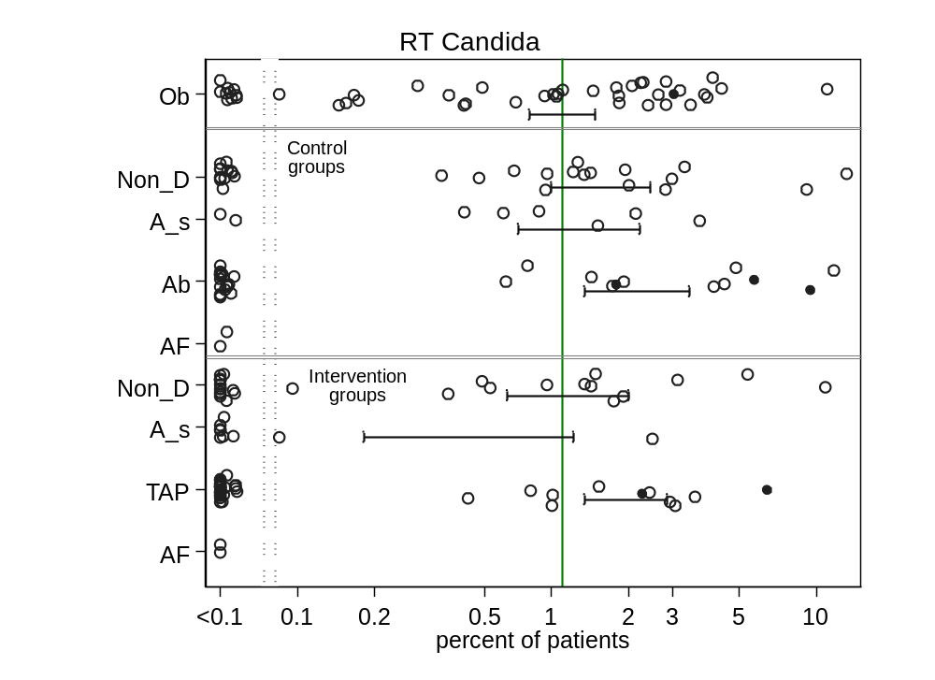
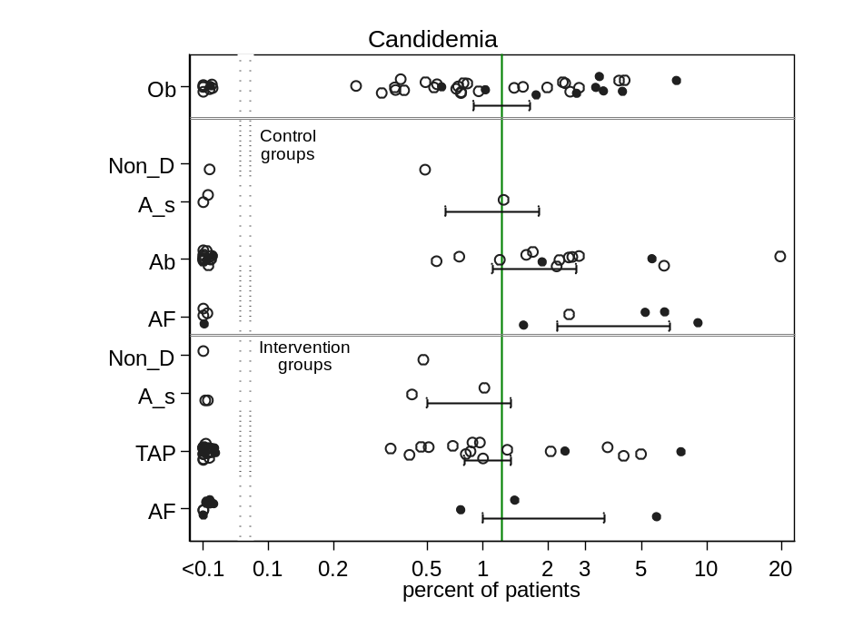
Figure s2a & b Scatter plots & 95% CI of RT Candida incidence (top) and Candidemia (bottom) in component (control and intervention) groups of various methods of infection prevention in the ICU, excluding studies with ICU-LOS<5 days. The benchmark incidence in each plot is the summary mean derived from the observation studies (central vertical line). The groups wide presence of candidemia risk factors (CRF) is identified by solid symbols versus not (open).
non-D is non-decontamination, A_s is anti-septic, TAP is topical antibiotic prophylaxis and AF is anti-fungal
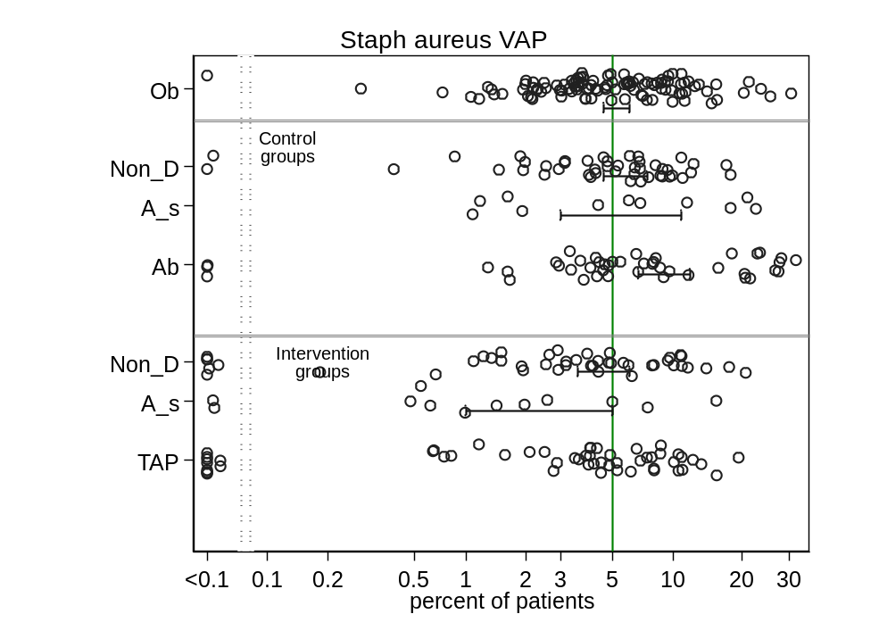
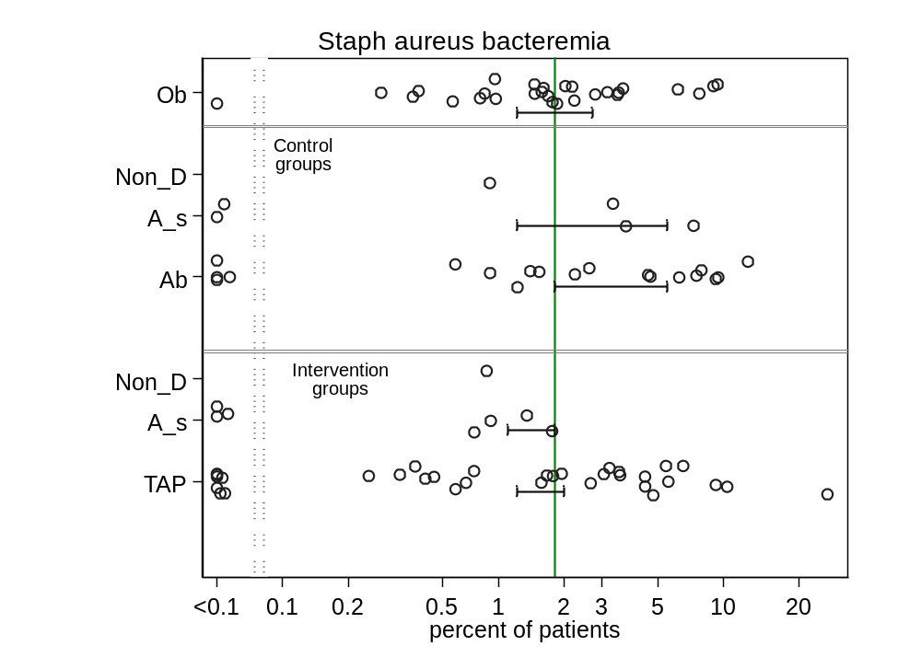
Figure s3a & b Scatter plots & 95% CI of Staph aureus VAP incidence (top) and Staph aureus bacteremia (bottom) in (control and intervention) component groups of various methods of infection prevention in the ICU, excluding studies with ICU-LOS<5 days. The benchmark incidence in each plot is the summary mean derived from the observation studies (central vertical line). non-D is non-decontamination, A_s is anti-septic, TAP is topical antibiotic prophylaxis and AF is anti-fungal
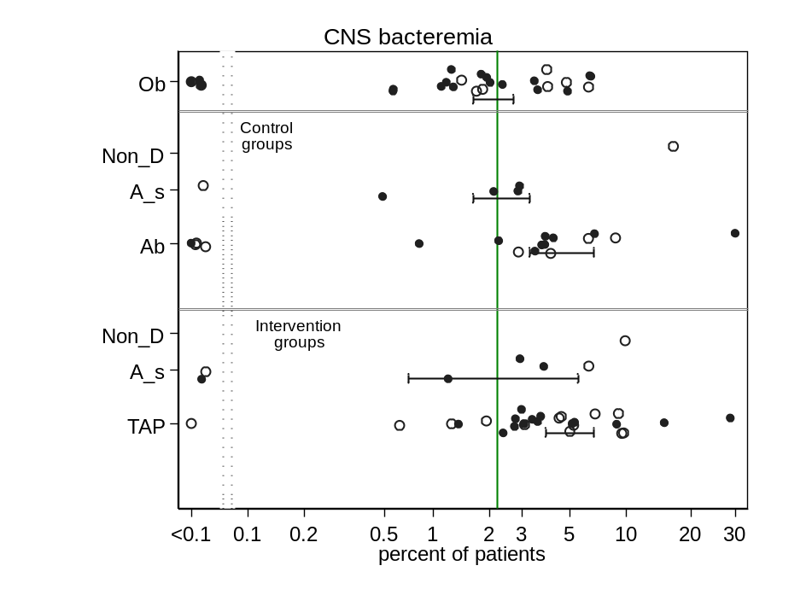
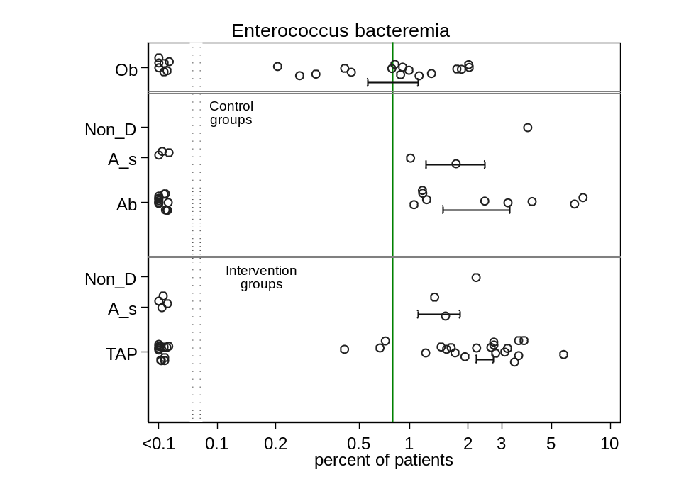

Figure s4a & b Scatter plots & 95% CI of CNS bacteremia incidence (top) and Enterococcus bacteremia (bottom) in (control and intervention) component groups of various methods of infection prevention in the ICU, excluding studies with ICU-LOS<5 days. The benchmark incidence in each plot is the summary mean derived from the observation studies (central vertical line). non-D is non-decontamination, A_s is anti-septic, TAP is topical antibiotic prophylaxis and AF is anti-fungal. Those studies using (solid) versus not using (open) CDC criteria for CNS bacteremia diagnosis are indicated.
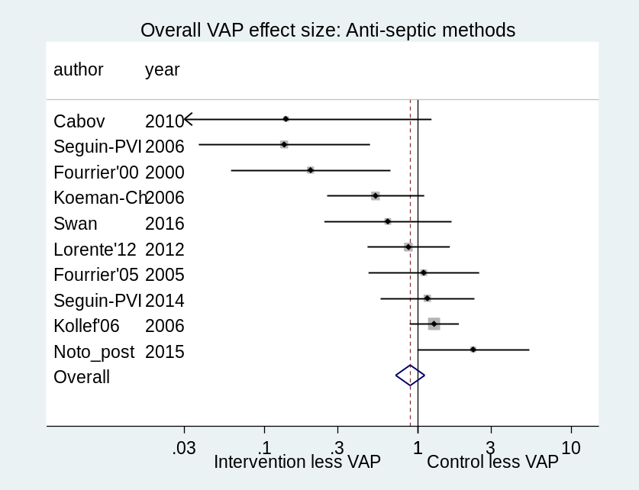
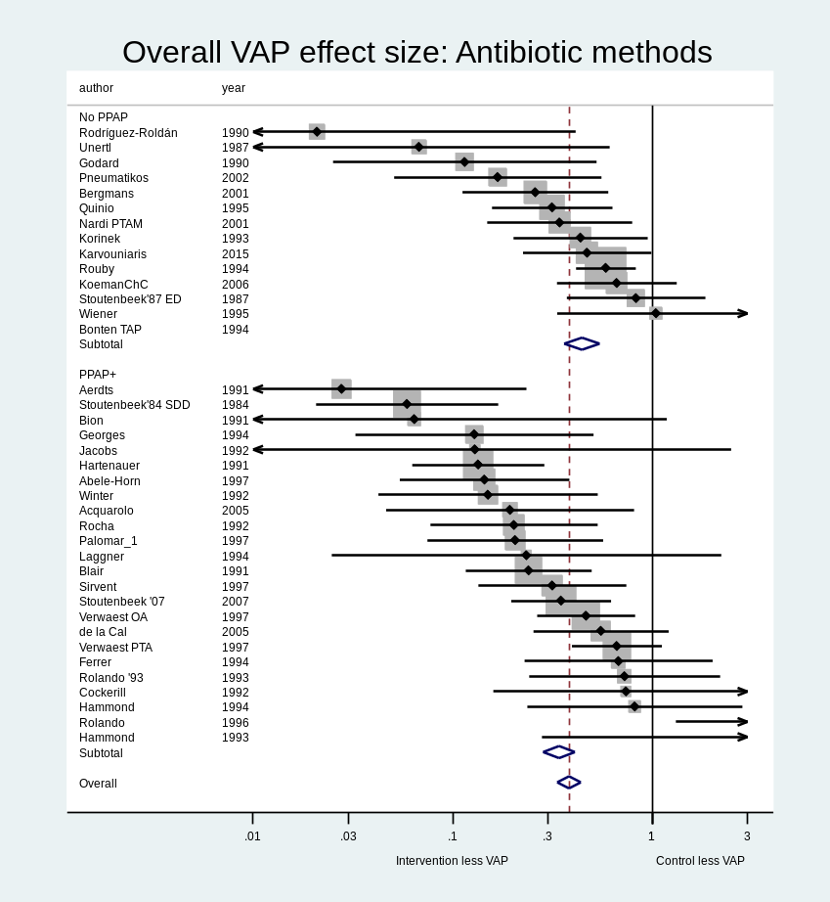
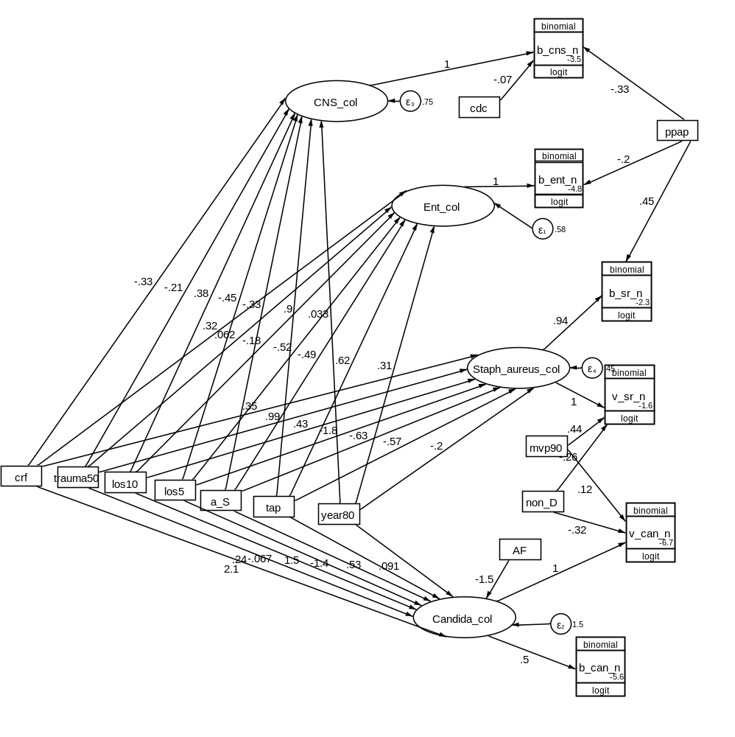
Fig S5 GSEM model 1 (all groups) (see Table 2 for abbreviations)

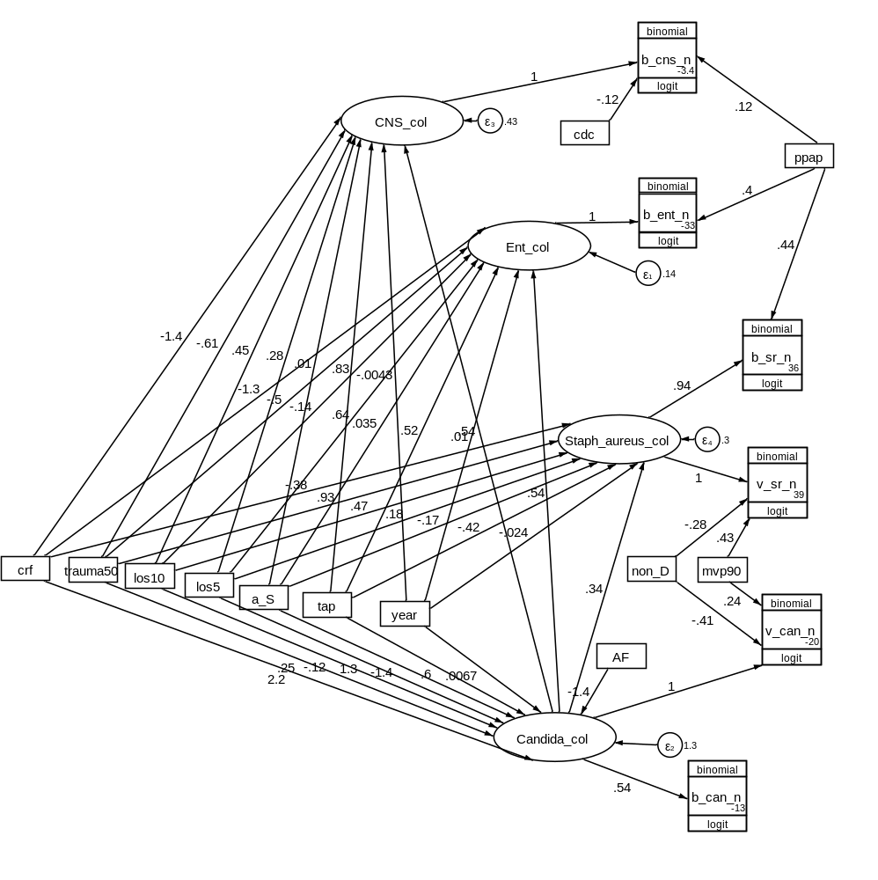
Fig S6 GSEM model 2 (all groups) (see Table 2 for abbreviations)

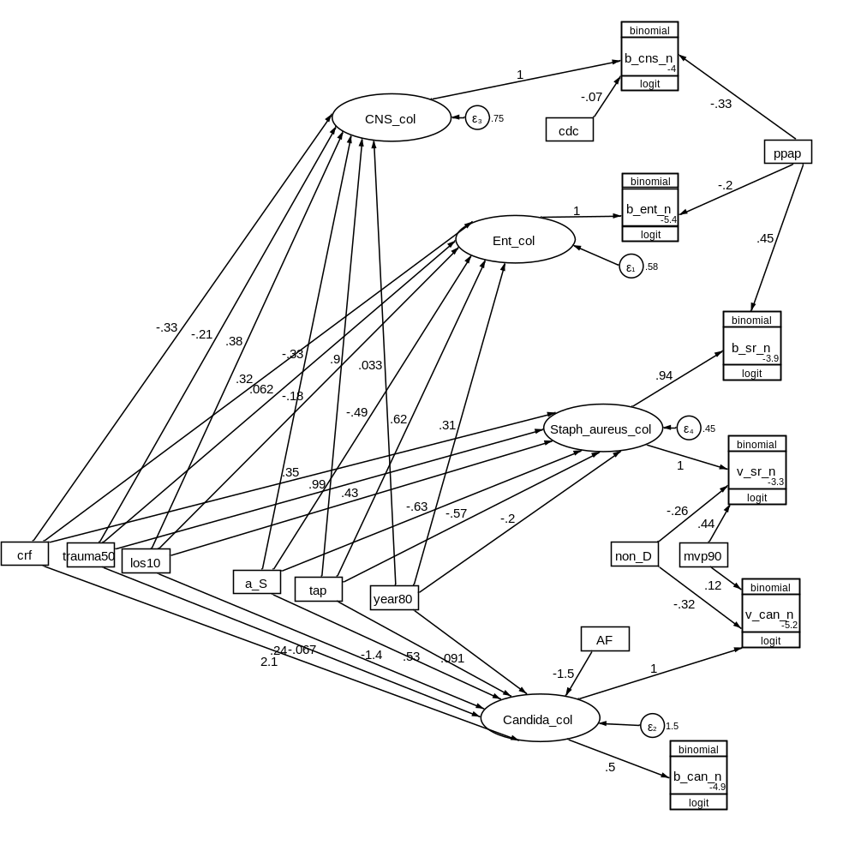
Fig S7 GSEM model 3 (excluding groups with ICU-LOS<5 days) (see Table 2 for abbreviations)

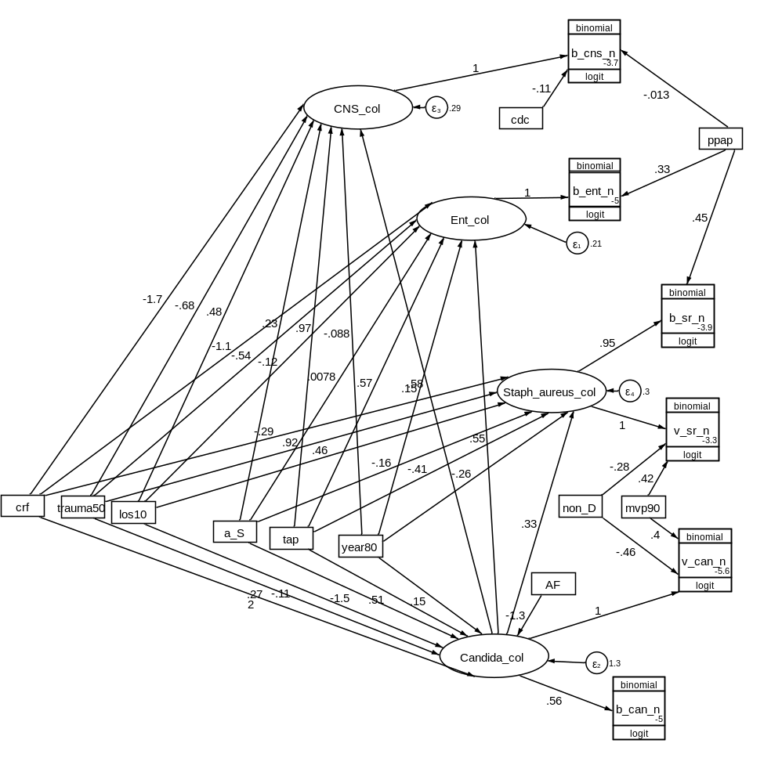
Fig S8 GSEM model 4 (excluding groups with ICU-LOS<5 days) (see Table 2 for abbreviations)

