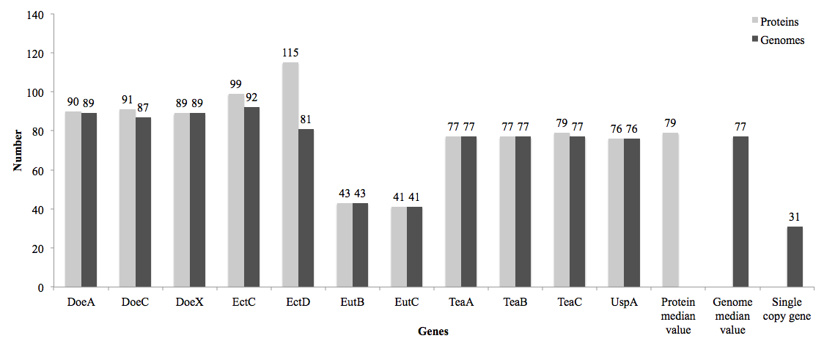
Figure S5. Single copy ectoine coding genes in the genus Halomonas

