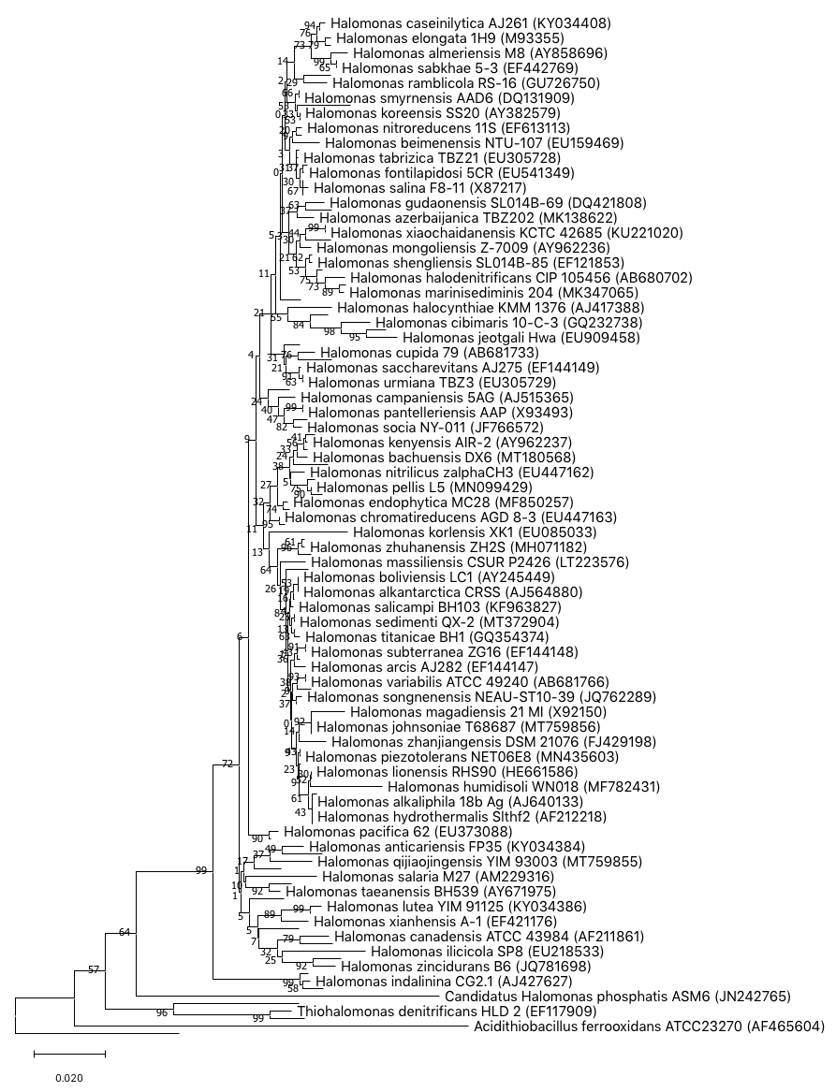
Figure S2. The evolutionary history of Halomonas species was inferred using the Neighbor-Joining method. Analysis using 16S rRNA gene sequences were conducted in MEGA X. The evolutionary distances were computed using the Jukes-Cantor method and are in the units of the number of base substitutions per site. The percentage of replicate trees in which the associated taxa clustered together in the bootstrap test (1000 replicates).

