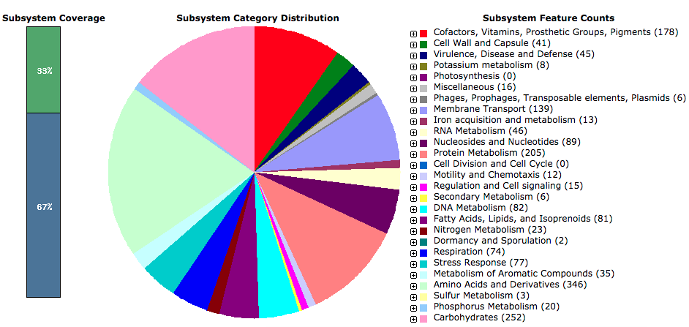
Figure S1. RAST genome analysis of Halomonas elongata 1H9

