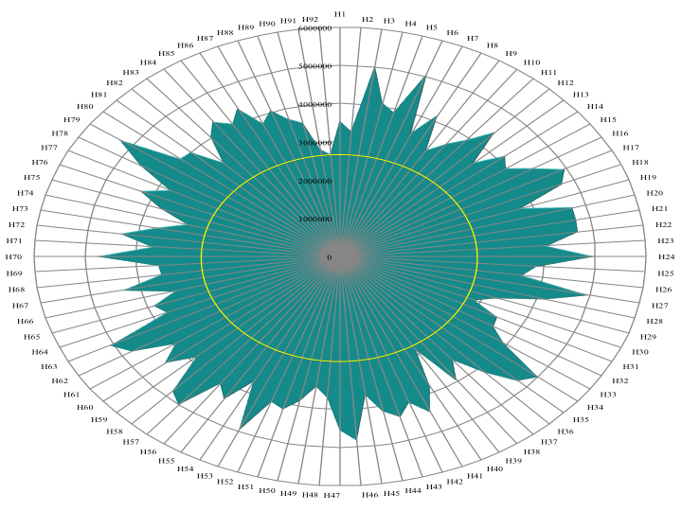
Figure S3. RADAR Chart of Genus Halomonas spp. (see supplementary table F1 for names of the species). Yellow circle indicates average genome length of each species.

